Hnd aPPLIED cOMPUTING

Software Development
  - Morgan Jones

Contents
Variables 1
If statements 1
Loops 2
Task 1 3
Task 2 4
Task 3 7

Variables
Variables are containers for storing different types of data values. There are different types of variables which have different functions. For example, one of the most used variables would be the integer. The integer variable stores whole numbers such as 123 or -123. Another example of a -different type of variable would be the double. The double variable stores numbers with a decimal place such as 12.3 or -12.3. The string variable is also another commonly used variable. The string variable store text such as hello. One final example of a variable would be the bool variable this variable stores values with two states such as true or false. Variables are important when writing programs because they are used to identify values and what they are. Once you initialize a variable with a specific data type, you cannot store an alternative data type.
Here are examples of different variables I have used:
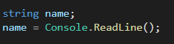
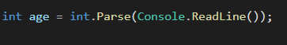

If statements
An if statement is a logical formula that has two possible outcomes. If something is true then do this else do that. If statements are logical blocks used within programming, they’re conditional statements that tell a computer what to do with certain information. In other words they let a program make decisions depending on variables. If statements are useful as it lets your program know whether it should execute a block if code. They are used frequently to specify a new condition to test, if the first condition is false.
Here is an example of an if statement I have used:
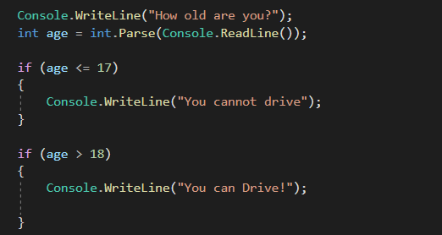

Loops
A loop is a block of code that will repeat repeatedly. A loop is used for executing a block of statements repeatedly until a particular condition is satisfied. For example, when you are displaying number from 1 to 100 you may want to set the value of a variable to 1 and display it 100 times, increasing its value by 1 on each loop iteration. Loops are needed in programming to create dynamic programs that have multiple purposes. Loops allows users to write the code once and repeat it as many times as needed, making it more likely for the program to run as expected. Also using loops instead of hundreds of lines of code is not only more efficient but is more professional as a coder. There are two types of loops, while loops and for loops. While loops will repeat while a condition is true, and for loops will repeat a certain number of times. A for loop has two parts, a header specifying the iteration and a body which is executed once per iteration. The header often declares an explicit loop counter or loop variable which allows the body to know which iteration is being executed. Then while loops control the flow statement that allows code to be executed repeatedly based on a given Boolean condition. The while loop can be thought of as a repeating if statement.
Here is an example of a while loop that I have used:
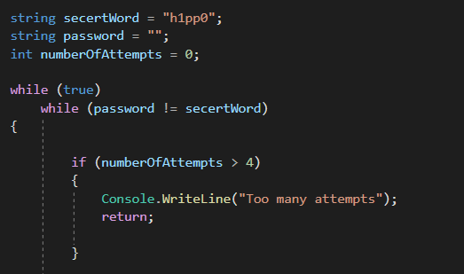

Task 1
Code:
Console.WriteLine("Please enter your name");

string name;
name = Console.ReadLine();

Console.WriteLine("Please enter your age");

int age = int.Parse(Console.ReadLine());

Console.WriteLine("Please enter your height");

double height = double.Parse(Console.ReadLine());

Console.WriteLine("So your name is " + name + ", your " + age + " Years old" + " and your " + height + " M tall");

This is what the program looks like when all values are entered correctly:
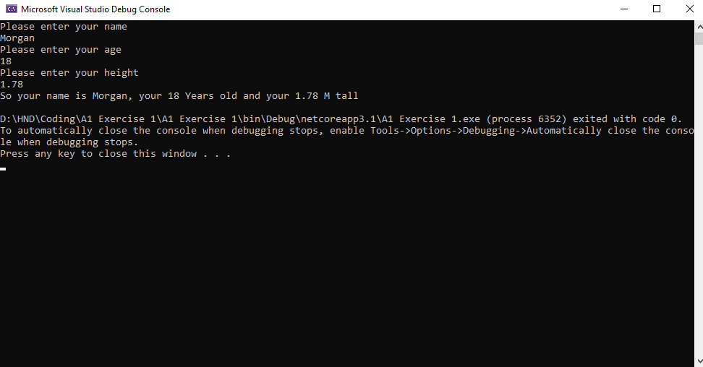
However, if you try entering a string into an integer you will receive an error message as your entering an incorrect value for that question
As this first program is very straight forward there are minimal logical stages:
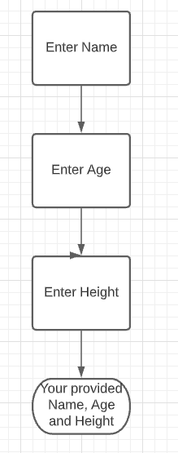
Validation:
This program makes use of three different variables. The first variable being string when asking for the user’s name. The second variable being an integer when asking for the user’s age. The final variable being double when asking for the user’s height in meters. Also, if the user tries entering an incorrect value into one of the questions, they will be stopped with an error message as they have tried to enter an appropriate value for that specific question.

Task 2
Code:
Console.WriteLine("Please enter the radius of the circle");
int radiusOfCircle = int.Parse(Console.ReadLine());

if (radiusOfCircle > 10)
{
Console.WriteLine("That seems a little too big try again");
Console.WriteLine("Please enter the radius of the circle");
int radiusOfCircle2 = int.Parse(Console.ReadLine());
}

double circleAnswer = (3.14 * radiusOfCircle);

Console.WriteLine("Please enter the side of the square");
int sideOfSquare = int.Parse(Console.ReadLine());

if (sideOfSquare > 10)
{
Console.WriteLine("That seems a little too big try again");
Console.WriteLine("Please enter the side of the square");
int sideOfSquare2 = int.Parse(Console.ReadLine());
}

Console.WriteLine("Please enter the width of the rectangle");
int widthOfRectangle = int.Parse(Console.ReadLine());

if (widthOfRectangle > 10)
{
Console.WriteLine("That seems a little too big try again");
Console.WriteLine("Please enter the width of the rectangle");
int widthOfRectangle2 = int.Parse(Console.ReadLine());
}

Console.WriteLine("Please enter the length of the rectangle");
int lenghtOfRectangle = int.Parse(Console.ReadLine());

if (lenghtOfRectangle > 10)
{
Console.WriteLine("That seems a little too big try again");
Console.WriteLine("Please enter the length of the rectangle");
int lenghtOfRectangle2 = int.Parse(Console.ReadLine());
}

Console.WriteLine("The shaded area is " + (360 - circleAnswer * 2) + "cm");

Program:
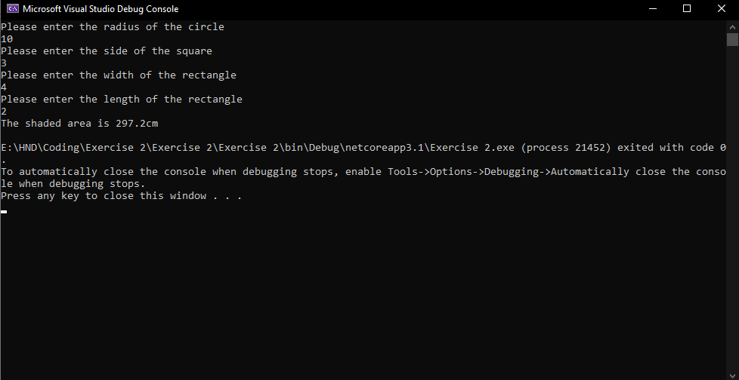
Logical stages:
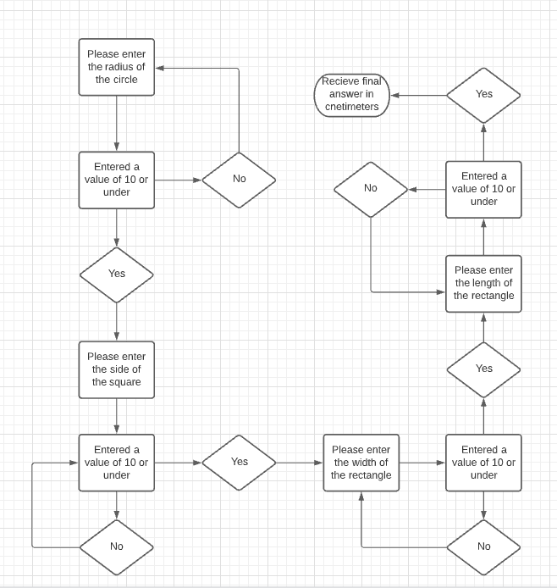
Validation:
With this program it asks you for a series of numbers. If all 4 numbers are 10 or below, they will be accepted, and the program moves on until its finishes and you will receive an answer. However, if you enter an inappropriate number that is too large (11 or higher) the program will provide an error message saying, “That seems a little too big try again” and will ask them to answer the question again. Once the user has entered appropriate answers for each question, they will receive their final answer of the shaded are in centimetres.
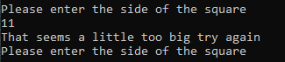

Task 3
Code:
Console.WriteLine("Enter miles used on Monday");

double monday = double.Parse(Console.ReadLine());

Console.WriteLine("Enter miles used on Tuesday");

double tuesday = double.Parse(Console.ReadLine());

Console.WriteLine("Enter miles used on Wednesday");

double wednesday = double.Parse(Console.ReadLine());

Console.WriteLine("Enter miles used on Thursday");

double thursday = double.Parse(Console.ReadLine());

Console.WriteLine("Enter miles used on Friday");

double friday = double.Parse(Console.ReadLine());

Console.WriteLine("Enter miles used on Saturday");

double saturday = double.Parse(Console.ReadLine());

Console.WriteLine("Enter miles on Sunday");

double sunday = double.Parse(Console.ReadLine());

double totalmileage = (monday + tuesday + wednesday + thursday + friday + saturday + sunday);
Console.WriteLine("Total mileage across the week was " + totalmileage);

Program:
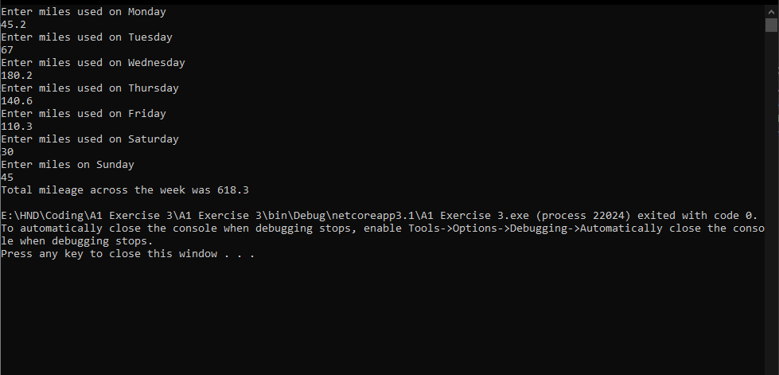
Logical stages:
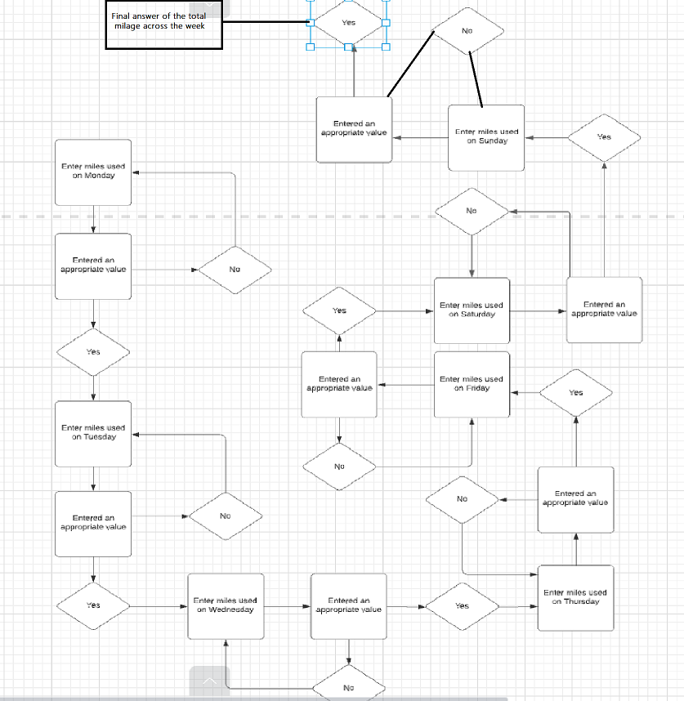
Validation:
With this program it asks you for the miles used on each day of the week. If the user has entered appropriate values for each day of the week, they will receive an answer for the total mileage across the week. For this program the double variable was used meaning numbers with and without decimals can be accepted. However, if the user tried to enter anything other than that such as words the program will deny it and the numbers will have to be filled in again to receive a total mileage for the week.

