  - ACBA4006

lighting layout, heat and sound.

Dan Griffiths.

Contents
1. Introduction 0
2. Calculations 1
1.Room index 1
2.Utilisation Factor 2
3.Number of lamps required. 4
4.Spacing and Layout for the lamp fittings. 5
3.Frequency and Wavelength 6
1.Building’s internal design and services support 6
2.Partition wall construction technique. 7
3.Choice of insulation available. 8
4.Thermal Transmittance and Thermal Resistance 9
1.Thermal Resistance 9
2.Thermal Transmittance 9
3.Heat loss through a buildings Fabric. 9
5.Thermal Conductivity Measurement. 10
References 11

Figure 1 Utilisation Factor Sheet. (Nantal, 2024) 3
Figure 2 lighting layout. 6
Figure 3 Staggered joist partition wall (White, 1993) 7
Figure 4 thermal conductivity. 10

Introduction

The first part of this report will calculate the lighting requirements for a factory. The dimensions of the building are 60 metres x 24 metres x 8 metres in height and the height of the work benches are 1 metre above the floor level. The reflectance’s of the ceilings are 0.3 and the walls are 0.5. The lighting design has specified fluorescent lamps in a recessed louvre with a Downward light output ratio (DLOR) 50%
The requirements for the Lighting Design Lumen (LDL) are 18,000 lumens. The required illumination for the factory area is 200lux at the working plane. The Light Loss Factor = 0.75.
The calculations to be made are for the Room index, The utilisation Factor (from tables), the number of lamps required, and a suitable layout for lamp fittings (value of S). All the workings will be shown.
The lay out of the lighting will be drawn on a scale plan indicating the best fit design for the luminaire installation indicating the centres of the lamps.
The second part of the report will define frequency and wavelength of a sound and then discuss the implications of dealing with these parameters in the following areas. The internal design and service support within a building partition wall construction technique, and the choice of insulation types available.
Finally, the relationship between Thermal Transition and Thermal Resistance will be defined when calculating heat loss through the building’s fabric. A supporting diagram will be drawn to show how thermal conductivity is measured, and then explaining why material type and distance are contributary factors in this calculation.

Calculations

1.Room index
Room index is fundamental to the design of a room. The room index takes into account the rooms length, width, and the height of the luminaire from the working plane to give a ratio sum which is then used with the reflectance values of the walls and ceilings of the room to select the correct luminaire for the specification and use of the room.
(Nantal, 2024)
Room index is a ratio sum, calculated using the below formula. (RI - Room Index)
RI = (L x W)
(Hm (L + W))
Where L = Length of the room
W = Width of the room
Hm = Height of the Luminaire measured from the working plane e.g. work bench.
From the information provided the Room Index can be calculated using the above formula.
Length = 60 metres, Width 24 metres, Height 8 metres and working plane is 1 metre above floor level
Mounting height for the luminaires is 7 metres (height = 8 m – 1m working plane = 7m)
RI = (60 x 24)
(7(60 + 24))
(60 x 24) =1440
(7(60 + 24)) = 588
RI = 1440/588
RI = 2.44
The calculations have given a Room Index of 2.44

2.Utilisation Factor

(Nantal, 2024)
The utilisation factor (UF) is a ratio of the luminous flux that reaches the working plane compared to the total luminous flux output from the lamps.
Utilisation Factor requires information from numerous factors, so the correct utilisation Factor can be chosen. These factors are:
Light output ratio (LOR) - The Properties of the Luminaire determine how much of the light is given off by the lamp, leaves the luminaire and the direction the light is emitted. Light that is emitted upwards (Up LOR) can only reach the working plane by reflection within the luminaire. Whereas light that is emitted downwards (Down LOR) will reach the working plane without any reflections.
Reflectance’s of the room surfaces such as walls and ceilings. Walls and ceilings that are lighter in colour reflect light more effectively than darker colours. This factor becomes more important when the Up LOR is higher.
Geometric shape of the room affects Utilisation Factor. Room index (RI) comes from the horizontal and vertical surfaces of the room.
Direct ratio is the proportion of the downward luminous flux that will reach the working plane without any reflection. The luminaire light distribution affects, this as luminaires with a narrow beam will emit a higher direct ratio than a larger solid angle which will emit a lower direct light ratio.
With the use of a Utilisation factor sheet from manufacturers and the different variables we can determine the correct luminaire that is required.
From the information below, the Utilisation factor can be determined using the Utilisation factor sheet.
Reflectance of ceilings 0.3 and 0.5 for walls.
Recessed louvres with a DLOR of 50% as specified.
Room index of 2.44.
The utilisation factor is 0.46 marked on the sheet below in red. Figure 1

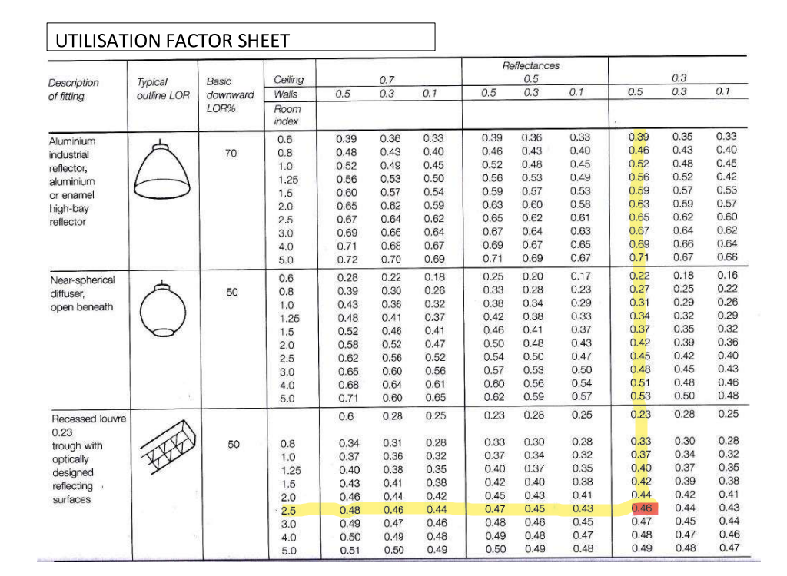
Figure 1 Utilisation Factor Sheet. (Nantal, 2024)

3.Number of lamps required.

(Nantal, 2024)
To calculate the number of lamps required for the factory the formula below is to be used with the information and specifications that have been given.
N = E x A
F x UF x LLF
Where,
N = Number of lamps required
E = Illuminance level required (lux)
A = area at working plane height (m2)
F = Average luminous flux from each lamp (lm)
UF = utilisation factor, an allowance for the light distribution of the luminaire and the room surfaces.
LLF = light loss factor, an allowance for a reduction in light output caused by lamp deterioration and dirt

N = 200 x 1440 = 288000 = 46.37 lamps
18000 x 0.46 x 0.75 6210
The calculation gave an answer of 46.37 lamps. This number must be rounded up to a whole number, as the illumination level at the working plane can be increase by up to a maximum of 70% of the required lux. Rounding down is not an option as the required lux at the working plane will be too low.
In this case the number of lamps can be rounded up to 48 Lamps, as this will give even spacing of the lamps within the factory.

4.Spacing and Layout for the lamp fittings.

(Nantal, 2024)
The spacing between fluorescent tubes in defusing luminaires has a maximum spacing of 1.5m from the centre of one lamp to another and multiplied by the mounting height of the lamp from the working plane. This is known as Smax Spacing is calculated using this formula Smax = 1.5x Hm mounting height (hm)
The mounting height required is 7m from the working plane.
Smax= 1.5 x 7 = 10.5 metres a part.
The layout of the lamps will be 4 rows of lamps across the width of the factory by 12 lamps to the length of the factory, giving a total of 48 lamps. When calculating the lamps layout and spacing the end rows should start at half of the Smax from the walls which is 5.25m. The drawing below shows the layout of the lamps evenly spaced at 4.5m over the factory area. The drawing includes the measurements of all the spacings with in the Smax rule. This gives even and consistent lighting across the factory.

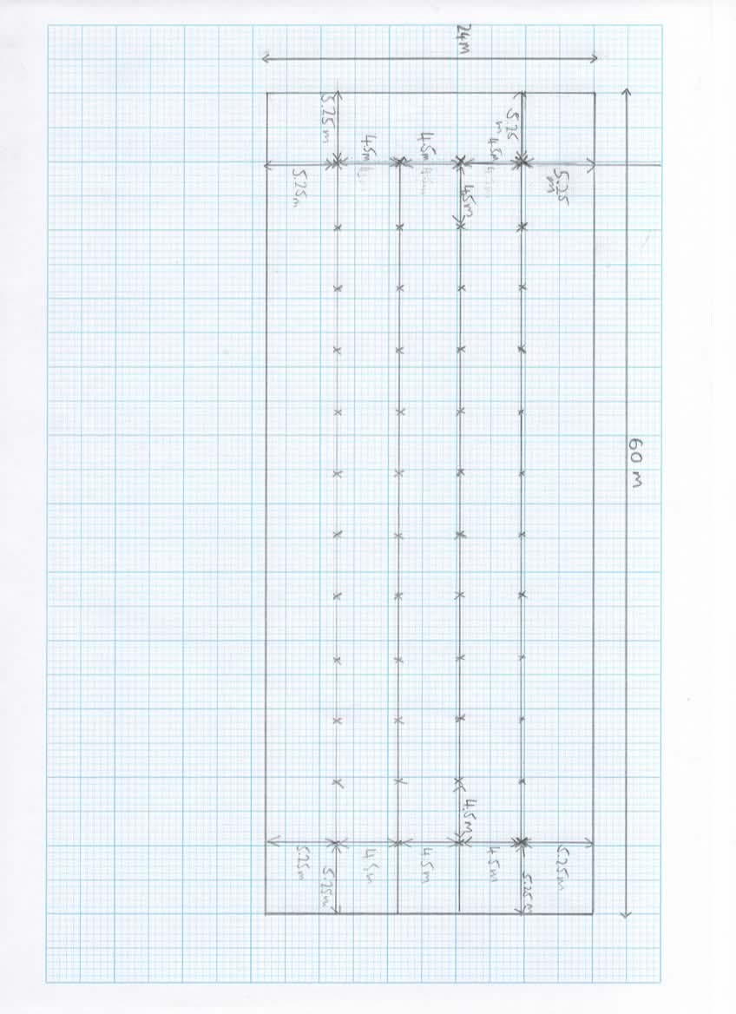
Figure 2 lighting layout.

3.Frequency and Wavelength
(Nantel A. , 2024)
A wavelength is the horizontal length of one wave cycle. Wavelength is denoted by the Greek symbol Lambda λ. Frequency is the number of vibrations per second. Frequency is expressed in the units of Hertz. (Hz)

1.Building’s internal design and services support
The activities within a building must be considered, when designing the internal layout. If the use of the building is for residential, commercial, or industrial. Different activities give off different frequencies and wavelengths of sound. If the internal area is to be used as a concert hall, the internal design should ensure that the entire audience can hear the concert at the same timings but not with an echo. For residential buildings, the internal design should aid in absorbing unwanted sounds to improve the comfort levels.

2.Partition wall construction technique.

Partition wall construction technique involves materials that can either effectively absorb or block sound. The thickness of the wall and materials chosen are influenced by the amount of sound insulation required. Thick dense materials are better at absorbing low frequency sounds, whilst high frequency sounds can be absorbed by lighter and more porous materials. Cavity walls are a good technique to aid in sound insulation as the air gap helps disrupt the path of the sound waves, making it harder for the sound waves to pass through the wall. (White, 1993). A Cavity wall with staggered joists can help reduce the amount of sound that passes through a wall, as the joist on one side of the wall dose not touch the wall on the other side. This stops the resonance of the sound traveling from one side to the other. See figure 2. Composite wall construction can aid in sound transition, as the varied materials used help disrupt sound trying to pass through. To stop a sound passing through a wall the wall must be thicker than the length of a sound wave. This makes low frequency sounds extremely hard to stop from penetrating buildings. Surfaces of partition walls can help reflect some of the sound back into a room, this can help reduce the amount of sound that can pass through the partition wall.
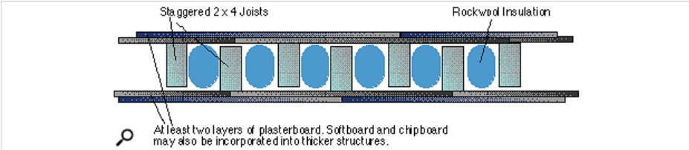
Walls should be free from gaps, as sound will be able to pass through freely and reduces the effects of the sound insulation.

Figure 3 Staggered joist partition wall (White, 1993)

3.Choice of insulation available.
(Nantel A. , 2024)
There are many types of sound insulation available. The type of sound insulation required depends upon the activities that are happening outside of the building, the use of the building, the way in which the sound is being transmitted and the sounds from with in the building. These sounds can be put into three categories: Ambient noise, Specific noise, and Residual noise.
The heavy weight construction of walls gives good sound insulation. Sound waves are vibrations, these vibrations have difficulty vibrating a dense, heavy structure. “The Mass Law States that: the sound insulation of a single leaf partition raises in proportion to its mass.” The doubling of mass increases the insulation value by 5-6 dB.
Mineral wools are a great sound insulator, it can be easily installed within stud walls and is great at absorbing airborne sounds as it is a dense material. This makes it harder for sound to pass through. It can be more effective with in a cavity wall as the mass of the wall is increased and allows for an air gap.
Panel absorbers are great for absorbing low frequency sounds in the ranges of 40-400 Hz. The panels absorb sound waves by converting them into mechanical vibrations, which lose their energy as of the friction inside the panel. Panel absorbers are mounted to a wall with a large air gap behind to further disrupt sound waves. Panel absorbers are normally seen in recording studios.
Porous absorbers are materials with a cellular network of interlocking pores such as fiberglass. They are good at absorbing high frequencies above 1kHz. They convert sound energy into heat.
(Welsh Govenment , 2004)
Sound insulation must meet the regulatory requirements as set out in Part E of the building regulations for use in Wales.

4.Thermal Transmittance and Thermal Resistance

1.Thermal Resistance
(Nantel A. , 2023)
Thermal resistance is a measure of how much an insulating material can resist the transfer of heat. This is shown as the R value. The higher the R value the higher, the insulating effect of the material. R Values are shown as m2/K/W.
Where; is 1 metre squared of a material to a specified thickness, K refers to a one-degree temperature difference in Kelvin across the material, and W refers to the amount of heat flow across the material in Watts.

2.Thermal Transmittance
Thermal Transmittance is referred to as U Value. U Value is the measure of heat through an element of a building. This indicates the amount of heat that will flow through a one metre squared area of a structure, when the temperature difference between the faces is 1 degree.
U value is expressed in the units of W/m2 K (Watts/m2 Kelvin)

3.Heat loss through a buildings Fabric.
U Values are reciprocal or the R Value. R=1/U or U=1/R.
When calculations are made for heat loss form a composite structure, the high the R Values of the materials used will give a lower thermal transmittance or U Value. The relationship between Thermal resistance and Thermal transmittance is critical for the thermal efficiency of a structure. A lower U Value means less energy consumption will be needed to heat the structure.
(Welsh Govenment, 2022)
The U Values of any new or existing structures must conform to the U Values set out in the building regulations as referenced above.

5.Thermal Conductivity Measurement.

(Nantel A. , 2023)
Thermal conductivity is the measure of the rate that heat is conducted through a material. Thermal conductivity measured in Watts per metre square of the surface area for a temperature gradient of one metre Kelvin per metre thickness- W/m K.
Thermal conductivity can be calculated using the formula below with the aid of the diagram figure 4.
Rate of Heat Flow= H = λ x A x (θ1 - θ2)
(Conductivity) T d
Where
H/t = Rate of heat flow(conductivity) between the faces (J/s=Watt)
λ = Coefficient of thermal conductivity for that material (Watt/m K)
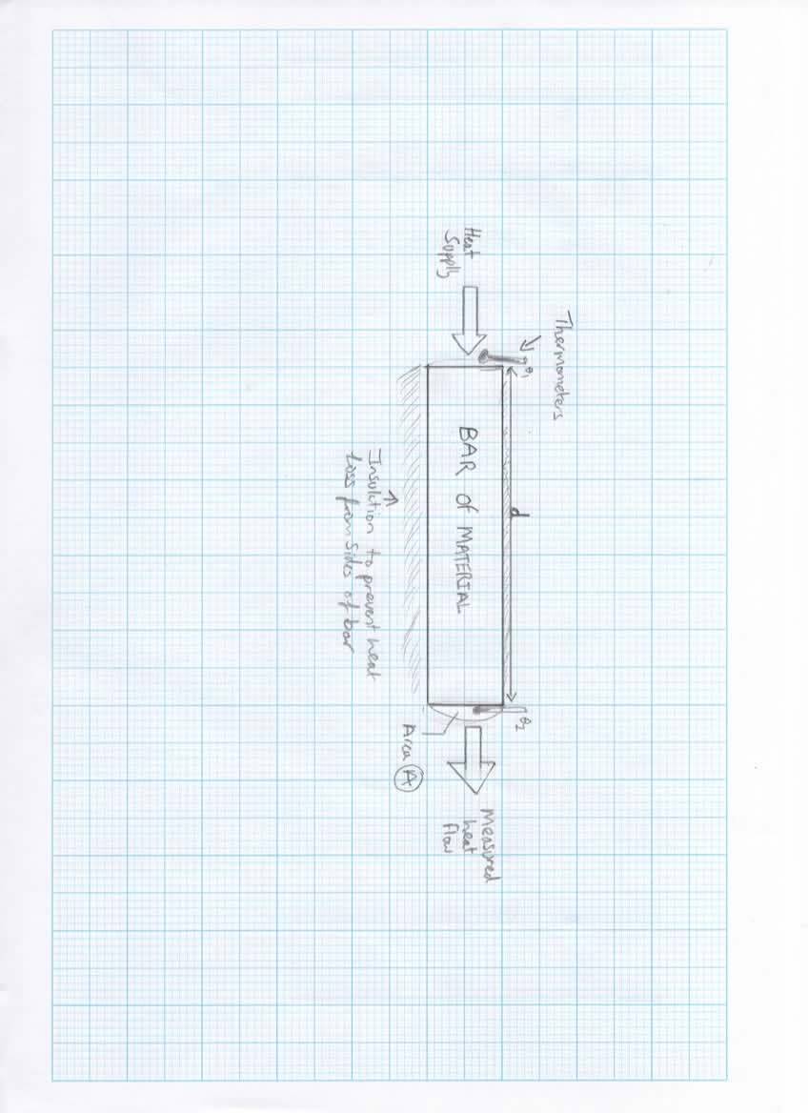
A = Cross sectional area of the sample(m2)
Θ1-θ2 = temperature difference between the faces (°C or °K)
d = distance between the faces (m)
Figure 4 thermal conductivity.

References
Nantal, A. (2024, January ). Artificial lighting . WISA Built Portfolio. UWTSD.
Nantel, A. (2023, October ). Thermal Energy . UWTSD.
Nantel, A. (2024, January ). Sound. UWTSD.
Welsh Govenment . (2004, June). Building regulations 2010 Approved document part E . Resistance to the passage of sound for use in wales. Welsh Govenment .
Welsh Govenment. (2022, November 23). Building Regulations 2010 Part L Volume 1 Dwellings 2022 edition for use in wales*. 30-34. Wales: Welsh Govenment.
White, P. (1993, October N/d). soundonsound.com. Retrieved from https://www.soundonsound.com/techniques/practical-studio-design-part3

