
Student Name: Parth Vipulkumar Patel
Student ID: 2532673
Master of Business Administration (MBA)
Module name: Marketing Management
Module code: LCMB7024
Lecturer's name: Lilla Maazouz
Submission Date: 14 August,2026
Word Count: Approx.2500

Table of Contents
Introduction 3
Element 1: Poster 3
Element 2: Segmentation, Targeting, Differentiation, and Positioning 5
Element 3: Marketing Mix (7Ps) for IKEA EcoLiving 10
Element 4: Reflection 14
References 16

Introduction
Sustainability is currently emerging as one of the most powerful forces of modern-day marketing because consumers want organisations to offer products and services that have limited negative environmental effect on them and generate long term value. To survive and live up to the evolving market expectations, therefore, companies are incorporating sustainable innovation in its branding, product developmental and customer interaction processes.
The second employs the Segmentation, Targeting, Differentiation, and Positioning (STDP) in identifying the most suitable target market and position in the competitive market. The third will create an elaborate marketing plan which will be based on the extended 7Ps marketing mix (Davidov and Nazzal, 2026).

Element 1: Poster
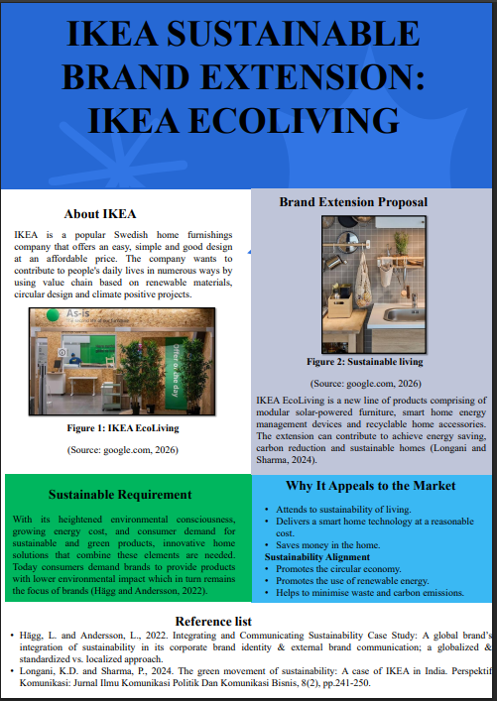

Element 2: Segmentation, Targeting, Differentiation, and Positioning
2.1 Introduction to the Brand Extension
As part of its vision of long lasting value, IKEA's sustainable brand extension is IKEA EcoLiving, which it intends to provide a chance to the consumers to create sustainable and energy efficient homes. The extension combines smart home solutions and environmentally friendly products, so that the customer can take advantage of the technology to reduce energy consumption and environmental impact, while the range is still affordable and usable, with innovative design.
2.2 Market Segmentation
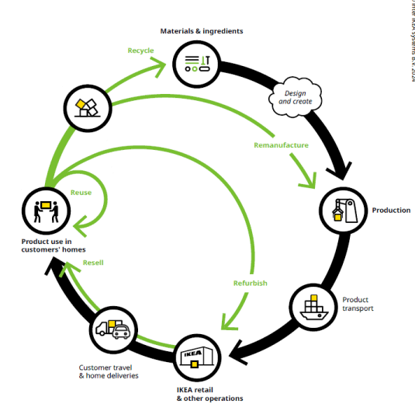
Figure 1: IKEA Green Marketing
(Source: themediaant.com, 2026)
Market Segmentation is used to divide the bigger market into smaller segments based on the common needs and buying pattern of customers in order to help IKEA. EcoLiving is segmented according to geographical, demographic, psychographic and behavioral data to ensure that marketing activities are conducted on the most relevant target groups (Mahalakshmi et al., 2024).
Geographic Segmentation
IKEA EcoLiving will be primarily aimed at urban and suburban consumers who are more and more interested in environmental sustainability and energy efficiency. The biggest markets are the developed ones whose environmental policies are well established and with a high percentage of smart home technology implementation, such as the United Kingdom, Canada and Australia, as well as Germany and Sweden (da Silva and Vargas-Sánchez, 2025). There is also a huge potential for growth in quickly developing economies that have growing middle-classes and environmental awareness.
Demographic Segmentation
The age group of 25 - 45 is the main target, which is the homeowner, a young family and working professionals with medium to high disposable income. More of this group tend to spend on home improvement items that will offer them financial and environmental benefits over the long term. The secondary segments are the environmentally conscious retirees and first-time home buyers seeking sustainable solutions that are affordable (Alzoubi, Al-Talib and Al Saad, 2023).
Psychographic Segmentation
The brand extension caters to the consumers who appreciate sustainability, innovation and responsible consumption. These are people who are actively looking for products that are in line with their environmental values and lifestyle choices. They like modern Scandinavian design, technology and products that improve their life and reduce environmental impacts (Rodrigo, 2023).
Behavioural Segmentation
EcoLiving's focus is on individuals who typically shop for home improvement products, intelligent home technology, and eco-friendly home solutions. They're loyal, they will ask lots of questions about the sustainable options they have before purchasing, and they are willing to pay for something that will last them a long time, that will save them energy (Davidov and Nazzal, 2026).
2.3 Target Market
The primary target group of IKEA EcoLiving are millennials and Generation Z consumers who aspire to sustainable living and are forming households. These customers are well informed and more interested in products that can save energy, protect the environment and are digitally connected.
The second target market is families, with children, who want to save money on their family's bills, but also want to make their home healthier and more sustainable. They appreciate products that help them use more energy efficiently, save money and make their families safer in the future(Steinarsdottir, 2024).
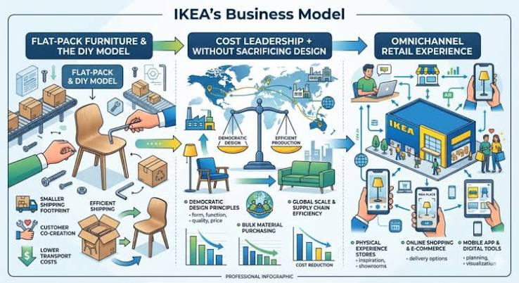
Figure 2: Business Model
(Source: youngurbanproject.com, 2025)
With a known brand for affordable home furnitures, IKEA stands strong to gain the customers among this group. Integrating smart technology into sustainable product design, EcoLiving combines the functional with the emotional customer need.
2.4 Differentiation Strategy
The IKEA EcoLiving brand extension is remarkable due to the combination of items it offers at an affordable price, Scandinavian design, smart technology, sustainability – all in one integrated product ecosystem. While there are many manufacturers out there that sell high dollar smart home products or stand alone sustainable items, IKEA has low-cost products that you can use to up your home without spending too much.
What is important, too, is IKEA has a vast store network all over the world, and a smart online platform to provide products. A feature that no competitor can match: EcoLiving makes customers' journeys more efficient thanks to professional installation support and digital energy-management solutions (Alzoubi, Al-Talib and Al Saad, 2023).
2.5 Positioning Strategy
IKEA EcoLiving will be an affordable and exciting sustainable home, letting the consumers live more responsible lives without sacrificing comfort and design. The extension focuses on simplicity, functionality and accessibility, thus enabling a wide range of households to make sustainable living possible.
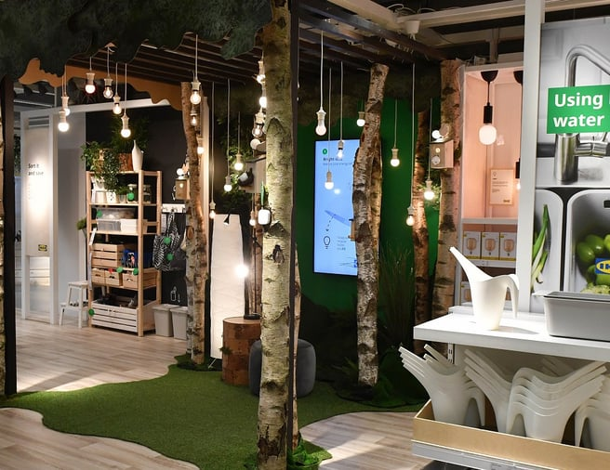
Figure 3: Sustainable Future
(Source: ingka.com, 2026)
The positioning statement for the brand extension is:
"Affordable smart living for a sustainable future."
It is a strong message that IKEA is committed to making and delivering products that are, and are perceived as, functional, attractive and environmentally friendly, and will offer value for the long-term customer. EcoLiving aims to be the trusted brand offering consumers the ability to save energy, save money and do their bit for the environment (Rodrigo, 2023).

Element 3: Marketing Mix (7Ps) for IKEA EcoLiving
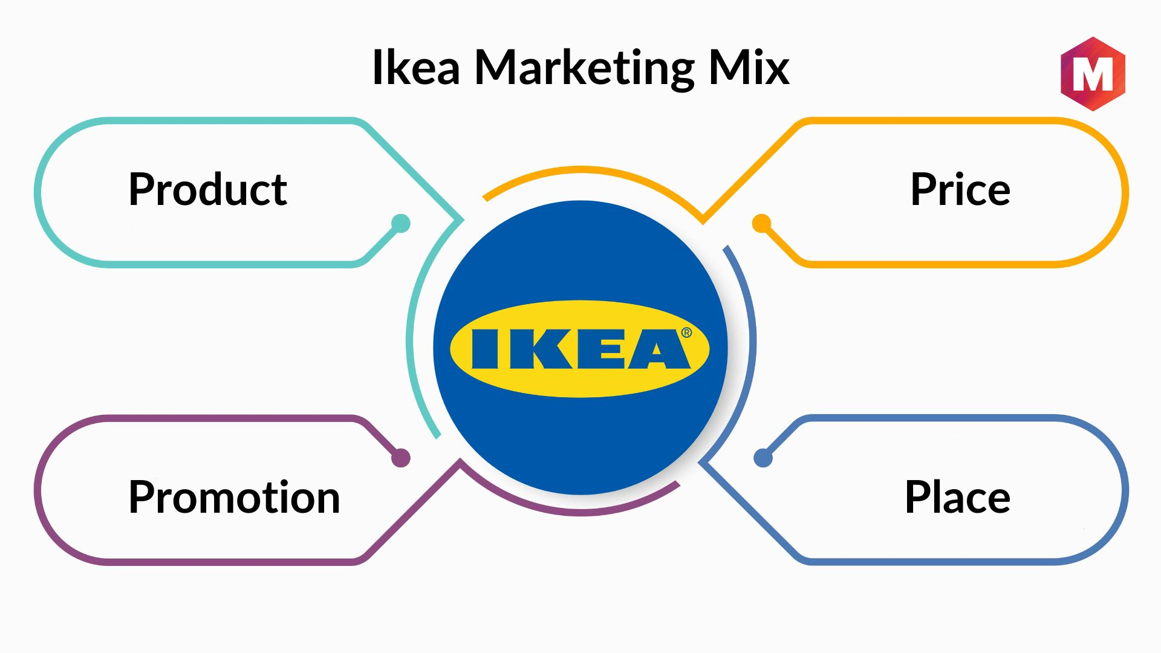
Figure 1: Marketing Mix (7Ps) for IKEA EcoLiving
(Source: marketing91.com, 2026)
3.1 Product
IKEA EcoLiving is a proposed brand extension that's a sustainable product and service ecosystem that helps the consumer to make energy efficient and environmentally responsible homes. It has solar-powered furniture, smart lighting, home energy monitoring solutions, recyclable storage, water-saving accessories for the home. Use of sustainable materials in the products, consistent with IKEA's commitment of product development (Abdul-Azeez et al., 2024).
The ability to be integrated with an app which enables the customer to monitor their energy consumption, receive personalised energy-saving tips and control smart devices in their home remotely, is one of the unique features of EcoLiving. Modularity also helps customers to upgrade or replace a single component in the product instead of replacing the entire product thus extending the product life cycle and reducing waste (Bouhia, 2022).
In addition to the IKEA physical products, IKEA will provide installation help, maintenance, and a take-back programme for the products, for recycling and responsible disposal. This complete offering enables to offer more value to customers and contributes to IKEA's goal of promoting circular consumption. EcoLiving enhances IKEA's sustainable home living reputation as an innovative leader in sustainability, by combining affordability, functionality and environmental responsibility.
3.2 Price
IKEA EcoLiving pricing will be based on value pricing, which is based on the value provided in terms of both financial and environmental outcomes to customers. Although it might be an investment initially, in the long term, the consumer will save money on the product because they will be using less electricity, maintenance costs and product life will be reduced.
IKEA will be selling a different price range to ensure that certain people can access the product. Single products or whole EcoLiving packages are made available for sale at package prices. If flexible payment methods and financing are offered along with sustainable technologies, there would be further decrease in financial barriers for households that adopt such technologies (Chakraborty, 2025).
IKEA's reputation of affordable products will be maintained by offering promotional discounts when introducing products, providing rewards for loyalty programmes, and special offers throughout the seasons. This pricing model is not only providing the market a low price, but long-term value.
3.3 Place
IKEA EcoLiving will be sold through a multi-channel approach and both stores and e-commerce channels will be linked together as a whole. Specific areas will be set up within old IKEA stores so that customers can experience and understand the products, and how they can make sustainable decisions for their home by experiencing and learning from the experts and demonstrations.
The products will also be available on IKEA's website and mobile app, allowing customers to easily browse, compare, customise and order products. The online ordering will be available with home delivery and professional installation (Dhanked and Lee 2025).
3.4 Promotion
IKEA EcoLiving's promotion will be aimed at both information and awareness raising: to give consumers information about sustainable living and to raise their awareness of the brand extension's environmental and economical benefits. Social media, search engine and video sharing website digital marketing campaigns will include product videos, customer testimonials and true-to-life energy saving stories.
Environmental consumers will be more inclined to purchasing products if their partnership with influencers is more solid with individuals who are interested in sustainability, architects, and interior designers. EcoLiving will offer customer interactive online tools which include virtual room planners and energy-saving calculators that will enable customers to see the benefits of the products before purchasing them (Jin, 2024).
IKEA Family members will get preferential discounts, have early access to new products and benefit from loyalty packages, all of which will foster repeat business and ongoing customer relationships. The overall promotional strategy reinforces the image of EcoLiving as an innovative product range and as a solution to sustainable living.
3.5 People
The IKEA EcoLiving customer experience is a very important aspect, which is provided by employees. Specialists in sustainable living, smart home technology and the functionality of these products will be trained to provide their sales, customer service and installation teams with the knowledge needed to lead their customers on the journey.
Customer service personnel will help customers before, during and after purchasing by giving them tips on installing, troubleshooting and maintenance. Products will be professionally installed ensuring fit and safety to further increase the customer's confidence and satisfaction.
IKEA's staff are its own advocates as they follow sustainability principles, but also because they build trust with their customers and help foster the company's ongoing relationships with its customers (Welinder, 2023).
3.6 Process
IKEA EcoLiving's customer journey has been simple, efficient and eco-friendly. Consumers start with IKEA's website, mobile app or physical stores, to view the products, and are then shown personalised recommendations based on their household requirements.
Buys can be made online or in-store, and delivered when requested with flexible delivery and optional installation. Once installed, customers can monitor their energy use through the EcoLiving mobile app, and access a customer service representative should they need it.
3.7 Physical Evidence
In terms of perception of quality, sustainability and trust, it is a physical evidence. It will be highlighted that the packaging used for EcoLiving products will be recycled and biodegradable, in order to reduce waste, the policy of IKEA (Bouhia, 2022).
There will be specific sections dedicated to Ecoliving in IKEA stores and a natural materials and display with interactive product demonstrations will give customers a true experience of the materials and digital displays. Nutritional or environmental claims and energy savings and sustainability certifications will be prominently displayed on the product label.

Element 4: Reflection
Reflection on Developing the Sustainable Brand Extension Marketing Strategy and Poster Presentation
In developing the sustainable IKEA brand extension, it was a great learning experience for me as it enabled me to gain a thorough understanding about strategic marketing and brand development. Before I had planned this project, I know that IKEA is a leading furniture company and is interested in sustainability (Abubakar et al., 2024).
Through the research of the company's sustainability programs and the creation of the EcoLiving brand extension, however, I had the opportunity to also gain insight into the importance of brand development as a means to reinforce the position of the company in the competition, but also to respond to environmental and social challenges. When planning an expansion it was important to think outside the box and ensure that the idea that I had proposed remains consistent with the current brand identity, customer expectations and the long term business goals of IKEA (Fabicka, 2022).
Marketing mix concept gave me more understanding of the various marketing activities and their relationship with each other and also how they will help the business to achieve a successful brand extension. But not only was I thinking about the product, but I was learning the importance of coordinating pricing, distribution, promotion, people, process and physical evidence strategies. These are all factors that help provide value to the customer and meet organisational goals. I gained an understanding that Sustainability is not just an environmental action, but also an important business strategy which influences product development, customer experience, operation and competitive advantage for long-term (Hanbing, 2024).
The exercise of poster presentation also helped me to improve my communication and presentation skills. The primary difficulty was to display detailed marketing information in a concise, clear and visually appealing manner (Li, Lin and Zhu, 2022). I found that communicating is as much about highlighting the most significant aspects and presenting them in a succinct and captivating way as it is about conveying lots of information.
During the project also my research and organization skills have been strengthened. Careful planning and time management was required to gather information, identify the existing sustainability trends and organise the information in a sound marketing strategy. I thought about the challenges in today's market and the solutions that can provide value to businesses and society (Pérez-Pérez, Berlanga and Victoria 2023). It also helped me gain confidence in business problem analysis and developing new marketing strategies with a logical approach.

References
Element 1
Hägg, L. and Andersson, L., 2022. Integrating and Communicating Sustainability Case Study: A global brand’s integration of sustainability in its corporate brand identity & external brand communication; a globalized & standardized vs. localized approach.
Longani, K.D. and Sharma, P., 2024. The green movement of sustainability: A case of IKEA in India. Perspektif Komunikasi: Jurnal Ilmu Komunikasi Politik Dan Komunikasi Bisnis, 8(2), pp.241-250.
Mathur, P., Malika, M., Agrawal, N. and Maheswaran, D., 2023. The context (in) dependence of low-fit brand extensions. Journal of Marketing, 87(1), pp.114-132.
Shafik, W., 2025. Social Media and Green Brand Engagement. In Agile Sustainable Marketing: Navigating Towards a Greener Future (pp. 78-93). Bentham Science Publishers.
Element 2
Alzoubi, A., Al-Talib, M. and Al Saad, W.K., 2023, March. Sustainability as a competitive advantage: IKEA as a case study. In 13th International Conference on Industrial Engineering and Operations Management (IEOM).
da Silva, M.D.L.C. and Vargas-Sánchez, A., 2025. SUSTAINABLE STRATEGIES, DIGITAL CIRCULAR ECONOMY, AND BRAND PURPOSE RECONFIGURATION IN RETAIL. Revista Ibero-Americana de Humanidades, Ciências e Educação, 11(8), pp.09-31.
Davidov, P. and Nazzal, A., 2026. IKEA Effect in the Evaluation of Academic Assignments. Вопросы образования/Educational Studies Moscow, (2).
Mahalakshmi, S., Nallasivam, A., Kumar, S.H., Kalavathy, K.S. and Desai, K., 2024, February. Sustainability by design: Ikea’s eco-friendly marketing efforts. In 3rd International Conference on Reinventing Business Practices, Start-ups and Sustainability (ICRBSS 2023) (pp. 145-161). Atlantis Press.
Rodrigo, I.C., 2023. Firm Resources and Capabilities and Their Impact on Sustainability: The Case of IKEA.
STEINARSDOTTIR, S.C., 2024. The impact of Corporate Social Responsibility on brand trust and customer loyalty: A quantitative study on IKEA (Doctoral dissertation, University of the Thai Chamber of Commerce).
Element 3
Abdul-Azeez, O.Y., Nwabekee, U.S., Agu, E.E. and Ignatius, T., 2024. Strategic approaches to sustainability in multinational corporations: A comprehensive review. International Journal of Frontline Research in Science and Technology, 3(02), pp.038-054.
Bouhia, G., 2022. Applying the circular economy concept to a sustainable business model for large retailers: the case of IKEA. International Journal of Competitiveness, 2(3), pp.212-233.
Chakraborty, U., 2025. Cultivating Sustainable Living Through Strategic Messaging: IKEA’s Sustainable Communication Strategy Towards “People & Planet Positive”. SAGE Publications: SAGE Business Cases Originals.
Dhanked, M. and Lee, S.P., 2025. Sustainable Product-Service Systems (S. PSS) Drive Customer Engagement in Customized Furniture: A Case Study of IKEA. Design Works, 8(1), pp.7-18.
Jin, R., 2024. Exploring the Significance of Enhancing Leadership for Promoting Sustainable Development in Enterprises. In SHS Web of Conferences (Vol. 200, p. 01027). EDP Sciences.
Welinder, A., 2023. Legitimizing sustainability talk in retail talk: The case of IKEA’s sustainability journey (No. 164). Lund University.
Element 4
Abubakar, A., Al. Jahwari, N.S. and Bakheet, A.H., 2024. The role of environmental and social innovations in the cost leadership strategy, value creation, and business performance: a comparative analysis of SMEs and large manufacturing companies. Human Behavior and Emerging Technologies, 2024(1), p.7078016.
Fabicka, W., 2022. CSR as an Element of a Marketing Strategy–The Example of IKEA. In The Best Practice of Marketing Management in Polish and International Enterprises (pp. 101-116). Wydawnictwo Uniwersytetu Łódzkiego.
HANBING, Q., 2024. THE INFLUENCING FACTORS OF INTERNATIONAL MARKETING STRATEGY FOR IKEA GROUP'S PRODUCTS (Doctoral dissertation, SIAM UNIVERSITY).
Li, X., Lin, Y. and Zhu, T., 2022, December. Application of Sustainable Development Theory in Furniture Industry Development—A Case Study of IKEA. In 2022 6th International Seminar on Education, Management and Social Sciences (ISEMSS 2022) (pp. 658-671). Atlantis Press.
Pérez-Pérez, L., Berlanga, I. and Victoria, J.S., 2023. Internal communication and employer branding within a humanistic model–a case study of IKEA (Spain, 2019–2021). Corporate Communications: An International Journal, 28(2), pp.213-229.

