

Data Handling & Business Intelligence (LCBB5000)

Name : Bianca Petronela Paunescu

Student ID : 2024896

Name of Lecturer: Gasso Wilson Mwaluseke

Title
Data Analysis and Visualisation

Table of Contents

PART 1……………………………………………………..…..........2
  - Pre-processing the data……………..……………………..2
  - Analysing the data….……….………………..………..…..3
  - Visualising the data......…………………………………....5
  - Excel functions………………………………..……....…...6
PART 2…………………………………….…………………..….....7
  - Vanilla flavour ice cream………………………………….9
  - Male and female students ………………………………....9
  - K-means clustering…………………………………….…..9
  - Data mining and text mining methods……………….….....9
  - Advantages and Disadvantages of SPSS and Excel………..9
Reference list…………………………………………………….......10

PART 1

Using the Superstore data provided, we are able to analyse the decrease in sales over the years. To do so, we must follow the next steps:
Step 1: Select the data we wish to include in the Pivot Table.
Step 2: By creating a Pivot chart, we can filter the data and create a table showing only information we are interested in.
Step 3: Add the Sales field into Values field, Order Date and Years fields into Rows field.
Step 4: Create a chart showing the decrease in sales over the years.
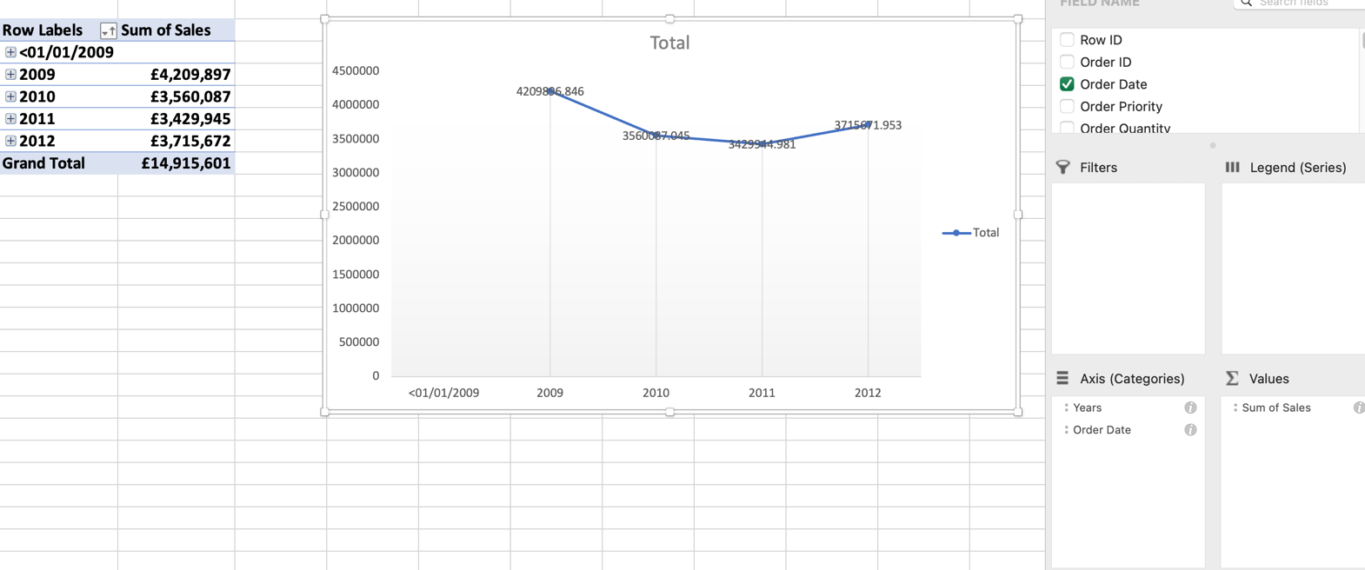

Prior to 2019, there have been no sales, but 2019 has proved to be the most productive years in terms of sales, with a record of £4,209,897. The following years haven’t been as profitable as 2019, resulting in a decrease over the following years, with sales of £3,560,087 in 2010 and £3,429,945 in 2011. However, we can notice a slight improvement in 2012, when the sales have increased comparing to the last couple of years, ending the year with £3,715,672 in sales.

Use of Excel - https://blog.hubspot.com/sales/dangers-of-using-spreadsheets-for-sales

- Pre-processing data

Advantages:
- Free to use
Spreadsheet software is widely accessible and sometimes free for most enterprises. The majority of users with an internet connection can view a spreadsheet, regardless of whether the business utilises Microsoft Excel or Google Workspace's Google Sheets.
- Easy to use
Spreadsheet data entry is largely intuitive and does not require extensive training to master, with the exception of creating complex formulas. Because of this, organisations that experience rapid growth and lack the time to devote to teaching new hires how to use sophisticated software might benefit from using spreadsheets.

Disavantages:
- Data not secured
Spreadsheets may be sent to everyone, everywhere, with the simple send of an email, unlike a dedicated system that requires access to log in. Because of this, it's simple for an unhappy or dishonest employee to give leads and consumer information to strangers.
- Duplicates
Even though everyone may begin by using the same data, this situation is unlikely to last for very long. The master spreadsheet will need to be updated each time a representative makes a modification in order for the rest of the team to be informed of the changes. Furthermore, if they fail to do so, you will have many copies of the same identical spreadsheet, each with slightly different data.
- Errors
Spreadsheets themselves aren't error-prone, but their users most certainly are. Spreadsheets inevitably include some sort of inaccuracy since they are used by so many individuals at once and are subject to so many revisions and computations. Because of this, it makes sense to spend money on database software that can either flag mistakes for users' attention or rapidly and accurately address them on its own. Because unless someone is constantly checking it row-by-row, the worst thing about spreadsheets, especially huge ones, is that it's easy to miss errors.

- Analysing data

Advantages:
- Easy to use tools for analysis (Pivot tables)
PivotTable is a drag-and-drop analysis tool available in Excel. Averages for complaints by category, location, date of purchase, and any other fields we have can be shown in a pivot table. Fundamentally, pivot tables assist with:
summarising extensive data sets, analyse a lot of data, investigate data insight,
put such observations in an approachable format.
- Data easy to analyse
Spreadsheets make data manipulation and analysis simple. We may make pivot tables, get data from other tabs, get rid of duplicates, multiply, divide, and add datasets. We can also search all rows and columns for a particular word or parameter.
Disadvantages
- Spreadsheets can make errors
Although spreadsheets themselves aren't prone to mistakes, their users unquestionably are. Spreadsheets are inherently inaccurate because they are utilised by so many people at once and are susceptible to so many calculations and modifications. Spending money on database software that can either highlight errors for users' attention or quickly and accurately resolve them on its own makes sense in light of this. Because the worst thing about spreadsheets, especially large ones, is that it's easy to notice errors unless someone is continually reviewing it row-by-row.

- Excel doesn’t update in real time
Spreadsheets in Excel are used to store outdated data. Data gets outdated the instant a user imports a CSV file and builds up a worksheet since they are unable to connect to a live data warehouse. Users are compelled by this to endure tedious manual procedures in order to repeatedly submit the same information.
https://www.sigmacomputing.com/blog/5-excel-disadvantages-for-data-visualization
- Tools are not very clear
Unless the user is familiar with Excel, it is quite difficult to know and to find the right formulas and charts to serve the purpose. Mostly every time a user is looking for assistance on a forum or Youtube video, to save itself the problem of testing and trying out various formulas.

- Visualising

Advantages
- Using charts/graphs
Spreadsheets may be used to show data, but the user need to know how to utilise them. Just need to open the reporting dashboards feature on a product like the HubSpot CRM to have data instantly represented. Spreadsheets may accomplish the same task, but in order to avoid errors, the user will need to know how to choose the data properly. He can easily construct charts and graphs using a spreadsheet's visualisation capabilities if he learns how to use them.
Disadvantages
- Visualising Data can be difficult
Users of spreadsheets may produce charts and graphs, as was already explained. But the essential phrase is "produce." Any type of data visualisation requires a lot of time and effort to put together in a spreadsheet. Since the graphics are optional, managers may decide to exclude them entirely. However, showing a spreadsheet with tens of thousands of rows would definitely create understanding issues amongst users.

VLOOK Function

Using Excel's VLOOKUP function, we may extract the data or information that corresponds to a certain piece of information by searching it up in a table or data collection.
The following parameters are used by the VLOOKUP function:
Lookup value (mandatory parameter) - The value that we want to search up in the first column of a table is specified by Lookup value.
Table array (mandatory parameter) - The data array that is to be searched is the table array. The left-most column of this array is where the VLOOKUP function looks.
Col index num is a necessary parameter that specifies the column inside the given table array from which we wish to get a value. It is a number.
If the lookup value is not exactly matched by the function's return value, Range lookup (optional parameter) specifies what the function should return. When the parameter is set to TRUE or FALSE, the following results:
TRUE - Approximate match, meaning use the closest match below the lookup value if an exact match cannot be obtained.
FALSE - Exact match, which means that if an exact match cannot be identified, an error will be returned. https://corporatefinanceinstitute.com/resources/excel/vlookup-guide/

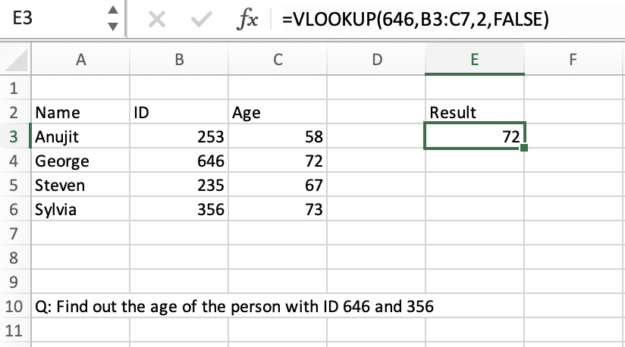

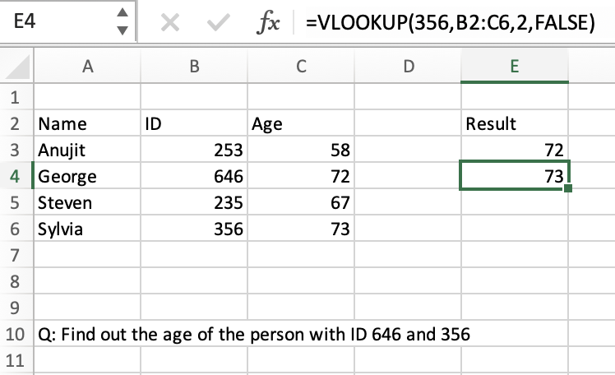

PIVOT Table

One of the fundamental tools for data analysis is the Pivot table.
Pivot Tables are created, among other things, to convey information. We use them to support our argument with transparent and understandable statistics.
Data that is recorded in a table can be summarised, sorted, reorganised, grouped, counted, totalled, or averaged using a Pivot table. It enables us to change rows into columns and columns into columns. Advanced computations may be performed on them when grouping them according to any field.
A pivot table may, to put it simply, organise items, records, and rows into categories, count the number of items in each category, add the value of the items or compute their average, discover the minimum or maximum value, and more. https://www.lumeer.io/pivot-table-complete-guide/#:~:text=A%20Pivot%20Table%20is%20used,using%20advanced%20calculations%20on%20them.

Using the data seen above and creating a PIVOT Table, we can filter the data in order to find out how old is each of the individuals, by utilising the names and age data we have been provided with. This tool is used to analyse the data provided.

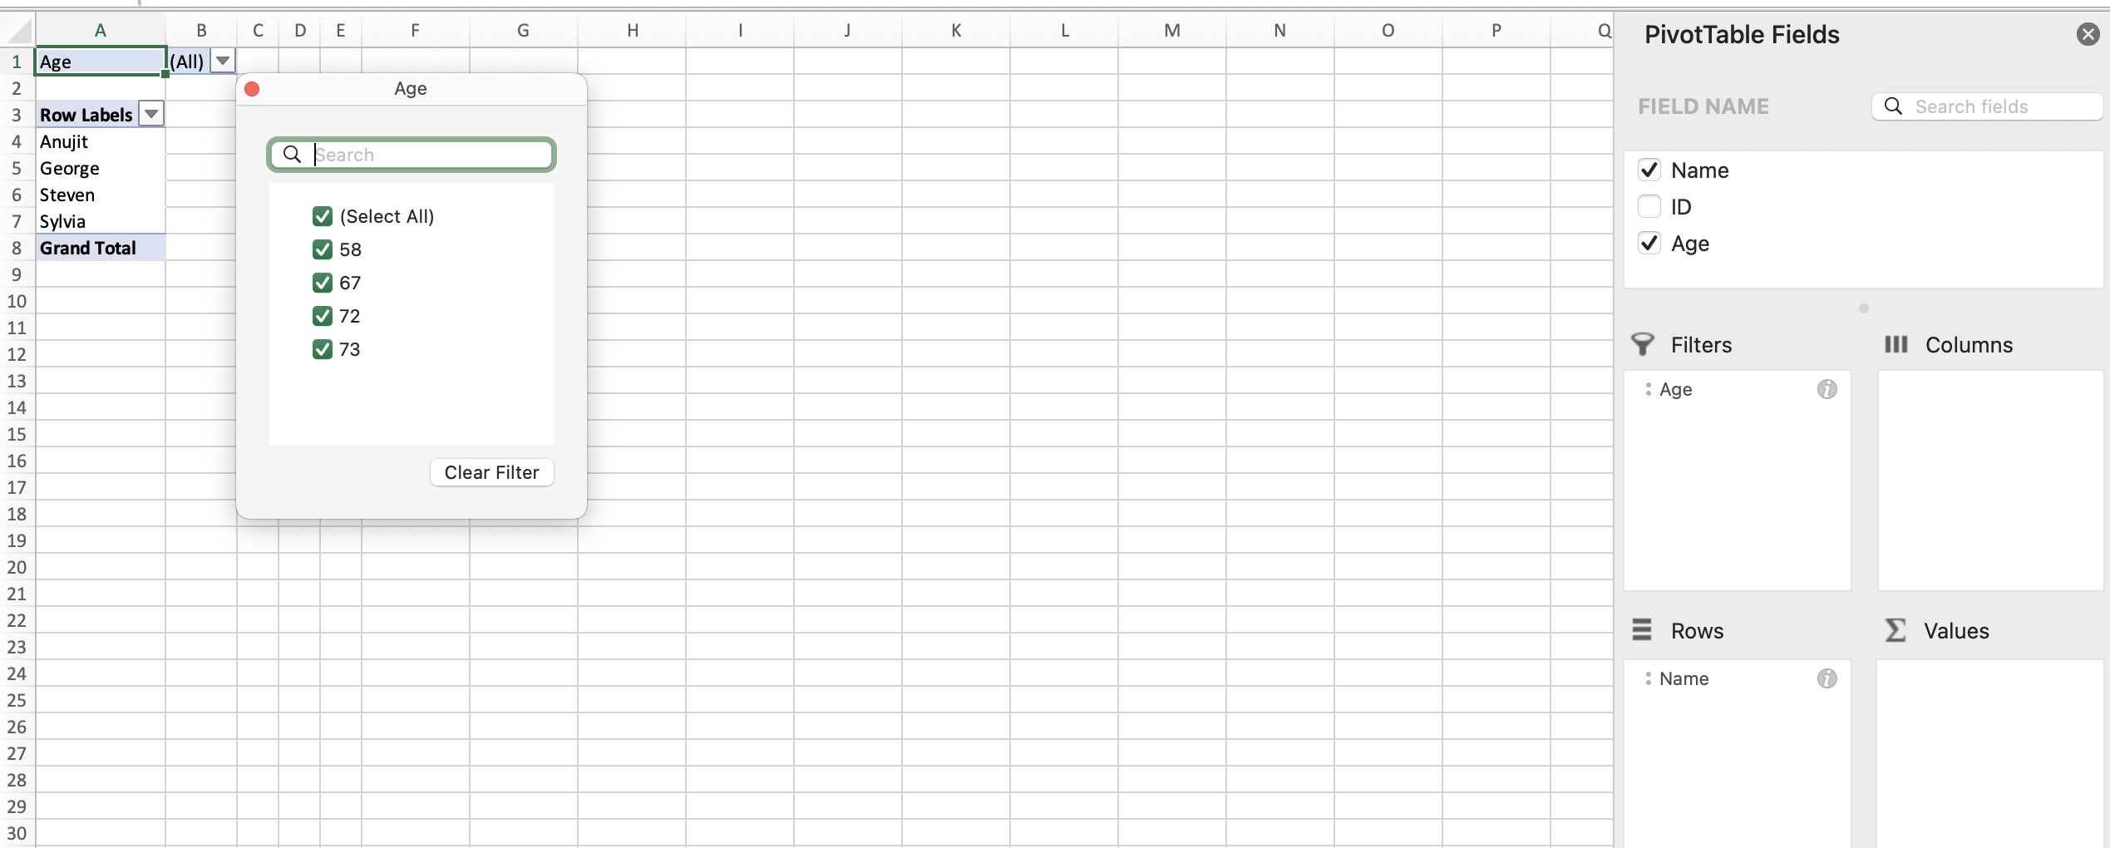

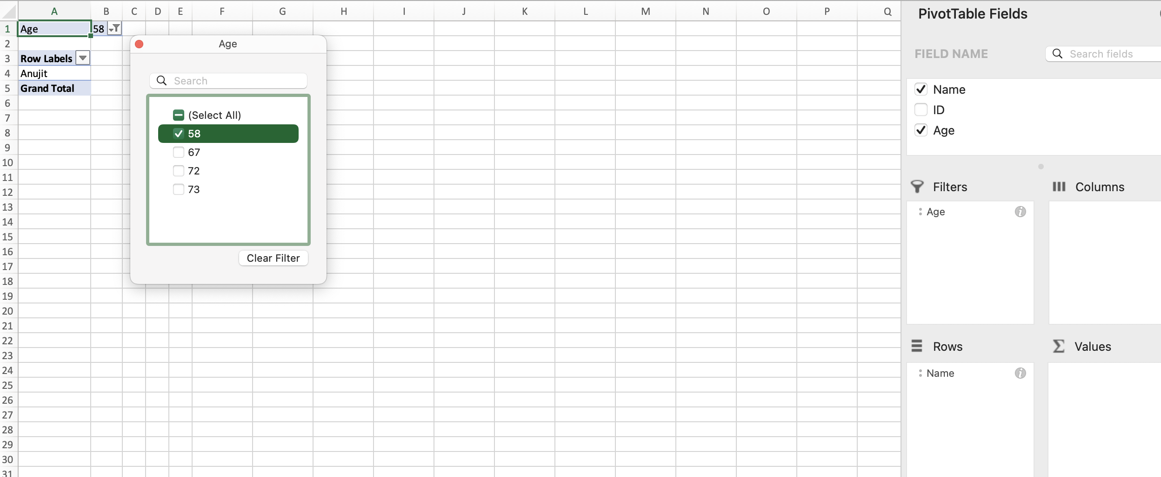

Graphs

A chart uses text, symbols, and/or visuals to illustrate how several data sets relate to one another. They are a widely used technique for information exchange in various contexts.
A chart presents data sets in a way that makes them easier for viewers to comprehend. That is, the efficacy of a chart is influenced by the presentation's quality. When we need to swiftly communicate the link between two or more pieces of data and we want our audience to remember this knowledge, charts are most useful. A chart can make information easier to understand by visually illustrating the relationship(s) between sets of data as opposed to reading long passages of text. This strategy outperforms displaying lists or tables of data, which require readers to analyse the data and identify trends. The construction of charts has become simpler and, in many cases, automated thanks to technology.

With the same data used previously, by selecting the name column and the age column, we can create a graph as a method of visualising and comparing the information.

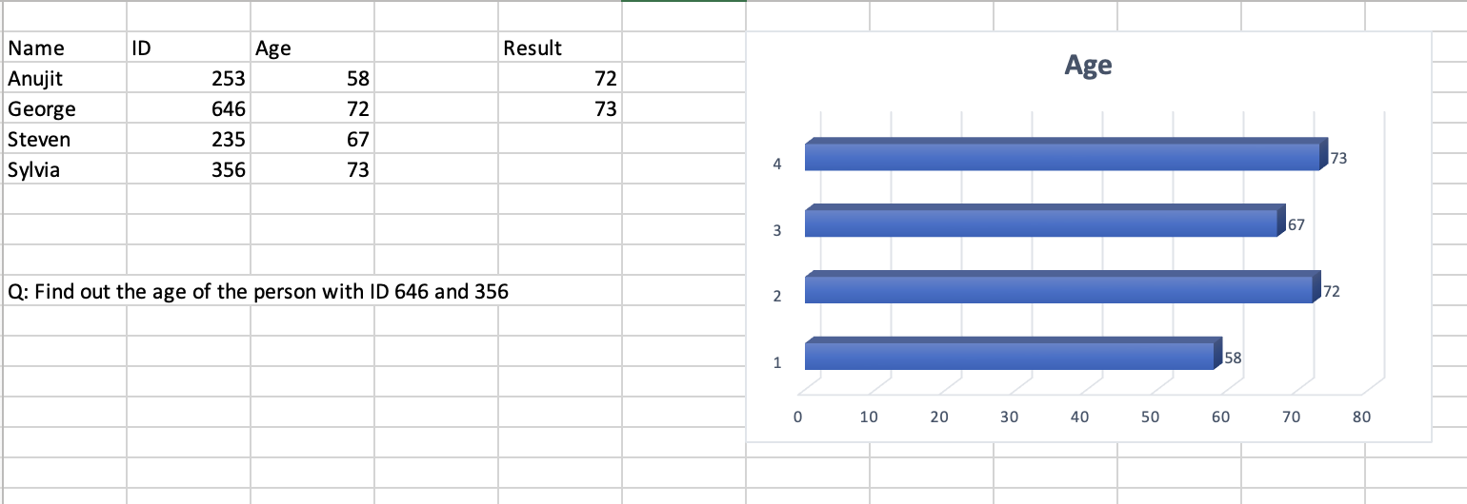

Part 2

Based on the datasets provided (Ice_cream.xls and Ice_cream_csv), we can use SPSS to obtain clearer information, in order to answer the questions proposed. We will create the parameters in Variable view (first screenshot) which will sync with information from Data view (e.g. 0, 1=Male, Female; 1, 2, 3=Vanilla, Chocolate, Strawberry) where we will input the data (second screenshot).

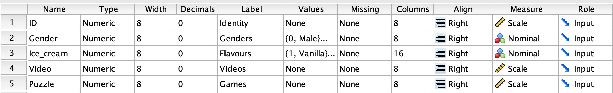

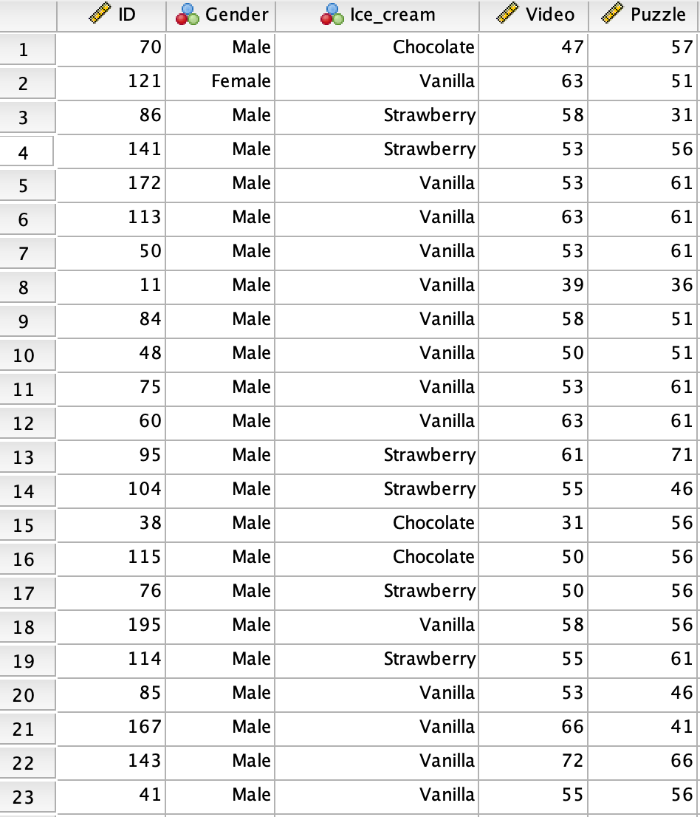

  - By transferring the information from SPSS, we can answer the question. The number of students who like vanilla flavour of ice cream is 95, as seen in the table below. A Pivot table has been used to show the findings.

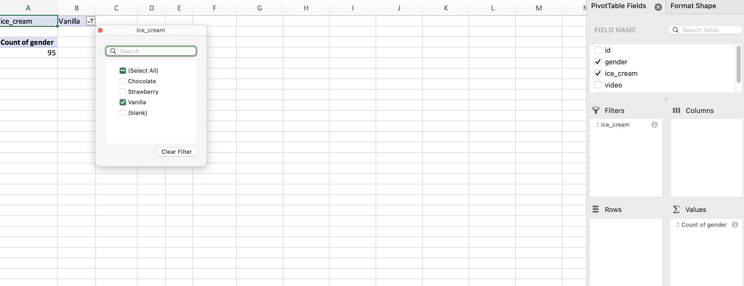

  - ?
  - ?

  - Data Mining
Finding patterns and relevant insights from large data sets is a process known as data mining. This method, which assesses both structured and unstructured data to find new information, is frequently used in marketing and sales to study consumer behaviour.

Data mining has countless potential uses across various industries, such as:
Financial services: Fraud detection is frequently employed in this industry, but it is not limited to it. The core concept is to use predictive analytics techniques to find fraudulent activity among a very large group of transactions.
Risk management: Another example from the financial services sector that can be used in other sectors, particularly when it comes to supply chain management, Predictive analytics and data mining can be used to solve a variety of issues, such as mistake detection and quantification, unit reviews or internal audits, fraud identification, identifying suppliers with the greatest failure rates, credit rating, etc.
Telecommunications & Media: It is understandable that many businesses work hard to enhance customer service. A customer may become a more devoted one than before if they are pleased with the support, they received following a negative encounter. Text analytics can either provide an automatic text block response to a question or at the very least quickly assign the request to the appropriate staff. (RapidMiner: Data Mining Use Cases and Business Analytics Applications
edited by Markus Hofmann, Ralf Klinkenberg )

Data warehousing is the procedure used to gather and store data prior to evaluation.
Before being imported into a data warehouse, data undergoes the three-step ETL process. Extract, Transform, and Load is referred to as ETL.
Data is duplicated and transferred from its source to a staging place in a warehouse. Names, dates, credit card numbers, etc. are examples of structured data (photos, videos, audio files, social media posts).
Transform: In this stage, the data is filtered, cleaned, and validated. Errors are also deleted. In order to fit the warehouse, the data is also prepared. Load: The converted data is then transferred to the data warehouse as the last step. As data is updated, these actions can be repeated. (Business Intelligence: Data Mining and Optimization for Decision Making
By Carlo Vercellis)
Working with big data is made simpler by data warehouses, especially for companies that manage substantial client bases, sales and billing reports, and resource plans. Businesses can segment and target consumers from huge collections of sales orders, product searches, or loyalty programme registrations utilising data warehousing. They can also store and evaluate a wide range of data points, including posts on social media about goods and companies.

Clustering is a method for representing data graphically, such as in graphs that display purchasing patterns or customer demographics for a specific product.
The act of grouping a number of various data points according to their qualities is known as clustering. Data miners can then easily segment the data into different subsets, enabling them to make more informed choices regarding general demographics (such as consumers or users) and their respective behaviours.
Clustering Data Methods
Using the partitioning approach, a data set is divided into a number of distinct clusters for examination in accordance with the standards of each cluster. Data points in this method are assigned to a single group or cluster.
the hierarchy of methods The data points used in the hierarchical technique are sorted according to commonalities into a single cluster. Then, each of these freshly formed clusters can be examined independently.
a density-based approach a machine learning technique in which data points plotted together are examined further whereas data points plotted separately are deemed "noise" and ignored.
Grid-based approach: This divides data into grid-based cells so that it can be clustered by specific cells rather than the entire database. Grid-based clustering has a quick processing time as a result.
Model-based approach: This approach finds the best data to fit each data cluster by building models for it.

Clustering makes it easier for firms to handle their data. Retailers can use clustering models, for instance, to identify which customers buy specific products, on which days, and how frequently. This can assist shops in marketing goods and services to people in a certain area or demographic.
Grocery stores can use clustering to categorise products according to a number of factors (brand, size, price, flavour, etc.) and better understand their sales habits. It may also be useful to auto insurance providers looking to better accurately price their policies by identifying a group of clients who frequently file large annual claims. In order to properly arrange branch hours and personnel, banks and other financial organisations may use clustering to better understand how clients use in-person vs virtual services. ( https://bootcamp.pe.gatech.edu/blog/10-key-data-mining-techniques-and-how-businesses-use-them/#warehousing )

Text Mining
As text mining focuses on giving unstructured data structure and analysing it to produce unique insights, it can be thought of as a subfield of data mining. Textual data analysis encompasses the aforementioned data mining methods that were previously discussed.
Modern businesses must now have the ability to use text mining. Companies are using text mining to make these vast amounts of unstructured data accessible and usable as they see unstructured data rise exponentially. For a variety of use cases, they have been able to achieve this and produce deeper business knowledge as well as smarter business decisions. Text mining is a method for extracting knowledge and useful information from text content using techniques like text classification, entity extraction (also known as named entity recognition), and sentiment analysis. This gives businesses the ability to extract insights, patterns, and trends from enormous amounts of unstructured data. In reality, because of its capacity to ignore all irrelevant information and offer helpful solutions, the enterprise has quickly adopted it.
Text mining is a method that consists of various steps that let you infer information from unstructured text data. The procedure of cleaning and converting text data into a readable format is known as text pre-processing, and it must be done before you can use various text mining techniques. Natural language processing (NLP) is a key component of this process, and to properly prepare data for analysis, it typically makes use of methods including language identification, tokenization, part-of-speech tagging, chunking, and syntax parsing. Once the text has been pre-processed, you can use text mining techniques to extract information from the data.
Cybercrime Prevention
The prevalence of communication tools and the internet's inherent anonymity both raise the danger of crimes committed online. By providing additional context for the intelligence that is being supplied to enterprise groups and law enforcement, text mining is now making cybercrime prevention easier. They are able to identify actual threats and reduce the number of false positives brought on by out-of-context phrase usage.
Customer Service
For customer service teams, text mining and natural language processing have been quite useful. They are frequently used to enhance the customer experience by utilising useful information from sources like surveys, trouble reports, and phone logs to enhance the efficacy, efficiency, and speed of problem resolution. Text analysis is crucial to chatbots because it collects the data required to provide customers a quick, automated response. As a result, businesses are able to significantly lessen their dependency on call centre agents to handle consumer issues.
Contextual Advertising
Text analytics are being used more and more in the sphere of digital advertising. Contextual advertising, as opposed to the conventional cookie-based strategy, examines the text on a webpage to comprehend the content more thoroughly. For instance, a Kindle advertisement might be presented to a reader of an article about the best recent book releases because of the post's relevancy. In addition to helping offer more precise and targeted adverts, this absolutely protects user privacy.
BI
Most business decision-making processes now include business intelligence tools as standard equipment. These technologies enable you to find patterns, trends, and possibilities from your data much more quickly than you could manually since they collect, store, and analyse the data for you. By including text mining into the process, BI systems can employ both structured and unstructured data to broaden the data sets that your model uses to produce business insight. As a result, you can build BI models that are more reliable and produce more insightful business data.
Social Media
Organizations have noticed that social media is one of the most prevalent sources of unstructured data nowadays. As a result, social media is valued throughout the business as a source of market and customer intelligence. Businesses use it to examine or assess a wide range of factors, including customer intent, brand perception, and product feedback. Companies may extract thoughts, feelings, and sentiment from enormous volumes of social commentary using text analytics to expose both the positive and bad aspects of customer engagement with brands and products. (https://www.expert.ai/blog/10-text-mining-examples/ )

  - Advantages and disadvantages of SPSS and Excel

Advantages | SPSS | Excel
 | Immediate response: It provides quick, dependable responses. | Easy to use: With the exception of constructing complex formulas, spreadsheet data entry is largely intuitive and does not require substantial training to grasp.
 | Interactive: It is interactive and includes helpful graphs and tables. | Using charts/graphs: Spreadsheets can be used to display data, but the user must be familiar with their use. The visualisation features of a spreadsheet make it simple to create charts and graphs.
 | Comparative measurements: Useful for both quantitative and qualitative data | Easy to analyse data: We can add datasets, multiply, divide, and create pivot tables. We can also acquire data from other tabs.
Disadvantages | SPSS | Excel
 | Limited data: A huge data set cannot be analysed with SPSS. | Insecure data: Spreadsheets, unlike dedicated systems that require access to log in, may be given to anybody, anywhere, with the simple send of an email.
 | Not complex enough: SPSS ultimately provides solutions too simple to complex problems that require more explanation. | Errors: Spreadsheets are inevitably inaccurate because they are used by so many people at once and are susceptible to so many calculations and modifications.
 | Graphs: When compared to Microsoft Excel, the graph features are more complicated. | Excel doesn't provide real-time updates: Outdated data is stored in Excel spreadsheets. Since they are unable to connect to a live data warehouse, the moment a user imports a CSV file and fills up a worksheet, the data becomes outdated.

Microsoft Excel is a spreadsheet programme used to store, arrange, and analyse data. Any function in any industry in business can profit from someone with great Excel skills. Excel is a potent tool that has established itself in commercial operations all throughout the world, whether for budgeting, organising customer sales lists, or assessing stocks or issuers. For planning, analysing, forecasting, recognising trends, reporting, and other purposes, businesses utilise Excel.
The areas of finance that use Excel spreadsheets the most and benefit from them include financial services and financial accounting. The majority of users are aware that Excel can add, subtract, multiply, and divide, but when used in conjunction with pivot tables, INDEX-MATCH-MATCH, and sophisticated IF functions, it is considerably more powerful.
While marketing and product managers depend on their finance departments to undertake the grunt work of financial research, utilising spreadsheets to establish customer and sales targets can help manage the salesforce and plan future marketing tactics based on past results.
By transferring that data to Excel, HR may identify trends, compile costs and hours by pay period, month, or year, and gain a better understanding of the distribution of their staff by function or pay grade. Using a massive spreadsheet of employee data and Excel, HR experts can identify the exact sources of expenditures and determine the best ways to prepare for and manage them moving forward. (https://www.investopedia.com/articles/personal-finance/032415/importance-excel-business.asp#:~:text=Microsoft%20Excel%20enables%20users%20to,and%20activities%20of%20their%20workforce. )

SPSS is a group of computer algorithms that examines empirical data from the social sciences. From the simplest to the most sophisticated models, SPSS provides a quick-visual modelling environment. For surveys, data mining, market research, etc., SPSS data is employed. Users of this software are able to manage, analyse, and present data in aesthetically appealing graphical forms because of its powerful features. The software is more user-friendly because it supports both a command-line and a graphical user interface.
It is used for survey data analysis by government agencies, academic institutions, market researchers, marketing organisations, health researchers, and many other groups.
1. Education
Educational institutions are under pressure to enrol and keep students each year. Not to mention the requirement that they draw in new pupils each year. SPSS can help with this.
Currently, SPSS is used by more than 80% of US institutions.
They can determine the likelihood of a student's future performance because to the ability of SPSS software to focus on trends. It makes use of a number of variables to inform them about at-risk students.
Faculty members at the college have access to a variety of complicated data sets that may be analysed using SPSS software to find hidden patterns.
2. Healthcare
For us to deliver top-notch healthcare, many problems must be resolved. Analytics can literally save your life in this situation. There are several application cases for using SPSS statistical analysis for healthcare delivery. University Hospitals of Leicester declares doctors are now using POPS, which is a system enriched by SPSS, to assess incoming patients and determine the severity of each case and prioritise treatment (https://www.ibm.com/analytics/statistical-software-industry-use-cases/) .
The privacy of patient information is sacred when it comes to the healthcare industry. In addition to having the potential to produce horrible results, inaccurate data is also timely, sensitive, and immediate. Healthcare businesses can use data to implement a patient delivery programme with the use of SPSS. Along with improving patient outcomes, it will also lower associated expenditures.
3. Retail
Analytics are frequently used in the retail sector for anything from initial stock planning to predicting future trends. Thanks to the rise of social media, forums, and review websites, consumers now have a lot of power when it comes to purchasing retail products. A lot of data is produced by retail organisations, and this data needs to be gathered, examined, and turned into insights that can be used. Businesses can give their customers fantastic experiences by utilising the data successfully with SPSS software.
Retailers can better understand their customers using SPSS research, offer the best solutions, and convey those solutions through the ideal channels. With the aid of SPSS analysis, everything can be discovered, from understanding how various client segments act to why they make particular purchasing decisions. Redcats Group are among those who chose SPSS to perfect their marketing strategies.

