strategic management and sustainability
LCBB6004

JAYALAKSHMI GOPALKRISHNAN

IONELA HUANITA PELTEA
2023156

Contents
Assessment 1 – Report 1
Introduction 1
Identification of key business strategies of Volkswagen past 5 years 1
Resources and capabilities of Volkswagen in past five years and the extent to which they are aligned with the current business strategies 5
Analysis how Volkswagen have tried to become more competitive considering the sustainability and the environment 7
Recommendation 11
Conclusion 12
References 13
Appendix 16

Assessment 1 – Report

Introduction
Aligning with the provided case study on one of the leading automakers of the globe, Volkswagen and understanding its business sustainability practises a report to be developed shortly evaluating its major business strategies of this automobile company past 5 years. This shall be followed with identifying the key organisational resources and capabilities of the organisation based on its past 5 years of business performances. The final segment of this report shall include a brief note of recommendation regarding how Volkswagen can further improve its business sustainability practises contributing to strengthen its current competitiveness.

Identification of key business strategies of Volkswagen past 5 years
In this section an identification of the past 5 years of business strategies undertaken by Volkswagen to be incorporate. In 2019, the company developed a business strategy to achieve its technological leadership in the automobile business sector and to achieve competitive profitability.
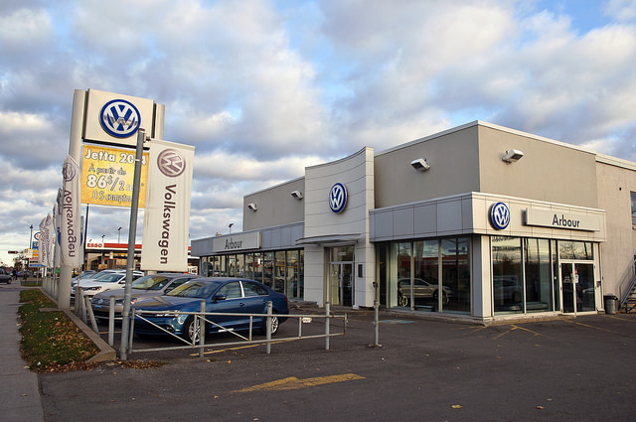
Source: (Volkswagen Group, 2019)
In this year the company was evident to enhance its program for future with TOGETHER 2025+ and took the strategic decision of shaping mobility for future generations by safeguarding sustainability.
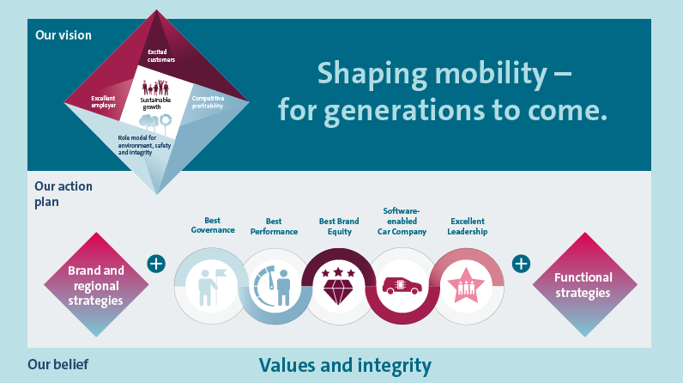
Source: (Volkswagen Group, 2019)
The company took a strategic decision of manufacturing automobiles cleaner, quieter, and safer and were also evident to enter into a commitment with Paris Agreement on climate protection. Being a part of TOGETHER 2025+ Group strategy the company introduced a complaint program Together4Integrity / T4I which was identified as the central pillar of the Group strategy (Volkswagen Group, 2019).
Referring to the company’s published annual report in 2020, the company’s business strategy was in continuation wit TOGETHER 2025+ strategy and hence the organisation became more focussed, efficient, innovative, and sustainable. In 2020 the company was focussed on adhering to five modules under TOGETHER 2025+ Group strategy and these modules were namely Best Governance, Best Performance, Best Brand quality, Software enabled car company and Excellent leadership. During this year aligning with the sustainability objectives the company introduced its Power Engineering Business Area and set the target dimension of excellent employer (Volkswagen -goals and key performance indicators 2020).
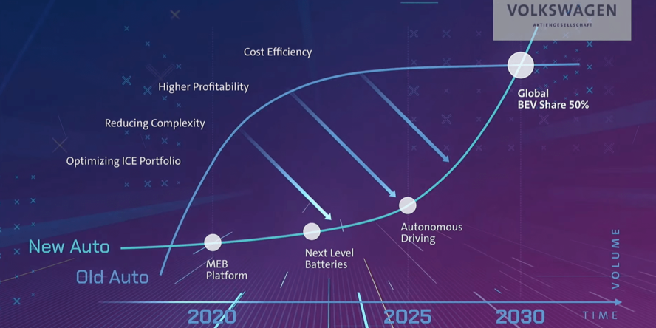
Source: (Volkswagen -goals and key performance indicators 2020)
In 2021, Volkswagen intending to restore its competitiveness and sustainable business practises was evident to inherit a new Group Strategy NEW AUTO – Mobility for generations which was approved by the Supervisory Board. The strategy’s focus was the world of mobility in 2023. Embedding NEW AUTO Group strategy in 2021 the company was involved towards a shift to e-mobility and digitalisation. Adhering with this business strategy Volkswagen was evident to focus to investing in manufacturing of cost efficient and sustainable better systems and concentred towards expansion of charging infrastructure. This shift in business strategy by Volkswagen can be linked with its future business strategy to manufacture self-driving vehicles in order to bring mode widening changes in the automobile sector (Goals and strategies Volkswagen, 2021).
Considering the year 2022, the business strategy of Volkswagen was more inclined towards e-mobility and business digitalization. The company was converted to deliver customer-focussed offering like customisation’s offering infrastructure solutions and mobile online services. Hence, in 2022 the primary business strategy of Volkswagen was to transform itself from an automobile manufacturer to a mobile service provider. In 2022, the company has developed a business strategy to offer it global customers around 50 completely battery-electric vehicles by 2023. Also, being a part of NEW AUTO Group strategy, Volkswagen implemented group quality strategy and was evident through its increased concerns in achieving maximum extent of customer satisfactory from ordering through to the digital ecosystem and post sales and customer services (Volkswagen strategic report, 2022).
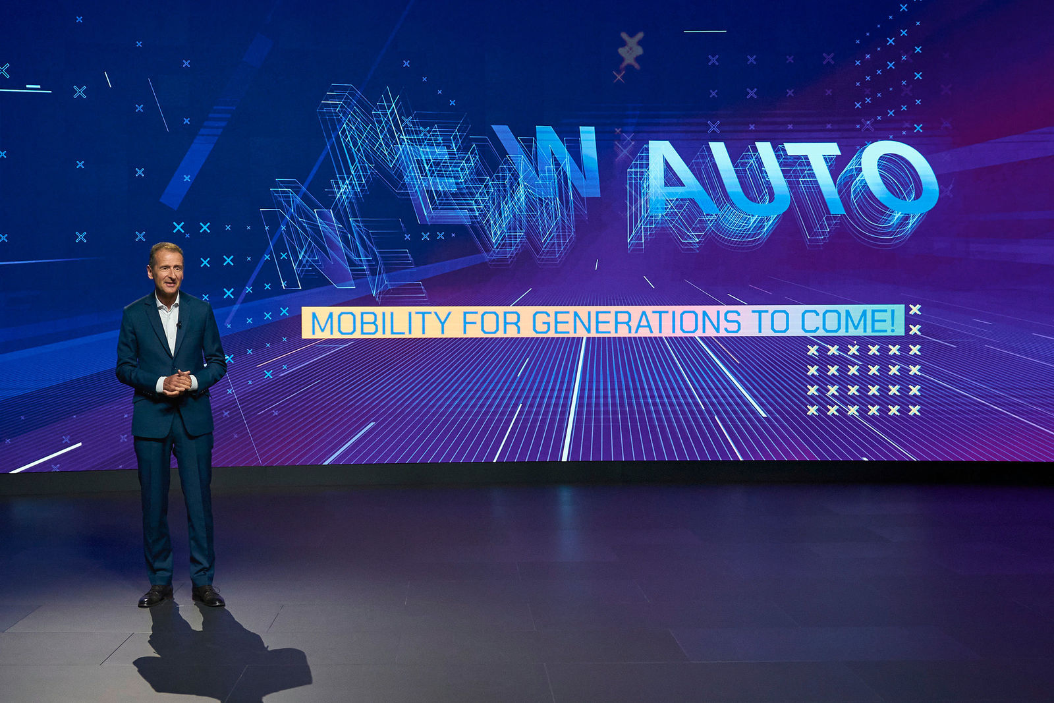
Source: (Volkswagen strategic report, 2022)
Responding to the market competition and increased tenacity to sustainable business practises in 2023, Volkswagen focussed on its strategy of transforming into a software-oriented company. The business strategies of Volkswagen were evident to adhere with TOP-10 program 2023 covering the areas of financial stability and planning.
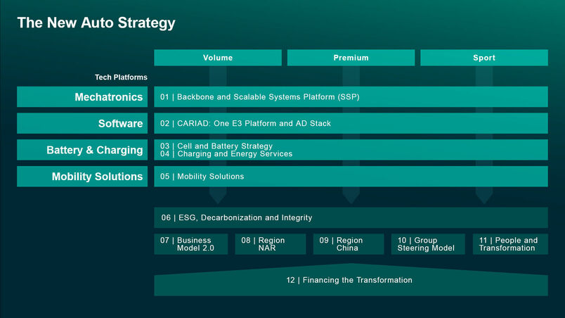
Source: (Strategy- Volkswagen, 2023)
In this year, the company’s business strategy was to concentrate on the growth EV market share and to incorporate a new Scalable Systems Platform by 2026. Embedding the NEW AUTO group strategy, Volkswagen have successfully established 12 Group initiatives and have aimed to focus on its existing technological platforms. This business initiative evident to be a part of Volkswagen Group strategic realignment (Strategy- Volkswagen, 2023).
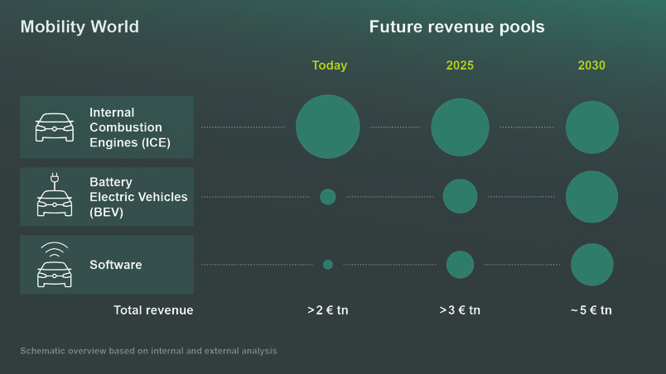
Source: (Strategy- Volkswagen, 2023)
Hence the above discussed business strategy of Volkswagen is evident through its focus in speeding up its shift to electric cars and revamping its existing software strategy in a five-year investment plan. The key concern of Volkswagen at present is to accelerate the production of cleaner vehicles that support least carbon emission (Strategy- Volkswagen, 2023).
Implementing the PESTEL analytical framework it is observed that the execution and or changes in above identified business strategies of Volkswagen there affected by the macro factors. Considering the impact of political factor on the business strategies, presence of a stable political situation is evident to help the company following its business strategies. Also, economic stability of the concerned nation acted as supporting factor to execution of the business strategies. However, considering the social factor the increasing awareness of the people towards the adverse health impact of carbon emission has increased their preferences towards electric vehicle. Hence this factor is considered to shift the business strategy of Volkswagen to manufacture electric vehicles. The advances of technology are evident to have a positive impact affecting Volkswagen concern to manufacture cost efficient and sustainable battery system promoting e mobility. Furthermore, referring to the environmental aspects, the increasing awareness to safeguarding to nature and its resources has contributed Volkswagen’s shift from the TOGETHER 2025+ to the NEW AUTO Group Strategy with an underlying aim to achieve carbon neutrality by 2050.
*PESTEL analysis in appendix sector

Resources and capabilities of Volkswagen in past five years and the extent to which they are aligned with the current business strategies
the core business resources of Volkswagen can be segregated under tangible and intangible resources.
Tangible resources of Volkswagen:
Manufacturing units- the cited organisation is evident to comprise of 70 manufacturing plants located at different parts of the globe. Additionally, the company’s production network is spread across 118 locations at a global scale. Wolfsburg Volkswagen factory is the biggest amongst all and spread across 70 million square feet of area (Production and locations- Volkswagen, 2022).
R&D unit of Volkswagen- the cited business has invested setting up its R&D units offering cutting edge technological innovations. The company has one of its largest R&D unit covering an area of 1.2 square kilometres and recognised as one of the largest automobile innovation centres in the world (Research & Development- Volkswagen, 2022).
Financial resources – the cited organisation has generated a revenue amounting to 279, 232, 000, 000 Euro in 2022 with an operating income of 22, 124, 000, 000 Euro. Referring to the financial statement published in December, 2022 Volkswagen’s intangible assets are worth 83, 241 million Euro reflecting evidences of solid financial foundations for the business (Balance sheet- Volkswagen 2022).
Human resources of Volkswagen- referring to the company annual report, 2022 Volkswagen have an employee base of 669, 000 comprising of professionally competent employees.
Charging station infrastructure – owner of a growing network of more than 800 electric vehicle charging stations coast-to-coast (Volkswagen strategic report, 2022).
Intangible resources of Volkswagen
Patents – the German automobile manufacturer has 103072 patents globally out of which 33698 have been granted. Also, more than 73% of Volkswagen’s patents are currently in an active state (Volkswagen patents 2022).
Volkswagen has made 2 business acquisitions and two investments. The company is evident to spent more than 122 million dollars for its business acquisition deals. Also, Volkswagen has invested in several sectors like Smart Cars, connected Vehicles and many more (Acquisitions by Volkswagen, 2022).
Volkswagen awards and recognition- the company was declared Motability Dealer Award Winer in 2017, honoured wit Gold Pin Award for Service, Top Retailer Group award in 2022, National Mobility award in 2019.
Capabilities of Volkswagen
Intending to understand the core business capabilities of Volkswagen its brand portfolio hac be highlighted reflecting the company’s ownership to arrange of high-profile brands like Audi, Porsche. Bentley, Lamborghini, and Bugatti.
The company’s successful global presence reflected through its worldwide business operational set up and huge customer base. The highly advanced R&D unit of Volkswagen along with its huge investment on designing and development of electric vehicles, autonomous driving, and digital transformation.
Presence of a strong supply chain
Volkswagen success in execution of several sustainability initiatives being actively focused to achieve the objective of TOGETER -Strategy 2025 (Volkswagen strategic report, 2022).
Referring to the above discussed organisational resources and capabilities of Volkswagen the same are evident to effectively align with the company’s current business strategy. Assuring sustainable business practises being one of the core business strategies of Volkswagen is evident to be in line with the identified resources and capabilities of this business. The organisation seems to have rightly utilised its resources assuring optimisation and to fetch the sustainability targets. The example of Zero Impact Factory can be cited with is an important element of production strategy of Volkswagen indicating its sustainable business practises (Volkswagen strategic report, 2022).
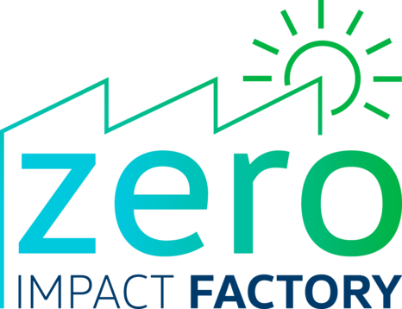
Source: (Volkswagen strategic report, 2022).

Analysis how Volkswagen have tried to become more competitive considering the sustainability and the environment
In order to examine the efforts undertaken by Volkswagen to strengthen its existing degree of competitiveness it is important to investigate the business sustainability practises and CSR strategies undertaken by the same. Hence referring to the recently published sustainability report of Volkswagen it is evident that the company is focused on actively contributing to the transition towards renewable energies and concerned in maximization of its resource efficiency and to promote the circular economy approach. The competitiveness of Volkswagen hence appears to be reflected through its sustainability practices indicating effective execution of economic, social, and ecological objectives simultaneously and with equal energy.
Aligning with the sustainability report of Volkswagen group of 2022 it is observed that the same has promoted circular economy by saving huge amount of carbon dioxide through the aluminium closed loop process since 2017. The company has increased its competitiveness by involving in decarbonisation process. This has been evident through Volkswagen’s success in delivering 527, 100 all electric vehicles at a global scale. The business sustainability practises or Volkswagen is also evident through its promotion to formation of a diverse working base. the company’s current competitiveness has been restored by its ability to develop and implement a new management approach responsible for supply chains has have trained more than 2900 supplies ion sustainability. Being associated with the T4I program the company has also successfully processed 1517 inquiries at the compliance information point (Volkswagen Group Sustainability Report, 2022).
Volkswagen being associated with the NEW AUTO Group Strategy since 2021 is evident to focus with its transformation towards e-mobilities and digitalization. This has not only reflected the environmental concerns of Volkswagen by its increased competitiveness to capture the business market of electric automobile. The initiatives taken by Volkswagen to be associated with cost efficient and sustainable production of battery system is sought to contribute to the competitiveness of this business (Volkswagen Group Sustainability Report, 2022).
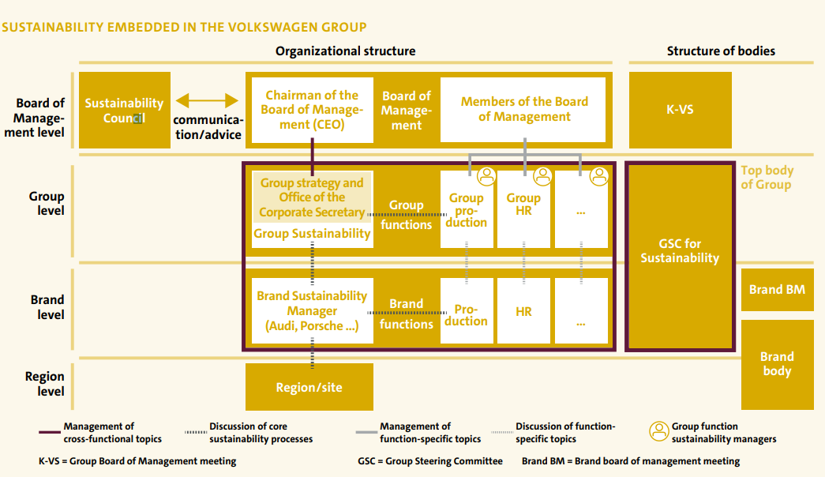
Source: (Volkswagen Group Sustainability Report, 2022)
Justified to add, the business strategic approach of Volkswagen Group aiming to become a global provider of sustainable mobility has resulted the company to become more focussed and innovation assuring strengthening its current market competitiveness embedding a sustainable business approach.
Volkswagen being committed to the Paris Climate Agreement has also focused on aligning its business practises with the 1.5-degree Celsius objective and aimed to deliver carbon neutrality by 2050. The competitiveness of this German automaker is reflected through its target to minimise carbon dioxide emission from passenger cars and light commercial vehicles by 30% compare to that of 2018. In order to achieve the same Volkswagen has taken the sustainable approach of increasing the proportion of recyclable material in it SSP-based vehicles (Volkswagen Group Sustainability Report, 2022).
Volkswagen’s sincere efforts to strengthen its current competitiveness is also projected through its inheritance to the Business Model 2.0 having an underlying aim to create a seamless and innovative product experience to successfully connect brands, customers, dealers, the partners, and the entire automobile market. Volkswagen efforts to manufacture connected vehicles by 2030 is considered to help the organisation building a competitive, data drive service portfolio enabling it to maintain its market leading position in near future (Volkswagen Group Sustainability Report, 2022).
Hence, considering Volkswagen association with the NEW AUTO Group Strategy the same is not only focussed on technological and product linked initiatives but also evident to improve the ESG performance of the organisation. Therefore, incorporating the above discussed sustainable business practises Volkswagen is believed to achieve an increased degree of business competitiveness along with growth in its market capitalization and an overall attractiveness to the company’s potential investors (Volkswagen Group Sustainability Report, 2022).
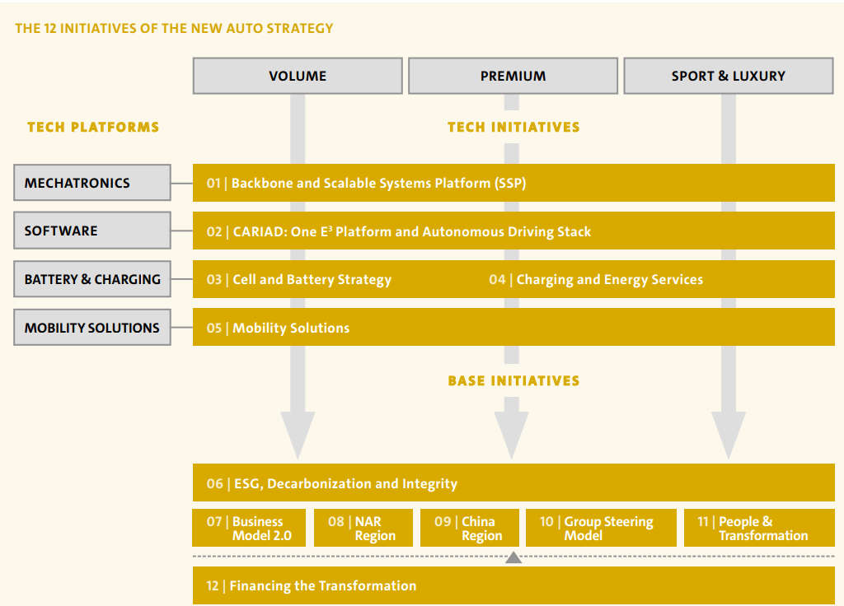
Source: (Volkswagen Group Sustainability Report, 2022).

Recommendation
In the present era of extensive business competition, a focus on executing business sustainability practises need to be one of the primary concerns of this leading German automobile business. Although the organisation has developed several sustainability strategies like green policy and its adherence to the environmental standards but it is further advised to focus more on this aspect. Hence, it is advisable for Volkswagen to assure meeting the economic, social, ad ecological objectives in course of pursuing with its business sustainable practises. Priority should be given by this organisation to incorporate long lasting values and assure conservation of nature and its resource through its responsible business practises (Das and Ghosh, 2023).
Understanding the importance of business sustainability, it is advisable of Volkswagen to go paperless as much as feasible and focus on recycling and optimised waste generation. The cited organisation is also suggested to consider using environmentally friendly materials and should be more concern to minimise generation of carbon footprint in course of its automobile manufacturing process. It is also recommended for Volkswagen to invest on decarbonisation of its aluminium supply chain to reduce generation of carbon footprint. The company is further advised to research on renewable energy in order to achieve its transition to sustainable energy for its automobiles. Further, the cited organisation is advised to invest on its R&D sector in order to improve its existing business sustainability practises (Das and Ghosh, 2023).
Volkswagen may also consider purchasing renewable electricity and focus on manufacturing vehicle that are compatible to low carbon powertrains. Focussing to adhere with the business ethical standards it is recommended for Volkswagen to organise mass awareness campaigns and may consider developing strategic partnerships and share know-how in order to develop a more sustainable future (Ortego, 2020).
This German automaker is also advised to encourage its business suppliers and dealers to lower carbon emission and may consider designing a portfolio of reduced and zero carbon vehicles. It shall also be a wise decision for Volkswagen to partner with several not-for-profit organisations in order to create an awareness regarding sustainability of nature. The above recommended actions can be taken by Volkswagen and it is expected the organisation shall be able to improve its existing competitive advantage by nurturing its business sustainability practises (Yu et al., 2022).

Conclusion
Adhering with the developed report Volkswagen is concerned to restore its competitive advantage by focusing on its organisational resources and business capabilities. The strategic decision taken by this organisation past 5 years is also considered to contribute in shaping the core organisational strength of Volkswagen. However, its reluctance over pursuing with business sustainability practises has damaged its brand reputation to a significant extent. Referring to the outcomes of Porter’s 5 forces it can be inferred that Volkswagen has an intense degree of market attractiveness and need to incorporate business innovative practises along with assuring its sustainability. The company’s focus on acting as a responsible organisation is hence believed to contribute in strengthening its existing competitive advantage thereby enabling the same to achieve a commendable extent of customer loyalty and business profitability.

References
(2022) Volkswagen careers. Available at: https://www.volkswagen-karriere.de/en/working-at-volkswagen/corporate-divisions/research-development.html (Accessed: 17 July 2023).
(2022) Volkswagen Group Sustainability Report . rep. Volkswagen Group. Available at: https://www.volkswagen-group.com/en/publications/more/group-sustainability-report-2022-1644.
Acquisitions by Volkswagen (no date) Tracxn. Available at: https://tracxn.com/d/acquisitions/acquisitionsbyVolkswagen (Accessed: 17 July 2023).
Balance sheet- Volkswagen (no date) Volkswagen Group Annual Report 2022. Available at: https://annualreport2022.volkswagenag.com/consolidated-financial-statements/balance-sheet.html (Accessed: 17 July 2023).
Das, A. and Ghosh, A., 2023. Vision Net Zero: a review of decarbonisation strategies to minimise climate risks of developing countries. Environment, Development and Sustainability, pp.1-37.
Goals and strategies Volkswagen (2021) Volkswagen Group Annual Report 2021. Available at: https://annualreport2021.volkswagenag.com/group-management-report/goals-and-strategies.html#:~:text=In%20the%20context%20of%20the,world%20of%20mobility%20in%202030. (Accessed: 17 July 2023).
Ortego, A., Calvo, G., Valero, A., Iglesias-Émbil, M., Valero, A. and Villacampa, M., 2020. Assessment of strategic raw materials in the automobile sector. Resources, Conservation and Recycling, 161, p.104968.
Production and locations- Volkswage, 2022, Volkswagen Newsroom. Available at: https://www.volkswagen-newsroom.com/en/production-and-locations-3695 (Accessed: 17 July 2023).
Research & Development- Volkswagen
Strategy- Volkswagen (2023) Volkswagen Group. Available at: https://www.volkswagen-group.com/en/strategy-15955 (Accessed: 17 July 2023).
Volkswagen Konzern - AR 20 - goals and key performance indicators (2020) Goals and Key Performance Indicators - Volkswagen Group Annual Report 2020. Available at: https://annualreport2020.volkswagenag.com/group-management-report/goals-and-strategies/goals-and-key-performance-indicators.html (Accessed: 17 July 2023).
Volkswagen Konzern - AR 2019 - goals and Strategies (2019) Volkswagen Group Annual Report 2019. Available at: https://annualreport2019.volkswagenag.com/group-management-report/goals-and-strategies.html#:~:text=Integrity%2C%20reliability%2C%20quality%20and%20passion,the%20future%20with%20TOGETHER%202025%2B. (Accessed: 17 July 2023).
Volkswagen patents (2022) Insights Gate. Available at: https://insights.greyb.com/volkswagen-patents/ (Accessed: 17 July 2023).
Volkswagen strategic report (2022) Volkswagen Group Annual Report 2022. Available at: https://annualreport2022.volkswagenag.com/group-management-report/sustainable-value-enhancement/quality.html (Accessed: 17 July 2023).
Yu, Z., Khan, S.A.R. and Umar, M., 2022. Circular economy practices and industry 4.0 technologies: A strategic move of automobile industry. Business Strategy and the Environment, 31(3), pp.796-809.
Appendix
PESTEL analysis on Volkswagen
Political – stable political situation is evident to encourage the business strategic approaches of Volkswagen
Economic- the stable economic situation of nation act as supportive element in perusal of business strategies.
Social- changing mindset and increased inclination to health within the current population has affected changing the business strategy of Volkswagen with its shift to e mobility.
Technology- the advances of technology identified as a supportive factor in execution of company’s business strategies
Environmental- increasing awareness to safeguarding of nature has compelled Volkswagen to shift from TOGETHER 2025+ strategy to NEW AUTO Group Strategy aiming to focus on designing and developing electric vehicle assuring carbon neutrality.
Legal- the company need to align with the legal framework in course of pursuing its business strategies.
VRIO analysis for Volkswagen
Issues or Parameters | Valuable | Rare | Imitable | Organisational support | Competitive advantage
Financial strength |  | X |  |  | Partial
Huge brand portfolio |  | x |  |  | Partial
Advanced R&D |  |  | X |  | Sustainable
Sustainability strategies |  |  | X |  | Sustainable competitive advantage
Successful in obtained 96% of external electricity from renewable sources |  |  | X |  | Sustainable competitive advantage
Charging stations ownerships |  |  | X |  | Sustainable
Source: self-developed

