ACCA5023 - NETWORK OPERATING SYSTEMS AND SERVICES
Assignment 2: Configure, and manage Virtualised network
Serena Jonathan (2306363)
2306363@student.uwtsd.ac.uk

Creating a Domain

1.3 & 1.6
The screenshot below shows that the domain has been successfully created. This configuration allows computers within the network to share user accounts and settings. Users are able to log into different machines and still access their data and preferences. In this way, a domain functions similarly to a centralised system like SOAC, where user information is managed and synchronised across devices.

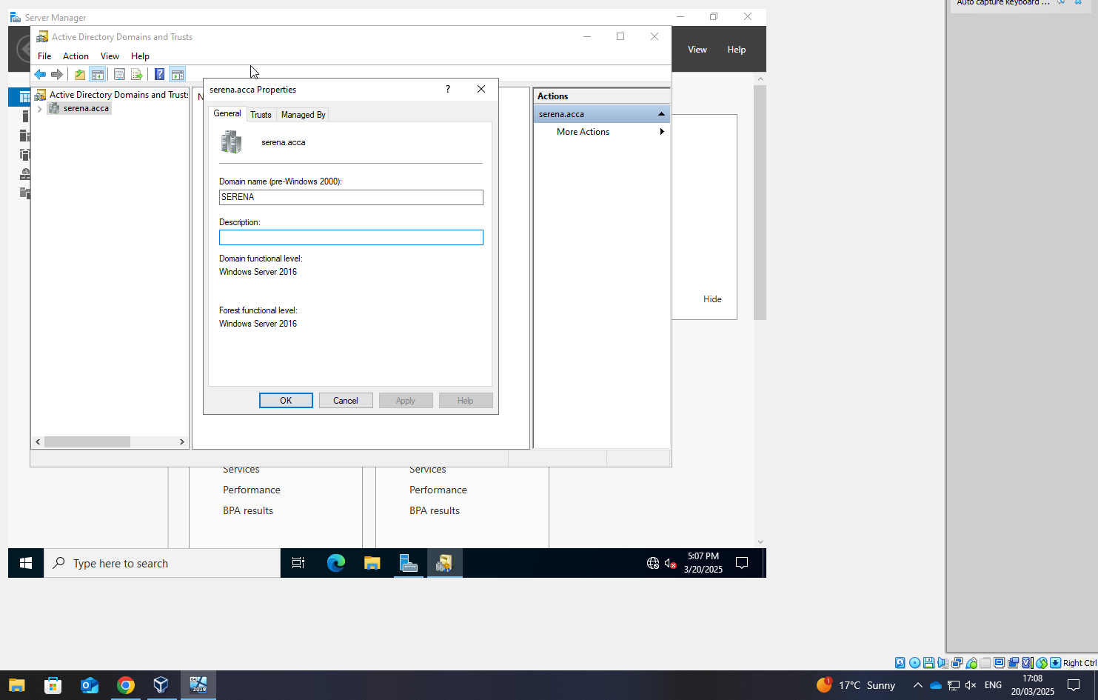

Setting up the DCHP

1.6
The screenshot below shows the DCHP set up on the Windows client. 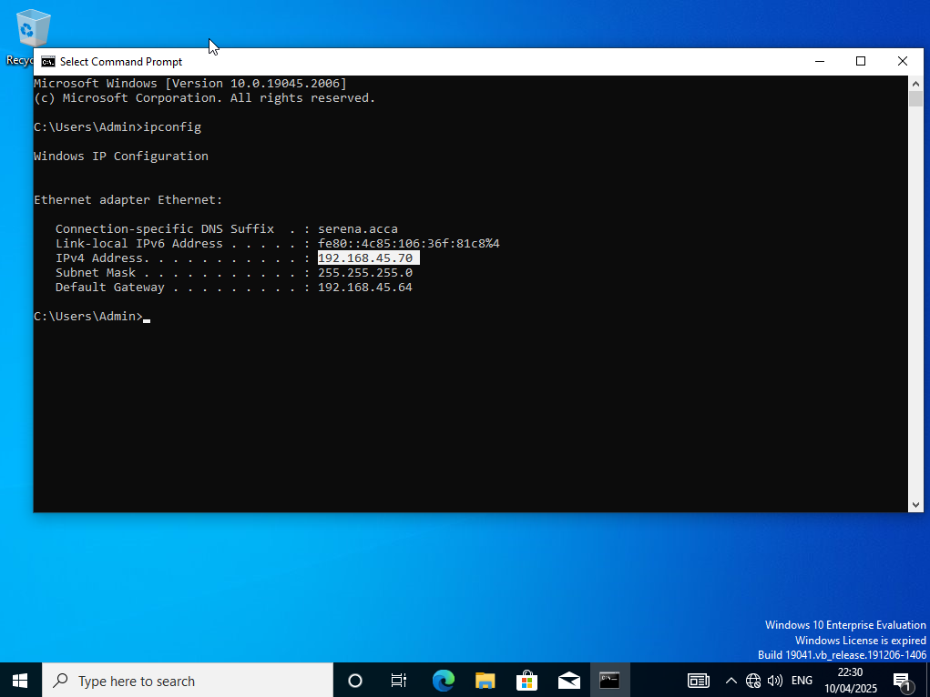

Creating User Accounts for serena.acca

1.6
The screenshot below demonstrates the creation of user accounts for the serena.acca domain, with all parameters configured as specified in the users_list_updated.xlsx document.

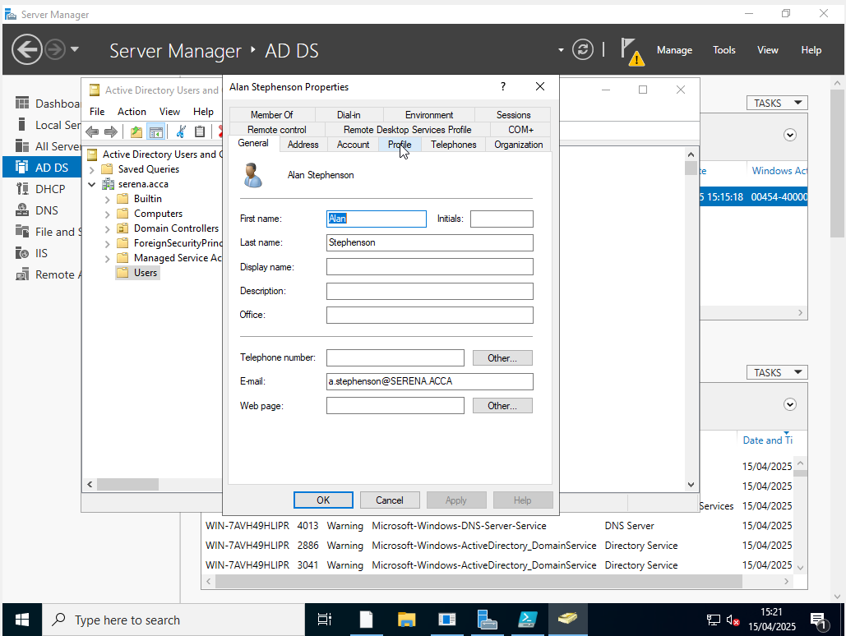

It shows the domain now has users, the below shows a list of these users:
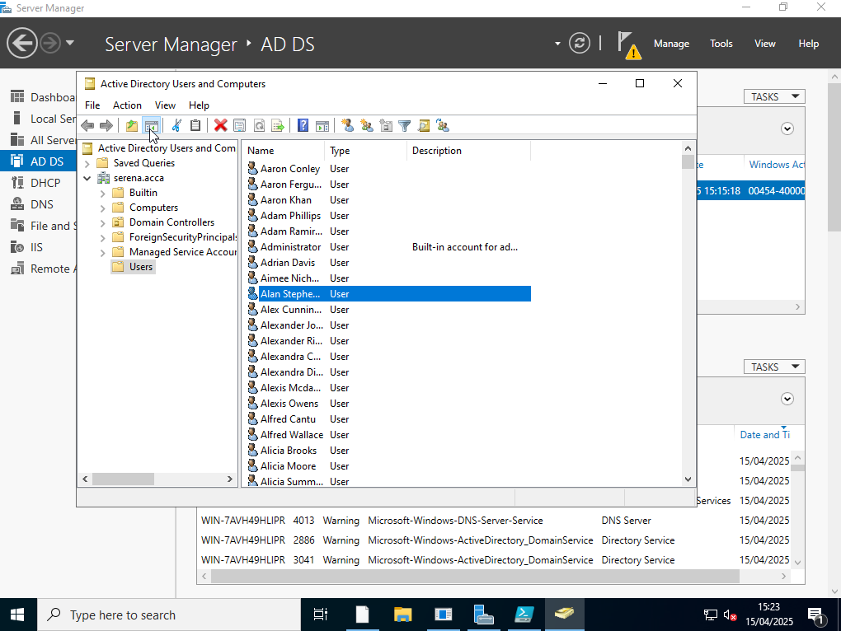

Mounting second disk drive to D:\SwanseaFiles.

1.8
The screenshot below demonstrates the process of sharing the drive on the network, making it accessible to any user with the appropriate drive mapping. The users from external networks (other than the local network) can now access the drive, but only with read-only permissions.

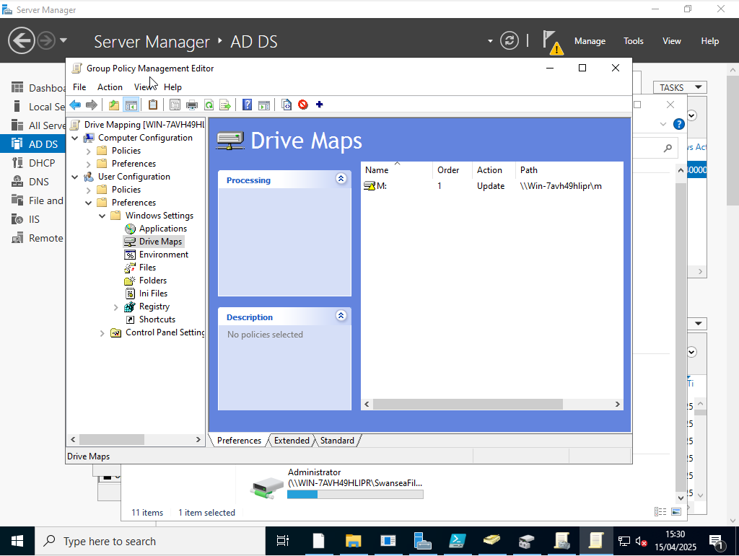

Routing and Remote access Service

1.1
Below is the outcome of step 1.1: Installation of the Routing and Remote Access Service and modification of firewall rules to allow ICMP traffic.

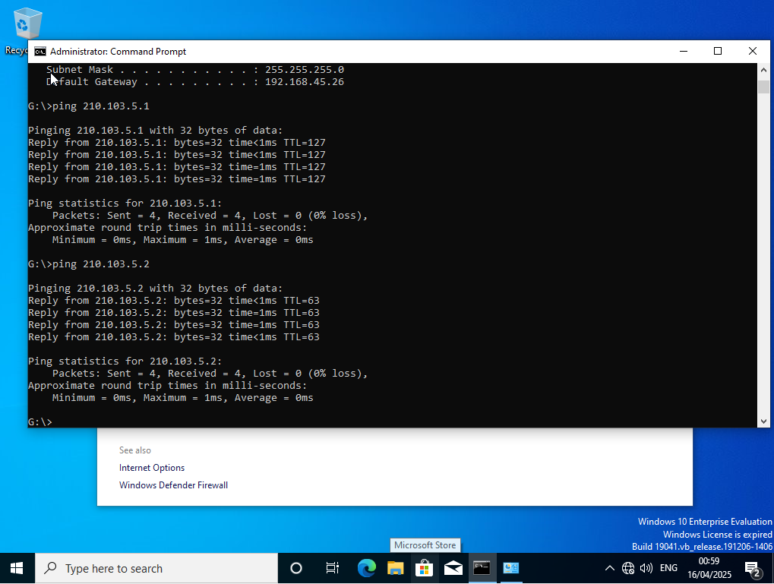

The screenshot below shows the Routing and Remote Access application. From the Windows client, it successfully pings the Linux server.
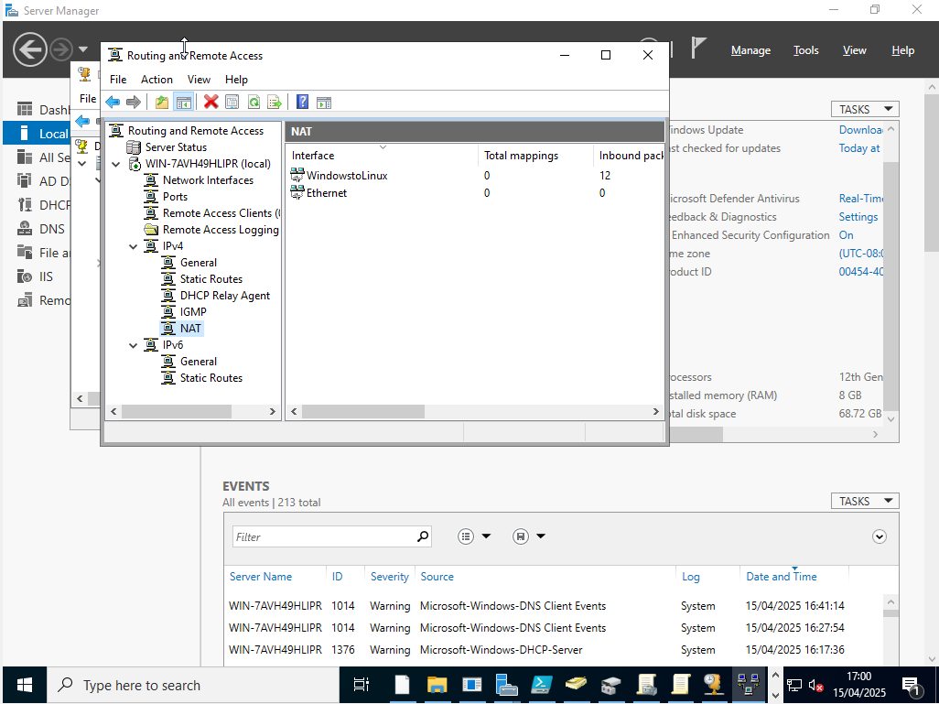

Creating a Reverse Lookup Zone Creating PTR Records for all Servers.

1.5
Below is the configuration for the forward lookup records (A records) for the servers in the 10.1.1.0/24 and 172.16.1.0/24 subnets, ensuring proper name resolution within the network.
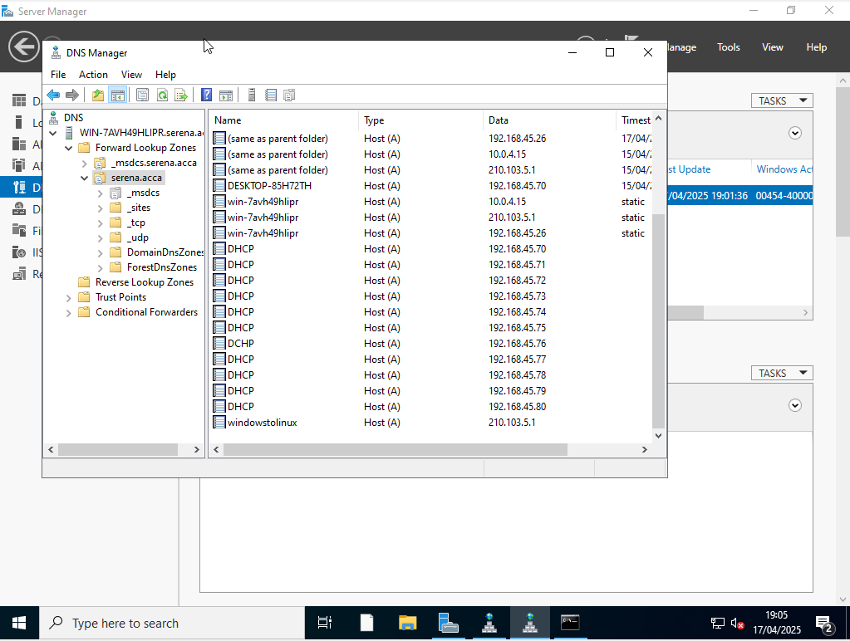

In addition to this, the reverse lookup records are displayed below, which show the identification of devices attempting to ping the network.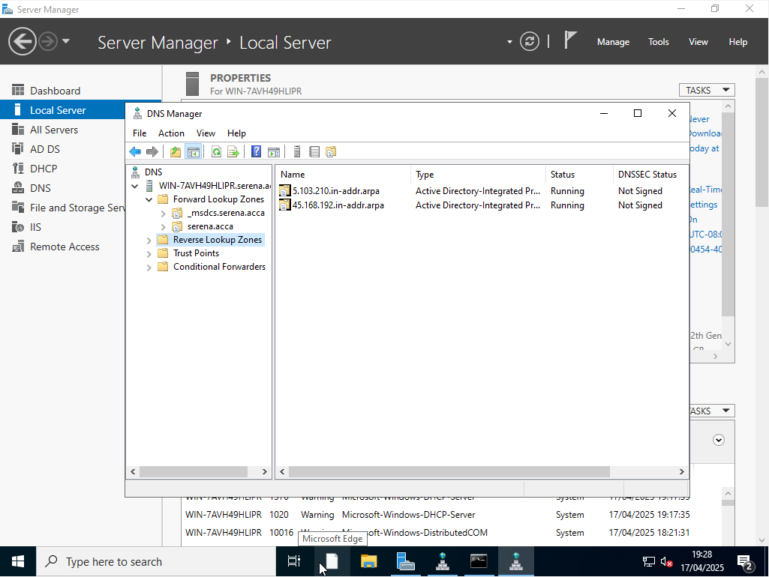
The screenshot below demonstrates the Linux server successfully pinging the domain, confirming that it can resolve and communicate with the domain defined using BIND.

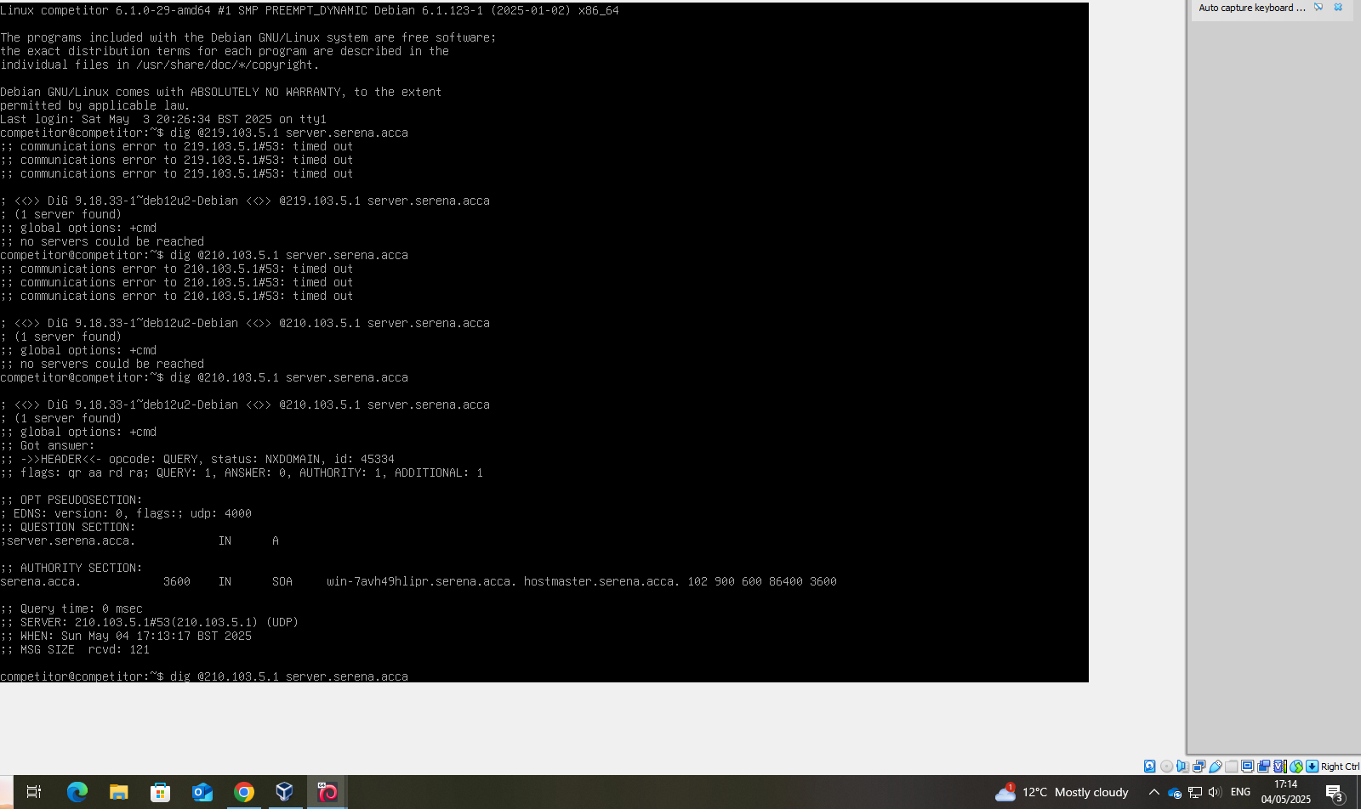

Creating a Child Domain

2.3
The below shows the child domain being created in Linux, named car.serena.acca in serena.acca tree.
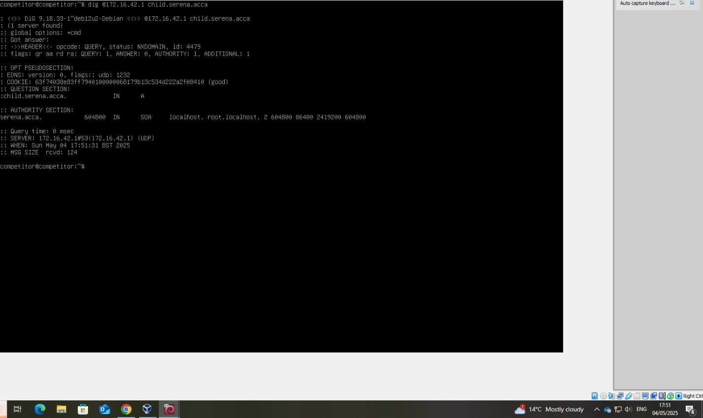
The below show that the child domains and the main domains has been defined on the Linux server:
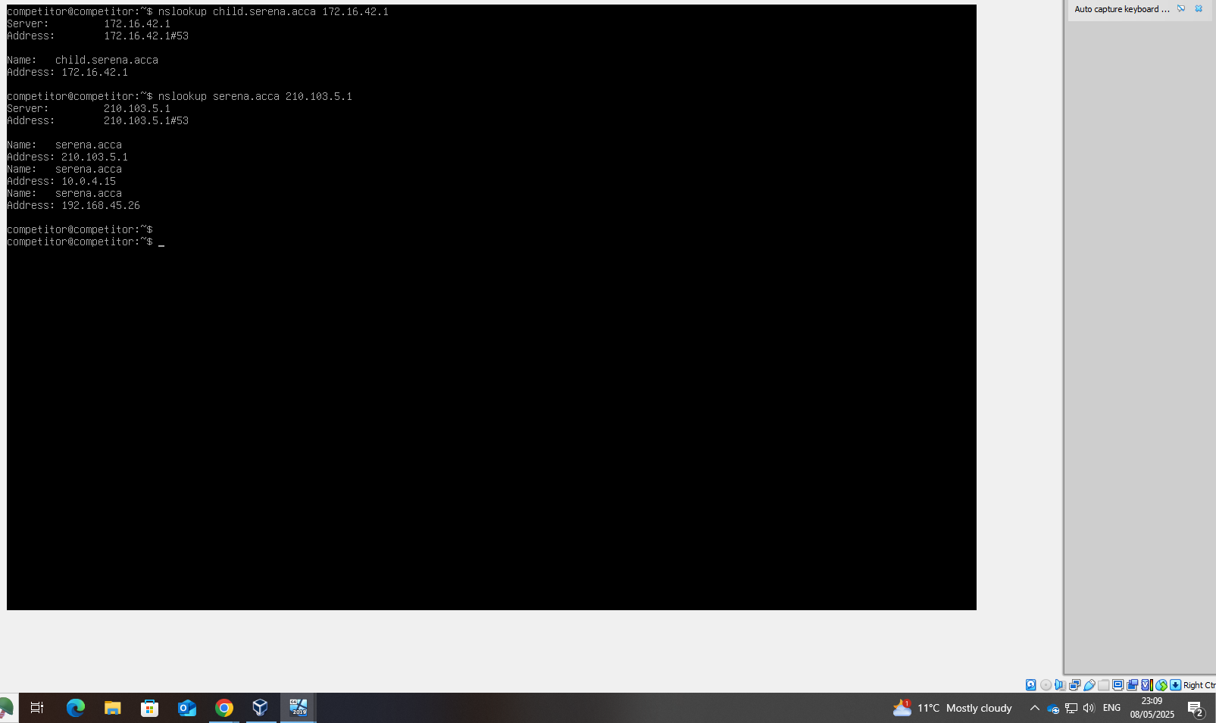

Network Infrastructure and Active Directory configuration

1.4
The screenshot below illustrates an enhanced PowerShell script that uploads the names from the provided document: users_list_updated.xlsx document, organising them alphabetically. This is achieved by importing the document containing all the user account details, formatted as follows.

