
Assignment 2:
Operating Systems
CertHE Computing Skills for Workplace

Computer Architecture and Operating Systems. ACCA4022_LON
Anum Paracha (Lecturer)
University of Wales Trinity Saint David
(London Campus)
Student Name: Daniel Bolanos Alvarez
Student Number: 2512075
Group: 01
Date: 12/08/2026

Table of Contents
Assignment 2: 1
1. Table of Contents 2
2. Introduction 1
3. Key functions of general Operating Systems 1
1.1 Process and Processor Management 1
1.2 Memory Management 2
1.3 File System Management 3
1.4 Security and Protection 4
4. Use of Windows OS CLI commands. 5
5. Use of Linux OS CLI commands. 16
6. 4. Use of Windows OS scripts. 21
7. Use of Linux OS scripts 27
8. Conclusion 28
9. References 28
References 28
10. Appendices 29

Introduction
In this document, I will explain the main functions of operating systems and some basic command-line and scripting tools. First, I describe important operating system tasks such as process and processor management, memory management, file system management, and security. Then, I show how to use command-line interface (CLI) commands in both Windows and Linux. Finally, I introduce basic scripting in Windows and Linux to demonstrate how tasks can be automated and how system administration skills can be improved.

Key functions of general Operating Systems

1.1 Process and Processor Management
Hardware & processor management: This could be considers one of the main jobs of an operating systems. The operating systems controls the computer hardware parts, such as the processor (CPU), memory, keyboard, mouse, monitor, and storage devices. The processor is often called the brain of the computer because it carries out instruction and performs calculations.
When many programs are running at the same time, the operating systems decides which programs should use the processor and for how long. This process is called scheduling. It help to computer work smoothly and prevents one program from taking all the processor’s time. Also helps to control hardware resource and makes sure that different devices work together correctly [1].

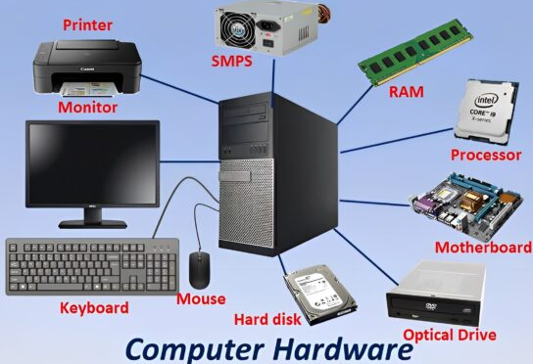

A few important hardware components in a computer

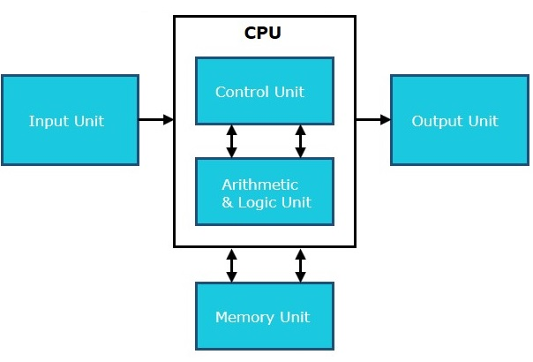
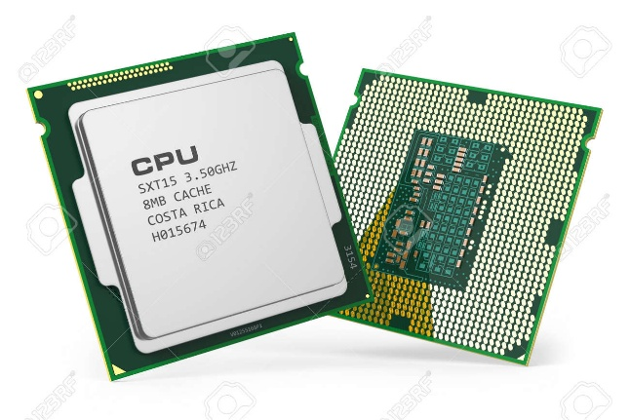

The part of the computer that performs calculations and executes instructions (CPU).

1.2 Memory Management
Memory management: This function is very important for the computer and the operating system. It help the computer use memory in the best way possible. The operating system keeps track of how much memory is being used and how much is free. When a program is opened, the operating system gives it the memory it need to run. When the program is closed, that memory becomes free and can be use by other programs.
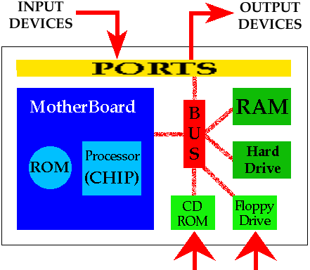
The operating system also makes sure that programs do not use each other’s memory. This helps keep the computer safe and working properly. If the computer runs low on memory, the operating system can use part of the hard drive as extra memory. This helps users run more programs at the same time.
By controlling and sharing memory carefully, it helps the computer run faster an more smoothly. It reduces wasted memory and allows user to use several applications at once without causing the computer to freeze crash [2].

MeKi is a new method that helps AI models become more powerful by using extra storage memory instead of more processing power. This allows smaller AI models to perform like larger ones without slowing down. Tests showed that a 1.7 billion-parameter model could work almost as well as a 4 billion-parameter model while keeping the same speed [3].
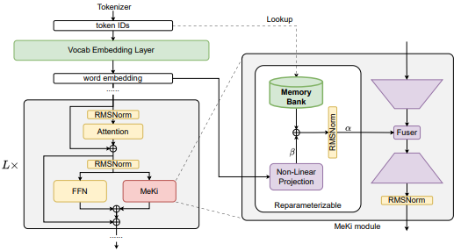
General overview of the proposed MeKi architecture. After training, all the re-parameterizable parts are merged into one static memory table to avoid FLOPs overhead.

1.3 File System Management

User Interface (UI): A user interface is the part of an operating system that allows users to interact with the computer. It provides a way for users to give commands and receive information from the system. Common examples include windows, icons, menus, and buttons.
The user interface works by taking the user's input, such as mouse clicks, keyboard typing, or touch gestures, and sending it to the operating system. The operating system then processes the request and displays the result on the screen. This makes it easier for users to use programs and manage computer tasks without needing to understand complex computer commands [4].

This section presents an overview of how interfaces facilitate interaction between users and computers.

1.4 Security and Protection

Security & Access control: Security and access control help keep a computer and its information safe. The operating system uses usernames and passwords to check who is using the computer. It also decides which files, programs, and settings each user can access.
When a user signs in, the operating system checks their details and gives them the correct level of access. This helps stop people from seeing, changing, or deleting information they should not use. Security and access control help protect the computer from unwanted access and keep data safe.
The highest permission level is called administrator, supervisor, or root access. A program with root access can control everything on the computer. It can change files, install programs, watch other programs, use the network, and change permissions.
A major security goal of an operating systems is to stop or detect users or malware that try to get permissions they are not allowed to have, especially root access [5].

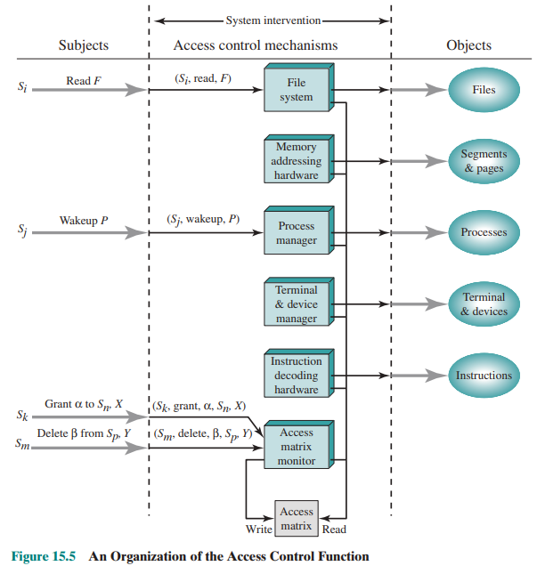

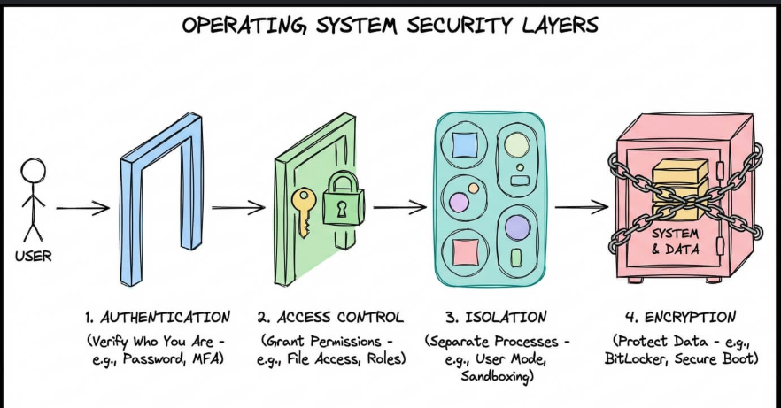
Steps of how operating system works for security and access control.
Input-Output device management: Is the process that allows a computer system to control how information enters and leaves the machine. The Core ensures that input devices like keyboards, mice, and scanners or the output devices such as monitors, printers, and speakers work smoothly with the operating system. The operating system uses a set of programs called drivers to translate signals between hardware and software, making sure each device communicate in a language that the system understands.
All the necessary conditions that are needed so that when you type on the keyboard, it appears instantly on the screen, or also when you send a document to a printer, the printer can works correctly [1].


Use of Windows OS CLI commands.

1. Process Management – tasklist
Command: tasklist /v
Description: Displays all running processes with detailed information such as PID, memory usage, and status.
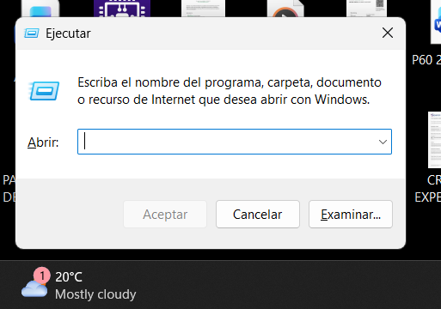
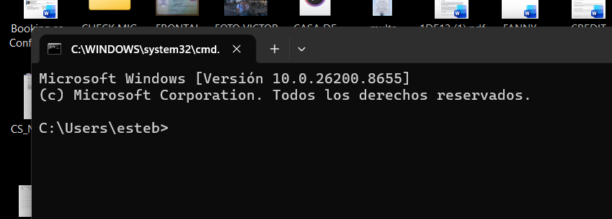
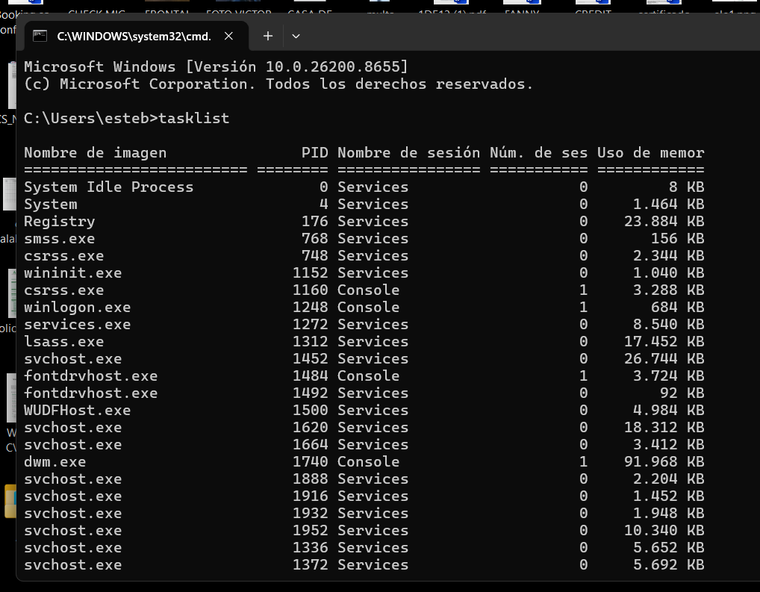
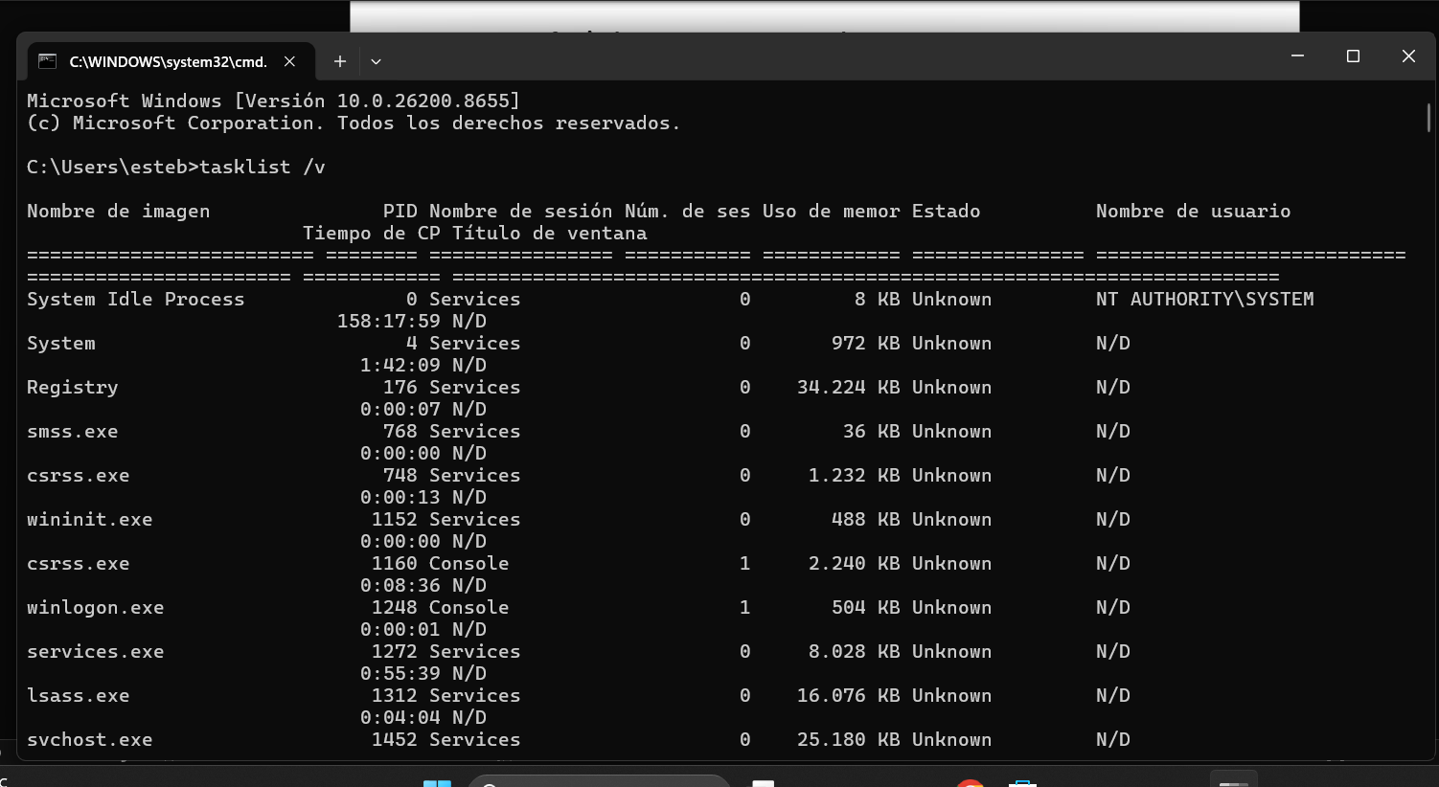
2. Network Monitoring – netstat
Command: netstat -an
Description: Displays active network connections and listening ports. The -a switch shows all connections, while -n displays numerical IP addresses and port numbers.
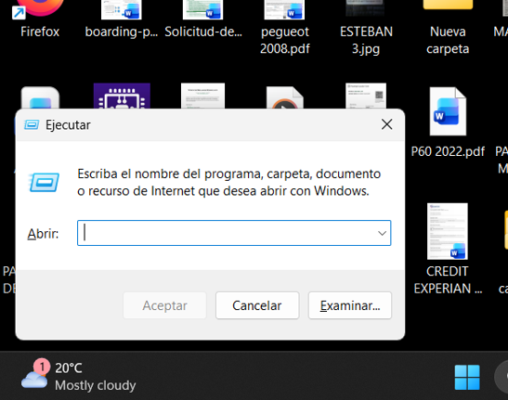
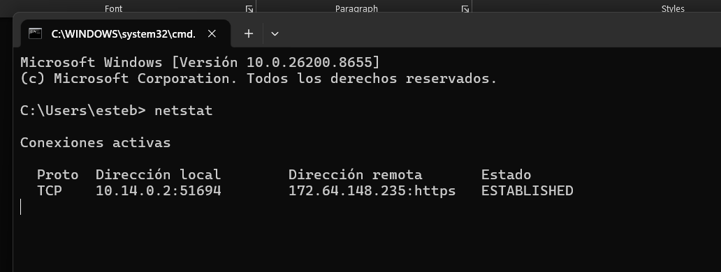
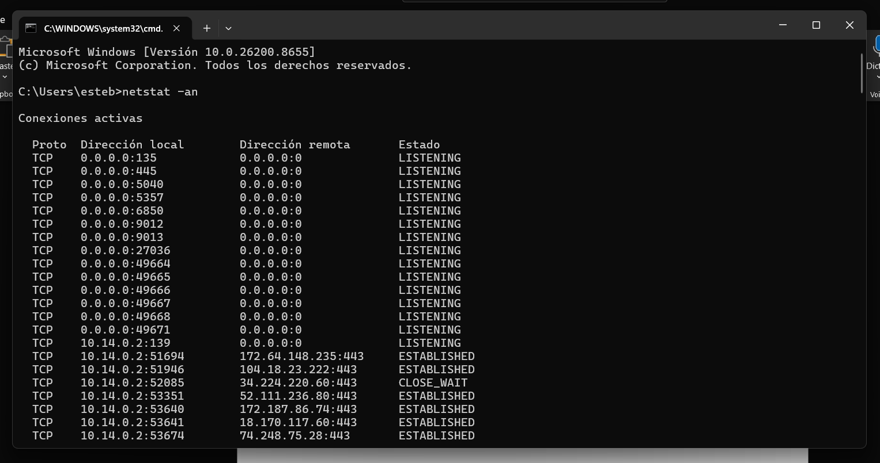
3. File & Directory Management – mkdir
Command: mkdir ProjectFiles
Description: Creates a new directory. This command is commonly used in batch scripts to generate folder structures automatically.
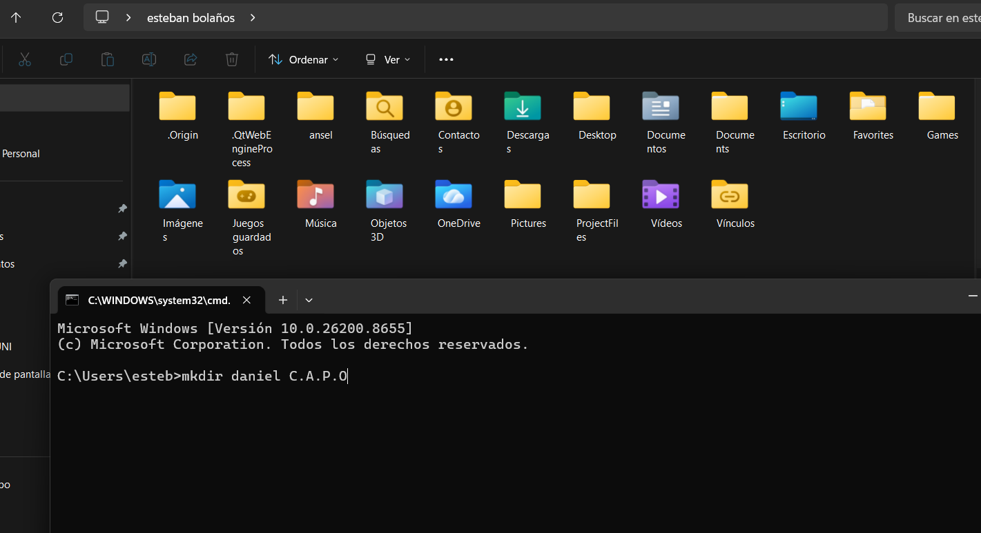
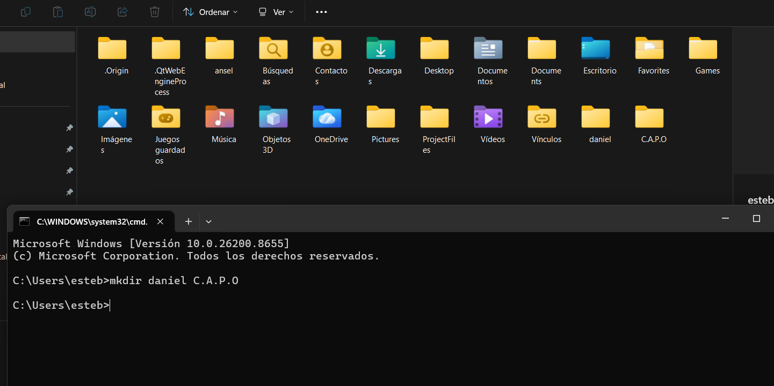
4. File & Directory Management – dir
Command: dir /s /p
Description: Lists files and folders in the current directory and all subdirectories. The /s switch includes subfolders, while /p pauses output one screen at a time.
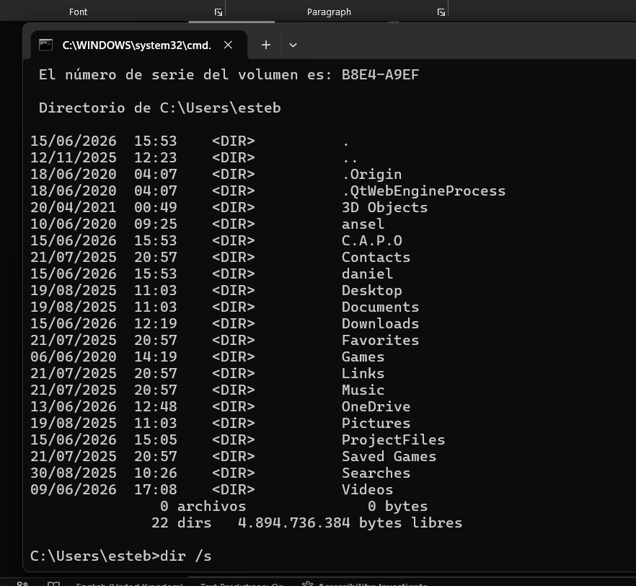

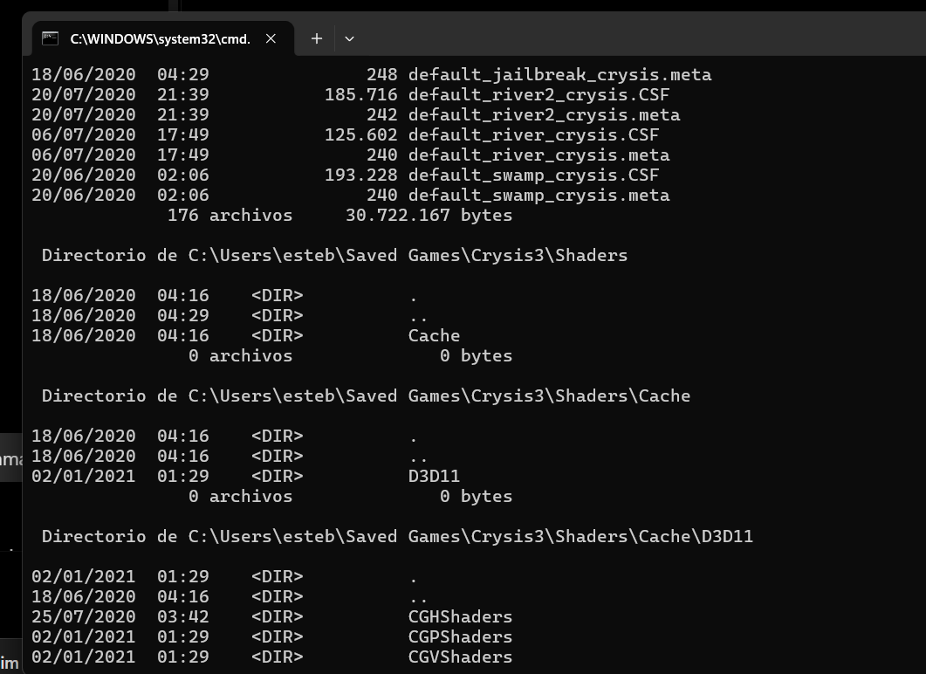
5. Process Management – taskkill
Command: taskkill /PID 1234 /F
Description: Terminates a process using its Process ID (PID). The /F switch forces termination when a program is not responding. Useful during troubleshooting.
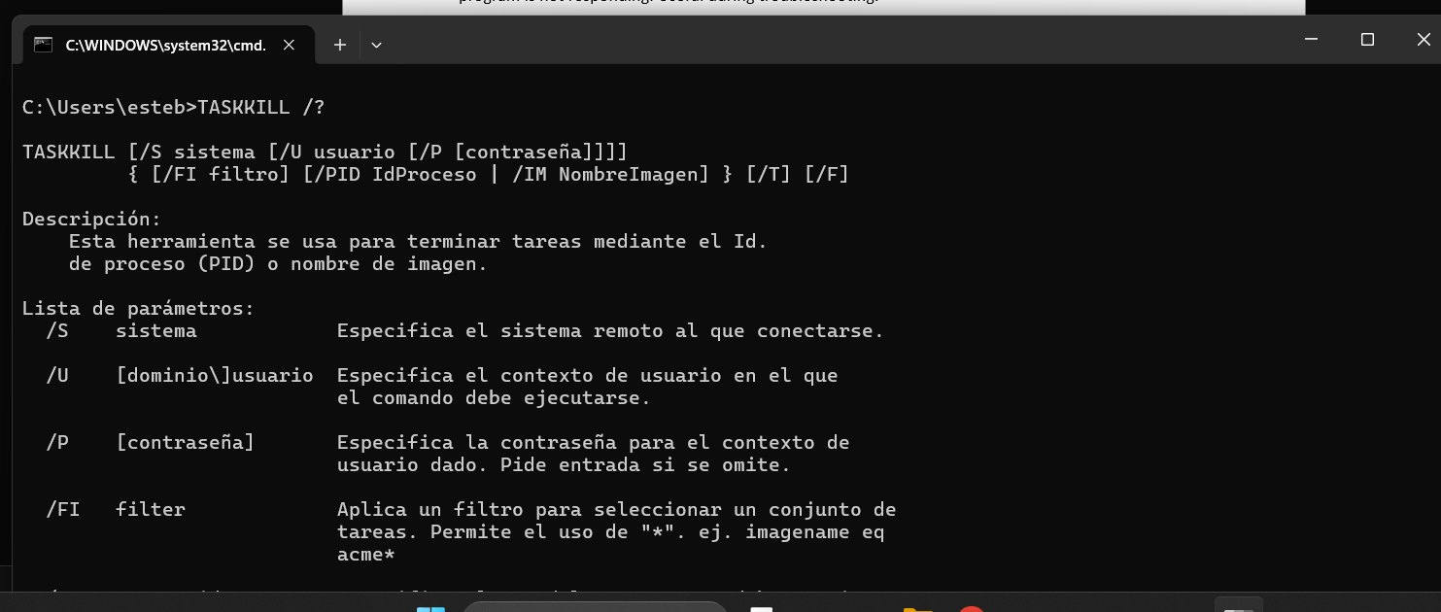
6. Network Testing – ping
Command: ping google.com -n 4
Description: Tests connectivity to a remote host. The -n 4 switch sends four echo requests and displays response times and packet loss statistics.

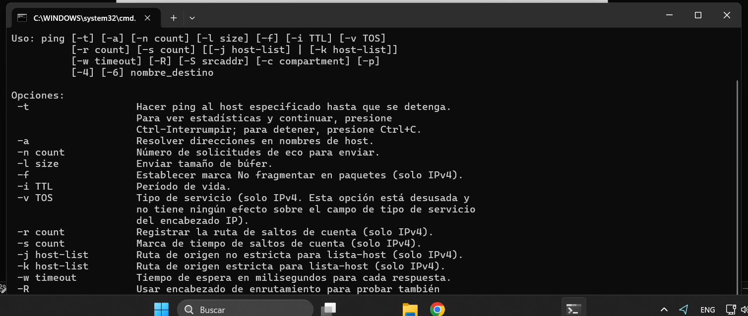

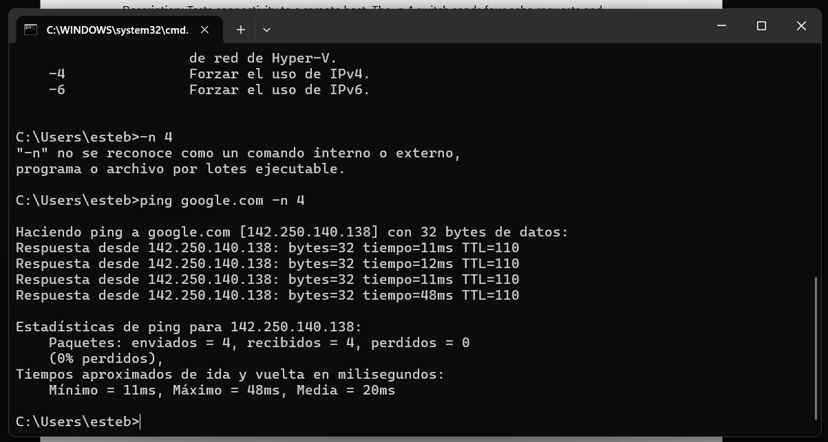
7. User Management – net user
Command: net user Student1 Password123 /add
Description: Creates a local user account. The /add switch adds the specified user to the system. Administrators can also view, modify, or delete accounts using this command.

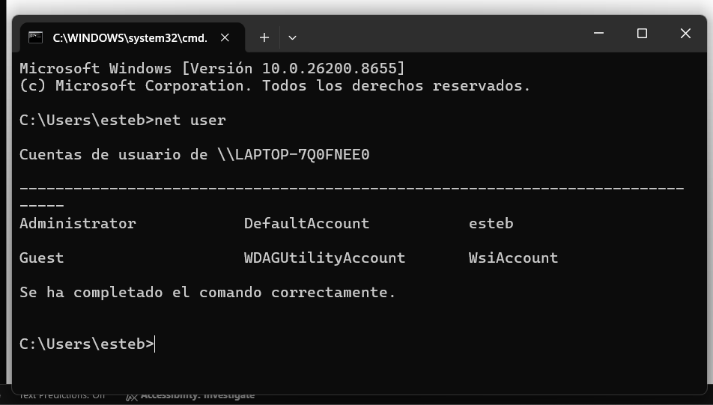
8. Task Scheduling – schtasks
Command: schtasks /create /sc daily /tn "BackupTask" /tr "C:\Backup\backup.bat" /st 18:00
Description: Creates a scheduled task that runs a batch file daily at 6:00 PM. The /create switch creates a new task, /sc daily specifies the schedule frequency, and /st sets the start time. Windows Task Scheduler can automate routine administrative tasks using this command.
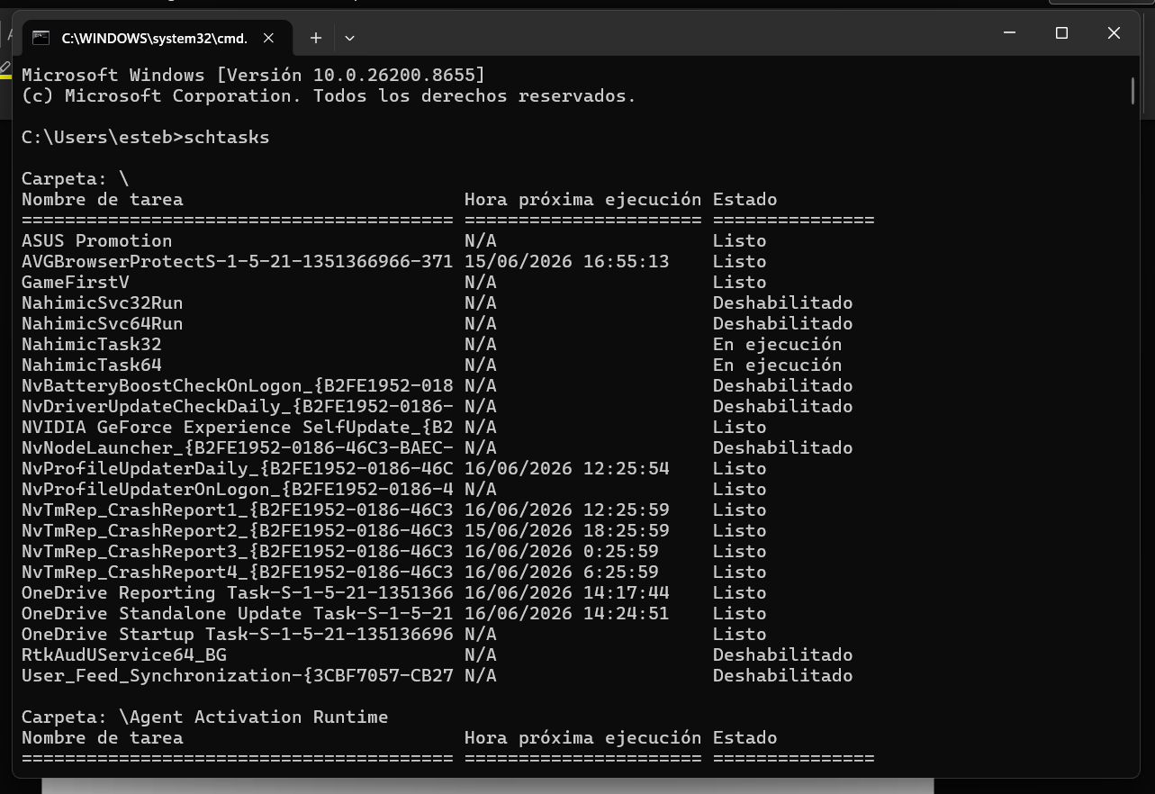
9. file enter – cd /
Command: cd
Description: Search and find the folder you want to go to.
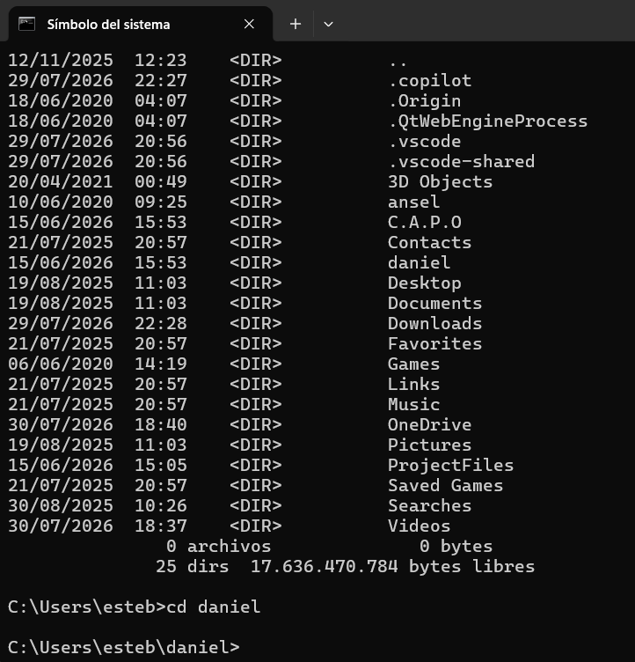
10. show the configuration – ipconfig
Command: ipconfig
Description: displays the network configuration of the device
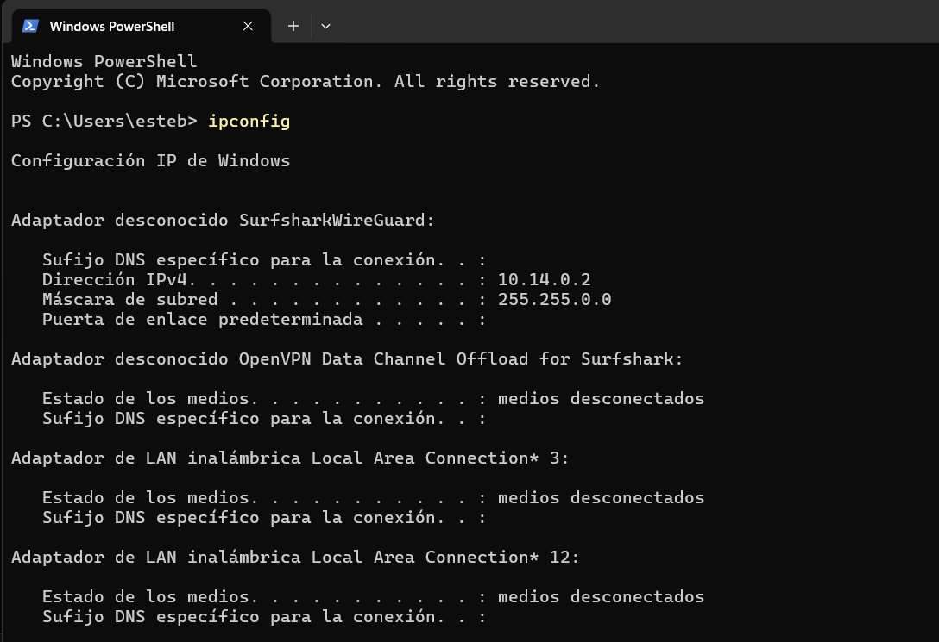
Conclusion.
Windows CLI commands provide efficient methods for managing processes, files, users, networks, and automated tasks. System administrators frequently use these commands within batch files to automate routine operations, improve productivity, and troubleshoot system issues without relying on graphical tools [1].

Use of Linux OS CLI commands.
1. The top Command for Mananging Linux Processes
Description: To track the running processes on your machine you can use the top command.
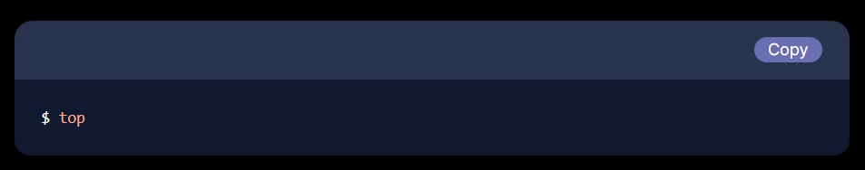
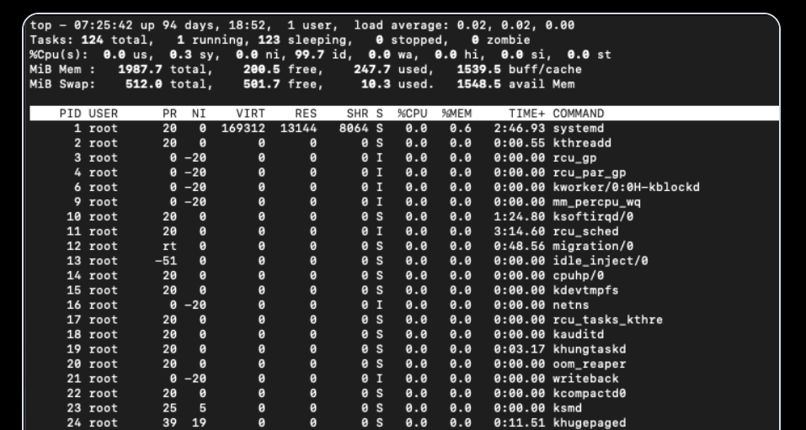
Top command displays a list of processes that are running in real-time along with their memory and CPU usage. Let’s understand the output a little better:
PID: Unique Process ID given to each process.
User: Username of the process owner.
PR: Priority given to a process while scheduling.
NI: ‘nice’ value of a process.
VIRT: Amount of virtual memory used by a process.
RES: Amount of physical memory used by a process.
SHR: Amount of memory shared with other processes.
S: state of the process
‘D’ = uninterruptible sleep
‘R’ = running
‘S’ = sleeping
‘T’ = traced or stopped
‘Z’ = zombie
%CPU: Percentage of CPU used by the process.
%MEM; Percentage of RAM used by the process.
TIME+: Total CPU time consumed by the process.
Command: Command used to activate the process.
You can use the up/down arrow keys to navigate up and down through the list. To quit press q. To kill a process, highlight the process with the up/down arrow keys and press ‘k’.
Alternatively, you can also use the kill command, which we will see later.
2 File & directory management
The locate command
Description: Like the find command, the locate command also searches the specified file. This command maintains and uses a database of all files and directories. It uses the following syntax.
The following image shows an example of the locate command. find [path] [expression] [action]
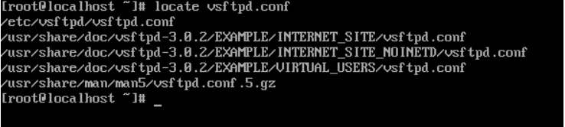
3. The diff command
Description: The diff command compares two files and prints the difference between them. This command is mainly used to determine the changes made in a file by comparing it with its backup copy.
Create a text file containing sample content. Make a duplicate of the file as a backup. Modify the original file, then use the diff command to compare the original and backup versions and identify the changes
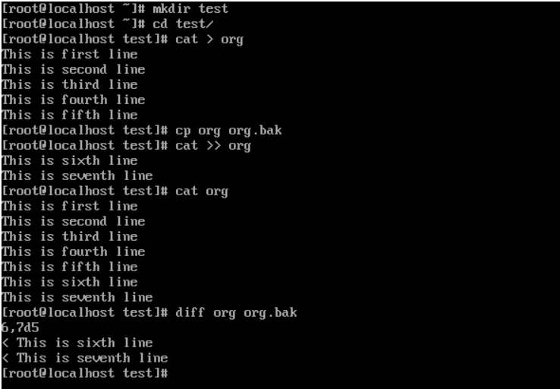

4. Command - Uptime
Description: How long a system has been running for
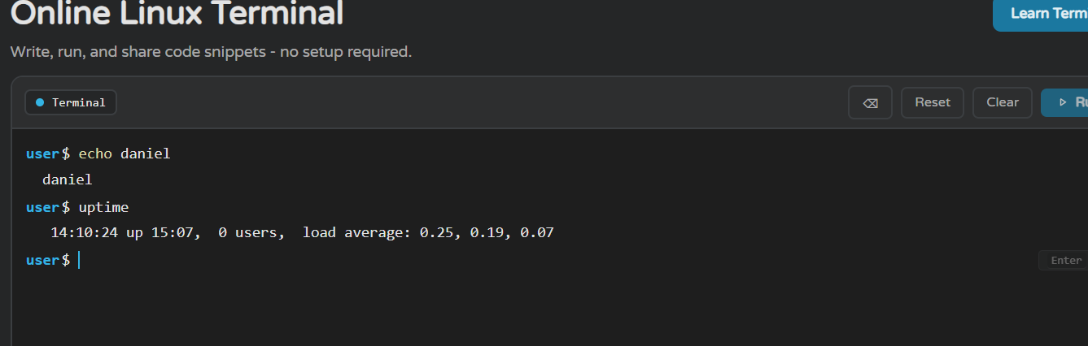
5. Command - echo
Description: Display or output text
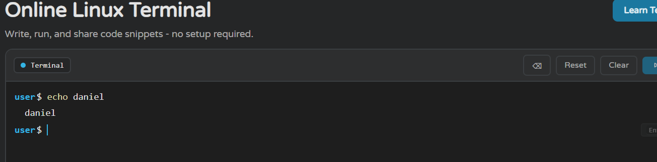

6. Command - PWD
Description: Displays the current route.
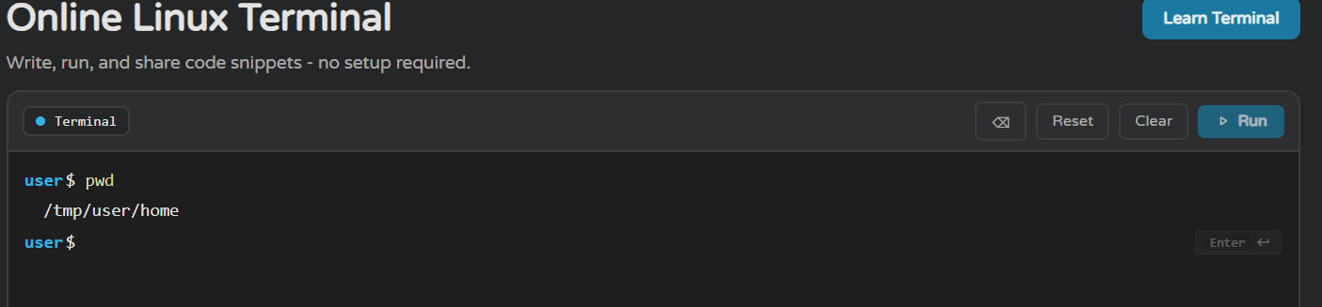

7. Network testing/monitoring
Netstat – Network Statistics
Description: The netstat is a command-line tool for monitoring incoming and outgoing network packet statistics as well as interface statistics. It is a very useful tool for every system administrator to monitor network performance and troubleshoot network-related problems.
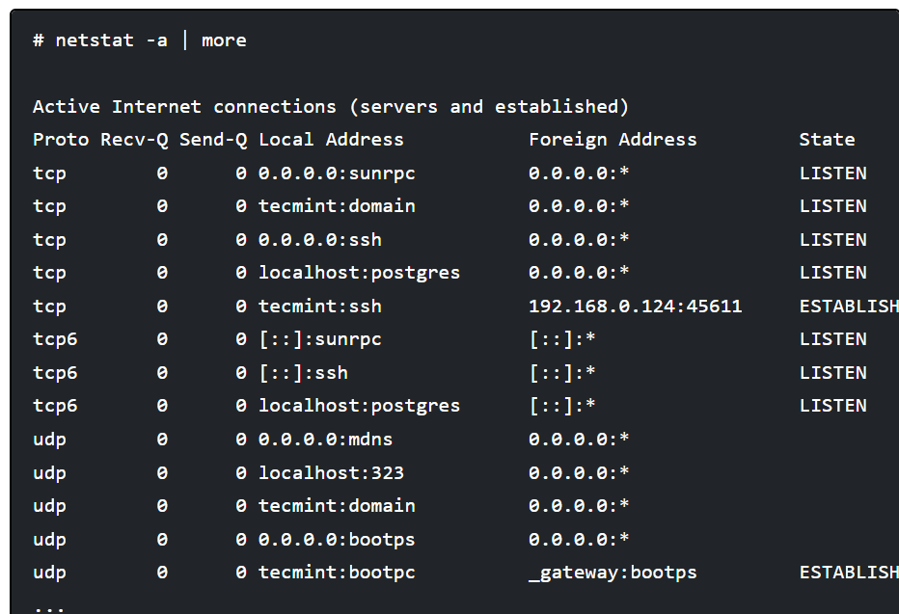
8 .User management
Managing users is an important job for a system administrator. They spend a lot of time working with user accounts. This includes three main tasks: creating new users, changing existing users, and removing users that are no longer needed.
Adding or creating user accounts
The useradd command adds a new user account. It requires a username as a compulsory argument. It uses the following syntax.
useradd [options] username
Options are optional. They allow us to customize the user account properties. If we don't specify them, it uses their default values.
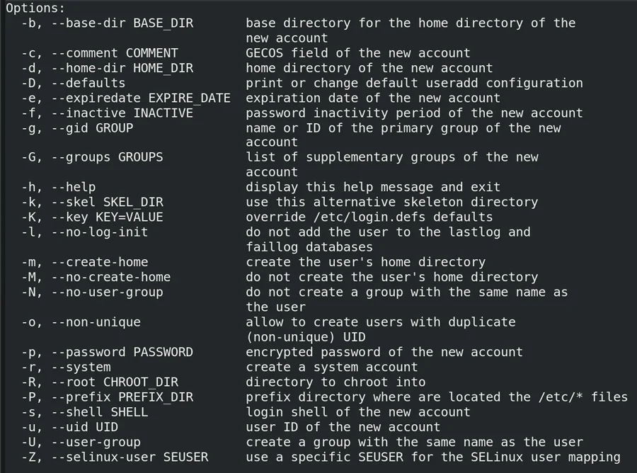
9 .Task scheduling.
Task scheduling allows you to run specific tasks at a particular time. Linux offers two native tools for task scheduling: at and cron. This tutorial explains how to use the at tool for task scheduling.
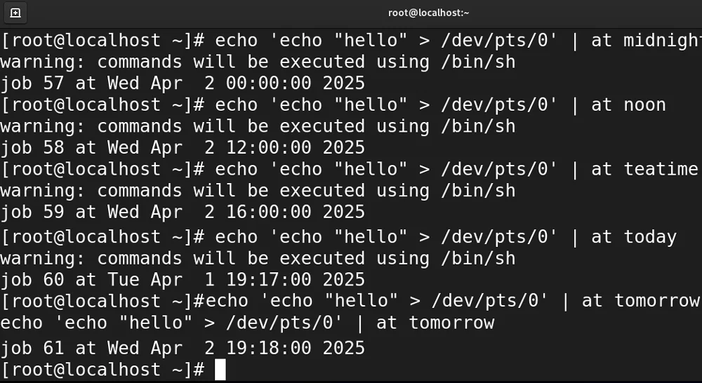
Task scheduling is essential for system administration. It allows you to execute commands and scripts at a specific time automatically. The at tool is for one go. The cron tool is for repetitive tasks [1]

10. Command - Pmap
Description: To show the memory map of a process
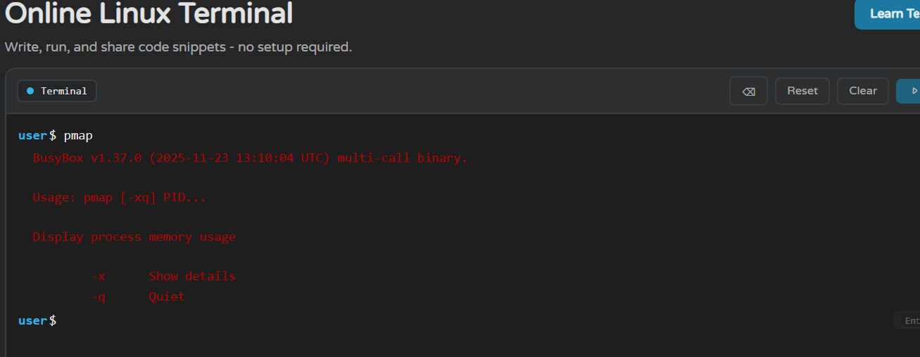

4. Use of Windows OS scripts.
Script 1: Check Internet Connection
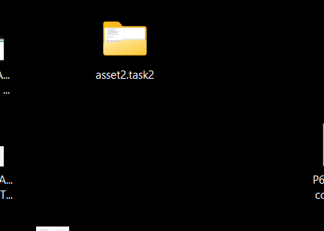
Create a folder to save the batch and then run it.
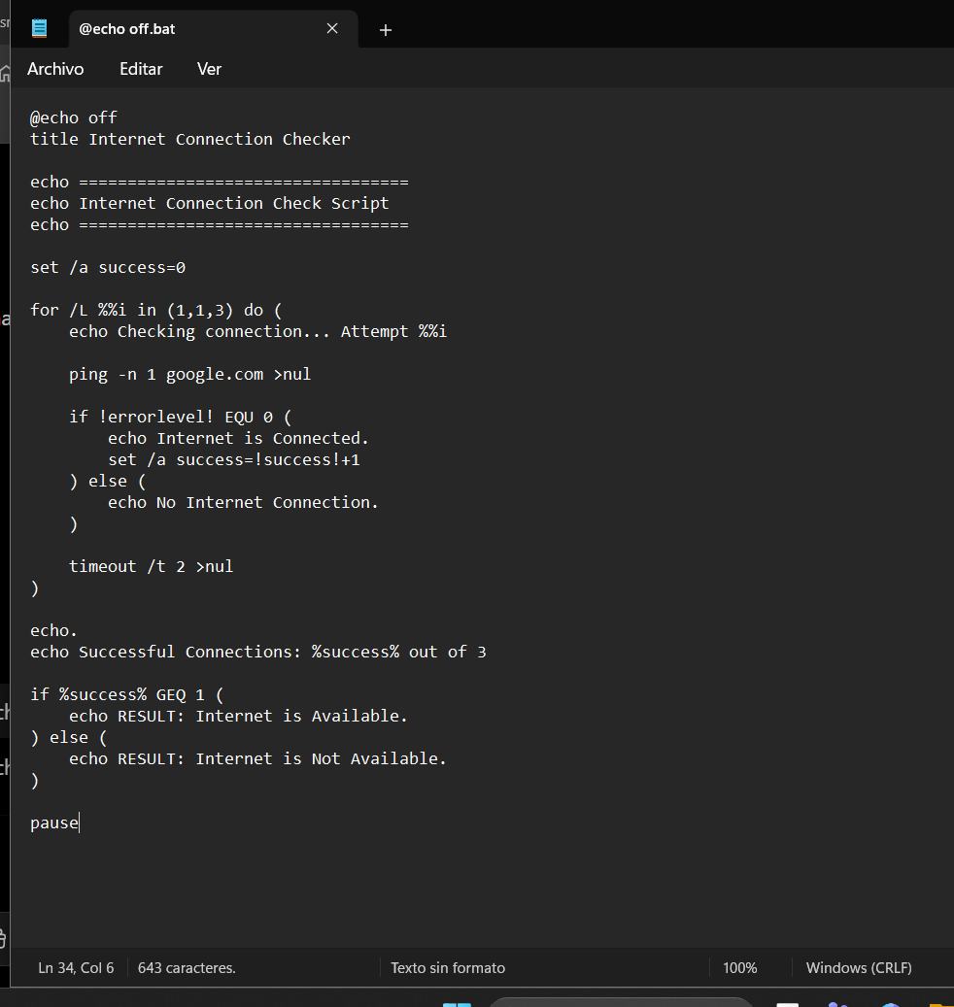
Create the batch code in Notepad and save it with the .bat extension.
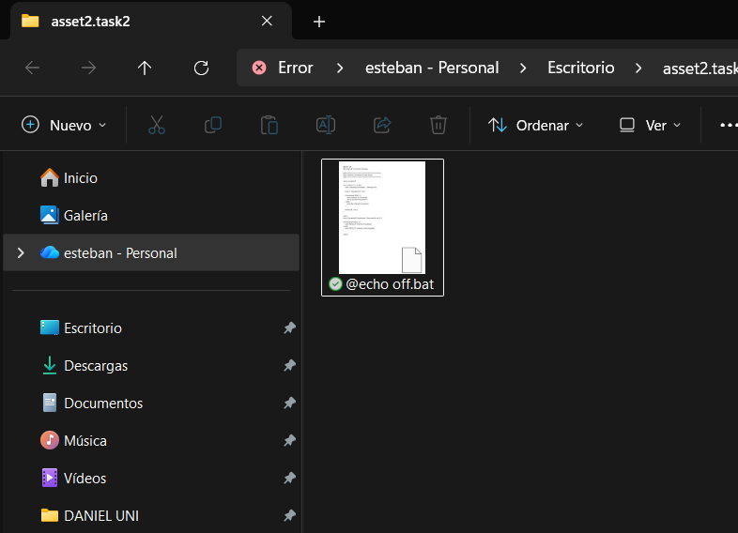
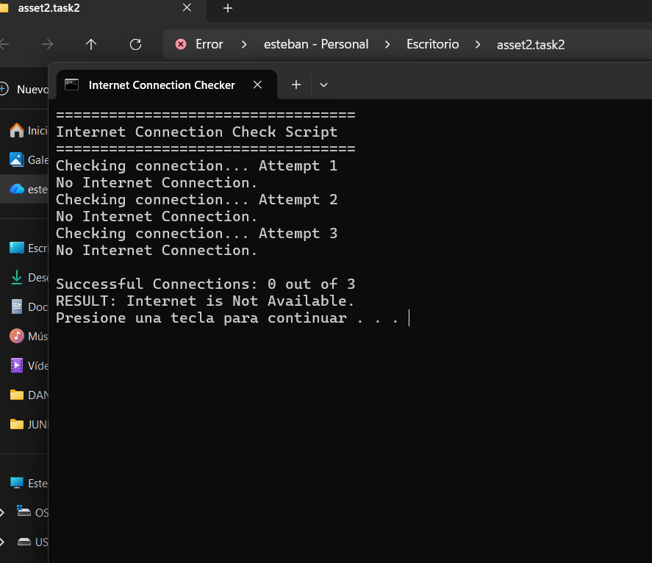
Run the batch file from the folder and verify the result
Script 2: Open a web site
Create a folder to save the batch and then run it.
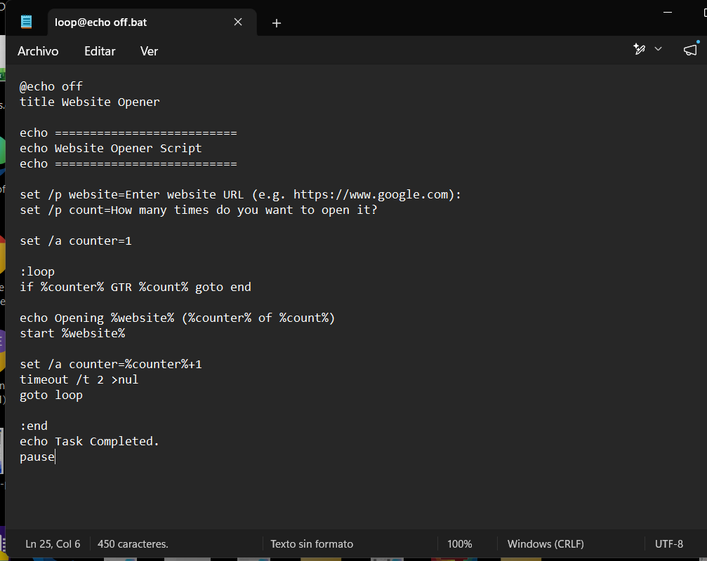
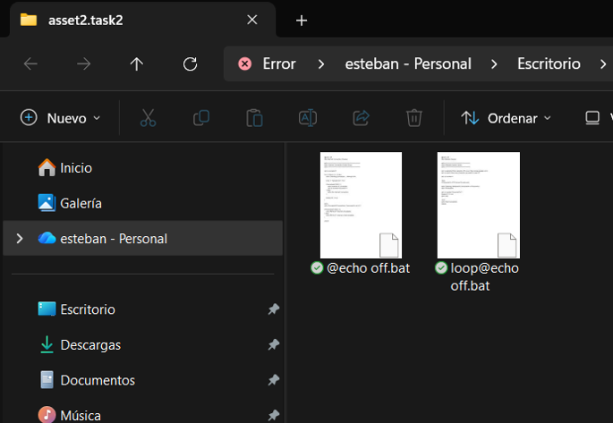
Create the batch file in Notepad
Batch file saved in the folder ready to be used
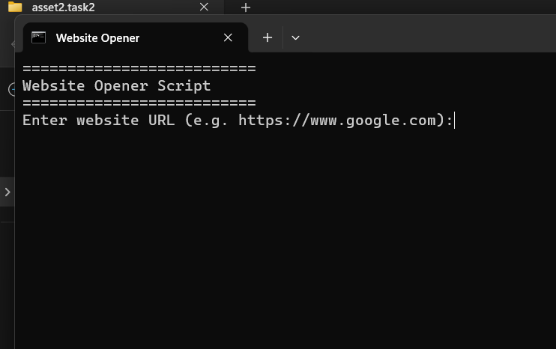
I pressed the enter key
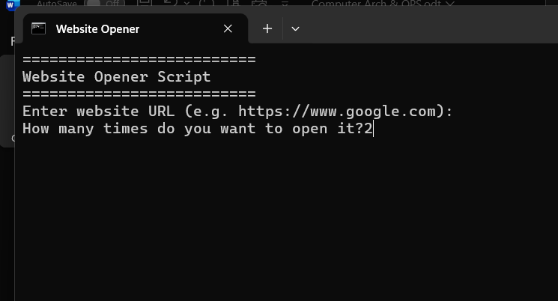

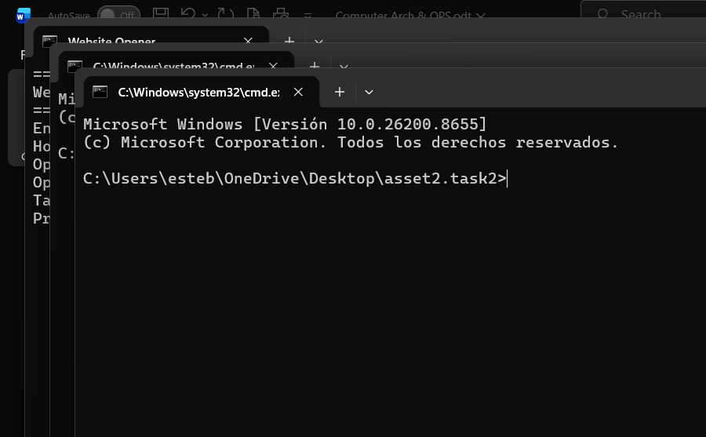
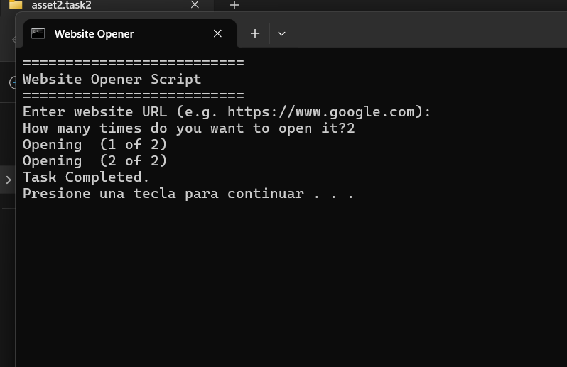

Use of Linux OS scripts
script 1: Salary calculation
Description: This script is designed to calculate an employee’s salary by determining the gross salary, applying relevant deductions (such as taxes, insurance, or other withholdings), and generating the net salary. It automates payroll calculations to ensure accurate, consistent, and efficient salary processing while reducing manual errors. The script may also account for factors such as overtime, bonuses, allowances, and employee-specific deductions.

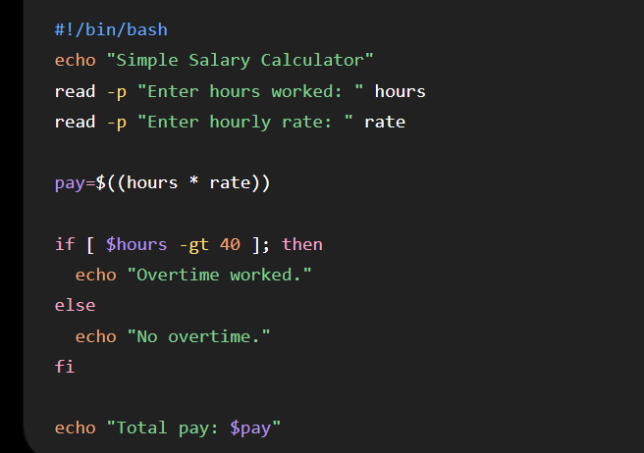
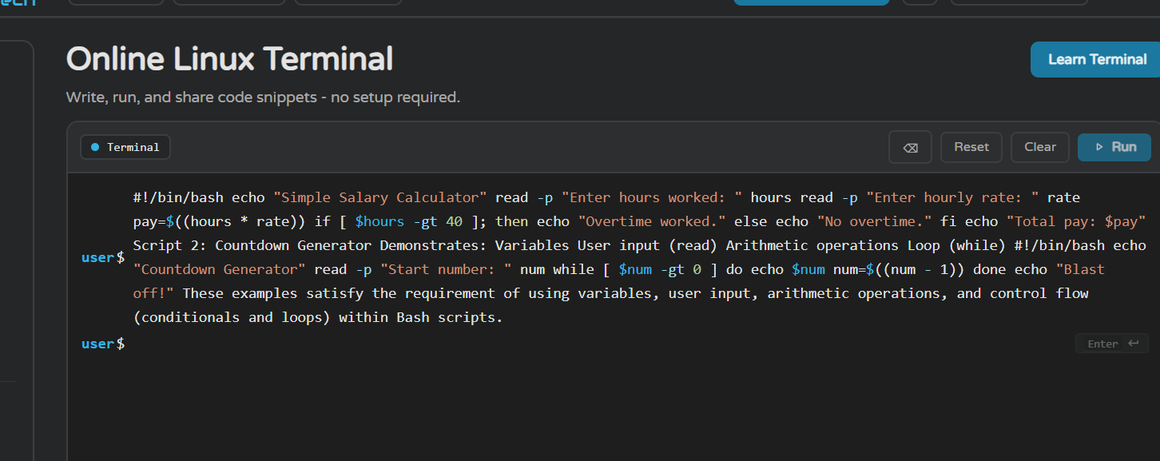

Script 2 – The activity generator
Description: This script selects and displays a random activity from a predefined list each time it runs.
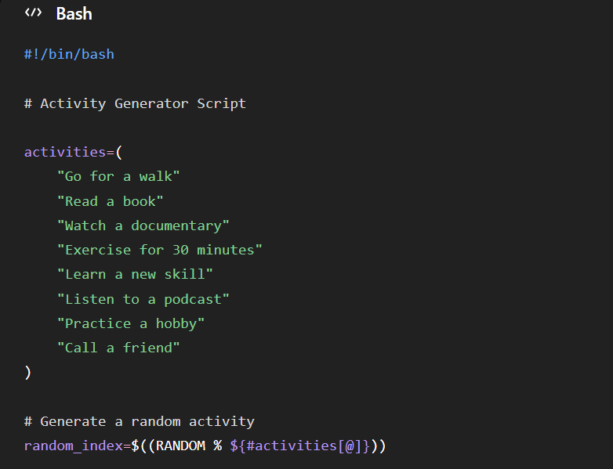
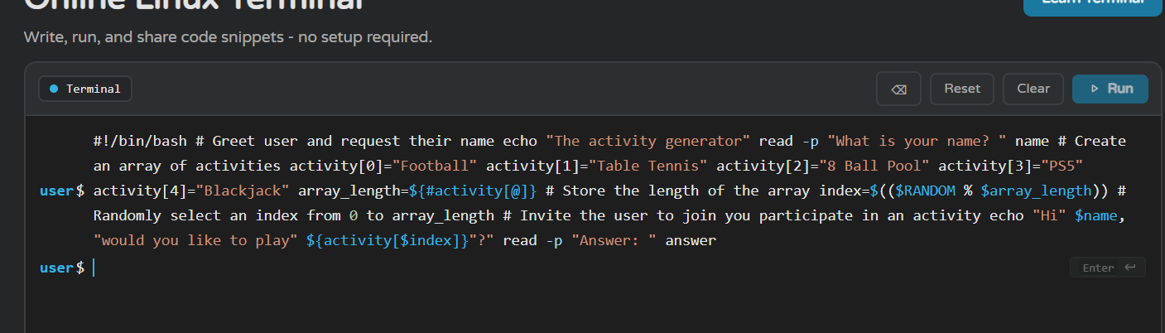

Conclusion
In conclusion, completing this project allowed me to learn a great deal about Windows and Linux operating systems, both their core functions and the use of commands and scripts for task management and automation. Through the various activities, I was able to develop a better understanding of process, file, user, network, and scheduled task management, as well as gain practical experience using command-line interfaces and creating basic scripts.

I believe that the knowledge gained during this project will be very useful for my academic and professional development. I hope that everything I have learned will serve as a solid foundation to confidently face the challenges and content I will encounter next year, as well as to continue developing my skills in the field of computer science and systems administration.

References

[1] | W. Shotts, The Linux Command Line, San Francisco: Willian Pollock, 2026.
[2] | AITS-TPT, "UNIT-I Operating Systems Functions," 26 August 2025. [Online]. Available: https://aits-tpt.edu.in/wp-content/uploads/2022/06/Operating_System-min.pdf.
[3] | Britannica, "Operating system (OS) | Definition, Examples, & Concepts," 26 August 2025. [Online]. Available: https://www.britannica.com/technology/operating-system.
[4] | UTC, "Chapter 8: Memory Management," [Online]. Available: https://www.utc.edu/sites/default/files/2021-04/2800-lecture8-memeory-management.pdf. [Accessed 26 August 2025].
[5] | University of Bologna (cs.unibo.it), "File Systems," [Online]. Available: http://www.cs.unibo.it/~sangio/SO_currentAA/Luc_SO/FileSystem/File_Systems1.pdf. [Accessed 26 August 2025].
[6] | MBIT, "Operating System Concepts, 8th Edition," [Online]. Available: https://www.mbit.edu.in/wp-content/uploads/2020/05/Operating_System_Concepts_8th_EditionA4.pdf. [Accessed 26 August 2025].
[7] | GeeksforGeeks, "How to Monitor System Activity in Linux | top Command," [Online]. Available: https://www.geeksforgeeks.org/linux-unix/top-command-in-linux-with-examples/. [Accessed 26 August 2025].
[8] | OpenStax, "6.4 Memory Management - Introduction to Computer Science," [Online]. Available: https://openstax.org/books/introduction-computer-science/pages/6-4-memory-management. [Accessed 27 August 2025].
[9] | TechRepublic, "How to use Windows 10's Resource Monitor to track memory usage," [Online]. Available: https://www.techrepublic.com/article/how-to-use-windows-10s-resource-monitor-to-track-memory-usage/. [Accessed 27 August 2025].
[10] | Testbook, "Process Management in Operating System - Learn Details Here!," [Online]. Available: https://testbook.com/operating-system/process-management-in-operating-system. [Accessed 27 August 2025].
[11] | Turing, "How to Use the Linux Free Command," [Online]. Available: https://www.turing.com/kb/how-to-use-the-linux-free-command. [Accessed 27 August 2025].
[12] | OpenStax, "6.5 File Systems - Introduction to Computer Science," [Online]. Available: https://openstax.org/books/introduction-computer-science/pages/6-5-file-systems. [Accessed 27 August 2025].
[13] | GeeksforGeeks, "df command in Linux with Examples," [Online]. Available: https://www.geeksforgeeks.org/linux-unix/df-command-linux-examples/. [Accessed 27 August 2025].
[14] | man7.org, "top(1) - Linux manual page," [Online]. Available: https://man7.org/linux/man-pages/man1/top.1.html. [Accessed 27 August 2025].
[15] | GeeksforGeeks, "System Protection in Operating System," [Online]. Available: https://www.geeksforgeeks.org/operating-systems/system-protection-in-operating-system/. [Accessed 27 August 2025].
[16] | Fiveable, "OS Security and Access Control | Cybersecurity and Cryptography Class Notes," [Online]. Available: https://library.fiveable.me/cybersecurity-and-cryptography/unit-5. [Accessed 28 August 2025].
[17] | PDQ, "10 PowerShell commands every sysadmin should know," [Online]. Available: https://www.pdq.com/blog/top-powershell-commands-to-know/. [Accessed 28 August 2025].
[18] | Active Directory Pro, "50 Basic Windows Commands with Examples," [Online]. Available: https://activedirectorypro.com/windows-cmd-commands/. [Accessed 28 August 2025].
[19] | Varonis, "Windows PowerShell Scripting Tutorial For Beginners," [Online]. Available: https://www.varonis.com/blog/windows-powershell-tutorials. [Accessed 28 August 2025].
[20] | NinjaOne, " How to Automate Repetitive Tasks with PowerShell," [Online]. Available: https://www.ninjaone.com/blog/how-to-automate-tasks-with-powershell/. [Accessed 28 August 2025].
[21] | Tom, " Essential PowerShell Commands for Beginners," [Online]. Available: https://medium.com/tomtalkspowershell/essential-powershell-commands-for-beginners-613bfa9cef82. [Accessed 29 August 2025].
[22] | Hostinger, " Bash Scripting for Beginners + Downloadable Free Cheat Sheet," [Online]. Available: https://www.hostinger.com/tutorials/bash-scripting-tutorial. [Accessed 29 August 2025].
[23] | It's FOSS, "Bash Scripting Tutorial for Beginners," [Online]. Available: https://itsfoss.com/bash-scripting-tutorial/. [Accessed 29 August 2025].
[24] | DataCamp, "How to Write a Bash Script: A Simple Bash Scripting Tutorial," [Online]. Available: https://www.datacamp.com/tutorial/how-to-write-bash-script-tutorial. [Accessed 29 August 2025].

[1] | A. Bindal, Designing Mobile Robot Interfaces with 16-bit Microchip Microcontrollers, San Jose State University, San Jose, CA, USA: Springer Nature Switzerland AG, 2023.

References

[1] |  | Shian Jia, Xinbo Wang, Mingli Song, Gang Chen, “Agent Centric Operating System -- a Comprehensive Review and Outlook for Operating System,” arxiv, p. 31, 15 11 2024.
[2] |  | Amod Holla, Mainakh Mukherjee, Anushka Mukherjee, West Lafayette, Kaushik Roy., “ROM-Overlaid STT-MRAM for Efficient MVM and Softmax Operations Towards Accelerating Transformer Inference,” IEEE Xplore, p. 1, 17 february 2026.
[3] |  | Ning Ding, Fangcheng Liu, Kyungrae Kim, Linji Hao, Kyeng-Hun Lee, Hyeonmok Ko, Yehui Tang, “Memory-based Expert Knowledge Injection for Efficient LLM Scaling,” arxiv, p. 15, 03 february 2026.
[4] |  | S.Sridevi, “USER INTERFACE DESIGN,” International Journal of Computer Science and Information Technology Research, vol. 2, no. 2, p. 12, 2014.
[5] |  | W. Stallings, Operating Systems, Edinburgh Gate: Ninth Edition, 2018.
[1] | T. Dawson, “Introduction to the Windows Command Line with PowerShell,” proquest, p. 10, 2016.

Appendices
Evidence of engagement with 1 online certified course




