

Cycles to Share Database
Module Code: ACCA5014
Module Lecturer: Kemi Ademoye
Student Name: Mohamad Wael Baghdadi
Student Number: 1708309
Course: (Mcomp) Software Engineering
Due Date: 20/03/2019

Table of Contents:
Table of Contents: 1
Table of Figures: 1
Table of Tables: 1
1. Abstract: 2
2. Introduction: 2
3. Performance Tuning 2
3.1- What is an index? 2
3.1.1- What does SQL INDEX do? 2
3.1.2- Type of index: 2
3.2- Indexes in Cycle to share scenario: 3
3.2.1- Cycle to share Database Tests (Before and after the Indexes): 4
4. Distributed Database 6
4.1- Distributed database solution for the Bike shop scenario: 7
4.1.1- Horizontal fragmentation: 7
4.1.2- Vertical fragmentation: 7
4.1.3- Mixed fragmentation: 8
4.1.4- Derived fragmentation: 8
5. References: 9
6. Appendix: 10
➢ Data generator: 10
➢ Tariff Rate: 10

Table of Figures:
Figure 1: Clustered and Secondary Indexes in Cycle to Share Senario 3
Figure 2: How the distributed database works[14] 6

Table of Tables:
Table 1: Database with and without Indexes 5
Table 2: Advantages and disadvantages of distributed database[14][16] 6

Abstract:
A database management system (DBMS) is a software program to create, edit, organize and manage databases. The DBMS allows the programmers and end users with an organized and methodical way to create, read, update, manage, delete and retrieve data.
The Database management system (DBMS) basically works as an interface between the database and application programs or end users, and to make sure that the data is organized and easily accessible for the user[1].

Introduction:
In this report, the author has described briefly what the performance tuning (index) in the database and what is the distributed database management system (DDBMS), including the solution for Cycle to share scenario for the indexes with identifying the reason in one table for all of them and the solution of how they can distribute the database.

Performance Tuning

3.1- What is an index?
The simple way to describe the index is like a pointer, for example, a dictionary or phone books or even a books, if the anyone wants to search for some word or some specific chapter inside this book, it will be too hard to start from the first page and look in each single page of the book to get what looking for, and even it takes lots of time to get the exact things, so the index is just when the user lookup the page number of the chapter in the index, then he can directly go to the page number and locate that specific chapter he looking for, which he reduce much time while he looking for each single page.
So, the Index can significantly improve the performance-tuning of a query, which is applied to call data from the database faster. while the users cannot see those indexes, so we can say that they are just used to speed up searches/queries[2],[3],[4],[5],[6],[7],[8],[9],[10].

3.1.1- What does SQL INDEX do?
- Can find the data or the information within a database very quickly.
- The index produces a list of rows of a database table as row can be referred to within a Section of the time with a minimal effort.
- Is a database structure which ranks one or more column values in a particular order.
- The performance of the index cannot be recognized when is allocating in small tables
- When the columns have different values, the index can work more efficiently and quickly
- the index sorts the data firstly and then sets an identifier for each row[11].

3.1.2- Type of index:
- Clustered.
- Non-clustered Index.
- Unique.
- Spatial.
- Full-text.
- index with included columns.
- XML [11],[7],[12],[13].

3.2- Indexes in Cycle to share scenario:
In this scenario the author has define the Clustered and Secondary indexes and which columns should avoid in one Excel table
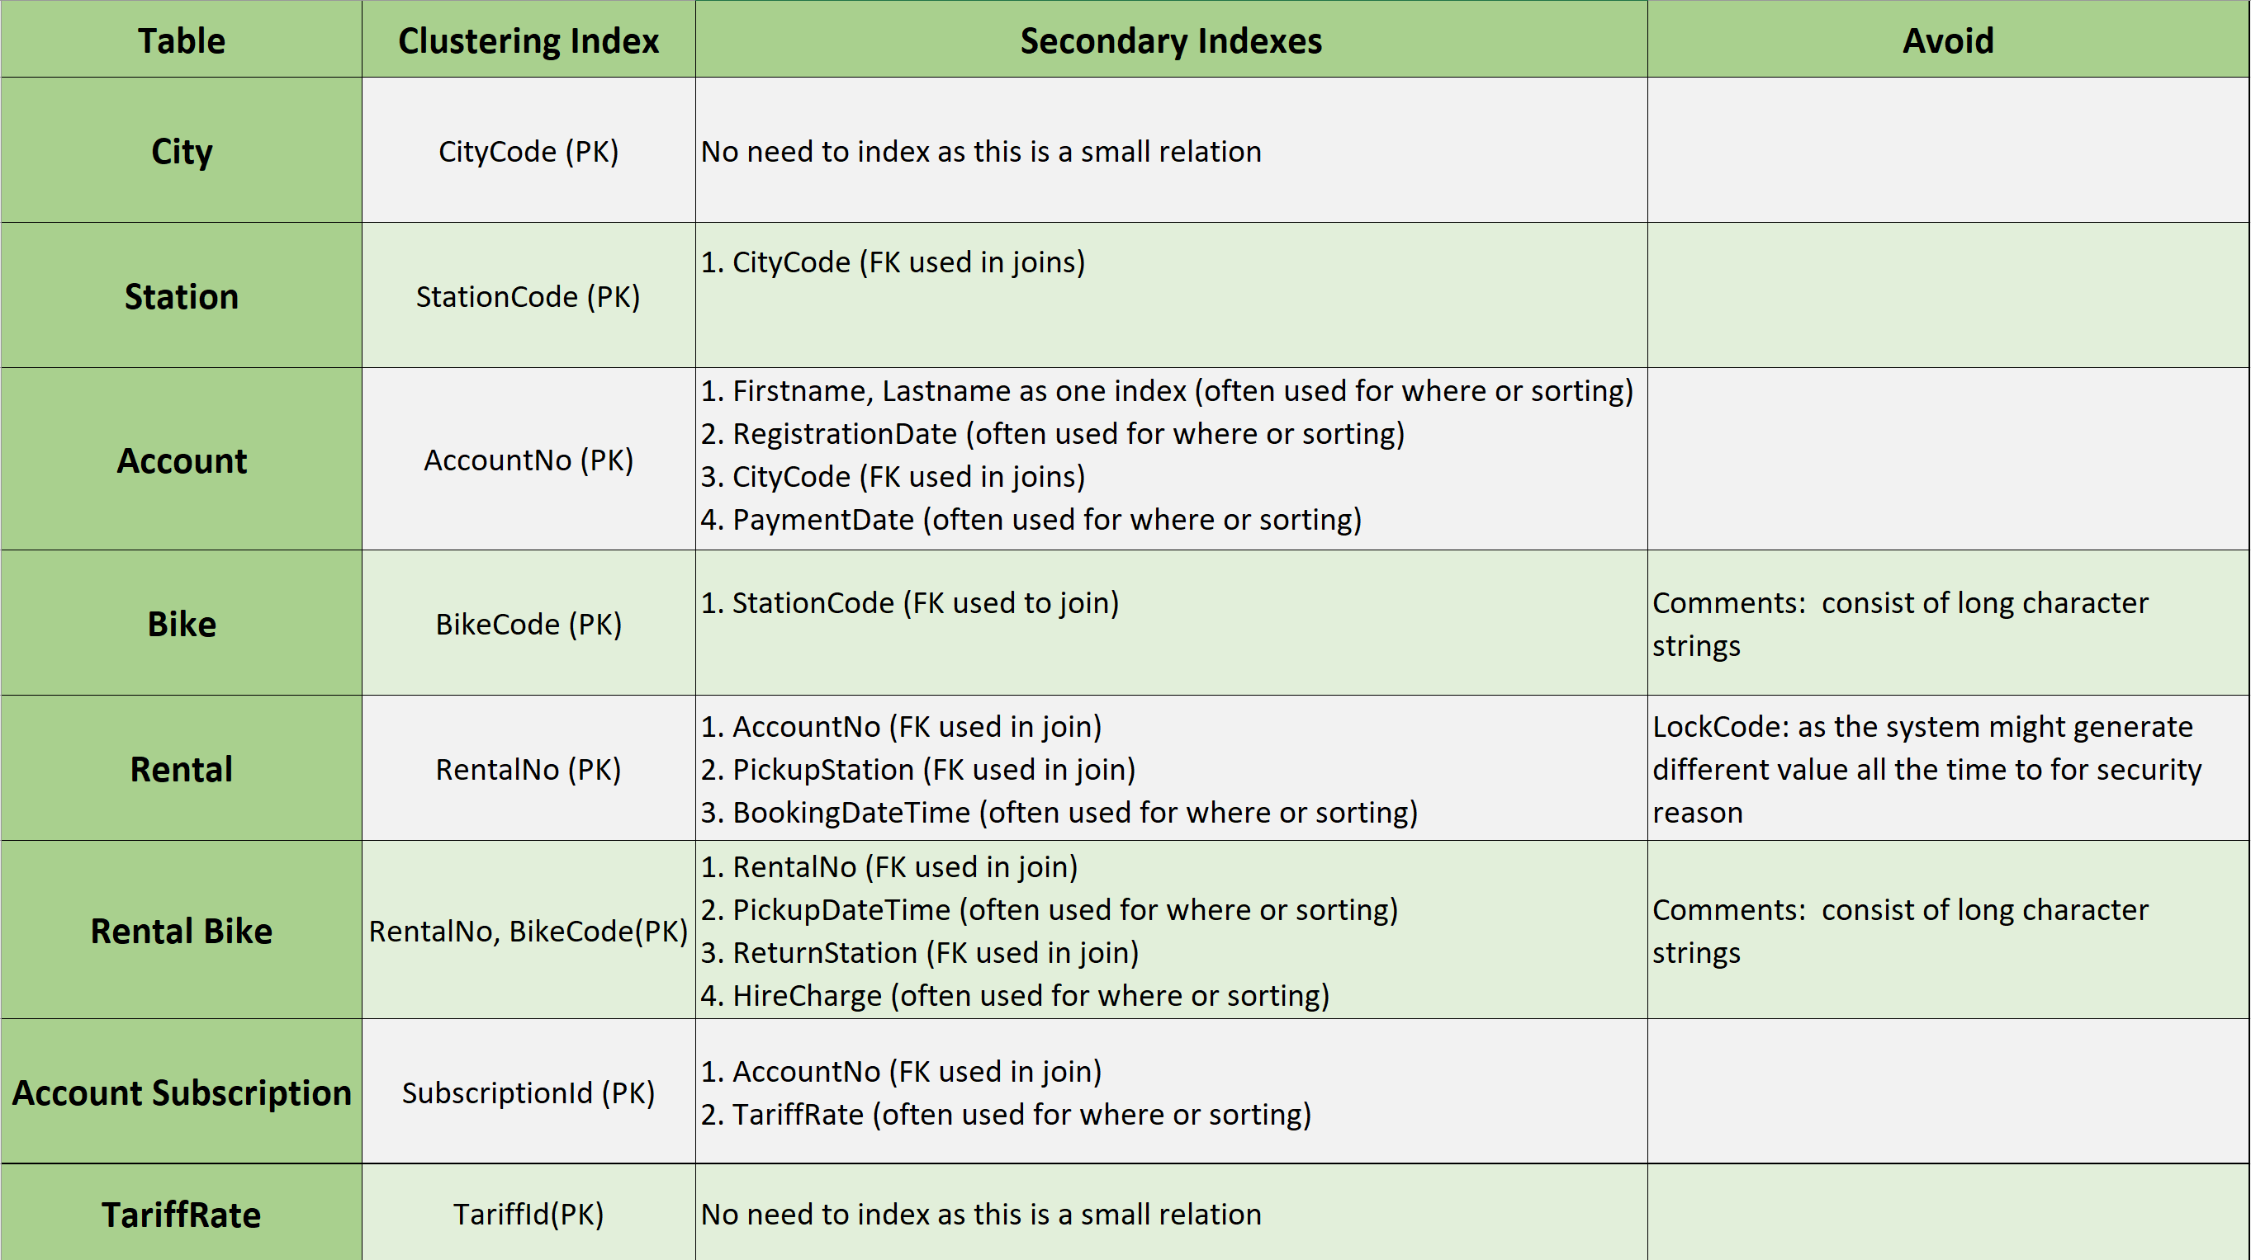
Figure 1: Clustered and Secondary Indexes in Cycle to Share Senario

3.2.1- Cycle to share Database Tests (Before and after the Indexes):
Reason | Before adding the index | After adding the index
- Account Table:  Adding an index to the columns (FirstName, Surname) to allow the user searching the name quickly, which they are organized in alphabetical order, Also it can be in opposite way like (Surname then FirstName) which depends for the company. | 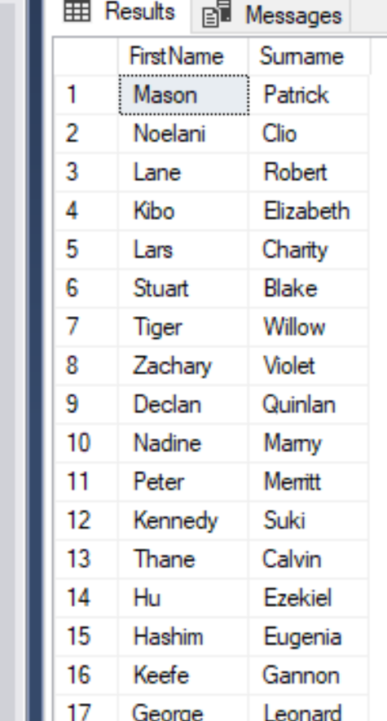 | 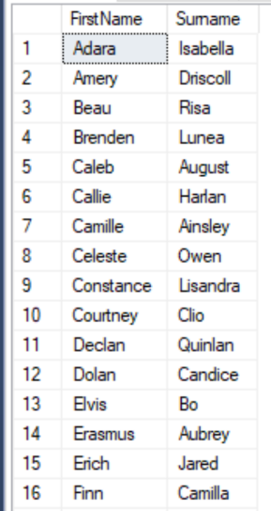
- Account Table:  Payment Date column: To let the user lookup for the payments dates from oldest to newest, or it can be from the newest to oldest as well. | 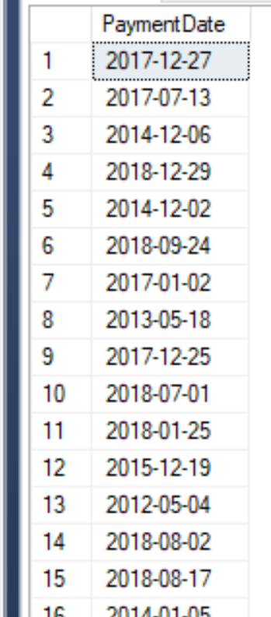 | 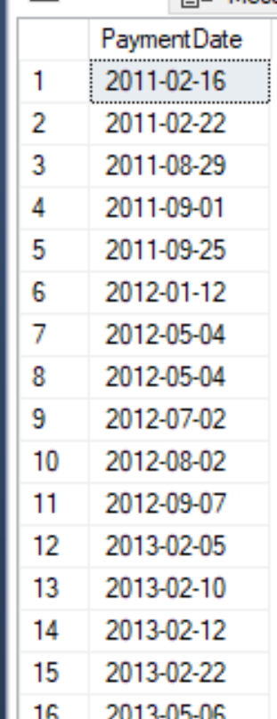
- Account Table:  To allow the user searching the registration date of the member by the oldest to newest, and even to make it easy for the use when he wants to check the registration date for some specific member. | 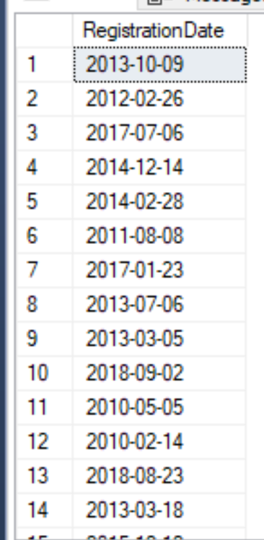 | 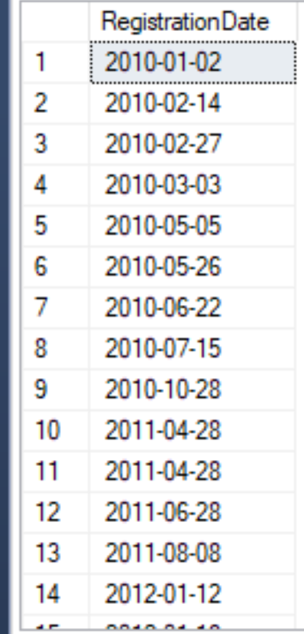
- Rental Table:  To allow the user looking for the booking dates and times from the oldest to newest. | 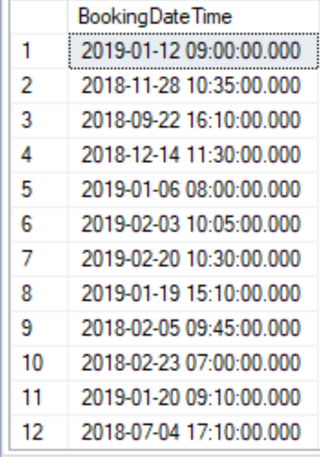 | 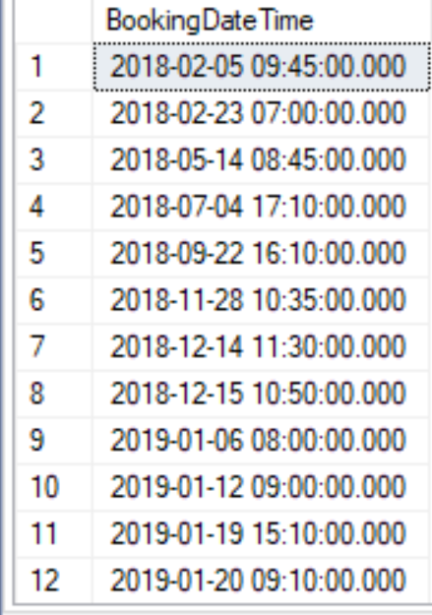
- Rental Bike Table:  To allow the user to search for the Pickup dates and times much quicker. | 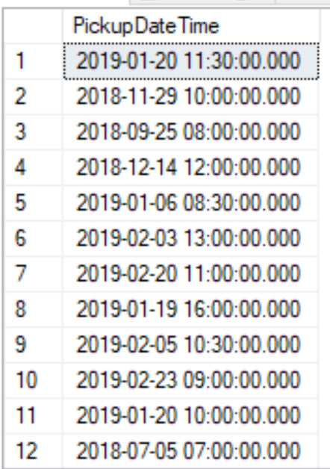 | 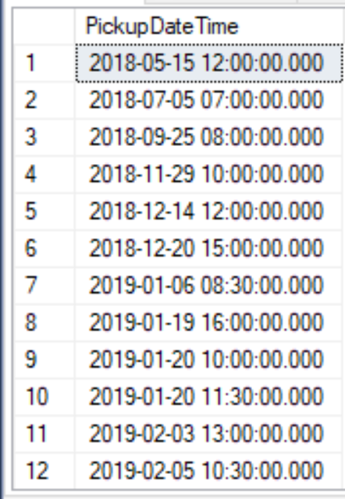
- Rental Bike Table:  To allow the user to know the Hire Charge quickly from smallest amount till the largest. | 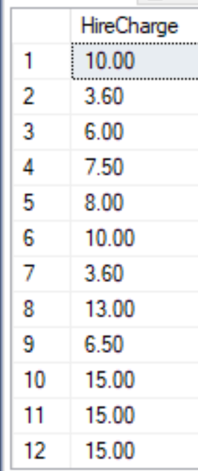 | 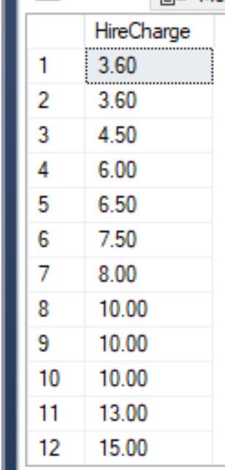
- Account Subscription Table:  To allow the user to know or calculate the Tariff Rate and who paid or not and which amount form smallest till largest. | 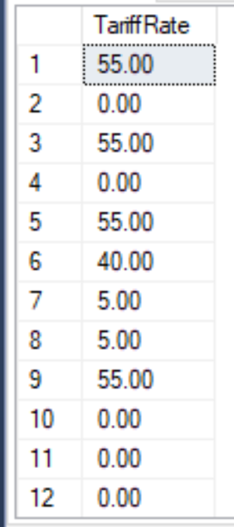 | 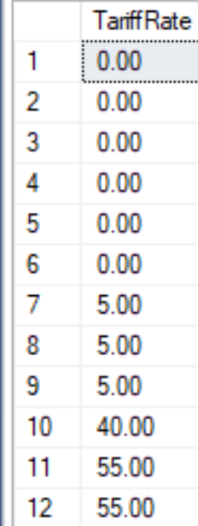
Table 1: Database with and without Indexes

Distributed Database
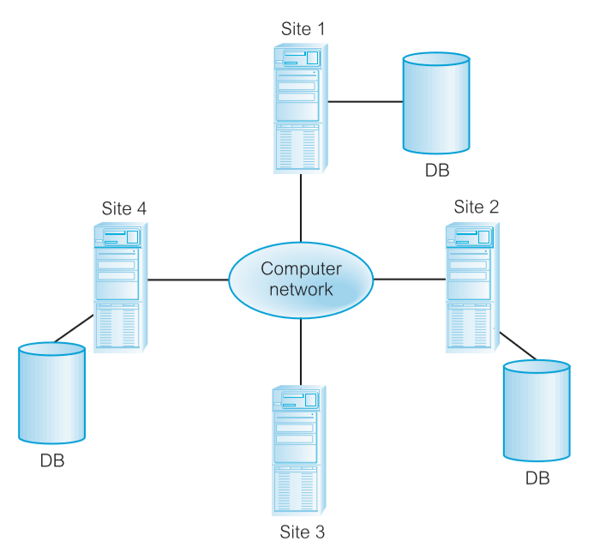
The distributed database management system is meant to split a signal logical database into several of fragments, each part of them is stored on one computer or more under separate control of DBMS, with computers connected to the network. Each site is capable of processing requests for users that require independent access to local data, it is also can be processing the data that has been stored on other computers in the same network[14][15][16].
Figure 2: How the distributed database works[14]
Types of fragmentation:
- Horizontal
- Vertical
- Mixed
- Derived

Distributed Database[14]
Advantages | Disadvantages
Improved shareability and local autonomy | Security
Reflects organizational structure | Integrity control more difficult
Improved availability | lack of standards
Improved performance | Complexity
Improved reliability | Cost
Modular growth
Economics
Remaining competitive
Integration
Table 2: Advantages and disadvantages of distributed database[14][16]

4.1- Distributed database solution for the Bike shop scenario:
The author has defined the four types of the fragmentation which they are:

4.1.1- Horizontal fragmentation:
City Table
Use primary horizontal fragmentation for City with minterm predicates. Horizontal fragments are:
C1 Region = ‘East’ and County = ‘Gwent’
C2 Region = ‘East’ and County = ‘South Glamorgan’
C3 Region = ‘East’ and County = ‘Mid Glamorgan’
C4 Region = ‘South West’ and County = ‘West Glamorgan’
C5 Region = ‘South West’ and County = ‘Carmarthenshire’
C6 Region = ‘West’ and County = ‘Carmarthenshire’

Reconstruction: C1 ∪ C2 ∪ C3 ∪ C4 ∪ C5 ∪ C6

4.1.2- Vertical fragmentation:
Account Table
Use vertical fragmentation for Account:
A1: ΠAccountNo, RegistrationDate, FirstName, Surname, DateOfBirth, Email, Password, PhoneNumber, Address, CityCode, Postcode, PaymentDate (Account)
A2: ΠAccountNo, PaymentCard, PaymentCardCVC (Account)

4.1.3- Mixed fragmentation:
Account Table
Use vertical fragmentation for Account:
A1: ΠAccountNo, RegistrationDate, FirstName, Surname, DateOfBirth, Email, Password, PhoneNumber, Address, CityCode, Postcode, PaymentDate (Account)
A2: ΠAccountNo, PaymentCard, PaymentCardCVC (Account)

Then used derived fragmentation on fragment A₁:
A_{ii}: A₁ _{CityCode} C_{i} 1 ≤ i ≤ 6

Reconstruction: (A₁₁ ∪ A₁₂ ∪ A₁₃ ∪ A₁₄ ∪ A₁₅ ∪ A₁₆ ) _{AccountNo} A₂

4.1.4- Derived fragmentation:
- Bike and Station Tables
Use derived fragmentation for Bike and Station:
B_{i}: Bike C_{i} 1 ≤ i ≤ 6
S_{i}: Station B_{i} 1 ≤ i ≤ 6

Reconstruction: (B₁ ∪ B₂ ∪ B₃ ∪ B₄ ∪ B₅ ∪ B₆ )
Reconstruction: (S₁ ∪ S₂ ∪ S₃ ∪ S₄ ∪ S₅ ∪ S₆ )

- Rental Table
Use derived fragmentation for Rental:
R_{i}: Rental _{AccountNo} A_{1i} 1 ≤ i ≤ 6

Reconstruction: (R₁ ∪ R₂ ∪ R₃ ∪ R₄ ∪ R₅ ∪ R₆ )

References:
[1] S. C. Craig S. Mullins, “What is database management system (DBMS)? - Definition from WhatIs.com,” Margaret Rouse, 2014. [Online]. Available: https://searchsqlserver.techtarget.com/definition/database-management-system. [Accessed: 09-Mar-2019].
[2] Steven. Roman, “Access database design and programming, second edition,” Comput. Math. with Appl., vol. 38, no. 11–12, p. 288, 2003.
[3] S. Chaudhuri and V. R. Narasayya, “An Efficient Cost-Driven Index Selection Tool for Microsoft SQL Server,” VLDB, pp. 146–155, 1997.
[4] F. D. Sun, Q. Guo, and L. Wang, “Study and Optimization of T-Tree Index in Main Memory Database,” Appl. Mech. Mater., vol. 427–429, pp. 2531–2535, 2013.
[5] “Indexes - SQL Server | Microsoft Docs.” [Online]. Available: https://docs.microsoft.com/en-us/sql/relational-databases/indexes/indexes?view=sql-server-2017. [Accessed: 09-Mar-2019].
[6] W3Schools, “SQL CREATE TABLE Statement,” W3Schools, 2015. [Online]. Available: https://www.w3schools.com/sql/sql_create_index.asp. [Accessed: 09-Mar-2019].
[7] J. Louden and M. L. Christensen, “Top 10 Questions and Answers.”
[8] “SQL Indexes.” [Online]. Available: https://www.tutorialspoint.com/sql/sql-indexes.htm. [Accessed: 09-Mar-2019].
[9] “SQL Server Indexes.” .
[10] W3Schools, “SQL CREATE TABLE Statement,” W3Schools, 2015. [Online]. Available: https://guide.freecodecamp.org/sql/sql-create-index-statement/. [Accessed: 09-Mar-2019].
[11] “SQL: CREATE INDEX - w3resource.” [Online]. Available: https://www.w3resource.com/sql/creating-index/sql-creating-index.php. [Accessed: 09-Mar-2019].
[12] “Indexes in SQL Server.” [Online]. Available: https://www.c-sharpcorner.com/UploadFile/8af593/index-in-sql-server/. [Accessed: 09-Mar-2019].
[13] M. Steynberg, “Understanding SQL Server Auditing,” SQL Shack. [Online]. Available: https://logicalread.com/sql-server-understanding-indexes-w02/#.XIMbJCj7RPZ. [Accessed: 09-Mar-2019].
[14] T. Connolly and C. Begg, Pearson.Database.Systems.A.Practical.Approach.to.Design.Implementation.and.Management.6th.Global.Edition.1292061189.pdf. 2014.
[15] “Distributed DBMS Security in Distributed Databases.” [Online]. Available: https://www.tutorialspoint.com/distributed_dbms/distributed_dbms_databases.htm. [Accessed: 20-Mar-2019].
[16] G. J. Bell.David, Distributed Database Systems. 1992.
[17] L. Mockaroo, “Mockaroo - Random Data Generator and API Mocking Tool | JSON / CSV / SQL / Excel,” 13/5 2018, 2018. [Online]. Available: https://mockaroo.com/. [Accessed: 17-Mar-2019].
[18] “generatedata.com.” [Online]. Available: https://www.generatedata.com/. [Accessed: 17-Mar-2019].

Appendix:

Data generator:
The author has used some websites to generate the data for some columns[17][18].

Tariff Rate:
- The author has set 3 prices for in the Tariff Rate to be different in (Pay as you ride), (Monthly) or (Annual)
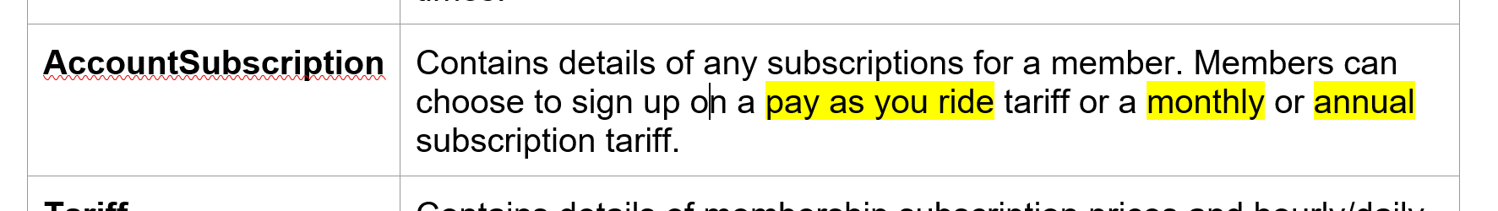
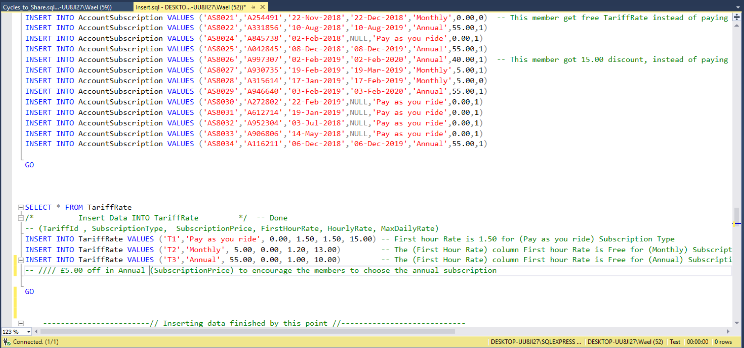
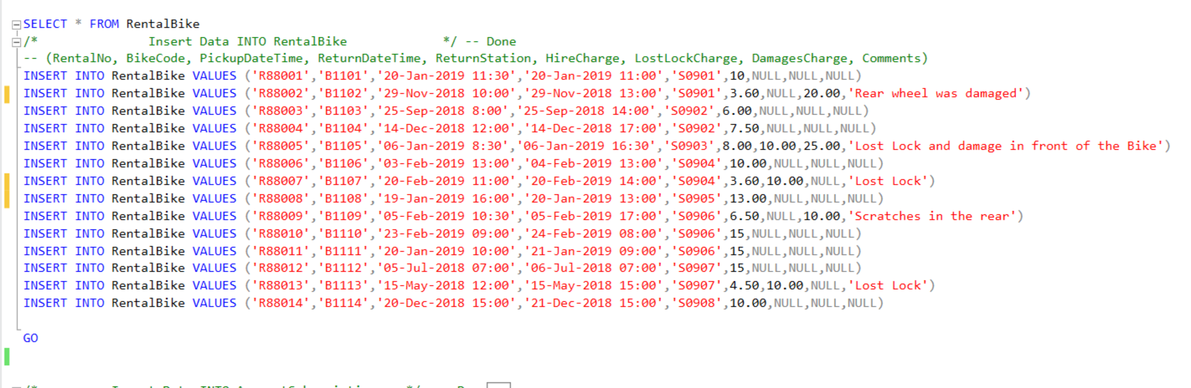
- But then he realized that the case study is just mentioned the (Pay as you ride) and (Annual)
So that meaning is the monthly price is the same price as annual price and the different only to let the customer make the payments every month instead of one payment for the whole year


