E-Portfolio Evidence of Learning
2022
BMHP 5014_BIRM
Iskra Tsvetanova Valkova (2026742)
Lecturer Mrs Azora Hurd
7/15/2022
University of Wales Trinity Saint David
Consisting of two different artefact tasks

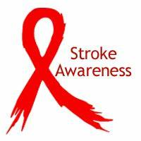

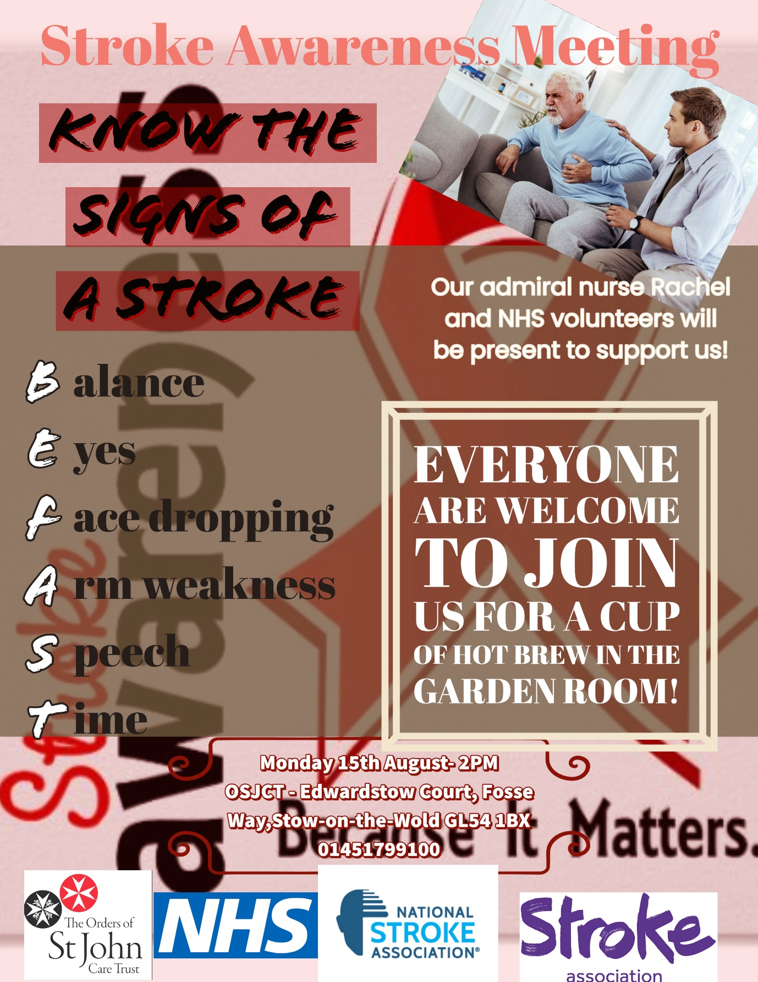

Contents
1.Introduction 3
2.Types of Strokes 3
2.1 Ischemic stroke 3
2.2 Haemorrhagic stroke 3
3.Stroke in UK 3
4.Stroke risk factors 3
5.Most common symptoms 3
6.Stroke treatment 4
7.References 7

Flyer

1.Introduction
In my E-Portfolio I have included two artefacts-a flyer and an elevated pitch. I am coming from perspective 3-I will develop a campaign on my own-to promote stroke awareness and educate the staff from Ewdardstow Court Care Home so they can act fast in case they spot stroke symptoms. I hope to be able to achieve that with the help of some NHS volunteers and admiral nurse Rachel, who will support me in accomplishing my project. (Act Fast Campaign,2022)

2.Types of Strokes
There are two main types of stroke-Ischemic and haemorrhagic with the first one being far more common.
2.1 Ischemic stroke. The ischemic one is due to large vessel atherosclerosis, aortocardioembolism or small vessels occlusion. The ischemic stroke can be embolic, which means that blood clot travels from different part of your body to your brain. Atrial fibrillation is disturbed which makes the heart to beat irregularly. About 87% of the strokes are ischemic.
2.2 Haemorrhagic stroke. The haemorrhagic strokes occur mostly due to hypertension but can be cause by specific vessel abnormalities as well. It results to a blood vessel rupture in the brain with a consequence if spilling blood in the surrounding tissues. This type of stroke affects about 13% of the patients.

3.Stroke in UK
Stroke is the second most common cause of death and the leading cause of disability in UK. IT is a cerebrovascular accident that manifests as neurologic deficits occurring due to interruption of the cerebral blood flow. It leads to a lack of oxygen and nutrients supplied to the brain, which causes brain cells to die. The causes, treatment and outcome are different according to the categories of stroke. Moreover, it can cause a long-term severe impairment in activities such as walking and speech. Also, it can lead to significant emotional burden with high percent of the survivor’s experiencing depression. The treatment and productivity loss coming from stroke cost approximately 8.9 billion per year which represents around 5% of the total UK NHS costs.

4.Stroke risk factors
A better understanding of stroke can help the health care providers in preventing, early identification and referral of the stroke patients. Insufficient knowledge about stroke risk factors and symptoms can affect the treatment of the patient. Several lifestyle conditions are identified as risk factors for stroke. These include diabetes mellitus, systematic arterial hypertension, high cholesterol levels, atrial fibrillation, carotid artery disease, smoking and alcohol use. The treatment of these risk factors can contribute to a significant change in stroke occurrence.

5.Most common symptoms
Patient aged 65 and over are the group most affected of stroke. The most common stroke symptoms include unilateral weakness, numbness and speech abnormality, confusion, headache with vomiting, difficulties in swallowing, trouble seeing with one or both eyes. Most of the patients cannot recall the signs and symptoms they have had, but most of them describe a difficulty in walking (impaired coordination) as something they definitely remember. Each year in the United Kingdom there are 110 000 first strokes and 30 000 recurrent strokes. Recognising the symptoms and receiving treatment within the first 3 hours is essential in proper management of the stroke.

6.Stroke treatment
Treatment depends on the type of stroke, including which part of the brain was affected and what has caused it. Treatment usually involves taking one or two different medication but on some occasions surgery might be needed as well.
Effective treatment of stroke can prevent long-term disability and save lives. If you suspect that someone is having a stroke, you have put the person into the right position, call 999 immediately and ask for an ambulance.

Elevated Pitch

Good afternoon, ladies and gentlemen,
My name is Iskra and I am part of the Orders of St John Care Trust. Today my purpose is to raise awareness about Stroke and to show you how you can react fast in case you spot someone having a stroke. I have invited our admiral nurse Rachel who is available to answer to your questions and also, we have got some NHS volunteers who are here to support us as well. Further help we might seek from the National Stroke Association, who are willing to cooperate and can respond to enquiries on number 03033033100.More information is available on htpp://www.stroke.org.uk. Act Fast company 2022 are also available for support on 01724856868; email: support@actfast.org.uk.
The aim of today’s meeting is to demonstrate the key points of the initial help someone might need when experiencing a stroke, therefore, to show you the steps you will need to follow when administering first aid to the patient. The knowledge you might gain is highly important as it might help to save someone’s life. I got inspired to start this project as both of my parents suffered from Stroke but at that time no one was able to recognise the sighs which led to them passing away.
Also, we had some stroke cases lately in some of our OSJCT homes and I definitely believe that stroke is quite a serious problem that needs to be addressed on time and with the proper knowledge.
Now I am going to guide you throughout the process of helping someone who is possibly suffering a stroke.
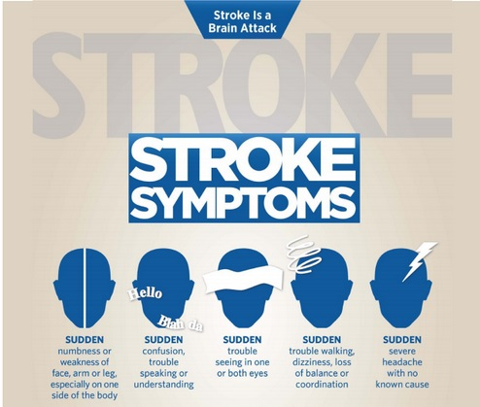

- F Face-has their face fallen to one side, mouth dropped, or they experience weakness of their arms or legs. Ask the person to try to smile and observe their face. If their smile appears uneven or their mouth or eyes have dropped, this could be a sigh of a stroke.
- A Arm-can the person raise both arms and keep them there? A patient with suspected stroke might not be able to lift both arms because of weakness and numbness. If one arm drifts downwards for example, or he cannot balance and coordinate equally both sides of the body, this might mean he is suffering a stroke.
- S Speech-Stroke can affect the speech-it might be slurred or garbled, or the person might not be able to talk or are hard to understand questions, therefore seeming confused. We can ask the person a simple question or to repeat a short phrase and check whether they are responding correctly.
- T Time is essential when one or all the symptoms are present. Call 999. Do not drive the patient to the hospital but request an ambulance to come immediately. It might be helpful to make a note of when exactly the symptoms have started to occur.

Thank you for your time and attention. If you have got some question, I will be very happy to answer, so is our Admiral nurse Rachel and our NHS volunteers.
If you still feel insure of how exactly you need to react in a situation of a stroke, you can attend an additional voluntary training with our OSJCT trainer Michelle.
Together we can help each other to fight stroke and save as many lives as possible!

7.References

1.Bath, P.M. and Lees, K.R., 2000. Acute stroke. Bmj, 320(7239), pp.920-923.
2.Bogousslavsky, J., Kaste, M., Olsen, T.S., Hacke, W. and Orgogozo, J.M., 2000. Risk factors and stroke prevention. Cerebrovascular Diseases, 10(Suppl. 3), pp.12-21.
3.Cloud, G. and Hoffman, A., 2013. National sentinel stroke audit 1998–2011. Clinical Medicine, 13(5), p.444.
4.Gomes, J. and Wachsman, A.M., 2013. Types of strokes. In Handbook of clinical nutrition and stroke (pp. 15-31). Humana Press, Totowa, NJ.
5.Gupta, A. and Thomas, P., 2002. Knowledge of stroke symptoms and risk factors among at-risk elderly patients in the UK. International journal of clinical practice, 56(9), pp.634-637.
6.Kothari, R., Sauerbeck, L., Jauch, E., Broderick, J., Brott, T., Khoury, J. and Liu, T., 1997. Patients’ awareness of stroke signs, symptoms, and risk factors. Stroke, 28(10), pp.1871-1875.
7.Mosley, I., Nicol, M., Donnan, G., Patrick, I. and Dewey, H., 2007. Stroke symptoms and the decision to call for an ambulance. Stroke, 38(2), pp.361-366.
8.Owen, N., 2010. Stroke-specific training for nurses. Stroke Association. April.
9.Rodgers, H., Ford, G.A. and Sniehotta, F.F., 2015. The stroke ‘Act FAST’campaign: Remembered but Dombrowski, S.U., White, M., Mackintosh, J.E., Gellert, P., Araujo-Soares, V., Thomson, R.G., not understood?. International journal of stroke, 10(3), pp.324-330.
10.Saka, Ö., McGuire, A. and Wolfe, C., 2009. Cost of stroke in the United Kingdom. Age and ageing, 38(1), pp.27-32.
11.Warlow, C.P., 1998. Epidemiology of stroke. The Lancet, 352, pp.S1-S4.
12.Zhang, Y., Chapman, A.M., Plested, M., Jackson, D. and Purroy, F., 2012. The incidence, prevalence, and mortality of stroke in France, Germany, Italy, Spain, the UK, and the US: a literature review. Stroke research and treatment, 2012.

