Exercises for Random Numbers

1. Guess my number

1a. Generate a random number and invite the user to guess what it is (use variable myGuess). Tell the user if they got it right or not.

Sample output:

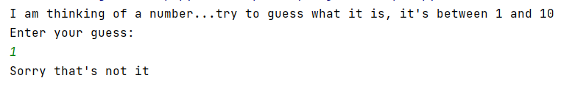

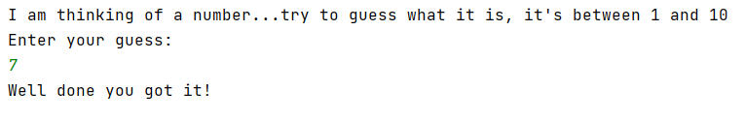

1b. Rework the program in 1a to allow the user to make guesses until they guess right:

Note: You will need to initialise guess here. Add the following line to your code just above your print statement. I will explain why later

Sample output:

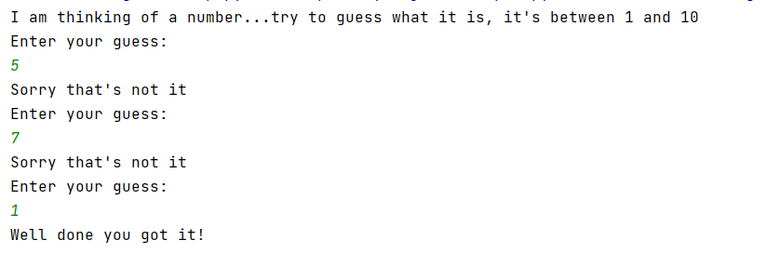

2. Jackpot game

2a. Write a program that generates a lucky number for the user (between 1 and 10). There is a prize associated with each number. 5 = Jackpot, 3,4,6,7 = consolation prize, everything else = no prize. Inform the user of their prize.

Sample output:

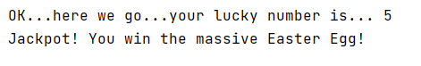.

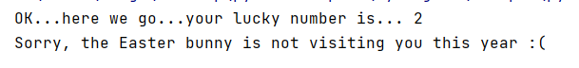

2b. Extend your game to allow the user to choose whether they want to play or not.

Sample output:

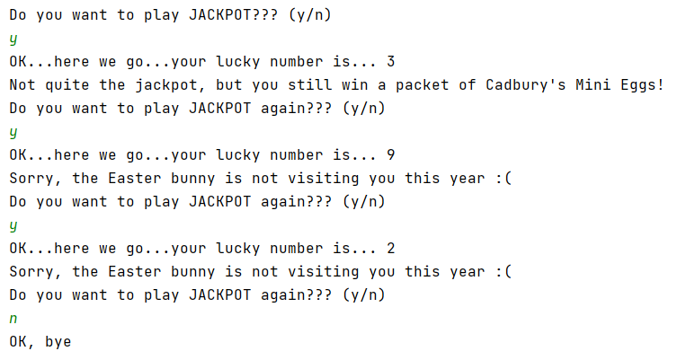

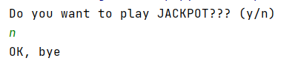

3. "Fruit" machine

3a) Generate 3 random numbers, each in the range 1 and 3.

Tell the user whether they have won (all numbers equal) or not.

Sample output:

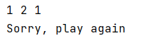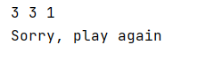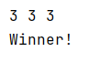

4. Lottery numbers

4a. Generate 6 lottery numbers (you could store these in individual variables, or in a list) Print your lottery numbers on the screen

Sample output:

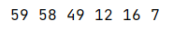

Note: Run the program a few times and you will see that there duplicates appear sometimes.

4b Sort your lottery numbers into order. Providing you have used a list in 4a) above, this is quite easy by using the sorted() function.
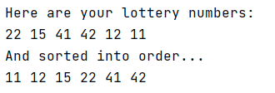

4c. (Very challenging) Adapt your program to stop duplicates appearing in your final lottery number list

