  Component One:  What are the key skills required when working in the housekeeping team? 750 words (+/- 10%)  Contribution to Overall Module Assessment: 25% | Student No  & Name: | 2127560  Alina Grigore
 | Module Title: | Operating Hotel Facilities
 | Module Code: | 4006
 | Lecturer: | Ffion Cumberpatch
Skills requirements while working in a housekeeping team
Housekeeping
Housekeeping refers to the maintenance and organization of living spaces, including cleaning, tidying, and other tasks that keep a home or workplace functioning smoothly. This can include activities such as dusting, vacuuming, laundry, dishwashing, and organizing belongings (Tesone, 2010). Effective housekeeping helps promote hygiene, safety, and a pleasant living or working environment.
Housekeeping team
A housekeeping team is a group of individuals responsible for the upkeep and cleanliness of living or workspaces. They perform tasks such as cleaning, organizing, and maintaining the area to ensure a safe, healthy, and comfortable environment (Vallen, 2012). The team may include housekeepers, custodians, janitors, and other personnel who work together to ensure efficient and effective housekeeping operations.
Essential skills for working in a housekeeping team with examples

Working in a housekeeping team requires a diverse range of skills that are essential for ensuring that the living or working space is clean, hygienic, and comfortable for occupants. These skills are crucial for maintaining a good reputation of the organization, which is especially important for the hospitality and healthcare sectors. In this essay, we will analyse and evaluate the key skills required when working in the housekeeping team with examples.
Attention to Detail
Attention to detail is one of the most crucial skills required in a housekeeping team. It involves a meticulous approach to cleaning and organization, ensuring that even the smallest details are taken care of (Ferdinand, 2017). For example, when I was cleaning a hotel room, I need to ensure that every corner of the room is cleaned, including the top of the wardrobe, behind the curtains, and under the bed.
Time Management
Time management skills are also important when working in a housekeeping team. Housekeeping staff needs to prioritize their tasks and ensure that they complete them within the given time frame. For instance, when I was cleaning a hotel room, I must ensure that the room is cleaned and ready for the next guest within the required time frame.
Teamwork
Teamwork is essential when working in a housekeeping team. Each team member should be able to work collaboratively with others to ensure that all tasks are completed efficiently and effectively (Johnston, 2012). For example, when I cleaning a large hotel room, it may require multiple housekeepers to work together to ensure that the task is completed on time.
Physical Stamina
Physical stamina is another essential skill required in a housekeeping team. Housekeeping staff need to be physically fit and able to stand, walk, and lift heavy objects for long periods. For example, when I cleaning a hospital room, I may need to lift heavy equipment or furniture.
Communication Skills
Effective communication skills are also vital when working in a housekeeping team. Staff need to be able to communicate with other team members, supervisors, and guests clearly and professionally (Rogers, 2008). For instance, when I was dealing with a guest complaint, I need to listen to the complaint attentively and respond in a polite and professional manner.
Customer Service Skills
Customer service skills are important when working in the hospitality sector, where housekeeping staff may interact with guests. They need to be friendly, approachable, and have good communication skills to deal with guest inquiries or complaints. For example, I may need to respond to a guest request for extra towels, which requires me to be polite, efficient, and timely.
Knowledge of Cleaning Techniques and Products
Housekeeping staff should have good knowledge of cleaning techniques and products (Fallon, 2010). They should know how to use different cleaning products effectively and safely, as well as which products are suitable for different surfaces and materials. For example, I should know that a disinfectant cleaner is required for cleaning hospital rooms to eliminate germs and bacteria.
Adaptability
Adaptability is an essential skill when working in a housekeeping team. Staff should be able to adapt to different situations, such as changing cleaning schedules, new cleaning techniques, or different work environments. For example, I may need to adjust their cleaning routine to accommodate a guest's special request.
Initiative
Initiative is another important skill required in a housekeeping team. Staff should be able to take the initiative to identify areas that require cleaning or maintenance and take appropriate action. For example, I should report any damage or malfunction of equipment promptly to the supervisor to prevent any inconvenience to guests.
So, working in a housekeeping team requires a diverse range of skills, including attention to detail, time management, teamwork, physical stamina, communication skills, customer service skills, knowledge of cleaning techniques and products, adaptability, and initiative (Casado, 2012). These skills are essential for ensuring sustainable success in this profession. I should focus on improving and developing these skills for career success in the long-run.
Word Count | 778 words

References
Casado, M. (2012) Housekeeping Management. London: Wiley.
Fallon, M. & Rutherford, D. (2010) Hotel Management and Operations. London: Pearson.
Ferdinand, N. and Kitchin, P. (2017) Events Management - An International Approach. 2nd ed. London:
SAGE Publications Ltd.
Johnston, R., Clark, G. &Shulver, M. (2012) Service Operations Management. London: Pearson.
Rogers, T. (2008) Conferences and conventions a global industry (2nd ed., Events management series).Oxford ; Boston: Butterworth-Heinemann.
Tesone, D. (2010) Principles Of Management For The Hospitality Industry. 1st ed. London: Routledge.
Vallen, G. &Vallen, J. (2012) Managing Hotel Operations. London: Pearson

Component Two:
Contribution to Overall Module Assessment: 25%

Problem | Why did it happen? | What are you going to do? | How will you prevent this from happening in the future? | What measures would you introduce to improve team effectiveness?
A room of a guest had not been properly cleaned | There could be various reasons behind this reason. It could be due to miscommunication between the housekeeping staff or insufficient time given to clean the room. The room might have been overlooked, or the staff might have missed cleaning certain areas of the room. It could also be due to a lack of attention to detail by the housekeeping staff or insufficient training provided to them (Leiter, 2010). | As the team leader, I would first apologize to the guest for the inconvenience caused and assure them that we will take immediate action to rectify the situation. I would then investigate the matter by speaking to the housekeeping staff to understand what went wrong and why the room was not cleaned properly. If there is any fault found in the cleaning process, I would take steps to rectify it and ensure that it doesn't happen again. I would also offer to move the guest to a clean room or provide additional cleaning services. | To prevent this from happening in the future, I would introduce the following measures:  - Conduct regular training sessions for the housekeeping staff to ensure that they are aware of the cleaning standards, guidelines, and best practices (Cottrell, 2019).  - Provide checklists to the housekeeping staff to ensure that all areas of the room are cleaned thoroughly and nothing is overlooked.  - Conduct regular quality assurance checks to ensure that the cleaning is up to the required standards.  - Improve communication between the housekeeping staff to ensure that all rooms are cleaned on time and nothing is missed out.  - Encourage guests to provide feedback on the cleaning services to improve the quality of service(Bridger, 2018). | To improve team effectiveness, I would introduce the following measures:  - Set clear expectations for the team and provide them with specific goals and objectives to achieve.  - Conduct regular team building activities to improve team morale and collaboration.  - Provide regular feedback to the team members on their performance and areas of improvement (Cottrell, S. 2019).  - Implement a rewards and recognition program to motivate and encourage the team to perform better.  - Empower team members to make decisions and take ownership of their work, which would increase their sense of responsibility and accountability(Bridger, 2018).

References
Bridger, E. (2018) Employee engagement: a practical introduction. 2nd ed. HR Fundamentals. London: CIPD
and Kogan Page.
Cottrell, S. (2019) The Study Skills Handbook. 5th ed. London: Red Globe Press.
Leiter, M. P. and Bakker, A. B. (2010) Work Engagement : A Handbook of Essential Theory and Research.
Hove [England]: Psychology Press

Table of Contents
Slide 1: Title page 1
Slide 2: Contents of the presentation 2
Slide 3: Introduction 3
Slide 4: Schedule for Training activities 4
Slide 5: Explanation of Training actions 5
Slide 6: Property knowledge 6
Slide 7: Cleaning equipment 7
Slide 8: Consumer service 8
Slide 9: Dailly-routine of housekeeping 9
Slide 10: Cleaning procedure, time management and evaluation 10
Slide 11: Safety strategy 11
Slide 12: Branding for Marriott Hotel Cardiff 13
Slide 13: Conclusion 14
References 16

Slide 2: Contents of the presentation
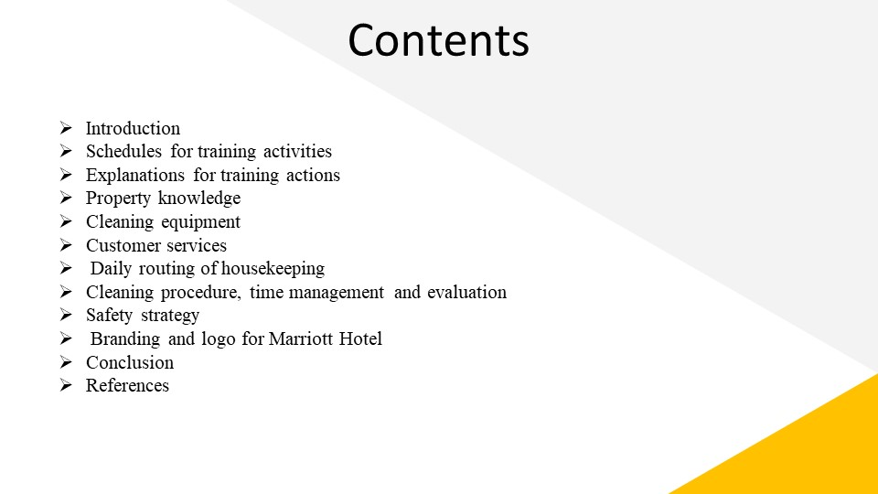

Slide 3: Introduction
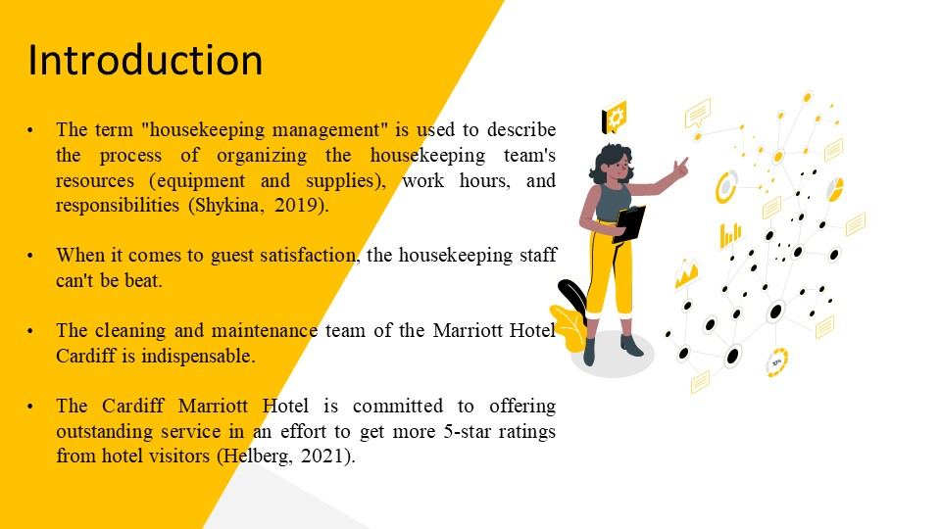
Training Notes:
Creating housekeeping staff that can boost visitor satisfaction through effective services is a challenge for the hospitality and tourism industry (Shykina, 2019). The cleaning and maintenance team of the Marriott Hotel Cardiff is indispensable. Therefore, the administration of the Marriott Hotel Cardiff has resolved to give the housekeeping staff extensive managerial support and control. Establishing a reliable cleaning crew Training in areas such as health and safety, customer care, effectiveness, and attitude, as well as general housekeeping basics, will be provided to all team members. The Marriott Hotel Cardiffis dedicated to providing exceptional service in the hopes of raising guest reviews.

Slide 4: Schedule for Training activities
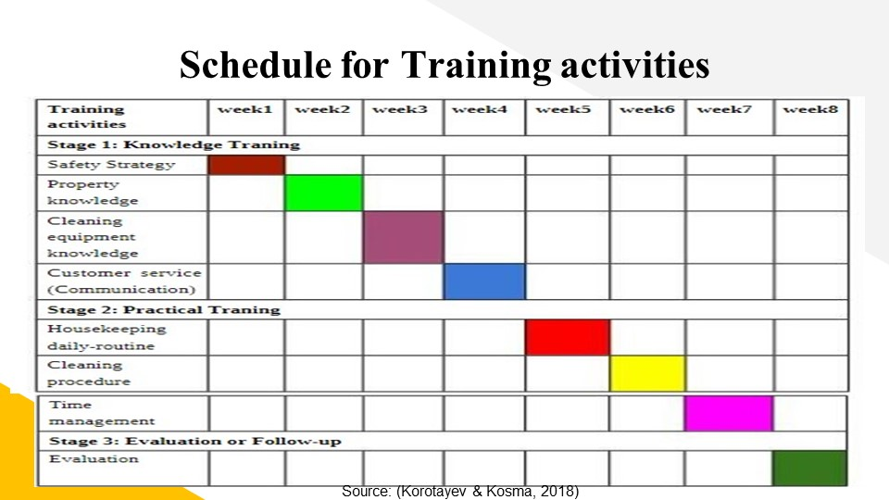
Training Notes:
The workshop will commence after eight weeks. A Gantt chart may be used to schedule training activities.

Slide 5: Explanation of Training actions
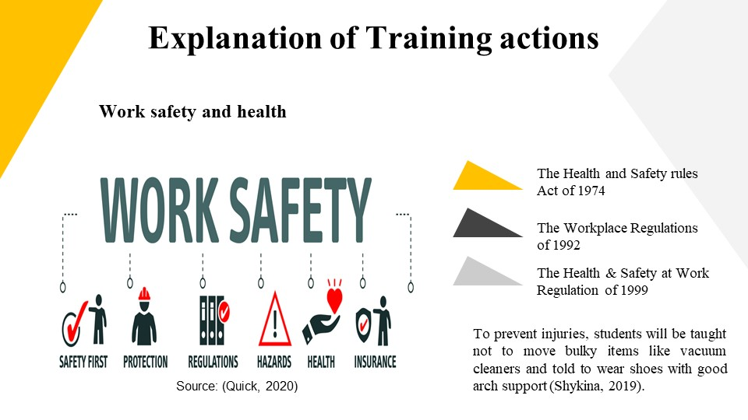
Training Notes:
Work safety and health
Multiple laws exist to safeguard Marriott Hotel Cardiff employees, customers, and visitors. In this package, one will find the Health and Safety rules Act of 1974, the Workplace Regulations of 1992, and the Health & Safety at Work Regulation of 1999, among others (Korotayev & Kosma, 2018). As such, the housekeeping crew will be given extensive training on what to dress while performing their duties. They're not going to go out and exercise. To prevent injuries, students will be taught not to move bulky items like vacuum cleaners and told to wear shoes with good arch support. They will be educated about the uses and dangers of a wide range of chemicals, from those used for floor cleaning to acids. Individuals will be shown how to properly store, handle, and use these items so that the housekeeping staff can do its job effectively. The housekeeping personnel will be given and shown how to utilize several pieces of safety equipment, such as protective shoes, a helmet, a PPE kit, and gloves (Quick, 2020).
Slide 6: Property knowledge
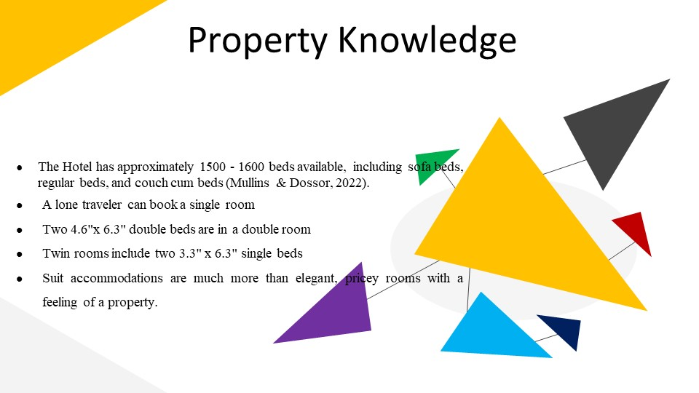
Training Notes:
Room kinds, bedding, room assignments, cleaning department layouts, and other hotel-specifics will all be covered. The Marriott Hotel Cardiff has approximately 1500 - 1600 beds available, including sofa beds, regular beds, and couch cum beds (Mullins & Dossor, 2022). There are straw-filled, rope-bound mattresses from the Renaissance period available today. Contemporary options for sleeping include everything from waterbeds and foam mattresses to king- and queen-size beds. Beds come in a variety of styles, some of the more notable ones being the Roman bed and the Egyptian bed. The Marriott Hotel Cardiff offers four distinct accommodation options.
- A lone traveler can book a single room
- Two 4.6"x 6.3" double beds are in a double room
- Twin rooms include two 3.3" x 6.3" single beds
- Suit accommodations are much more than elegant, pricey rooms with a feeling of a property.
Housekeeping is required in the laundry room, minibar, and all public spaces including restrooms, hallways, common areas, and the entrance. This training will provide an in-depth familiarity with the Marriott Hotel Cardiff and its facilities, both of which are essential to the success of the new position.

Slide 7: Cleaning equipment
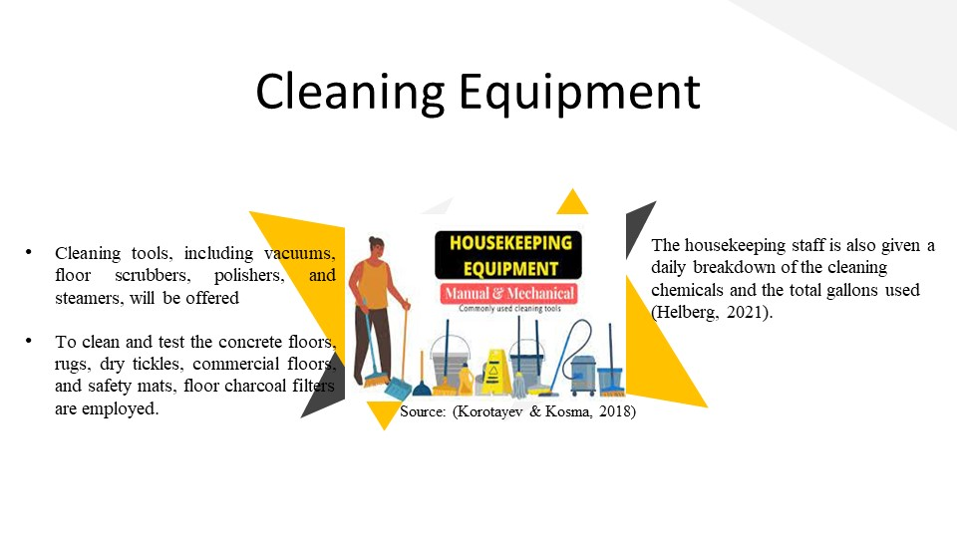
Training Notes:
Extensive instruction and hands-on experience with a wide range of cleaning tools, including vacuums, floor scrubbers, polishers, and steamers, will be offered. Cleaning upholstery and floors with a vacuum cleaner couldn't be simpler (Korotayev & Kosma, 2018). Shine can be restored to floors with the help of a polishing machine. To clean and test the concrete floors, rugs, dry tickles, commercial floors, and safety mats, floor charcoal filters are employed. There is no better way to get rid of germs and bacteria than using a steam vapor machine in the bathroom or kitchen. The housekeeping staff is also given a daily breakdown of the cleaning chemicals and the total gallons used. Storage and the risks involved will also be shown. Each cleaning substance's Safe Data Sheet (SDS) application will be demonstrated. Staff in the housekeeping department will be familiar with several signal words, such as Dancer,Caution,and Warning, and what they mean (Kappa et al., 2019).

Slide 8: Consumer service
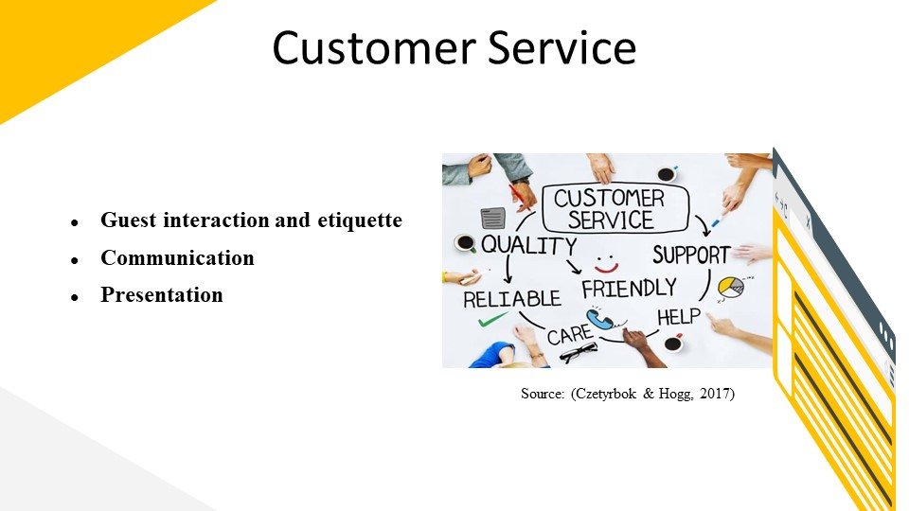
Training Notes:
1.Guest interaction and etiquette
The customers' happiness and satisfaction depend on the cleaning staff's ability to communicate with them in a kind and professional manner. Employees will have an understanding of cultural norms and norms for making a friendly first impression throughout training(Helberg, 2021). For the housekeeping staff, this means more self-assurance and social skills.
2. Communication
Interaction between the cleaning staff and other areas at the Marriott Hotel Cardiff relies heavily on effective communication. Organizational success relies heavily on effective communication, which is essential for anything from responding to guests' requests to disseminate precise schedule instructions or announcing last-minute adjustments (Cottrell, 2019).
3. Presentation
It's a set of abilities parallel to those required for proper social interaction. To various stakeholders, the housekeeping employees at the Marriott Hotel Cardiff will represent the hotel and its brand in the manner in which they conduct themselves. The way in which hosts and guests keep themselves clean and behave has a significant impact on the establishment's reputation (Czetyrbok & Hogg, 2017). As a result, the housekeeping workers at the Marriott Hotel Cardiff will hone their public-speaking abilities.

Slide 9: Dailly-routine of housekeeping
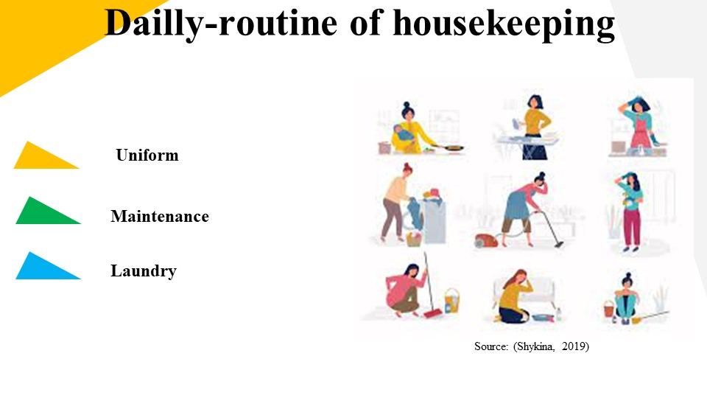
Training Notes:
1. Uniform
There are two major functions that uniforms serve. Housekeepers can avoid exposure to harmful chemicals and stains caused by detergents and cleaning supplies by dressing in uniforms (Shykina, 2019). This helps the personnel at the Marriott Hotel Cardiff project the same high-quality image that guests have come to expect from the hotel.
2. Maintenance
The cleaning staff's primary duty in the realm of restoration is to report problems, rather than to take part in fixing them. There are certain things that the housekeeping staff must notify, such as damaged TV remotes and the need for repairs to the headlamps and electrical appliances. The cleaning staff's foresight speeds up the fixing procedure, which in turn reduces visitor complaints (Bridger, 2022).
3. Laundry
Because of the hotel's size, the housekeeping crew at the Marriott Cardiff does not have to handle the laundry services itself. It is important, however, that they also are instructive with regard to proper laundry care. In order to provide excellent in-room service, employees must be well-versed in the proper techniques for folding various fabrics, making a mattress, and putting towels.

Slide 10: Cleaning procedure, time management, and evaluation
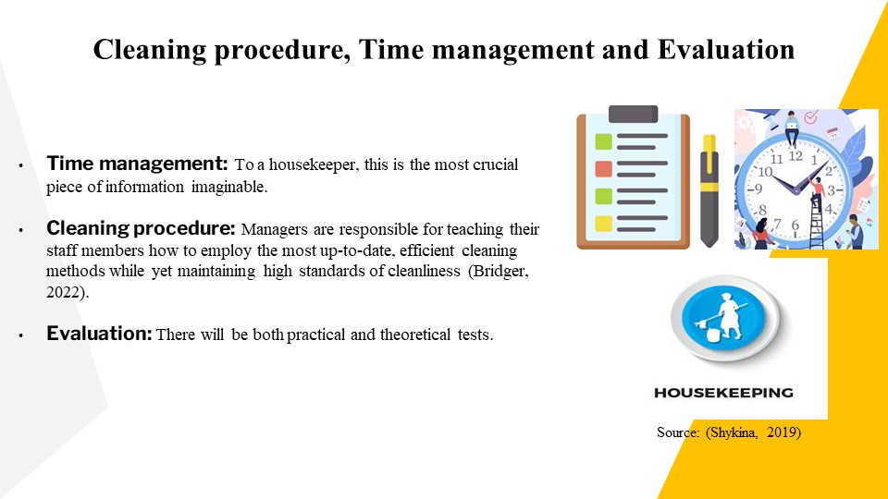
Training Notes:
Cleaning procedure
Practical cleaning skills will be taught in addition to an understanding of the necessary tools throughout training. Managers need to equip them with the knowledge and ability to perform cleaning services effectively and efficiently through the use of modern, time-saving techniques (Brinkman, 2020). The housekeeping crew will utilize the most effective cleaning method based on the type of clean up or the specific circumstances.
Time management
It's the single most important thing a housekeeper can know. The staff's ability to manage their time effectively will allow them to prioritize cleaning tasks on a daily basis (Shykina, 2019). They will be effective in serving their customers because of this.
Evaluation
There will be both practical and theoretical tests administered to determine how well each employee has grasped the course material. The HR division will be able to see the individual progress of the housekeeping workers in terms of knowledge gained.

Slide 11: Safety strategy
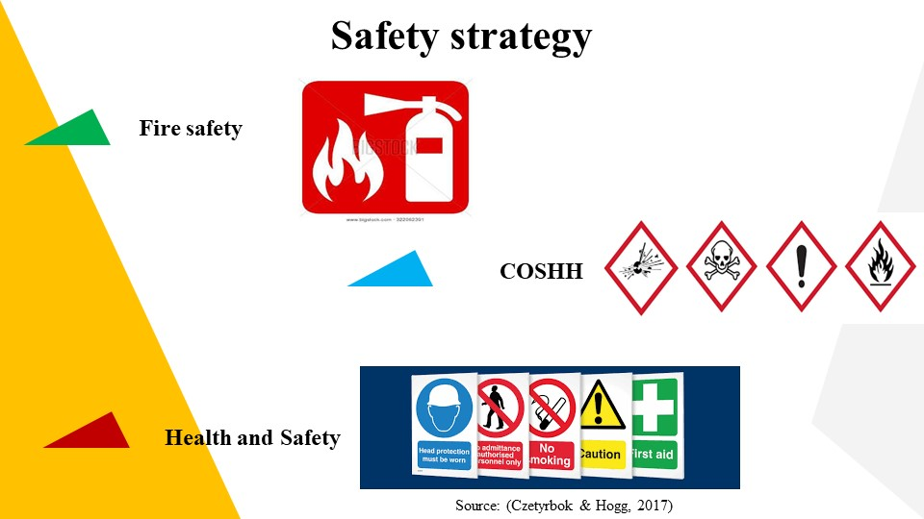
Training Notes:
The managers of the Cardiff Marriott Hotel will take the following measures to ensure the safety of the housekeeping crew.
1. Fire safety
Both Wales and England are subject to the requirements of the Regulatory Reform Act of 2005. The Safety Laws Act of 2006 applies to the Scots-Irish region (Korotayev & Kosma, 2018). These regulations were updated to ensure a baseline level of protection against fire in all non-residential settings. Employers at the Marriott Hotel Cardiff are solely responsible for ensuring a fire-safe corporate world (Bridger, 2022). Fire risk assessments can be conducted to locate vulnerable populations and eliminate potential fire hazards. The following conditions must be met in order to determine the firing sequence:
- Assessment of fire threats and risks is being carried out. Like, say, finding the gasoline and the spark.
- People of all kinds, including guests, employees, clients, and contractors, should be treated as potential threats.
- Taking every precaution to eliminate danger, and if that isn't possible, establishing safety measures to cover what's left.
- Having a secure place to keep the gasoline and any other combustible materials.
- Scheduled inspections of fire safety procedures with subsequent reports.
2. COSHH
The acronym COSHH stands for the Control of Substances Hazardous to Health (Quick, 2020). To minimize workers' exposure to hazards, employers will handle hazardous materials themselves, including storage, handling, and transportation. Chemicals, items containing chemicals, mist, dust, convulsing gases, hazardous gases, and biological agents are all part of the Control of Substances Hazardous to Health (COSHH) list. The management group will determine which substances pose a threat and evaluate the potential consequences of continuing to use them. With the right amount of these ingredients and the implementation of necessary controls, they will get rid of or significantly minimize any threat that has been discovered (Kappa et al., 2019). A course in the presentation usage of these chemicals will be offered. Plans for emergencies and health monitoring will be established.
3. Health and Safety
The management team at the Marriott Hotel Cardiff will look after the House Cleaning and other employees beyond what is reasonably possible, in accordance with the Safety and Health Regulation act of 1974 (Czetyrbok & Hogg, 2017). They will provide training and orientation programs to establish and sustain a secure working environment. All required measures will be taken to maintain a secure environment and the proper handling, transportation, and storage of potentially hazardous products. Individual can count on receiving a PPE package. Hotel are instituting a new safety and health policy.

Slide 12: Branding for Marriott Hotel Cardiff
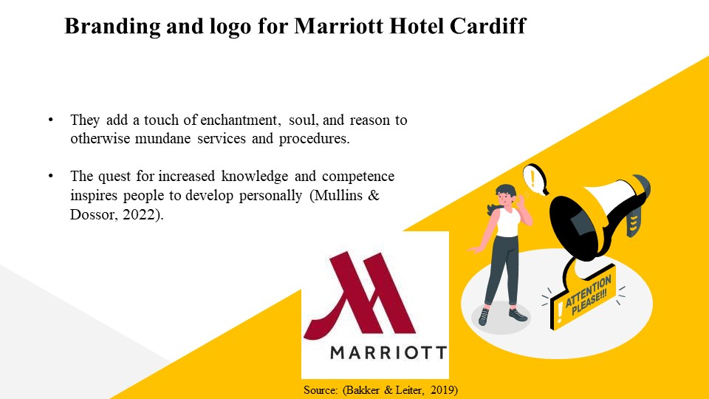
Training Notes:
Branding Statement: The staff is what makes the Hotel what it is. Everyday services and processes are given a dose of magic, spirit, and rationality thanks to them. They are motivated to improve themselves by the pursuit of greater knowledge and skill. The program's core players have huge dreams and are making progress in their careers thanks to the Objectives and Ambition program (Bakker & Leiter, 2019).

Slide 13: Conclusion
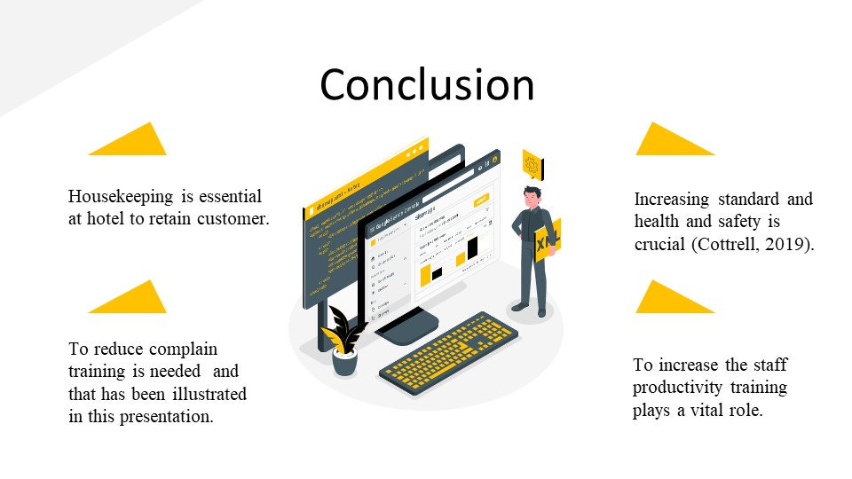
Training Notes:
Housekeeping is one of the vital issues in hotels like Marriott Cardiff. Due to a lack of training and development, there might be complaints from the customer regarding housekeeping. To overcome complaints, the manager needs to provide proper housekeeping training and skill development to its staff and ensure their productivity at work.

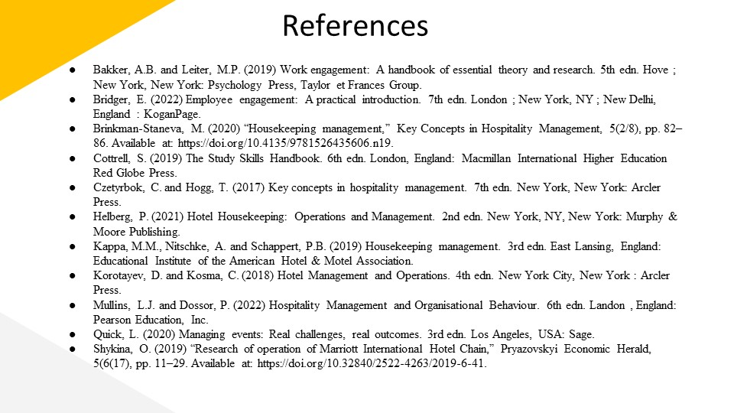


References
Bakker, A.B. and Leiter, M.P. (2019) Work engagement: A handbook of essential theory and research. 5th edn. Hove; New York, New York: Psychology Press, Taylor et Frances Group.
Bridger, E. (2022) Employee engagement: A practical introduction. 7th edn. London; New York, NY; New Delhi, England: KoganPage.
Brinkman-Staneva, M. (2020) “Housekeeping management,” Key Concepts in Hospitality Management, 5(2/8), pp. 82–86. Available at: https://doi.org/10.4135/9781526435606.n19.
Cottrell, S. (2019) The Study Skills Handbook. 6th edn. London, England: Macmillan International Higher Education Red Globe Press.
Czetyrbok, C. and Hogg, T. (2017) Key concepts in hospitality management. 7th edn. New York, New York: Arcler Press.
Helberg, P. (2021) Hotel Housekeeping: Operations and Management. 2nd edn. New York, NY, New York: Murphy & Moore Publishing.
Kappa, M.M., Nitschke, A. and Schappert, P.B. (2019) Housekeeping management. 3rd edn. East Lansing, England: Educational Institute of the American Hotel & Motel Association.
Korotayev, D. and Kosma, C. (2018) Hotel Management and Operations. 4th edn. New York City, New York: Arcler Press.
Mullins, L.J. and Dossor, P. (2022) Hospitality Management and Organisational Behaviour. 6th edn. Landon, England: Pearson Education, Inc.
Quick, L. (2020) Managing events: Real challenges, real outcomes. 3rd edn. Los Angeles, USA: Sage.
Shykina, O. (2019) “Research of operation of Marriott International Hotel Chain,” Pryazovskyi Economic Herald, 5(6(17), pp. 11–29. Available at: https://doi.org/10.32840/2522-4263/2019-6-41.

