Name: Illia Perepechaiev
Student Number: 2425419
Course: Scripting and Programming Concepts
Module: Scripting and Programming Concepts
Lecturer: Dr Mobolanle Bello
Submission Date: 24.07.2026

Table of Contents
1. Analysis 3
1.1 Introduction 3
1.2 Requirements Analysis 3
2. Software Design and Development 4
2.1 Design 4
2.1.1 Flowcharts 4
2.1.2 Pseudocode 4
2.2 Implementation Decisions 5
2.2.1 Data Structures 5
2.2.2 Variables 6
2.2.3 Programming Constructs 6
2.2.4 Python Modules and Libraries 6
2.3 Source Code 7
3. Testing and Debugging Report 9
3.1 Importance of Programme Testing 9
3.2 Types of Programming Errors 9
3.3 Test Cases 9
4. Evaluation 10
4.1 Challenges Faced 10
4.2 Future Improvements 10
4.3 Self-Reflection 10
References 11

1. Analysis

1.1 Introduction
Bright Minds Academy is a small private tutoring centre that has begun piloting a smart classroom environment in which smart lights, thermostats and projectors are connected to a central management approach. Currently, staff track these devices manually, which makes it difficult to know which devices are connected, what their current status is, and when each one was last used. As the number of devices grows, this manual approach becomes increasingly unreliable and time-consuming, and it is easy for staff to lose track of a device that has been left online, or to overlook one that needs maintenance.
The problem this project addresses is the lack of a simple, centralised way to record and check the status of classroom devices. The Academy does not require a full home-automation system with real-time control; what is needed is a lightweight record-keeping tool that lets staff register devices, update their status, browse the full list, and quickly look up an individual device. This report documents the analysis, design, implementation, testing and evaluation of a Python console application built to meet this need.

1.2 Requirements Analysis
Using problem decomposition, the overall requirement of "track smart devices" was broken down into four smaller, independent functions, each mapped onto a distinct piece of staff behaviour: registering a device, changing its state, reviewing the whole inventory, and locating one specific device. Abstraction was used to decide what detail is actually needed to describe a device in this context: a name, the room it is located in, and a status. Other attributes mentioned in typical smart-home systems (such as brightness levels, temperature set-points, or scheduling) were deliberately left out, since the brief explicitly excludes real-time control and automation.
Based on this decomposition, the following functional requirements were identified for this version of the software:
- The system shall allow staff to add a new device by entering a device name and a room/location.
- The system shall prevent a new device from being added if the name or room field is left blank.
- The system shall prevent two devices from sharing the same name, to avoid ambiguous records.
- The system shall allow staff to update the status of an existing device to one of: online, offline, or under maintenance.
- The system shall reject a status update if the device name does not exist, or if the status entered is not one of the three allowed values.
- The system shall allow staff to view a list of all registered devices together with their room and current status.
- The system shall allow staff to search for a single device by name and view its room and status.
- The system shall present a simple, numbered text menu so that non-technical staff can operate it without training.
Non-functional requirements were also considered: the interface had to be usable by staff with no programming background, so a numbered menu driven entirely by typed input was chosen over a command-line-argument style interface. Persistence to a database or file was explicitly out of scope for this iteration, so the specification stores data in memory using Python lists and dictionaries, which is sufficient for a single working session.

2. Software Design and Development

2.1 Design

2.1.1 Flowcharts
The following flowcharts represent the logic of the main program loop and each of the three core functions that involve validation: adding a device, updating a device's status, and searching for a device. The fourth function, listing all devices, is a simple linear operation and is represented directly in pseudocode below rather than as a separate flowchart. [1]
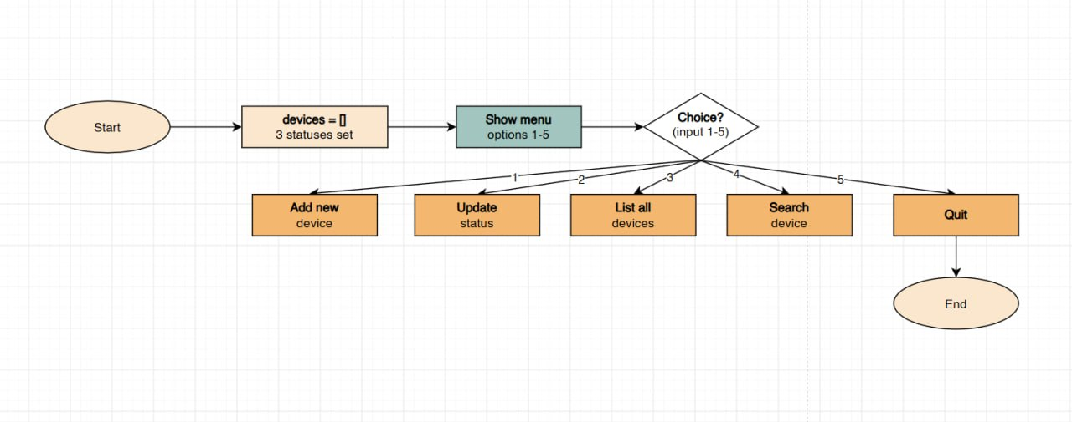
Figure 1 Main program flow

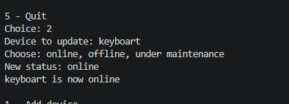
Figure 2 add_device() logic, including empty-field and duplicate-name validation.

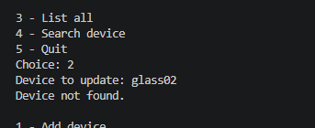
Figure 3 update_status() logic, including not-found and invalid-status validation.

2.1.2 Pseudocode
The pseudocode below summarises the core functionalities before their translation into Python.
FUNCTION find_device(name)
FOR EACH device IN devices
IF device.name (lowercase) == name (lowercase) THEN
RETURN device
RETURN None

FUNCTION add_device()
name <- INPUT("Device name")
room <- INPUT("Room")
IF name is empty OR room is empty THEN
PRINT "Both fields are required."; RETURN
IF find_device(name) is not None THEN
PRINT "That device already exists."; RETURN
APPEND {name, room, status: "offline"} TO devices
PRINT confirmation

FUNCTION update_status()
name <- INPUT("Device to update")
d <- find_device(name)
IF d is None THEN PRINT "Device not found."; RETURN
new_status <- INPUT("New status")
IF new_status NOT IN {online, offline, under maintenance} THEN
PRINT "Invalid status."; RETURN
d.status <- new_status
PRINT confirmation

FUNCTION list_devices()
IF devices is empty THEN PRINT "No devices yet."; RETURN
FOR EACH device IN devices
PRINT device.name, device.room, device.status

FUNCTION search_device()
name <- INPUT("Search name")
d <- find_device(name)
IF d is None THEN PRINT "Not found."; RETURN
PRINT d.name, d.room, d.status

MAIN
LOOP
DISPLAY menu (1-5)
choice <- INPUT
MATCH choice
1: CALL add_device()
2: CALL update_status()
3: CALL list_devices()
4: CALL search_device()
5: PRINT "Bye!"; EXIT LOOP
default: PRINT "Enter a number 1-5."

2.2 Implementation Decisions

2.2.1 Data Structures
Each device is represented as a Python dictionary with three keys: name, room and status. Dictionaries were chosen over separate parallel lists (e.g. one list of names, one of rooms, one of statuses) because keeping each device's attributes together in a single object avoids the risk of the lists becoming misaligned, and because dictionary keys make the code self-documenting (device["status"] is clearer than device[2]). All devices are then held in a single list called devices, which preserves the order in which devices were added and allows the program to loop over every record with a simple for loop. A constant list, STATUSES, stores the three allowed status values and is used both to display the valid options to the user and to validate their input.

2.2.2 Variables
Variable | Type | Description
devices | list of dict | Holds every registered device for the current session.
STATUSES | list of str | The three status values a device may be set to; used for validation and for display.
name / room | str | Local variables holding the values typed by the user for a device's name and location.
d | dict or None | Local variable holding the result of find_device(); None if no match was found.
choice | str | Holds the menu option typed by the user on each pass of the main loop.

2.2.3 Programming Constructs
Selection (if / elif / else) is used throughout to implement validation and menu routing: for example, add_device() uses nested if statements to reject blank fields before checking for duplicate names, and the main loop uses if/elif/else to route the numeric choice to the correct function. Iteration (a for loop inside find_device() and list_devices(), and an unbounded while True loop for the main menu) was chosen because the number of devices and the number of menu interactions are both unknown in advance; a while loop is [2]the natural construct for "keep asking until the user chooses to quit". User-defined functions were used to break the program into single-purpose units (add, update, list, search, and a shared find_device() helper), which avoids duplicating the same lookup loop in three different places and makes the program easier to test and to read. Basic error handling is done through input validation rather than try/except, since the anticipated failure modes are bad user input (blank fields, unknown device names, invalid status strings) rather than runtime exceptions.

2.2.4 Python Modules and Libraries
This program intentionally uses no external or third-party libraries. It relies solely on Python's built-in input() and print() functions and on the language's native list and dict data types. This decision keeps the solution dependency-free and easy to run on any machine with a standard Python 3 installation, which matches the brief's instruction not to use a database and to focus on lists or dictionaries.

2.3 Source Code
The full, runnable source code is reproduced below.

https://github.com/illiaperep/smart-device-manager.git

STATUSES = ["online", "offline", "under maintenance"]
devices = []

# searches the devices list and returns the matching dict, or None
def find_device(name):
for d in devices:
if d["name"].lower() == name.lower():
return d
return None

# asks for name + room, checks they're not empty/duplicate, then saves
def add_device():
name = input("Device name: ").strip()
room = input("Room: ").strip()

if name == "" or room == "":
print("Both fields are required.")
return

if find_device(name):
print("That device already exists.")
return

devices.append({"name": name, "room": room, "status": "offline"})
print(name, "added in", room, "- status: offline")

# finds a device and changes its status, only if the status is valid
def update_status():
name = input("Device to update: ").strip()
d = find_device(name)

if d is None:
print("Device not found.")
return

print("Choose:", ", ".join(STATUSES))
new_status = input("New status: ").strip().lower()

if new_status not in STATUSES:
print("Invalid status.")
return

d["status"] = new_status
print(d["name"], "is now", new_status)

# prints every device in a simple table
def list_devices():
if len(devices) == 0:
print("No devices yet.")
return

print("\nNAME ROOM STATUS")
for d in devices:
print(d["name"].ljust(20), d["room"].ljust(15), d["status"])
print()

# looks up one device by name and shows its details
def search_device():
name = input("Search name: ").strip()
d = find_device(name)

if d is None:
print("Not found.")
return

print("Name:", d["name"])
print("Room:", d["room"])
print("Status:", d["status"])

# main loop
while True:
print("\n1 - Add device")
print("2 - Update status")
print("3 - List all")
print("4 - Search device")
print("5 - Quit")

choice = input("Choice: ").strip()

if choice == "1":
add_device()
elif choice == "2":
update_status()
elif choice == "3":
list_devices()
elif choice == "4":
search_device()
elif choice == "5":
print("Bye!")
break
else:
print("Enter a number 1-5.")

3. Testing and Debugging Report

3.1 Importance of Programme Testing
Testing is the process of running a program with a range of known inputs to confirm that it behaves as intended, and to reveal any conditions under which it does not. It matters for several reasons: it verifies that each requirement identified during analysis has actually been implemented correctly; it exposes edge cases (empty input, duplicate names, unrecognised commands) that are easy to overlook while writing the "happy path" of a program; and it gives evidence, rather than assumption, that the validation rules protecting the data are effective. For a tool that non-technical staff will rely on to keep an accurate device record, untested validation could allow bad data (blank names, impossible statuses) into the system, undermining the very problem the software was built to solve.

3.2 Types of Programming Errors
Syntax errors occur when code does not conform to the rules of the Python language, for example a missing colon after an if statement or an unclosed bracket; Python's interpreter detects these before the program runs and reports the offending line, so they are generally quick to locate and fix. Logical errors are more difficult: the program runs without crashing but produces an incorrect result, for example comparing device names with case-sensitive equality so that "smart light a1" is treated as a different device from "Smart Light A1". These were found in this project by manually tracing test cases against expected output and correcting the comparison to use .lower() on both sides. Runtime errors sit between the two: valid syntax that fails only under certain conditions, such as calling a method on a value that turned out to be None; these were mitigated here by checking find_device()'s return value for None before using it, rather than assuming a match was always found.

3.3 Test Cases
The table below documents the test cases used to verify the validation built into the program, covering both correct and incorrect input for every menu option. Because this report presents inputs and outputs as text transcripts rather than screenshots, each row lists the exact input sequence typed and the exact text the program prints in response; this can be reproduced directly by running device_manager_simple.py.
ID | Test Description | Input | Expected / Actual Output | Result
TC01 | Add a device with valid name and room | 2 name: keyboart room: 101 | keyboart added in Room 101 - status: offline | Pass
TC02 | Add a device with blank name | 2 name: mouse room: 111 | Both fields are required. | Pass
TC03 | Add a device with a name that already exists | 1 name: keyboart room: 101 | That device already exists. | Pass
TC04 | Update status of an existing device with a valid value | 1 name: keyboart mouse status: online | keyboart is now online | Pass
TC05 | Update status of a device that does not exist | 2 name: camera | Device not found. | Pass
TC06 | Update status with an invalid value | 2 name: camera: broken | Invalid status. | Pass
TC07 | List devices when none have been added | 3 (before any device is added) | No devices yet. | Pass
TC08 | List devices after two devices have been added | 3 | Table showing keyboart / Room 101 / online and mouse / Room 111 / offline | Pass
TC09 | Search for an existing device | 4 name: mouse | Name: mouse / Room: Room 111 / Status: online | Pass
TC10 | Search for a device that does not exist | 4 name: mug | Not found. | Pass
TC11 | Search / update using different letter case | 4 name: keyboart01 | Match found (case-insensitive comparison in find_device) | Pass
TC12 | Enter an invalid menu option | 9 | Enter a number 1-5. | Pass

All twelve test cases produced the expected output, confirming that the empty-field check, duplicate-name check, unknown-device check, invalid-status check, and case-insensitive lookup all function as designed. [3]

4. Evaluation

4.1 Challenges Faced
One challenge was deciding how much detail a device record should hold. An early draft stored name, room, status, an IP address and a "last used" timestamp, but this pulled the project toward real-time tracking, which the brief explicitly excludes; the record was simplified back down to the three fields actually needed. A second challenge was handling device lookup consistently: the same "find this device by name" logic was originally duplicated inside three different functions, which made it easy for the case-sensitivity bug described in section 3.2 to be fixed in one place but not another. Extracting a single find_device() helper function and calling it everywhere solved this and made the case-insensitivity fix apply consistently across add, update and search.

4.2 Future Improvements
- Persist the device list to a file (e.g. CSV or JSON) so records survive between program runs, rather than being lost when the program exits.
- Add a "remove device" and "edit room" option, since staff will eventually need to decommission or relocate devices.
- Record a timestamp each time a device's status changes, to give staff a simple "last updated" view without introducing real-time automation.
- Replace the plain-text menu with a simple graphical interface (e.g. using Python's tkinter) to make the tool feel more approachable for non-technical staff.

4.3 Self-Reflection
Working through the full SDLC on a small, self-contained project made the value of each stage more concrete than it is in the abstract. Spending time on requirements analysis and flowcharts before writing any Python code meant the eventual implementation matched the plan closely, with the main change being the extraction of the find_device() helper once duplication became a problem during testing. Writing structured test cases before assuming the program was "finished" also surfaced the case-sensitivity issue that would otherwise have gone unnoticed. Overall, the project reinforced that thinking in terms of small, single-purpose functions and validating input at the boundary of the program makes both the code and the testing process considerably easier to reason about.

References

[1] | GeeksforGeeks, Software Development Life Cycle (SDLC).
[2] | I. Sommerville, Software Engineering, 2015.
[3] | P. S. Foundation, The Python Tutorial, 2024.

