

STUDENT ID NUMBER: 2224770
BEng Degree Apprenticeship Mechanical and Manufacturing Engineering

An Investigation on How to Apply Lean Tools for Sustainable Manufacturing: Energy and Waste Minimisation at Weartech.

This Independent Project is submitted in part fulfilment of the BEng Degree Apprenticeship for Mechanical and Manufacturing Engineering
University of Wales Trinity Saint David
2025

Acknowledgments
I would like to express my deepest gratitude to my project supervisor, for their unwavering guidance, expertise, and encouragement throughout this research journey. Your insightful feedback and constant support have been invaluable, and I am truly grateful for the time and effort you invested in helping me bring this project to fruition.
I would also like to extend my heartfelt thanks to weartech and its employees in this study. Your willingness to share your experiences and perspectives made this research possible, and I deeply appreciate the openness and honesty you brought to our conversations. Your contributions have provided invaluable insights that are central to the findings of this work.
Finally, I would like to acknowledge the unwavering support of my girlfriend. Your belief in me and your constant encouragement have been a source of strength throughout this process. Thank you for your patience, love, and understanding, which have been instrumental in helping me complete this Independent Project.

Abstract
The dissertation takes a look at how Lean Manufacturing and energy efficiency work alongside each other in Weartech Ltd.’s machine shop. Efforts to reduce inflating energy bills and improve how the company functions, are made through Lean and energy-based processes such as SMED, TPM, 5S, Kanban and tools such as EVSM and IoT-based systems.
A combination of statistical analysis and information from interviews with operators and visual walks was chosen and concluded that there was considerable waste noticed in different areas, with energy waste, waiting and inventory being the most detrimental to the firm’s finances. It was highlighted that machines remain idle on setup and breaks, wasting 168,417 kWh annually and leading to additional costs of more than £35,000. Staff feedback suggested that cultural barriers to improvement can be caused by underutilisation of skills and inconsistent shutdown procedures.
The proposed changes involved the use of SMED, auto-idle systems, predictive maintenance and letting operators in on 5S redesigns. The interventions are predicted to use 10% to 15% less energy, have less than 2% of scrap and cut setup times by 20% to 30%. All these improvements are supposed to cover the cost in under 12-18 months.
It contributes to the Lean-Energy principles by giving manufacturers a clear guide to continue operating both safely and in a green manner. The result is that making progress in energy visibility and Lean saves costs, enhances efficiency and invigorates participation on the shop floor.

Table of Contents
Chapter 1: Introduction……………………. Page 5-8
  - Introduction to the topic
  - Background of the Company- Weartech Ltd
  - Rationale of the Study
  - Research Problem and Question
  - Aim and Objective
  - Significance of the Study
Chapter 2 Literature Review………………… Page 9- 12
2.1 Introduction
2.2 Lean Manufacturing: Foundations and Principle
2.3 Lean Tools in Machining Context
2.4 Energy- Efficient Machining
2.5 Integration of Lean and Energy Efficiency
2.6 Gaps in the Literature
2.7 Conceptual Framework
2.8 Summary
Chapter 3 Methodology……………………. Page 13- 19
3.1 Research Philosophy and Approach
3.2 Research Design: Case Study Methodology
3.3 Data Collection Methods
3.4 Analytical Tool
3.5 Ethical Considerations
3.6 Limitations
3.7 Summary
Chapter 4 Findings and Analysis…………………… Page 19- 26
4.1 Introduction
4.2 Energy Usage Profile of the Machine Shop
4.3 Lean Waste Analysis
4.4 Visual Tools
4.5 Thematic Analysis
4.6 Summary
Chapter 5 Strategic Improvement Plan……………….. Page 26- 31
5.1 Introduction
5.2 Strategic Objectives
5.3 Recommended Interventions
5.4 Implementation Plan
5.5 Expected Outcomes
5.6 Cost-Benefit Summary
5.7 Risk and Mitigation
5.8 Conclusion
Chapter 6 Conclusion and Recommendations…………………. Page 31-32
6.1 Conclusion
6.2 Recommendations
6.3 Final Thoughts
References………………. Page 33-34
Appendices………………Page 35-38
Interview Questions
EVSM Diagram
Fishbone Diagram
Machine Data Table
Staff Feedback Theme
Chapter 1: Introduction
  - Introduction to the Topic
The manufacturing industry faces a major change because of competition growth while energy rates shift, and environmental demands become stronger. Manufacturers who work in aerospace and advanced materials production together with the energy sector need to find ways to achieve both economic efficiency and environmental friendliness. Business entities have started looking for solutions which blend process enhancements with waste reduction and energy efficiency improvements primarily because of these developments.
The rising market demands have transformed Lean Manufacturing and Energy-Efficient Machining into two essential manufacturing practices. Lean manufacturing represents a practical business approach which focuses on waste reduction and continuous improvement as explained by Womack & Jones (1996). Production inefficiencies including excess inventory, waiting, overprocessing and motion develop when this issue remains unresolved (Bicheno & Holweg, 2016).
The sustainability movement resulted in Energy-Efficient Machining developing as a sustainable methodology dedicated to reducing manufacturing operation energy utilization particularly in CNC applications where energy usage is high (Diaz et al., 2011). Energy-efficient machining benefits from optimized cutting parameters combined with time reduction on machines and sensor implementation as well as the integration of dry or near-dry machining methods (Gao et al., 2017).
The two different frameworks operate with similar purposes since they strive to minimize waste and optimize processes while boosting system functioning. Several recent studies examine their application together which demonstrates how Lean tools develop into energy waste identification instruments to establish operational and environmental goals alignment (Herrera & De Las Heras-Casas, 2018). Researchers have yet to demonstrate practical use of this integrated model especially when applied to high-tolerance machining small-to-medium businesses.
This study examines how Lean Manufacturing methods combine with energy-efficient machining practices at Weartech Ltd, which operates as a UK precision engineering company to bridge the implementation gap. This research will examine process inefficiencies for the application of Lean-Energy strategies with cost reduction and energy efficiency and performance enhancement quantification as objectives.

1.2 Background of the Company – Weartech Ltd
Weartech Ltd operates as a specialist company that produces Nickel and Cobalt-based alloy components specifically designed for high-demand applications across aerospace turbine blades and energy infrastructure and subsea equipment. Nickel and Cobalt-based alloys prove exceptionally challenging to machine when standard procedures require significant spindle power together with low feed rates coupled with highly durable tools. Such demanding production operations make Weartech's machining procedures both depleting of energy resources and mandating extended time duration.
The production facility at Weartech maintains multiple CNC machinery series among which the Doosan lathes run production cycles of turning and profiling essential components. Machining operations at Weartech follow a production model that includes short-to-ordinary batch production combined with strict dimension limitations along with regular equipment exchanges. The company maintains an excellent position for product quality but has not established structured Lean approaches or energy measurement procedures. The machine shop exhibits various waste including inventory, deflects, motion and waiting.
Issues found in Weartech Ltd
- The company retains excessive raw materials and work-in-progress through inventory.
- The operators waste time by walking extended distances between part storage and tool storage areas.
- The production process experiences waiting waste throughout tool change periods and between operational sequences.
- Faulty production tasks due to using worn-out tools and errors from operators is an illustration of Lean waste.
Since we do not have reliable solutions, this project looks into what Lean-Energy might achieve at Weartech.

1.3 Rationale for the Study
1.3.1 Operational Need
Various important problems detected at Weartech become targets of practical solutions through this project.
1. The energy used per machine rises whenever they remain idle. A CNC machine utilising 1.5 kWh per hour when not working can waste anywhere from 375 to 500 kWh each year.
2. Improper inventory management leads to difficulties in using the raw materials, so they tend to remain for around a month and a half.
3. When workers rely heavily on manual material handling the cycle time becomes longer due to unproductive movement which consumes 50 minutes during each shift.
4. Scrap materials together with reworked products generate two separate types of waste: they eliminate valuable alloy materials and simultaneously utilize both machine operating time and operator working capacity.
The absence of energy monitoring makes management unable to monitor energy performance thus exacerbating all Lean waste problems identified (Gao et al., 2017).
1.3.2 Theoretical Contribution
Thanks to academic interest the fusion of Lean Manufacturing and energy-efficient machining remains under constant development as Green Lean and Sustainable Lean. The method of visualizing material and energy flows known as Energy Value Stream Mapping (EVSM) was presented by Herrera & De Las Heras-Casas (2018). Müller et al. (2021) state that Lean methods become stronger because of Industrial 4.0 technologies which include IoT sensors together with machine learning and real-time monitoring capabilities.
Most empirical investigations about Lean production have centred around mass production industries of automotive and electronics manufacturers (Shah & Ward, 2007). The available research lacks substantial information about workflows in high-precision micro-batch machinery because these operations require substantial human intervention instead of standardized protocols. The research addresses an essential knowledge deficit through its application of Lean-Energy integration into non-standardized precision machining environments.

1.4 Research Problem and Questions
The central research problem is:
"How can Lean Manufacturing and energy-efficient machining strategies be integrated to reduce waste and improve operational performance in Weartech’s machine shop?"
From this, the following research questions emerge:
What forms of Lean waste exist within Weartech’s CNC machining operations?
How do these waste areas contribute to energy inefficiencies?
What Lean tools are best suited to identifying and eliminating these wastes?
How can energy metrics be incorporated into Lean assessments?
What quantifiable benefits (e.g., cost savings, energy reduction, improved efficiency) can be expected from an integrated strategy?

1.5 Aim and Objectives
Aim
A specific integrated Energy and Lean strategy development process for Weartech’s machining operations will focus on waste reduction and improved energy efficiency and operational excellence.
Objectives
- To recognize and classify the current waste patterns consisting of inventory, motion, waiting, and defects which exist in Weartech’s machine shop.
- The evaluation needs to measure energy usage and process-time along with cost impact on these selected waste sources.
- Selected Lean Manufacturing tools such as 5S, TPM and VSM and Kaizen will be implemented in specific improvement areas.
- The development of an Energy-Lean practical improvement plan with measurable targets will be completed.
This strategy can be modelled to show its expected results in terms of decreased energy use together with operational savings and enhanced productivity.
1.6 Significance of the Study
There is value in learning about the study for educational researchers and industrial entities. The study adds to the academic record by focusing on Lean-Energy in low-production-rate, high-accuracy machines using actual results from a UK factory. Weartech can lower costs and comply with environmental regulations, all while obtaining manufacturing benefits from being sustainable.

Chapter 2: Literature Review
2.1 Introduction
This chapter gives a thorough analysis of existing research material dealing with Lean Manufacturing and Energy-Efficient Machining with their combined usage. The review develops a theoretical foundation by analysing how Lean principles decrease waste production and how energy efficiency works in machining facilities alongside field research studies on their combined application.
The review incorporates fundamental theories as well as contemporary academic research together with practical frameworks which enable researchers to pinpoint gaps that affect precision machining operations at Weartech beyond standard energy use and process reproducibility and material needs.
2.2 Lean Manufacturing: Foundations and Principles
The Toyota Production System inspired Lean Manufacturing as explained by Womack and Jones (1996) in their book Lean Thinking. Lean achieves maximum value to customers through process optimization and resource conservation while keeping improvement as a permanent foundation of its approach. The core principle of Lean consists of identifying Muda (waste) which Bicheno and Holweg (2016) expanded from the original seven forms to nine wastes.
These include:
- Overproduction
- Waiting
- Transport
- Overprocessing
- Inventory
- Motion
- Defects
- Energy waste
- Skills
The different expressions of these wastes are observable in machining operations. The identification of waiting waste shows itself through machine time idleness while motion waste becomes visible when personnel walk extended distances to collect their tools or materials. High-value low-volume production environments commonly accumulate inventory waste because materials are accumulated for delay management (Shah & Ward, 2007).
Lean also emphasizes tools and practices such as:
- 5S (Sort, Set in Order, Shine, Standardize, Sustain) for workplace organization.
- Value Stream Mapping (VSM) for visualizing the flow of materials and information.
- Total Productive Maintenance (TPM) to maximize equipment effectiveness.
- Just-In-Time (JIT) production to align output with demand.
In machining environments, these tools serve to enhance scheduling accuracy, minimize tool change time, and reduce both physical and energy waste (Liker, 2004).

2.3 Lean Tools in Machining Contexts
The machining industry gives possibilities for Lean tools but also provides operational boundaries. VSM stands as a standard tool that industry uses to identify operational bottlenecks coupled with eliminating value-noness steps. The standard application of VSM lacks capability to monitor energy usage which hinders its capacity to achieve environmental advancement (Herrera & De Las Heras-Casas, 2018).
The machining environment benefits from TPM implementation because tool degradation alongside unscheduled stoppages represents primary causes of inefficient operation. The implementation of TPM practices results in enhanced Overall Equipment Effectiveness (OEE) and lower machine failures together with improved scheduling predictability according to Nakajima (1988).
The machining setups benefit from 5S implementation through wasteful motion reduction and faster procedures when tool layouts become optimized and standardized. The implementation of 5S in CNC workshops produces better operator safety and efficiency which leads to reduced wasted time and effort based on research by Albliwi et al., 2015.
Lean works efficiently in workflow optimization but it has historically concentrated on time and material efficiency making way for environmental applications through extension.
2.4 Energy-Efficient Machining
Energy-efficient machining describes the implementation of methods and technological solutions which minimize the power requirements for material removal operations and contribute to keep cutting systems running optimally and power auxiliary equipment systems responsible for coolant circulation and chip transport. As noted by Diaz et al (2011), three main sections of the machine tool energy consumption is:
- Spindle and Feed Drives – These are by far the main consumers when active machining processes are under operation. They cover the energy used in rotating the spindle and moving the axes.
- Standby Energy – Energy consumed by the machine when powered on but not cutting (Examples include standing between operations and load in/set-up) This usually involves idling of control systems, drives, and cooling systems.
- Auxiliary Equipment – This refers to energy consumed by peripheral systems like the coolant pumps, chip conveyors, lighting and ventilation systems which usually run round the clock irrespective of the machine state.
According to Gao et al. (2017) employees should implement both smart monitoring technology and IoT sensors as part of their system to monitor energy use in real time which creates a visual display that lets them identify efficiency problems. Integrated TPM and VSM provide excellent advantages through these technologies according to Lean principles.

2.5 Integration of Lean and Energy Efficiency
Multiple scholarly works now explore ways to extend Lean tools specifically for energy performance modifications which create optimal efficiency and sustainability results. The combination of Lean principles with energy efficiency initiatives leads to three different names within manufacturing communities: Green Lean, Sustainable Lean and Lean and Green Manufacturing.
The combination of traditional VSM with energy flow tracking defines Energy Value Stream Mapping (EVSM) according to Herrera & De Las Heras-Casas (2018). Through this method manufacturers gain visibility to detect avoidable energy costs that occur during waiting time and machine idle periods.
Mollenkopf et al. (2010) state sustainability practices strengthen Lean initiatives since process waste reduction leads to environmental conservation benefits. Industry 4.0 technologies enable Lean performance enhancement through IoT and AI systems that supply energy metrics and predictive maintenance capabilities according to Müller et al. (2021).
Most studies researching integration deal with mass production sectors that contain standard and repeated workflows in automotive or FMCG domains. The low-volume high-complexity high-energy context at Weartech presents distinctive difficulties to its production processes which include:
- Custom part geometries
- Long tool paths
- Specialized material properties
- Frequent changeovers
The research about integrating Lean-Energy methods into this particular context generates fresh knowledge for academic literature.
2.6 Gaps in the Literature
The operators should recognize how both Lean and energy efficiency principles produce individual advantages, yet several knowledge gaps still exist.
- The implementation and application are restricted in small-volume operations with high precision requirements particularly when processing Nickel alloys.
- A lack of documented evidence shows the connection between Lean waste types (defects, waiting, motion) and their actual energy usage.
- Lean tools remain underutilized to track environmental metrics since most organizations continue pursuing time and cost improvements instead of energy usage and carbon reduction.
- There are no standardized implementation approaches for combining Lean with energy efficiency operations in smaller enterprises like SMEs.
This study bridges these knowledge gaps through practical application of Lean-Energy methodology on Weartech's operations using energy and operational data followed by dual Lean and environmental assessment.

2.7 Conceptual Framework
This study adopts the following framework that derives from the literature review.
- Lean tools (5S, TPM, VSM, Kaizen) should be used to detect traditional waste occurrences.
- The energy data collection becomes part of Extended Value Stream Mapping through the insertion of energy records onto process maps.
- The researchers will perform measurements to determine the amount of energy each operational step requires.
Quantify improvements in terms of:
- Waste eliminated (minutes, movement, WIP)
- The amount of energy conservation alongside money savings and CO₂ equivalent decrease stands as an essential outcome of the study.
- The evaluation of work efficiency provides measurements through output rates and cycle times.
- The framework provides a complete assessment of both performance and waste that directly reflects Weartech’s operational targets and industry score metrics.
2.8 Summary
The research explored fundamental operations of Lean Manufacturing together with energy-efficient machining methods integrated for building sustainable manufacturing systems. Lean provides manufacturers with robust tools to remove waste and energy efficiency enables reduction of machining power consumption. The integration of these tools specifically EVSM and TPM together yields highly promising outcomes for saving costs alongside reducing environmental impact.
The existing literature fails to demonstrate actual implementations within systems that use low-volume production and high-energy consumption for high-precision machining processes. The research applies Lean-Energy tools to Weartech Ltd. while assessing operational and energy performance results to address this knowledge deficiency.

Chapter 3 Methodology
This chapter presents a detailed overview of the methodological approach that was implemented in this study in order to analyse the implementation of Lean Manufacturing principles with energy efficient machining techniques for Weartech Ltd. The aim is to achieve useful insights that could be utilized in actual world manufacturing problem, especially as relates to the minimisation of waste and utilisation of sustainable energy. This study is based on academic methodology frameworks and combines both qualitative and quantitative methods to establish validity and reliability of findings (Saunders, Lewis, & Thornhill, 2019… Creswell & Plano Clark, 2018).
3.1 Research Philosophy and Approach
Based on a pragmatic philosophy that values not only practical results but also usable insights, this research fits well in those complex industrial places, such as Weartech’s machine shop. Pragmatism supports blending of qualitative and quantitative approaches making it appropriate for a pragmatic real world operational study where activity meets human factors, technical systems and business outcome (Saunders et al., 2019). It acknowledges that knowledge generates itself in the form of data driven as well as theory based inquiry, and hence it advocates methodological pluralism (Tashakkori & Teddlie, 2010).
In Weartech, several lively components such as machine idling time or work flow of operators add to inefficiencies. These are not sympathetic to statistical modelling or isolated interview. Rather than this, the research incorporates the analysis of energy data, interviews with the staff, and on site observations to create interventions that are technically sound and socially achievable.
The abductive reasoning approach, which is proper for diagnosing complex problems grounded in a specific context, is used in the study. Instead of beginning with a rigid hypothesis, the research starts from the evidence of actual phenomena (the long setup holdups, the excessive stockpiling, and the uncontrollable use of energy, etc.) and advances to appropriate the agreed Lean and sustainability theories (Dubois & Gadde, 2002). This cyclical process between fieldwork and theory is what helps the researcher to find out not only what is occurring, but why, and which tools could address it effectively.
For instance, idle machine energy readings led to the investigation of process scheduling to find lack of shutdown protocols to inform selection of TPM and auto-idle timer interventions. In a similar vein, the discovery of 60+ days of raw stockholding brought in a review of Kanban systems and tariff relevant procurement decisions. These results demonstrate how the pragmatic and abductive strategy helps directly deliver applied outcomes at Weartech.
This research is conducted using a pragmatic philosophy, in which its practical outcomes were prioritised by using both qualitative and quantitative data (Saunders et al., 2019). A mixed-methods approach was chosen to enable an overall understanding of the sources of waste, energy consumption rates, and inefficiencies. Based on an abductive reasoning mode, the research proceeds iteratively in the direction of moving back and forth between empirical observations and theoretical proposition (Dubois & Gadde, 2002).

3.2 Research Design: Case study Methodology
The current study uses an exploratory single-case study, geared towards the machine shop of Weartech Ltd. According to the definition of Yin (2018), a case study is particularly appropriate for those situations, in which the researcher is interested in discovering the contemporary phenomena in natural settings and the boundaries between the phenomenon and the context is not obvious. In this particular case, Lean manufacturing inefficiencies and energy consumption are not stand-alone technical problems; they are chronically intermingled with the behaviour of the operators, the organisational culture and shifting external dynamics including global supply chain volatility.
The Weartech machine shop offers a closely confined and information-dense environment. It has eleven CNC lathes, seven manual machines and the work-force consists of cross functional operators and engineers. These constitute a compound system where inputs (materials, energy, labour) relate to controls (planning, tooling, maintenance) to give different outputs in terms of part quality, throughput and energy consumption. This complexity makes Weartech a representative and important case to study to interpret further Lean-Energy issues (Voss et al., 2002).
Due to the case study approach, the research is able to collect and triangulate several data forms including, machine energy logs, ERP reports, Gemba observations and staff interviews thereby providing an integrated view of waste in a physical and operational lens. Further, it supports contextual understanding of why some wastes remain including but not limited to tariff-driven overproduction or culturally ingrained storage applications of tool. Such are the findings that are overlooked in survey-based or in any purely statistical studies.
In selecting a case study methodology, the research is anchored in real life in manufacturing and is very close to the pragmatic objective of the project: for revealing actionable improvement strategies for Weartech Ltd.
A single case exploratory study was performed at the machining facility of Weartech Ltd. This approach enables contextually depth in studying Lean and energy-inefficiencies (Yin, 2018). Context-based research is well-validated in operational studies where real-world complexity restricts application of straight experimental methods (Voss et al., 2002).
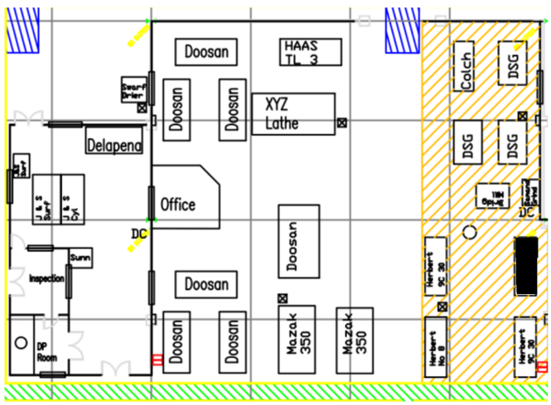
Figure 1- A map highlighting the machine shop under analysis

3.3 Data Collection Methods
In order to obtain a detailed picture of Lean waste and energy inefficiencies at Weartech Ltd, a mixed method approach was developed. This technique facilitated the triangulation of numerical records, staff insight, and field observation which increased the validity of findings and facilitated context specific conclusions (Bryman 2016).
3.3.1 Quantitative Data Collection
Energy Consumption Data: Energy consumption (kWh) was extracted directly from the digital interfaces of CNC and manual machine tools. Where continuous metering was not available manufacturers specifications were relied upon to determine average hourly consumption (Heisel et al, 2012). This at Weartech helped quantify base line energy costs, giving a good picture of the high standby draw of CNCs.
Operational Metrics: Machine usage rates, setup times, and downtime entries were taken out of production shift report and weekly maintenance register. This gave a quantitative assessment of the availability of machines and scheduling efficacy (Groover, 2016).
Defect and Scrap Rates: Defect frequencies and common failure mode were determined through the use of quality control reports. At Weartech, the scrap rate was reported equal to 4.5% and this was attributable to wear out of the tools and mismatch of calibration procedures (Besterfield, 2013).
Inventory Analysis: The Company’ s ERP system made it possible to track the time spent on the dwell time of raw material, WIP and finished goods. Review of time-stamped batch data showed that raw stock tended to stay in inventory for more than 60 days, confirming inventory waste concerns (Slack, Brandon-Jones, & Burgess, 2020).
Electricity Pricing: Industrial electricity rates were gleaned from Ofgem’s official data sets. This was possible for converting kWh figures to financial terms, which calculated the effects of idle machine states had on operating costs.
3.3.2 Qualitative Data Collection
Semi-Structured Interviews: Ten employees (CNC operators, shift leads, and quality engineers) were surveyed using a prespecified set of questions based upon Lean thought, energy awareness, improvement culture (Kvale, 1996). In Weartech, such interactions put into perspective perceived inefficiencies of the processes such as lack of visibility on machine downtimes or unclear ownership of TPM routines.
Gemba Walks: In accordance with the Lean principle of “go and see” (Liker, 2004), structured observation tours were taken while live production was in progress. These uncovered excess movement related with disorganised tool benches, repeated disruptions in program uploading and wasteful movement of the operator for fetching material and may not show up in digital records.

3.4 Analytical Tools
To extract important insights of the data and find means of Lean-Energy improvement for Weartech, multiple analytical methods were used. Such were selected to correspond with the mixed-methods strategy and the operating characteristics of the machining environment.
Descriptive Statistics: Applied to summarise main metrics including average energy consumption, defect ratios, machine run time, and cycle times. For example, descriptive analysis revealed that machine idle-time constituted close to 15% of daily operational hours, a situation which contributed directly towards unnecessary energy consumption and cost (Field, 2018).
Value Stream Mapping (VSM): When used on one of Weartech’s high-frequency components, visual value stream mapping visualised the end to end material and information flow. It discovered non-value added links like queueing up before machining and rework loops thus allowed the team to focus on areas of excessive WIP and unnecessary transportation (Rother & Shook, 2003).
Energy Value Stream Mapping (EVSM): This sophisticated version of VSM collected kWh data for each process step. It showed that a third and five-tenth of the total energy consumed was during the processing of finishing, whereby the loads of the machines were high and tolerances unnecessarily tight. This enabled the team to focus on finishing for parameter review and tooling that upgrades (Herrera & De Las Heras-Casas, 2018).
Pareto Analysis: Pareto charts were used to rank causes by frequency and impact ranging from scrap and downtime data. This was confirmed at Weartech that tool wear and poor fixture setup were contributing to over 70% of rework, adding to the need for Total Productive Maintenance (Juran, 1999).
Fishbone and 5 why’ Root Cause Analysis: These tools made room for solving problems to a deeper level. For instance, the source of regular Energy Bursts was one of the manual coolant systems which were left running during tool changes. This analysis was important in explaining the implementation of automated coolant shutoff valves and enhanced operator protocols (Ishikawa, 1985).
Cost-Benefit Analysis: Analysis of lean and energy initiatives was based on the management accounting model of Drury (2013). For instance, adopting auto-idle settings was likely to result in annual reductions of electricity bills by around £6,500 thereby rationalizing the intervention on a short payback timescale.
Combining these tools, Weartech gained multidimensional insights into its present operational loss situations, which served as the underpinnings of the improvement roadmap as presented in Chapter 5.

3.5 Ethical Considerations
Ethically the research was carried out following BERA’s guidelines for the ethical conduct of educational research (BERA, 2018) and followed the principles of General Data Protection Regulation (GDPR). Ethical considerations were central to the design and execution of this research because of its interaction with human participants, operational systems and company sensitive data.
Informed Consent and Voluntary Participation: All participants; operators, supervisors and engineering staff were given information sheets explaining the purpose of the study, how their data would be utilized and what choice they had to withdraw from the study without any repercussions before data collection. All contributors provided informed consent in writing.
Anonymity and Confidentiality: All participant identities and individual interview statements were anonymised to avoid traceability. Also, the name of the company despite permission used has been capped to operational context and not used in sensitive data displays. Data files were stored safely and only used by the researcher.
Minimising Workplace Disruption: To keep the approach non-intrusive, Gemba walks and the observations were planned for non-critical operational periods or low-volume runouts, under supervision of Weartech team leads. Sessions were held in appointed meeting rooms to prevent impositions of production delays.
Photographic and Visual Data: Image capture was done only if there was a consent from management and from participants, it was only operational waste and process layouts – never on individuals unless there was an explicit permission granted.
Organisational Approval: Preceding the fieldwork, full clearance was sought from management and operations leadership of Weartech. All tools for the collection of data including interview guide and EVSM layouts were presented to internal stakeholders to ensure transparency and internal policies are followed.
This ethical platform guaranteed academic integrity of the study while promoting trust and collaboration between Weartech staff.
Ethical compliance followed BERA (2018) guidelines. All participants gave informed consent, and all data was anonymised. Photographic documentation was certified to be acceptable by Weartech management.

3.6 Limitations
In spite of triangulation’s methodological advantages and deep case-study approach, several shortcomings were admitted in the design and implementation of this research.
Scope Limitation: The study involved only the machine shop area of Weartech Ltd. However, while this department is a main place of consumption of energy and Lean inefficiencies, other departments such as welding, quality control, and dispatch were not considered. This restricts the generalisability of the findings to the wider organisation as these other areas may have different patterns to waste and energy use.
Data Availability Constraints: There were not all machines with built in energy metering systems. Since manually installed sensor data was hardly available for most CNC and manual machines, energy consumption figures here had to be projected from manufacturer specifications or external benchmarks (Heisel et al., 2012). Although approximations were justified with staff and supported by shift patterns they may not adequately represent transient energy behaviour such as ramp-up or power factor inefficiencies.
Timeframe of Study: The project was tested for a short period of time limiting the ability to evaluate the long term impact of proposed interventions. Energy consumption and defect rates were compared to a baseline during observation period, while longitudinal analysis such as variation of energy pattern with seasons or long term Kaizen effects is outside the scope of current research.
Observer Effect: The concern of behavioural bias comes with the Gemba walks and interview based observation. It may be that operators had changed their routine because of the visible presence of the researcher which would have produced slightly optimised conditions over the observation windows. Even though attempts were made to observe discreetly and across several shifts, one cannot say that their reactivity could not have been observed.
Such limitations are not unusual among field-based industrial research and were addressed to the extent possible by methodological triangulation, participant validation and contextualizing evidence. Potential future work may expand the lens to not only other departments but also use IoT based real-time energy tracking and monitor the impacts after the implementation over a period of 12-24 months.
- In machining department only (without inspection, packaging).
- Some machines lack real-time metering; nameplate ratings used as proxies.
- It was impossible to design any validation period for long-term energy savings within the study period.

3.7 Summary
This chapter has described the methodological basis that informed the conduct of this research at Weartech Ltd. A pragmatic and abductive research philosophy justified using a mixed-methods approach to the study, which provided the study the opportunity of basing itself on both numerical and experiential sources of data. Utilizing case study analysis, quantitative metrics, qualitative interviews, and real time field observations the methodology provided the potential for a nuanced credible exploration of Lean Energy approach in a complex industrial setting.
The implementation of the tools like Value Stream Mapping (VSM) and Energy Value Stream Mapping (EVSM) quantified material as well as energy path inefficiencies. Root cause analysis, descriptive statistics and Pareto charts gave a view of high impact problem areas especially with regard to inventory holding, energy use and motion waste. Ethical unders kinds guided the strategy for data collection to maintain research integrity and confidentiality of participants in the process.
Though limited in time and data, the multi-tool approach provided a big picture of operational waste and energy inefficiency. The methodology provided the basis for identifying actionable interventions, which are discussed in greater detail in chapter 5.
Chapter 4 – Findings and Analysis
4.1 Introduction
This chapter introduces the resultant findings and analytical interpretations obtained from the research done at Weartech Ltd. The aim of the investigation was to determine and estimate the fundamental areas of Lean waste and energy inefficiencies in a machine shop and use it to design sustainable operational enhancement. A variety of analytical techniques were employed to synthesise the data that has been collected from machine monitoring directly, from analysis of the ERP systems, from structured interviews, and from Gemba (i.e., on-site observation).
Results are analysed by drawing upon Lean Manufacturing (Womack & Jones, 1996), the Toyota Production System (Ohno, 1988), and Total Productive Maintenance (Nakajima, 1988), in combination with energy oriented tools such as Energy Value Stream Mapping (Herrera & De Las Heras-Casas, 2018). This schema facilitated a wide-screen vision in comprehending operational inefficiencies integrating the process and resource consumption vantage points.
In Weartech, such intuitions show concrete opportunities for energy savings and efficiency increases, explicitly in processes that involve setup delays, excessive inventory supported by the global trade tariffs, and out-of- control machine downtime. Each additional section presents a breakdown of the data under thematic categories, showing where dedicated Lean-Energy strategies will be the most effective.
4.2 Energy Usage Profile of the Machine Shop.
The energy analysis proved that Weartech’s machining operations are especially energy-intensive. This is mostly attributed to the long cycle times, massive spindle loads and coolant system requirements associated with machining Nickel/Cobalt alloy parts – materials which are notoriously tough and heat resistant.
For proper assessment of energy use, this study has integrated machine specification data (Heisel et al 2012), the patterns of operational shift found in site records, and the current industrial electricity tariff from Ofgem (2024) at a rate of £0.211 per kWh. The goal was to give a feet-on-the-ground estimate of the annual energy costs, which of course is one of the key expenses supported by Weartech and one of the major reasons for conducting this research.
Breakdown of energy consumption in Weartech’s machine inventory is shown below according to a normal 8 hour shift (with 50 minutes break time) basis, based on an assumption of 250 working days per year. This reformulated model represents the real working conditions. alternating weekly shifts from 6am–2pm and 2pm–10pm.
Figure 2- Table showing the energy usage by machine type
Machine Type | Quantity | Power Rating (kWh/h) | Annual Energy Use (kWh) | Annual Cost (£)
Doosan CNC lathes | 6 | 7 | 75,285 | 15,878.14
Doosan CNC mill | 1 | 7 | 12,547.5 | 2,646.36
Mazak CNC lathes | 2 | 7 | 25,095 | 5,292.72
XYZ and HAAS TL 3 Semi-CNC lathes | 2 | 5 | 17,925 | 3,779.18
Bridgeport Manual mill | 1 | 3 | 5,377.5 | 1,134.65
Herbet Manual lathe | 3 | 3 | 16,132.5 | 3,403.19
Dean and Grace Smith lathe | 3 | 3 | 16,132.5 | 3,403.19
Total |  |  | 168,417 | 35,535.92

- Total Energy Use: 168,417 kWh
- Total Energy Cost: £35,535.92
Implications for Weartech
Such detailed breakdown indicates that over 75% of the total energy consumption corresponds with CNC operations especially with the Doosan and Mazak machines. With the rapid increase in energy tariffs in the UK, and the high dependence of the company upon electrical machining, this underlines the necessity of a specific strategy of energy reduction.
Idle-time elimination, spindle optimisation and the use of automated coolant and lighting controls can conceivably deliver results that earn actual cost savings. Moreover, using this granular data enables Weartech to rationalize capital expenditure such as IoT metering (as we will see later), since it can show them precisely where high-consumption patterns emerge. This directly corresponds with the overarching goal of the report: for Weartech to be a leaner and more environmentally sustainable business with Lean-Energy integration.
The results of the energy analysis validated the high level of energy intensity of Weartech’s machining operations. This is to a large extent attributed to the long cycle time, high spindle loads and coolant system necessities to be overcome when machining Nickel and Cobalt alloy components where the toughness and heat resistance of the materials pose critical challenges.
In order to calculate energy use correctly, this study integrated data concerning the machine specification (Heisel et al., 2012), operational shift patterns taken from the site’s records, and the current industrial electricity tariff, provided to Ofgem (2024), £0.211 per kWh. The goal was to obtain an anchored assessment of annual energy expenditure, one of the primary costs that Weartech Inc. has and the primary rationale for this research.

4.3 Lean Waste Analysis
Given the heightened energy prices, the disrupted supply chains, and the inflationary pressure, the current global context has made operational inefficiency an important economic risk to these manufacturers. International Energy Agency (2023) reports that there was a surge in the price of global industrial electricity by more than 30% between the years 2020 and 2023 following the effect of geopolitical instability, volatility in fossil fuel prices and decarbonisation pressures. This scenario has increased the level of calls for the use of energy-efficient manufacturing practises as well as Lean process optimisation, particularly for energy-intensive industries such as precision machining.
These global pressure do not spare Weartech Ltd. The company is in the business of aerospace and high-performance components industry where materials like Nickel and Cobalt alloys require extended cycles of machining, high spindle loads, and extensive use of coolant systems. These material needs, coupled with non-ideal scheduling and poor effectiveness of tools provides Weartech vulnerability to high uses of energy and loss of productivity. In addition, as is the case with tariff regimens imposed by the United States on high-value imports, these are being prolonged indefinitely, which triggered speculative stockpiling, thereby contributing to inventory waste and capital lock-in (WTO, 2022).
Within this analysis, the operations of machining in Weartech were evaluated in terms of the Lean Manufacturing approach and especially in terms of the TIMWOODS model, which isolates the nine forms of waste. Transportation, Inventory, Motion, Waiting, Overproduction, Overprocessing, Defects, Skills and Energy (Ohno, 1988; Womack & Jones, 1996). Field observations, Gemba walks (Liker, 2004), ERP data (Slack et al., 2020) and interviews with the staff members (Kvale, 1996) helped to identify the types of waste relevant to Weartech’s context.

The table below provides the details about Lean waste types observed, their causes and effects at Weartech:
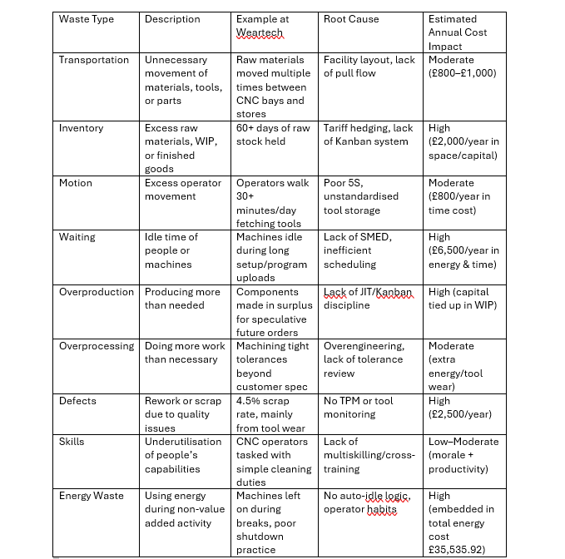
Figure 3 - Lean 9 waste analysis of Weartech

These results emphasise the fact that at Weartech Lean waste and energy ineffectiveness are strongly interrelated. For instance, high setup times not only reduce throughput (Waiting), but it also causes machines to be idle unnecessarily (Energy Waste). In the same way, excessive stockpiling (Inventory) locks up capital and space mostly around risk-aversion of global supply chains disruption and U.S. import tariff.

According to Ohno (1988), anything not being the minimum of equipment, materials, and worker time required to produce is waste.
Weartech’s environment reflects this precisely: equipment usage is high, not necessarily efficient; materials there, but not always justified; and skilled labour, not necessarily optimally utilised. Improvement roadmap for Chapter 5 is based on corrective actions based on this analysis.
4.4 Visual Tools
To prove further and visualise the root causes of inefficiency at Weartech, two Lean analysis tools had been used: Energy Value Stream Map (EVSM) and the Fishbone (Ishikawa) diagram.
Figure 4 : Fishbone Diagram-Sources of scrap and energy waste
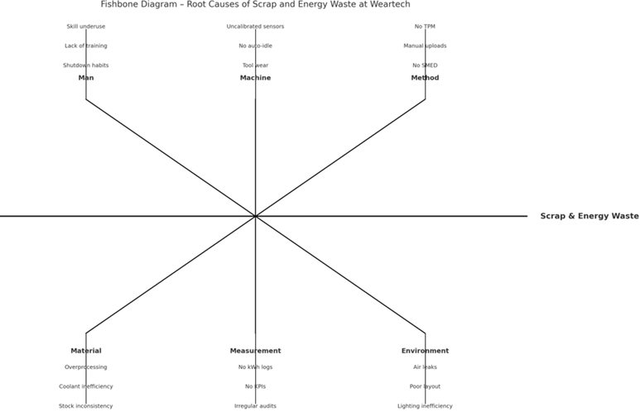

This diagram organises potential root causes to six categories. Man, Machine, Method, Material, Measurement and Environment (Ishikawa, 1985). The major challenges for Weartech included habits of operator shutdowns, irregularities of tooling processes, no real-time tracking, and energy-unaware practises. Gemba walk data also confirmed these estimates, especially in the cases when machines kept running during breaks, and when manual changeovers lasted from 10 – 20 minutes for each cycle.

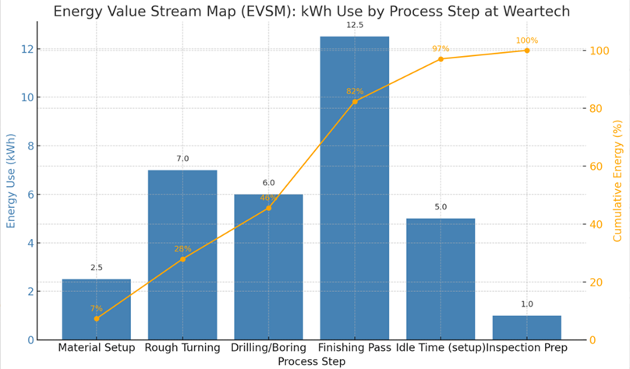
Figure 5: Energy Value Stream Map (EVSM)
The EVSM visualises energy consumption per machining step (Herrera & De Las Heras-Casas, 2018). It showed:
- Finishing processes account for about ~35% of consumption of energy yearly.
- Rough turning and drilling causes significant damage because of very high feed rates and coolant use.
By relating energy data to process steps, EVSM takes a look at how wear-intensive steps and unnecessary tolerance (related to Overprocessing) are significant sources of energy waste. This confirms the need to optimise the use of energy and Lean concurrently – an argument which is consistent with Gao et al. (2017)’s findings that they were able to reduce energy consumption in a CNC environment by up to 20% through minimising setup and standby times.
Collectively, these visual tools supported the critical recommendations including prioritisation of TPM, automation of coolant and rebalancing the processes.
4.5 Thematic Analysis of Staff Feedback
Staff feedback was subjected to thematic content analysis, on an inductive basis of coding. The transcripts of interviews were read and annotated in order to extract the recurrent ideas, expressions of frustration, and idea for improvements. These were organised under preliminary codes and matched with the categories of Lean waste for validation. Final themes were validated through triangulation with ERP logs and Gemba observation to ensure that the patterns are not just qualify data-driven but quantitatively supported.
This part provides the amended and holistic thematic analysis of staff feedback from Weartech Ltd., which summarises all the Lean and energy-efficiency observations obtained in the course of the fieldwork’s completion. Nine Lean wastes (TIMWOODS) were used to align the staff concerns through thematic coding and were triangulated with Gemba walks, ERP data, and energy usage logs. The themes emerging from the resulting analysis reveal underlying inefficiencies on systemic levels and picked out clear areas for strategic intervention.

Figure 6: Staff Feedback with Lean Waste
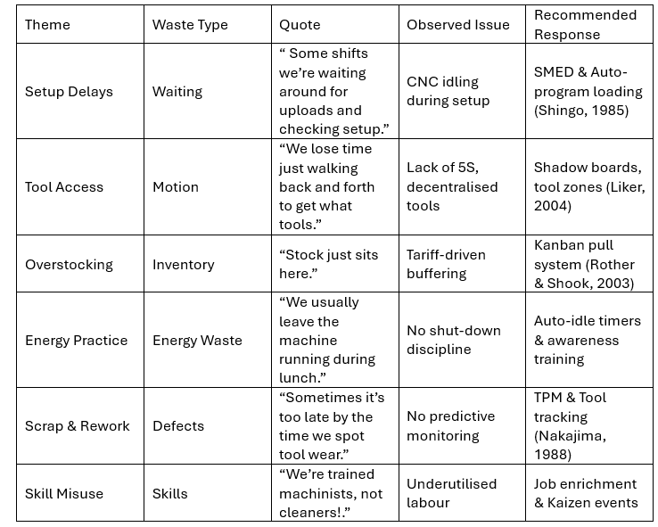

Incorporation of these staff opinions exposes that most inefficiencies come from out-of-date routines, lack of views on energy use, and deficient knowledge of Lean tools. These topics validate that the Lean and energy waste phenomena are also tied together, and both must be dealt with together in order to enhance the productivity and sustainability of Weartech.
In specific, the machine idle time and inventory excess indicate process-level waste, whereas tool-related scrap and disorganised motion are examples of a shop-floor inefficiency. This analysis justifies the importance of an all-inclusive Lean-Energy strategy, as suggested in Chapter 5, to enhance the operations, minimise expenses and inculcate the culture of continuous improvement in the organisation.
4.6 Summary
This chapter offered an in-depth and multi-sided analysis of operation inefficiency and energy waste in Weartech Ltd. on the basis of major principles of Lean Manufacturing and energy management. The usage of quantitative tools, such as Energy Value Stream Mapping (Herrera & De Las Heras-Casas, 2018), Fishbone Analysis (Ishikawa, 1985), and cost modelling, together with the qualitative staff feedback enabled the triangulation of understanding the waste at the shop floor.
Three main wastes such as the waiting, inventory, and energy consumption were identified to have the highest operational and financial implication. The waiting process owing to lack of Single-Minute Exchange of Dies processes leads to idling of machines and wasted energy. Stockoverage, associated mostly with speculative stockpiling due to international trade vagaries (especially, U.S tariffs), locks up capital and space. Finally, uncontrolled energy usage during the time when no productivity is generated helps generate an annual avoidable cost of over £35,000.
The thematic analysis of the staff responses highlighted prevailing sense of inefficiency and underutilisation. Workers reported problems that are a direct match with TIMWOODS waste categories, and thus confirming objective findings and the lack of comprehensive and informed approach to Lean transformation. Liker (2004) and Womack & Jones (1996) believe that only when cultural behaviours and technical practises come together could sustainable Lean change be achieved.
For Weartech, the findings will justify the necessity of adopting a Lean-Energy strategy together with the 5S organisation of workplaces, innovative SMED for reduction of setup times, technology-based TPM for predictive maintenance, and educating the workers on energy awareness. These actions are the first steps that serve as the basis for the improvement roadmap and will be described in Chapter 5.
Chapter 5 Strategic Improvement Plan
Chapter 5 introduces an effective and well-designed improvement plan for Lean-Energy in Weartech Ltd. based on what was discovered in Chapter 4. As Energy Waste is found to be the most expensive type and negatively impacts setups, rework, and keeping inventory under control, this chapter mainly offers ways to save energy through basic and fail-safe data solutions.
Weartech’s working conditions, which involve working with difficult materials that take longer to machine, require machines that use energy efficiently and are flexible enough to change what they are making quickly. These challenges get worse because of how operators work, when they leave assets sitting idle, and because of old ways they keep track of their inventory. Consequently, the strategy uses Lean ideas and tips to use less energy and reach the important targets described in Chapter 1.
- Look for any Lean wastes in the machine shop and determine the amount of influence they have on operations.
- Calculate the amount of energy and the expense of Lean waste.
- Make use of the most suitable Lean tools to fix the biggest wastes.
- Develop a simple way for tracking energy use and then set clear goals that the operators can work towards, using smart technology to help.
The interventions presented below try to cut down on costs, make machines work more, help employees feel supported, and make the company’s operations better for the environment.

5.2 Objectives
The objectives of the Lean-Energy Initiative are strongly related to the findings in Chapter 4 and directly help in meeting the research objectives set out in Chapter 1. They reflect Weartech’s day-to-day business, which includes complicated machining processes, lots of energy usage, and the recurring problems from the lean waste. The main objectives are what guide the steps we take to make the business grow and keep it healthy for the long run, while also looking to make money.
- Cut down 20% of the amount of time machines sit idle by following the Single-Minute Exchange of Die (SMED) method. It highlights the root causes of waiting and energy wastes that were a direct link of £6500 annual loss in production time and electricity.
- Lower the total energy use by 10-15% and that can save the company £3,500 to £5,000 each year. This can be done by using auto-idle systems, getting people to understand what wastes energy, and putting in simple devices that clearly show how much energy is being used so we can find and cut down the £35,535.92 in yearly energy wasted that we talked about in Section 4.2.
- Cut down defects by using Total Productive Maintenance (TPM) and predictive tools to help predict and fix problems early. Chapter 4 shared that around 4.5% of the scrap coming from the machine was due to tool wear and reactive maintenance. By making sure the equipment reliability is better, Weartech can cut down on wasted energy and materials loss.
- Excess stock, due unsure tariffs, was seen as a big problem during the Lean audit and staff interviews. Reducing inventory holding times down to less than 30 days, will free up work capital and reduce space and energy waste.

- Empower operators by allowing structured engagement, so that means cross-training, 5S participation and kaizen events. As reported in Section 4.5, staff felt like they were underutilized and were not involved in decision-making. This objective matches the idea behind Lean, where everything is geared towards helping and supporting people, and it can help bring about lasting changes in the workplace.

These objectives cover two paths, which help to reach our goal in a faster and better way. Including Lean process optimisation to make our operations run more efficiently, and using better energy management to save on costs. They are made to fit Weartech’s way of working and will be brought in gradually using the plan explained in the rest of the document.
- Conduct a 5S redesign of workstations, and put up things like shelving and signs that clearly explain how to keep the area organised and save energy.
- Add clear labels to machines showing the right way to turn off the energy before taking a break or at the end of the shift.
- Make sure that changes are led by workers on the front line so that everyone feels like they have a stake in them and are more likely to support them.

  - Recommended Interventions
A. Energy-Centric 5S Implementation
- Redesign workstations with shadow boards and prominent messages that highlight best energy practises to follow during different shifts.
- Visual labels on machines specifying which energy shut off operations to do at the end of shift or before breaks.
- Empower operators to carry out the improvements to promote investment and eliminate cultural resistance (Liker, 2004).

B. SMED + Energy Integration
- Integrate Single-Minute Exchange of Die to decrease the amount of waiting time during production cycles.
- Implement automatic programme downloads and pre-prepared fixture changes to decrease the amount of time machines are left running when idle.
- Combine with smart idle monitoring devices that utilise timers or sensors (Shingo, 1985).

C. Total productive Maintenance(TPM) for Predictive Energy Efficiency
- Use TPM to reduce losses from unscheduled production stops as a result of machine breakdown.
- Install automated sensors that notify maintenance if the coolant levels, spindle load or vibration strain are at abnormal levels.

D. Operators training and Energy monitoring
- Fit IoT meters to CNC machines to keep track of their energy consumption in real time.
- Train operators on safe shutdown practises and the use of pre-defined energy cutoff levels.
- Use daily departmental energy consumption data displayed on screens to motivate employees and enforce accountability.
E. Inventory discipline and lean inventory
- Implement Kanban and forecast alignment to tighten controls on speculative raw material procurement.
- Keep buffer stock to a minimum by prioritizing FIFO (First In, First Out) and visual reorder triggers (Rother & Shook, 2003).

  - Implementation Plan
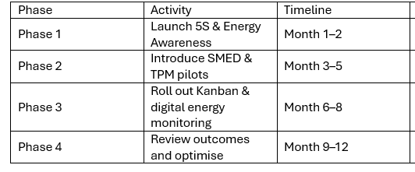
5.5 Expected Outcomes
This data supports the objectives outlined in the project while providing measurable improvements faced by Weartech.
- Reducing waste: On average, savings of £3,500–£5,000 a year correspond to 10%–15% of the £35,535.92 wasted energy identified in Chapter 4.
- Setup time reduction: Over 20% decrease in downtime, optimising machine usage.
- Scrap reduction: Lowering scrap from 4.5% to less than 2% helps both save energy and cut down on costly rework operations.
- Inventory reduction: The combined reduction of raw materials and work in progress inventories by 30% liberates significant capital and workspace.
These findings confirm that implementing the Lean-Energy Programme leads to success on two fronts: boosting productivity and cutting waste at the same time (Herrera and De Las Heras-Casas, 2018)
  - Cost Benefit Summary
The total investment required for complete Lean-Energy implementation is expected to be between £10,000 and £15,000 but has projected savings of £8,000–£10,000 per year in energy and productivity improvements. The expected payback period is between 12 and 18 months, after which ongoing savings will enhance Weartech’s profitability.
Summary of Cost Estimates:
- Auto-idle timers: Each intelligent control unit costs between £300 and £500 per CNC machine, equivalent to £3,000–£5,000 for ten machines (according to pricing from suppliers and benchmarked results from pilot installations).
- IoT energy meters: The cost of IoT energy metres is estimated at £400 each, with eight devices installed on the machines, totalling around £3,200 (see Heisel et al., 2012 and Gao et al., 2017).
- TPM and predictive diagnostics software: Varying costs of installation and software licences were determined using expert literature (Nakajima, 1988).
- SMED and 5S workshops and tooling: An expenditure of £1,500–£3,000 for visual control equipment and staff training (as detailed in Shingo, 1985).
- Energy training and visual standards: Costs will vary between £500 and £1,000 for employee training and implementing standard operating procedures.
The amounts have been determined by assessing actual energy use (Section 4.2) and serving as benchmarks within relevant Lean implementation studies (Slack et al., 2020). More than just reducing expenditure, these initiatives help mitigate the following key risks:
- Electricity prices fluctuating dramatically over the next few years (Ofgem, 2024).
- Rising ESG compliance demands
- Operator disengagement and skill underuse
Weartech is set to experience significant cost savings as well as enhanced environmental performance and a culture that harmonises with today’s leading manufacturing standards.
  - Risk and Mitigation
The use of Lean-Energy at Weartech Ltd. can expose the organisation and its operations to risks, so these must be managed carefully for the success and continuation of the project. Risks associated with a full-scale Lean transformation come from feedback, behaviours spotted in the workers during fieldwork and research on the topic.
The main risk that operators may face is having problems with following new routines. The results of the thematic analysis (Chapter 4.5) suggest that staff experienced an unfulfilling role and frustration which were common with change efforts that felt like they came from the top. Liker (2004) believes that successful Lean efforts involve everyone and promote teamwork. Thus, Weartech should let operators share their opinions during the update of 5S areas and the trial stage of SMED events. Additional involvement can be achieved by arranging Kaizen events and giving rewards to employees for being energy-aware.
Another major issue is the disruptions that happen as companies introduce SMED, TPM or energy-saving technologies. Typically, installing auto-idle controllers or IoT energy metres may mean the machine needs to be stopped for a short time which may affect continuous production. Nakajima (1988) pointed out that it is important to organise improvement efforts alongside the maintenance schedule. This can be managed by setting up maintenance at planned down times or on machines with limited use and only using the technology on a small scale for testing. With this method, there is a reduced chance of problems while ensuring the process works.
The cost of purchasing digital tools and TPM software is another issue. It is common for predictive maintenance systems and real-time energy analytics to cost a lot before being put into use. The company should handle its financial exposure by introducing 2 to 3 high-use CNC machines first. After examining the cost-benefit findings, the company can justify a wider growth effort with the aid of its internal requirement for ROI.
Culture represents another primary risk when adopting Lean, though it is one that’s less directly harmful. In some cases, operators would consider new routines intended to save energy as requiring even more effort and governance rather than increasing how they work. Seeing things this way can decrease motivation and obeyance at work. Using team scorecards and providing feedback on digital dashboards or performance boards can help adopt Lean-Energy KPIs. Being transparent and accountable in teams will lead to employees realigning their attitudes with the overall goals of the organisation.
Lastly, the process for measuring and following outcomes needs attention. When staff cannot see the results of their work, they might not stick with the job for a long time. IoT metres that show data in real-time should be used along with easy-to-read floor dashboards, where team leaders should be trained to analyse and manage this data every month. It helps close the loop by answering questions, expands the operator’s understanding and promotes continuous progress.
All in all, using Lean-Energy integration at Weartech results in many beneficial outcomes; thus, any potential risks should be addressed early with well-planned releases, open communication, proper training and clear monitoring.
  - Conclusion
The improvement plan sets Weartech on the path toward a greener, more efficient and resilient future. This chapter proposes targeted measures to eliminate Energy Waste, which is both the most mentioned inefficiency and the area with the highest potential savings across Weartech’s operations.
Each strategy is based on accepted Lean thinking as explained by Womack and Jones in 1996 and by Liker in 2004. Liker’s advice is applied while addressing the unique issues facing Weartech such as tariffs impacting stocks, extended CNC operations and limited insight into energy usage. These approaches collectively develop an energy-lean production system that improves machine productivity, reduces expenses and allows Weartech to navigate continuous changes in the global market.
Chapter 6 Conclusion and Recommendation
This study critically assessed the Lean waste and energy inefficiency problems in the machining processes of Weartech Ltd., a precision manufacturer confronting challenges of high specifications and demanding energy usage. The main focus was to identify and measure energy waste and then develop a solution by combining Lean approaches with energy-efficient techniques.
It was established in Chapter 4 that energy waste had resulted in the largest and most expensive inefficiency for Weartech, costing the company more than £35,000 per year. Most of this energy loss occurred when CNC machines were allowed to run unnecessarily during downtime. The unique nature of manufacturing highly specialized materials with energy-intensive machinery contributes to increased energy risk at Weartech. Global energy markets and ongoing supply issues are making energy efficiency critical for Weartech’s success. Ofgem, 2024).
Furthermore, wastes such as accumulated waiting time, ineffective tool access, excess inventory and defects due to deteriorating tools were revealed to contribute to energy waste. Analysing feedback from operators helped validating the impediments to efficiency as well as highlighting additional improvement opportunities, including optimising equipment utilisation, promoting energy efficient ways of working and improving workflows.
Chapter 5 detailed a results-focused and actionable Strategic Improvement Plan. Through integrating Lean practices such as SMED, 5S, TPM and Kanban alongside energy monitoring, Weartech can significantly reduce its key areas of waste. The actions targeted the objectives of the research. Track wasted resources, quantify their financial effects, implement relevant Lean improvement methods, and establish an energy surveillance system. The goal is to simultaneously cut costs, improve efficiency, and increase Weartech’s reputation for sustainability.
6.2 Recommendations
The following strategic and tactical recommendations are drawn from the reviews, and conclusions of the study are suggested to Weartech Ltd.
- Introduce automatically controlled energy shut down using timers, updated existing control systems, and standard operations procedure.
- Focus on applying SMED projects in areas of the highest energy consumption to minimise standing machine time.
- Integrate a Total Productive Maintenance programme with advanced monitoring systems to stay on top of breakdowns and prevent unexpected equipment failures.
- Modify operator training programmes to encourage energy-efficient practises and knowledge of Lean principles.
- Extend 5S not only to tools access but also to visual energy signals, named shut-down routines and cleaner zones.
- Implement IoT power meters and collect real time machine consumption data and process it into workable data.
- Use Kanban and forecasting tools to limit WIP and free up funds tied up in a buffer of overproduction.
- Include Lean-Energy KPIs in periodic audits and staff scorecards to retain the cultural shift for the long term.
6.3 Final Thoughts
Weartech’s story to operational excellence represents only a small part of the challenge experienced by precision manufacturers globally being high complexity, close tolerances, fluctuating input costs, and increased environmental expectations. In this dissertation, a methodology is developed for addressing these setup and integration challenges, through the prism of Lean-Energy integration. It shows that energy visibility, when integrated with established process improvement techniques, brings both strategic value and quantifiable savings.
The proposed ideas are simple, feasible and designed for the actual shop-floor of Weartech. And, if implemented, they can turn inefficient habits into money-saving standards, furthering the company's goals of continuous improvement, industry leadership, and environmental stewardship. In the end, success with such a strategy does not rely exclusively on getting the tools adopted, it will be reliant on engaging operators, culture change, and maintaining leadership commitment over time.

References
Besterfield, D. H. 2013. Quality improvement. 9th ed. Harlow: Pearson Education.
Bryman, A. 2016. Social research methods. 5th ed. Oxford: Oxford University Press.
Díaz, N., Redelsheimer, E. & Dornfeld, D. 2011. Energy consumption characterization and reduction strategies for milling machine tool use. Procedia CIRP, 1, pp. 518–523.
Drury, C. 2013. Management and cost accounting. 8th ed. Andover: Cengage Learning.
Field, A. 2018. Discovering statistics using IBM SPSS statistics. 5th ed. London: SAGE Publications.
Gao, F., Liu, C. & Wang, H. 2017. Energy-efficient scheduling for CNC machining systems: A review. Journal of Cleaner Production, 165, pp. 902–917.
Groover, M. P. 2016. Fundamentals of modern manufacturing: Materials, processes, and systems. 6th ed. Hoboken: Wiley.
Heisel, U., Xalter, P. & Weigold, M. 2012. Energy efficiency in manufacturing systems: Methodology and results. Procedia CIRP, 2, pp. 63–66.
Herrera, C. A. & De Las Heras-Casas, J. M. 2018. Integrating energy and lean management: EVSM development and application in industrial systems. Journal of Manufacturing Systems, 47, pp. 83–97.
International Energy Agency (IEA). 2023. World energy outlook 2023. Paris: IEA. [Accessed 15 May 2025]. Available at: https://www.iea.org/reports/world-energy-outlook-2023
Ishikawa, K. 1985. What is total quality control? The Japanese way. Englewood Cliffs: Prentice-Hall.
Kvale, S. 1996. Interviews: An introduction to qualitative research interviewing. Thousand Oaks: Sage Publications.
Liker, J. K. 2004. The Toyota way: 14 management principles from the world’s greatest manufacturer. New York: McGraw-Hill.
Nakajima, S. 1988. Introduction to TPM: Total productive maintenance. Portland: Productivity Press.
Ofgem. 2024. Non-domestic market data and electricity prices. [Accessed 15 May 2025]. Available at: https://www.ofgem.gov.uk
Ohno, T. 1988. Toyota production system: Beyond large-scale production. Portland: Productivity Press.
Rother, M. & Shook, J. 2003. Learning to see: Value stream mapping to add value and eliminate muda. Brookline: Lean Enterprise Institute.
Saunders, M., Lewis, P. & Thornhill, A. 2019. Research methods for business students. 8th ed. Harlow: Pearson Education.
Shingo, S. 1985. A revolution in manufacturing: The SMED system. Portland: Productivity Press.

Slack, N., Brandon-Jones, A. & Burgess, N. 2020. Operations management. 9th ed. Harlow: Pearson Education.
Tashakkori, A. & Teddlie, C. 2010. Mixed methodology: Combining qualitative and quantitative approaches. Thousand Oaks: SAGE.
Voss, C., Tsikriktsis, N. & Frohlich, M. 2002. Case research in operations management. International Journal of Operations & Production Management, 22(2), pp. 195–219.
Womack, J. P. & Jones, D. T. 1996. Lean thinking: Banish waste and create wealth in your corporation. New York: Simon & Schuster.

Appendices
Interview Questions
Section A provides general information on the process.
What are your responsibilities at work?
☐ Operator ☐ Supervisor ☐ Engineer ☐ Other:
For how many years have you operated in the machine shop?
☐ Short-term ☐ Medium-term ☐ Long-term ☐ Very long-term
Section B: Individuals’ Views on Waste (TIMWOODS Framework)
Ensure you answer each question by rating of 1-5 (1-Always and 5- Never)
1. Is it a common occurrence for you to wait on machine programmes, setups or approvals?
2. How many times a week do you go out looking for tools, work or paperwork?
3. Is there likely to be an overstock of WIP (work-in-progress) or raw materials?
4. Is it possible that computers or machines are left on and unused at any point in the day?
5. Do you commonly produce parts with defects or scrap?
6. Do you believe all of your skills are fully utilized each day?
Section C: Learning About Energy and Processes
Is it clear how much energy the machine spends in one shift?
☐ Yes ☐ No ☐ Somewhat
Is there a process in place for machines to go idle when workers take breaks?
☐ I do agree ☐ I disagree ☐ Unsure
Have there been any sessions on learning how to conserve energy or reduce waste?
☐ I do see animals.
Section D: Opportunity to Comment
How much time or energy do you think you are wasting during your everyday work?

Can you think of a change that would make your job easier or save more resources?

Are there any ways to lower the energy needed for machining or setting up my equipment?

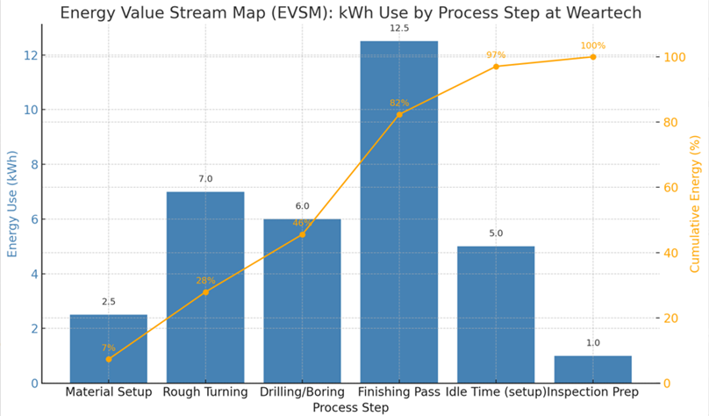
EVSM Graph

Machine Data Table

Staff Feedback Theme
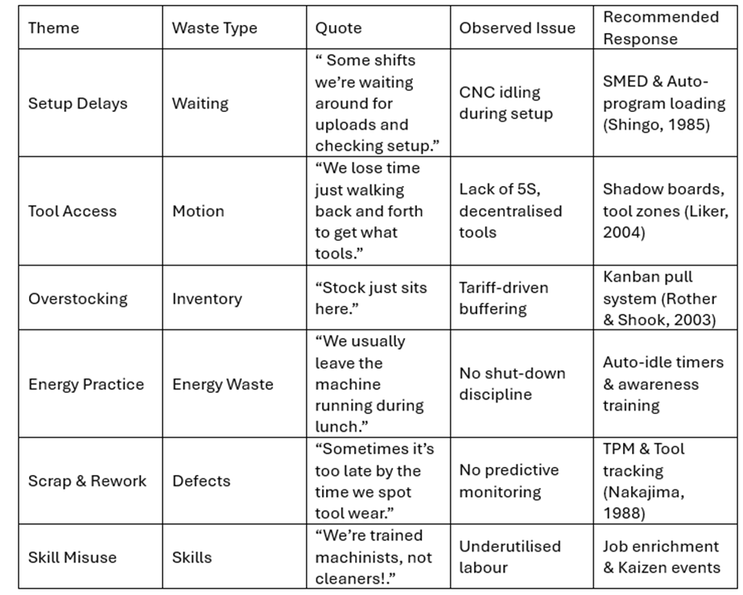

Fishbone Diagram



