

Managing Enterprise in the 21st Century
Business Plan: Indian Room Restaurant in UK
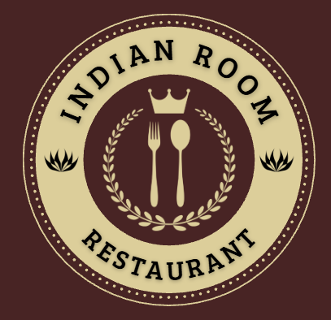

Submission Date:
Lecturer: BIRMINGHAM: DR CHUNG LAI JOHNNY WAN
LONDON: DR CHARLES OHAM

Group Information

Table of Contents
Group Information 2
Executive Summary 5
Business Concept 6
Business Description 6
Product Description 7
Business Objectives (SMART Objectives) 7
Short-Term Objectives (less than a year) 7
Long-Term Objectives (More than a year) 8
Market Analysis and Marketing Plan 9
Market Analysis (Competitors, Customers, Target Groups) 9
PESTEL Analysis 10
SWOT Analysis 11
Marketing Mix (4Ps) 11
Management Team 13
Management Team and Their Background 13
Organisational Chart 13
Key Milestones 14
Financial Plan (One Year) 15
Sources of Finance 15
Cash Flow Forecast 15
Sales Forecast 16
Cost of Production Forecast 17
Break Even Analysis 17
Operations and Management Plan 18
Production of Good and Service 18
Technology Plan 18
Human Resource Plan 18
Expansion Plan 18
Business Model Canvas 19
Reference List 20
Appendices: 22

Executive Summary
Indian Room Restaurant will be a UK-based startup and focus will be laid on offering authentic Indian cuisine through takeaway, dine-in and delivery services. Indian Room Restaurant will focus on affordability, quality and sustainability with targeting different customer groups. Skilled management, effective marketing, expansion plans and modern technology will help Indian Room Restaurant to achieve profitability, sustainable growth and customer satisfaction.

Business Concept

Business Description
Figure 1: Logo of Indian Room Restaurant
(Source: Self-Created)
Indian Room Restaurant in the UK will be a startup Indian restaurant. Additionally, focus will be laid on offering modern fusion dishes along with authentic Indian cuisine. The Indian Room Restaurant will provide takeaway, dine-in, home delivery services and online ordering with sustainable packaging to meet the diverse preferences of customers. Hierarchical management structure will be followed that includes an owner-manager, restaurant manager, kitchen staff, head chef, marketing assistant and service staff that can aid to ensure daily operations efficiently. Indian Room Restaurant will operate as a “Private Limited Company (Ltd.)”, providing greater business credibility, limited liability protection for the shareholders and opportunities to attract investment along with support for future expansion.

Product Description
Indian Room Restaurant will offer a large variety of freshly prepared Indian dishes such as biryanis, curries, vegetarian tandoori grills, vegan meals, desserts along with traditional beverages. Healthier options and seasonal menus will also be available. Authentic spices, high-quality ingredients and excellent customer service will be helpful to differentiate the restaurant.

Business Objectives (SMART Objectives)
Objective: To achieve 70% sales in a month within first 12 months and maintaining 85% customer satisfaction by exceptional service, high-quality food and effective marketing
Specific | Achieve robust business growth through increasing restaurant sales monthly through takeaway, dine-in and online delivery services
Measurable | Reach 70% sales in a month and maintain 85% customer satisfaction rate
Achievable | Accomplishing through competitive pricing, quality food, excellent customer service, partnerships with food delivery platforms and digital marketing
Relevant | Supporting goal of building a reputable, profitable along with sustainable Indian restaurant in the UK
Time-bound | Achieving within the first 12 months
Table 1: SMART Objectives
(Source: Self-Created)

Short-Term Objectives (less than a year)
- Achieving operational break-even in the first year
- Successfully launching the restaurant within 6 months
- Building robust local brand awareness through digital marketing
- Recruiting and training skilled employees
- Establishing partnerships with local suppliers and food delivery platforms

Long-Term Objectives (More than a year)
- Introducing corporate event and catering services
- Increasing profitability and annual revenue by 20% each year
- Developing robust customer loyalty programme
- Expanding through opening additional restaurant branches in the UK
- Building Indian Room Restaurant into a trusted and recognised Indian dining brand across the UK

Market Analysis and Marketing Plan

Market Analysis (Competitors, Customers, Target Groups)
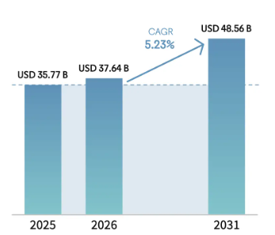
Figure 2: Restaurant Market in the UK
(Source: Mordor Intelligence, 2026)
The restaurant industry in the UK is increasingly competitive and market size is projected to be “USD 48.56 Billion” with “5.23% CAGR” by 2031 (Mordor Intelligence, 2026). Indian Room Restaurant will compete against established Indian restaurants such as The Cinnamon Club, Dishoom and multiple local independent restaurants. Besides this, Indian Room Restaurant will differentiate based on its offerings of authentic regional Indian cuisine, affordable pricing, modern fusion dishes and excellent customer service.
Segmentation | Targeting | Positioning
- Segmentation on demographics, income, lifestyle, dining preferences | - Young professionals, university students, families, individuals seeking authentic Indian cuisine, tourists, vegan and vegetarian options | - Positioned at premium yet affordable destination for Indian dining  - Quality ingredients, authentic flavours, welcoming ambience, and takeaway, convenient dine-in and delivery services
Table 2: “Segmentation, Targeting, Positioning (STP)” Framework
(Source: Self-Created)

PESTEL Analysis
Factors | Description | Impact
Political | - UK scores 70 in Corruption Perceptions Index (Transparency International, 2026)  - Trading partners are the US, Germany, Netherlands, Switzerland, France (Department for Business & Trade 2026) | Positive
Economic | - GDP increased by 1.3 % (Office for National Statistics, 2026)  - Inflation rate rose by 2.8% (Office for National Statistics, 2026) | Positive and Negative
Social | - Population is equivalent to 0.84% of the total world population (Worldometers, 2026)  - Increasing multiculturalism | Positive
Technological | - Adopted artificial intelligence (AI), robotics, cloud-based computing systems (Office for National Statistics, 2025) | Positive
Environmental | - “Net Zero by 2050” (Ministry of Justice, 2024)  - Sustainability initiatives can be helpful | Positive
Legal | - “Companies Act 2006” (legislation.gov.uk, 2026)  - “Consumer Rights Act 2015” (legislation.gov.uk, 2026) | Positive
Table 3: PESTEL Analysis of the UK
(Source: Self-Created)

SWOT Analysis
Strengths | Weaknesses
- Authentic Indian cuisine  - Maintaining sustainability with biodegradable and eco-friendly packaging, sourcing from local suppliers to lower transportation emissions  - Quality ingredients  - Experienced chefs  - Multiple service options | - Limited market recognition  - High investment initially
Opportunities | Threats
- Increased demand for Indian food  - Online delivery market  - Business expansion | - Increasing operating costs  - Strong competition  - Changing consumer preferences  - Economic uncertainty
Table 4: SWOT Analysis of Indian Room Restaurant
(Source: Self-Created)

Marketing Mix (4Ps)
Factors | Description
Product | Authentic Indian meals, vegan and vegetarian dishes, beverages, desserts, dine-in, takeaway and delivery services
Price | Competitive value-based pricing will be used
Place | Located in a commercial area in the UK for dine-in with online ordering through restaurant’s website and delivery platforms
Promotion | Digital marketing will be adopted to reach to customers through social media, influencer collaborations, Google advertisements, customer loyalty programmes, seasonal promotions along with local community events to increase customer retention and brand awareness
Table 5: Marketing Mix (4Ps)
(Source: Self-Created)

Management Team

Management Team and Their Background
The management team will include the Owner or Managing Director who will oversee financial management, strategic planning and business growth. The Head Chef will have extensive expertise in menu development, authentic Indian cuisine along with food quality management. The Restaurant Manager will focus on supervising daily operations, customer service and staff scheduling. The Marketing Executive will focus on promotions, managing digital marketing and customer engagement. Furthermore, the Finance and Administration Officer will focus on handling payroll, accounting, regulatory compliance and budgeting.

Organisational Chart
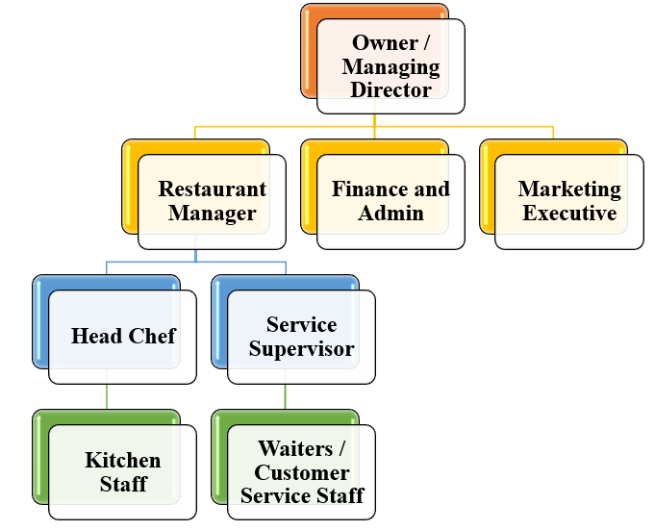
Figure 3: Organisational Chart for Indian Room Restaurant
(Source: Self-Created)

Key Milestones
Milestones | Month 1 | Month 2 | Month 3 | Month 4 | Month 5 | Month 6 | Month 7 | Month 8 | Month 9 | Month 10 | Month 11 | Month 12
Business registration, location selection and funding
Restaurant renovation, staff recruitment and supplier agreements
Staff training, marketing campaign launch and menu testing
Official restaurant opening
Achieve break-even, expand online delivery services and build customer loyalty
Table 6: Key Milestones for Indian Room Restaurant
(Source: Self-Created)

Financial Plan (One Year)

Sources of Finance
- Owner's Personal Investment (Equity)
- Bank Loan
- UK Start Up Loan
- Family and Friends Investment
- Business Grants
- Trade Credit
- Equipment Finance/Leasing
- Retained Profits

Cash Flow Forecast
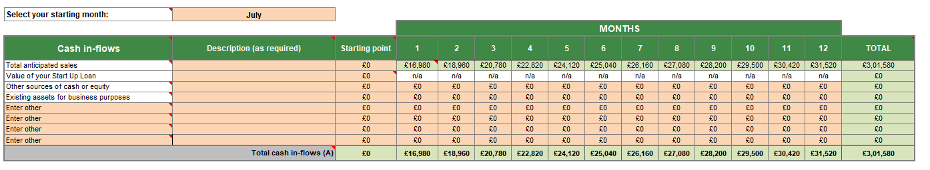
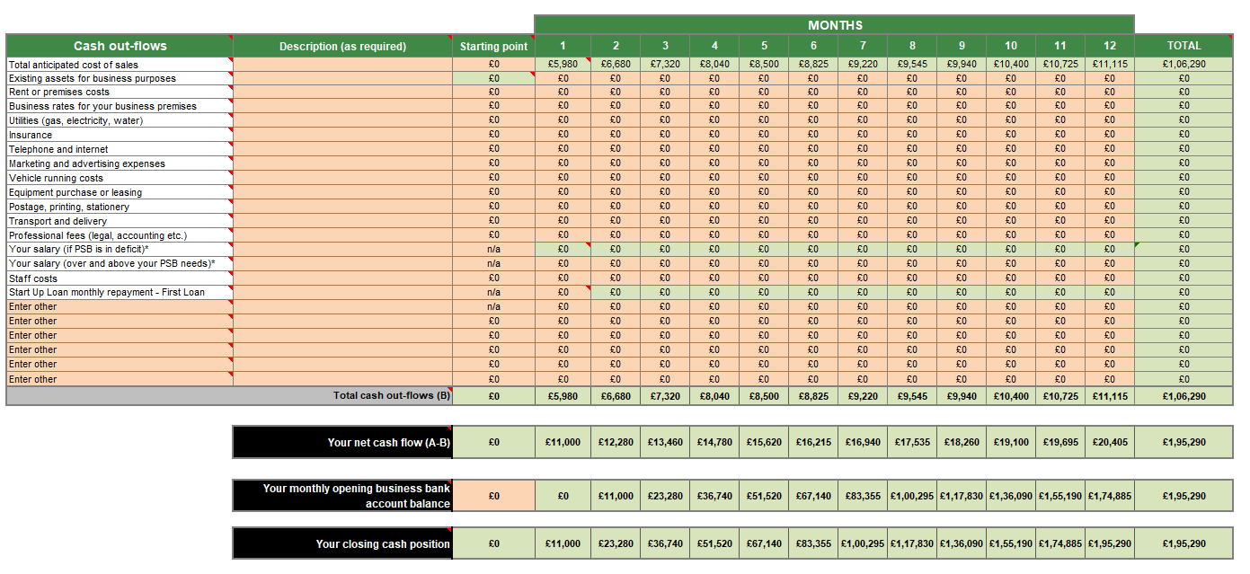
Figure 4: Cash in-flows and Cash out-flows of Indian Room Restaurant
(Source: Self-Created)
The cash flow forecast helps to reflect the sufficient funding for covering the operating expenses with maintaining positive cash balances. It can be noted that increasing monthly sales along with controlled costs helps to support loan repayments, liquidity and sustainable business growth.

Sales Forecast
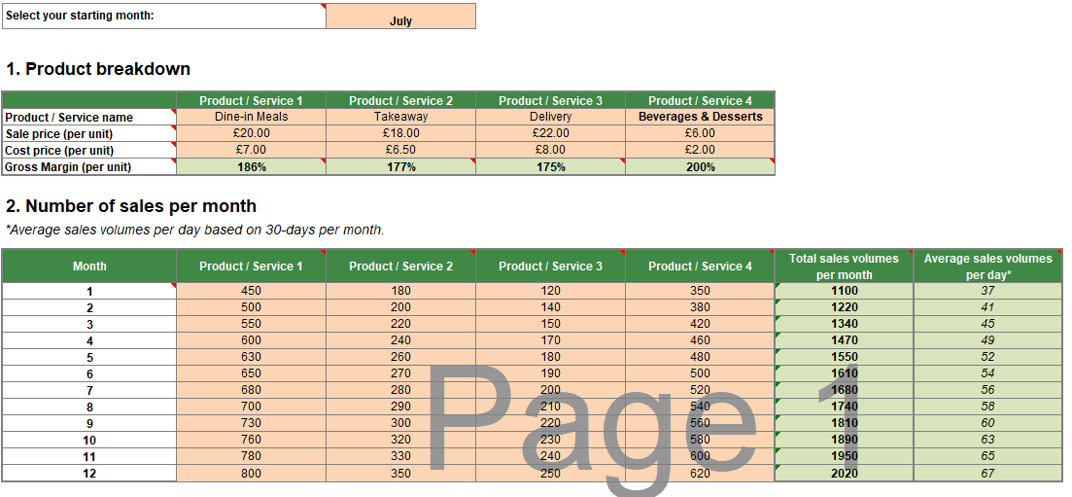
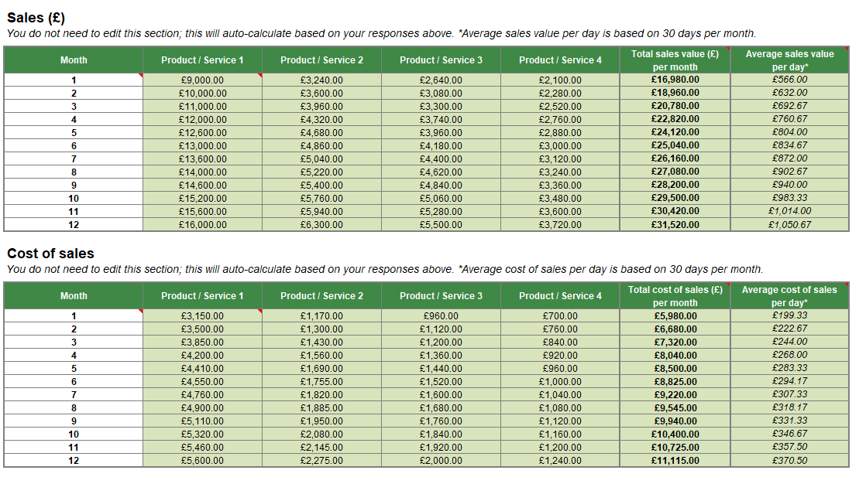
Figure 5: Sales Forecast of Indian Room Restaurant
(Source: Self-Created)
The sales forecast helps to project steady monthly revenue growth by marketing activities, increasing customer demand along with delivery services. Furthermore, achieving higher sales volumes improves cash flow, strengthens profitability and supports long-term sustainability in business.

Cost of Production Forecast
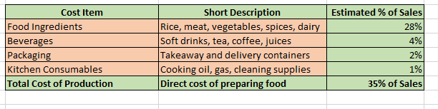
Figure 6: Cost of Production Forecast of Indian Room Restaurant
(Source: Self-Created)
The Cost of Production Forecast helps in estimating that the direct costs of preparing as well as serving food, incorporating beverages, ingredients, kitchen consumables and packaging. The above figure reflects that the costs remains around “35% of sales”, that can enable Indian Room Restaurant to maintain a healthy gross profit margins with efficient inventory management, ensuring quality along with sustainable financial performance in the first year.

Break Even Analysis
The break-even analysis helps in indicating that the Indian Room Restaurant is anticipated to cover the fixed along with variable costs once it achieve stable on the monthly sales level. Effective cost control, increasing customer demand as well as a gross margin of around 65%, Indian Room Restaurant is forecasted to reach its break-even point in the first year, after which it might begin generating profits.

Operations and Management Plan

Production of Good and Service
Indian Room Restaurant will focus on preparing fresh Indian dishes everyday with the usage of high-quality ingredients that are sourced from local, reliable suppliers. Strict food safety procedures, standardised recipes along with quality control measures will be maintained with ensuring hygiene, consistency and customer satisfaction (Okpala and Korzeniowska, 2023). Besides this, services will incorporate takeaway, dine-in, home delivery and online ordering.

Technology Plan
“Point-of-Sale (POS) system”, digital payment facilities, online reservation platform, accounting systems and inventory management software will be adopted. Besides this, a dedicated website and Social media platforms will support customer engagement, online marketing along with food delivery services.

Human Resource Plan
Qualified chefs, servers, cleaners, kitchen assistants and administrative staff will be employed. Employees will receive training on a regular basis in customer service, food hygiene, operational procedures and health and safety. Incentive schemes and performance appraisals will encourage employee retention and motivation in Indian Room Restaurant.

Expansion Plan
Indian Room Restaurant will be expanded by opening additional branches in different major cities in the UK, strengthening online delivery operations, introducing catering services along with developing franchise opportunities to elevate long-term profitability and market presence.

Business Model Canvas
Key partners  Local suppliers  Delivery platforms  Farmers | Key Activities  Cooking  Serving  Marketing  Delivery | Value Proposition  Authentic Indian food  High quality  Affordability | Customer Relationships  Friendly service  Loyalty programme | Customer Segments  Families  Professionals  Students  Tourists
Key partners  Local suppliers  Delivery platforms  Farmers | Key Resources  Staff  Kitchen  Recipes  Premises |  | Channels  Restaurant  Website  Social Media  Delivery Apps
Cost Structure  Rent  Salaries  Ingredients  Utilities  Marketing |  |  | Revenue Streams  Dine-in  Takeaway  Delivery  Catering
Table 7: Business Model Canvas for Indian Room Restaurant
(Source: Self-Created)

Reference List
Transparency International, (2026). “Our Work In United Kingdom”. Available at: https://www.transparency.org/en/countries/united-kingdom [Accessed on: 13th July 2026]
Department for Business & Trade (2026). “Trade and investment core statistics book”. Available at: https://www.gov.uk/government/statistics/trade-and-investment-core-statistics-book/trade-and-investment-core-statistics-book [Accessed on: 13th July 2026]
Office for National Statistics, (2026). “Gross Domestic Product (GDP)”. Available at: https://www.ons.gov.uk/economy/grossdomesticproductgdp [Accessed on: 13th July 2026]
Office for National Statistics, (2026). “Inflation and price indices”. Available at: https://www.ons.gov.uk/economy/inflationandpriceindices [Accessed on: 13th July 2026]
Worldometers, (2026). “U.K. Population”. Available at: https://www.worldometers.info/world-population/uk-population/ [Accessed on: 13th July 2026]
Office for National Statistics, (2025). “Management practices and the adoption of technology and artificial intelligence in UK firms: 2023”. Available at: https://www.ons.gov.uk/economy/economicoutputandproductivity/productivitymeasures/articles/managementpracticesandtheadoptionoftechnologyandartificialintelligenceinukfirms2023/2025-03-24 [Accessed on: 13th July 2026]
Ministry of Justice, (2024). “Climate change and sustainability strategy”. Available at: https://www.gov.uk/government/publications/climate-change-and-sustainability-strategy-moj/climate-change-and-sustainability-strategy [Accessed on: 13th July 2026]
legislation.gov.uk, (2026). “Companies Act 2006”. Available at: https://www.legislation.gov.uk/ukpga/2006/46/contents [Accessed on: 13th July 2026]
legislation.gov.uk, (2026). “Consumer Rights Act 2015”. Available at: https://www.legislation.gov.uk/ukpga/2015/15/contents [Accessed on: 13th July 2026]
Mordor Intelligence, (2026). “UNITED KINGDOM QUICK SERVICE RESTAURANT MARKET SIZE & SHARE ANALYSIS - GROWTH TRENDS AND FORECAST (2026 - 2031)”. Available at: https://www.mordorintelligence.com/industry-reports/united-kingdom-quick-service-restaurant-market [Accessed on: 13th July 2026]
Okpala, C.O.R. and Korzeniowska, M., 2023. Understanding the relevance of quality management in agro-food product industry: From ethical considerations to assuring food hygiene quality safety standards and its associated processes. Food Reviews International, 39(4), pp.1879-1952. https://www.tandfonline.com/doi/pdf/10.1080/87559129.2021.1938600
Marinakou, E. and Giousmpasoglou, C., 2022. Chefs' competencies: a stakeholder's perspective. Journal of Hospitality and Tourism Insights, 5(1), pp.205-229. http://eprints.bournemouth.ac.uk/34812/1/JHTI-06-2020-0101.R2_Proof_hi.pdf

Appendices:
Production Forecast
Sales Assumption and Cash Flow Forecast

