1/16/2024
Intro to Web and Database Concepts (ACCA4023)
Assessment 1
Aliu Djalo (2117368)

University of wales trinity saint david

Table of Contents:
Introduction………………………………………………………………………………………………… 2
Section 1: Requirements. 2
Section 2: Implementation. 2
❖ Validation: 5
Evaluation Section. 5
a. Website Usability; Accessibility; Search Engine Optimisation (SEO). 5
b. Evaluation of completed Website: 6
1. Usability and Utility: [15] 6
2. Search Engine Optimisation (SEO): 7
3. Accessibility: 7
Appendices: 8

Introduction

The intention of this report is to explain the work carried out to develop a website for tourists to make various bookings and holiday packages.

Section 1: Requirements.
The website was designed with tourists in mind who want to have the option to view different vacation packages along the cost of Wales. Packages can include hotel stay that also includes an activity such as speed boat experience along the coast.
The website is linked to different other websites such as (Hotels.com, Airbnb, Plum Guide, UberEATS). Visitors can choose packages based on availability and price.
The target audience is for anyone who is looking for adventure and loves to be outside in the fresh air, taking in the natural beauty of the coastline and rivers of Wales. The packages on offer are suitable for solo travellers or for group bookings.
The website has a support service on offer to the user, so if they want to speak with customer services about anything to do with their booking, they are contactable through various means, e.g., telephone, email etc. [1]

Section 2: Implementation.
- Index Page: this page contains the menu tab and some text about the website.
The background-Image was created using this website. [2]
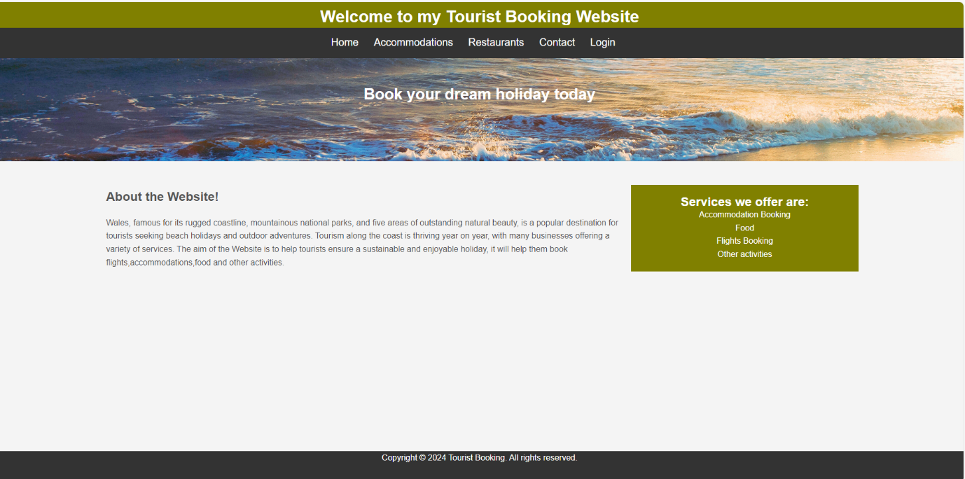

- Accommodation Page: It contains options to choose a type of stay and click on the button “Book Now” that will take you to other booking websites to reserve a stay of your choice. [3]
The Images were downloaded in this website. [4]
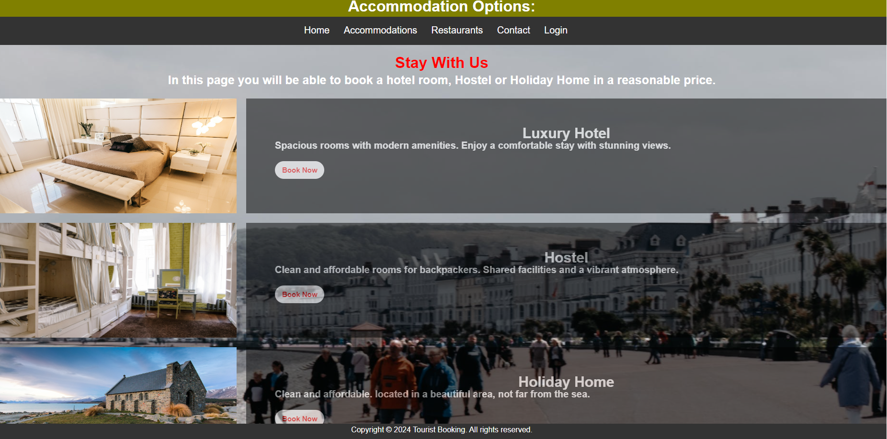

- Page Restaurants: In this page the visitor will be able to order food online by clicking on the “click here to make your order” button. [5]
The image used on the background was downloaded here. [4]
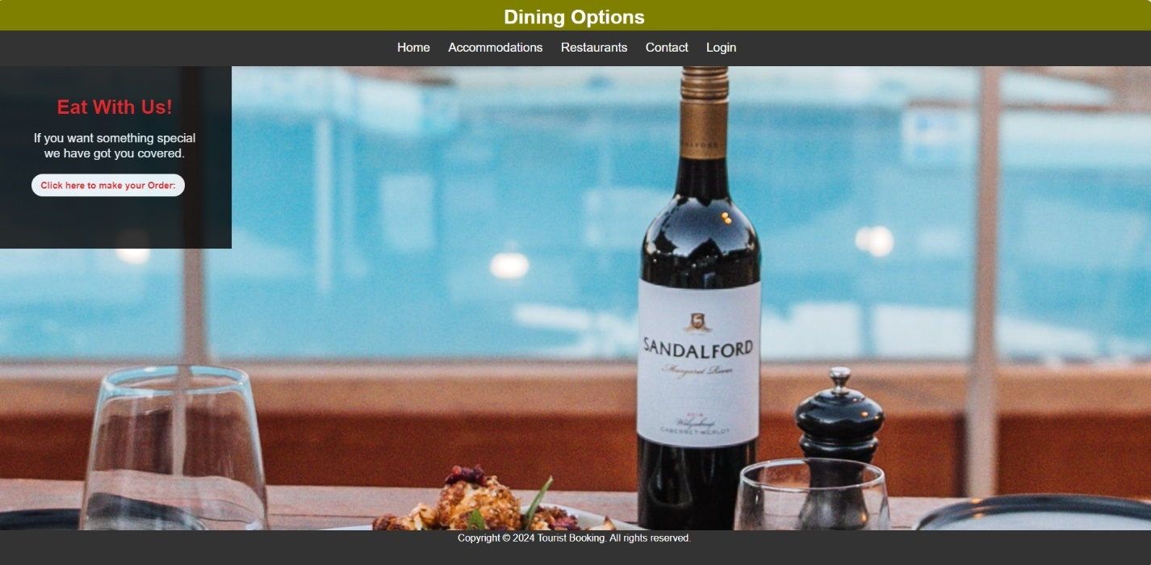

- Contact Page: Visitor will be able to contact the customer service about any concern. [6]
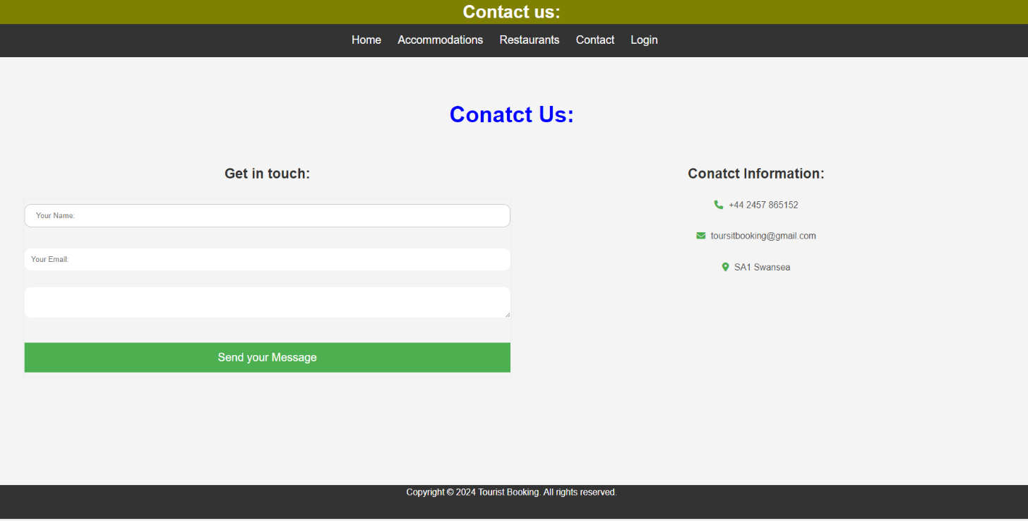

- Login Page: In this page, tourist will be able to login and reset password. [7]
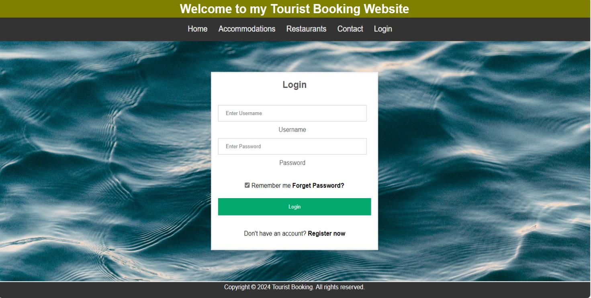
The background image was downloaded in this website. [4]

Validation:
The validation of the website has been conducted and a brief description of the errors and how they were corrected will be explained below. [8]
- Index page:
- Description: the error suggests using the <h1> element as a top-level heading only.
- Correction: The author has not done any correction in this error; the reason is because he thinks it is not a huge error, but he might be wrong.
- Description: it was recommended to declare the language of the document using the “lang” attribute.
- Correction: The attribute was added on <html> tag. <html lang="en">
- Accommodation page:
- Description: The warning indicates the presence of trailing slashes on void elements, which may not be necessary and can cause issues.
- Correction: Trailing slashes were removed from void elements like <br> instead of <br/>.

Evaluation Section.
The following are all very important when analysing the quality of a website:

Website Usability; Accessibility; Search Engine Optimisation (SEO).
Website usability: this primarily refers to how easy it is for users to navigate a website and accomplish their goals of what they want to do on a particular website, e.g. purchase a kettle. Ensuring that a website is user-friendly is vitally important if a company wants customers to return time and time again and convert clicks into sales when selling products and services. If users can easily navigate your website and find what they're looking for, they're more likely to convert. [9]
A well-designed website also takes into consideration its accessibility to a variety of disabled users. By having an accessible site, it allows companies to reach more people and be more inclusive.
Useability is an iterative process and requires constant testing and refining to ensure that user experience is always positive. [10]
Accessibility: is primarily about people and barriers to participation. It is the practice of making websites usable for all visitors, including those with disabilities, impairments, and limitations. [11]
Most common accessibility issues are: [12]
• Insufficient colour contrast
• Missing alternative text on images
• Lack of keyboard access
• No captions, transcripts, or audio descriptions on videos
• Incorrect heading structures
• Missing form field labels and inaccessible error messages
There are four main guiding principles of accessibility upon which WCAG has been built. These four principles are known by the acronym POUR:
Perceivable: content is presented in ways that can be accessed by all, not everyone accesses content using vision and companies should not make that assumption.
Operable: content is presented in ways that can be operated by all, not everyone interacts with content using a keyboard and mouse.
Understandable: content is presented in ways that can be understood by all, it should not confuse or be difficult to understand.
Robust: content is reliable and compatible to a wide variety of devices, assistive technology, and standards. [13]
Search Engine Optimisation (SEO): Search engines like Google favour websites that deliver a positive user experience. Good usability can actually lead to better rankings in search results. [14]

Evaluation of completed Website:

Usability and Utility: [15]
- Navigation: The navigation bar is well-structed with clear links, making it easy for users to access different pages of the website.
- Consistency: The overall layout is consistent, same header and footer design are maintained throughout the website.
- Reliability: The font size and color choices are reasonable.
- Clarity: the content is clear and provides a brief introduction to the purpose of the website.
- Responsive Design: The website has been tested on different devices (desktop and tablet).

- Recommendations for further improvements:
Consider integrating social media links or feeds to enhance user engagement, ensure a high contrast between text and background for better visual, provide more information about services offered, to incorporate more appealing images and to conduct various usability testing on different devices.

Search Engine Optimisation (SEO):
(SEO) techniques that are applied to the website are:
- Title Tag: Which is considered the first step in on-page SEO.
- Meta description: The author included a meta description, providing a summary of the website’s purpose.
- Heading Tags: The author has used (H1) as heading tags.
- Image Alt Attributes: Alt attributes are present which is a good for accessibility and SEO.
- URL Structure: The URLs are clean and descriptive, which is good for user and SEO.
- Internal Linking: They are used in the navigation bar.
- Relevant keywords: a meaningful text is used in the index page, which helps on the SEO.
- Responsive design: On the CSS file, a responsive design is used to ensure a good user experience on various devices. [16]

Accessibility:
- Perceivable:
- The use of appropriate heading tags (h1, h2) provides a structured and easily perceivable hierarchy of information.
- Alt attributes for images are used to unsure that non-text content is perceivable by screen readers.

- Operable:
- The navigation is operable through both mouse and keyboard.

- Understandable:
- The content is well-organized and understandable with clear headings and descriptive link text.
- The navigation is straightforward and predictable which contributes to a more understandable user experience.

- Robust:
- The use of proper HTML structure and testing on different browsers contributes to the robustness of the website. [17]

Appendices:

- Index Page:
<!DOCTYPE html>
<html>
<head>
<meta charset="utf-8" />
<title>Tourist Website</title>
<link rel="stylesheet" type="text/css"
href="Style.css">
</head>
<body>
<header id="main-header">
<div class="container">
<h1>Welcome to my Tourist Booking Website</h1>
</div>
</header>

<nav id="navbar">
<div class="container">
<ul>
<li><a href="#">Home</a></li>
<li><a href="accommodation.html">Accommodations</a></li>
<li><a href="restaurants.html">Resraurants</a></li>
<li><a href="contact.html">Contact</a></li>
<li><a href="login.html">Login</a></li>
</ul>
</div>
</nav>

<section id="showcase">
<div class="container">
<h1> Book your dream holiday today
</h1>
</div>
</section>

<div class="container">
<section id="main">
<h1>About the Website!</h1><br/>
<p>Wales, famous for its rugged coastline, mountainous national parks, and five areas of outstanding natural beauty, is a popular destination for tourists seeking beach holidays and outdoor adventures. Tourism along the coast is thriving year on year, with many businesses offering a variety of services.
The aim of the Website is to help tourists ensure a sustainable and enjoyable holiday, it will help them book flights,accommodations,food and other activities.
</p>
</section>

<aside id="sidebar">
<h2>Services we offer are:</h2>
<ol>
<li>Accommodation Booking</li>
<li>Food</li>
<li>Flights Booking</li>
<li>Other activities</li>

</ol>
</aside>
</div>

<footer id="main-footer">
<p>Copyright &copy; 2024 Tourist Booking. All rights reserved.</p>
</footer>
</body>
</html>
- Accommodation Page:
<!DOCTYPE html>
<html lang="en">
<head>
<meta charset="utf-8">
<title>Tourist Website</title>
<link rel="stylesheet" type="text/css"
href="Style.css">

</head>
<body>
<header id="main-header">
<div class="container">
<h1>Accommodation Options:</h1>
</div>
</header>

<nav id="navbar">
<div class="container">
<ul>
<li><a href="index.html">Home</a></li>
<li><a href="#">Accommodations</a></li>
<li><a href="restaurants.html">Restaurants</a></li>
<li><a href="contact.html">Contact</a></li>
<li><a href="login.html">Login</a></li>
</ul>
</div>
</nav>
<div class="body">
<div class="heading"><br>
<h1>Stay With Us</h1>
<p>In this page you will be able to book a hotel room, Hostel or Holiday Home in a reasonable price.</p>
<br>
</div>

<section class="accommodation-content">

<div class="accommodation-item">
<img src="./Images/pexels-jonathan-borba-3144580.jpg" alt="Hotel Room">
<div class="description">
<h2>Luxury Hotel</h2>
<p>Spacious rooms with modern amenities. Enjoy a comfortable stay with stunning views.</p><br>
<a href="https://uk.hotels.com/Hotel-Search?adults=1&children=&destination=Wales%2C+United+Kingdom&endDate=2024-01-28&gclid=3bb86c66a93815b587fb09c742a2c07a&gclsrc=3p.ds&latLong=&locale=en_GB&mapBounds=&msclkid=3bb86c66a93815b587fb09c742a2c07a&pwaDialog=&regionId=11220&semcid=HCOM-UK.UB.BING.DT-c-EN.HOTEL&semdtl=a1410735203.b11338106947538855.g1kwd-83632523296445%3Aloc-188.e1c.m13bb86c66a93815b587fb09c742a2c07a.r1718a3466417d34e168b673f8010938a128101cb5811934993d01a5009271b3f4.c18tnNBX-75mU4rBEcFxNsSQ.j141471.k14139.d183631865784026.h1e.i1.l1.n1.o1.p1.q1.s1.t1.x1.f1.u1.v1.w1&siteid=300000005&startDate=2024-01-27">Book Now</a>
</div>
</div>

<div class="accommodation-item">
<img src="./Images/pexels-cottonbro-studio-5137980.jpg" alt="Hostel Room">
<div class="description">
<h2>Hostel</h2>
<p>Clean and affordable rooms for backpackers. Shared facilities and a vibrant atmosphere.</p><br>
<a href="https://www.airbnb.co.uk/a/discover/?account_id=142001801&campaign_id=380399330&ad_id=81295252727418&ad_group_id=1300722480043717&keyword_id=kwd-81295386733010:loc-188&device=c&&c=.pi2.pk380399330_1300722480043717&gclid=51b9688e7ed314b3d5d10d2f92988660&gclsrc=3p.ds&msclkid=51b9688e7ed314b3d5d10d2f92988660&utm_source=bing&utm_medium=cpc&utm_campaign=GBR%3ADTM%3AGENERIC%5BBMM%5D&utm_term=hostels&utm_content=Generic%3AHostels%2BBMM%3ASKAG%3AHostels&gclid=51b9688e7ed314b3d5d10d2f92988660&gclsrc=3p.ds">Book Now</a>
</div>
</div>

<div class="accommodation-item">
<img src="./Images/pexels-pixabay-417315.jpg" alt="Holiday Home">
<div class="description">
<h2>Holiday Home</h2>
<p>Clean and affordable. located in a beautiful area, not far from the sea.</p><br>
<a href="https://www.plumguide.com/search?account=PlumguideUnitedKingdom&device=c&location=Wales--United-Kingdom&msclkid=68574f4937a01243ee702ae8db455204&placeId=ChIJ7Q8cbLY0ZEgRouilirxxux4&uc=&utm_campaign=UK_UK_HIGH_E&utm_content=HolidayHome_Wales_2001_gb&utm_medium=PPCGeneric&utm_source=bing">Book Now</a>
</div>
</div>
</section>
</div>
<footer id="main-footer">
<p>Copyright &copy; 2024 Tourist Booking. All rights reserved.</p>
</footer>
</body>
</html>

- Restaurants:
<!DOCTYPE html>
<html lang="en">
<head>
<meta charset="utf-8">
<title>Tourist Website</title>
<link rel="stylesheet" type="text/css"
href="Style.css">

<style>
body{
background-image: url('./Images/pexels-rachel-claire-6126306.jpg');
background-repeat: no-repeat;
background-position: center;
background-size: auto;
}
.Welc{
width: 380px;
height: 300px;
background-color: black;
opacity: 0.8;
padding: 55px;
}
.Welc h1{
text-align: center;
color: red;
}
.Welc p{
font-size: 20px;
color: white;
text-align: center;

}
.Welc a{
color: red;
font-weight: bold;
font-size: 15px;
border-radius: 30px;
padding: 10px 15px;
background-color: #fff;

}
</style>
</head>
<body>
<header id="main-header">
<div class="container">
<h1>Dining Options</h1>
</div>
</header>

<nav id="navbar">
<div class="container">
<ul>
<li><a href="index.html">Home</a></li>
<li><a href="accommodation.html">Accommodations</a></li>
<li><a href="#">Restaurants</a></li>
<li><a href="contact.html">Contact</a></li>
<li><a href="login.html">Login</a></li>
</ul>
</div>
</nav>
<div class="Welc">
<h1>Eat With Us!</h1><br>
<p>If you want something special we have got you covered.</p><br>
<a href="https://www.ubereats.com/gb?utm_source=Bing_NonBrand&utm_campaign=CM2336905-search-bing-nonbrand_184_-99_GB-National_e_web_acq_cpc_en_T1_Competitors_Exact_just%20eat_kwd-77790872941182:loc-188__1244648466512978_e_c&campaign_id=638335063&adg_id=1244648466512978&fi_id=&match=e&net=o&dev=c&dev_m=&ad_id=&cre=&kwid=kwd-77790872941182:loc-188&kw=just%20eat&placement=&tar=&gclid=670b0398351b1524cdc8663ae9ed5439&gclsrc=3p.ds&msclkid=670b0398351b1524cdc8663ae9ed5439">Click here to make your Order:</a>

</div>

<footer id="main-footer">
<p>Copyright &copy; 2024 Tourist Booking. All rights reserved.</p>
</footer>
</body>
</html>
- Contacts:
<!DOCTYPE html>
<html lang="en">
<head>
<meta charset="utf-8">
<title>Tourist Website</title>
<link rel="stylesheet" type="text/css"
href="Style.css">
<link rel="stylesheet" type="text/css"
href="https://cdnjs.cloudflare.com/ajax/libs/font-awesome/6.5.1/css/all.min.css">
<Style>

*{
margin: 0px;
padding: 0px;
box-sizing: border-box;
font-family: sans-serif;
}
.cont{
min-height:100vh;
background-color: lighter;
padding:50px;
text-align: center;
}

.cont1 h1{
font-size: 40px;
margin-bottom: 80px;
margin-top: 40px;
color: blue;
}
.cont-wp{
display: grid;
grid-template-columns: repeat(2,1fr);

}
.cont-f{
text-align: 40px;
}
.cont-f h2{
margin-bottom: 30px;
color: #333;
font-size: 25px;
}
.f-gr{
margin-bottom: 30px;
}
input, textarea{
width: 100%;
padding: 12px;
border-radius: 12px;
border:none;
background-color: white;
color: #333;
}
input:focus,
textarea:focus{
outline: none;
box-shadow: 0 0 8px #bbb;
}
button{
display: inline-black;
padding: 15px 24px;
background-color: #4caf50;
color: #fff;
border: none;
cursor: pointer;
font-size: 20px;

}
.cont-info{
text-align: 20px;
}
.cont-info h2{
font-size: 25px;
margin-bottom: 30px;
color: #333;
}
.cont-info p{
margin-bottom: 30px;

}
.cont-info i{
color:#4caf50;
margin-right: 10px;
}
@media screen and (max-width: 768px){
.cont1{
padding: 20px;
}
.cont-wp{
grid-template-columns: 1fr;

}
}
</Style>
</head>
<body>
<header id="main-header">
<div class="container">
<h1>Contact us:</h1>
</div>
</header>

<nav id="navbar">
<div class="container">
<ul>
<li><a href="index.html">Home</a></li>
<li><a href="accommodation.html">Accommodations</a></li>
<li><a href="restaurants.html">Restaurants</a></li>
<li><a href="#">Contact</a></li>
<li><a href="login.html">Login</a></li>
</ul>
</div>
</nav>

<section class="cont">
<div class="cont1">
<h1>Conatct Us:</h1>
<div class="cont-wp">
<div class="cont-f">
<h2>Get in touch:</h2>
<form>
<div class="f-gr">
<input type="text" name="name" placeholder="Your Name:">
</div>
<div class="f-gr">
<input type="email" name="email" placeholder="Your Email:">
</div>
<div class="f-gr">
<textarea name="name" placeholder="Your Message:"> </textarea>
</div>
<button type="submit">Send your Message</button>
</form>
</div>
<div class="cont-info">
<h2>Conatct Information:</h2>
<p><i class="fas fa-phone"></i>+44 2457 865152</p>
<p><i class="fas fa-envelope"></i>toursitbooking@gmail.com</p>
<p><i class="fas fa-map-marker-alt"></i>SA1 Swansea</p>
</div>
</div>
</div>
</section>

<footer id="main-footer">
<p>Copyright &copy; 2024 Tourist Booking. All rights reserved.</p>
</footer>
</body>
</html>
- Login:
<!DOCTYPE html>
<html lang="en">
<head>
<meta charset="utf-8">
<title>Tourist Website</title>
<link rel="stylesheet" type="text/css"
href="Style.css">
</head>
<body>
<header id="main-header">
<div class="container">
<h1>Welcome to my Tourist Booking Website</h1>
</div>
</header>

<nav id="navbar">
<div class="container">
<ul>
<li><a href="index.html">Home</a></li>
<li><a href="accommodation.html">Accommodations</a></li>
<li><a href="restaurants.html">Restaurants</a></li>
<li><a href="contact.html">Contact</a></li>
<li><a href="#">Login</a></li>
</ul>
</div>
</nav>
<div class="login">
<form action="" method="post">
<div class="login-form">
<h2>Login</h2>
<div class="Input-box">
<input type="text" placeholder="Enter Username" name="uname" required>
<label>Username</label>
<input type="password" placeholder="Enter Password" name="psw" required>
<label>Password</label>
</div>
<div class="reminder">
<label>
<input type="checkbox" checked="checked" name="remember"> Remember me
</label>
<a href="#">Forget Password?</a>
</div>
<button type="submit">Login</button>
<div class="register">
<p>Don't have an account? <a href="#">Register now</a></p>
</div>
</div>
</form>
</div>

<footer id="main-footer">
<p>Copyright &copy; 2024 Tourist Booking. All rights reserved.</p>
</footer>
</body>
</html>
- CSS:
body{
background-color:#f4f4f4;
color:#555;
font-family:Arial, Helvetica, san-serif;
font-size:16px;
line-height:1.6em;
margin:0;
}

.container{
width:80%;
margin:auto;
overflow:hidden;
}

#main-header{
background-color:olive;
color:#fff;
text-align: center;
height: 50px;

}

#navbar{
background-color:#333;
color:#fff;
text-align: center;

}

#navbar ul{
padding:0;
/*height: 50px;*/
list-style: none;

}

#navbar li{
display:inline;
}

#navbar a{
font-size:20px;
padding-right:25px;

}

a{
color:white;
text-decoration: none;
}

a:hover{
color:yellow;
}

#main-footer {
position: fixed;
left: 0;
bottom: 0;
width: 100%;
height: 40px;
background:#333;
color:#fff;
text-align:center;

}

#main{
float:left;
width:70%;
padding:10px;
box-sizing: border-box;
}

#sidebar{
float:right;
width:30%;
background:olive;
color:#fff;
padding:20px;
box-sizing: border-box;
text-align: center;
}

#showcase{
background-image:url("./Images/Webpage background 2.PNG");
background-repeat: no-repeat;
background-size: auto;
opacity:1.0;
background-position:center right;
min-height:200px;
margin-bottom:30px;
text-align:center;
}

#showcase h1{
color:#fff;
font-size:30px;
line-height:1.6em;
padding:30px;
}

@media only screen and (max-width:600px){
#main{
width:100%;
float:none;
}

#sidebar{
width:100%;
float:none;
}

#navbar li{
display:block;
}
}

*{
padding: 0px;
margin: 0px;
box-sizing: border-box;
list-style: none;
font-family: sans-serif;

}
/*Accommodation page style*/
.body{
height: 100%;
justify-content: space-around;
align-items: center;
background-image:url("./Images/pexels-lisa-fotios-17428255.jpg");
background-repeat: no-repeat;
background-size: auto;
background-position: center;

}

.heading{
text-align: center;
}
.heading h1{
color: red;
padding-bottom: 10px;

}
.heading p{
font-size: 25px;
color: white;
text-align: center;
font-weight: bold;

}

.description a:hover{
letter-spacing: 3px;
transition: 0.6s;
}

.accommodation-item{
display: flex;
margin-bottom: 20px;

}

.accommodation-item img{
width: 500px;
height: 240px;
margin-right: 20px;
}

.description {
flex: 1;
width: 200px;
height: 240px;
background-color: black;
opacity: 0.5;
padding: 60px;
font-weight: bold;
}
.description h2{
text-align: center;
color: white;
font-size: 30px;
}
.description p{
font-size: 20px;
color: white;
}
.description a{
color: red;
font-weight: bold;
font-size: 15px;
border-radius: 30px;
padding: 10px 15px;
background-color: #fff;

}
.description a:hover{
letter-spacing: 1.5px;
transition: 0.6s;
}
@media (max-width: 600px) {
.accommodation-item{
flex-direction: column;
}

.accommodation-item img{
margin-right: 0;
margin-bottom: 10px;
}
}

.login{
font-family: Arial, sans-serif;
margin: 0;
padding: 0;
display: flex;
align-items: center;
justify-content: center;
height: 80vh;
text-align: center;
background-image:url("./Images/pexels-matt-hardy-3560168.jpg");
background-repeat: no-repeat;
background-size: cover;
background-position: center;

}

.reminder {
font-size: 16px;
color: black;
margin: 25px 0 10px;
}

.reminder a {
color: black;
font-weight: 600;
}
.register{
font-size: 16px;
color: black;
margin: 25px 0 10px;
}
.register p a {
color: black;
font-weight: 600;

}
.Input-box {
width: 400px;
margin: 30px 0;
border-bottom: 2px solid white;
}

.login-form {
border: 3px solid #f1f1f1;
width: 450px;
background-color: #ffffff;
padding: 16px;
box-shadow: 0 0 10px rgba(0, 0, 0, 0.1);
}

input[type=text], input[type=password] {
width: 100%;
padding: 12px 20px;
margin: 8px 0;
display: inline-block;
border: 1px solid #ccc;
box-sizing: border-box;
}

button {
background-color: #04AA6D;
color: white;
padding: 14px 20px;
margin: 8px 0;
border: none;
cursor: pointer;
width: 100%;
}
button:hover {
opacity: 0.8;
}

.container {
padding: 16px;
}

span.psw {
float: right;
padding-top: 16px;
color: black;
}

@media screen and (max-width: 300px) {
reminder.a {
display: block;
float: none;
}

References:
[1]. Calming seaside towns. Available: https://www.visitwales.com/inspire-me/holidays/weekend-itinerary-coastal-mid-wales?gclid=a942bf6f1fa21bcb3318daea43d3fd9a&gclsrc=3p.ds&msclkid=a942bf6f1fa21bcb3318daea43d3fd9a&utm_source=bing&utm_medium=cpc&utm_campaign=Generics%20-%20Mid%20Wales%20-%20Broad&utm_term=mid-wales&utm_content=DSA.
[2] . What will you design today?. Available: https://www.canva.com/en_gb/.
[3] 17 May, 2021.
[4] Anonymous (). Free Stock Photos, Royalty Free Stock Images & Copyright Free Pictures · Pexels. Available: https://www.pexels.com/.
[5] 15 Jun, 2019.
[6] 25 May, 2023.
[7] Anonymous (). How To Create a Login Form. Available: https://www.w3schools.com/howto/howto_css_login_form.asp.
[8] Anonymous Anonymous The W3C markup validation service. The W3C markup validation service. Available: https://validator.w3.org/.
[9] Interaction Design Foundation. (). What is Usability - The Ultimate Guide. Available: https://www.interaction-design.org/literature/topics/usability.
[10] Sabina Idler. (-09-30T13:00:00+00:00). Principles of Website Usability | 5 Key Principles Of Good Website Usability. Available: https://www.crazyegg.com/blog/principles-website-usability/.
[11] 02/21/23, 02/21/23.
[12] Anonymous Anonymous WebAIM: Community. WebAIM: Community. Available: https://webaim.org/community/.
[13] W3C. W3C. Introduction to understanding WCAG 2.0 | understanding WCAG 2.0. Introduction to understanding WCAG 2.0 | understanding WCAG 2.0. 2023. Available: https://www.w3.org/TR/UNDERSTANDING-WCAG20/intro.html.
[14] W. c. Team. W. c. Team. Understanding search engine optimization: What is SEO? Understanding search engine optimization: What is SEO? 2023. Available: https://www.web.com/blog/what-is-seo/.
[15] L. Zappa. (-02-01T08:49:08+00:00). Website usability | Common usability issues | Examples | Testing and benefits. Available: https://userreport.com/blog/website-usability/.
[16] (Jul 4,). he Role of SEO in Web Development: Optimizing for Search Engines. Available: https://www.linkedin.com/pulse/role-seo-web-development-optimizing-search-engines-krishna-r/.
[17] W. W. A. I. (WAI) and Editor: Shawn Lawton Henry. (November 20,). Introduction to Web Accessibility. Available: https://www.w3.org/WAI/fundamentals/accessibility-intro/.

