
- B a c k g r o u n d o f t h e
- o r g a n i z a t i o n ;

- T h e c h a l l e n ges b e f o r e t h e I n t r o d u c tion o f modern t e c h n o l o g y ;

- I n s i g h t s t o modern technology i n t r o d u c e d ;

- T h e i m p a c t o f technology i n t r o d u c e d ;

- Lessons th a t c a n b e d r a w
- Fro m t h e c a s e s t u d y .

GROUP
PRESENTATION

NAMES OF GROUP PRESENTATION :

-VITALBA LEONE -MIHAITA MUNTEANU -SEAN FERGUSON -STOYAN
GROZDANOV

-MIRISH SALIEVA

- .July 5, 1948, became a historic moment in British history because the health and care was only accessible to people who could pay were available to everyone.
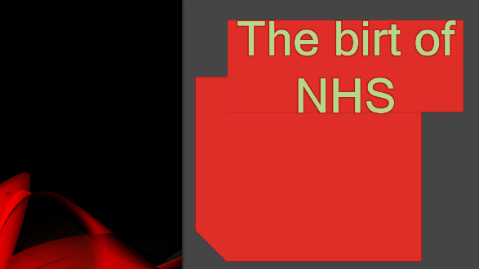


- The first meeting of the "The state medical service association" took place in 1912 .

.ON JULY 5, 1948, SYLVIA BECKINGHAM WAS HOSPITALIZED IN MANCHESTER FOR LIVER DISEASE TREATMENTS AND WAS THE FIRST PATIENT TO BE TREATED BY THE NHS.

 .The national health system was launched in  the post-war Attlee government, the need to create the NHS was thought because the system in that time was insufficient and therefore needed a change.


- _IN 1945, THE NEW LABOR GOVERNMENT ENTERED INTO A MANIFESTO THAT PROMISED A REVOLUTION IN HEALTH, ANEURIN

BEVAN, MINISTER OF HEALTH, HAD THE AMBITION TO BUILD A HEALTH SERVICE BASED ON THE PRINCIPLES WHICH SHOULD BE FREE OF USE, AVAILABLE FOR ALL THOSE WHO THEY NEEDED, PAID FOR GENERAL
 | - 1948-1957 The pharmaceutical |  |  |  |  |  |  |  | TAXATION_
industry
 |  |  | become to create new drugs.
 |  |  |  |  |  |  | The polio |  | with the
 | -Enoch Powell has started the move |  |  |  |  |  | introduction |  |  | of | the vaccine |  | i
 |  |  |  |  |  |  | 1956 almost |  |  | disappeared.
 | towards closing the old asylums.
 |  |  |  |  |  |  | Heart disease, |  |  | tuberculosis,
. In 1962 Powell's hospital plan proposed |  |  |  |  |  |  | and stroke have
 |  |  |  | development of hospitals |  | for
 | the |  |  |  |  | for | experienced a drastic
 | residential areas of approximately
 |  |  |  |  |  |  | decline over the years.
 | 125,000 inhabitants and outlined a
model that went from district to district



THE CHALLENGES BEFORE THEINTRODUCTION OF MODERN TECHNOLOGY

POOR COMMUNICATIONS:

- THE WAY HOW THE PATIENTS INTERACT WITH NHS

- COMMUNICATION INSIDE NHS ORGANIZATION

- COMMUNICATIONS ACROSS NHS ORGANIZATIONS



ADMINISTRATIVE:

1.LOSING TIME AND MONEY

2.STAFF MANAGEMENT

3.RESOURCE MANAGEMENT


POOR EMPLOYER’S
PERFORMANCE:

1.LACK OF TRAINING

2.EMPLOYER SKILLS

3.FEEDBACK


Insights to the modern technology
introduced;

1. Patient friendly technology:

- Modern day technology improves productivity and makes run process easier for parents, care home and hospital.

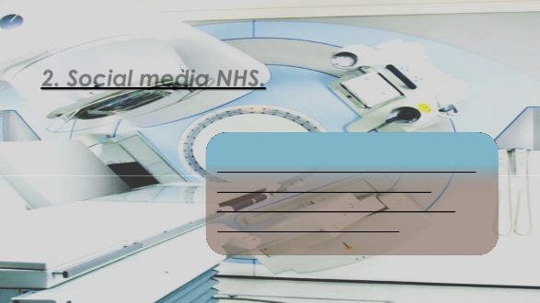

2. Social media NHS.

-Maintains an effective digital communication network allows staff and surgeries to communicate easily.

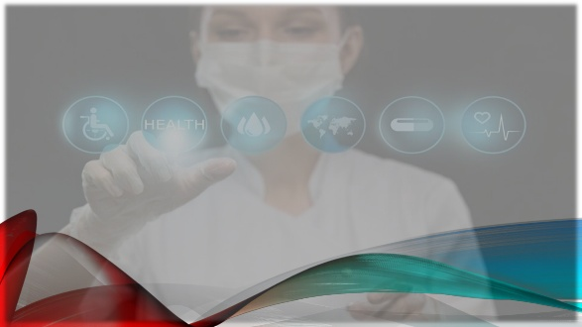

3.Smart phones and tablet
-The communication and future treatments become common used via smart phones, tablets and
computers.

4.Challenge of 2020
-The world pandemic of 2020 challenge the NHS and technical advances for saving lives.


- THE IMPACT OF THE TECHNOLOGY
INTRODUCTION;

1. DELIVERY of BETTER HEALTH CARE

- IMPROVEMENT IN MEDICAL AND TECHNOLOGY CREATES A NEW

OPPORTUNITY FOR SKILLED STAFF.

2.INFORMATIVE STRUCTURE

Includes, digital medicine and effective care with transforming general practice.




3.INTERNAL AND EXTERNAL COMMUNICATION

-Better
management and
human resources
are improving
patients quality.


  - AND LESSON THAT CAN BE DRAW FROM THE CASE STUDY

- Patient and e-Referral Service (e-RS)

The NHS e-Referral Service makes really easy and quick the booking process, both for patient and doctor

2. Sage staffing app

The life is became much easier with in safe staffing app for the all NHS staff.



3. Technology Enable care service

-Whit TECS creation patient traceability and real time monitoring become more effective for patient and care staff

4.The general improvement in NHS with the technology

-Medicine transforms over the 20 years with
Module title- Digital research skills
Module code- BMSW4003
Student name- Vitalba Leone
Student number- 1916153
Lecturer name- Terry Walcott

The birth of the NHS
July 5, 1948, became a historic moment in British history because the health and care only accessible to people who could pay were available to everyone. The national health system was launched in the post-war Attlee government, the need to create the NHS was thought because the system in that time was insufficient and therefore needed a change. Beatrice Webb's 1909 minority report of the royal commission argued that the current system was antiques dating back to the Victorian era but despite strong arguments had not been well taken by the liberal government. Liverpool physicist Dr. Benjiamin Moore had a great vision for the future of health and care, his ideas were reported in "The Down of the health age". The first meeting of the "The state medical service association" took place in 1912 (Brian, 2020). On July 5, 1948, Sylvia Beckingham was hospitalized in Manchester for liver disease treatments and was the first patient to be treated by the NHS. About 2,700 British hospitals were run by charities or councils, the only people who were entitled to free treatment were those who had a job. In 1945, the new Labor government entered into a manifesto that promised a revolution in health, Aneurin Bevan, minister of health, had the ambition to build a health service based on the principles which should be free of use, available for all those who they needed, paid for general taxation (the independent, 2008). 1948-1957 The pharmaceutical industry become to create new drugs like cortisone, mental health tablets like depression, schizophrenia, diuretics, and antihistamines. The introduction of drugs during this decade as the polio vaccine, dialysis for chronic renal failure and chemotherapy for some cancers became available with an increase in costs. Enoch Powell has started the move towards closing the old asylums. Powell's plan aimed the total elimination. In 1962 Powell's hospital plan proposed the development of hospitals for residential areas of approximately 125,000 inhabitants and outlined a model that went from district to district.
the national health service has had a great development over the years, in fact, life expectancy was on the rise, infant deaths had decreased as did the deaths from polio which with the introduction of the vaccine in 1956 almost disappeared. Heart disease, tuberculosis, and stroke have experienced a drastic decline over the years.
List of referencing
Tema sul lavoro ieri e oggi [WWW Document], 2016. . Studentville. URL https://www.studentville.it/studiare/tema-sul-lavoro-ieri-e-oggi/ (accessed 4.22.20).
The birth of the NHS [WWW Document], 2008. The Independent. URL http://www.independent.co.uk/life-style/health-and-families/features/the-birth-of-the-nhs-856091.html (accessed 4.17.20).

The Birth of the NHS [WWW Document], n.d. Historic UK. URL https://www.historic-uk.com/HistoryUK/HistoryofBritain/Birth-of-the-NHS/ (accessed 4.15.20).
Triggle, N., 2018. The history of the NHS in charts. BBC News.

Digital skills and research method
Name student: Mihaita Munteanu
Lecture’s name: Terry Walcott
Student number: 1913128

The challenges before introduction of modern technology
Before introductions of the modern technology the NHS organization faces many issues. Start with 70s the digital era begins to replace the old technology. Before been hard for patients and medical institutions ( GP, hospitals ,ambulance ) to have a efficient communications and this could affect patients life. The new technology give us the advantage to use the online products (mails, appointments online ,resource) witch make our life much easier . One of the bigger advantage of data technology is time and money saving
The way how the clinics work together is essential to deliver the best experience of care for patients. Before introduction of modern technology the main way to communicate was by letters and phones this making time of response to be too long and the communication not the most efficiently one .However the relation between clinical ,hospitals and commercial partners suffering the same problem because of slow communication..
British hospitals are facing a staffing crisis long time before establish of NHS in 1948. One of the bigger problems was low salary level and poor job advertising. However at the begin of NHS didn’t was enough qualified people to work on British hospitals so the government lunch the recruiting campaign from Caribbean (Stephanie Snow, Emma Jones | 08 March 2011).More people training to join NHS every year. Recruiting agency play a major role in training and recruiting staff for NHS. If in the past the recruitment process was difficult now due to new technology is much efficient and the jobs can be advertised in real time. With the new changes the management and human resources can have a better interaction with the staff and potential candidate. Lack of skilled workers was another issue who NHS faced in the past. Online training, meetings, conferences can now be done in real time even if the employees are not in the same location which makes it possible to improve work quality and jobs can be filled more easily by skilled workers. The way how NHS interacts with patients and business partners is reflecting in Feedback. With a low way of communications the Feedback for the patients did not was a priority and this not helping the NHS. The more feedback good or bad an organization receive this help then to improve quality of service provide. On this day the feedback have a major impact.

Digital research skills
Student name- Sean Ferguson
Student number- 1966821
Lecturer- Terry Walcott

Insights into modern technology introduced: NHS

The National health service provides a public funded safety net to the United Kingdom which we heavily rely upon. Vulnerable people depend on this service often with patients desperately needing vital lifesaving treatments and therapies such as chemotherapy and radiotherapy. Modern day technology has been designed to make processes run smoother, faster, safer, and more inaccurately. Further advancements are being developed and older being modified or upgraded to improve productivity be it in care homes or hospitals. The population of the United Kingdom currently stands at approximately 66million people as of 2020 a 24% increase of the estimated population we had in 1948 when the NHS first began. This increase brought a demand for newer, more accessible and efficient forms of communications and treatments in which a huge technological progression would be able to accommodate.

Around 165K people in the UK die each year of cancer making it a Grande 28% of all deaths recorded, but thanks to radiation therapy one of the modern day advancements in radiology we can save many more lives. Patients diagnosed in England and Wales have an approximate 50% chance of surviving of the disease for 10 years or more. Many diseases in the UK are diagnosed and treated via digital communications, tablets and computers applications for smart phones are all common tools of which are easily available. To grow as an organisation the NHS maintains an effective digital communications network which allows digital devices to share data throughout the entire service relaying messages to the patients and the public through digital media. Online prescriptions, medical records and files that would once fill a library have now been uploaded and transferred into virtual records accessible online saving space, time and money. The above-mentioned devices, machines and digital network the NHS provide, and use are not the only forms of technology of which have become a part of daily treatment processes. Here are more examples of some of the most important forms taken in the specialistic settings of surgeries all the way to communicating through social media.

- Patient friendly technology
- Social media
- Staff management technology
- Infection detection technology
- Hybrid operating rooms
- Smartphones and tablets
- Ultrasound devices
- Surgical equipment

“I would not be here today if it were not for the NHS. I have received a large amount of high-quality treatment without which I would not of survived”. (Stephen hawking)

Every day of 2020 has gradually got worse in terms of hospital and care home tragic deaths from the city of Wuhan, China. A pandemic only comparable to that of the Spanish influenza in 1918 has completely taken hold of the NHS which has drained vital resources that are desperately needed to save lives. With the lifesaving technical advances in modern medicines that can be created and used to daily save thousands of lives.
Analysing the data of the organisation I concluded that modern technology is vital for communication and any position held from the patients receiving treatment to the nurses, doctors and healthcare professionals. They working tirelessly around the clock to provide everyone in the United kingdom the same opportunity of receiving effective lifesaving treatments and care of which are all fundamentally organised, orchestrated and run by the use of the modern day technology introduced.

Digital skills and research method
Student name: Stoyan Grozdanov
Student number – 1913753
Lecturer – Terry Walcott

The impact of the technology introduced
Delivery better health care
- Semnificatuv improvements in medical and technology.
- Create new opportunities.
- Skilled staff
Informatics infrastructure
- Digital medicine
- Effective care
- Transforming general practice
- Public trust and security
Internal and external communications
- Improving people/patients quality
- Better management and human resources
- Strengthening the NHS / industry partnership.

Technology is widely used in many areas of life and NHS. Digital technologies bring many opportunities to improve people’s health and experience of service. Digital access to NHS services giving people options for ordering repeat prescriptions and booking appointments in primary care remains low despite. The functionality being widely available.
The technologies now play a key role in the economy and many people everyday lives. Technology made better communication between people and NHS staff, sach as online booking, online appointment, email’s, phones and more..
According to information provided by NHS, as October 2019 96 per cent of GP patients in England can use the NHS app to connect to their practice.
The technology is integral to many of the changes envisaged in the NHS long term plan. This is including ambitions for people in their own homes using remote monitoring and digital tools.

CONCLUSION
LESSONS LEARNED FROM CASE STUDIES
Student name: MIRISH SALIEVA
Student number:1913122
DSR -BMSW4003
Lecture name: Terry Walcott

- Patients and e-Referral Service (e-RS)
- Safe staffing app
- Technology Enable Care Services (TECS)
- Patients and e-Referral Service (e-RS)
- The NHS e-Referral Service makes really easy and quick the booking process, either for the patients or the Doctor. With the old-style paper system, the patients have to wait for referral letter and then plus another 6 to 8 weeks before to received only details about appointment over the hospital. The patients can query the hospital and only to find out that they have not received referral. The electronic system instantly removed the gap and preventing the referral falling through the net. The patients can be provided from the GP with access code, so they can book appointment and reduce waiting time.
- Safe staffing app
- The hospital staff leaders did not have correct information about position and departments on board. The have to entrust on manual examination of staffing levels at some point in the day. The solution comes with an easy to use app for mobile devices covering all departments. Managers and staff can see exact time and positions covered. Staffing changes during shifts are up to date to maintain real live positions. The app has benefits of staff can redirect to place where needed more, can reduce spending with reports from staff leaders about staff levels can be transferred in place where needed rather than booked from an agency. The staffing app include information about supporting training packages and etc.
- Technology Enable Care Services
- The use of TECS application improved patients traceability real time monitoring give the patients chance to interact with the health staff. NHS staff also using TECS as help them to track and manage patient’s health care. The TECS become a challenge for some patients - some patients did not want to use digital application as they well know their condition. Study case show that some other patients did not know how to use technology and prefer previous method. Although TECS is not meant to be used from everybody but can be very supportive for both patients and staff.
- The general improvement in NHS with the technology
- The NHS is a key contribution and dedicated partner to creating an atmosphere where technology can be improved and validated and used to enhance programmers to improve performance and minimize cost. The potential goes hand-in-hand with further improving the ability of research base clinical trials and creating an atmosphere that allows biotech and MedTech companies to grow and prosper. As medicine transform over the next 20 years, the state of the technology at our universities, together with the NHS creates unique opportunities for developing and new market, businesses and jobs based in United Kingdom. Changing the way of innovation on is delivering to the patients, providing enticing place to study and develop new technologies in collaboration with innovation.
- My sources of information
- http://digital.nhs.uk/services/e-referral-service/case-studies/patient-case-study
- https://Improvement.nhs.uk/resources/safe-sustainble-and-productive-staffing-case-studies /
https://www.england.nhs.uk/tecs/
- The general improvement in NHS

developing new technology and changing the way of innovation.

THANK YOU

