Harrison Meadows 2501629
Element 1 Academic poster
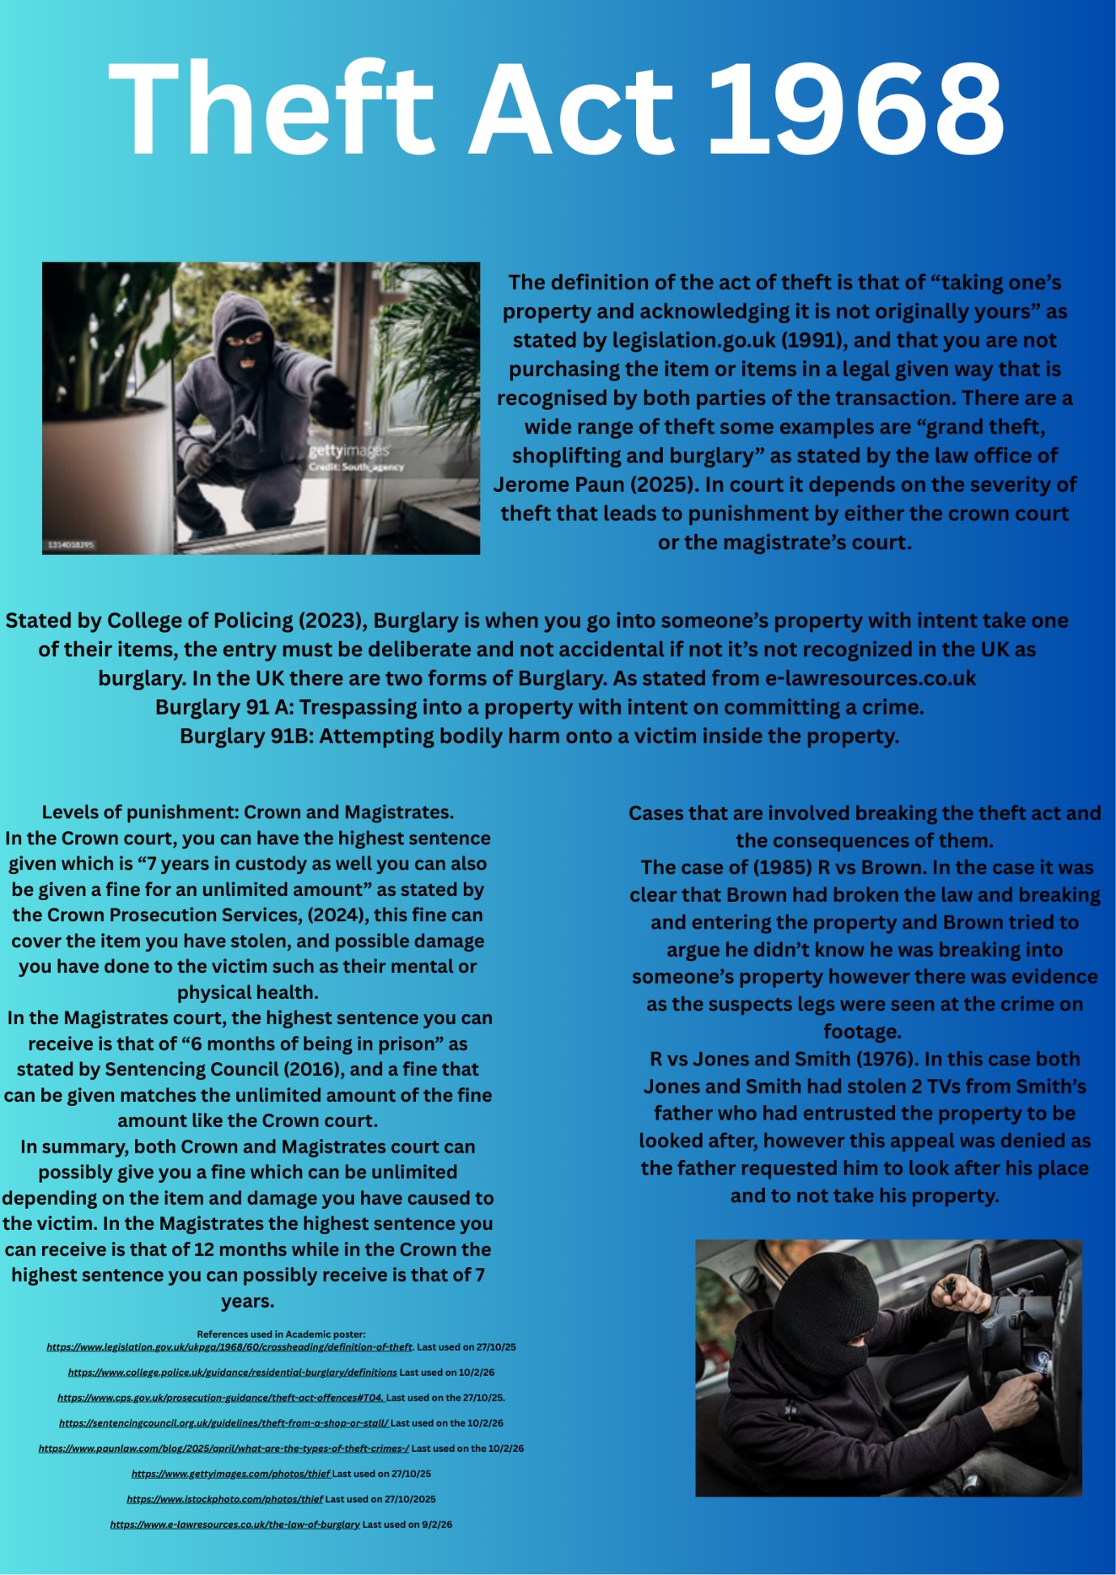
Acknowledgement
I confirm that I have not used any AI tools in the research and creation of this assignment. I confirm that I have not presented any AI generated materials as my own work. I confirm I have copies of my drafts, notes, and other resources I used, which I may be asked to provide in evidence.

Element 2 Referencing exercise and Reflecting essay
Reference List:
College of policing: “Constable.” Available at https://www.college.police.uk/career-learning/support-for-career-development/policing-professional-profiles/core-rank-profiles/constable. (Accessed 25/10/25)
Metropolitan Police: “Life as an officer.” Available at https://www.met.police.uk/police-forces/metropolitan-police/areas/c/careers/police-officer-roles/police-constable/overview/life-as-an-officer/. (Accessed 25/10/25)
Police Federation: PDF titled “The Office of Constable” of page 4. Available at https://www.polfed.org/media/14239/the-office-of-constable-with-links-2018.pdf. (Accessed 25/10/25)
Thames Valley Police: “Police Officer.” Available at https://tvpcareers.co.uk/roles/police-officer/. (Accessed 25/10/25)
North Wales Police: “Police Constable PC.” Available at https://www.northwales.police.uk/police-forces/north-wales-police/areas/careers/careers/police-officers/. (Accessed 25/10/25)
Kent Police: “Protecting all life.” Available at https://www.kent.police.uk/police-forces/kent-police/areas/kent-police/c/careers/police-officer-roles/police-constable/. (Accessed 25/10/25)
Norfolk Constabulary: “Unparalleled job satisfaction.” Available at https://www.norfolk.police.uk/police-forces/norfolk-constabulary/areas/careers/join-us/police-officer/. (Accessed 25/10/25)
Hertfordshire Constabulary: “What is the role of a police officer.” Available at https://www.herts.police.uk/police-forces/hertfordshire-constabulary/areas/careers/police-officers/police-officers/what-is-the-role-of-a-police-officer/. (Accessed 25/10/25)
Cumbria Police: “Frontline police officer.” Available at https://www.cumbria.police.uk/police-forces/cumbria-constabulary/areas/careers/careers/police-officers/the-role-of-a-police-officer/. (Accessed 25/10/25)
Association of Police and Crime Commissioners or APCC: “Responsible for totality of policing.” Available at https://www.apccs.police.uk/role-of-pcc/. (Accessed 25/10/25)
Workbred: “Maintaining law and order while also being the security of the public.” Available at https://workbred.co.uk/career/police-constable. (Accessed 25/10/25)
Oxford Academic: “3 new routes to enter for the role of policing.” “Key barrier.” “Could not always utilize the academic teaching in practical policing settings.” Available at https://academic.oup.com/policing/article/16/1/122/6421685. (Accessed 25/10/25)
BBC news: “I came away feeling elated, motivated, fulfilled, needed. I felt alive.” Available at https://www.bbc.co.uk/news/articles/cdd311l6g58o. (Accessed 25/10/25)
Pepper, I. Published (2010) Crime Scene investigations: Methods and Procedures Page 8. “Metropolitan Police Service.” Available athttps://www.google.co.uk/books/edition/Crime_Scene_Investigation_Methods_And_Pr/-LsWte7rUAEC?hl=en&gbpv=1&dq=Police+Constable+role+within+the+UK&pg=PA8&printsec=frontcover. (Accessed 25/10/25)
Careers Met Police: “Investigate crimes and pursue offenders.” Available at https://www.careersmetpolice.co.uk/careers/police-constables. (Accessed 25/10/25
UK Parliament: “Policing in the UK” Available at https://commonslibrary.parliament.uk/research-briefings/cbp-8582/. (Accessed 25/10/25)
Cheshire Constabulary: “Same powers in law as every other police officer.” Available at https://www.cheshire.police.uk/police-forces/cheshire-constabulary/areas/cheshire/careers/careers/the-role-of-a-special-constable/. (Accessed 25/10/25)
Prospects: “Police officers protect the public from crime, as well as supporting victims and witnesses of crime, providing reassurance to local people in the community.” Available at https://www.prospects.ac.uk/job-profiles/police-officer. (Accessed 25/10/25)
Essex Police: “New challenge, dealing with different situations and maintaining order.” Available at https://www.essex.police.uk/police-forces/essex-police/areas/essex-police/ca/careers/police-officers/police-constable/life-as-a-pc/. (Accessed 25/10/25)
National Careers Service: “Police Constable.” Available at Police officer | Explore Careers | National Careers Service. (Accessed 25/10/25)

Reflective Essay:
In this reflective essay, it will be discussed my research process into the role of a Police Constable. Using a range of sources both online and in real life I will discuss the impacts of my findings and how I came to find them throughout my research, and how I was able to go through them and ensure they were credible and factual while avoiding those that were the fake or through the work of AI.
Throughout the research on the role of a Police Constable It has used a variety of sources from the internet through, google scholar, research paper along with official Government websites from the UK along with several police stations around the UK with how the role of Constable is important to the community at whole, along with how Constable’s are the backbone of the police. In my research it became clear that it used a variety of statistics from gathered research that complimented the belief of Constables, through google scholar the published papers accessed were able to go into more detail about the role of a Constable and how effective they can be within communities with not only helping the crimes but also with building relationships with the people of the community by attending to their needs and building connections that can help build a sense of trust between the general public and the officer allowing for more crimes to be reported.
The credibility of the sources online are ones to be verified and checked before use, for an example the official Government websites are credible sources as they are valuable and open to the public for them to view. The Government allows statistics to be shown along with transparency to the general public is needed for the people to trust the government, the government official websites allow for information to be given to properly inform the public of the statistics from their community to ensure that they are reliable. Official police stations websites are also trustworthy as the same rules apply as the government with building trust for the community with additions being made over to inform the community of current events. For google scholar articles being published, I go through where the author has acquired their sources of information it should be noted however, the published articles are gone through by officials to ensure that they are trustworthy and accurate to publish online.
Initially I used the University’s library to gather information from the most reliable sources could be located and to be looked into for researching further into. My overall experience in the library was pleasant it was clear where I could locate information I could use for researching purposes along with staff willing to lend a hand in helping point in the right direction into the research task. It was quite welcoming allowing for everyone to be safe and open along with having privacy in the library, I have yet to go back to the library, but I must admit it was a positive atmosphere.
While researching for the role of a Constable, it was quite hard not to use AI as a source for finding references as it was quite easy to fall into but I wanted to ensure I got the best possible research possible with credible sources, with AI it makes up false leads or misleading sources that are not at all relevant to the subject I was researching for however it is easy to use I didn’t use AI to help ease the workload but with the amount of false sources that AI can produce it was not worth a risk by taking a chance on AI. The researching of sources was more tempting to use AI as a tool that I could use to ensure I get sources quickly, but they were factually wrong or just made up. With references it was hard to discover official ones with the ones that are designed to be misleading and to have wrong information being cited as a source with a false author along with having only face value information without going into detail about the topic in question.
Whenever a person is using AI they have to ensure that their source is reliable this means fact checking the source ensuring that the author is legitimate along with where they gathered their sources from, the published date is also important as a source from 2010-2020’s is less likely to be that of AI, along with checking the legitimacy ensuring the website it belongs on is also a real and official website that has other sources like it that are proven to be factual and not made by AI. AI has gotten advanced in recent years and because of this people fall victim to false websites with fake sources in order to get views on their website. Double checking the source is real is a method which I will be taking forward if I were to ever encounter a scenario in which I use AI with help on finding sources for material I can use in my research.
During the research of the role of a police constable, the methods I would often find myself using were ones I wouldn’t normally use as I’m adjusting to using Google Scholar I’m finding it more reliable than websites as the sources they use on published articles is more accurate and factually helpful for using sources as part of discovering research methods.
For next time, I think I’ll be using a lot more of Google Scholar on finding sources and not relying on the websites, finding more sources on Google Scholar will also allow me to find more credible sources in which I can find more arcuate sources for future assignments.
In Conclusion, the research I used in finding Police Constable was a wide variety of sources with myself going back multiple times to ensure that the information I gathered is correct and factual while avoiding those that are not factual nor help point out where the sources originally come from.

