Academic and Employability Skills
Student Name: Shahanaz Choudhury
Student I.D: 1713067

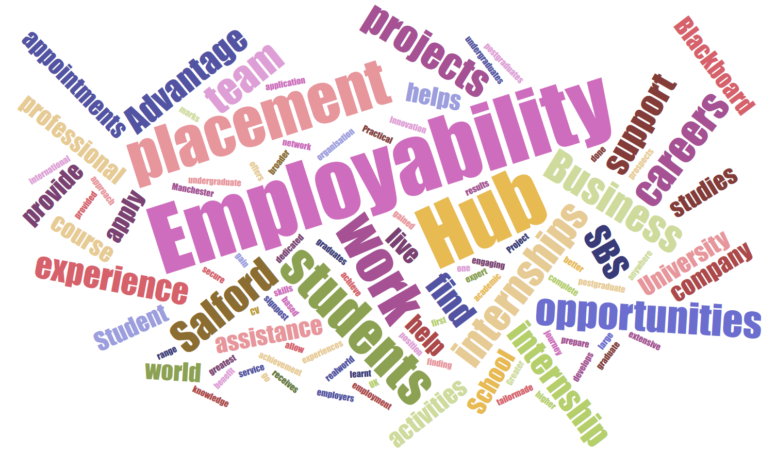
This Photo by Unknown Author is licensed under CC BY

Introduction:
With the development of social, economic and technology the competition among different companies are increasing day by day. The companies are looking for development of the human resources and most importantly they are demanding employees who have some knowledge, understanding and skills before joining in a job. So basically, they are emphasizing on the employability skills where it becomes easy to recruit them and needs less effort to make them fully functional in professional workplace setting. Here this report is about the employability skills where different aspects of employability skills are discussed including the importance of employability skills in modern day perspective. The importance of employability skills is also evaluated from employers’ perspective in this report. After that the employability skills I have and how those are developed are discussed here. Finally, how other necessary employability skills can be developed is also explained in this report.
Discussion on employability skills:
Employability skills refer to those skills defined by Cottrell (2015) those are needed to not only get an employment but also ensure progress in that job and achieve the performance and strategies objectives of employer effectively and efficiently. According to Marsh (2016) employability skills are those basic skills required to do a job efficiently and ability to learn other job-related skills gradually. From that perspective the graduate students are required to develop as much as employability skills as possible in their academic setting so that they can quickly adapt the professional environment and serve the organization.
Neugebauer (2014) suggested that the graduate students must develop their employability skills to enhance their possibility to get a job competing with other job seekers because the employer look for the most suitable individual those have capability to cope up the professional working environment. There is range of employability skills and the employability skills set may differ from on industry to another. So, it is important for the graduating students to choose the right career goal top select the right set of employability skill. Regardless the industry job differences there are some common set of employability skills every industry whether that is from manufacturing or service industry; the employers always value those skills. Rook (2015) addressed those skills like communication skills, self-management skills, problem solving skills, teamwork skill, life-long learning skill, time management skills, technology skills, planning and organizing skills.
In many researches and surveys, it is found that employability skills are needed for graduates and employer to serve different purposes, but those purposes are directed to common goal. For example, for employer’s employability skills can help to reduce the cost of training and development that is increasing in recent times. For example, in the Employer Skills Survey UK, 2015 it is found that the employers in UK have spent 43.8bn, 43bn and 45.4bn in 2011, 2013 and 2015 respectively that is a huge cost of operation for the employers. This cost can be reduced if the job seekers are effectively trained to develop job related skills in their academic setting. So, in recent years the employers are putting more value on employability skills and as a result the academic institutions are also giving more importance of developing employability skills in the academic setting.
Why employers need employability skills:
Employability skills are very important both for employer and the job seekers like the graduate students. In modern day due to the technological and social development the demand of people has changes a lot and also changing rapidly where the companies are competing intensely with each other to meet the customers demand with innovative and improved quality of services. Behind all this activity the most important role is played by the human resources. Bratton and Gold (2017) stated that human resource is the only self-organized resource that manages other non-human resources to ensure higher quality organizational performance. From that point of view employer wants to develop most skilled human resources to develop a competitive advantage in order to compete with other competitors. In this occasion if they can recruit half skilled human resources with basic job knowledge it saves time and money for the employer. Employability skills effectively help to develop half skilled human resources for employer and recruiters. From the job seekers’ perspective employability skills help to represent them fit for any kind of job. Why employers need employability skills are stated below addressing some common employability skills-
- Communication skill is preferred as the most important employability skills employers look into the graduates that became clear in many researches and surveys. According to (UKCES) UK Commission for Employment and Skills (2016) mentioned that about 91% employers in UK said that communication skill is one of the top three employability skills they usually look for in their job candidates for any level of job in the organizational hierarchy.
- Critical thinking skill is another important employability skill most of the employers look into job candidates because they want that the employees can handle the professional critical situations in different job scenario like working in a team or individually to achieve performance targets.
- Teamwork skill is required by the employer to ensure performance efficiency within workplace and to ensure collective working approach of employees.
- Time management skill is also preferred by many employers to ensure punctuality in workplace and keep customer commitment strictly to ensure quality of service.
Skills I have:
As a graduate student I have aim to get a good gob and develop my career. So, understanding the current employment situation and demand of the employers I have developed some key employability skills discussed below and how I have implemented those skills are also discussed here-
Communication skills: I have got the understanding about different communication skills like verbal and non-verbal communication skills. According to Trought (2017) verbal communication is based on the use of letters and grammatical languages that is used to express the idea or feelings by speaking or writing. I have developed my verbal communication very well that will be helpful for communicating with colleagues and management in a professional workplace setting. In my academic environment I have developed the verbal communication by preparing quality academic reports and delivering presentations of ranges of topics.
Critical thinking skill: This is another important employability skill I have developed during my academic life and especially in graduate level which will be helpful for me to deal with critical and problem situations. I have developed this skill by doing assignments where I had to deal with critical assignments like researches and report writing. I had to use brainstorming techniques to find the solutions of any assignments from different perspective.
Teamwork skill: Teamwork skill helps to enhance work efficiency and confidence to deal with any difficult situation where collective approach is used with contribution of all team members (Schomburg, 2014). Team work skill is always preferred by the recruiters because it helps to improve the employee performance and helps to achieve the performance objectives. I have developed this skill by working in class teams where every team member were assigned with specific role and responsibilities. In several time I have found that it becomes very difficult to complete a task individually but when it is approached as a team it becomes easy. I am also confident that in professional workplace this skill will help me to share idea and experiences with team members to get help from them and also involve in helping others.
Time management skill: As a student I am very good at time management because through continuous practice I have developed this skill to do tasks within time. For example, doing all kind of academic tasks like attending class and completing assignments within time, I have developed time management skill. Regard time management I have developed the skill of preparing routine. In my professional working environment this skill will be very useful to complete all kind of job responsibilities and activities within expected time limit because time is money and valuable to the employer.
Technology skill: Technology is the most powerful tool of development that changes rapidly and brings development quickly if it can be adapted and utilized properly (Wentz, 2015). Most of the employer realized this truth and developed their technologies with their maximum effort related to organization management and operations those are used in administration to production. I have developed basic technological skills like using the modern-day computer technologies like word processing, data management and social media. I have knowledge about some useful software like MS Word, PowerPoint, Excel etc.
Skills I need to develop:
I have developed some key employability skills but still there are lots of area of improvement and also need to develop some other employability skills to make me as a strong job candidate and to get a good job. I have discussed some such key skills below-
Leadership skills: Leadership skills are the set of some very useful soft skills those are essential for an employee to represent as an influential figure among others and guide them to achieve any goal or objective (Green, 2017). Leadership skills are developed with the perfect combination of some supportive employability skills like communication, organizing, management, team work and motivation skill. I need to develop leadership skills to grow my career and become one of the parts of organization management. Initially I want to start with entry level job and gradually want to grow my career. In this occasion it is important to grab the attention of recruiter where recruiters look for those individuals who has self-management and motivating ability that can influence other employees.
Non-verbal communication skill: I have good verbal communication skills that I have already developed but still I realize to develop non-verbal communication skill that is essential to meet the professional level communication needs. It is essential to develop the professional gesture, posture and body language during verbal communication in a professional setting that carries the personality of an individual. I need to demonstrate this skill in communication with management and colleagues. From that perspective I need to develop this employability skill must be developed to enhance my possibility to get a good employment.
Continuous learning skill: learning has no time and boundaries. I have to develop the mentality to learn from every situation and especially in a professional environment I have to have this skill because continuous learning can help to develop professional skills. To do so, I have to be flexible to learn from subordinates, peers and superiors in the organization where I will be employed. Employers or recruiters want to recruit those individuals who have the mentality and flexibility to learn new professional skills and become skilled to adapt different professional situations.
Technology skills: I have developed some technological skills like developed basic software and data management skills but still I need to develop technological skills. In this case it is important to decide which type of technological skills I need to develop like if I want to develop my career in service sector then I need to develop service sector relevant technological skills. On the other hand, based on the functional job I want to choose the technological skills can be developed like if I choose marketing job my technological skills will be relevant to marketing job.

Conclusion:
The importance of employability skills is realized during completing this report where the discussion is focused from both employer and graduates’ perspective. It is realized that employers emphasize on employability skills to develop a competitive advantage by recruiting skilled graduates who have some level of experiences to do a job. On the other hand, graduates emphasize on employability skills to develop them as a suitable candidate to get a good employment opportunity.

References:
Cottrell, S. (2015) Skills for Success: Personal Development and Employability. 2nd ed. UK: Macmillan International Higher Education.
Mishra, K. (2014) Employability Skills That Recruiters Demand. IUP Journal of Soft Skills. Vol. 8, pp. 50-55.
Marsh, R. (2016) Skills for Employability Part One: Pre-Employment. 3rd ed. UK: Christal Publishing.
Neugebauer, J. (2014) Employability: Making the Most of Your Career Development. 3rd ed. UK: SAGE Publications Ltd.
Rook, S. (2015) The Graduate Career Guidebook: Advice for Students and Graduates on Careers Options, Jobs, Volunteering, Applications, Interviews and Self-employment. UK: Macmillan International Higher Education.
Bratton, J. and Gold, J. (2017) Human Resource Management: Theory and Practice. 4th ed. UK: Macmillan International Higher Education.
Trought, F. (2017) Brilliant Employability Skills: How to stand out from the crowd in the graduate job market. UK: Pearson Education Limited.
Schomburg, H. (2014) Employability and Mobility of Bachelor Graduates in Europe. 2nd ed. UK: Springer Science & Business Media.
Wentz, Frederick H. (2015) Soft Skills Training: A Workbook to Develop Skills for Employment. UK: SAGE Publications Ltd.
Green, Cary J. (2017) Success Skills: For High School, College, and Career. UK: SAGE Publications Ltd.

