

LEVEL 5

SEMESTER 1 / 2

MODULE CODE: SHSS5066

MoDule Title: exercise Referral
aSSESSMENT TYPE: Practical assessment
Assessment/Component: 2

COMPONENT WEIGHTING: 70 %

DURATION: 2500 words

MODULE TUTOR: David Gardner

SUBMISSION DETAILS 3pm on 8th May 2020 through turnitin

Exercise Referral

Scenario

You are employed as an exercise referral consultant in a local health and fitness club. You have been referred a new client with a specific health condition (to be determined) and need to conduct a full health and fitness assessment prior to designing an exercise programme.

Tasks

Using the information and data collected from you first assessment devise and justify a 6 week training programme

Analyse the data collected with respect to appropriate referenced norm data and justify short term training objectives.

Write a report including the information above, describing and interpreting the data and explaining the training plan and objectives.

Requirements

The report should be about 2500 words and include the following sections;

- Overview of the general health benefits of exercise.
- Overview of exercise referral, including epidemiological information.
- Summary of the health condition and any issues relating to performing exercise.
- Interpretation of specific assessment data you have collected.
- Justification of the initial exercise programme based on referral guidelines, assessment data, other information colleged and research evidence.
The report should be written with the client in mind and therefore consider appropriate use of tense and pronouns.

Assessment Criteria

Details relating to the specific requirements on grading levels will be provided during lectures and within the generic level descriptor provided on moodle.

Specific questions can be addressed during tutorials.

School of Sport, Health & Outdoor Education

Assessment Feedback Sheet

Student No./Name:

Module Code: SHSS5066
Module: Exercise referral

Personal Evaluation – to support your academic progress please complete the section below BEFORE submitting your work.
What do you consider to be the best aspects of this work?
Which aspects do you consider could have been improved in this piece of work?
What have you found most satisfying whilst undertaking this submission?
ASSESSMENT CRITERIA | Learning  Outcomes |  | GRADE
ASSESSMENT CRITERIA |  |  | Poor  < 25% | Unsatisfactory  26-39% | Satisfactory  40 – 49% |  | Good  50 – 59% | Very Good  60 – 69% | Excellent  70 – 84% |  | Exceptional  85– 100% | %
Overview of health | 1, |  |  |  |  |  |  |  |  |  |  | 10
Overview of exercise referral |  |  |  |  |  |  |  |  |  |  |  | 10
Analysis of information collected | 1 |  |  |  |  |  |  |  |  |  |  | 30
Training programme and justification | 1 |  |  |  |  |  |  |  |  |  |  | 30
Report Structure and format |  |  |  |  |  |  |  |  |  |  |  | 10
References | 1 |  |  |  |  |  |  |  |  |  |  | 10
It is expected that students will present work that is proof read, correctly referenced and adheres to the Assessment Checklist. Therefore a range of 0 – 10 marks will be deducted for non-completion of any of the points on the checklist below.
TUTOR COMMENTS:
Submission date:  via Turnitin |  | Return date:  (at least within 4 weeks) |  |  |  | Tutor: |  |  |  | Mark:

Assignment Checklist

- Please complete the Personal Evaluation section of the Assessment Feedback sheet, add your name and details, and paste the whole of this assignment document into the front of your assignment

- Submission is a single .pdf file, clearly labelled with your name and module code
- Font style - Times New Roman, size -12 for text and 14 for headings
- Ink colour – black only
- Line spacing – 1.5 line spacing and 2cm- 2.5cm page margins
- Quotations more than three lines to be indented 1 line spacing
- One line space between paragraphs, paragraphs must be left aligned
- Pagination (your assignment should have page numbers)
- All tables and figures are internally referenced and have a title
- Word count checked and written at end of text (before references and any appendix)
- Assignment is within 10% of the word limit (excluding references and any appendices)
- All references in the text are included in the reference list
- Correct referencing as described in UWTSD Harvard Referencing Handbook on the Library website https://www.uwtsd.ac.uk/media/uwtsd-website/content-assets/documents/library-and-learning-resources/infoskills/harvard-eng.PDF
- Correct spelling and punctuation, using UK English
- Grammar and syntax correct- double check anything that has a green line under it
- I have read my assignment out loud to myself and it makes sense and is easy to read
- Somebody else has read my work and it makes sense to him or her!
- I have checked and I have not plagiarised
Failure to follow these guidelines will cost you marks!
Exercise Referral
Exercise has defined as “physical activity that you do to make your body strong and healthy” (Cambridge Dictionary, 2020). The majority of people within Britain, have shown that they are currently not taking part in enough exercise required to maintain a healthy lifestyle (Iliffe et al, 1994). Lamb. S (1993) stated that if current health care workers (such as the National Health Service) have an increase in promotion to physical activity within the general population within their practices, great benefits may follow such as a decrease in cardiovascular disease, reduction of fractured hip cases, a reduction in depression and anxiety and an overall improvement in functional health in elderly people. Kurt, et al (1992) stated that there is growing evidence which states that exercising regularly, will show benefits within health and function of the elder generation in a various ways.

Table 1- Health Benefits Associated with Regular Physical Activity (Azar et al, 2018)
Adults
Lower Risk of all-cause mortality | Lower risk of Type 2 Diabetes | Reduced risk of dementia
Lower Risk of Cardiovascular disease mortality | Lower risk of adverse blood lipid profile | Improved quality of life
Lower Risk of Cardiovascular disease | Lower risk of cancers of the bladder, breast, colon, kidney, lung and stomach | Reduced anxiety
Lower Risk of hypertension | Reduced risk of dementia | Reduced risk of depression
Slowed or reduced weight gain | Improved bone health | Improved sleep
Weight loss | Improved physical function | Lower risk of falls

Table 1 (Azar et al,2018) shows that exercise can not only improve and reduce the effects of certain condition and limit them, exercise can also have a great value on the mental health of individuals.

Jenssan et al (2010) conducted a study that looked at the effects on exercise within school aged children and youth. It was stated that the greater amount of physical activity an individual endures, the greater health benefits of which that person would apprehend. Jenssan et al (2010) It is also stated that, even with a moderate amount of exercise/ physical activity would show to have great amount of health benefits in high-risk individuals (this includes obesity, high blood pressure). Aerobic-based activities that stress the cardiovascular and respiratory systems have the greatest health benefit, other than for bone health, in which case high-impact weight bearing activities are required.

Another aspect of which has shown to have great benefits while enduring physical activity is the reduction in anxiety and the risk of depression. Exercise can reduce anxiety and reduce the risk of depression. With that, Callaghan (2004) stated that “exercise improves mental health by reducing anxiety, depression, and negative mood and by improving self-esteem and cognitive function”. with that in mind, another stated by Dunn and Jewell (2010) also suggested that exercise enhanced “psychological well-being, protect against symptoms of anxiety and development of anxiety disorders, protect against depressive symptoms and development of major depressive disorder, and delay the effects of dementia and the cognitive decline associated with aging”.

Overview of exercise referral
Watson. P, (2017) states that it is known that early exercise referral schemes (ERSs) was created in the early 1990s. This was introduced across Great Britain that included the advice of health professionals that refer inactive individuals, who possess health conditions for exercise. A record has shown that by 2011, it is estimated that 600+ ERSs were shown to be in practise within the UK (Watson. P.,2017). However, it is known that little amounts of ERSs corporations have included great amounts of detail when evaluating protocols, although, despite the effects of short-term benefits health, very little literature is known of their long-term effectiveness (Watson. P.,2017). The National Institute for health and Care Excellence (2014) also stated that the exercise referral scheme is defined as “seek to increase someone’s physical activity levels on the basis that physical activity has a range of positive health benefits.”
The exercise referral scheme, includes a programme, which includes specific adaptation to the individual’s needs and to improve their current physical health. For this to happen, the individual would need to be referred by a health professional such as a doctor or a physiotherapist. Places of which the programme takes placed is within the local community or the leisure centre, and would normally have another health profession with them. The average time a programme lasts on average, is between 6-12 weeks.

With that, the Andrew. C (2001) stated that the National Quality Assurance Framework which is directly utilised for exercise referral schemes, entails more than just recommendations or vouchers to attend fitness classes. It is shown that exercise referral programmes include individualised programmes that cater for the client’s needs (Andrew. C., 2001). The following is the framework for the programme to include:
● Establish a formally agreed process for the selection, screening and referral of specific patients.
● Conduct appropriate assessment of patients prior to the exercise programme.
● Provide a specific range of appropriate and agreed physical activities for a defined period of time, which maximise the likelihood of long-term participation in physical activity.
However, some evidence suggests that poor approaches have been identified within the NERSs scheme, due to evaluation and limited integration with the individuals which, in essence, puts a risk within a challenging public health climate (Watson. P, 2017).

Summary of the health condition
The client is of 60 years of age, who was referred to the exercise referral scheme, due to suffering from angina and Cardiovascular Disease (CHD). The client also suffers from high cholesterol. He currently is taking Lisinopril, which is a medicine for the treatment of high blood pressure (NHS, 2020) and the substance Lovastatin, which can be used to help lower cholesterol levels. Aspirin is also consumed in small doses by the client, of which, is used as a blood-thinning medicine (NHS, 2020). The client partakes in physical activity, mostly by walking. He regularly smokes and has no trouble sleeping. His eating habits include takeaways/ ready meals rather than home cooked meals. Consumption of 2-3 fruits a day is also eaten while indulging in (on average) 4 units of alcohol per week during the evening and this increases by 6-8 units on the weekends. Dobkowski et al, (2017) stated that exercise can help reduce the current high levels of blood pressure and a lower heart rate. This has been proven by journal of the American College of Cardiology.
Another conclusion was found by Connor et al., (2019), that frequent exercise within adults who currently have CHD condition, has been shown that improvements of the cardiopulmonary capacity and psychosocial functioning. This also shows improvement irrespective of cardiac related diseases and the severity. As exercise has shown to give great benefits to health and those who have CHD, further knowledge and counselling should be given to patients with CHD with the knowledge of the importance of exercise.
Collection and interpretation of Data
To know the current stage of fitness that the client is currently at, tests would need to be conducted to identify the clients overall health and fitness to determine what the programme should entail. Tests include Blood Pressure, Timed up and Go test, Grip Strength max, Body Mass Index (This includes the weight and height of the individual), predicted rate VO2, Resting heart, Sit and reach test, 2 minute step test. All tests allowed a recovery period between each testing times. This reduced the chance of the client being tired or out of breath before completing the next fitness test. Prior any testing was conducted, anthropometric testing was completed (height and weight). The stature of the client was recorded at 162.5cm with a total weight of 80kg. After these tests were completed, blood pressure was the first test to be conducted. A score of 138/88mmHg. From looking at normative data and the guidelines, the score has placed him within the above average reading, which puts him in the Pre-High Blood pressure category which can be identified within figure 1. The reading shows to be just outside of the high blood pressure category, which should be avoided at all costs to increase the chance of an ideal blood pressure reading. Resting heart rate was recorded at 82bpm, which puts him within the normal category within his age group, according to the British Heart Foundation.
Figure 1- Blood Pressure chart for adults (Blood Pressure Association 2008)
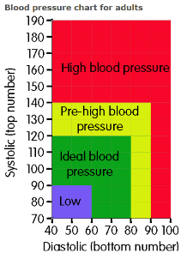
VO2 max was the next test that was conducted. The test that was utilised to calculate VO2 max, was the step-up test. The client was required to complete as many steps ups as possible within a timeframe of 2 minutes. The client scored a predicted VO2 max of 22ml/kg/min, compared to normative data and the general health guidelines, this places him in the poor category within his age group.

Figure 2- Norm data for VO2 max (Hayward, 1998)
Male (values in ml/kg/min)
Age | Very Poor | Poor | Fair | Good | Excellent | Superior
13-19 | <35.0 | 35.0 - 38.3 | 38.4 - 45.1 | 45.2 - 50.9 | 51.0 - 55.9 | >55.9
20-29 | <33.0 | 33.0 - 36.4 | 36.5 - 42.4 | 42.5 - 46.4 | 46.5 - 52.4 | >52.4
30-39 | <31.5 | 31.5 - 35.4 | 35.5 - 40.9 | 41.0 - 44.9 | 45.0 - 49.4 | >49.4
40-49 | <30.2 | 30.2 - 33.5 | 33.6 - 38.9 | 39.0 - 43.7 | 43.8 - 48.0 | >48.0
50-59 | <26.1 | 26.1 - 30.9 | 31.0 - 35.7 | 35.8 - 40.9 | 41.0 - 45.3 | >45.3
60+ | <20.5 | 20.5 - 26.0 | 26.1 - 32.2 | 32.3 - 36.4 | 36.5 - 44.2 | >44.2

The clients scored a 30.25 kg/$m^{2}$ for their BMI testing, of which, when compared to the normative data, with the clients weight and height kept record (162.5cm, 80kg), has places the client within the obese weight. The other test that was conducted was the body fat percentage, which was calculated by a Tanita machine which sends an electrical pulse to identify the muscle and fat percentage. He scored a body fat % of 27, of which, puts him within the 80th percentile of his age category.

Figure 3- Normative data for body fat % (Welch et al, 2017)
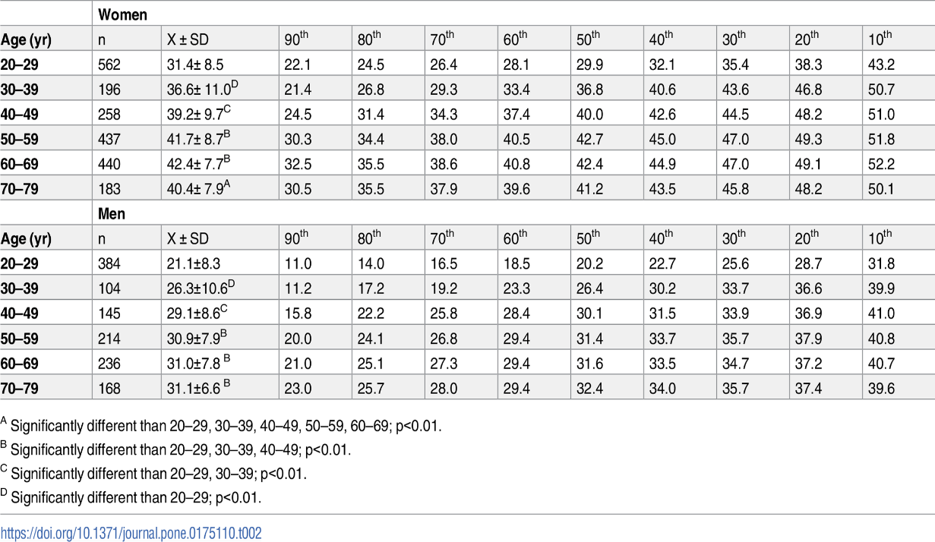

The final test was the grip strength test, for this, he scored on his dominant arm a 25kg squeeze, whereas on his non-dominant hand he scored a 24kg squeeze. From normative data, the category that the client falls into for his age group (60-69 years) “weak” for both his dominant and non-dominant hand.
Figure 4- Normative data for Grip strength (Massy-Westropp et al 2011)
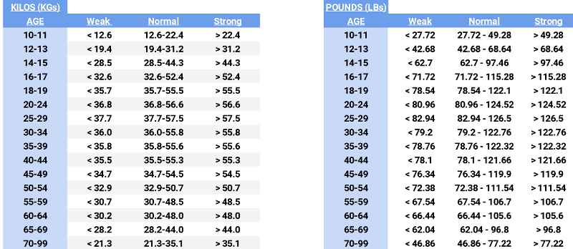

The sit and reach test was then completed, with the client giving a score of 14cm. after looking at normative data, the client falls into the “fair” category, which is below average for his age. This would need to be looked at for an area of which would need improving.

(https://cartwrightfitness.co.uk/sit-and-reach-normative-data/, 2020) Figure 5 shows normative data for a sit and reach test.
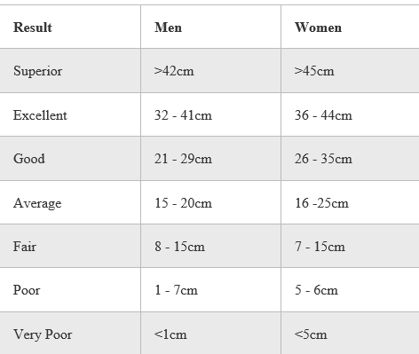

Lastly, the client completed the final test which was the timed up and go test (TUG). This required the client to get up, out of his chair to then walk 3 meters and return back to the chair and sit back down. This test would identify any requirements of walking aids that the client would need to utilise. With that, if the score the client got was greter than 14 seconds, then statistics show that they are at great risk of injury from flling. If they scored greater than 20 seconds, a walking aid would be recommended to the client as they would be at the highest risk of injury and may even have a helper to support them throughout the day.

(Lysack, 2010) with that, the client score was 17.6 seconds for this test. From normative data, it would be recommended that they have a walking aid when leaving the house and from walking around their home or garden. Improving the client’s mobility and plyometric status would help improve the clients score and reduce their chances of injury (reference)

Exercise Referral Programme
After looking at the results that the client gained, and then comparing the results to the normative data, it is clear that the client is below average within his age group from all the test scores of which was produced. The following programme will be hugely beneficial to help improve hi current scores and to gain scores that are within the average marker for his age. With that, thorough investigation would be needed to identify the types of exercises that would be useful to the client, without injuring the client. With that being said, inclusion of their current exercise regime that was created by a professional. With that in mind, other activities will be conducted outside of the gym to include the environment of which the client will be mostly in (such as walking to the shops).

Justification of Programme
This programme, will help improve the client’s current fitness status and would show improvements upon completion of the 6 week programme. The programme entails moderate and vigorous exercises that would be beneficial to the client. A mixture of strength and endurance training will be used within this programme, with a mixture of low and high repetitions which will help improve his quality of living (Haff et al., 2016). As the client progresses within the programme, so will the intensity of each session and exercise. It is recommended shown that the recommended amount of exercise and adults should endure is 30 minutes a day (for 5 days), 150 minutes per week of moderate activity (wen et al., 2011). With the knowledge of what the client would like to improve, this will be noted and will be targeted, with exercises that will help improve his goal. These aspects may include a circuit of such exercises like squats (weight baring), lateral pulldown, leg extension and leg curl, leg press and to finish off with having done a warm up and a cool down on either a treadmill or a cross trainer. Throughout these sessions, a follow up will be implicated to have a “catch up” session see how the client is doing within their sessions. With that, the application of endurance training has multiple benefits that would benefit the client’s goal (Haff et al., 2016). Walking has shown to possess huge benefits to help improve aerobic fitness and promote fat loss. This also improves the plyometric status and co-ordination with the variety terrain. However, this may lead to injury, so awareness must be taken when walking on uneven surfaces to reduce the chance of the client falling. Aerobic training has also shown benefits that will be useful to help the client’s fitness, with improvements of their current blood pressure and their BMI score (Karsten et al, 2018). With that, obesity within older men has a direct effect of their current VO2 max and shows that current training with the correct application each week, shows to improve their VO2 max score, which also improves their lung volume (Lovell et al 2012). The application of strength training when performing multiple chair stands at one given time, this will help improve the muscular endurance, as well as muscular strength with the quadriceps and hamstring working both concentrically and eccentrically as well as glutes and gastrocnemius also being stressed throughout this exercise (Haff et al., 2016). For the client to be able to improve their current flexibility level, regular static and dynamic exercises would help improve their current level. Each stretch would be held for 15 seconds per stretch and to be repeated a minimum of 3 times.

Word count: 2559

Appendices
Programme
Week 1
Day | Exercise | Sets and reps | Progression | Regression
Monday | Basic Stretches, Dynamic + Static  Stand up and Sit Down of Chair  outdoor walk | 2 sets, 6 reps  15 minute | N/A | N/A
Tuesday | Rest Day | N/A | N/A | N/A
Wednesday | Stretching exercises  Weekly gym session | N/A | N/A | N/A
Thursday | Basic Stretches, Dynamic + Static for recovery following gym session | N/A | N/A | N/A
Friday | Rest Day | N/A | N/A | N/A
Saturday | Basic Stretches, Dynamic + Static  Leg raises with light resistance bands  outdoor walk | 2x8  15 minute | N/A | N/A
Sunday | 25 minute outdoor walk | N/A | N/A | N/A

Week 2

Day | Exercise | Sets and reps | Progression | Regression
Monday | Basic Stretches, Dynamic + Static  Stand up and Sit Down of Chair  outdoor walk | 2 sets, 6 reps  15 minute | N/A | N/A
Tuesday | Rest Day | N/A | N/A | N/A
Wednesday | Stretches  Weekly gym session | N/A | N/A | N/A
Thursday | Basic Stretches, Dynamic + Static for recovery following gym session | N/A | N/A | N/A
Friday | Basic Stretches, Dynamic + Static  Leg raises with light resistance bands  Arm raises with light resistance bands | N/A  2x10  2x8 | N/A | N/A
Saturday | Rest Day | N/A | N/A | N/A
Sunday | Walk | 25 Minute | N/A | N/A

Week 3

Day | Exercise | Sets and reps | Progression | Regression
Monday | Basic Stretches, Dynamic + Static  Leg raises with light resistance bands  Arm raises with light resistance bands  Outdoor walk | 2 sets, 10 reps  2 sets, 8 reps  10 minute | N/A | N/A
Tuesday | Rest Day | N/A | N/A | N/A
Wednesday | Stretches  Weekly gym session | N/A | N/A | N/A
Thursday | Stretches for recovery from Gym session  10 minute brisk outdoor walk | N/A | N/A | N/A
Friday | Stretches  Stand up and Sit Down of Chair (2 sets, 6 reps)  2x10 Leg raises with light resistance bands | 2x10  2x8 | N/A | N/A
Saturday | Rest Day | N/A | N/A | N/A
Sunday | 15 minute Brisk Outdoor Walk | 25 Minute | N/A | N/A

Week 4

Day | Exercise | Sets and reps | Progression | Regression
Monday | Basic Stretches, Dynamic + Static  2x10 Leg raises with light resistance bands  2x8 Arm raises with light resistance bands  Brisk outdoor walk | 2 sets, 10 reps  2 sets, 8 reps  10 minute | N/A | N/A
Tuesday | Rest Day | N/A | N/A | N/A
Wednesday | Stretches  Weekly gym session | N/A | N/A | N/A
Thursday | Stretches for recovery from Gym session  brisk outdoor walk | 15 minute | N/A | N/A
Friday | Stretches  Stand up and Sit Down of Chair  Leg raises with light resistance bands | 2 Sets, 10 reps  2x10 | N/A | N/A
Saturday | Rest Day | N/A | N/A | N/A
Sunday | Brisk walk | 15 Minute | N/A | N/A

Week 5

Day | Exercise | Sets and reps | Progression | Regression
Monday | Stretches  Stand up and Sit Down of Chair  Leg raises with light resistance bands | 3 sets, 8 reps  2 sets, 10 reps | N/A | N/A
Tuesday | Rest Day | N/A | N/A | N/A
Wednesday | Stretches  Weekly gym | N/A | N/A | N/A
Thursday | Stretches  Walk up and down corridor | (20 minutes) | N/A | N/A
Friday | Basic Stretches, Dynamic + Static  2x10 Leg raises with light resistance bands  Arm raises with light resistance bands  Brisk outdoor walk | 2x10  2x8  15 minute | N/A | N/A
Saturday | Rest Day | N/A | N/A | N/A
Sunday | Brisk walk | 20 Minute | N/A | N/A

Week 6

Day | Exercise | Sets and reps | Progression | Regression
Monday | Stretches  Stand up and Sit Down of Chair  2x10 Leg raises with light resistance bands | 3 sets, 8 reps  2 sets, 10 reps | N/A | N/A
Tuesday | Rest Day | N/A | N/A | N/A
Wednesday | Stretches  Weekly gym session | N/A | N/A | N/A
Thursday | Stretches  Walk up and down corridor | 20 minutes | N/A | N/A
Friday | Basic Stretches, Dynamic + Static  2x10 Leg raises with light resistance bands  2x8 Arm raises with light resistance bands  15 minute Brisk outdoor walk | 2x10  2x8  15 minute | N/A | N/A
Saturday | Rest Day | N/A | N/A | N/A
Sunday | Brisk outdoor walk | 20 Minute | N/A | N/A

Reference
Azar, A., 2018. Physical Activity Guidelines for Americans. U.S. Department of Health and Human Services, 2, p.31.
Bloodpressureuk.org. 2020. Blood Pressure : Blood Pressure Chart. [online] Available at: <http://www.bloodpressureuk.org/BloodPressureandyou/Thebasics/Bloodpressurechart> [Accessed 8 May 2020].
Bhf.org.uk. 2020. Your Heart Rate. [online] Available at: <https://www.bhf.org.uk/informationsupport/how-a-healthy-heart-works/your-heart-rate> [Accessed 5 May 2020].
Brusasco, V., 2012. Spirometric definition of COPD: exercise in futility or factual debate? London: .

Craig, A., GREAT BRITAIN DEPARTMENT, OF HEALTH, GREAT BRITAIN DEPARTMENT OF HEALTH AND, SOCIAL SECURITY and GREAT BRITAIN DEPARTMENT OF HEALTH, & SOCIAL CARE, 2001. Exercise Referral Systems : a National Quality Assurance Framework [ebook]. London: London : Department of Health.
Dobkowski, D. and Eckel, R., 2017. Increased exercise reduces CHD mortality risk. Cardiology Today, 20(11), pp. 9.

Haff, G., Triplett, N.T. and NATIONAL STRENGTH & CONDITIONING ASSOCIATION (U.S.), ISSUING BODY, 2016. Essentials of strength training and conditioning. Fourth edition. edn. Champaign, IL : Human Kinetics.

Heyward, V., 1998. The Physical Fitness Specialist Certification Manual. The Cooper Institute for Aerobics Research, Dallas TX,, 3rd Edition, p.48.

Imboden, M., Welch, W., Swartz, A., Montoye, A., Finch, H., Harber, M. and Kaminsky, L., 2017. Reference standards for body fat measures using GE dual energy x-ray absorptiometry in Caucasian adults. PLOS ONE, 12(4), p.e0175110.

Iliffe, S., Tai, S.S., Gould, M., Thorogood, M. and Hillsdon, M., 1994. Prescribing exercise in general practice. London:

Janssen, I. and Leblanc, A., 2010. Systematic review of the health benefits of physical activity and fitness in school-aged children and youth.

Karsten, V.W., Amaryllis, H.V.C., Wim, V.B., Dhondt, A., Tanghe, A., Ans, V.G., Celie, B. and Calders, P., 2018. The effects of aerobic exercise on eGFR, blood pressure and VO2peak in patients with chronic kidney disease stages 3-4: A systematic review and meta-analysis. PLoS ONE, 13(9), pp. e0203662.

Kurk, Elward AND Eric, .Larson, 1992. Benefits of Exercise for Older Adults: A Review of Existing Evidence and Current Recommendations for the General Population. The Department of Internal Medicine, the University of Washington, Seattle, Washington, 8(1), pp. 35-50.

Lovell, D.I., Cuneo, R., Wallace, J. and Mcellan, C., 2012. The hormonal response of older men to sub-maximum aerobic exercise: The effect of training and detraining. Steroids, 77(5), pp. 413-418.
Lysack, C., 2010. Handbook Of Assessment In Clinical Gerontology. 2nd ed. Elsevier Science.
Massy-Westropp, N., Gill, T., Taylor, A., Bohannon, R. and Hill, C., 2011. Hand Grip Strength: age and gender stratified normative data in a population-based study. BMC Research Notes, 4(1).
nhs.uk. 2020. Aspirin: Low Dose To Prevent Heart Attacks And Stroke. [online] Available at: <https://www.nhs.uk/medicines/low-dose-aspirin/> [Accessed 9 May 2020].
nhs.uk. 2020. Lisinopril: Medicine To Treat High Blood Pressure. [online] Available at: <https://www.nhs.uk/medicines/lisinopril/> [Accessed 9 May 2020].

Wastson, P., 2017. Stuck in the “exercise” trap: Current issues and future directions for UK exercise referral schemes. The European Journal of Public Health, 27.

Wen, C.P., Wai, J.P.M., Tsai, M.K., Yang, Y.C., Cheng, T.Y.D., Lee, M., Chan, H.T., Tsao, C.K., Tsai, S.P. and Wu, X., 2011. Minimum amount of physical activity for reduced mortality and extended life expectancy: a prospective cohort study. The Lancet, 378(9798), pp. 1244-1253.

