

PROGRAMME: MBA – International Business
Term 2

STUDENT NAME: VIVEK ODEDRA
STUDENT ID: 2505516

MODULE: STRATEGIC MANAGEMENT
MODULE CODE: LCMB7003

Lecturer’s Name: Amare Daste

Word Count:5052

Executive Summary

This report presents a critical assessment of the strategic management practices of the Associated British Foods (ABF) based on some of the major analytical frameworks, such as PESTEL, VRIO, Balanced Scorecard and SWOT. Kaplan and Norton have regarded the combination of non-financial and financial approaches as a necessity of successful strategic assessment. The discussion finds that ABF's competitive advantage is largely based on the cost leadership strategy, enhanced with good supply chain and business diversification. Nevertheless, issues like inadequate digitalisation, risks to commodity fluctuations, and rather partial compatibility of sustainability with strategic systems have been noted. The report also points out that the organisation has good financial and operating performance, but there is a need to enhance strategic coherence and long-term adjustability. The provided recommendations are based on increasing digital capabilities, enhancing sustainability integration, and increasing portfolio performance. In general, the results indicated that ABF has a high degree of success in the market, but it should be strategically adjusted continuously to keep the competitive advantage in a changing global environment.

Table of Contents

SECTION 1 – STRATEGIC ANALYSIS 4
1. Organisational Context & Overview 4
2. External and Internal Environment Analysis 6
2.1 External Environment Analysis – PESTEL 6
2.2 Internal Analysis and VRIO to evaluate strategic capabilities of the organisation 9
3. CSR and Sustainability objectives 13
4. Comprehensive and holistic view of the Organization 14
4.1 Balanced Scorecard 14
5. Strategic Choices & Implementation 16
6. Strategic Evaluation & Recommendations 18
6.1 SWOT Analysis 18
6.2 BCG Matrix 20
6.3 Strategic recommendations 21
SECTION 2 – REFLECTIVE ACCOUNT 22
1. Description 22
2. Feelings 22
3. Evaluation 23
4. Analysis 23
5. Conclusion 24
6. Action Plan 24
References 25

SECTION 1 – STRATEGIC ANALYSIS

Organisational Context & Overview
Associated British Foods plc (ABF) is a dominant multi-national conglomerate, which, since its inception in 1935 by W. Garfield Weston, has developed a good global presence, as it was initially a bakery-oriented company, but later developed into a company with diversified interests in food production and retailing (Associated British Foods, 2025). The organisation is based in London and engages employees in over 50 countries, with approximately 138,000 people, which can be attributed to its large international presence and scale of operations (London Stock Exchange, 2025). Overload, ABF has grown strategically, either by acquisition or by diversification, over the decades to become a multi-segment corporation, not what it used to be, a traditional food manufacturer. Strategically, the mission of ABF is to provide safe, nutritious and affordable food and clothing at a great value, and this focus on dual products is related to providing value-based retail products and essential consumer goods (Associated British Foods, 2025). This value proposition is supported by its long-term orientation in value creation to the stakeholders, such as customers, suppliers and shareholders, which is oriented towards its sustainable growth goals.
The company has a very diversified business model that is organised in five key divisions, namely Retail, Grocery, Ingredients, Sugar and Agriculture. Mainly, its retail company, Primark, is a revenue powerhouse with revenues based on the sales amounting to about £9.4 billion pounds in 2024, alone with a support of a network of more than 470 stores worldwide (World Footwear, 2025). In the meantime, through its food and ingredients divisions, it has the ABF has brands of Twinings, Ovaltine, and Ryvita known around the world, a massive sugar and agricultural business, and the company thus makes ABF one of the largest manufacturers of baker’s yeast and sugar globally.
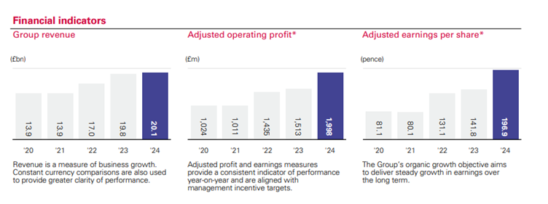
Figure 1: Financial Indicators of ABF
(Source: Associated British Foods, 2025)
Financially, ABF is very strong in the market, where it records group revenue of about £20.1 billion and adjusted operating profit of £1.998 billion in 2024, which shows high recovery and enhanced efficiency in operations (Associated British Foods, 2025). Nevertheless, recent performance is also a manifestation of volatility, as revenue decreased to 19.5 billion pounds in 2025 because of the difficulties in the sugar segment and the pressure of macroeconomics. This underscores the existence of cyclical risks in its diversified portfolio (ABF, 2025). In the industry scenario, ABF is engaged in the global food processing industry as well as the fast-fashion retail sector, which is very competitive. Its major rivals are multinationals like Nestle and Unilever within the food industry, and Inditex (Zara) and H&M within the retail industry, which makes ABF the only hybrid organisation that competes in the industry. Specifically, Primark has reinforced its competitive advantage by securing market shares in the UK retail sector, where the company has registered a market share of about 6.8% in clothing retailing (ABF, 2025a). Altogether, ABF is a good performing FTSE 100 company with a diversified source of revenue, but its performance is still subject to sector-related challenges, especially within commodities like sugar, which still demands reiterated strategic responses.

External and Internal Environment Analysis

2.1 External Environment Analysis – PESTEL
Factor | Key Issues (with Data) | Impact on ABF
Political | - UK National Living Wage increased to £11.44/hour (Government of the UK, 2025)  - Trade policy instability affecting EU sugar imports  - Brexit-related supply chain barriers  - Political instability in Africa (sugar sourcing regions) | - Rising labour costs increase Primark expenses  - Supply chain risks in sugar/agriculture  - Need for diversified sourcing strategy  - Regulatory compliance pressure
Economic | - UK inflation fell from 10% in 2022 to 3% in 2024 (Inman and Knowles, 2026)  - Interest rates at 5.25% (Burr and Willems, 2025)  - Sugar division losses up to £40m (Davey, 2025) | - Cost pressures across supply chain  - Reduced consumer purchasing power  - Profit volatility in sugar segment  - Strategic need for cost leadership (Primark)
Social | - Shift toward value-for-money retail consumption  - Rising ethical sourcing expectations  - Changing food consumption (health trends)  - Primark UK market share 6.8% clothing (Fashionnetwork, 2025) | - Supports Primark low-cost strategy  - Pressure for sustainable sourcing  - Product portfolio adjustments needed  - Brand positioning as “affordable value”
Technological | - Annual digital infrastructure investment in 2022 reached £9.2 billion (ONS, 2025)  - Expansion of digital retail capabilities  - Supply chain automation in food production  - Data analytics for consumer behaviour | - Improves efficiency & cost control  - Supports omnichannel retail growth  - Enhances operational scalability  - Requires continuous capital investment
Environmental | - Focus on decarbonisation initiatives (2025)  - Climate impact on agriculture yields  - Pressure to reduce carbon footprint  - Rising energy costs in production | - Increased compliance costs  - Risk to agricultural supply chains  - Need for sustainable sourcing strategy  - Opportunity for ESG differentiation
Legal | - Labour law compliance such as wages and working conditions  - Environmental regulations tightening  - Food safety and quality standards  - Trade tariffs affecting imports/exports | - Higher compliance costs  - Legal risks across global operations  - Need for governance frameworks  - Impacts pricing and margins
Table 1: PESTLE Analysis
(Source: Self-developed)
As per analysis, the external environment is a major structural environment that influences strategic decision-making in modern organisations. Khan et al. (2025) argued that the external cost drivers of firms that adopt cost leadership mechanisms are especially susceptible to regulatory interventions and labour market policies. These forces can be observed in a labour-intensive format of retailing, wherein the efficiency of operations is a decisive factor that affects competitiveness. Associated British Foods has to keep on streamlining its cost structures in order to maintain its value-based positioning. Also, geopolitical unpredictability and issues associated with trade make the global supply chains more complicated, especially in the areas that are reliant on commodities. Uzozie et al. (2022) noted that multinational companies with a presence in various regions should come up with dynamic solutions that will help mitigate external risks and enable the supply chains to be resilient. This supports the role of strategic flexibility and diversification. In this regard, the multi-sector coverage of the organisation adds a shock resistance to the isolated external shocks, but it also exposes the organisation to a diversified regulatory and political setting.
Economically and socio-technologically, the outside influences bring both limitations and prospects, which impact the strategic long-term direction. Macroeconomic volatility necessitates organisations to have adaptive capabilities in order to cope well with changing conditions of demand and costs (Joussen et al., 2025). This is especially applicable in those environments that are typified by a dynamic consumer buying power and pattern of consumption. Associated British Foods has an advantage in linking its retail strategy with value-seeking consumer behaviour, as it is facing increased demands on its ethical sourcing and sustainability. Ardiansyah and Alnoor (2024) cited that social responsibility should be incorporated in the main strategies of organisations in order to stay legitimate and gain the confidence of their stakeholders. Moreover, the innovations facilitate the functioning of efficiency as a means of technological progress, though they require the investment and renewal of organisations. Digital integration is not a functional update but a strategic necessity, which transforms competitive relationships (Ul Amin and Khan, 2024). Taking these circumstances into account, ABF, therefore, has to strike a balance between cost efficiency and innovation and sustainability promises to sustain its competitive advantage in a highly dynamic external environment.

2.2 Internal Analysis and VRIO to evaluate strategic capabilities of the organisation
Resource / Capability | Type | Value | Rarity | Imitability | Organisation | Competitive Implication
Primark retail network | Tangible | ✔ | ✔ | ✔ | ✔ | Sustained competitive advantage
Diversified business portfolio | Tangible | ✔ | ✔ | ✖ | ✔ | Temporary advantage
Brand portfolio (Primark, Twinings etc.) | Intangible | ✔ | ✔ | ✔ | ✔ | Sustained competitive advantage
Global supply chain capability | Capability | ✔ | ✔ | ✔ | ✔ | Sustained competitive advantage
Cost leadership model | Core Competency | ✔ | ✔ | ✔ | ✔ | Sustained competitive advantage
Financial resources | Tangible | ✔ | ✖ | ✖ | ✔ | Competitive parity
Innovation & technology capability | Capability | ✔ | ✔ | ✖ | ✔ | Temporary advantage
Table 2: VRIO Analysis
(Source: Self-developed)
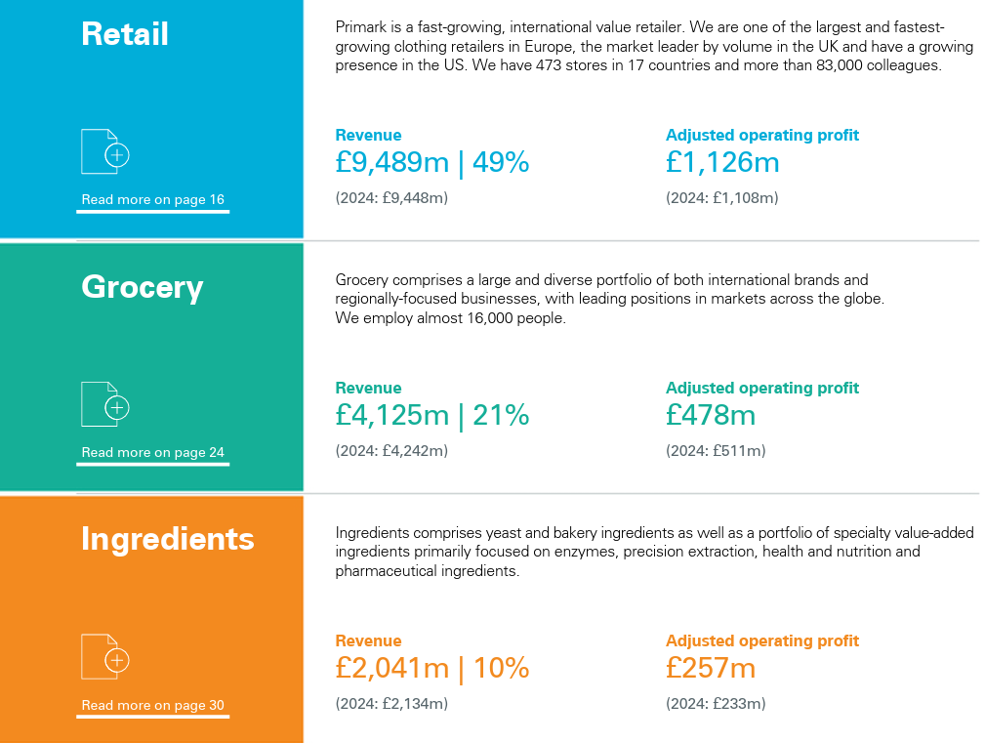
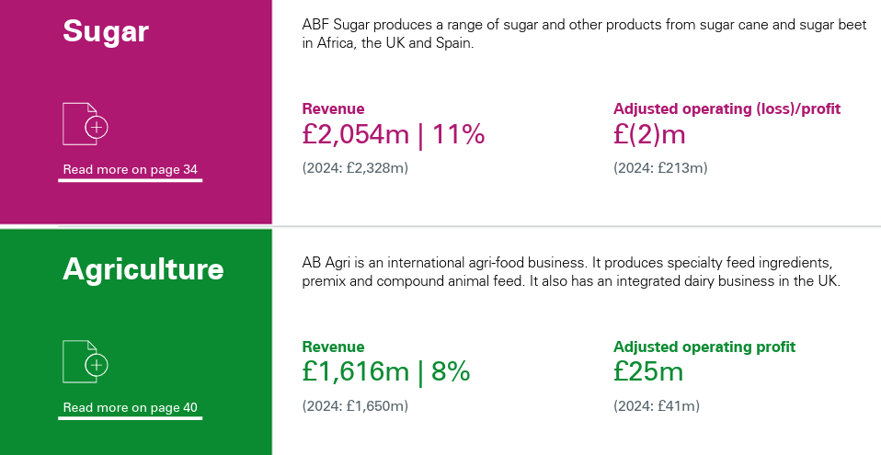
Figure 2: Annual report of ABF (2025)
(Source: ABF, 2025c)
Sustainable competitive advantage is essentially about the ability of companies to organise and mobilise internal resources according to the strategic goals. Abid et al. (2023) suggested that in organisations where resources are not just valuable but also integrated into organisational processes, which competitors find it difficult to imitate, organisations will perform better. This is quite specific to markets where the scale and efficiency of operations dictate the competitive positioning. As emphasised in their recent corporate reporting, Primark presently has more than 470 stores in 18 markets exporting its products to customers around the world (Primark, 2025). This is the biggest physical footprint with all the economies of scale and market accessibility. This is the large retail presence that has been experienced by ABF. Figure 2 has revealed ABF’s large and diverse portfolio is its retail segment, with a revenue of £4,125m in 2025, followed by the “yeast and bakery ingredients” segment with a revenue of £2,041m (ABF, 2025c). all these financial aspects allowed it to build on its efficiency of distribution and its cost structure. Besides, a vertically-integrated sourcing strategy provides a closer control over the production and procurement process, eliminating the reliance on external intermediaries. However, even though diversification in food, agriculture and retail segments helps in distributing risks, it creates complexities in coordination that need powerful managerial synergies. It is believed that resource ownership is an insufficient element to gain a competitive advantage. However, this capability depends on how effectively resource management and integration are implemented in the context of the overall strategic framework (Stoelhorst, 2023).
Additionally, the long-term competitiveness is propagated by the capacity of the organisation to constantly adapt and restructure its processes of operations to the environmental changes. Bari et al. (2022) note that dynamic capabilities help the firm to maintain a lead by integrating, developing, and reorganising internal capabilities in changing environments. This is especially true in industries that have price elasticity and volatile consumer needs. The latest performance findings show that the organisation has realised adjusted operating profit amounting to £1.998 billion (ABF, 2025). It showed that the organisation is highly efficient in its operations despite the volatility of the sector it operates. ABF claimed the utilisation of its cost leadership model and supply chain coordination to sustain their competitive position, especially in the value-driven markets in their retail outlets. Moreover, ongoing investments in capital in the areas of operational efficiency and infrastructure building enable the process of scalability, but these are not necessarily rare types of investments that can be replicated by other competitors as well. Grameen Sharapov and Ross (2023) observed that sustainable advantage is developed when companies conduct their operations in a distinctive manner that can hardly be aped. Thus, the initial resource, as well as the integrative system of the cost efficiency, the scale and the supply chain capabilities, is not a single asset, but rather a combination of the reinforcing entities, and provides the long-term strategic position of the organisation.

CSR and Sustainability objectives
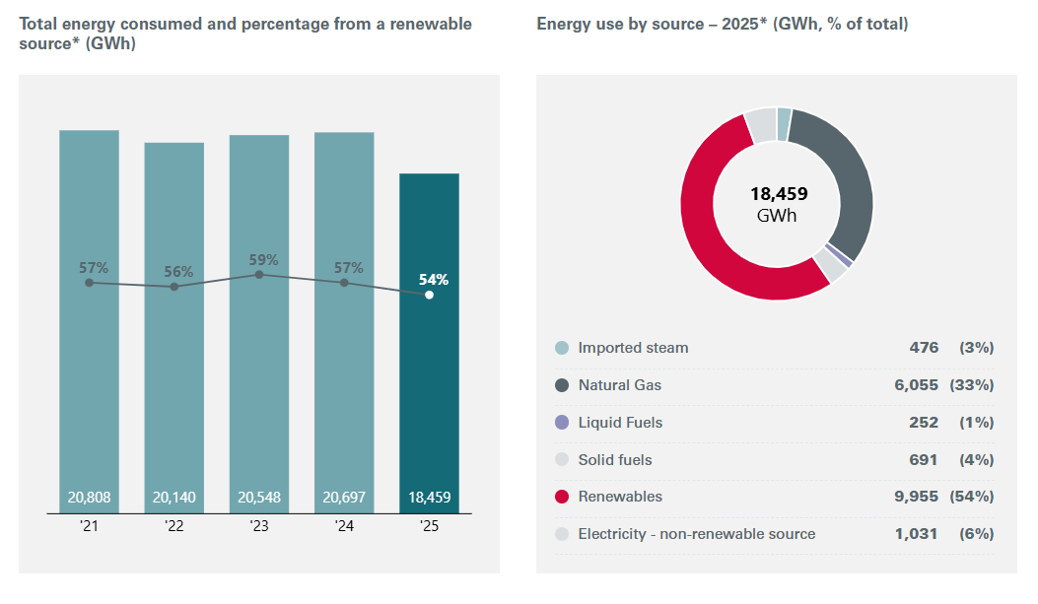
Figure 3: Total energy consumed and percentage from a renewable source
(Source: ABF, 2025b)
Considering sustainability practices at big multinational organisations based on the available ESG disclosures, it can be said that these practices are increasingly built around quantifiable environmental performance and open governance frameworks. Audi and Yu (2024) state that companies that incorporate sustainability indicators into their reporting systems on operations show responsibility and value creation in the long term more. This can be seen in the fact that total Scope 1 and 2 emissions have reduced since 2,779 and 2,410 thousand tonnes CO2e in the last few years, which point to the fact that energy efficiency and emissions management have improved (ABF, 2025b). ABF enjoys this enhancement via responsive operational reengineering and surveillance systems in its business units. Moreover, management systems that encompass ESG monitoring and data that is independently guaranteed make initiatives of sustainability more credible. Nonetheless, even though good progress has been measured, the distribution of the emissions in particular groups implies marginal performance, which is worrisome when it comes to establishing the homogeneity in the application of sustainability within the organisation.
Strategically, sustainability efforts seem partly consistent with business long-term goals and especially in terms of operational efficiency and lowering the risk of environmental impact. Alfawaire and Atan (2021) have put it in a way that sustainability is the source of competitive advantage when incorporated in strategic core, but not a situation where sustainability is a marginal operation. This point of view shows one of the main weaknesses, since the allocation of emissions is extremely consolidated among the sugar segment, where it allocates about 72% of all emissions, and other divisions represent much less (ABF, 2025a). Associated British Foods is a company that is undertaking sustainability in its activities by introducing climate and resource efficiencies; but because they are not set in uniform targets across the company, their strategic integrity is diminished. Sustainable strategies have the ability to undermine functionality and reduce long-term influence. Thus, the reduction of the number of emissions and the level of transparency in its governance are evident, but its sustainability plan is still rather unsuccessful and partially consistent, which means that the central integration requires greater strength to increase the uniformity of performance and its competitive Britishness.

Comprehensive and holistic view of the Organization

4.1 Balanced Scorecard
Perspective | Objectives | KPIs | Targets | Strategic Initiatives
Financial | Improve profitability & cost efficiency | Operating profit margin, revenue growth | Sustain profit growth despite volatility | Cost control, diversification, efficiency improvements
Customer | Deliver value-for-money products & customer satisfaction | Market share, customer footfall, brand perception | Increase retail market share | Expand Primark stores, maintain low pricing strategy
Internal Processes | Enhance supply chain efficiency & operational performance | Inventory turnover, supply chain lead time | Improve operational efficiency | Vertical integration, sourcing optimisation, logistics efficiency
Learning & Growth | Strengthen innovation, workforce capability & sustainability | Employee productivity, ESG performance metrics | Improve workforce skills & sustainability performance | Investment in technology, training, sustainability initiatives
Table 3: Balanced Scorecard
(Source: Self-developed)
Performance of an organisation can be explained in terms of a combination of financial and non-financial indices that will contribute to the achievement of strategic goals. Kurznack et al. (2021) stated that the greater the performance measurement in various dimensions, the higher the strategic coherence and value creation in firms. Such a multidimensional approach emphasises the significance of the connection between financial performance and operational effectiveness and positioning. According to the arguments of Grishunin et al. (2022), organisations pursuing financial measures only are at risk of missing important factors in long-term performance, especially those that can be connected to internal processes and customer value. Associated British Foods demonstrates such an integrated response via its concern with cost-effectiveness and the control of its operation that underlies its larger competitive position. Nevertheless, in case causal relationships between perspectives are not clearly stipulated, the balanced scorecard may prove to be ineffective (Kumar et al. 2022). It implies that although the organisation has indicated an alignment between its financial and operational goals, the success of the performance management relies on the effectiveness with which the two linkages have been applied and followed up.
Under more general strategic formulations, incorporating customer, internal process and learning facets underlines the significance of the ongoing capacity building and organisational flexibility. Forrest et al. (2022) suggests that organisations that link customer value propositions with internal operations and learning potentials will have higher chances of communication survival. This opinion is also justified by Chenhall (2005), who claims that the system of performance measurements should develop as the priorities and external circumstances of the strategy change. Associated British Foods uses its cost leadership strategy and size of operation to provide customers with value in a cost-effective manner. Nevertheless, most of the traditional balanced scorecard models do not include the dimensions of sustainability effectively, which constrains their applicability in contemporary strategic environments (Chehimi and Naro, 2024). This is also one of the limitations as can be seen whereby environmental as well as social performance indicators are not well-built into core performance frameworks. Moreover, according to Gahan et al. (2021), organisations need to entrench the concepts of innovation and learning within their strategic systems in order to be competitive in fluid conditions. Thus, although the organisation has a high level of congruence in the financial, customer, and operational lenses, a partial approach to incorporating the sustainability and innovation measures is a decisive loophole, which can influence the long-term strategic performance.

Strategic Choices & Implementation
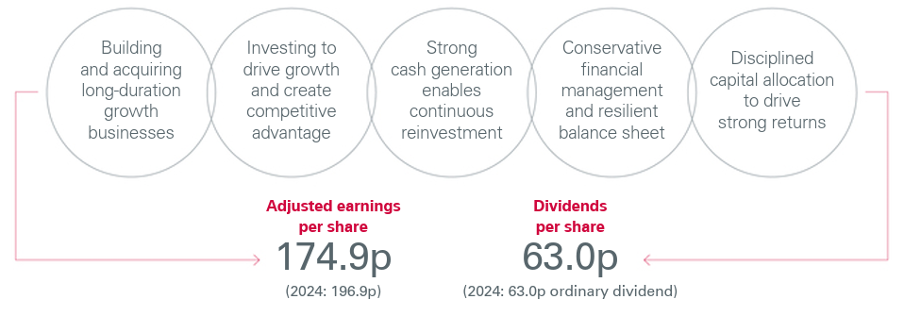
Figure 4: sustainable and long-term growth strategy of ABF (2025)
(Source: ABF, 2025c)
In accordance with the strategic positioning of the firms estimated in the context of the competitive market of retail and consumer goods, cost leadership and selective differentiation offer a stronger competitive advantage. Khan et al. (2025) explained that the cost leadership strategy helps firms to leverage over competitors due to lower operational costs, especially in markets that are sensitive to price. This can be seen in ABF’s retail model that helped it to witness high-volume sales with low margins that are being dwelt upon. Most importantly, the annual report revealed that 2025 has been “a year of intense strategic and operational activity” for ABF. Figure 4 shows ABF Group’s adjusted earnings per share (EPS) of 174.9p (£1.749) (ABF, 2025c). The retail segment keeps on an international growth with the latest store openings in the United States and Central and Eastern Europe. ABF capitalises on this expansion program using the model of Primark to provide fashionable products at a much lower price than competitors like Zara and H&M, frequently lower pricing products, which enhances its value offer. Nevertheless, the dependency on the cost leadership alone puts it under threats like price and margin remuneration. Adding aspects of differentiation, such as a better in-store experience and product range, will increase customer loyalty without making the costs too high (Bruckberger et al. 2023). Diversification presented on a corporate level into food, agriculture and ingredients also offers stability. This has been observed when performance of the retail sector is subjected to changes, but food segmentation offers consistent revenue flows. Secondly, the international expansion into more than 18 markets is an indication of strategic geographic expansion as it allows the company to access new consumer segments and to limit its reliance on maturity in the market.
Regarding the implementation aspect, it can be said that effective change management and organisational coordination of strategies are critical success factors in these strategies. Dugbartey and Kehinde (2025) observed that effective implementation of strategies needs organisational change processes and adjustments at different levels of the organisation to be effective. The organisation has also expanded capital expenditure to facilitate expansion of the stores, logistics infrastructure and improvement in operational efficiency. ABF has been able to exercise flexibility by initiatives like ensuring efficiency of its supply chain and reacting to the increasing cost of inputs by streamlining its sourcing operations. Nevertheless, operating in various markets brings with it some operations with some challenges such as cultural differences, regulatory compliance and complexity of the supply chain. Indicatively, the business in the US market needed to be modified such that the stores formats and products needed to reflect such a local consumer demand. Moreover, diversification introduces coordination issues in the different business segments that cause complexity in management. Companies that work in different industries need to strike the balance between the strategic control and the flexibility to adapt to the local conditions (Sen et al. 2023). Although cost leadership with its diverse differentiation and diversification is the most suitable strategic pathway, it requires a good change management system, effective coordination and relentless integration with the global market dynamics.

Strategic Evaluation & Recommendations

SWOT Analysis
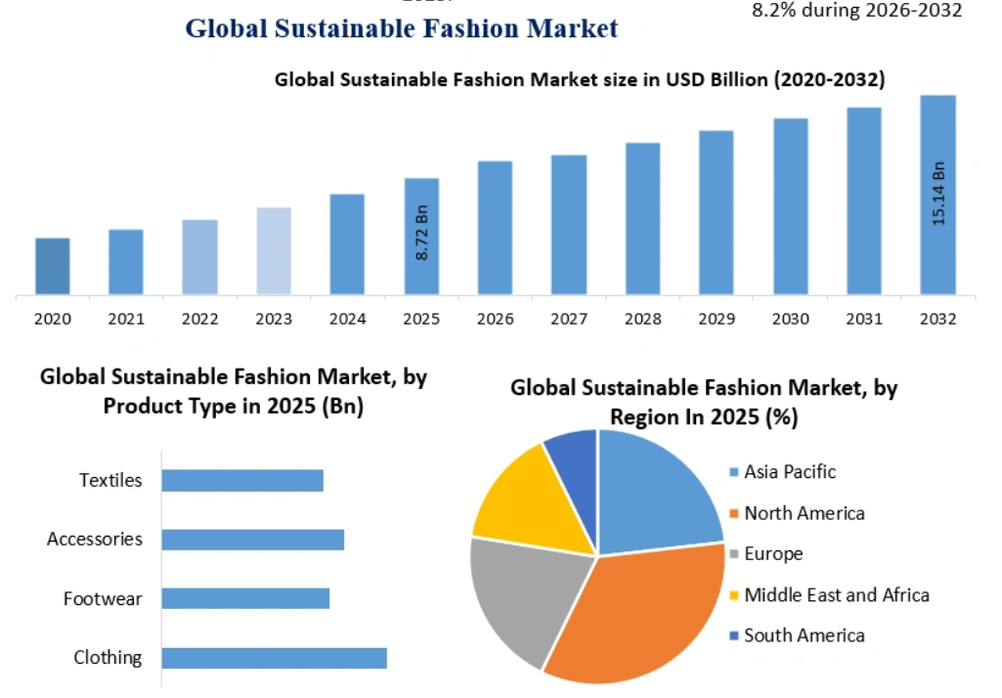
Figure 5: Global Sustainable Market
(Source: Einpresswire, 2025)
Strengths | Weaknesses
- ABF has a strong cash flow from operations of approximately £1.1 billion, (ABF, 2024)  - This supports reinvestment capacity  - The adjusted operating profit of retail and grocery are £1,126m and £478m respectively (ABF, 2025c)  - Primark’s continued expansion with net addition of new stores annually, strengthening physical presence | - Heavy reliance on physical retail, with no full-scale global e-commerce model  - This has limited its digital competitiveness  - High exposure to low-margin retail model, making profitability sensitive to cost increases
Opportunities | Threats
- As shown in figure 5, growth of sustainable fashion market is expected to reach $15.14 billion by 2032 globally (Einpresswire, 2025)  - This has created new product opportunities  - Adoption of AI-driven supply chain systems improving efficiency and demand forecasting | - Increasing raw material and energy cost volatility impacting production margins  - Intensifying fast-fashion competition with rapid product cycles and innovation  - Huge competition from key players, such as Nestle, Kerry Group plc and Danone (Globaldata, 2026)
Table 4: SWOT Analysis
(Source: Self-developed)
The competitive advantage is motivated by the strong positioning of resources and limited by structural weaknesses. Indriyani et al. (2025) asserted that firms need to match strength with the external opportunities to remain in performance. This can be seen through how ABF is using its vast network of retail outlets and diversified portfolio to facilitate expansion. One of the main advantages of ABF is that its market presence and its stable revenue of £19.5bn (group revenue) that protect the company (ABF, 2025c). ABF prioritises strengthening its customer value proposition by means of different “product offerings, price and price perception, and digital customer engagement with a view to driving like-for-like sales” (ABF, 2025c). However, due to its dependence on Primark, it is vulnerable to industry-specific risks. Moreover, there is a lack of a robust e-commerce model to help it compete in digital retail markets. The possibilities of international growth, demand for low-cost products, lead to future growth, and external threats, in terms of increasing costs and stiff competition, put pressure on margins. Thus, insofar as strong strategic positioning is evident within the organisation, the long-term performance is subjected to a diminishment of risks of dependency and adjustment to the trends of digital transformation.

6.2 BCG Matrix
Business Segment | BCG Position | Justification
Primark (Retail) | Star | High market share and strong growth through global expansion
Grocery (Twinings, Ovaltine) | Cash Cow | Stable demand and consistent revenue generation
Sugar Division | Question Mark | Volatile performance and declining profitability
Agriculture & Ingredients | Cash Cow / Low Growth | Stable but limited growth potential

Table 5: BCG Matrix
(Source: Self-developed)
Portfolio balance is very important to maintaining long-term growth. As stated by Mutambo et al. (2022), companies need to resource the various business units effectively to ensure that the overall performance is optimised. This can be traced in the dependence of the organisation on its retail sector as a major growth engine. Associated British Foods classifies Primark as a Star because of its growth and presence in the market, with its stable cash flows, and the grocery and ingredients segments are a source of stable cash flows. The sugar division is, however, a strategic issue because of the volatility and lower profitability. Such an imbalance implies that there should be a strategic redistribution of resources. As long as there are strong segments, it means financial stability, but poorly performing divisions can decrease the total efficiency. Hence, developing sustainable growth and enhancing profitability, portfolio management is required.

6.3 Strategic recommendations
Existing strategy of ABF is analysed to be functional, but not completely geared towards long-term competitiveness. Business of this organisation has been effective due to the use of cost leadership and diversification, which enhances stability and growth (ABF, 2025a). Nevertheless, digital capability, excessive dependency on the retail segment, and lack of uniformity in performance by business units are issues. Bari et al. (2022) claimed that sustainable competitive advantage necessitates strategic alignment and constant adaptations to changes in the market. Digital transformation should be one of the key focuses of Associated British Foods, specifically, its ability to increase online retail presence and compete with other fast-fashion competitors. Second, the organisation needs to lessen the reliance on Primark by enhancing performance at the lower performing sections, like sugar, either through restoring or divesting. Thirdly, this would involve increased sustainability integration into the core strategy to have increased resilience in the long term and comply with regulations. Further expansion into high-growth international markets should also be favourable with localised strategies to mitigate operational risks. Correlations between environment and firm capabilities result in better long-term performance of firms that match strategy with changes in the environment and capabilities (Indriyani et al. 2025). Thus, ABF can increase its competitive advantage and pursue sustainable further growth by enhancing digital abilities and optimising its portfolio as well as improving sustainability integration.

SECTION 2 – REFLECTIVE ACCOUNT

Description
This assignment was intended to critically examine the strategic management practice of one of the multinational practices through the application of some of the most important theoretical approaches, like PESTEL, VRIO, Balanced Scorecard, and SWOT. Mohamed et al. (2022) opines that reflective practice helps the learner to gain higher knowledge through the connection of theory to experience. In doing this task, I had done a vast amount of research with reference to academic journals, company reports, and other reliable online references in order to consider both internal and external strategic factors. It was done by synthesising multifaceted information, searching strategic problems and strategizing theory in practical situations. This was not based on just acquiring theoretical knowledge but on interpreting its application in a real-life organisational environment. It was also a more critical thinking task and demanded because the assignment did not just need the description of the strategies, but also to evaluate them and make an assessment.

Feelings
At the first level, I was not sure how to resolve such a complex and theory-heavy task, especially when it comes to combining various strategic models into a congruent analysis. Emotions have a dominant role in the learning process and can affect motivation and engagement (Wang et al. 2022). The further I went, the more I became confident because of the knowledge about the implementation of strategic models. Nonetheless, I also had issues in making sure that I did not write descriptively but in a critical manner. It was also feared that one would not repeat something in one section and then in the other and still make sense. In the long term, I established a better structure for information examination, which minimised confusion and enhanced my self-confidence in working with the complicated academic challenges.

Evaluation
Generally, the research process was efficient in increasing my knowledge of the concept of strategic management. The capacity to use various frameworks in a single organisation was one of the major strengths because it is a whole picture of the strategic position of the organisation. Lombardi et al. (2021) also observe that the best way to learn is by people participating in the practical application of concepts to real life. The assignment has enabled me to gain analytical skills by connecting theory with practice. Nevertheless, the weakness lay in the inability to create a balance between depth and clarity, since certain concepts needed to be described in detail while being concise. Also, retrieving pertinent and current academic sources was time and work-intensive. Even though I managed to find credible sources, it was not easy to incorporate them into the analysis in the first instance.

Analysis
The overall feeling of having accomplished this assignment brings out the essence of reflective learning in the process of preparing critical thinking skills. Cattaneo and Motta (2021) argue that it is through reflection that people can criticise their efforts and be able to enhance their performance in the future. This process has enabled me to appreciate that I cannot just learn theory but have to be able to apply theory critically in practice. The application of theories like VRIO and the Balanced Scorecard revealed how strategic tools can be applied to determine organisational performance from different perspectives. In addition, I realised the role of not doing descriptive writing and doing analysis and evaluation. As Weng et al. (2023) note, deep learning takes place when students are involved in learning concepts and not when they memorise information. This task also helped me embrace a more serious approach to learning, involving assumption questioning, comparison, and the formation of received arguments. In addition, the process of reflection has improved my skill of assessing information in more than one way and structuring complex concepts into analytical form. I have learned to be more aware of the way theoretical models are linked and how they can be used together to give a more extensive understanding of organisational strategy. Another beneficial effect of this experience was that it has enhanced my confidence in working on academic research, specifically, on how to choose reliable sources and incorporate them well into my work. Also, I identified the need to have logical flow and cohesion in the various parts of the assignment, where every part played a significant role in the general argument.

Conclusion
Finally, this assignment has greatly increased my knowledge regarding strategic management as well as the practical implementation of theoretical frameworks in the performance analysis of organisations. Reflection lets people learn through experience and advance future behaviour. My analytical and research abilities have also been strengthened, especially in the area of appraisal of complicated information and how to give properly organised arguments. I also got to know about critical thinking and how one must be able to back their arguments with authoritative academic references. Yet, I understand that I still can and will make some progress, especially in the area of making the theory more of an integrated part and better comprehensible. This has been an eye-opener, as the experience will aid in my future academic and professional growth.

Action Plan
It is based on this contemplation that I would seek to work on my academic writing and analysis tasks in subsequent assignments. Transformative learning happens when people engage in a critical mind over what they have assumed and change their minds. Academic literature is another area I intend to become more active in to enhance my knowledge about theoretical concepts and be able to use them more effectively in a critical manner. Also, I will come up with more effective time management skills to enable me to have enough time to conduct research, analyse, and revise. I will as well consult lecturers and peers to get their feedback to understand how to improve and be more effective in the job. Additionally, I wish to enhance my skills in incorporating more than one framework, not redundantly, so that every part would contribute a different value to the whole analysis. These enhancements will put me in a better position to deliver good academic work in subsequent exams.

References
ABF (2024). Strong performance across our key financial metrics. Available at: https://www.abf.co.uk/content/dam/abf/corporate/ar-assets-2024/pdfs/abf-annual-results-presentation-2024.pdf.downloadasset.pdf [Accessed on: 11.03.2026]
ABF, (2025). Annual Results Announcement Available at: https://www.abf.co.uk/media/news/2025/2025-annual-results-announcement [Accessed on: 12.03.2026]
ABF, (2025a). Operating review Available at: https://www.abf.co.uk/content/dam/abf/corporate/Documents/investors/results-and-presentations/2025/abf-annual-results-2025-announcement.pdf.downloadasset.pdf [Accessed on: 15.03.2026]
ABF, (2025b). Carbon and climate Available at: https://www.abf.co.uk/responsibility/our-material-topics/carbon-and-climate [Accessed on: 15.03.2026]
ABF. (2025c). Associated British Foods plc / Annual report 2025. Available at: https://www.abf.co.uk/media/news/2025/2025-annual-results-announcement [Accessed on: 10.03.2026]
Abid, N., Dowling, M., Ceci, F. and Aftab, J., 2023. Does resource bricolage foster SMEs' competitive advantage and financial performance? A resource‐based perspective. Business Strategy and the Environment, 32(8), pp.5833-5853. https://onlinelibrary.wiley.com/doi/pdfdirect/10.1002/bse.3451?casa_token=Ij5kZGuZtVEAAAAA:5NGdfegeQ44PMHXcKKFViIznMbCsV80RxJY5zKQXR9brrbZXgu3sgS9xlIZsZzugrENWkZJR1Gh04A
Alfawaire, F. and Atan, T., 2021. The effect of strategic human resource and knowledge management on sustainable competitive advantages at Jordanian universities: The mediating role of organizational innovation. Sustainability, 13(15), p.8445. https://www.mdpi.com/2071-1050/13/15/8445
Ardiansyah, M. and Alnoor, A., 2024. Integrating corporate social responsibility into business strategy: creating sustainable value. Involvement International Journal of Business, 1(1), pp.29-42. https://ejournal.agungmediapublisher.com/index.php/iijb/article/download/5/5
Associated British Foods, (2025). ABF at a glance Available at: https://www.abf.co.uk/about-us/abf-at-a-glance [Accessed on: 17.03.2026]
Associated British Foods, (2025). Tracking our progress Available at: https://www.abf.co.uk/content/dam/abf/corporate/ar-assets-2024/pdfs/abf-annual-report-2024.pdf.downloadasset.pdf [Accessed on: 15.03.2026]
Audi, M. and Yu, H., 2024. Strategic value creation through corporate social responsibility adoption for sustainable financial performance. Journal of Policy Options, 7(4), pp.14-21. http://resdojournals.com/index.php/jpo/article/download/385/638
Bari, N., Chimhundu, R. and Chan, K.C., 2022. Dynamic capabilities to achieve corporate sustainability: a roadmap to sustained competitive advantage. Sustainability, 14(3), p.1531. https://www.mdpi.com/2071-1050/14/3/1531
Bari, N., Chimhundu, R. and Chan, K.C., 2022. Dynamic capabilities to achieve corporate sustainability: a roadmap to sustained competitive advantage. Sustainability, 14(3), p.1531. https://www.mdpi.com/2071-1050/14/3/1531
Bruckberger, G., Fuchs, C., Schreier, M. and Van Osselaer, S.M., 2023. Retailing Groundedness: How to improve customer experience, brand perceptions, and customer loyalty through feelings of groundedness. Journal of Retailing, 99(4), pp.594-604. https://www.sciencedirect.com/science/article/pii/S002243592300057X
Burr, N., and Willems, T. (2025). About a rate of (general) interest: how monetary policy transmits Available at: https://www.bankofengland.co.uk/quarterly-bulletin/2024/2024/about-a-rate-of-general-interest-how-monetary-policy-transmits [Accessed on: 15.03.2026]
Cattaneo, A.A. and Motta, E., 2021. “I reflect, therefore I am… a good professional”. On the relationship between reflection-on-action, reflection-in-action and professional performance in vocational education. Vocations and Learning, 14(2), pp.185-204. https://link.springer.com/content/pdf/10.1007/s12186-020-09259-9.pdf
Chehimi, M. and Naro, G., 2024. Balanced Scorecards and sustainability Balanced Scorecards for corporate social responsibility strategic alignment: A systematic literature review. Journal of Environmental Management, 367, p.122000. https://www.sciencedirect.com/science/article/pii/S0301479724019868?casa_token=diCz4zbIdVsAAAAA:piXGQ2E3rYfzR-9Bo3ocWaMRlLH6PNMPuYcddWq4waywCtlltEURAtYiSvo-rmO309_PE21dRg
Davey, J. (2024). Sugar warning dents shares in Primark-owner AB Foods. Available at: https://www.reuters.com/business/retail-consumer/ab-foods-keeps-annual-guidance-primark-unit-cuts-sugar-outlook-2025-04-29 [Accessed on: 15.03.2026]
Dugbartey, A.N. and Kehinde, O., 2025. Optimizing project delivery through agile methodologies: Balancing speed, collaboration and stakeholder engagement. World Journal of Advanced Research and Reviews, 25(1), pp.1237-1257. https://www.researchgate.net/profile/Adriana-Dugbartey/publication/388175971_Corresponding_author_Adriana_N_Dugbartey_Optimizing_project_delivery_through_agile_methodologies_Balancing_speed_collaboration_and_stakeholder_engagement/links/678d448aec3ae3435a6e0a39/Corresponding-author-Adriana-N-Dugbartey-Optimizing-project-delivery-through-agile-methodologies-Balancing-speed-collaboration-and-stakeholder-engagement.pdf
Einpresswire, (2025). The Sustainable Fashion Market was valued at USD 8.72 billion in 2025 and is projected to reach USD 15.14 billion by 2032, growing at a CAGR of 8.2%. Available at: https://img.einpresswire.com/large/1073475/sustainable-fashion-market-grap.png#851x690 [Accessed on: 14.03.2026]
Fashionnetwork, (2025). Primark sees ups and downs in latest year, owner hints at standalone spin-off for business Available at: https://uk.fashionnetwork.com/news/Primark-sees-ups-and-downs-in-latest-year-owner-hints-at-standalone-spin-off-for-business,1779604.html [Accessed on: 18.03.2026]
Forrest, J.Y.L., Novikov, D.A., Larson, S., Wang, F. and Yang, J., 2021. Competitive advantages and values created and attained out of well-crafted customer value propositions. Studies in Business and Economics, 16(2), pp.53-73. https://sciendo.com/2/v2/download/article/10.2478/sbe-2021-0024.pdf
Gahan, P., Theilacker, M., Adamovic, M., Choi, D., Harley, B., Healy, J. and Olsen, J.E., 2021. Between fit and flexibility? The benefits of high‐performance work practices and leadership capability for innovation outcomes. Human Resource Management Journal, 31(2), pp.414-437. https://onlinelibrary.wiley.com/doi/pdf/10.1111/1748-8583.12316?casa_token=xY83WFv3yyQAAAAA:RgMNl66eDSs0UN7YSHkwlU8XOt7R2gjvoMLdGVnmGv__Hm52xMAfU66RQ_UF5nfRlRjtCTm5_AKaKQ
Globaldata, (2026). Associated British Foods Plc: Competitors. Available at: https://www.globaldata.com/company-profile/associated-british-foods-plc/competitors/ [Accessed on: 18.03.2026]
Government of the UK, (2025). National Minimum Wage and National Living Wage rates. Available at: https://www.gov.uk/national-minimum-wage-rates [Accessed on: 11.03.2026]
Grishunin, S., Suloeva, S. and Burova, E., 2022. Development of risk management mechanism and the system of risk metrics to evaluate and enhance the long-term orientation of the strategies of non-financial companies. Risks, 10(9), p.182. https://www.mdpi.com/2227-9091/10/9/182
Indriyani, E.P., Suhariadi, F., Lestari, Y.D., Aldhi, I.F., Rahmawati, E., Hardaningtyas, D. and Abbas, A., 2025. Sustaining infrastructure firm performance through strategic orientation: Competitive advantage in dynamic environments. Sustainability, 17(3), p.1194. https://www.mdpi.com/2071-1050/17/3/1194
Indriyani, E.P., Suhariadi, F., Lestari, Y.D., Aldhi, I.F., Rahmawati, E., Hardaningtyas, D. and Abbas, A., 2025. Sustaining infrastructure firm performance through strategic orientation: Competitive advantage in dynamic environments. Sustainability, 17(3), p.1194. https://www.mdpi.com/2071-1050/17/3/1194
Inman, P., and Knowles, T. (2026). UK inflation falls to 3%, boosting hopes of early cut in interest rates. Available at: https://www.theguardian.com/business/2026/feb/18/uk-inflation-falls-interest-rates-bank-of-england [Accessed on: 15.03.2026]
Joussen, T.P., Kanbach, D.K. and Kraus, S., 2025. Enabling strategic change toward resilience: a systematic review from a dynamic capabilities perspective. Strategic change, 34(3), pp.373-405. https://onlinelibrary.wiley.com/doi/pdf/10.1002/jsc.2626
Khan, H., Khan, Z. and Knight, G., 2025. International marketing agility and cost leadership strategies of frontier emerging market exporters in advanced economy markets. International Business Review, 34(3), p.102422. https://www.sciencedirect.com/science/article/pii/S0969593125000356
Khan, H., Khan, Z. and Knight, G., 2025. International marketing agility and cost leadership strategies of frontier emerging market exporters in advanced economy markets. International Business Review, 34(3), p.102422. https://www.sciencedirect.com/science/article/pii/S0969593125000356
Kumar, J., Prince, N. and Baker, H.K., 2022. Balanced scorecard: A systematic literature review and future research issues. FIIB Business Review, 11(2), pp.147-161. https://journals.sagepub.com/doi/pdf/10.1177/23197145211049625?casa_token=drPSs9hsafoAAAAA:dE2Vvd7hqCsL8cyNWvWX21hgz51w92b5vYQS8QfKJKD4nCDGq3jlLpXzGIRd1-on97MPZpyz12M
Kurznack, L., Schoenmaker, D. and Schramade, W., 2021. A model of long-term value creation. Journal of Sustainable Finance & Investment, pp.1-19. https://www.tandfonline.com/doi/pdf/10.1080/20430795.2021.1920231
Lombardi, D., Shipley, T.F. and Astronomy Team, Biology Team, Chemistry Team, Engineering Team, Geography Team, Geoscience Team, and Physics Team, 2021. The curious construct of active learning. Psychological Science in the Public Interest, 22(1), pp.8-43. https://journals.sagepub.com/doi/pdf/10.1177/1529100620973974?casa_token=aPWGgeK8N1QAAAAA:sYNghsdN-82Dps-qmg4oEaeRAyHXzAcWAzbg411Y4KDn0AGOZwMTFcUxZRF4o1NFX1ffHmR7vBM
London Stock Exchange, (2025). Interim Results Announcement. Available at: https://www.londonstockexchange.com/news-article/ABF/interim-results-announcement/17009923 [Accessed on: 15.03.2026]
Mohamed, M., Rashid, R.A. and Alqaryouti, M.H., 2022. Conceptualizing the complexity of reflective practice in education. Frontiers in psychology, 13, p.1008234. https://www.frontiersin.org/journals/psychology/articles/10.3389/fpsyg.2022.1008234/pdf
Mutambo, N., Mwange, A., Manda, R., Chiseyeng’i, J., Mashiri, G. and Bwalya, J., 2022. Principles and practices of strategy for effective and efficient performance of business organisations. European Journal of Business and Management, 14(14), pp.52-68. https://www.researchgate.net/profile/John-Bwalya-3/publication/362919633_Principles_and_Practices_of_Strategy_for_Effective_and_Efficient_Performance_of_Business_Organisations/links/63076fc161e4553b9539b703/Principles-and-Practices-of-Strategy-for-Effective-and-Efficient-Performance-of-Business-Organisations.pdf
ONS, (2025). Redefining investment in digital infrastructure in the UK. Available at: https://www.ons.gov.uk/economy/economicoutputandproductivity/productivitymeasures/articles/redefininginvestmentindigitalinfrastructureintheuk/2024-07-31 [Accessed on: 13.03.2026]
Primark, (2025). Primark - About Us Available at: https://www.primark.com/about-us [Accessed on: 11.03.2026]
Sen, S., Savitskie, K., Mahto, R.V., Kumar, S. and Khanin, D., 2023. Strategic flexibility in small firms. Journal of Strategic Marketing, 31(5), pp.1053-1070. https://www.tandfonline.com/doi/pdf/10.1080/0965254X.2022.2036223?casa_token=2FX9a5cWx58AAAAA:kt_qNkted3MwMn7NqWwb8JxAGwPiBGfEITfVPs3QJ6AszO3RWh7f8WEc983h5mM_NARZPzF19nLd
Sharapov, D. and Ross, J.M., 2023. Whom should a leader imitate? Using rivalry‐based imitation to manage strategic risk in changing environments. Strategic Management Journal, 44(1), pp.311-342. https://sms.onlinelibrary.wiley.com/doi/pdf/10.1002/smj.3226?casa_token=x6AbgfJsAxYAAAAA:zVXzWPZI61C3YPb0Q04vsethh0n3ny4mDkBR2ud_IxNpSBeVOzRWcpr2TbimvEWcDqQISjeb8Pf-MQ
Stoelhorst, J.W., 2023. Value, rent, and profit: A stakeholder resource‐based theory. Strategic Management Journal, 44(6), pp.1488-1513. https://sms.onlinelibrary.wiley.com/doi/pdf/10.1002%2Fsmj.3280
Ul Amin, N. and Khan, M.A., 2024. Driving Competitive Advantage in the Digital Era: The Role of Dynamic Capabilities, Innovation, and Leadership. Dinasti International Journal of Economics, Finance & Accounting (DIJEFA), 5(5). https://www.researchgate.net/profile/Muhammad-Asif-Khan-2/publication/387324285_Driving_Competitive_Advantage_in_the_Digital_Era_The_Role_of_Dynamic_Capabilities_Innovation_and_Leadership/links/6768feda894c55208523319a/Driving-Competitive-Advantage-in-the-Digital-Era-The-Role-of-Dynamic-Capabilities-Innovation-and-Leadership.pdf
Uzozie, O.T., Onaghinor, O., Esan, O.J., Osho, G.O. and Olatunde, J., 2022. Global supply chain strategy: Framework for managing cross-continental efficiency and performance in multinational operations. International Journal of Multidisciplinary Research and Growth Evaluation, 3(1), pp.938-943. https://www.allmultidisciplinaryjournal.com/uploads/archives/20250416162238_MGE-2025-2-261.1.pdf
Wang, J., Zhang, X. and Zhang, L.J., 2022. Effects of teacher engagement on students’ achievement in an online English as a foreign language classroom: The mediating role of autonomous motivation and positive emotions. Frontiers in psychology, 13, p.950652. https://www.frontiersin.org/journals/psychology/articles/10.3389/fpsyg.2022.950652/pdf
Weng, C., Chen, C. and Ai, X., 2023. A pedagogical study on promoting students' deep learning through design-based learning. International journal of technology and design education, 33(4), pp.1653-1674. https://link.springer.com/content/pdf/10.1007/s10798-022-09789-4.pdf
World Footwear, (2025). Primark ends full year on growth path Available at: https://www.worldfootwear.com/news/primark-ends-full-year-on-growth-path/10177.html [Accessed on: 20.03.2026]

