CULTURAL TOURISM
An investigation into the culture and heritage in Wales primarily the city of Swansea.

STUDENT: Raffique George
STUDENT NUMBER: P151586
MODULE: RESEARCH METHODS
PRESENTEED TO: Kathryn Flynn
Table of content
CONTENT PAGE
INTRODUCTION
1.0 Title………………………………………………………………………………………………………….. 3
1.1 Research Rationale…………………………………………………………………………………… 3
1.2 Aim………………………………………………………………………………………………….………… 3
1.21 Objective…………………………………………………………………………………………………. 3
2.0 Background Rationale………………………………………………………………………………… 4
2.1 Literature Review………………………………………………………………………………………. 4
METHODOLGY
3.0 Research…………………………………………………………………………………………………….. 5
3.1 Research Purpose………………………………………………………………………………………. 5
3.2 Data collection…………………………………………………………………………………………… 5
4.0 The research ‘onion’………………………………………………………………………………….. 6
4.1 Research Approach/ strategy…………………………………………………………………….. 6
4.2 Research population and sample……………………………………………………………….. 6
4.21 Advantage of using stratified random sampling……………………………………….. 7
4.22 Disadvantage of using stratified random sampling…………………………………… 7
5.0 Reliability and Validity………………………………………………………………………………. 7
6.0 Limitations………………………………………………………………………………………………… 8
7.0 Ethical consideration…………………………………………………………………………………. 9
8.0 Resource and Planning………………………………………………………………………………. 10
8.1 Analysis…………………………………………………………………………………………………….. 10
8.2 Conclusion………………………………………………………………………………………………… 10
Appendix i………………………………………………………………………………………………………. 11
Appendix ii……………………………………………………………………………………………………… 12
References……………………………………………………………………………………………………… 13

Cultural Tourism
1.0 Title: An investigation into the culture and heritage in Wales primarily the city of Swansea.

1.1 Research Rationale: this research investigates the role in which the welsh culture and heritage aids in promoting Wales as a destination and how important it is to keep the culture alive being that culture is forever evolving.

1.2 Aim: to analysis how the welsh culture is being promoted as a tourism initiative.

1.21 Objective:
- To research the importance of culture and heritage in Wales.
- To examine the Welsh culture and its development as a tourism product.
- To evaluate the socio economic benefits of culture, and how it has improved within its immediate environment.

2.0 Background Rationale:
The topic of culture was chosen because it sews an intricate background on the moral values and meaning of life to safeguard for future generations as culture is ever evolving. It also plays an integral role in the tourism sector of any economy because of how distinctive it is across the world. Undertaking such research will illustrate the benefits, linkages, growth and evolution of cultural tourism in Swansea and Wales altogether.

2.1 Literature Review:
Culture is the backbone of any vibrant and thriving society, as it is an institution that supports both creativity and collective ways of life (Miller & Yudice, 2002). These values shared can be expressed in many different ways through music, art, food and folklore. It is used to celebrate and remember the past but is however as culture evolves, it adapts to the advancement of society. Hofstede (2002) defines culture as a shared programming of the mind that distinguishes members of one group of people from another. However, the concept of culture states that culture is not representative of an entity but is thought to be a signifier enabling human activity (Barker, 2002).
The Welsh culture
Primarily one of the most unique and diverse cultures in the United Kingdom. It is full of legends and traditions, even though it has Celtic roots, it is heavily influenced by England for centuries so both share common aspects yet are totally distinctive; possessing its own unique language, beliefs and national pride.
Culture tourism
Most attempts to define cultural tourism consists of the consumption of culture by tourist (Richard, 1996). It is a form of tourism with connections with a countries culture focusing on its uniqueness and the diversity of its customs. This branch of tourism focuses on preserving history thus giving tourist the experience needed to understand culture. As wales is becoming more and more diverse, there in an introduction to many different ethnic backgrounds portraying and embedding there norms and customs adding to the welsh culture. In turn, the immigration of these people helps to promote wales as a tourist destination as they have families who visit would then promote wales as a tourist destination. And since tourism in big business in wales, it shows that tourist would at least spend £14 million a day collectively while in wales, whether they are learning about the history and culture or the heritage of the Welsh. This £14 million then amounts to a staggering £5.1 billion per year (Business Wales, 2017).

Methodology
3.0 Research
Research is the systematic application or principle of undertaking an investigation to establish something factual or theoretical (Kumar, 2008). While Saunders et al claims that research is an interpretation of finding things out from a systematic collection with a clear purpose.

3.1 Research Purpose
A descriptive research approach was used when compiling research for the assessment as it aims to provide the researcher with a better understanding of the welsh culture casting a light on what is currently affecting its promotion and effectiveness.

3.2 Data collection
For achieving information for this research, both quantitative and secondary data collection methods were used. The purpose of using these methods is to obtain and record information in order to make appropriate decisions in relation to the topic of choice.
Quantitative research method is used to describe and measure the levels of occurrences based on calculations and numbers exhibiting a relationship between research and theory as a deduction (Saunders, 2012).
Secondary data is based on data that has already been researched upon and collected (Saunders, 2012). This type of data is initially recorded, so using this data the research can back up whatever information collected for the project; whether they are from newspaper articles, journals or books, they should also be credited in the authors reference list.
Questionnaires are classed as both qualitative and quantitative method of research depending on the type of questions asked. Since this investigation is of quantitative nature, answers obtained through multiple choice or closed ended questions will be analysed using methods that relates to quantitative measures.
(appendix 1 are some questions within the questionnaire to be used).
Sampling

4.0 The research ‘onion’
Source: Mark Saunders, Philip Lewis and Adrian Thornhill 2012.
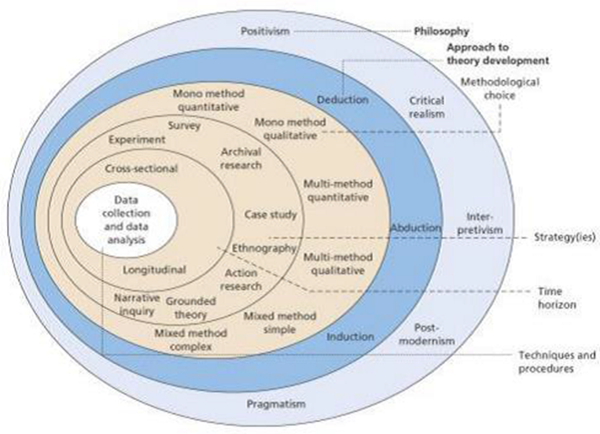
The research onion is used to help researchers describe the stages into which the researcher must take when formulating an effective methodology for concise analysis of the research.

4.1 Research Approach/ strategy
To carry out gathering more information for the assessment, questionnaires were used to obtain information. Both closed ended and multiple choice were used. The use of questionnaires is quite advantageous as increases the speed of data collection and is cost effective.
Structured interviews will also be used for in gathering information as it consists of predetermined questions and data analysis will be relatively straight forward because the researcher can contrast and compare different answers to the same question.

4.2 Research population and sample
The research population deals with the person or group of people directly taking part in the investigation while sampling deals with the demographic of choosing who is best for doing the investigation. While there are many forms of sampling, the researcher decided to choose stratified random sampling. Using this method will divide the research population into two or more groups, doing this will give a different spectrum regarding carrying out the aim and objectives of the study.
4.21 Advantage of using stratified random sampling:
One advantage of using this sampling method, is that it captures key population characteristics in the sample.
4.22 Disadvantage of using stratified random sampling:
One disadvantage is accurately selecting each member of the population into a single stratum.

5.0 Reliability and Validity
Reliability refers to whether the researcher will get the same answer using the same instrument for the investigation more than once; with reliability, it is concerned that every time the observer will become a source for that data provided. Wilson (2010) argues that reliability is closely associated with subjectivity and the adaptation to a subjective approach to the study by the researcher as the levels to the study will be compromised.
Research reliability can be categorized into three divisions:
- Test-retest reliability, this relates to reliability being measured when the same investigation is being conducted more than once over different time periods using the same samples.
- Parallel forms reliability, this is where the investigation conducted is measured buy information obtained by the same sample group using more than one investigation method.
- Interrater reliability, this measures the results collected by different investigators using the same methods and the importance and benefits can be referred to subjectivity.

Validity of research can be explained as the bases of which the requirements for scientific research is generated. Oliver (2010) considered validity as a compulsory requirement for all types of investigations. Cohen et al (2007) specified that there are different forms of validity research that is; validity as a content, construct, face, concurrent, internal and external validity and criterion related validity.

6.0 Limitations
It is evident that the researcher may have some limitations in carrying out this investigation. Some limitations are:
- Sample size- if the sample size is to small, statistics would not be significantly relatable with the data that has already been set. To avoid this the researcher can advance to a larger sample size to generate the information needed to correlate with previous research.

- Formulation of research aim and objective- the researcher may have formulated the aim and objective poorly resulting in a misunderstanding of the task at hand. To avoid this the researcher should be specific and the focus of the study increased.

- Lack of previous studies in the researched area- there maybe little of no information on the topic of choice or the previous reviews maybe to narrow. To ensure enough information is gathered the researcher can broaden his/her scope and look into journals, newspaper articles and books.

7.0 Ethical consideration
The ethics should be specified for this investigation as one of the most important parts of this proposal as it will be deemed as a failure if this is missing. For this research proposal, Bryman and Bell (2007) points were reviewed and used as they represent the importance of the principles for ethical consideration. The both writers’ states that:
- Research participants should not be subjected to harm
- Research data should be private and confidential
- The consent of the participant should be obtained before the investigation is carried out
- Participant should be respected
- Avoid being biased and misleading
To address the ethical consideration on the proposal, the researcher should adhere to the ethic code as well as the ethics code of the university.

8.0 Resource and Planning
Resource planning is a guide in conducting the project. It aims in helping the researcher develop a sense of direction in planning, monitoring and organising the project.
To improve the quality and clarity of the investigation, the researcher will:
- Think about the topic and ensure that it is sufficiently focused upon.
- Write a detailed proposal to anticipate issues to be dealt with.
- Devote time for planning.
- Be organised and take note when undertaking literature survey and collecting data.
- Allocate enough time to write, review and edit research and writing.
To complete the study effectively, the researcher will use; online articles, journals and reviews relevant to the topic.

8.1 Analysis
Because data from the investigation will be quantitative, it is expected to turn the raw numbers into meaningful data through critical and rational thinking. The quantitative approach is associated with finding evidence to support or reject the hypothesis formulated in the researching process.
The use of Microsoft Spreadsheet and SPSS will be used to analyse the findings. Using these software is advantageous because they are cost effective any statistical data is recorded easily.
(A Gantt chart is shown in appendix 2).

8.2 Conclusion
It can be concluded at all the necessary steps were chosen to collect, record and formulate data for the investigation of the topic of choice. The topic was researched upon and the aims and objective created, with the aid of a questionnaire data was collected based on what the sample population had to say about the topic.
Appendix i
Questionnaire example

(2) What does the word culture mean to you?
……………………………………………………………………………………………………………………………………………………………………………………………………………………………………………………………………………………………….

(4) Do you consider yourself to be a patriotic person?
Yes No

(7) How important do you think it is for the welsh culture is in differentiating itself from the rest of the UK?
Important Very Important Not Quite

(7b) Give reason for your answer.
……………………………………………………………………………………………………………………………………………………………………………………………………………………………………………………………………………………………….

(12) What do you think can be done culturally to boost tourist in wales?
……………………………………………………………………………………………………………………………………………………………………………………………………………………………………………………………………………………………………………………………………………………………………………………………………………………………………………….

Appendix ii

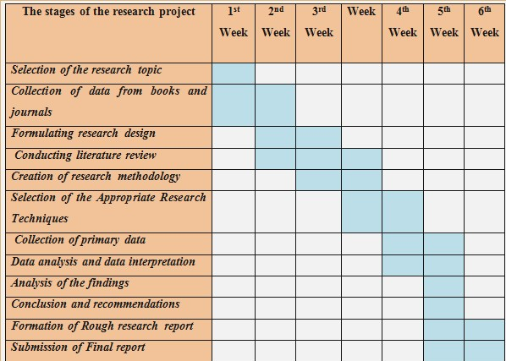
This Gantt chart represents the time and steps used to formulate, and record information for the longevity of the investigation.
N.B. the chart is a rough representation of what would be done for the proposed investigation. Dates and stages may differ.

References
Barker, C. and Galasiński, D. (2002). Cultural studies and discourse analysis. London: SAGE.
Bbc.co.uk. (2018). BBC - Wales -Culture in Wales. [online] Available at: http://www.bbc.co.uk/wales/culture/sites/aboutwales/pages/culture.shtml [Accessed 20 February. 2018].
Bryman, A. & Bell, E. (2007) “Business Research Methods”, 2nd edition. Oxford University Press.
Cohen, L., Manion, L., Morrison, K, & Morrison, R.B. (2007) “Research methods in education” Routledge.
Everyculture.com. (2018). Culture of Wales - history, people, traditions, women, beliefs, food, customs, family, social. [online] Available at: http://www.everyculture.com/To-Z/Wales.html [Accessed 4 Mar. 2018].
Hofstede, G., Pedersen, P. and Hofstede, G. (2002). Exploring culture. Yarmouth, Me.: Intercultural Press.
Kumar, C. (2008). Research Methodology. First edition. New Delhi: APH Publishing Corporation.
McKercher, B. and Du Cros, H. (2015). Cultural tourism. New York: Routledge.
Oliver, V, 2010, 301 Smart Answers to Tough Business Etiquette Questions, Skyhorse Publishing, New York USA.
Research Methodology. (2018). Reliability and Validity - Research Methodology. [online] Available at: https://research-methodology.net/research-methodology/reliability-validity-and-repeatability/ [Accessed 26 February. 2018].
Saunders, M., Lewis, P. & Thornhill, A. (2012) “Research Methods for Business Students” 6th edition, Pearson Education Limited.
Wilson, J. (2010) “Essentials of Business Research: A Guide to Doing Your Research Project” SAGE Publications.

