Critical evaluation of BMW’ internal and external analysis and competitive advantage

Student ID: 2030583
Student name: Silviu Rosu

Table of Contents
Introduction 3
Critical evaluation of the challenges of their internal and external business environments of BMW 3
Internal environment analysis 3
SWOT analysis of BMW 4
External environment analysis of BMW 5
PESTEL analysis of BMW 5
Porter’s five forces model of BMW 7
Value Chain analysis of BMW 9
Competitive advantage of BMW 10
Conclusion 11
References 12

Introduction
German expensive car maker BMW is renowned for its style, dependability, as well as advanced technologies. And over 140 nations are served by the corporation’s automobile sales. Additionally, the firm’s objective is to serve the globe by providing value–added products for sustainable transport, and it is achieving this goal by introducing high-quality items in the premium market. The most luxury attributes and newest technologies are included in its automobiles, as one would anticipate from a luxury automaker (Wänke, Bohner, and Jurkowitsch, 1997).

Critical evaluation of the challenges of their internal and external business environments of BMW

Internal environment analysis

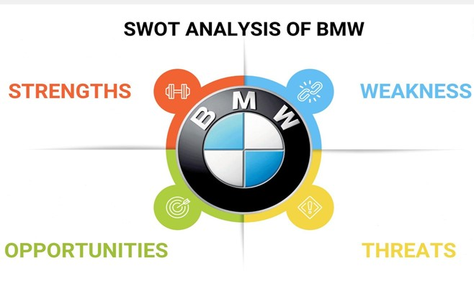
Source-01: (Schleimer, and Riege, 2009)
Figure-01: The SWOT analysis of BMW

SWOT analysis of BMW
Strengths of BMW
The major elements of BMW’s company that provide it a competitive advantage in the marketplace are examined in the company’s strengths. Having a strong financial state, a skilled personnel, differentiated products, and intellectual properties like corporate image are several key aspects of a company’s strengths (Simms, and Trott, 2006).
High quality luxury car: BMW is fixated on finding the ideal harmony between sturdiness, efficiency, as well as premium luxury. Each vehicle that leaves the production is expertly built to deliver cutting-edge vehicles for regular use.
High brand image: The brand’s image plays a major role in consumer judgments about premium products. BMW is one of the brands that is most associated with quality.

Weaknesses of BMW
High level of debt: A brand’s shortcomings are specific areas of its operation that can be improved to achieve the competitive advantage. Some flaws can be described as qualities that the business lacks or that its rivals possess better. Massive debt restricts a company’s capacity to make R&D investments. Additionally, it won’t be capable of making expensive acquisitions that would accelerate the company’s growth. The company is poor in this circumstance (Kukkamalla, Bikfalvi, and Arbussa, 2020).
Heavy maintenance: BMW automobiles are durable, pricey, and challenging to maintain. Its upkeep costs are really high. Because it uses complex engineering processes, maintaining the automobiles need for expert technicians and particular dealers. This is a drawback for the company because purchasing a BMW involves additional costs in addition to the high purchase price.

Opportunities of BMW
Any company has the potential to improve in certain sectors in order to grow its customer base. Opportunities for a company include international growth, product enhancements, improved customer service, etc.
A growing presence in global markets: Automobile sales are expected to increase in emerging markets in the future. BMW can put itself in a situation to seize this chance by making investments in developing areas. If BMW enters territories that can avail this luxury, those countries may experience increased revenues.

Threats of BMW
Strong competitors: The brands of BNW’s competing companies are a challenge. Because of increased automobile manufacturing, regular technology upgrades, and competitive pressures, competitiveness in the automobile industry is constantly rising. Tesla and other electric vehicle manufacturers pose a danger to BMW’s ability to compete in this market and dominate it.BMW constantly battles rival premium brands for global market because of the fierce rivalry (Kukkamalla, Bikfalvi, and Arbussa, 2020).
High government regulations: Government agencies all over the world are promoting fuel-efficient automobiles and environmental sustainability. These environmental challenges might raise the cost of manufacturing for the business which would have an influence on global income. This poses a threat to the company’s ability to compete in a competitive marketplace. Any firm may face risks in the form of elements that could harm its operations.
Threats might come from a variety of sources, including rising rival activities, shifting governmental priorities, alternative goods or services, etc. (Wänke, Bohner, and Jurkowitsch, 1997).

External environment analysis of BMW

PESTEL analysis of BMW
The PESTLE Analysis emphasizes the various extrinsic circumstances that have an influence on the company’s performance. PESTLE analysis is a method that is essential for businesses like BMW since it enables them comprehend competitive landscape and continually improving their operations.
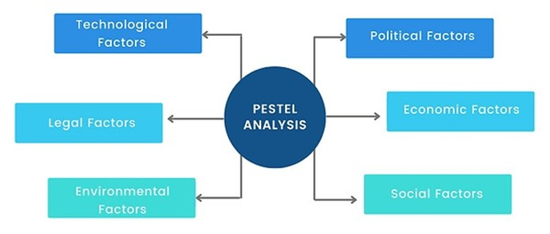

Source-02: (Schleimer, and Riege, 2009)
Figure-02: The PESTLE analysis of BMW

Political factors
BMW is one of the top producers of expensive cars worldwide. Two significant political variables have had an impact on BMW. The aggravation of the economic conflict between the United States and Beijing. Furthermore, Britain’s choice to leave the European Union is primarily to blame for the growing economic instability in Germany. Because of the increased government taxes placed on the items moved between the United States and China, the financial markets suffered, which decreased the value of the stocks in the automobile industries.
In addition to the two european states’ ongoing diplomatic crisis, the European Union increased its customs duties on aluminum and steel products from the United States of America (Kukkamalla, Bikfalvi, and Arbussa, 2020).

Economic factors
Variations in the world economy have an impact on BMW’s earnings, profitability, and performances. The profitability of the corporation might be significantly impacted by particular locations, such as Europe. And the GDP has changed over the past few years. Because the exchange rate is so unstable, it is challenging for BMW to forecast earnings for the upcoming year.

Social factors
There are regionally specific cultural distinctions in every nation. As a result, BMW should modify its offerings and advertising to suit the marketplace it serves. This involves customization for each market; an all-encompassing strategy won’t achieve the desired outcomes.

Technological factors
Any automobile manufacturer must innovate and adjust in order to differentiate itself in the automobile sector’s fierce competition. This entails incorporating the most recent technology for each vehicle. The BMW Group is proud of its commitment to technology as well as innovations. The automobiles may include driverless cars, hybrid powertrains, including automated parking. Self-driving car companies like Tesla are at the frontier of the technology, but BMW Group thinks of making it available to the public at large (Simms, and Trott, 2006).

Legal factors
The BMW Group complies with numerous property regulations regarding their cars’ electronics, which includes Wi-Fi and Bluetooth. It’s more difficult since the Group should follow the laws of every nation where the automobiles are produced and distributed. Any modifications to these rules (in any specific place) have the potential to significantly slow down or stop BMW’s development of new technology (Wänke, Bohner, and Jurkowitsch, 1997).

Environmental factors
Customers generally are concerned about the state of the environment. Additionally, Emissions of carbon dioxide as well as automobile fuel use are two significant issues. BMW has jumped wholeheartedly into the development and marketing of electric automobile designs in an effort to appeal to this group. These vehicles consume less petroleum than the norm. Additionally, the BMW Group is expanding the public’s selection of electrical vehicles models.

Porter’s five forces model of BMW

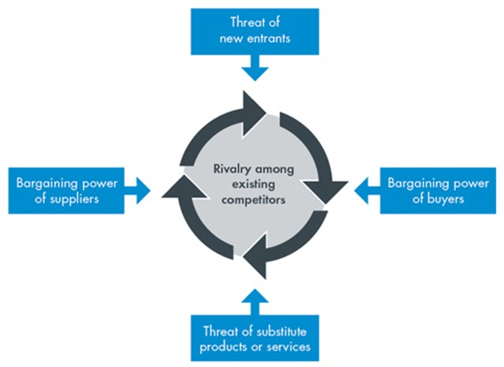

Source-03: (Schleimer, and Riege, 2009)
Figure-03: The Porter’s five forces model analysis of BMW
Threat of new entrants
The threats of new entrants is also low since there has needed a huge capital investment for launching new automobile business and there is also a strict government regulations. Besides, existing firms have strong brand image (Kukkamalla, Bikfalvi, and Arbussa, 2020).
Bargaining power of suppliers
To continue working with BMW, the suppliers must uphold the ethical standards but also employ moral and environmentally friendly strategy. This results in the supply chain partners of BMW having a somewhat low total negotiation strength. Consequently, BMW has a significant corporate image, including its suppliers, collaborating with BMW is a compelling business opportunity.
Each of these elements give BMW more influence in the global car business. BMW, meanwhile, strives hard to control its strategic partnerships and focuses in the training and development of all its partners (Wänke, Bohner, and Jurkowitsch, 1997).

Bargaining power of customers
Buyers’ bargaining ability has a significant impact on any major, international company’s efficiency and revenues. The ability of clients to negotiate is influenced by a number of elements. Clients’ bargaining position has significantly expanded in the 21st century as a result of competitive pressure, increased enforcement, shifting consumer preferences, particularly reduced switching expenses. Consumers generally are knowledgeable and do their homework before making a buying decision. Additionally, the authority has increased the level of control in favor of the consumer, which has resulted in a greater emphasis on product performance and accident prevention (Simms, and Trott, 2006).

Threat of substitutes
Any automotive brand, particularly BMW, such as the possibility of alternatives, is a significant influence on demand as well as profits. Although the threat of alternative products for BMW comes from a myriad of perspectives, there are a number of elements that also minimize the effects. The primary competitors to BMW are competing businesses in the same sector as well as other modes of mobility. Although the threat of substitute products for BMW comes from a range of sources, there are a number of elements that also decrease the risk. The primary competitors to BMW are competing companies in the same sector as well as other modes of mobility. For the majority of BMW automobile customers, possessing one of their elegant cars is an issue of status, elegance, and privilege. BMW provides a superior client experience (Simms, and Trott, 2006).

Intensity of Rivalry
In the automotive sector, there is a huge competition. The market is filled with competitors for BMW, including Audi, Mercedes, Skoda, FCA, Ford, Toyota, Tesla, and Land Rover. The current companies are significantly making investment in advertisement and R&D to create novel innovative products and attract more customers, even though new competitors cannot enter this competitive market easily. In addition, as competition intensifies, businesses are creating alliances to boost their comparative advantage and make automobiles close to where they will be sold. Therefore, losing market dominance will result from losing focus on research and development or quality of products. To combat the strain of competition, continued attention on R&D and customer service is important. The level of competition in the sector is extremely high globally.

Value Chain analysis of BMW

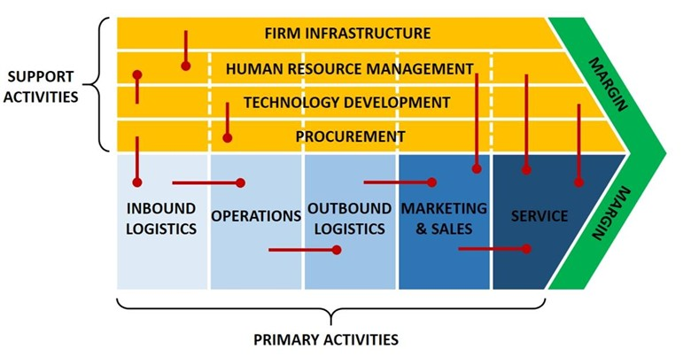
Source-04: (Schleimer, and Riege, 2009)
Figure-04: The Value chain analysis of BMW

Primary Activities of BMW

Operations
BMW is operating their business globally and they are selling their luxury car over 140 countries and also manufacture excellent quality automobile.
Materials management
This informs about the firm’s outward flow of products in the direction of its clients. BMW has built up a sizable dealer and merchant network. BMW’s subsidiaries firms primarily manage its products and marketing beyond the Germany.

Sales and marketing
The primary component of the marketing communications strategy that the BMW Group has historically used significantly has been newspaper and television advertisements. But, over the past couple of years, the business has been effective in utilizing internet as a way for cost-effective advertising as well as a way to quickly reach international audience.

Customer service
One of the key components of BMW Group’s competitive edge is its outstanding post-sale services, in particularly (Kukkamalla, Bikfalvi, and Arbussa, 2020).
Secondary Activities
Human resource
In this way, BMW strives to have a personnel that is equitable in terms of origins, abilities, and expertise across a range of professions.

Organizational infrastructure
The two company’s primary divisions at BMW are the car and motorcycle industries. A finance element is included in addition to that.

Competitive advantage of BMW
By its innovative marketing techniques, the business gained recognition as one of the premium brands. Additionally, the company is well-represented on Twitter. BMW has a sizable following, and the firm uses these platforms to promote its products and services by producing high-quality material. Some of the sources of competitive advantages are as follows:
- Superior quality of automobile
- Excellent design of automobile
- Reliability of automobile
- Strong corporate image
- Presences of global market
According to the Porter’s Five Forces Analysis, BMW has a good competitive position in the world’s automotive market. In addition to having significant negotiating leverage with distributors, it also has additional resources and capabilities, including enhanced client service, innovative products, as well as a worldwide supply chain and production system. The competitiveness in the automotive sector has increased significantly (Simms, and Trott, 2006).

Conclusion
BMW’s SWOT analysis aids in the firm’s examination of its corporate strategy and development of any reforms to boost revenue. It draws attention to its advantages, dangers, shortcomings, and opportunities. BMW has maintained their leading market position, although competitive pressure, primarily emphasizing development of new products and excellence. According to Porter’s study of the sector’s five factors, BMW is well-positioned and will probably keep to have good growth over the coming years (Kukkamalla, Bikfalvi, and Arbussa, 2020).

References
- Wänke, M., Bohner, G. And Jurkowitsch, A., 1997. There are many reasons to drive a BMW: Does imagined ease of argument generation influence attitudes?. Journal of Consumer Research, 24(2), pp.170-177.
- Kukkamalla, P.K., Bikfalvi, A. And Arbussa, A., 2020. The new BMW: business model innovation transforms an automotive leader. Journal of Business Strategy.
- Loch, C.H., Pich, M.T., Terwiesch, C. And Urbschat, M., 2001. Selecting R&D projects at BMW: A case study of adopting mathematical programming models. IEEE Transactions on Engineering Management, 48(1), pp.70-80.
- Cobley, K., Coleman, N., Siden, G. And Arndt, N., 1997, June. Design of new three stage low pressure turbine for the BMW Rolls-Royce BR715 turbofan engine. In Turbo Expo: Power for Land, Sea, and Air (Vol. 78682, p. V001T03A072). American Society of Mechanical Engineers.
- Kauerhof, A., 2017. Strategies for Autonomous, Connected and Smart Mobility in the Automotive Industry. A Comparative Analysis of BMW Group and Tesla Motors Inc. GRIN Verlag.
- Simms, C.D. and Trott, P., 2006. The perceptions of the BMW Mini brand: The importance of historical associations and the development of a model. Journal of Product & Brand Management.
- Schwarz, C., Schünemann, E., Durst, B., Fischer, J. And Witt, A., 2006. Potentials of the spray-guided BMW DI combustion system (No. 2006-01-1265). SAE Technical Paper.
- Johansson-Stenman, O. And Martinsson, P., 2006. Honestly, why are you driving a BMW?. Journal of Economic Behavior & Organization, 60(2), pp.129-146.
- Loch, C., Sting, F., Bauer, N. And Mauermann, H., 2010. How BMW is defusing the demographic time bomb. Harvard business review, 88(3), pp.99-102.
- Schleimer, S. And Riege, A., 2009. Knowledge transfer between globally dispersed units at BMW. Journal of Knowledge Management.
- Indacochea-Beltran, J., Elgindy, P., Lee, E., Vignesh, T., Ansourian, P., Tahmasebinia, F. And Marroquín, F.A., 2016, August. Dynamic analysis of the BMW tower in Munich. In AIP Conference Proceedings (Vol. 1762, No. 1, p. 020002). AIP Publishing LLC.

