March 28, 2021

Key words to describe proposal:
Organisational Change, Values, Values systems, Open Systems Thinking

Do values impact organisational change? A pragmatic enquiry at Control Techniques Ltd.
BMPF7200 Research Proposal
Nigel evans: 1813546
Introduction:
Organisational change is the process of transitioning from an organisation’s current state to a desired future outcome both at an individual and organisational level (Kotter, 2012). Change is triggered by internal and/or external events and affects all organisations in all industries. Todnem (2005) reported 70% of organisational change initiatives fail and cited a lack of a framework being the principle driver for poor success rates. McKinsey (2019) reports the same statistic 15 years later with organisational change initiatives failing to deliver on expectations, but expands on the reasons to include: insufficient aspiration, change initiative not bought into, skill deficiencies not addressed, employee capabilities, lack of change infrastructure, leadership cadence and environment. Organisational change specialists focus on the skills, behaviours and environment to promote change. If the success rate of organisational change has not improved over the last 15 years, then it could be argued that the approach taken by business leaders to control/influence these tangible activities is not achieving the desired result. There is less understanding of the hidden or intangible aspects, such as values, which have an underlying influence on the success or failure of organisational change.
Control Techniques Ltd (CT) is a typical organisation that is dynamic in responding to technological breakthroughs and emerging markets from its Customers to deliver value to its shareholders. I have experienced and led significant organisational change projects at an operational level that drive increased output with less resources and consolidation of business functions across regions to build economies of scale to improve operational profit. The programmes have been conducted with varying degrees of success and has led me to explore the intangible aspects of organisational change. Organisations that outperform their peer groups often have an embedded coaching structure that generates high performing teams (Clutterbuck and Megginson, 2006). Values are a key element and often overlooked as they are deep rooted in the organisation’s culture or with teams and individuals. Values define what is important to us and shape our lives, give meaning and provide the foundation to our beliefs. They influence our decisions, actions and behaviours, are hierarchical in nature and through ever increasing levels of complexity form value systems. If our values are aligned with our work, they support and provide motivation. Change can expose a disconnect with values and cause conflict or stress. Values can conceivably make or break organisational change.
There is extensive research into organisational change (Burnes, 2004; Todnem, 2005; Holbeche, 2009; Kotter, 2012; McKinsey, 2019) and values (Quinn and Rohrbaugh, 1981; Lencioni, 2002; Burns and Jackson, 2011; Jonsen et. al., 2015; Fischer and Boer, 2016) but there is a dearth of research where the interconnections are explored across value systems in an organisational change context. Developing an understanding of the deeper beliefs at play across values systems will provide significant contribution to successful change programmes whether they are with organisations, groups or individuals. The proposed research will explore these areas and will provide academic and commercial value with organisational change strategies, human resources and recruitment.

Research aims:
For my research, I plan to explore values and their inter-relationship to organisational change at CT. Unlike other studies of work-based values, I intend to explore open systems thinking (Emery, 2000 and Senge, 2017) in context to values being a semi-permeable boundary which individuals, groups and business functions transcend during transformational change projects. The research intends to explore the nexus of academic knowledge of organisational change and values to develop a framework to provide qualitative and quantitative feedback loops as values are enriched through organisational change where new beliefs are developed.
My research will explore values of CT employees and determine key variables that enable the value system to be transcended and gain insight into how and why. By examining open systems thinking, I propose to develop a framework from the key variables to monitor the held beliefs and moment of insight as values transition between value systems. The framework will add value to academic and organisational research by providing a nexus to existing theories.
To my knowledge, research has not explored this nexus using a mixed methods approach; by using quantitative methods to examine values of an organisation’s employees; and through qualitative methods to explore moments of insight through organisational change. The principle aim of this research is to identify key variables that enable an individual to transcend value systems by monitoring the held beliefs through moments of insight as mental maps of the world overlap with a desired organisations future state.

Indicative literature review:
Yuen (2018, p.34) summarised from a Deloitte readiness report for Industry 4.0, that “radical change is needed” by organisations in preparation for increased automation and teams will assemble and disband quickly in the future rather being formed slowly over time. Change is therefore essential in dynamic organisations as they strive to meet the demands of the markets they operate within and the expectations of shareholders who demand high profitability in return of share capital growth. Handy (1994) approached this by conceptually considering change as a sigmoid curve that represents a life cycle which organisations are having to compress at an increasing rate. The notion by Handy is built upon the theory of Kübler-Ross (1969) who examined the process of change during bereavement and was developed further by Parker and Lewis (1981) to apply the model in organisational situations (Figure 1) to illustrate typical human responses to change.
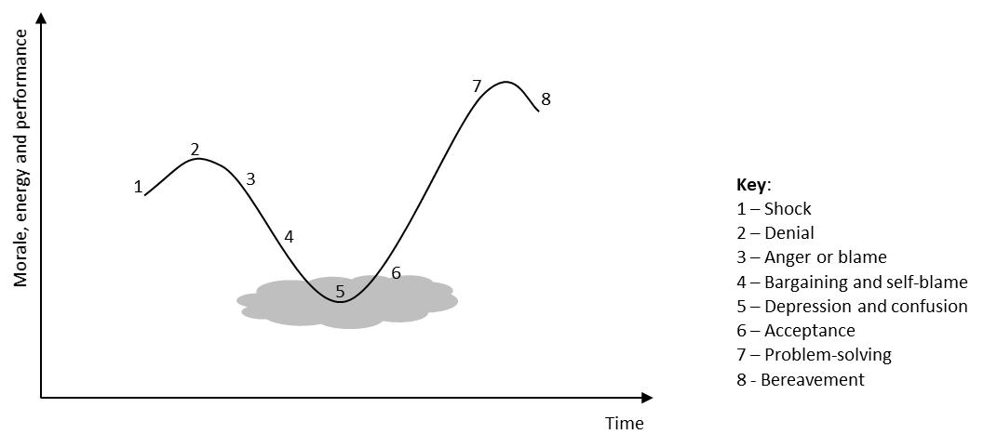
Figure 1. The Human response to change
The model has practical implications for organisations managing change as the journey is personal to each person experiencing change and not all employees will be at the same synchronised point in the journey at the same time. The business leader will need to intuitively identify who is at what stage in the journey to maintain stability with the team, as change will only be effective and sustained when everyone reaches point 7 simultaneously. The model is focused on attitudes and behaviours during the change cycle and is somewhat based on Maslow’s hierarchy of needs as people embrace or resist change.
Research into the failure of organisational change (Laclair and Rao, 2002; PriceWaterhouseCooper, 2004, Ferris 2013 and Prosci, 2018) has focused with methodology, skills, effective preparation and disciplined management being required to demonstrate effective change management. Balogun et. al. (2008) take this a stage further to consider diversity being an obstacle to achieving alignment, but again are focused with the behaviours and capability.
Change Management gurus such as John Kotter, Daniel Goleman, Jeff Hiatt, Kurt Lewin and Don James focus their approach to organisational change on the behaviours, skills and prescribed project planning to execute change effectively. Jim Hemerling takes this a step further by introducing a culture of continuous learning, but all fall short to examine the impact organisational, personal and group values have on change.
Perhaps it is not surprising there is focus on methodology, skills and behaviour as these can be readily measured. McGregor (1960) with his Theory X and Theory Y made assumptions based on the contrasting theory of X and Y relating to the behaviour, skills and the environment. Briggs Myers and Myres (1965) considered diversity with their psychological questionnaire (Myres-Briggs Type Indicator) which offers insights to behavioural preferences that people show. From the 8 preferential types, it is only with the Feeling preference that values and beliefs are considered.
Change theories (Huczinsky and Buchanan, 2007; Bridges, 2009 and Pink, 2011) consider resistance to change to be behavioural and can be managed through reward or penalty, or by giving people more autonomy. These theories do not go beyond the behavioural aspects to understand why or the values at play that counter the direction of change.
Lewin’s 3-stage model and Kotter’s 8-step model for organisational change are well established and frequently used by organisations. Creating new habits by changing behaviours and methodology is their primary focus but they do not consider the core values of organisations or employees. Senge (2017) introduced systems thinking to enable organisations to change by building a learning organisation that is underpinned by coaching to support business leaders with anxieties through loss of control. The model develops new practices and meaning to organisational strategy and vision by building on cultural alignment but falls short to consider the nexus of values. Peters and Waterman (1982) developed a 7-step model for McKinsey which is centred on an organisation’s shared values which connects strategy, structure, employees, skills, systems and style but falls short to consider the values of the employees.
Rock and Schwarz (2006) considered behaviours are shaped by the assumptions and beliefs we hold and are defined by our mental maps of the world. Changing the mental map requires a moment of insight, ah-ha! A new range of possibilities come from a change in beliefs and attitudes which stem from a new personal discovery or ah-ha moment. These signals are generated from the orbital frontal cortex which is close to the part of the brain (amygdala) that operates fight, flight or freeze and linked to the prefrontal cortex which is the thinking brain. Understanding this link enables us to appreciate the emotional and irrational responses that Handy referred to with the sigmoidal curve (Figure 1).
The learning through transformation of experience (Kolb, 1984) is acquired from thought provoking and insightful questions to create the ah-ha moments. It is conceivable from the postulations from Rock and Schwarz (2006), the new/enriched mental map of the world is developed when the belief system accepts the moment of insight. If the emergent belief system overlaps with the desired new state (Figure 1, points 6-7), then it is possible for the desired state to become the new norm and thus sustain the change. As Todnem (2005) and McKinsey (2019) report 70% of change programmes fail, it indicates that sustained change must come from experiential learning rather than didactic learning processes to support change.
From an organisation perspective, there are many drivers for change whether it is planned, emergent, contingency or by choice (Todnem, 2005) which can be helped or hindered by the organisations culture and/or structure. Trompenaars and Hampden-Turner (2012) consider the works of Edgar Schein and describe organisation culture in 3 ordered levels. At the uppermost level 1, artifacts and the environment are visible; at level 2, the norms and values define what is right or wrong. Level 3 describes the basic assumptions of the organisation’s culture which are seldom communicated but underpin the norms and values. The values at CT are documented in employee handbooks which support the approach of McKinsey’s 7-step model with shared values.
Organisations can have very different cultures which support or resist change. Technology companies are constantly developing and evolving, so change is common. Political cultures on the other hand have very strong command and control and would not easily adapt to Senge’s (2017) system thinking by adopting a learning culture. Firmly entrenched cultures of command and control may therefore be resistant to change. The organisation’s structure that is fixed and hierarchical will make change more difficult (Kotter, 2014) and adopt the social control construct that an employee must work hard to succeed. Whereas autonomous self-directed teams can determine their own work-life balance and generate frequent change. In these organisations, experiential learning is dominant, so beliefs and attitudes are constantly developing.
Managing successful organisational change programmes includes ensuring the skills, knowledge and behaviours are developed. Organisations that analyse learning needs, have learning and development plans implemented with the learning effectiveness monitored can transition to a learning / coaching culture. The success of organisational change is predominantly determined by results that is driven by methodology in support of the principle models of change. Learning in this context is taken from a problem-solving approach where each action drives a result and then fed back to generate new results until the desired outcome achieved, which Revans (1980) described as single loop learning.
Beliefs are changed because of the ah-ha moment when the mental map of the world is changed and enriched by the underlying assumptions of how we see the world. If a new set of assumptions or paradigm of how we see the world is created, this feedback system stretches beyond a methodological approach of action, result and feedback to a social system where new underlying assumptions are created. This secondary feedback is recognised as double loop learning (Revans, 1980) and is possibly missing when measuring the success of change, as traditional methods do not capture when the new range of possibilities are discovered.
The focus with Revans and subsequent research has been with leadership development and developing skills and behaviours. Is there a missing element with established organisational change models to consider the underlying assumptions or beliefs by employees? If captured, the enriched values could be observed emerging as the new social system of values between organisation and employee become aligned.
Senge’s (2017) model of a change process takes multiple perspectives into consideration. Systems thinking requires a major shift from the linear process models offered by Lewin and Kotter to being able to see change as a much bigger picture. It considers going beyond cause and effect, to include time and environment as change programmes can unravel over time and be impacted by internal and external factors. The model does not consider away and toward strategies that can be observed through experiential learning or consider how the underlying beliefs are changing.
The linkages between beliefs, skills, behaviour and environment (Figure 2) are discussed by Dilts (1990) in the logical levels. Building on the works of Bateson (2000) he argues that in the process of learning, change and communication there are natural hierarchies of classification. The function of each level being to give structure to the level below it and rules for changing something at one level are different to the lower level. Changing something at a lower level could affect the upper level but changing something in an upper level would bring about change in the lower level in order to support the higher level.

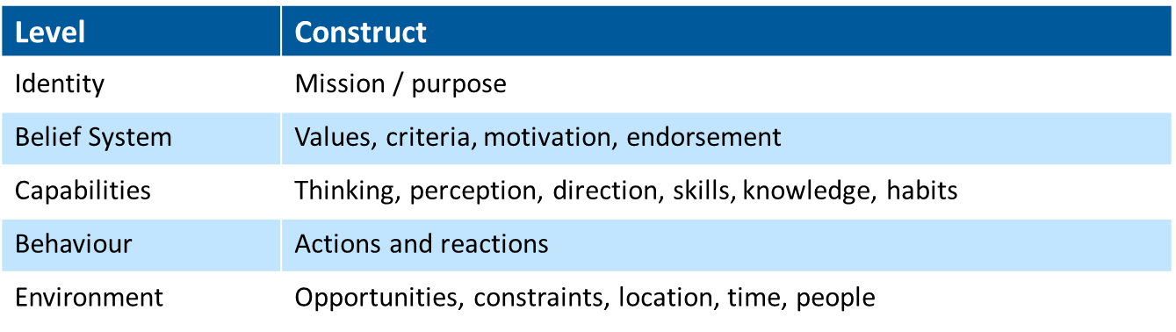
Figure 2. Logical Levels (Dilts, 1990)

The model provided by Dilts goes part way to understanding the observations by Todnem (2005) and McKinsey (2019) with 70% of organisational change failing as the principle focus of change is with methodologies, skills and behaviour. The activities at the lower level can have an inference on the belief system, but if change does not emanate from the belief system, then change will not be sustained. Senge (2017) commented that change programmes can unravel over time but does not explore the underlying causes. Effective and sustainable organisational change would benefit from understanding our values and congruence with the organisation’s shared values.
Our values are a fundamental aspect of cognition (Jones, et. al. 2016) and represent the deep-rooted inner beliefs that we hold. They are the red lines which we simply avoid crossing and if crossed, we become uncomfortable as they can cause conflict which Lencioni (2002) observed as deeply ingrained principles. These red lines or core values are shaped by life experiences and influence our attitudes, behaviour, skills and the environment to which we interact.
Researchers have explored values from several paradigms (Graves, 1970; Rokeach, 1973; Scheler, 1973; Schwartz, 1992; Hofstede, 1980; Quinn and Rohrbaugh, 1983) and developed meaning from multiple perspectives. Schwartz (2012) has contributed significantly to values research with inclusion of his Portrait Values Questionnaire (PVQ) with the European Social Survey (ESS) and World Value Survey (WVS). Although these studies provide direct data, they do not examine values in an organisational context. Consiglio et al. (2017) report limited studies into work-based values and in their own assessment cross referenced Schwartz (1992) theory to postulate work-based values. Their study broadly reports similar values in a work-based context to the individual values reported through the 10 basic value types. It does not assess how work values influence an individual. Leuty and Jansen (2011) comment further in their research that there is no common construct to define work values and call for guidance in selecting a measure of work values with academics.
There is limited research to understanding the values at play across an organisation which could provide an important role in averting conflicts during change or potentially having the change derailed in its entirety. An organisation having studied the shared values would be able to assess the management strategies and plans that might impinge on the individuals and/or the organisation. Where misalignment is identified, then business leaders would be able to work closely with these employees to acknowledge the divergence and address through appropriate strategies.
Hambrick and Mason (1984) noted the need to consider how personal values would affect strategic decision making. A project leader or manager’s filtering process of external factors could have a bearing on how information is perceived and interpreted (Arthur, Herdman and Yang, 2016). Scheler (1973) set out a hierarchical theory of values and emotions. At the lowest level, values are examined as if something is agreeable or disagreeable where at the higher level there is comprehension of culture awareness and an ability to perceive if things can be true or false which underpins the very possibility of philosophy and science (Cutting, 2016)
Graves (1970) advanced Maslow’s hierarchy of needs where a person’s values evolve over time and in a reasonably predictable manner and considered that people and systems react and develop in response to external factors. He theorised that nature is not a set thing and is emergent and continuously evolving as it is a dynamic open-ended system. Value systems could be conceivably built from levels of self-actualisation, as systems and people develop psychologically further and thus embed organisational change at each level of self-actualisation. In other words, change will be embedded and not a short-lived initiative as it is the belief system driving the change.
The psychological standpoint of our values transcending situations as they are very slow to change and that we generally have very few, was developed through the works of Rokeach (1973). Through his research, he demonstrated links between the importance of values and diverse beliefs and behaviours (Hanel, Litzellachner and Maio, 2018) but fell short of developing a method to predict the linkage between different values and their associated beliefs and behaviour.
Acknowledging the notion of Allen and McCarthy (2015) that cognitive behaviour sets the foundations to managing change. The proposed research should contribute to understanding if values affect organisational change and provide insight to HR, recruitment, project management and team development to deliver effective change initiatives.

Indicative methodology / methods:
Research in the field of values goes beyond an analytical paradigm, such as a positivist epistemology which is underpinned by an objectivism ontology. Positivist research will analyse data through a pre-defined and structured method to try and be as objective as possible. The researcher would be a detached observer to minimise contaminating the findings as statistical tests are applied to the data to identify correlations between the variables being studied. Quantitative methodologies enable respondents to provide defined responses to a Likert scale in a values survey through categorised labels of like me or not like me (Schwartz, 2012) or strongly agree / disagree (Rokeach, 1973). There is an accompanying strict guideline for the researcher to be distant to maintain integrity and ethical standards. Participants being selected through random probability methods with a clear boundary of countries, occupations, business functions, age and gender could provide a basis for the data to be generalised across the whole of the organisation, but not the whole population in the case of this study.
To discover a person’s lived experiences is limited with a quantitative research design (Rubin and Rubin, 2005). Exploring values through the belief system will require qualitative research to provide insight into respondent’s cognitive experiences, perception, behaviours, linguistics and emotion. Qualitative research is principally built upon a constructivist ontology with an interpretivist epistemology and assumes meaning is interpreted from the participant’s experiences. Researching the values at play will enable an immersion in the setting and through observation, interaction, participation, interviews, case history, document analysis or cultural aspects the study will gain insight of the person as there are no preconceived ideas of cognition as each participant will differ. Reality in this case is built upon social construction which enables research validity to be achieved through evaluating the complexity so interpretations can be drawn from an assessment of the environment and the variables being researched. By using appropriate and rigorous methods, authentic data can be gained by gaining real insight and empathy from the participants to their viewpoints, meanings, values and issues.
Organisations are continuously evolving and responding to market changes which means that the reality is dynamic as it is interpreted, debated and renegotiated. For this study, it is not possible to focus with either an interpretivist or positivist epistemology as mixed methodologies will be required to explore employee’s values and the interplay with organisational change. I propose to use a pragmatic ontology as it accepts there can be single or multiple realities that are open to empirical enquiry (Creswell and Clarke, 2011). As it enables the best method to be utilised in the research to answer the research question, validity can be maintained by using existent values questionnaires and procedures to quantitively explore values. Well-formed semi-structured interviews through quantitative methods will facilitate discovery from the experience without being overwhelmed by the complexity or context, and therefore maintain high validity as it draws on the understanding of the participants. However, as Broom and Willis (2007) point out, whilst a diverse set of methods and methodologies may be embraced in the study, there may be a tendency to derive from a distinct philosophical standpoint and take a positivist or constructivist/interpretivist approach.

Methods:
Figure 3 illustrates the proposed stages of the research method.
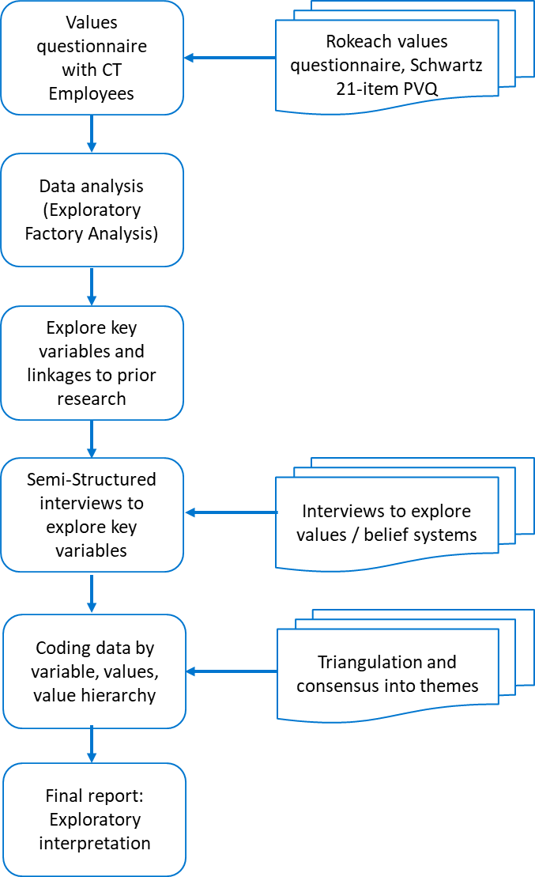
Figure 3. Stage of research method.

As a sponsored student, I will be requesting the employees at CT to undertake a web-based or emailed survey using an established values questionnaire (proposals include Rokeach, 1973 and Schwartz, 2012). The respondents will be representative of Finance, Procurement, Customer Services, Planning, Logistics in Manufacturing locations (Mid Wales, Hampshire and Romania) and Regional Sales locations (UK, and Europe). It is anticipated that questionnaires will be received from over 100 respondents and will be representative of working age between 18 and 65 years, gender and will provide details of job title, region, length of service and time in current position. They will not be requested for their name to ensure anonymity.
Data will be analysed through SPSS to provide quantitative assessment with descriptive statistics and exploratory factor analysis to identify variables. The emergent latent variable(s) will be examined and their linkages to established values theory explored.
The next stages in the research will be dependent on the variables identified through the quantitative exploration of values. As the survey will be conducted with employees from junior positions through to management levels and Executive / General Management, it is anticipated there will a random blend of 5 to 10 respondents that have experienced and/or led organisational change.
Using semi-structured interviews, the random sample will be interviewed to consider their experience of change (being led and/or leading change) and the implications of values in a work-based context. Verbal, visual, and kinaesthetic responses will be recorded during the interview through observation and audio recordings either in person or on-line with the interviewee’s permission. The rich data collected will be transcribed and coded for analysis using a package such as Nvivo. Triangulation of the data to the emergent themes will ensure data validity by building consensus during analysis.
The research will discuss the emergent variables from quantitative analysis and consider the nexus of values from qualitative enquiry to explore values in a work-based context.

Risks / Ethical considerations:
The response rate to the values questionnaire may pose a risk as a limited response will incur a non-response bias (Fincham, 2008) to the research. If this should present itself, then the respondents may not reflect the breadth and depth of values across each of the business functions. To compensate for this, a mixed-mode approach is to be taken using a web-based questionnaire and emailed questionnaires to encourage a higher response rate. Any emailed responses will extract the questionnaire and delete the sender to maintain anonymity during data analysis. Using the internal company communication platform combined with functional business leaders support to encourage survey completion, it is anticipated that employees can be encouraged to complete the survey to achieve a response rate above 80%.
The research proposes to explore held values with participants at different stages of organisational change. Research design must clearly define participant selection criteria relating to the research question, theoretical perspectives and evidence informing the research (Sargeant, 2012) for the semi-structured interviews to prevent bias in the research. Anonymity of the participants must be maintained throughout the research with the research design also taking ethical considerations into account. The sample size for qualitative assessment is planned to be 5 to 10 interviews of 1 to 2 hours duration. However, this will be assessed during the research if new concepts emerge then additional interviews will be considered.
Ensuring qualitative research quality and rigor will require authenticity of the rich data provided from the interviews and trustworthiness from the ensuing analysis. I expect to achieve authenticity by having a carefully considered research design, semi-structured questions organised around the research question to maintain focus and data triangulation to provide a comprehensive review. Conducting the data analysis will require a clearly defined process and include detail of how the coding developed. Should discrepancies arise between the interviewees, then consideration must be given to resolving these to prevent bias and my own potential influence.

Conclusion:
Utilising an established values questionnaire in a work-based context it is anticipated latent variables will emerge from exploratory factor analysis. The variables detected will form the basis of qualitative exploration with the participants and facilitate a richer discovery of the belief system and interaction of values during organisational change. Exploring the participants perception of successful and failed change initiatives will facilitate examination of the impact of values on organisational change and gain insight into how and why. Through discussion of the qualitative analysis in conjunction with organisational change theory and open systems thinking it is conceivable a framework will emerge to monitor the held beliefs through moments of insight as enriched mental maps of the world are developed and overlap with the desired future state of organisational change.

References:
Allen, M.S., and McCarthy, P.J. (2015) ‘Be Happy in your Work: The Role of Positive Psychology in Working with Change and Performance’, Journal of Change Management, 16(1), pp. 55-74.
Balogun, J., Hope-Hailey, V., Johnson, G., and Scholes, K. (2008). Exploring Strategic Change (3rd ed.). London: Prentice-Hall.
Bateson, G. (2000) Steps to an ecology of mind. Chicago: The University of Chicago Press.
Bridges, W. (2009) Managing Transitions: Making the most of change. 3rd edn. London: Nicholas Brealey.
Briggs Myres, I and Myers, P.B. (1965) Gifts Differing: Understanding personality type, 2nd edn. Mountain View, CA.: CPP Inc.
Broom, A. and Willis, E. (2007) Researching health: Qualitative, quantitative and mixed methods. London: Sage.
Burns, B. and Jackson, P. (2011) ‘Success and Failure in Organizational Change: An Exploration of the Role of Values’, Journal of Change Management, 11(2), pp. 133-162.
Burnes, B. (2004) Managing Change: A Strategic Approach to Organisational Dynamics, 4th edn. Harlow: Prentice Hall.
Consiglio, C., Cenciotti, R., Borgogni, L., Alessandri, A. and Schwartz, S.H. (2017) ‘The WVal: A New Measure of Work Values’, Journal of Career Assessment, 25(3), pp. 405-422.
Creswell, J.W. and Clark, V.L.P. (2011) Deisigning and Conducting Mixed Methods Research. 2nd edn. Thousand Oaks. CA.: Sage.
Clutterbuck and Megginson (2006) ‘Creating a coaching culture’, Industrial and Commercial Training, 38(5), pp. 232-237.
Dilts, R.B. (1990) Changing Belief Systems with NLP. California: Meta Publications.
Emery, M. (2000) ‘The Current Version of Emery’s Open Systems Theory’, Systemic Practice and Action Research, 13(5), pp. 623-643.
Fincham, J.E. (2008) ‘Response Rates and Responsiveness for Surveys, Standards, and the Journal’, American Journal of Pharmaceutical Education, 72(2), pp. 1-3.
Ferris, K. (2013) ITSM Solution Projects Need Organisational Change Management, Macanta Consulting, Australia. Available at: http://macanta.com.au/wp-content/uploads/2014/07/ITSM-Solution-Projects-and-OCM-V1.0.pdf (Accessed on: March 6, 2021).
Fischer, R. and Boer, D. (2016) ‘Values: the dynamic nexus between biology, ecology and culture’, Current Opinion in Psychology, 8(4), pp. 155-160.
Graves, C.W. (1970) ‘Levels of existence: an open systems theory of values’, Journal of Humanistic Psychology, 10(2), pp. 131–155.
Hambrick, D. C., & Mason, P. A. (1984) ‘Upper echelons: The organization as a reflection of its top managers’, Academy of Management Review, 9, pp. 193–206.
Huczinsky A.A. and Buchanan, D.A. (2007) Organizational Behaviour. Harlow: Pearson Education Ltd.
Hofstede, G. (1980) Cultures Consequences: International Differences Work Related Values. Newbury Park: Sage Publications, Inc.
Jones, N. A., Shaw, S., Ross, H., Witt, K. and Pinner B. (2016) ‘The study of human values in understanding and managing social-ecological systems’. Ecology Society, 21(1). Available at: https://www.ecologyandsociety.org/vol21/iss1/art15/ (Accessed: 28 June, 2020).
Jonsen, k., Galunic, C., Weeks, J., and Braga, T. (2015) ‘Evaluating espoused values: does articulating values pay off?’, European Management Journal, 33(5), pp. 332-340.
Holbeche, L., (2009) ‘Organisational development – what’s in a name?’, Impact, 26, pp. 6-9.
Kolb, D.A. (1984). Experiential learning: Experience as the source of learning and development Volume 1. Englewood Cliffs, NJ: Prentice-Hall.
Kotter, J.P., (2012) ‘Accelerate’, Harvard Business Review, 90(11), pp. 44-149
Kübler-Ross, E. (1969) On death and dying. New York: Macmillan.
Laclair, J.A. and Rao, R.P. (2002) Helping employees embrace change. The McKinsey Quarterly, Autumn, pp. 17-20.
Lencioni, P.M., (2002) ‘Making your values mean something’, Harvard Business Review, July, pp. 113-117.
Leuty, M.E. and Hansen, J.C., (2011) ‘Evidence of construct validity for work values’, Journal of Vocational Behaviour, 79(2), pp. 379-390.
McGregor, D.M. (1960) The human Side of Enterprise. New York : McGraw-Hill.
Parker, C. and Lewis, R. (1981) Beyond the Peter Principle, Managing Successful Transitions. Available at: http://www.ralphlewis.co.uk/Change_files/Beyond%20the%20Peter%20Principle.pdf (Accessed on: March 6, 2021)
Pink, D.H. (2011) Drive: The surprising truth about what motivates us. Edinburgh: Cannogate.
Peters, T. and Waterman, R. (1982) In search of excellence: Lessons from America’s best run companies. New York: Harper and Row.
PriceWaterhouseCoopers, (2004), Boosting Business Performance though Programme and Project Management Available at: https://www.mosaicprojects.com.au/PDF/PwC_PM_Survey_210604.pdf (Accessed on March 6, 2021).
Prosci, (2018) Best Practices in Change Management, 2018 edn. Fort Collins CO: Prosci.
Quinn, R.E., and Rohrbaugh, J. (1981) ‘A competing values approach to organizational effectiveness’, Public Productivity Review, 5(2), pp. 122−140.
Quinn, R. E., and Rohrbaugh, J. (1983) ‘A spatial model of effectiveness criteria: Towards a competing values approach to organizational analysis’, Management Science, 29, pp. 363–377.
Revans, R. (1980) Action Learning: New Techniques for Management. London: Frederick Muller Ltd.
Rokeach, M. (1973) The Nature of Human Values. New York, NY: The Free Press.
Rubin, H and Rubin, I. (2005) Qualitative Interviewing: The Art of Hearing Data. 2nd edn. London: Sage.
Sargeant, J. (2012) ‘Qualitative Research Part II: Participants, Analysis, and Quality Assurance’, Journal of Graduate Medical Education, 4(1), pp. 1-3.
Scheler, M. (1973) Formalism in ethics and non-formal ethics of values: a new attempt toward the foundation of an ethical personalism. 5th edn. Evanston: Northwestern University Press.
Schwartz, S. H. (2012) ‘An Overview of the Schwartz Theory of Basic Values, Online Readings in Psychology and Culture’, 2(1). Available at: https://doi.org/10.9707/2307-0919.1116 (Accessed on: 13 July, 2020).
Senge, P.M., Roberts, C., Ross, R.B., Smith, B.J. and Kleiner, A. (2017) The Fifth Discipline Fieldbook. Strategies and tools for building a learning organisation. 19th edn. London: Nicholas Brealey Publishing.
Todnem, R. (2005) ‘Organisational Change Management: A Critical Review’, Journal of Change Management, 5(4), pp. 369-380.
Trompenaars, F. and Hampden-Turner, C. (2012) Riding the Waves of Culture: Understanding diversity in global business. 3rd ed. London: Nicholas Brealey.
Yuen, P. (2018) ‘7 forces that will change the way you work’, Accountancy SA, October, pp. 34-35.

