Student name: Mariana Lavinia Neda
Student id: 2312753
Module title &code: Managing Projects In Organisations BMSW5009
Assessment type : Written report

Managing Projects in Organisations
Written report & Reflective blogs

Table of Content

1. Introduction 9
2. Lifecycle and Project Planning Overview 10
3. Critical Evaluation of Project Management Tools and Techniques 12
4. Stakeholder Analysis 14
5. Analysis of Project Results and Performance 15
6. Suggestions for Future Projects 16
7. Conclusion 16
References 18

Task 2

1. Introduction
Project management in organisations entails the implementation of systematic approaches in the realisation of stipulated goals within time, cost and quality limits (Haass and Azizi, 2019). In this report, a group project will be described that was done in the real world to acquire useful project management skills and give assistance to a social cause. The volunteering activity was conducted in a 100% plant-based bakery in Cardiff called Riverside Sourdough with a mission to raise awareness and money to support children with cancer. The opportunity entailed cleaning of the bakery facility as an abstract expression of giving out as a way of documenting the work through photography to express the validity of the activity and experience of doing it. The general purpose of the project was to imbibe social responsibility along with the process of academics. Particularly, they included: to develop and conduct an effective fundraising event; to use the major tools and techniques of project management such as project stakeholder analysis and life cycle planning; and to critically reflect on the effectiveness of developed project. This report will convey on the manner in which project management frameworks were incorporated during the activity and identify important project outcomes, as well as lessons.


Figure: 100% plant-based bakery, Riverside Sourdough
(Source: Instagram, 2025)

2. Lifecycle and Project Planning Overview
The project used the typical five-phase project life cycle, which is the initiation, planning, execution, monitoring, and closure. This framework greatly facilitated the process of going from ideation to completion.
During the initiation stage, the project group adopted a significant cause, which is assisting needy children with cancer and came up with workable brainstorming ideas on how project team could help out (Vuorinen and Martinsuo, 2019). Having examined the feasibility and availability of stakeholders, collaborating with Riverside Sourdough, a bakery that is locally prominent in terms of community presence has been considered. It was a suggestion which focused on volunteering time at the bakery to clean it up in order to spread awareness and promote charitable donations.
In the planning stage the project team identified roles, responsibilities, the date of the volunteer day and liaised with bakery management. A stakeholder matrix was also prepared and a simple Gantt Chart to control timelines was prepared. Such resources as cleaning products and computers to record the activity were calculated.
The implementation step entailed stepping in Riverside Sourdough on Sunday morning and conducting the cleaning activity as scheduled. Every member of the team was assigned particular jobs, ranging in scrubbing the surface to operating the equipment (Mitchell and Clark, 2019). The event went on without any hitches and a comprehensive documentation of the event was done through photos.
Monitoring was concurrent with the execution and constant WhatsApp communication and scheduled meetings helped keep the everyone on track (McClory et al., 2017). To make it match with the goals, the team involved main stakeholders bakery staff, charity contacts, and university supervisor.
Lastly, during the closure stage, the Project team assessed the level of success in the project in terms of objectives achieved, the opinion of the bakery and reflections by the group. This evidence in the form of images and comments made by the stakeholders was also collected by team members with the purpose of including it in the final report. The life cycle model enabled us to ensure control and coherence in all stages, which further demonstrated the importance of structured project management in the attainment of social impact objectives.
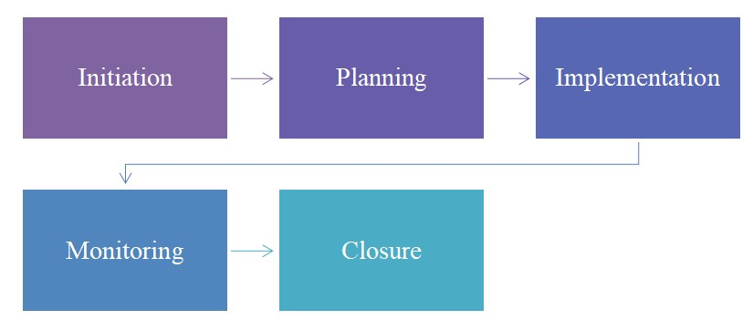

Figure: Project Management Lifecycle

(Source: Learner)

3. Critical Evaluation of Project Management Tools and Techniques
Adequate project management tools and techniques must be employed to ensure the successful implementation of any project which should also be the case with small-scale volunteer projects. Various tools were also used to organise the fundraising activity at Riverside Sourdough in this project. These were the Gantt chart, the quad chart and the stakeholder analysis. Further, other project management techniques which include time management, resource allocation and risk assessment were also used to steer the project to become successful.
The preferred visual tool of timeline planning was the Gantt chart where the main processes were marked, including team meeting, contacting the bakery, and the volunteer clean-up day (Varajão et al., 2020). This has been able to enable sufficient time to be allocated in the planning process and no important task was omitted. Although the chart was quite primitive, it still helped to understand deadlines and enabled team members to organise according to academic and personal requirements.
The quad chart came in handy in the analysis of risks as well as during project planning (Radujković and Sjekavica, 2017). There were four quadrants which were critical phases, namely, project planning, resource management, risk analysis and project closure. This frame helped the team to consider all aspects holistically regarding what was required to be successful. As an example, it pointed to the necessity to evaluate risks associated with the cleaning process, e.g. possibility of allergic reactions to cleaning chemicals or time pressure during the day of implementation. Moreover, another quadrant of “project closure” helped us not to miss visual evidence and performance analysis.
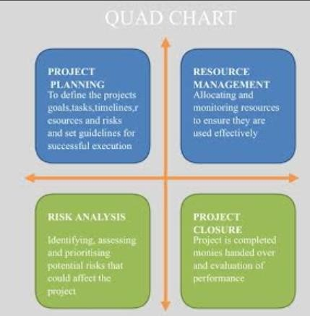

Figure: QUAD Chart

(Source: Learner)
Use of stakeholder analysis made it possible to come up with a list of all the stakeholders that have a stake in the project (Cameron and Green, 2019). These were split into four brackets, which included Keep Satisfied (e.g. university lecturer and bakery), Actively Engaged (e.g. charity representatives and team members), Monitor (e.g. children beneficiaries), and Keep Informed (e.g. broader student cohort). This analysis has been able to guide us to prioritise communication efforts and expectations management. As a case in point, project team made sure that the bakery received timings and expectations so that trust and cooperation could be established.
Techniques-wise, time management was critical to the nature of the time limit and other coursework of the team (Alzoubi, 2022). Frequent group discussions and scheduling ahead allowed us to meet deadlines. Distribution of resources was also an important part; people were allocated their duties according to their strength (e.g. logistics, cleaning, documentation), cleaning supplies and phones to take grey colour pictures were organised.
Assessment of risks was incorporated at the planning and the monitoring phases. The risks that may happen, such as delays, absenteeism, and miscommunications, were predicted and reduced via insurance planning (Varajão et al., 2020). As an example, a backup cleaner was chosen in case of non-appearance, and interaction among the team members was maintained on all channels.
Although these tools were useful, they had limitations. The Gantt chart was not as detailed as it could have been, as well as frequent. Also, the quad chart was a very conceptual tool but not interactive; this meant that tracking the live risk or task was impossible. In addition to that, although the stakeholder mapping was useful in theory, keeping everyone (most prominently the external stakeholders such as the charity) on board was a rather strenuous task as it was difficult to have a continuous interaction with all stakeholders because of time limits and the absence of direct access.
In general, the project was organized and guided effectively by these tools. Their incorporation enabled the team to foresee difficulties, synchronize stakeholder purposes, and coordinate implementation in within a short time environment. Nevertheless, further initiatives may require more active digital instruments (e.g., Trello, Microsoft Project) to support the monitoring and advance the work in real-time and collaborative stages.

4. Stakeholder Analysis
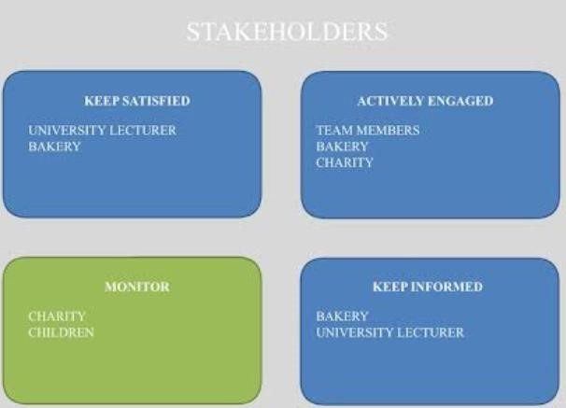

Figure: Stakeholder Analysis
(Source: Learner)
A project management process called stakeholder analysis performs crucial roles; it helps project teams identify and address individuals or organisations whose interest in the project outcome (Pedrini and Ferri, 2019). At Riverside Sourdough, stakeholders were classified by power and interest grid, which allowed us to understand what to do or how to interact well with every set of group of people. The chart categorised stakeholders into four groups namely: Keep Satisfied, Actively Engaged, Monitor and Keep Informed.
Along with the University Lecturer and the Bakery were included within the group of Keep Satisfied. This being the case, they were not involved much in the day to day decisions, but their consent and satisfaction was mandatory. The lecturer had to observe academic criterion whereas the bakery had to be sure that the cleaning would be performed professionally and with respect. Team Members, Bakery and Charity made up the Group called Actively Engaged. This group was highly interested, and it has different levels of influence. Execution of the project was deferred to the team members, the venue and support came in form of the bakery and the social cause was represented by the charity. These participants were brought in the decision process, schedule and logistics and their opinions influenced the project course (Sperry and Jetter, 2019).
In the category of Monitor team members have found the Charity Representatives and the Children who are the beneficiaries of the initiative. Although they did not have a great direct impact, they played a central moral role, reminding their purpose towards the project. They were observed delicately to make sure that the project had ethical standards (Nguyen, 2019).
The Learn More category had the Bakery and University Lecturer, who cared about the final product and needed to be informed consistently even though having no direct power over the work of the project.
Communication was handled with the help of WhatsApp and personal meetings mostly. The engagement was mainly successful except with the bakery who thanked us on professional conduct. The limited issues were scheduling and prompt responses of the external stakeholders (Pedrini and Ferri, 2019).

5. Analysis of Project Results and Performance
Riverside Sourdough project has been able to achieve the essence of the endeavours and the ability to work as a team within the setting of real-world projects. Good team cooperation was one of the finest things (Schmutz et al., 2019). All members were active in planning, execution, and communications and there was no hitch in the way the activity was executed. The bakery personnel and the lecturer at our university also gave us positive reviews about the quality and professionalism of our work. A more practical and satisfying final product was also created out of the project, which was that the bakery was cleaned, and out of the awareness and fundraising done by us on behalf of children with cancer were raised.
Nonetheless, there were certain points that did not turn out as expected. Time management proved to be a challenge because of existing academic and personal engagements and hence it was not possible to agree on a specific time (Lacerenza et al., 2017). This meant that there was a last-minute change of roles and responsibilities which put more pressure on the team. The physical aspect of the clean-up exercise together with the emotional burden of executing the sensitive cause created an emotional and physical strain on certain members. Nevertheless, these challenges were excellent chances to adjust the team, and thoughtful talks allowed us to identify room to improve. On the whole, it was a good learning process to handle not only people but assignments within time limitations and the pressure of emotions.

6. Suggestions for Future Projects
A few suggestions to make similar projects more successful in the future can be obtained on the basis of our own experience. First, it is possible to rely on some advanced planning tools such as Trello or Microsoft Project so that we can monitor the task in real time and have better coordination (Thesing et al., 2021). Secondly, improved communication strategies level would also aid in ensuring that the stakeholders are engaged on a regular basis via shared calendars or project platforms. Uncertainty would be reduced by incorporating early risk mitigation measures such as pre-scheduling or pre-task contingency plans. Moreover, the preparation of the training in teams and delegation prior to the beginning of the project would be able to guarantee a clear perception of the roles and an equal distribution of responsibilities (Al-Nabae and Sammani, 2019). Lastly, elements of monitoring, like weekly target updates, would streamline accountability and help the conflicting questions to be incorporated or eliminated at an early stage.

7. Conclusion
Based on the above discussion, it can be summarised that this project has demonstrated the importance of organised project management in making a significant social impact via a volunteer effort. Some of the primary planning tools like the Gantt chart, stakeholder analysis, and the quad chart gave a broad scope to planning and implementation. Strong stakeholder consultation and collaboration were necessary to the success of the project, even though the project was exposed to various challenges including; time limitations and emotional requirements. The need to plan in advance, identify the risks, and communicate has been highlighted here. On an individual basis, our knowledge of the dynamics of working on a real project and has exposed us to practical skills and knowledge that can be used in both an academic and a professional setting has been enhanced in the project.

References
Al-Nabae, M.G. and Sammani, D., 2019. Training methods for developing project team members. International Journal of Innovation and Industrial Revolution, 1(1), pp.01-12.
Alzoubi, H.M., 2022. BIM as a tool to optimize and manage project risk management. International Journal of Mechanical Engineering, 7(1), pp.1-12.
Cameron, E. and Green, M., 2019. Making sense of change management: A complete guide to the models, tools and techniques of organizational change. Kogan Page Publishers, pp.45-89. Haass, O. and Azizi, N., 2019. Knowledge sharing practice in project-oriented organisations: A practical framework based on project life cycle and project management body of knowledge.
International Journal of Project Organisation and Management, 11(2), pp.171-197.
Instagram, 2025. Instagram Page of Riverside Sourdough. Available at: https://www.instagram.com/riversidesourdough/?hl=en (Accessed: 19 June 2025).
Lacerenza, C.N., Marlow, S.L., Tannenbaum, S.I. and Salas, E., 2018. Team development interventions: Evidence-based approaches for improving teamwork. American psychologist, 73(4), p.517.
McClory, S., Read, M. and Labib, A., 2017. Conceptualising the lessons-learned process in project management: Towards a triple-loop learning framework. International Journal of Project Management, 35(7), pp.1322-1335.
Mitchell, S.L. and Clark, M., 2019. Reconceptualising product life-cycle theory as stakeholder engagement with non-profit organisations. Journal of Marketing Management, 35(1-2), pp.13-
39.
Nguyen, T.S., 2019. Investigation into stakeholder management in complex projects, pp.98-213.
Pedrini, M. and Ferri, L.M., 2019. Stakeholder management: a systematic literature review. Corporate Governance: The International Journal of Business in Society, 19(1), pp.44-59. Radujković, M. and Sjekavica, M., 2017. Project management success factors. Procedia engineering, 196, pp.607-615.
Schmutz, J.B., Meier, L.L. and Manser, T., 2019. How effective is teamwork really? The relationship between teamwork and performance in healthcare teams: a systematic review and meta-analysis. BMJ open, 9(9), p.e028280.
Sperry, R.C. and Jetter, A.J., 2019. A systems approach to project stakeholder management:
Fuzzy cognitive map modeling. Project management journal, 50(6), pp.699-715.
Thesing, T., Feldmann, C. and Burchardt, M., 2021. Agile versus waterfall project management: decision model for selecting the appropriate approach to a project. Procedia Computer Science, 181, pp.746-756.
Varajão, J., Fernandes, G. and Silva, H., 2020. Most used project management tools and techniques in information systems projects. Journal of Systems and Information Technology, 22(3), pp.225-242.
Vuorinen, L. and Martinsuo, M.M., 2019. Lifecycle view of managing different changes in projects. International Journal of Managing Projects in Business, 12(1), pp.120-143.

