Assignment Submission Form
Wales Academy for Professional Practice and Applied Research

Please complete this form and send with your submission to wappar@uwtsd.ac.uk
Wales Academy for Professional Practice and Applied Research office COPY

Student Number: _____________2241526_____________________________
Student’s Name: _____________Aaron Hulson__________________________
Tutor Name: ________________Julie Crossman_________________________
Assignment Title: _____________Authenticity and the role of the leader______
Module Code: ___________________BMPF7021_________________________
Submission Date: ________________18/08/2023________________________
Your work will not be marked unless it is accompanied by this statement.
I confirm that this is my original work and that I have adhered to the University’s policy on plagiarism.
Student’s Name: ___Aaron Hulson______Signature_____A.Hulson____________
Wales Academy for Professional Practice and Applied Research Staff only

Received by:_____________________Date submitted:____________________

Student Receipt
Student Number: ______________________________________________
Student’s Name: _______________________________________________
Tutor Name: _________________________________________________
Assignment Title: ______________________________________________
Module Code: __________________________________________________
Submission Date: _____________________________________________
Wales Academy for Professional Practice and Applied Research Staff only

Received by:_____________________Date submitted:____________________

A reflective assignment exploring and critically evaluating own leadership qualities and assessing the impact of these on the workplace
Module BMPF7021
Submission Date
18/8/23
Word Count
3927
Table of Contents
Introduction 1
Main Body 2
Definitions of Leadership 2
Importance of Leadership 3
The role of the leader 3
Leadership Theories and models 4
Action Centred Leadership 4
Situational leadership 5
Transformational Leadership 7
Transactional Leadership 9
Compassionate Leadership 10
Conclusion 12
Referencing – Harvard Referencing 13

Introduction
Leadership can take many different forms, it is an immensely complex topic with an ever-changing evidence base which constantly contradicts each other, Northouse (2016) states that due to generational differences and global influences, leadership will continue to have different meanings for different people. It can be described and defined in many ways, while being talked about in several contexts including healthcare, politics business and war.
Throughout history, leaders have shaped the world, whether inspiring followers to care for others such as Mother Teresa, campaigning for non-violent peace and democracy like Dalai Lama, fighting for equal rights as Martin Luther King did or through the violent conquest of Europe that Julius Caesar performed.
Each of these leaders have shown a variety of leadership styles, some are charismatic skilled visionaries and excellent communicators who inspire others such as Winston Churchill or Martin Luther King while others rule with an autocratic leadership style with the threat of punishment or reward being used to enforce their will such as Adolf Hitler or Joseph Stalin. Whether religious or not, religious texts also write about great leaders, Jesus is said to have shown servant leadership, these leaders focus on addressing the needs of their followers rather than focusing on themselves (Blanchard, 2003), they focus on the growth and wellbeing of their team while nurturing them to reach their full potential.
Various leadership styles are relevant to healthcare and although more evidence is constantly being published there is no definitive agreed approach to guide NHS leaders. Perhaps this is the point, as although leadership can be researched, taught, and adopted, each individual leader is different, and it could be argued that it is this individuality that can create great leaders across the National Health Service. In this essay I will define leadership, discuss the importance of leadership, and examine five different leadership theories then critically evaluate their appropriateness and suitability for adoption into the Welsh Ambulance Service Trust (WAST) leadership vision. As a Senior Paramedic in WAST, my role is to care for the wellbeing and clinical development of the team and therefore it is vital that I exemplify leadership qualities and apply these to my clinical practice.

Main Body

Definitions of Leadership
To answer the question of which leadership theories and models are most appropriate for application into the Welsh Ambulance Service it is important to define what leadership is. There are varying definitions of what makes a up leadership, Western (2008) argues that leadership has many diverse meanings that cannot always be identified and continues by stating “like beauty, you will know leadership when you see it”. This statement argues that leaders are defined in the eye of the beholder which would argue that leadership traits such as charisma, self-confidence and assertiveness are prominent factors in what makes a good leader, this is known as trait theory. This theory of leadership was first proposed by Thomas Carlyle (Spector, 2016) who argued that history was shaped by leaders and the ability to lead is something they are born with. The rationale was that people are born with leadership traits as described above and these traits produce certain patterns of behaviour. Counter to this is research by Stogdill (1948) who argued that leadership is not just down to personal traits but due to the interaction between an individual and a social situation. Hollander (1984) gives another view to this up by stating that leadership is a relationship between leaders and followers while Blaber (2008) defines it as a process whereby an individual influences another in order to achieve an objective or task.
Northouse (2016) sums up leadership by stating it is a process whereby an individual influences a group of individuals in order to achieve a common goal.

Importance of Leadership
Leaders can affect society in many ways whether inspiring it to mobilise for war such as many of Winston Churchills famous speeches or ensuring a society is adequately prepared to face global threat such as the COVID 19 pandemic in 2020. From having a strong leadership, the public can stand strong in the face of adversity, while a weak leadership can result in panic and a lack of will to follow the rules set by the government such as the loss of confidence the public had in the government following the “party gate scandal”. Credibility is also an important aspect for leadership in the NHS as without it, team dynamics fall apart as the followers lose faith in the leader’s ability to lead. Kouzes and Posner (2019) argue that credibility is a key indicator of leadership and can be characterised by traits such as honesty, the ability to inspire others and competence, all these factors are critical for leaders in the NHS.
Avolio and Bass (2002) claim that in organisations, effective leaders lead to higher morale and improved productivity with more successful teams while ineffective leaders result in low team performance. They also state that in the public sector, a good leader can be an inspirational driver to push society forward and have a positive outcome for a generation of people, this is again vital for the NHS as it relies on these inspirational and credible leaders to continue to function effectively.

The role of the leader
The role of the leader can change depending on who is assessing it or the circumstance that is taking place, servant leadership theory voices that the role of the leader is to serve the followers, others would argue the role of the leader is to complete a task or objective. In politics some would consider the role of the leader is to maintain order and keep the country stable even though some of the decisions made may be difficult or ones they don’t like, while in healthcare it would be to lead a team in order to care for an individual’s needs. Adair (1979) brings these aspects together by presenting the action centred leadership model and states that good leaders need to manage three main areas well, these are the Task, the Team and the individual. This will therefore be one of the leadership theories to study further.

Leadership Theories and models
There are a multitude of leadership styles, theories and models that stretch throughout the 20th and 21st centuries and it is important to understand that no one style of theory fits every situation, setting or institution, Bass (1990). It is therefore important to discuss a variety of differing theories then apply them to the healthcare environment.

Action Centred Leadership
This style of leadership was developed by Adair (1979) and focuses on the Task, the Team and the Individual (Figure 1), he states that good leaders need to manage these three main areas well which will result in leaders developing the team, enhancing quality and building morale.
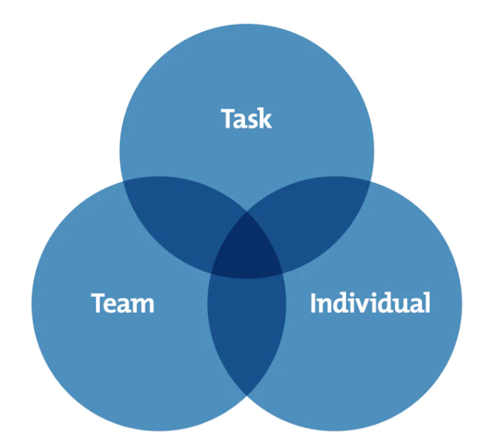
Figure 1: John Adair’s Action Centred Leadership Model

Clinical practice fits well with this simple model (Barr and Dowding, 2016) as it is simple to use and can be adapted to any leadership situation. It can be broken down as follows:
- The Task
The leader’s role is to identify the aims and the vision for the group, to create plans and timescales, to provide direction, to define what success will be and to review and adjust the plan accordingly (Adair, 2007).
- The Team
The leader must work to resolve conflicts, develop team working while encouraging them to achieve the task while giving appropriate feedback and understanding the team member’s needs (Blaber, 2008).
- The Individual
The leader must also focus on attending to the personal needs of each team member including appraising and listening, giving praise, training, development, and clinical supervision (Adair, 2007). These last 3 points are of particular importance to WAST’s leadership structure as the emergence of the Senior Paramedic role is aimed at targeting these key areas.
Blaber (2008) argues that effective leadership occurs when all three circles overlap thereby managing the Task, the Team and the Individual effectively. A criticism of the model is that it can be seen as too authoritarian as it is a rigid model without much flexibility built into it, this can be balanced however by focusing more on a certain aspect of the model such as Figure 2 below.
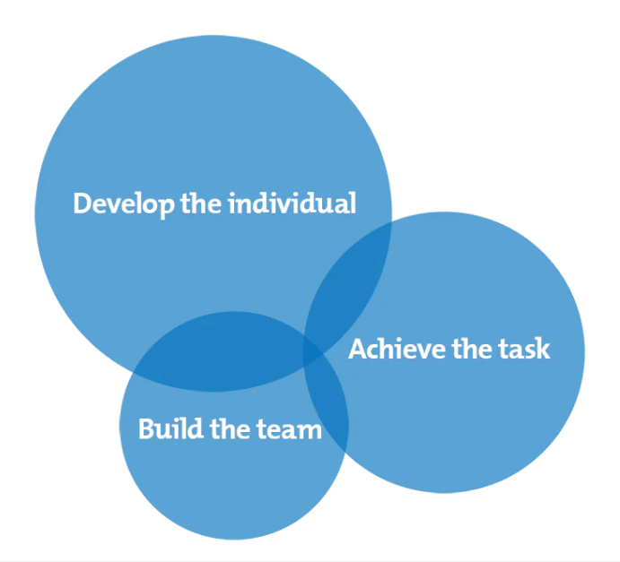
Figure 2: John Adair’s adapted Action Centred Leadership Model

Adair’s (1979) action centred leadership model is straightforward, easy to understand and teach, is simple to follow and use and can be adapted to use with a multitude of personality types, it would therefore be a great model to use across the NHS and specifically the Welsh Ambulance Service leadership team.

Situational leadership
Situational Leadership can be defined as a “flexible, adaptive style of leadership that determines whether a leader is more directive or supportive based on their follows individualised needs” (Baker, 2022). The main premise of Situational Leadership is that the style of leadership implemented should depend on the situation in question and the needs of the team (Northouse, 2016). An effective leader therefore needs to alter their leadership style depending on what situation is developing in order to meet the needs of the team. This can be achieved by evaluating their team and assessing their capabilities in completing possible tasks with certain skill sets. Part of this assessment must also be on the assumption that over time, the team members skill set, motivation and dedication may change. Once this assessment has been made, leaders should decide whether a directive or supportive leadership style would be the most appropriate style to use for the team member of the situation in question.
Hersey and Blanchard were the original founders of the situational leadership theory, Blanchard (1985) built on the original work and developed the Situational Leadership II (SLII) model (figure 3). This model was designed to help leaders adapt their leadership styles according to the needs of the individual/team. It has two aspects to it which both need to be discussed and can be broken down into Leadership styles and the Development level of the subordinates (Northouse, 2016).
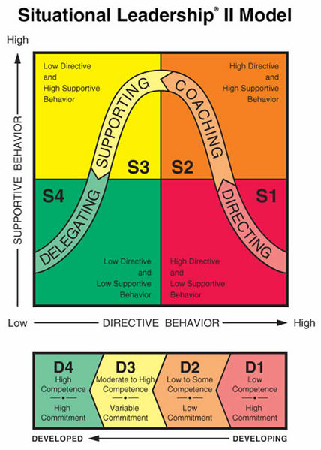
Figure 3: The Situational Leadership II (SLII) model

The leadership style refers to the behaviour pattern of the leader and includes both directive and supportive behaviours. Irgens (1995), describes directive behaviour as the leader giving detailed rules for the team members to follow, while describing supportive behaviour as the leader encouraging the team, communicating well, and listening to their concerns and needs. Directive behaviors clarify what is to be done, how it is done and who is responsible for it while supportive behaviors involve two-way communication and responses that show social and emotional support to others. This has exciting applications into the NHS as healthcare is also run on this basis of mutual understanding, openness, and trust.
Leadership styles can further be broken down into four distinct categories: Directing, Coaching, Supporting and Delegating. The development level depends on the competence and commitment of the team members. These development levels range from low competence to high competence and can be easily applied to the Welsh Ambulance Service staff.
- D1: These are inexperienced staff who are keen to learn and progress.
- D2: Inexperienced or demotivated staff who have lost the drive to progress due to factors such as other negative staff around them and factors such as ambulance delays.
- D3: Highly competent staff with variable commitment which could be experienced staff where their commitment goes up and down through their career depending on internal and external factors such as ambulance delays, professional developments, and new opportunities.
- D4: These are the experienced high performers who are dedicated to the task despite external challenges.
Challenges to the leadership style are that there is a lack of a strong body of research in the field which raises questions on the theoretical basis of the approach. Research also conducted by Vecchio (1987), found that in situational leadership, it is more appropriate to match a highly structured style of leadership with immature members of the team but found less reliable evidence for matching other supportive behaviour with other directive behaviour.
Western (2008) argues that certain situational leadership theories attempt to package the issues faced by leaders into over simplistic assumptions and that they are too often presented in a solution-focused way that give answers to leadership problems. He continues that there needs to be more research around how leaders address the context of situational differences including the size of the organisation, the size of the team and the social context of the organisation.
This model has exciting possibilities for adoption into WAST and the wider NHS, as Northouse (2016) argues, one of the main strengths of situational leadership in the medical context is that it is easy to understand, easily adapted in a variety of settings and it is very prescriptive, meaning that it tells you what to do and what not to do in a variety of various contexts. This ensures that NHS staff of all different roles, genders, races, and ages can easily adopt the Situational Leadership model and apply it to their current practice. As Baker (2022) articulates, Situational Leaders serve in a way that gets everyone working toward a collective vision.

Transformational Leadership
This style of leadership strives to achieve positive change by empowering and encouraging others. Transformational leaders aim to motivate their followers to achieve their mutual goals (Blaber, 2008), they do this through their charismatic and intellectual skills and are categorised as visionaries that can be a catalyst for change in their working environment by encouraging the team to see a vision and change their perception of reality (Barr & Dowding, 2016).
Blaber (2008) states that transformational leadership is a co-operation between the leader and the follower, it is about empowering employees to achieve the best they can and that through relationships it can encourage both parties to reach their desired goals.
Bass (1985) argues that transformational leadership has a profound effect on followers by raising their feeling of importance and inspiring them to work towards their organisations, Bass (1985) developed 4 leadership factors for transformational leaders and are as follows:
- Charismatic individuals which act as strong role models to followers.
- Inspirational motivational leaders who have high expectations and push their followers to achieve their best results.
- Intellectual leaders who stimulate their team to be creative and innovative.
- Considerate leaders who support their followers and delegate them tasks to allow them to grow.
Bass (1985) continues by stating that these factors allow leaders to produce greater effects than that of transactional leaders. Transformational leadership can also have a profound effect on organisations as a whole. If the relationships at the top tier of management are built on a mutual understanding, trust and empowerment then can then be cascaded through the organisation to each level of leadership and followers. Blaber (2008) backs this up by arguing that if the organisation has an empowering culture, then they are more likely to retain their staff and their staff are likely to have an increased level of satisfaction in their work. However, although a change of culture can often be seen as positive and refreshing, it is important that this change is monitored closely and managed in a way that brings about the desired result. Barr and Dowding (2016) argue that transformational leaders have the potential to gain a great deal of control over their followers which has led to exploitation of large numbers of followers such as Adolf Hitler and Saddam Hussein, Western (2008) expands on this by citing that a transformational leader can create a fantasy whereby they will be a saviour which may lead a psychological dependency from their followers.
Northouse (2016) states that when transformational leadership is applied to an organisation (in our case, WAST) a manager or leader may attempt to change the values of the organisation to reflect a more human standard of fairness and justice, this is currently represented by the Welsh Ambulance Services behaviours (2023) (Figure 4). Northouse adds to this saying that both the leaders and the followers emerge from these changes stronger and with a higher set of moral values.
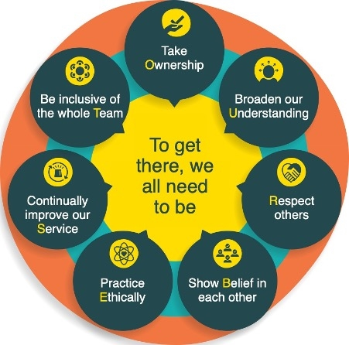
Figure 4: WAST Behaviours

If applied to WAST, this style of leadership has the potential to create a generation of leaders that will inspire and enthuse their followers to achieve their best performance for the benefit of the patient, the trust and themselves. Martin and Swinburn (2012) claim that strong leadership is vital for the correct quality of care to be given in the unscheduled care sector and therefore by demonstrating Bass’ (1985) leadership factors it has the potential to transform WAST’s leadership hierarchy.

Transactional Leadership
Northouse (2016) argues that the transactional leader emerges from transformational leadership. Transformational leaders individualise the needs of the team members and their personal development, while transactional leaders focus on the relationship between the leaders and their followers. He states that this link between transformational and transactional leadership is a continuum rather than independent leadership styles.
Transactional Leadership focuses on the exchanges that occur between leaders and their followers (Northouse, 2016). Leaders provide rewards or punishments based on their team's performance such as a bonus when they accomplish goals. Western (2008) argues that this is based on a relationship between the leader and the follower where the leader offers incentives to the follower and in return the job is done efficiently, Bass and Avolio (1994) state that Transactional leaders rely on "contingent rewards" whereby leaders set up clear expectations of performance from the team and rewards the individuals based on meeting key targets. Northouse (2016) argues that these transactional leaders are influential as it is in the best interests of the team members to follow the leader's direction and accomplish the agreed goals.
There are two types of Transactional leaders according to Humphrey (2014): Management by exception-active and management by exception-passive. Management by exception-active leaders take an active role in searching for and correcting problems before they become a major concern while management by exception-passive leaders wait until an issue becomes a serious problem that requires an action to fix. This second type could develop into a laissez-faire style of leadership where the manager fails to exert any leadership at all meaning that the entire team may lack drive and direction. It can be argued that the transactional leadership style is more suited to use by managers rather than leaders as it focuses on the basic management process of organising, planning, and controlling, it is at risk of creating an environment of power and control (Juneja, 2023).
Bass and Riggio (2006) favour the transformational style of leadership over the transactional style as transformational leaders stimulate and inspire their followers to extraordinary outcomes while transactional leaders may deny rewards which may lead to poor morale and poor team cohesion. O'Shea (2009) conducted a study examining 726 leaders and found that a combination of both transactional leadership and transformational leadership have positive results. Specifically transformational leadership combined with the passive management by exception transactional style would lead to an optimal leadership. This shows that often a combination of flexible leadership styles may be the most effective model leadership. Wang (2011) backs up this premise by finding that a combination of transformational leadership and contingent rewards had positive effects of their followers.
The Senior Paramedic role is one based on mutual relationships of trust and encouragement with no financial rewards or punishments being used. When mistakes are made, it is WAST’s policy to support the staff through these incidents so that learning can occur, and the mistake is not made again. Transactional Leadership styles are therefore unlikely to work well in the NHS as salaries are not performance indicated and performance is often derived from personal dedication and not financial goals.

Compassionate Leadership
Barr and Dowding (2016) define compassion as a measure of how care is given through relationships based on empathy, dignity, and respect while West (2021) expands on this by defining compassionate leadership as a relationship whereby the leader enables their followers to achieve their full potential through careful listening, understanding and supporting which ensures they feel valued and respected.
The Kings Fund (2017) found that when leaders have a high commitment to quality and compassionate care, it has a positive effect on several factors including the health and wellbeing of staff, clinical effectiveness, patient safety, and patient experience. As the Dalai Lama stated, “When we are motivated by compassion and wisdom, the results of our actions benefit everyone, not just our individual selves” (cited by Bailey and West (2022).
Atkins and Parker (2012) state that compassionate leadership can be measured based on four components of compassion, these are Attending, Understanding, Empathising and Helping. Bailey and West (2022) developed the following diagram (Figure 5).
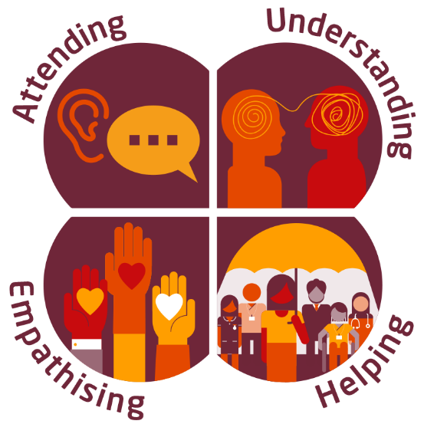
Figure 5: Compassionate Leadership

- Attending
Actively listening to others while exploring problems and ensuring that they have their full attention while noticing their suffering (West 2021).
- Understanding
Attempting to explore the individual issues people have and the situations they find themselves in, it involves exploring differing perspectives rather than enforcing the leaders own personal views (Bailey and West, 2022).
- Empathising
Mirroring the other persons feelings through a genuine relation with the individual’s distress without allowing the emotion to overwhelm either individual (West 2021).
- Helping
Supporting the individuals involves providing the tools they need to continue with their role and removing barriers that prevent them effectively achieving their goals (The Kings Fund 2017).
This leadership style has several exciting potential applications into WAST. Staff who are supported with clear goals by compassionate leaders are shown to have significantly lower levels of stress with increased satisfaction and reduced sickness levels (Bailey and West, 2022). This would be of benefit to not only our staff but also the organisation as a whole, as WAST often struggles with high sickness levels and a high demand on the service.
Secondly, patients who have treated by staff who have themselves been led with compassion are shown to have a higher level of care and satisfaction (West and Dawson, 2012). Therefore, by implementing this style of leadership throughout the trust, it is likely to improve patient care and outcomes. Specifically, through ensuring that Senior Paramedics adopt a compassionate style of leadership, it enables them to encourage the team members by ensuring they actively listen to individuals’ concerns, understand their situations, empathise with their feelings then help and support them through their practice.

Conclusion
In conclusion, from reviewing these 5 leadership styles it can be deduced that many of these leadership styles have both positive and negative aspects to them. No one leadership style is perfect for every situation that may be encountered while several of the theories achieve similar results in different areas. Situational Leadership is a flexible style of leadership that allows leaders to adapt their approach based on their follows individualised needs while Adair’s (1979) Action Centred Leadership model is more fixed and rigid, both styles are easy to understand, easily adapted into the NHS and very prescriptive. Transformational leadership is more applicable to the NHS than Transactional leadership style as it focuses on empowering and encouraging the team rather than financial goals which are not applicable to the NHS banding structure.
Compassionate leadership would be the immediate choice for implantation into WAST as it focuses on the health and wellbeing of the workforce while ensuring safe patient care and clinical quality. There are also several recent publications that support this style of leadership and are promoting them across NHS trusts such as The Kings Fund paper (2017).
By adopting this leadership style of attending, understanding, empathising, and helping, WAST would aim to encourage, support and inspire its staff across all areas of the organisation.

Referencing
Avolio, B. J., & Bass, B. M. (2002). Developing potential across a full range of leadership. Open Journal of Leadership, Vol.2 No.4.
Adair, J. E. (1979). Action-Centred Leadership. London: McGraw-Hill.
Adair, J. E. (2007). Develop your leadership skills. London: Kogan Page.
Atkins, P. W. B., and Parker, S. K. (2012). Academy of Management Review 2012, Vol. 37, No. 4, 524–546.
Bailey, S., and West, M. (2022). What is compassionate leadership. TheKingsFund, Retrieved from: https://www.kingsfund.org.uk/publications/what-is-compassionate-leadership on 1/7/23.
Barr, J., and Dowding, L. (2016). Leadership in Healthcare. (3rd ed). London: Sage.
Bass, B. M. (1985). Leadership and performance beyond expectations. New York. Free Press.
Bass, B. M. (1990). Bass & Stogdill,s Handbook of Leadership. (3rd ed). New York: The Free Press.
Bass B. M., & Avolio B. J. (1994). Improving organizational effectiveness through transformational leadership. Thousand Oaks, CA: Sage.
Baker, C. (2022). What is situational leadership and how do you practice it, retrieved from: https://leaders.com/articles/leadership/situational-leadership/ On 6/4/23.
Blaber, A. (2008). Foundations for Paramedic practice: A theoretical perspective. Maidenhead: Open University Press.
Blanchard, K., Zigarmi, P. and Zirgami, D. (1985). Leadership and the One Minute Manager: Increasing Effectiveness through Situational Leadership. New York: Morrow.
Blanchard, K. (2003). Servant Leadership. Nashville: Thomas Nelson Inc.
Goleman, D. (2000). Leadership that gets results. Harvard Business Publishing. March-April.
Humphrey, R, H. (2014). Effective leadership: Theory, cases and applications. LA: Sage Publications.
Hollander, E. P. (1984). Leadership dynamics: A practical guide to effective relationships. New York: Free Press.
Irgens, O, M. (1995). Situational leadership: a modification of Hersey and Blanchard. Leadership and Organizational Development Journal 16 (2), 36– 42.
Kouzes, T.K. and Posner, B.Z. (2019). Influence of managers mindset on leadership behavior, Leadership & Organization Development Journal, Vol. 40 No. 8, pp. 829-844.
Martin. J and Swinburn, A. (2012). Paramedic Clinical leadership. Journal of Paramedic Practice 4(3), 181 – 182.
Northouse, P. G. (2016). Leadership: Theory and Practice, 7th ed. London: SAGE Publications.
O'Shea P. G., Foti R. J., Hauenstein N. M. A., & Bycio, P. (2009). Are the best leaders both transformational and transactional? A pattern-oriented analysis. Leadership, 5, 237–259.
Spector, B. A. (2016). Carlyle, Freud, and the Great Man Theory more fully considered. Leadership, 12(2), 250–260.
Stogdill, R. M. (1948). Personal factors associated with leadership, a survey of the literature. The Journal of Psychology: Interdisciplinary and Applied, 25, 35–71.
The Kings Fund. (2017). Caring to change: How compassionate leadership can stimulate innovation in health care. Retrieved from: https://www.kingsfund.org.uk/sites/default/files/field/field_publication_file/Caring_to_change_Kings_Fund_May_2017.pdf on 11/7/23.
Vecchio, R, P. (1987). Situational leadership theory: An examination of prescriptive theory. Journal of applied Psychology, 72(3), 444-451.
Wang G., Oh I., Courtright S. H., and Colbert A. E. (2011). Transformational leadership and performance across criteria and levels: A meta-analytic review of 25 years of research. Group & Organization Management, 36, 223–270.
Welsh Ambulance Service Trust. (2023). Behaviours. Retrieved from Be Our Best - Welsh Ambulance Services NHS Trust on 3/8/23.
West, M. A., and Dawson, J. F. (2021) Employee engagement and NHS performance. Retrieved from: https://www.kingsfund.org.uk/sites/default/files/employee-engagement-nhs-performance-west-dawson-leadership-review2012-paper.pdf on 11/7/23.
West, M. A., (2021). Compassionate Leadership. UK:Swirling Leaf Press.
Western, S. (2008). leadership, a critical text, 1st ed. London: Sage Publications.

A reflective assignment exploring and critically evaluating own leadership qualities and assessing the impact of these on the workplace
Module BMPF7021
Submission Date
18/8/23
Word Count - 5916

Table of Contents
Introduction 17
Main Body 17
My Leadership Styles 21
Reflection 22
Conflict Management 25
Emotional intelligence 28
Human Factors 29
Communication 32
Core values 32
Conclusion 36
Referencing – Harvard Referencing 36
Appendices 38
Appendix 1 – Overview of Insights 38
Appendix 2 – The insights wheel 40
Appendix 3 – Personal SWOT Analysis 41
Appendix 4 – Personal Development Plan 42

Introduction
In this assignment I will explore my own style of leadership and reflect on my own leadership journey through joining the ambulance service on patient transport, progressing to a Paramedic, mentoring Paramedic students, supporting new staff then developing into a Senior Paramedic. I will discuss how my personal relationships, behaviours and my own leadership styles have impacted the people around me and my relationships with colleagues. I will then critically evaluate and reflect on my own practice using several reflective models and referring to an insight’s evaluation (Appendix 1) of my leadership practice. I will lastly conclude the essay by producing a Personal Development Plan (Appendix 4) and applying this to my own practice to improve my future leadership abilities and relationships.

Main Body
Looking back on my leadership journey so far, I can see that I have been utilising leadership skills and styles since my early life, through sports teams such as rugby and football and through social groups at school. My first position of official Leadership was working as a youth worker as a late teen, as part of this role I would manage small groups of young children in various activities including running games, craft activities and events. At that time, I had little to no knowledge of any leadership styles, theories or even techniques, I just performed my duties on an ad hoc basis, just doing what I thought was best with no guidelines or framework to work from.
Much of these basic leadership skills were either inherited traits such as honesty, trustworthiness and communication or they had been gained simply through watching and learning from other leaders. The college of Paramedics (2017) outlines several values that leaders should exemplify, some of which I have inherited which can be backed up by trait theory but many more of which I have had to develop, learn, and master over time.
While my early leadership journey was based more on intuition, my next exposures of leadership were as a first aider working in small teams and as a section commander in the UK armed forces, I had very low experience and training when I started the roles but through working closely with guidelines, I was able to apply that training and lead colleagues in various situations.
When I started my career in the ambulance service, it was as a patient transport attendant. In this role I became a follower, I watched closely, tried to form part of the team and I learned from others. I was inspired by one of my mentors, he exhibited all the traits that I aspire to be in a leader, he was charismatic, knowledgeable, honest, trustworthy and had great communication skills, he showed transformational leadership, he empowered me and pushed me to achieve my best and apply for the Paramedic Science Diploma.
While on the Paramedic Science Diploma I became part of a team all working towards the common goal of qualifying as a Paramedic. It was during this time that I noticed that my actions had profound reactions to other people’s behaviour, and I began to develop a sense of emotional intelligence. As part of my peer group, I adopted a positive friendly attitude mixed with a hard-working self-disciplined ethic, but my introvert personality pushed me towards becoming a “grey man” in the class where I did not single myself out from the group or “put my head above the parapet”, this is backed by the insights profile which states “Aaron’s focus is inward, meditative and reflective” and “He does not seek positions of “front-end” leadership, preferring to act behind the scenes”. Over time however, I opened to the group and became more confident which allowed me to have greater relationships with my peers and work better in teams and as a leader. This statement is again backed up by the insights proforma: “He prefers to integrate slowly into even the most non-threatening situation. As he gets to know you, he becomes more enthusiastic and open”.
One of the biggest impacts of my early career was when I was contacted by one of my colleagues even before I joined the station, it was a simple welcome to the area message, but this act showed a great deal of emotional intelligence and exceptional communication skills. This one act showed me more about what a leader is than any other single aspect, it ensured I felt welcome, supported and part of the team, it inspired me to do my best for the team and the service. This act exemplified servant leadership as it motivated me to do my best through my colleague engaging and encouraging me to become part of the team. This approach is something I have kept with me and continue to do to this day when new staff are joining the team.
While working as a Paramedic I have also been mentoring students and staff, unknowingly adopting a Situational style of leadership that has included both directive and supportive behaviours (Figure 1, Blanchard, 1985). Although I did not know about this style of leadership at the time, by looking back at how I coached and mentored students I can see that I did follow this process and will also continue to do so in the future.
Figure 1: The Situational Leadership II (SLII) model (Blanchard et al, 1985)

An example of utilising this model with Paramedic students can follow the S1 – S4 chart.
- S1: These are new student who require a high level of direction to complete tasks such as performing full sets of observations for patients until they are proficient in the task.
- S2: These students may be approaching the end of their first year of study, they are still learning how to perform different skills and tasks and they require high support while they continue to learn their role.
- S3: Students that are mid-way through their course often require little direction as they have learnt how to treat most presenting conditions and have completed summative assessments in most areas but may still require support as they gain the confidence to practice these skills and put their newfound knowledge into practice.
- S4: These are students approaching the end of their course, they can be relied on to practice safely and require little support or direction but simple mentoring to perfect their techniques.

When the Senior Paramedic role was first introduced to WAST I was both excited and hesitant to apply for the position. The Senior Paramedic role was presented as a clinical leadership role which supported the staff of the workforce and was a vital link between the senior management team and the front-line staff, however, it also advertised a non-clinical aspect of the job which would focus on managing care bundles and ensuring compliance with policies.
This second point initially put me off applying for the position as I was reluctant to be dragged into a managerial position where I would be pulled away from the clinical aspect of my career and forced into dealing more with statistics, figures and targets. In 2022 I reconsidered the role, I was ready for a change and a new challenge, the monotony of ambulance delays was starting to take its toll on me and although I enjoyed mentoring new staff and Paramedic students, seeing them also be demoralised pushed me to want to do more. Colleagues had already voiced I had excellent mentoring skills and would make a good Senior Paramedic, but I was unsure whether I wanted to leave my colleagues behind who I had great relationships with.
In my interview for the role, one of the questions asked was what would be some of my greatest challenges in the role, I stated that a weakness of mine would be dealing with conflicts and how I would have to overcome this by creating meaningful relationships with staff members so that I could have honest conversations based on trust and confidentiality rather than frustration and anger. This is backup up by my insights evaluation which states that “Aaron may avoid conflict and unpleasantness in resolving issues.”
There are many types of conflict and various ways of approaching these conflicts which I will shortly discuss in more detail, however one clinical aspect of this is the immediate resolution of an issue when a patient’s treatment is at risk and comes under the realms of assertiveness.
The PACE assertiveness tool (Figure 2) has been developed to assist staff in a process of communication and providing clarity in stressful crisis situations. The premise is that the user starts by probing a colleague, then alerts them to a danger, challenges their actions and acknowledges an emergency if the situation is not resolved. An example of this is a Senior Paramedic taking control of a cardiac arrest scenario where an airway is at risk:
Probe – “Daniel, can you please check the airway?”
Alert – “Daniel, I am concerned about the airway, can you please support it?”
Challenge – “Daniel, the airway is at risk, I need you to secure it immediately”.
Emergency – “Daniel, step away from the patient, I am taking control of the airway”.
By following this stepwise process clinical leaders can begin by empowering staff to take charge of the problem and fix it themselves, but it still has scope to progress to a full escalation if the staff member is unable to perform their role or is out of their depth.
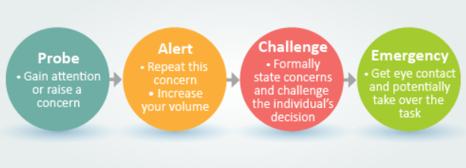
Figure 2: The PACE Assertiveness Tool – Royal College of Obstetricians and Gynaecologists (2023)

My Leadership Styles
I have used several leadership styles throughout my leadership development such as the Situational Leadership style as discussed above, I now aim to utilise a transformational style of leadership on the whole as it has a number of benefits which represent how I want to lead. It “engages with individuals to create a connection, which raises the morality and motivation of both the leader and the follower” (Northouse, 2016).
Bass and Stogdill (1990) developed a seven-factor leadership model comprising of both transformational and transactional elements, the transformation factors (Figure 3) consists of four leadership factors.
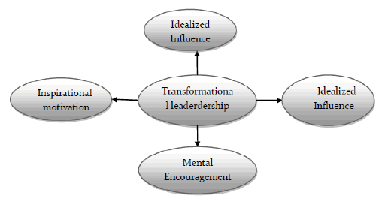
Figure 3: The Transformational Leadership factors (Bass and Stogdill, 1990)

Factor 1 (Individualised Influence) focuses on the leaders being strong role models for the followers to identify with and relate to. These leaders should have a high moral compass with high ethical conduct, in WAST, Senior Paramedics are seen as very competent and skilled clinicians who are highly skilled at leading a team.
Factor 2 (Inspirational Motivation) relates to the expectations the leader has from their followers. Senior Paramedic leaders should exemplify the behaviours of the trust to push them forward and improve the staff’s commitment to become part of the organisation and team dynamic.
Factor 3 (Intellectual Stimulation) pushes followers to achieve the best results for their patients through promoting problem solving and self-development. This can be achieved through Senior Paramedics clinically mentoring the team, running training sessions and challenging their knowledge and practice.
Factor 4 (Individualised Consideration) represents leaders who provide supportive environments to followers to encourage growth and good communication. Senior Paramedics should aim to exhibit this transformational leadership factor as it ensures that staff have time and support to reflect on traumatic incidents so they can process them in a timely manner and therefore reduce the likelihood of developing adverse mental health conditions such as post-traumatic stress disorders.
Since qualifying as a Senior Paramedic and working in the role I have strived to ensure I embody all the traits and values that a good leader should have, but leaders can also make mistakes and I am no exception. I believe that it is important that leaders learn from these mistakes so that they do not make the same mistakes again.

Reflection
Reflection is a critical aspect of learning; it is how we can identify situations that have not gone to plan and improve them as well as situations that have succeeded and should be consolidated.
Taylor (2000) states that reflection is defined as considering thoughts and memories through contemplation in order to make sense of them, then to make contextual changes as required. Freshwater (1998) gives a definition from a clinical perspective arguing that it is an important part of clinical development and stops us from becoming tunnel visioned allowing us to explore alternate approaches while Blaber (2008) states that due to time restrictions, ambulance clinicians don’t always have time for immediate debriefs so it is important to go back and reflect on incidents to learn from the experience and therefore benefit future patient care.
Schon (1983) states that reflection can be used to breach the gap between theoretical knowledge and applied practice then use this bridge to change future practice, this has particular relevance when putting theoretic leadership skills into practice. Throughout this assignment I will be discussing and reflecting on my leadership approaches, how they affect the people around me and how I can change my practice and situational awareness to improve my leadership abilities. Confidentiality will be maintained during these reflections with any identifying details being omitted.
There are several models of reflection that can provide a structure around a reflection, these are designed to guide an individual around the process of reflection and therefore assist with enabling reflection, they are not however, designed to impose exactly what reflection is (Johns, 2000). Gibbs (1988) developed the reflective cycle (figure 4), this model focuses on the feelings we have about an event and how these feelings affect our future practice, it is comprises of six stages of reflection including a description of the event, the individuals feelings about the event, an evaluation of what went good or bad, analysis of the situation and a conclusion, it then closes with an action plan.
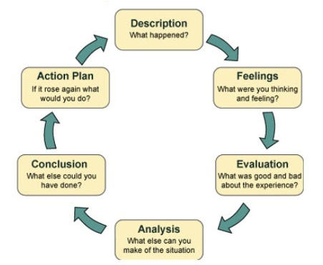
Figure 4: Gibbs reflective cycle (1988).

Another model of reflection I will discuss in this assignment was developed by Kolb. Kolb (1984) stated that learning occurs between theory and experience, although I have gained substantial knowledge of leadership styles and theories, I aim to further improve my leadership ability through gaining this experience and learning from it. Kolb (1984) developed the reflective practice model (Figure 4), it begins with the concrete experience which is something new or unusual and could be leading the incident in question, it progresses to reflective observation, which is reflecting on the experience, thinking about what the result was. Abstract conceptualisation is where the individual builds up a mental picture of what they have experienced, and they make conclusions based on their observations and Active Experimentation is putting these theories into practice. Kolb’s (1984) model (Figure 5) has the advantage of it being easy to use and implement, it can therefore easily be adapted to the context of leadership.
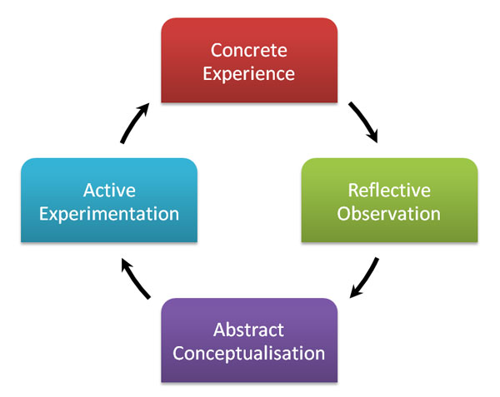
Figure 5: Kolb’s (1984) Reflective Practice Model

The last model of reflection to consider in this assignment is the IFEAR model of reflection (Figure 6) (Smart, 2011). This model is an adaption of the Gibbs model of reflection (1988) developed for use in the ambulance service and has 5 stages of reflection. These 5 stages are a description of the incident, feelings about the experience, evaluation of care and an analysis of the practice then the individual’s reaction and response to the incident.

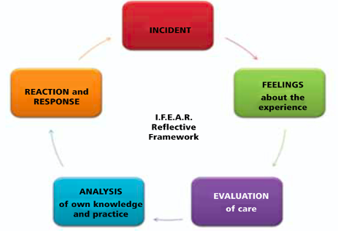
Figure 6: The IFEAR Model of Reflection (Smart 2011)

As I progress through the assignment and reflect of my experiences and development, I will apply these models of reflection to them in order to improve my practice.

Conflict Management
Conflict in the workplace can often be a make or break for staff, it can result in poor relationships, poor morale, and a loss of staff through disciplinaries and resignations. NHS England (2022) define conflict as behaviour intended to disrupt another’s individuals’ goals, if it can be managed effectively, it can be a transformational positive change. NHS England (2022) state it can take 3 forms:
- Task Conflicts - Can involve differences of opinions, ideas, or viewpoints.
- Process conflicts – This is the disagreement of how to achieve desired outcomes.
- Relationship conflicts – This is the breakdown of relationships due to interpersonal incompatibility based on behaviours, characteristics, or personal values.

As part of my personal leadership development, I have also delt with conflict during my position as a Senior Paramedic, these situations can arise during intense critical incidents where staff have different view of how to provide the best care for a patient and sometimes from different agencies all trying to complete their individual goals. I have realised it is important to attempt to see other pints of view to resolve conflicts or stop them happening in the first place. From utilising the Gibbs framework, I have reflected on a situation I found myself in that I did not expect.
Description
While working as a Senior Paramedic during strike action I found myself in conflict between two factions, those who wanted to strike to improve working conditions and fighting for a “fairer pay deal” and those that wanted to just do the best for the patients and continue working as normal. As a Senior Paramedic during this time, I was expected to follow the trusts management plan however my own beliefs and morals were firmly on the side of fighting for better working and pay conditions, I was therefore torn between the two.
It was during these strike days that some staff were working overtime while others were losing pay on strike that staff were beginning to conflict and bicker, and I was no different. During a strike day a colleague contacted me stating they were working with someone who was doing overtime and I made a comment that they were taking pay off the staff members on strike, the staff member in question initially laughed about it and we both jokes at each other about it.
Later that week I heard that the individual had also been in arguments with other staff members about working overtime on a strike day and he had become upset about it.
Feelings
My initial reaction was anger to see some staff members effectively making money out of others while they were on the picket line fighting for everyone’s working and pay conditions to be improved, when I spoke to the staff member, I thought that making light of the stressful environment we found ourselves in would help to lighten the mood and reduce tension. As the conversion was over the phone, I was unable to pick up on non-verbal communication which may have informed me he was not seeing the conversation as I was. When I heard that the staff member was upset by what had happened, I felt guilty that my actions had such as an adverse effect on the individual, I was angry that he had taken it in that context then sad that I had contributed to his situation.
Evaluation
From this experience I realised how such small actions or conversations can have a dramatic effect on others, this is particularly evident in the context of leadership as a Senior Paramedic is part of the senior leadership team and therefore should not be breaking the trusts behaviours in such as way and instead should be supporting and empowering staff to feel part of the team. From this experience I have leant that it is vital that from this point forward I have a greater understanding and awareness of how my actions can affect others.
Analysis
From analysing the incident, I can deduce that both communication and emotional awareness are critical factors in this situation and from investigating these areas I will be able to improve my leadership abilities and skills.
Conclusion
Once I realised the mistakes I had made, and the relationship I had damaged I approached the individual to attempt to salvage that relationship and make amends. From having this conversation, the individual stated that he was working the shift as he had booked it without realising it was a strike day and he would have been put on an overtime ban if he had cancelled it. I have realised it is important to see other people’s views before entering situations and to have an open mind in all conversations, this is the Broadening our understanding part of the WAST behaviours.
Action Plan
If this situation arose again, I would ensure I remained objective about people’s personal opinions and actions, I would ensure that I remained impartial and supported the team and the individuals rather than adding to segregation. NHS England (2022) released a “Managing Conflict” tool which I can apply to my practice to improve my conflict management abilities, this tool begins by identifying the signs of conflict, advises what do through working through what has happened, containing the conflict, then taking positive steps wo deal with the issues (Figure 7). Fisher (2000) states that leaders are in the position to alleviate tensions, deal with disruptive behaviours and fix misunderstandings. These simple guides may help to do this.
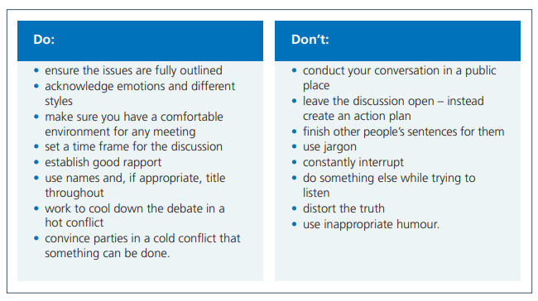
Figure 7: Conflict Resolution Checklist (2022)

There is an obvious link between leadership styles and how a leader can make conflict in the workplace, as Saeed et al argue (2014), “Leaders react to problems, resolve crisis, reward and punish followers, provide encouragement and support to followers”. Many of these actions are based within leadership styles such as providing encouragement and support in transformational leadership and using reward and punishment in transactional leadership. Knapp et al (1988) back this up by stating that managers may need to adapt their behaviours to deal with differing situations, some situations may require direct confrontation while other may be handled more slowly and delicately, this adaption of technique could be argued as situational leadership.
Gasper (1992) argued that transformational leadership results in a greater level of team performance, motivation, and satisfaction. In difficult environments and conflict, transformational leaders are more likely to be successful as they seek to actively manage conflicts in a positive manner. Therefore, by adopting a transformational leadership style when attempting to deal with conflict, it should help to improve by ability to do this.
From here I will also discuss emotional intelligence and how it can influence an ability to lead.

Emotional intelligence
This is our ability to self-manage ourselves and our relationships effectively and consists of four factors, these are our social awareness, social skills, self-awareness, and self-management (Goleman, 2000), (Figure 8). Social awareness is the sensing the emotions of the team members while having social skills is the ability to respond to these emotions and influence members through excellent communication, collaboration, and conflict management. Self-awareness is the ability to understand the emotions you are feeling and the stresses you are under while self-management is positively controlling and managing these emotions while displaying a view of honesty and integrity.
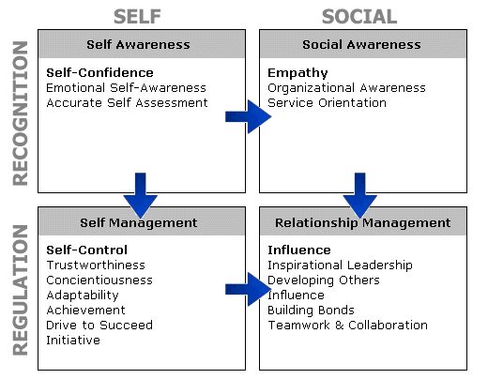
Figure 8: The Emotional Intelligence Appraisal

Emotional intelligence is a critical element of leadership in healthcare as without it we are at high risk of not managing our own emotions, effectively leading to a lack of team member confidence in the leader. By misreading the understanding and responsiveness of the team, the leader may lose situational awareness leading to a loss of control of the incident and consequently a poor patient outcome. By utilising the IFEAR reflective model (Smart 2011) I will reflect on an incident I attended involving emotional intelligence.
The Incident
I received a call to a motorcyclist who had been knocked off his motorbike on a busy dual carriageway, en-route I was informed by the control desk that the patient was in cardiac arrest. I drove to the incident address but the control desk were not providing additional information such as other resources in attendance or which carriageway the incident had occurred on, and I was unsure how to access the incident. On my arrival another crew were caring for the patient, he was not in cardiac arrest, I took over his care and he was eventually conveyed into the local emergency department and recovered well from his injuries.
Feelings
On initially receiving the call that a patient was in cardiac arrest, my adrenaline kicked in and I drove to the scene as fast and safely as possible, it is important to be emotionally aware when driving or an emergency driver can easily experience “Red Mist” which is a process whereby a driver becomes tunnel visioned into driving as fast as possible and forgets about safety. When I didn’t receive further details, I became extremely stressed as I had to guess which carriageway the accident was on which couldn’t have resulted in a prolonged drive. When I arrived on scene, I was elated to hear the patient was better than expected but while I took a handover from the staff on scene, I was too eager to examine the patient myself rather than control my own emotions and focus more on the needs on the team and opportunity to develop them.
Evaluation
Although the standard of care to the patient was well provided, I missed an excellent opportunity to stand back and manage the team from the foot of the patient. Specifically, one of the staff members present was a trainee Paramedic and in retrospect I should have allowed her to perform the patient examination, cannulate the patient, give appropriate medications and package the patient with support close by if required. This would have empowered her to further improve her skills and practice.
Analysis
From examining my own approach, qualifications, and experience, I am well aware that I should have stood back from the incident and supported my colleagues from a safe distance while providing supportive guidance, however, in this incident I became emotionally unaware due to the stress I had been experiencing prior to arriving on the scene.
Reaction and Response
From Analysing and Evaluating my practice in this incident I can identify that I would become a more effective and transformational leader if I became more Emotionally Intelligent and was more aware of how Human factors such as the environment around me can affect my ability to lead.

Human Factors
As part of my initial Senior Paramedic training, we were taught about human factors and how outside influences such as the people around us and the environment we find ourselves in can influence our ability to perform well in a situation. Factors such as the high levels of stress explained in the reflection above can affect our emotions and inhibit our ability to step back and take in the whole situation or event.
“Human factors are organisational, individual and environmental job characteristics that influence behaviour in ways that can impact safety” (The Clinical Human Factors Group, 2023). Also called ergonomics, human factors comprise of individuals physical and mental characteristics as well as the organisational factors and society.
Human factors can also be described as non-technical skills (Resuscitation Council UK, 2021), they are things that affect our performance and are contributory factors to skill performance and overall patient care. Non-technical skills can be broken down into individual parts (Figure 9), these are situational awareness, decision making, team working including leadership and task management.
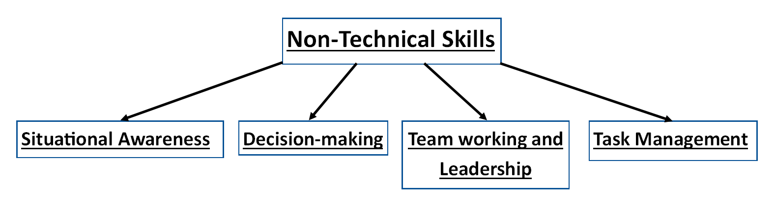
Figure 9: Non-Technical Skills

Situational awareness underpins all patient encounters, its about being aware of all the information being provided, it consists of 3 key stages, these are gathering information, interpretation of this information and future planning (Resuscitation Council UK, 2021).
Decision making relates choosing one option from several choices, bringing all the information together, determining the appropriate interventions and clear and concise communication to enact on this decision.
Team working and leadership is especially relevant in this assignment, Team working consists of knowing the team believing in their role, ensuring they are competent in their assigned role and are open to communicate freely. Leaders need to be knowledgeable and credible enough to lead the team, they can do this through role modelling by adopting a transformation leadership style, they also need to have great communication skills, be open to new ideas and trust the team for support.
Task management is the allocation of team by ensuring that each team member plays to their strengths and are competent to complete the assigned role. It also involves being inclusive of all team members, managing conflicts, identifying the resources required and debriefing the team after an incident.
Again, by using IFEAR reflective model (Smart 2011) I will demonstrate how the use of these non-technical skills has improved my leadership abilities.
The Incident
While working on a rapid response vehicle I self-tasked to assist a crew who were en-route to a motorcyclist who had crashed into another car. I did this as I could see the crew in question were both relatively new and had limited exposure to traumatic injuries, when I arrived on scene, I saw the crew were busy assessing the patient in question. I informed the crew I was there to assist them and not take over, I left them to continue their assessment while I supported from a distance with any equipment they required, I also kept a close eye to make sure the patient was being cared for effectively. Once aboard the ambulance it was clear they were unsure about a specific treatment plan, so we talked through what the guidelines stated and what the benefits of a treatment plan might be. We also discussed whether the hospital should be informed and the best way to do this. Once I was happy the patient was in good hands, I left the crew to convey the patient, so they knew I had confidence in their ability to continue the patient care unassisted.
Feelings
Before I arrived at the call, I was apprehensive that the crew may not be providing the best care available as they were inexperienced however, when I arrived on scene, I was pleasantly surprised I didn’t need to take over in any immediate way, it gave me the time to take in the scene. I acquired as much information as I could from both bystanders and through observing the progress of the crew, I then used this information to discover the mechanism of injury, likely injury patterns and treatment options prior to prompting the crew as required. Although unexperienced I knew the crew were appropriately qualified for the task in hand and felt that by standing back it wound empower the crew to achieve their best and therefore the best treatment for their patient.
Evaluation
By adopting this transactional supportive approach, the patient received a good standard of care and the crew felt supported to treat the patient within their own scope of practice while increasing their experience.
Analysis
During this incident I showed a good understanding situational awareness and applied the principles of non-technical skills, I ensured I kept my hands off the patient which allowed me to view the incident and staff members from a distance without being tunnel visioned into specific treatment care. I also met up with the crew at the hospital to debrief the incident and they seemed proud that I trusted in them to complete the patient care unassisted.
Reaction and Response
From reviewing this incident, I can ascertain that I have increased my non-technical skills since the previous reflection, this has allowed me to focus more on the team and less on my own clinical skills.

Communication
Communication is a critical aspect in both working in or leading teams, Ellis (2003) states that it is an essential skill for required for all ambulance staff and NHS workers. Maxwell (1999) argues that communication is one of the 21 indispensable qualities of a leader, Maxwell continues by stating that communication is vital, as good leaders must be able to share their knowledge with one another to achieve organisational goals.
From reviewing my insights portfolio there is limited mention of communication other than “Written communications are most effective with him”. From reflecting of my past experiences, I was previously uneasy speaking or leading groups, however over time I have attended various training courses which has brought out my confidence, I am now happy to lead situations, teams and even lead training days myself. This newfound confidence has increased my communication abilities as I attempt to empower a team to achieve their best and learn from them during two-way communication.
From improving my communication skills and confidence, I have found that it influences both my behaviours and that of my peers. This has led to greater interpersonal relationships and repour with my team as they are open to non-judgmental criticism and conversations.

Core values
Although a leader’s specific characteristics and traits are critical in how they perform and lead a team, it is also important for a leader to reflect the moral values of their organisation. Each organisation has its own set of values specific to their area of focus. The Welsh Ambulance Service’s Core Values are called the WAST Behaviours (2023), (Figure 10).
Figure 10: WAST Behaviours

These Behaviours define what an organisation is striving to achieve but not necessarily the values that it currently embodies. The strengths wheel (Figure 11) developed by Driver (2011) can be utilised to measure the organisational aspirations on several aspects. The centre of the wheel represents a score of 0 and the outer rim has a value of 10, the user indicates their current level of strength in that field then indicates a second score to show the level of improvement they are aiming for in that field, this will create a triangle for each value.
From utilising the strengths wheel, it can measure how a leader in an organisation meets the values of their trust and what their aspirations are to improve.
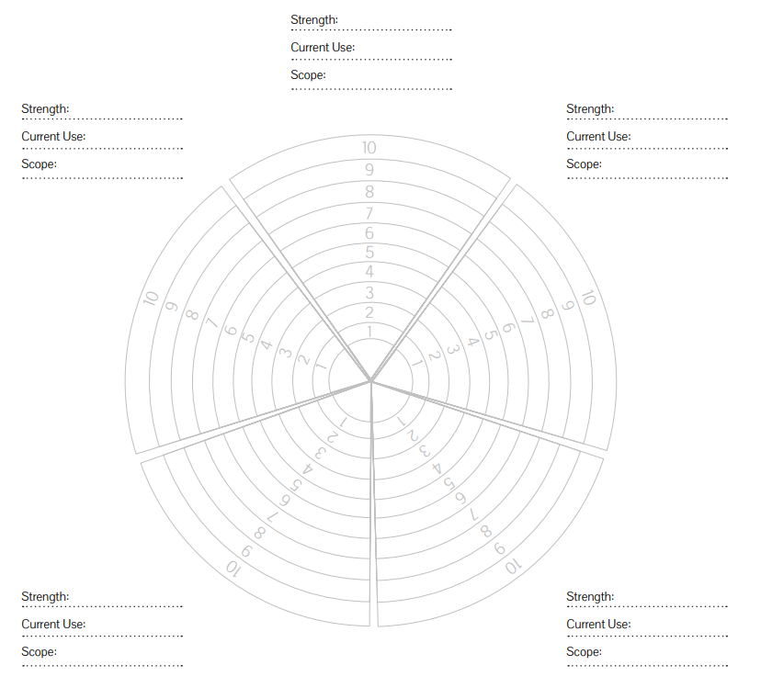
Figure 11: The strengths wheel – Positive Psychology Practitioner’s Tools (Driver, 2011).
As a leader in WAST, I must represent the Trusts Core values which include the following:
- Take Ownership: I aim to take accountability and reflect on my experiences.

6 → 8

- Broaden our Understanding: I welcome feedback and take on constructive criticism.
7 → 9

- Respect others: I show respect to all team members and communicate with Empathy.
8 → 9

- Show Belief in each other: I put trust in the team members and encourage them to achieve their best.
6 → 8

- Practice Ethically: I will stand up for what is right and standby my team members when something goes wrong.

7 → 9

- Be inclusive of the whole Team: I actively seek to involve all members of the team in activities both inside and outside of work, however, from reviewing the conflict reflection it is clear I can improve on my tolerance of other views.

6 → 8

- Continually improve our Service: By observing the insights discovery wheel (Figure 12), my strongest leadership attribute is being supportive to my team, this is backed up by my transformational style of leadership and from the way I aim to care for my teams clinical and emotional needs. The insights profile also backs up this premise with the following quotes: “He provides practical support quietly, painstakingly and conscientiously” and “Charmingly supportive of others, he can stay behind the scenes working at practical jobs requiring empathy and service”.

8 → 10


Figure 12: The insights discovery wheel

Conclusion
In this essay I have discussed and evidenced how my own personal and professional development has affected my relationships with the staff around me and the effect my leadership styles on others. A variety of models have been utilised to reflect from my leadership journey and I will now utilise this information to create a SWOT analysis (Appendix 3) and a Personal Development plan (Appendix 4) that aligns with both myself and my organisations leadership objectives.

Referencing – Harvard Referencing
Bass, B. M. (1990). Bass & Stogdill,s Handbook of Leadership. (3rd ed). New York: The Free Press.
Blanchard, K., Zigarmi, P. and Zirgami, D. (1985). Leadership and the One Minute Manager: Increasing Effectiveness through Situational Leadership. New York: Morrow.
Driver, M. (2011). Coaching Positively – Lessons for coaches from Positive Psychology.
Ellis, R. (2003). Interpersonal Communication in Nursing: Theory and Practice. (2nd ed). Edinburgh: Churchill Livingstone.
Fisher, R.J. (2000). “Intergroup conflict”, in Deutsch, M. and Coleman, P.T. (Eds), The Handbook of Conflict Resolution, Jossey-Bass Publishers, San-Francisco, CA, pp. 166-185.
Freshwater, D. (1998). Cited in Reflective Practice: A Guide for Nurses and Midwives. Maidenhead: Open University Press.
Gasper, J.M. (1992). “Transformational leadership: an integrative review of the literature”, Dissertation Abstracts International, University Microfilms No. 9234203.
Gibbs, G. (1988). cited in Transforming Practice through Clinical Education, Professional Supervision and Mentoring. London: Elsevier.
Goleman, D. (2000). Leadership that gets results. Harvard Business Publishing: Boston.
Johns, C. (2000). Cited in Reflective practice in Nursing, 3rd ed. Blackwell Publishing Ltd: Oxford.
Knapp, M.L., Putnan, L.L. and Davis, L.J. (1988). “Measuring interpersonal conflict in organizations: where do we go from here?”, Management Communication Quarterly, Vol. 1, pp. 414-429.
Kolb. D. A. (1984). Experiential Learning experience as a source of learning and development. New Jersey; Prentice Hall.
College of Paramedics. (2017). Practice Educator Guidance Handbook. Exeter: Short Run Press Ltd.
Maxwell, J, C. (1999). The 21 Indispensable qualities of a leader. Nashville: Thomas Nelson.
NHS England. (2022). Managing Conflict. Retrieved from https://www.england.nhs.uk/wp-content/uploads/2022/01/qsir-managing-conflict.pdf on 6/8/23.
Northouse, P. G. (2016). Leadership: Theory and Practice, 7th ed. London: SAGE Publications.
Resuscitation Council UK. (2021). Non-technical skills in resuscitation. (8th ed). London: Resuscitation Council UK.
Royal College of Obstetricians and Gynaecologists. (2023) The PACE Assertiveness Tool retrieved from: https://elearning.rcog.org.uk/new-human-factors/types-communication/probe-alert-challenge-and-escalate-model on 28/7/23.
SAEED, T., ALMAS, S., ANIS-UL-HAQ, M. and NIAZI, G. (2014). Leadership styles: relationship with conflict management styles. International Journal of Conflict Management, 25(3), pp. 214-225.
Schön, D. (1983). Cited in Reflective Practice: A Guide for Nurses and Midwives. Maidenhead: Open University Press.
Smart, G. (2011). I.F.E.A.R reflection: an easy template to use adaptable template for paramedics. Journal of Paramedic Practice, 3(5): 255-257.
Taylor, B.J. (2000). Cited in Reflective Practice: A Guide for Nurses and Midwives. Maidenhead: Open University Press.
The Clinical Human Factors Group. (2023). What are clinical human factors. Retrieved from https://chfg.org/what-are-clinical-human-factors/ on 6/8/23.
Welsh Ambulance Service Trust. (2023). Behaviours. Retrieved from Be Our Best - Welsh Ambulance Services NHS Trust on 3/8/23.

Appendices

Appendix 1 – Overview of Insights
These statements provide a broad understanding of Aaron's work style. Use this section to gain a better understanding of his approaches to his activities, relationships and decisions.
Personal Style
Serious, conscientious and loyal, Aaron is a dedicated worker. He will seek an environment in which he can be quietly productive. He is at his best in work that involves people and task, where co-operation can be achieved through goodwill. Although others may comment on his serene demeanour, he himself may report that he is feeling quite worried and distressed. His observed behaviour does not always match his inner state. He relates to, remembers and builds on positive experiences. He can complete practical tasks and do repetitive work effectively.
Aaron's focus is inward, meditative and reflective. He will make an effort to remember names and special occasions and make his office or home a pleasant place in which to work. Aaron likes to prepare well and prefers to know why and how things happen. Aaron prefers to live his life in a structured and organised manner and prefers to work within established guidelines on tasks requiring detail and routine implementation. Easy-going, neat and orderly, he nonetheless values appreciation from others.
He believes people should say what they mean and mean what they say. Written communications are most effective with him. One of Aaron's strengths is an ability to let others work at their own pace coupled with an awareness of the unique contribution each person makes. He is responsible and faithful to his commitments and obligations. Aaron provides practical support quietly, painstakingly and conscientiously, usually behind the scenes. He tends to be disinterested in subjects for which he sees no practical application.
Normally a flexible and open minded person, he may dig in his heels to defend something he believes in and that is being threatened. He is easy-going and low key and may be prone to doubting his own ability. In everyday activities, Aaron is tolerant, open-minded, flexible and adaptable, enjoying the present moment. Aaron displays fierce loyalty to and for people who report to him. If he makes a serious mistake at work he may feel guilty for a long time.
Aaron is seen by others as open, mild, modest and rather self-effacing. Cautious, conventional, diplomatic and sincere, Aaron is a precise and disciplined person with high standards and expectations of himself. He tends to take the things he does well for granted and usually underrates and understates himself. He does things in a routine manner and is consistent, conscientious and reliable. His strong sense of personal values may make him reserved around strangers whose values he feels may conflict with his own.
Interacting with Others
At work, Aaron is good at blending productivity with an interest in, and compassion for, the workforce. Though perhaps hard to get to know, he is a trustworthy confidante who accepts a wide range of behavioural differences in others. Charmingly supportive of others, he can stay behind the scenes working at practical jobs requiring empathy and service. He has a great deal of personal warmth but may not show it until he knows a person well. He is a pillar of strength in the home, at work, and in his community.
He does not seek positions of “front-end” leadership, preferring to act behind the scenes. Aaron brings harmony and goodwill to any situation in which he finds himself. Basically loyal, trusting and understanding, he needs harmonious relationships in his life and is most sensitive to conflicts and disagreements. He is seen by most people as kind and sympathetic. If he feels he is being put under too much pressure, he may dig his heels in and become stubborn.
He more often expresses his deeply felt feelings through actions than through words. By remaining open-minded to untested or unconventional solutions, he would develop greater tolerance for differences and end up being more effective. He will often seek a strong protector or may ultimately rebel against authority. He has a desire to be loyal to a protective organisation and may be content to spend all his working life with the same trusted employer. He will be prepared to remain apart from active participation in new teams. He prefers to integrate slowly into even the most non-threatening situation. As he gets to know you, he becomes more enthusiastic and open.
Decision Making
Aaron is an excellent “sounding board” for others who are seeking to explore their own ideas. He will support those he considers as friends but can feel rather pressured if made to act against what he considers as his better judgement. His natural leadership style is to resist change for change's sake and to slow down impulsive decision making. He tends to make sound future decisions only after deeper reflection. He can be overly lenient with non-producers, which often results in problems in matters that require the application of discipline.
He may appear dismissive of decisions made on “gut-feel” rather than objective analysis. He is reticent about expressing his feelings and may be rather slow to make decisions as he wants to gather all essential information before acting. He is usually aware of the need to comply with the established view. He may worry too much, and on significant long term issues may exhibit indecision. He is prepared to make decisions through group consensus.
With his moderate, affable stance, Aaron is considerate, patient and willing to go along with those he considers friends. He is frustrated by authoritative restrictions and resents being told how to work. He may dislike time disciplines and he may avoid conflict and unpleasantness in resolving the issue. Above all, he is concerned with what is “right” and because of this may appear slow in the decision making process. He usually delays decision making until all the facts and details are available. He recognises judgements that rely heavily on logical analysis, but then may ignore this in making his decisions.

Appendix 2 – The insights wheel

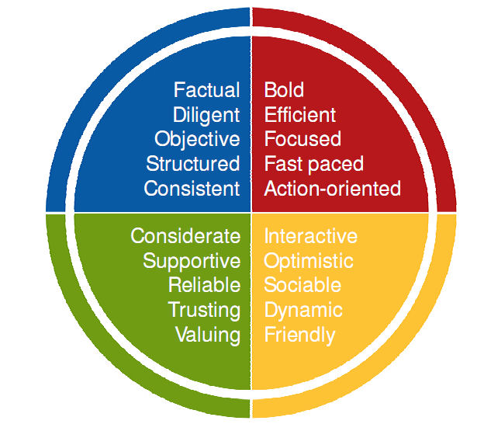

Appendix 3 – Personal SWOT Analysis

Strengths:  - I set high personal standards of performance.  - I make time for people and their problems.  - I am quiet and conscientious.  - I am open-minded, trusting and tolerant of others.  - I am logical and work well with tasks and people.  - I like to work for the common good.  - I am friendly and caring to others.  - I learn from experience. | Weaknesses:  - I dislike sudden change.  - I am over-tolerant of others' inability to perform.  - I can ignore evidence which does not support my original perception.  - I may not forcefully express my ideas or feelings and I don’t always want to understand abstract theories as I have an over-dependence on rules and procedures.  - I settle snugly into my comfort zone with ease, and I may worry unduly and am prone to pessimism.  - I can sometimes lack drive or initiative when pressured.
Opportunities  - By continuing to set high personal standards but being tolerant of my own and others’ failures and staying people minded I can continue to learn from my failures and support my colleagues.  - I will aim to put these strengths to good use by utilising them in the clinical field through front line leadership.  - I can minimise my weaknesses through being aware of them and actively ensuring I don’t make the same mistakes twice, in particular I must aim to be more open to new practice, theories and points of view.  - I aim to continue to improve my leadership abilities while also branching into education through running CPD activities to clinically mentor the workforce. | Threats  - There is the risk that if I fail to address my weaknesses, I may become stubborn in my practice and arrogant that my way is always the best way.  - There is the risk that I may become too comfy in my position, so it is important to always push to improve.

Appendix 4 – Personal Development Plan

Identified area for development | How it will be achieved/activity | Support or resources required | Timeline (Short, Medium and Long term) | How and when will benefits be identified
Conflict Management  To not avoid conflicts, to ensure any issues are vocalised and fully outlined then work to cool down the conflict and acknowledge emotions and different opinions. | To reflect on conflict that I view in the workplace and when I experience it personally.  To attend a conflict management workshop. | Reflection Frameworks such as Gibbs (1988).  Face to face or online courses. | Short.  Medium. | Constant feedback and self-assessment.  Personal reflection, 01/02/2024.
Assertiveness  To improve my confidence and abilities to assert myself when required. | To utilise the PACE assertiveness tool to improve my assertiveness.  To review PODCASTs and literature focusing on assertiveness in healthcare. | The PACE assertiveness tool.  Smart phone/apps | Short Term.  Short Term. | Constant feedback and self-assessment.  Personal reflection, 01/02/2024.
Communication Skills  Improve my active listening skills and two-way communication through constant feedback. | To review literature on communication in healthcare and communicating as a leader.  To attend a workshop or course based on improving my communication skills. | Journals, Books and online articles/courses.  Membership to Journal of Paramedic Practice  Face to face or online courses. | Short Term.  Medium Term. | Constant feedback and self-assessment, 01/11/2023.  Personal reflection, 01/02/2024.
Delegation  To be able to delegate tasks and trust in the team to complete those tasks with minimal interference. | Through attending Advanced Life Support courses and running skill stations where I direct a team. | Access to an ALS course (already granted). | Short Term. | 01/10/2023 by attending in an ALS course.
Emotional Intelligence  To increase my awareness of my self-awareness, self-regulation, empathy and social skills. | To utilise Goleman’s emotional intelligence appraisal tool.  To reflect on the effect my behaviour has on others. | Hard copy of Goleman’s emotional intelligence appraisal tool.  Reflection Frameworks such as Gibbs (1988). | Short Term.  Short Term. | Constant feedback and self-assessment, 01/11/2023.  Constant feedback and self-assessment, 01/11/2023.
Non-Technical Skills  To improve my non-technical leadership skills including my situational awareness, my decision making, my team working/leadership abilities and the use of task management. | To review PODCASTs and literature focusing on non-technical skills (specifically the Resus Room PODCAST.  Through attending Advanced Life Support courses and running skill stations where I focus on improving these specific non-technical skills. | Smart phone/apps.  Access to an ALS course (already granted). | Short Term.  Short Term. | Personal reflection, 01/11/2023.  01/10/2023 by attending in an ALS course.
Vulnerability  To ensure I remain resilient to manipulation by others I aim to be more objective, less emotional and not rush to make quick decisions. | Through ensuring I am aware of my own and others’ emotions by utilising Goleman’s emotional intelligence appraisal tool.  To attend a workshop or course based on improving my personal resilience to manipulation. | Hard copy of Goleman’s emotional intelligence appraisal tool.  Face to face or online courses.  Support from line managers/WAST. | Short Term.  Medium Term. | Constant feedback and self-assessment, 01/11/2023.  Personal reflection, 01/02/2024.
Leadership and Change | To continue with my own leadership journey and specifically complete the Leadership and Change Module as part of the Leadership in Healthcare Post Graduate Diploma | Continued study time from WAST and University Resources. | Long Term. | 01/08/2024 and a pass of the module.

