Security analysis and solution recommendations for Skywalker organisation

Owen Evans
University of Wales Trinity Saint David
Kings Road,
Swansea,
Wales

Networking and Cybersecurity Essentials

Table of contents

Abstract……………………………………………………………………….2

Introduction………………………………………………………………...2

Task 1 – Overview………………………………………………………..2

Task 2 – Vulnerabilities…………………………………………………3

Task 3 – Encryption file formats……………………………………4

Task 4 – Topology…………………………………………………………5

Task 5 – Mitigation recommendation……………………………8

Conclusion…………………………………………………………………….9

Reference list…………………………………………………………………9

Abbreviations…………………………………………………………………12

Appendices…………………………………………………………………….13

Abstract

This report discusses the results of the research conducted after assisting with the penetration testing completed by a third-party consultant on behalf of the Skywalker organisation. It was found that the Skywalker organisation has multiple vulnerabilities that could cause harm to their network. This report will discuss an overview of cyber threats, vulnerabilities, and attacks, while also using past research from other sources to provide information on the five vulnerabilities found. A topology was created to provide a visual insight on how one of the vulnerabilities found, default login credentials, could look like within the organisation. Skywalker also run the risk of encrypted file formats, containing malware and viruses, known as rnsmrw and Evillock. The final element of the report will provide security device recommendations that Skywalker should take into consideration to improve the security of the organisations network.

Introduction

The Skywalker organisation was found to be at risk due to different vulnerabilities and encrypted file formats. Provided in this report will be a simple overview of cyber attacks before delving into the research conducted on the different vulnerabilities found within the organisation. A physical and logical topology example is provided to show how a vulnerability could look within the network. The report will provide recommendations so that the Skywalker organisation can secure their network from potential cyber threats.

Task 1 – Overview

A threat can be defined as any circumstance or event that could potentially have a negative impact on an organisation, company or individual. With regards to cyber threats this would specifically include an information system that is being used to exploit a possible vulnerability in the system through unauthorised access [1].
Cyber threats change constantly and there are multiple different types of threats. A few of the most common types of threats are malware, ransomware, Distributed Denial of Service (DDoS) attacks, and spam and phishing. Malware is known as malicious code or software, and it aims to infect a program with the intention to cause damage and destruction. Malware can infect a system through email files and links and possibly removable media, among other things. Ransomware is a form of malware that prevents a user from accessing their system. This malware type encrypts your files and requires you to make an online payment to gain a key to access your files. The problem is that there is no guarantee that if you pay for the key, that you will actually receive it. DDoS attacks overwhelm an online service through excessive traffic and use botnets to plant malware on infected computers. Spam and phishing are unwanted and fake emails that aim to gain sensitive information from a user by appearing as a trusted source [2].
Threats can have a significant impact on a network. Different threats are designed to disrupt an organisation in some manner. This could be by gaining information or by attacking the network to cause damage and disruption. A Microsoft security intelligence report showed that around 45% of malware attacks require user interaction in some way and so proper security training is important for all Skywalker members [3].
A definition of vulnerability in a network is a weakness that can be exploited by a cybercriminal to successfully launch an attack with the aim to achieve a certain end goal. A vulnerability can be exploited in several ways. A flaw in a system that is an unintended functionality created during the implementation of the system itself. A feature in a system is an intended functionality that is useful for a user and their experience, however, can be exploited and misused by an attacker. User error is a common vulnerability and even if a system is well built to minimise risks of cyber threats, simple mistakes by a user can undo a systems security implementations. An example of user error could simply be clicking on a fake email or having weak, easy to guess passwords [4].
A cyber-attack is when a cybercriminal exploits a vulnerability to disable an organisations system or steal information, data, and finances. A cybercriminal will use different methods to attack, as mentioned above, these can include malware, ransomware, DDoS, and phishing, among multiple other methods. Some examples of recent cyber-attacks involve the Russia/Ukraine conflict where Ukraine’s government and military, in the first few days had a 196% increase in cyber-attacks [5]. Another serious incident was the WannaCry ransomware attack that breached personal data, affecting organisations worldwide, including the NHS [6].

Task 2 – Vulnerabilities

Default login credentials are the password and usernames given to a user when an account is initially created and are mainly intended for testing purposes. Attackers can obtain default credentials relatively easily through basic brute force attacks and occasionally, they can be found in databases online [7]. Brute force attacks are when an attacker systematically goes through each combination of possible passwords to try and gain access to a system [8]. Identifying services and software that uses default credentials is a possible first step. This can be found through network scans that Skywalker should conduct regularly. A possible solution could be when the system forces you to change your password as soon as a new account is created. Another possible solution is enforcing the use of multi-factor authentication. This will mean that even if an attacker manages to guess a password, they will still need a second form of authentication to access your account, and this usually comes in the form of a code or personal recognition technique like a fingerprint scan [7].
Telnet is an outdated protocol used for sending information across a network. The issue with it is that other machines on the network can view the traffic between the machines communicating. If logins are in cleartext over unencrypted connections, then this makes it possible for others on the network to eavesdrop into the communication. By doing this, the person eavesdropping can steal information like passwords and other sensitive information. The information stolen could then be used for cyber-attacks in the future as the attacker will be able to impersonate you as they have your details. They could also destroy possibly important data from your machine and connected networks or systems and plant backdoors so that they can gain access in the future [9]. A solution for this vulnerability is to move on from Telnet to a protocol like SSH [10]. SSH or Secure Shell protocol provides secure remote login and strong authentication and encryption when communicating between devices [11].
Secure Socket Layer (SSL) and Transport Security Layer (TLS) are security protocols that encrypt traffic between endpoints, such as a web service and browser. The aim of the protocol is to make sure all data exchanges remain secure and confidential as SSL/TLS is used for internet traffic [12]. Information disclosure is simply when a website leak users’ sensitive information unintentionally [13]. Information disclosure is a vulnerability that exists in SSL/TLS and if exploited an attacker would be able to decrypt SSL/TLS traffic. To do this an attacker inserts unencrypted data into a secure channel and performs a man-in-the-middle (MitM) attack [14]. A MitM attack is when an attacker intercepts the unaware victim’s communication with another entity [15]. Hypertext Transfer Protocol Secure (HTTPS) uses SSL/TLS protocol [16] and so, an attacker can intervene in any redirections during HTTPS requests and create an unsecure connection that the victim is still unaware of, this is known as SSL stripping. A possible prevention method is using authentication for added security [17] and making sure that the newest TLS version is enabled, which currently is TLS 1.3 [18].
SSL v1 was never publicly released due to security concerns, SSL v2 was publicly released, but quickly replaced a year later, in 1996 with SSL v3 [19][20]. SSL is outdated and now it is recommended to upgrade to the newest TLS version [21]. A vulnerability known as ‘POODLE’ was discovered that allows attackers to steal confidential information when exploited [22]. ‘POODLE’ stands for Padding Oracle On Downgraded Legacy Encryption and is requires an attacker to successfully employ three stages. The initial stage is when the attacker commits a MitM attack to intercept communications. The attacker then forces the victim into switching a server into an older connection like SSL v3 by constantly dropping connections. The final step is using the POODLE attack to steal encrypted information and view it as plaintext [23]. It is recommended that SSL is disabled and configuring the system to the newest protocol like TLS 1.3 [24].
Rivest, Shamir, Adleman (RSA) created the RSA Algorithm which is a key encryption method used for secure transmissions of data on the internet. The algorithm factorises a large number which makes it more difficult for an attacker to break into a message. RSA has two keys, a public key that is provided to all users and includes two numbers, one of which results from two large prime numbers. A private key derives from the two prime numbers in the public key but remain private [25]. The private key generates a digital signature and can decrypt messages encrypted through the public key, which also verifies the digital signatures [26][27]. RSA implementation of less than 2048 bits is unsafe and can cause memory corruption during the computation stage. This allows an attacker to attack using a remote code execution (RCE) [28]. RCE allows attackers to execute malicious code. Vulnerabilities involved with RCE could be executing malware or taking control of a compromised machine. Possible mitigation and detection methods for RCE would be to inspect traffic, set up zero-trust security access control strategies [29] and to replace certificates that hold unsafe RSA keys with a longer key, so they can be reissued [30].

Task 3 – Encryption file formats

Rnsmrw is a file format that has been renamed and encrypted by ransomware known as Gremit Locker [31]. This form of ransomware usually comes through attachments in a phishing email that install ransomware on the victim’s device. The ransomware disguises as ‘Microsoft Hostmanager.exe’ and uses AES encryption. Spotting the infected files is simple and the ransom is usually lower, however, this is because the attackers may send fake decryption keys, so that they can demand more money [32]. Like any ransomware attack, it can impact reputation and lead to further attacks [33]. The encrypted files are not recoverable, but the best way to recover from an attack is to create backups of non-infected files and to install up to date malware prevention software to delete the ransomware from the system [32].
The Evillock virus can infect a system through a victim clicking fake ads or misleading links on compromised websites. However, a Trojan horse is the usual entry method [34]. Trojan malware is malicious code that infiltrates a system after being presented as legitimate and harmless [35]. The malware is difficult to identify as it uses a complex algorithm and remains hidden while encrypting files. This makes files inaccessible, and it can also modify, copy, or steal information, as well as install more malware, further disrupting performance. A decryption key is needed to decrypt the files, making backups vital, but only restore backups after removing malware from the system. Checking your devices performance, programs, and processes regularly can help detect the malware. If you manage to detect it, then you can remove it by viewing applications, software or properties of a process and ending the tasks and deleting them, however, antivirus software is the easier method [34][35].

Task 4 – Topology

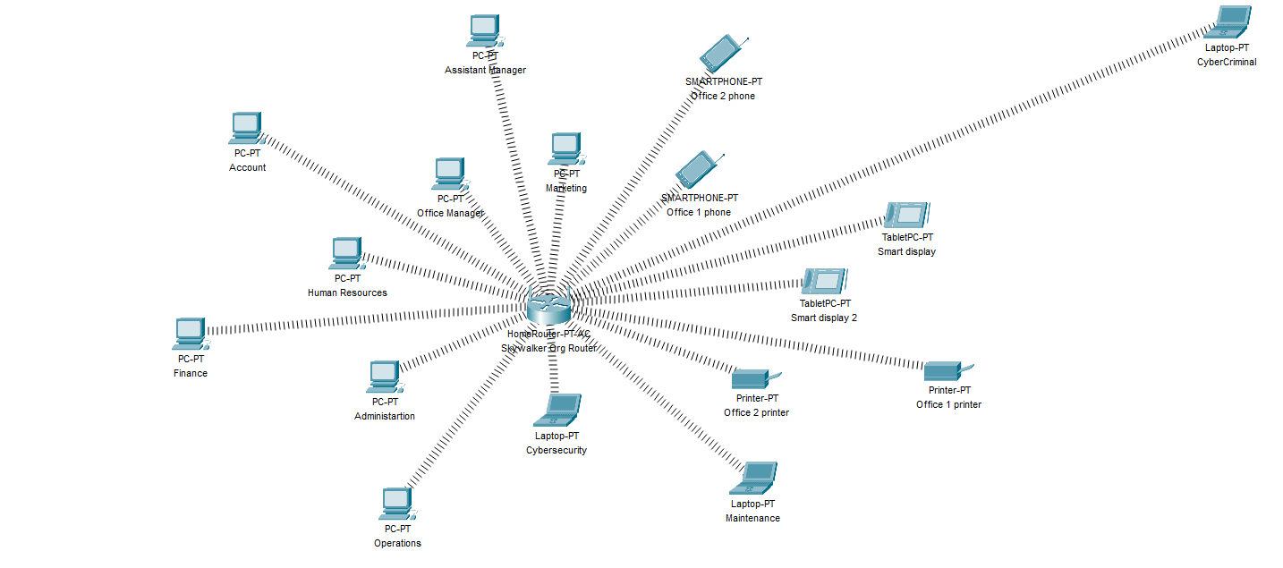
Skywalker organisation topology showing each physical device and their connection to the main router.
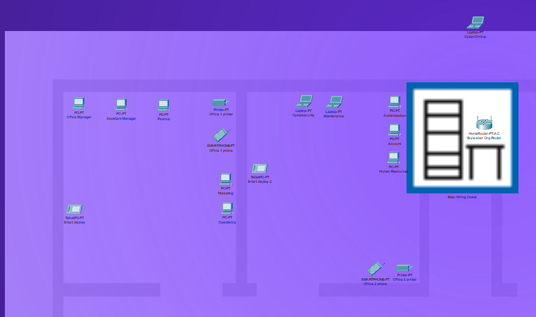
Skywalker potential physical layout.
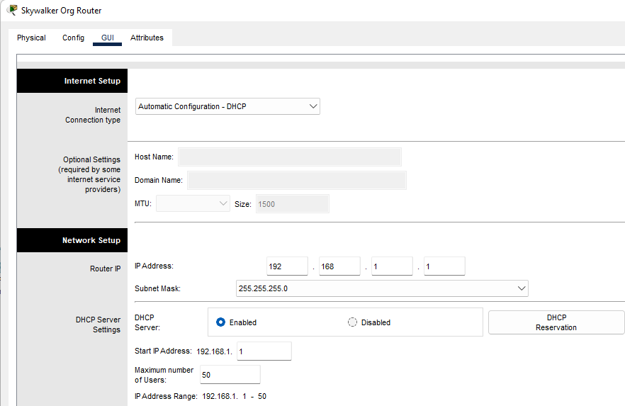
The routers IP address, range, and subnet mask that will be used for all connecting devices.

The routers credentials have remained as the default after setup. These passwords will usually be something simple like password or admin. Both are weak and easy for cybercriminals to attack.
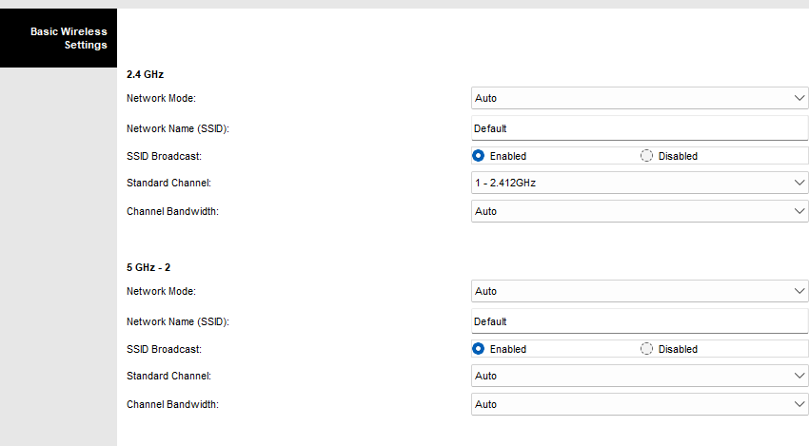
The routers settings all remain as default making the security of the network vulnerable.
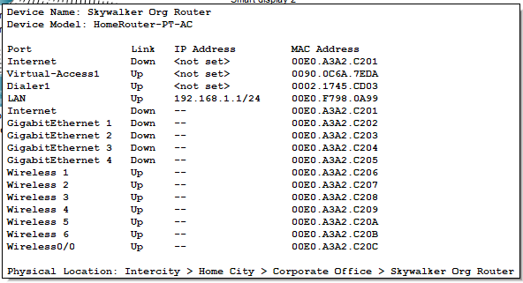
The routers IP is in the 192.168.1.1/24 range, all devices on the network connect through the same gateway and subnet.
Details of the devices connecting to the network (appendix A for all devices). All the examples show that the devices use the same gateway (192.168.1.1).
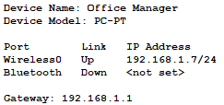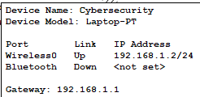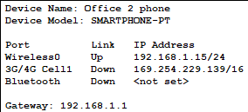
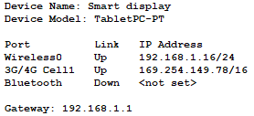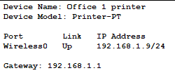
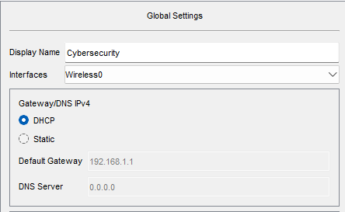
DHCP assigns an IP address that is within range to all devices on the network automatically, this helps combat simple human errors.
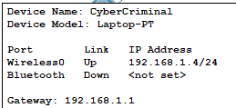
A cybercriminal is on the same network and so can access the router using the default credentials. These could be obtained through brute force attacks. A cybercriminal would have access to all of Skywalker’s network traffic, which can allow them to commit further attacks.
To secure their network Skywalker can make sure that default credentials like the Service Set Identifier (SSID) and the passwords are all changed immediately [36].

Task 5 – Mitigation recommendation

There are many different network security devices, all with the aim of securing and protecting a network. Potential security devices that could be beneficial to Skywalker include appliances that can manage, detect, remove, and prevent possible threats. Some recommendations for Skywalkers network could be:
Firewalls that can be set up to block connections from outside the internal network. They can also be configured to block specific IPs and ports.
An Intrusion Protection System (IPS) can monitor network traffic, detecting malware, DDoS, and other intrusion types. IPS can link with the firewalls to request devices be quarantined if they are infected.
A Unified Threat Management (UTM) is a potentially cost-effective method as it combines firewalls, intrusion detection and prevention systems, among other features. However, due to this being one system, there is a single point of failure which means if it fails the entire network could be taken down.
Using a Virtual Private Network (VPN) means that Skywalkers traffic goes from the VPN into the internal network, instead of accessing external sources like the internet.
Device backup and recovery which is possible through network management tools and means if the network does encounter any issues, then the organisations files can be recovered [37].
Access control systems. The three main types being discretionary access controls (DAC) that assigns access based on specified rules. Role-based access controls (RBAC) that assign access based on organisational roles and mandatory access controls (MAC) that is the most secure, but also the most time consuming and high management option as it requires an administrator to create settings based on hierarchical classifications [38].
Simple antivirus software that can detect, quarantine, and delete malicious code from the network. Many devices have these built in, but they can also be purchased for relatively cheap [39].
A final recommendation for Skywalker to consider would be least privilege. This means that only the minimum rights necessary are granted and only for the time needed. After this necessary time, the privileges are removed [40].

Conclusion

From this report, Skywalker should conduct further research and review of their organisations network. First steps should be to check the SSID and passwords and change them from default. Incorporating multi-factor authentication for an extra layer of protection and access controls to prevent employees gaining unnecessary access will help prevent possible internal breaches. The organisation had multiple outdated properties that can be easily resolved. Moving from Telnet to SSH, disabling SSL and moving to TLS 1.3 and replacing certificates that hold unsafe RSA keys so that a certificate that holds RSA keys with 2048 bits can be reissued are all updates that are required so that the organisation can remove the major vulnerabilities found during penetration testing. Final recommendations for Skywalker would be to obtain and configure antivirus software, VPN, and firewalls throughout the organisation as these will all aid in keeping the organisation more secure. More research into all the mentioned vulnerabilities, file formats and other common cyber threats could be beneficial to improve on the findings of this report.

Reference list

[1] National Institute of Standards and Technology, "Threat - Glossary", Csrc.nist.gov. [Online]. Available: https://csrc.nist.gov/glossary/term/threat. [Accessed: 09 July 2022].
[2] Commonwealth of Massachusetts, "Know the types of cyber threats", Mass.gov. [Online]. Available: https://www.mass.gov/service-details/know-the-types-of-cyber-threats. [Accessed: 09 July 2022].
[3] Proofpoint, "Network Threats - Types of Network Security Threats", Proofpoint.com. [Online]. Available: https://www.proofpoint.com/uk/threat-reference/network-delivered-threats#. [Accessed: 09 July 2022].
[4] National Cyber Security Centre, "Understanding vulnerabilities", ncsc.gov.uk, 2015. [Online]. Available: https://www.ncsc.gov.uk/information/understanding-vulnerabilities. [Accessed: 12 July 2022].
[5] Checkpoint, "What is a Cyber Attack?", Check Point Software. [Online]. Available: https://www.checkpoint.com/cyber-hub/cyber-security/what-is-cyber-attack/#. [Accessed: 16 July 2022].
[6] National Crime Agency, "Cyber crime", Nationalcrimeagency.gov.uk. [Online]. Available: https://www.nationalcrimeagency.gov.uk/what-we-do/crime-threats/cyber-crime. [Accessed: 16 July 2022].
[7] Cybersecurity and Infrastructure Security Agency, "Risks of Default Passwords on the Internet | CISA", Cisa.gov, 2016. [Online]. Available: https://www.cisa.gov/uscert/ncas/alerts/TA13-175A. [Accessed: 20 July 2022].
[8] Esheridan and Owasp Foundation, "Blocking Brute Force Attacks", Owasp.org. [Online]. Available: https://owasp.org/www-community/controls/Blocking_Brute_Force_Attacks#. [Accessed: 20 July 2022].
[9] Carnegie Mellon University School of Computer Science, "Telnet Encryption", Cs.cmu.edu. [Online]. Available: https://www.cs.cmu.edu/~droh/755/encr_telnet.html. [Accessed: 25 July 2022].
[10] Mageni, "Telnet Unencrypted Cleartext Login", mageni.net, 2019. [Online]. Available: https://www.mageni.net/vulnerability/telnet-unencrypted-cleartext-login-108522. [Accessed: 25 July 2022].
[11] SSH Academy, "SSH Protocol – Secure Remote Login and File Transfer", Ssh.com. [Online]. Available: https://www.ssh.com/academy/ssh/protocol. [Accessed: 25 July 2022].
T. Ylonen, "Secure Login Connections over the Internet", Sixth USENIX Security Symposium Proceedings, pp. 37-42, 1996. Available: https://archive.org/details/1996-proceedings-6th-security-san-jose/mode/2up. [Accessed 25 July 2022].
[12] B. Hendricks, "What is SSL/TLS Termination?", Snapt.net, 2020. [Online]. Available: https://www.snapt.net/glossary/ssl-tls-termination. [Accessed: 25 July 2022].
[13] PortSwigger, "Information disclosure vulnerabilities", Portswigger.net. [Online]. Available: https://portswigger.net/web-security/information-disclosure#. [Accessed: 25 July 2022].
[14] Microsoft, "Description of the TLS/SSL protocol information disclosure vulnerability", Support.microsoft.com, 2016. [Online]. Available: https://support.microsoft.com/en-us/topic/ms16-065-description-of-the-tls-ssl-protocol-information-disclosure-vulnerability-cve-2016-0149-may-10-2016-7af955c4-ac73-6c50-dfbb-8267e6284df5#. [Accessed: 25 July 2022].
[15] K. Chivers, "What is a man-in-the-middle attack?", Us.norton.com, 2020. [Online]. Available: https://us.norton.com/internetsecurity-wifi-what-is-a-man-in-the-middle-attack.html#. [Accessed: 25 July 2022].
[16] CIO, "The HTTPS-Only Standard - Technical Guidelines", Https.cio.gov. [Online]. Available: https://https.cio.gov/technical-guidelines/#. [Accessed: 25 July 2022].
[17] Beagle Security, "Man-in-the-Middle (MITM) Attack: Types, Techniques and Prevention", beaglesecurity.com, 2020. [Online]. Available: https://beaglesecurity.com/blog/article/man-in-the-middle-attack.html. [Accessed: 25 July 2022].
[18] B. Posey, "Network security gets a boost in Windows Server 2022", TechTarget, 2022. [Online]. Available: https://www.techtarget.com/searchwindowsserver/tip/Network-security-gets-a-boost-in-Windows-Server-2022#. [Accessed: 25 July 2022].
[19] Kinsta, "TLS vs SSL: What's the Difference? Which One Should You Use?", Kinsta.com, 2022. [Online]. Available: https://kinsta.com/knowledgebase/tls-vs-ssl/. [Accessed: 26 July 2022].
[20] Citrix, "How Do I Block SSLv2 on NetScaler?", Support.citrix.com, 2020. [Online]. Available: https://support.citrix.com/article/CTX205288/how-do-i-block-sslv2-on-netscaler. [Accessed: 26 July 2022].
[21] Mageni, "SSL/TLS: Deprecated SSLv2 and SSLv3 Protocol Detection", mageni.net, 2017. [Online]. Available: https://www.mageni.net/vulnerability/ssltls-deprecated-sslv2-and-sslv3-protocol-detection-111012. [Accessed: 26 July 2022].
[22] R. Barnes, "The POODLE Attack and the End of SSL 3.0 – Mozilla Security Blog", Mozilla Security Blog, 2014. [Online]. Available: https://blog.mozilla.org/security/2014/10/14/the-poodle-attack-and-the-end-of-ssl-3-0/. [Accessed: 26 July 2022].
[23] TechTarget Contributor, "what is a POODlE attack?", WhatIs.com, 2021. [Online]. Available: https://www.techtarget.com/whatis/definition/POODLE-attack. [Accessed: 26 July 2022].
[24] Cybersecurity and Infrastructure Security Agency, "SSL 3.0 Protocol Vulnerability and POODLE Attack", Cisa.gov, 2016. [Online]. Available: https://www.cisa.gov/uscert/ncas/alerts/TA14-290A. [Accessed: 26 July 2022].
[25] Y. Singh, "RSA Full Form", geeksforgeeks.org, 2021. [Online]. Available: https://www.geeksforgeeks.org/rsa-full-form/. [Accessed: 26 July 2022].
[26] IBM, "RSA private and public keys", Ibm.com, 2022. [Online]. Available: https://www.ibm.com/docs/en/zos/2.1.0?topic=keys-rsa-private-public. [Accessed: 26 July 2022].
[27] CA/Browser Forum, "Baseline Requirements for the Issuance and Management of Publicly-Trusted Certificates, v.1.0", Cabforum.org, 2012. [Online]. Available: https://www.cabforum.org/wp-content/uploads/Baseline_Requirements_V1.pdf. [Accessed: 26 July 2022].
[28] OpenSSL, "Heap memory corruption with RSA private key operation", openssl.org, 2022. [Online]. Available: https://www.openssl.org/news/secadv/20220705.txt. [Accessed: 26 July 2022].
CVE, "CVE-2022-2274 Detail", Cve.org, 2022. [Online]. Available: https://www.cve.org/CVERecord?id=CVE-2022-2274. [Accessed: 26 July 2022].
[29] Checkpoint, "What is Remote Code Execution (RCE)?", Check Point Software. [Online]. Available: https://www.checkpoint.com/cyber-hub/cyber-security/what-is-remote-code-execution-rce/#. [Accessed: 26 July 2022].
[30] Tenable, "SSL/TLS Certificate RSA Keys Less Than 2048 bits", tenable.com, 2021. [Online]. Available: https://www.tenable.com/plugins/was/112540. [Accessed: 26 July 2022].
[31] File-Extensions, "How to open and convert files with RNSMWR file extension", File-extensions.org. [Online]. Available: https://www.file-extensions.org/rnsmwr-file-extension#description. [Accessed: 26 July 2022].
[32] GoldSparrow, "Gremit Ransomware", enigmasoftware.com. [Online]. Available: https://www.enigmasoftware.com/gremitransomware-removal/. [Accessed: 26 July 2022].
[33] N. Jones, "5 Ways Ransomware Can Negatively Impact Your Business", egnyte.com, 2022. [Online]. Available: https://www.egnyte.com/blog/post/5-ways-ransomware-can-negatively-impact-your-business#. [Accessed: 26 July 2022].
[34] E. Stewart, "Evillock Virus File Ransomware Removal (+File Recovery)", owser.org, 2017. [Online]. Available: https://dowser.org/evillock-virus-file-ransomware-remove/?noamp=mobile. [Accessed: 26 July 2022].
[35] A. Vigderman and G. Turner, "What Is a Trojan Horse Virus & How Do You Get Rid of It?", security.org, 2022. [Online]. Available: https://www.security.org/antivirus/trojan/. [Accessed: 26 July 2022].
[36] National Cybersecurity Alliance, "Securing Your Home Network", https://staysafeonline.org/, 2022. [Online]. Available: https://staysafeonline.org/online-safety-privacy-basics/securing-your-home-network/. [Accessed: 27 July 2022].
[37] Restorepoint, "What Are Network Security Devices?", restorepoint.com. [Online]. Available: https://www.restorepoint.com/topics/what-are-network-security-devices. [Accessed: 27 July 2022].
[38] R. Townsend, "Access Control Models", Westoahu.hawaii.edu, 2018. [Online]. Available: https://westoahu.hawaii.edu/cyber/best-practices/best-practices-weekly-summaries/access-control/. [Accessed: 27 July 2022].
[39] National Cyber Security Centre, "What is an antivirus product? Do I need one?", https://www.ncsc.gov.uk/, 2019. [Online]. Available: https://www.ncsc.gov.uk/guidance/what-is-an-antivirus-product. [Accessed: 27 July 2022].
[40] M. Gegick and S. Barnum, "Least Privilege | CISA", Cisa.gov, 2013. [Online]. Available: https://www.cisa.gov/uscert/bsi/articles/knowledge/principles/least-privilege. [Accessed: 27 July 2022].

Abbreviations

AES – Advanced Encryption Standard
DAC – Discretionary Access Controls
DDoS – Distributed Denial of Service
DHCP – Dynamic Host Configuration Protocol
HTTPS – Hypertext Transfer Protocol
IP – Internet Protocol
IPS – Intrusion Protection System
MAC – Mandatory Access Controls
MitM – Man in the Middle
POODLE – Padding Oracle On Downgraded Legacy Encryption
RBAC – Role-Based Access Controls
RCE – Remote Code Execution
RSA – Rivest, Shamir, Adleman
SSH – Secure Shell Protocol
SSID – Service Set Identifier
SSL – Secure Socket Layer
TLS – Transport Layer Security
UTM – Unified Threat Management
VPN – Virtual Private Network

Appendices

Appendix A – Topology screenshots

PCs
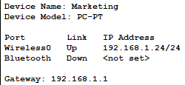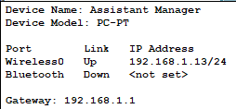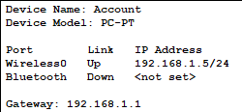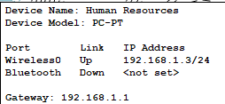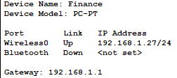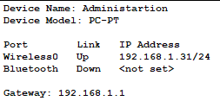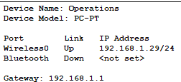
Laptops
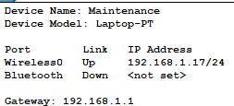
Additional devices
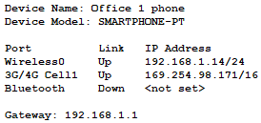
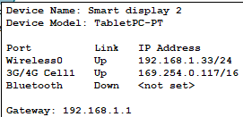
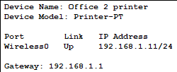

Appendix B – Certificates for Task 4

Cisco Introduction to Packet Tracer

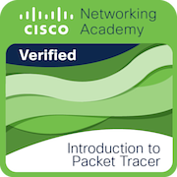
https://www.credly.com/badges/25556b5e-6846-46be-ad1f-2e0bec4f35f1/public_url

Cybersecurity Foundation

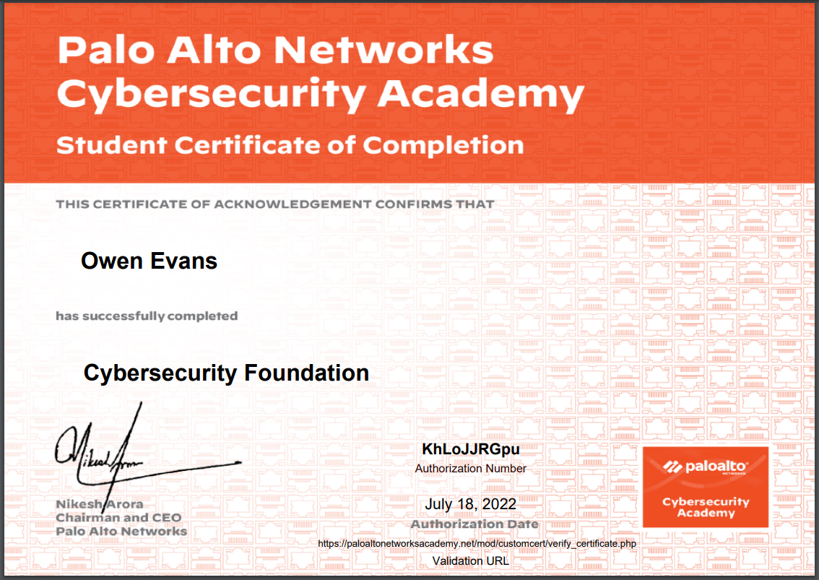
https://paloaltonetworksacademy.net/mod/customcert/view.php?id=286909&downloadown=1

Network Security Fundamentals

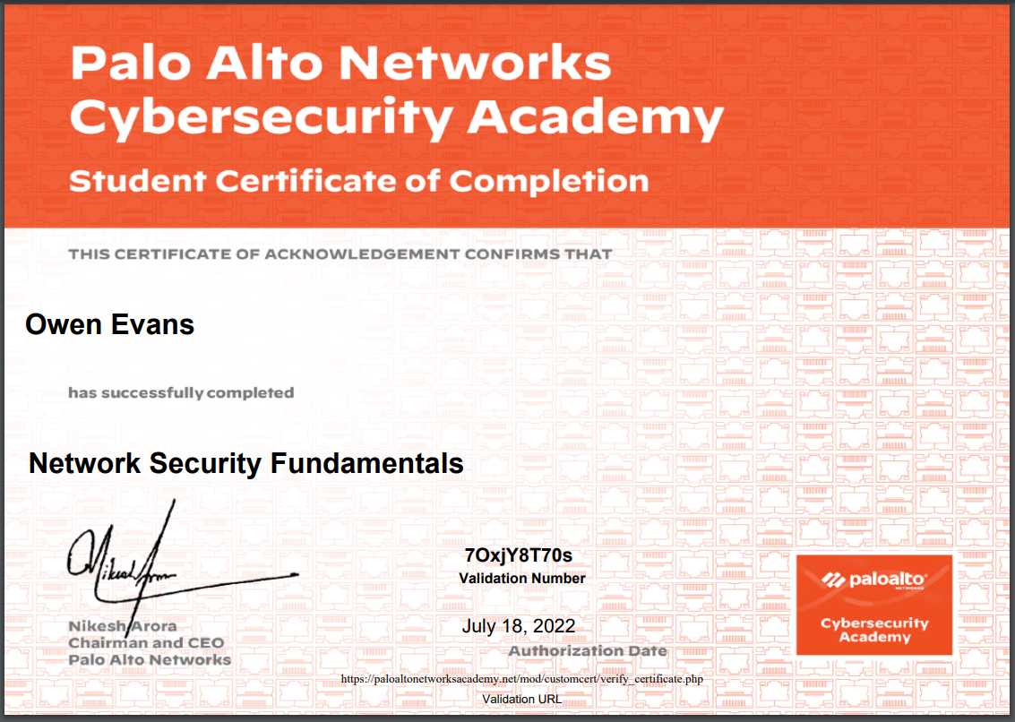
https://paloaltonetworksacademy.net/mod/customcert/view.php?id=287206&downloadown=1

Appendix C – topology plan



