Jane Howie
1810691
BMPF7003 Module 1
Word Count:

Part 1
Critically evaluate a range of theories and models that you have recently studied, explaining their relevance to your workplace practice and procedures and develop a strategy applying what you have learned to improve your practice.

2700 words

Breathiness in Female Adolescent Singers: What are the physical and psychological impacts?

Park, Perkell, Matthies and Stepp (2019) state, “Breathiness is a vocal percept that is mainly the result of hearing the sound generated by the audible escape of air past a speakers glottis due to incomplete closure”, Why is this a regular occurrence for female singers and how can we support this in our practice? (Park et al., 2019, p3656)

My objectives were to study the changes of the female adolescent voice, the impacts this can have on the individual and how we can help as practitioners and tutors, by analysing recent scientific studies and literature. I decided this would be a good area to research, as majority of my students are young females who are at this crucial point in their life. I wanted to gain accurate knowledge in an area where there is not as much focus on the challenges females experience with their voice before, during and after they reach puberty. As a new vocal tutor, I want to be able to draw on this knowledge and develop a strategy to help current and future students.

Beginning my research, it was noticeable that this topic was gender biased as there was a significant focus on the developmental and physiological challenges of the adolescent male voice. Nevertheless, more awareness has been brought to the vocal change’s female adolescents experience (Gackle, 2006, 2019; Decoster, Ghesquiere and van Steenberge, 2008). Lynne Gackle found that girls in fact do go through physical changes with their voice from as young as ten, she developed The Five Phases of Development later adding the psychological impacts females experience(Sweet, 2015). This can be used to distinguish the individual physical capabilities (pitch, range, resonance, register transitions) and can identify any concerns for the teacher or individual (Decoster, Ghesquiere and van Steenberge, 2008). Without clear guidance and support from their teacher females can develop unhealthy habits or technique. These changes can be physical, mental and emotional for young girls and are brought on before, during and after puberty(Decoster et al. 2008). This essay will look at menstruation, puberty, mutational chink and the physiological changes young females experience and how we can support the challenges they may face.

The onset of puberty for females can occur between the ages of ten and thirteen(Abitbol, Abitbol and Abitbol, 1999), research has found that girls are starting puberty three to four months earlier every decade(Biro et al., 2013). During this time, they develop body hair and odour, growth spurts, menstruation and breast development for girls. In addition, both sexes experience changes in their speaking and singing voice. Boys vocal change being more extreme and noticeable to the ear. However, in the report, Vocal Pedagogy and the Adolescent Female Voice, Katharin Rundus highlights that the female adolescent voice endures the same profound changes as males although, the same reaction is not given due to the change not being as extreme (Anglin et al., 2017). Stressing the importance of supporting girls through this change. Huff-Gackle, argues that these changes are simply developmental (Huff-Gackle, 1985). Even so, the development is of the structure of their instrument and having an awareness and understanding of the progression of the muscles and organs involved is vital.
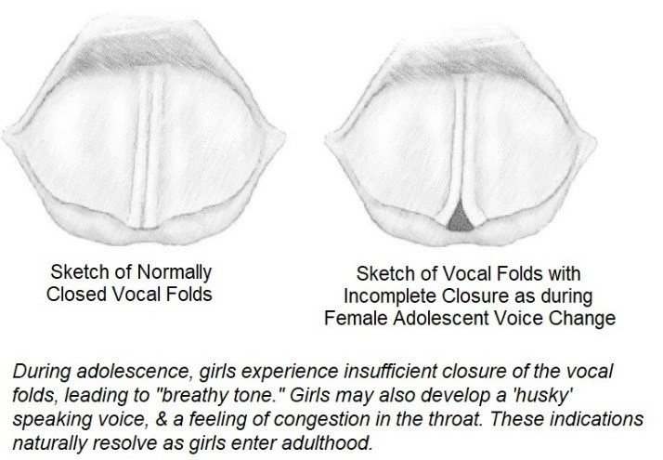
Girls are noted to experience weaknesses in range, cracks, breaks, inability to pitch and erratic changes in their voice (Gackle, 2006). The hormones, oestrogen, progesterone and testosterone are the influential factor in the fluctuations females experience with their voices from youth to adult (Raj et al., 2010). The combination of oestrogen and progesterone cause the voice to drop one third lower than a child (Raj et al., 2010; Sweet, 2015). The larynx increases in height and width whilst the vocal folds increase in length between three and four millimetres (Phillips, Williams and Edwin, 2012; Sweet, 2015). As a result of the larynx and vocal folds maturing, the interarytenoids that sit on either side of the folds become weakened (Ballantyne and Brunssen, 2018). Inhibiting the folds to adduct, creating a triangular shaped gap known as ‘Mutational Chink’(Adrian and Warwick, 2016; Gackle, 2019). The allows extra air to pass through causing a breathiness in the vocal quality (Gackle, 2019). Moreover, physical changes such as: weight, height, development of skeleton, muscles, breasts and molars, are all contributing factors to vocal transformation (Decoster et al. 2008).
Figure 1: Adolescent Female Vocal Folds,2018

Gackle (2019) uses the visual comparison of ‘shades of colour’ to illustrate the vocal changes in females. She uses the various shades of blue to depict the elusive physiological changes, explaining both sexes start as ‘light blue’. However, at the onset of puberty a male voice completely changes colour whilst the female stays the same, but the shading alters (Gackle, 2019). Explaining her statement that female vocal change is developmental and unobservable to the ear (Huff-Gackle, 1985). She also notes that the adult voice does not fully transpire to early or mid-twenties therefore categorising the voice at such an early stage can be detrimental (Gackle, 2019). Females may require substituting between to different part in the choir depending on the stage of vocal change or cycle. Therefore, it is important to listen and observe the sound and work with the singer.

Gackle’s work with various female choirs aided her the study of adolescent’s female voice (1985, 2006, 2019). Most recently, she has updated her five phases of change in girls’ voices, progressing to a developmental framework to help support practitioners and teachers. Illustrating each phase and its vocal characteristics and range (Gackle, 2019)(See Apendix 1). Phase 1 being Prepubertal, currently the voice is the same as the male, clear in tone and flexible and agile through both registers. Phase 2A Premenstrual, girls demonstrate the same range, but breathiness is audible at some points. Some experience loss in their upper or lower range. Phase 2B post-Menarche, ‘huskiness’ is perceived, there is a decrease in range and loss of some pitches. At this phase girls may exhibit Soprano II or alto qualities (this does not mean that this is solely where their voice lies) it is easier to produce phonation. Phase 3 Young Adult, richness in timbre, there is an increase in range, flexibility and agility.

Timothy MacDougall in an interview in January 2017, discussed effective exercises to support the weaknesses and tension happening within the vocal folds. He recommends singing a ‘five note scale’ on a closed vowel sound, perhaps ‘I’, this helps the singer to find forward placement, once this is established they start moving through the vowels were ‘breathiness’ is clear (MacDougall cited in: Anglin et al., 2017). Karen Rundus also interviewed in February of the same year also promotes exercises on a closed vowel sound like ‘I’. She also encourages using Straw exercises as this releases tension adding that this can be used with any singers not just the developing voice. She stresses the importance of teaching ‘bel canto’ principles as this provides proper closure of the vocal folds and stops any improper techniques forming (Rundus cited in: Anglin et al., 2017)

In A Study of Voice Changes in Various Phases of Menstrual Cycle and in Postmenopausal Women, tests were carried out to understand the changes women experience during each phase of the twenty-eight days of a cycle:
Phase 1 Menstrual: days 1-5
Phase 2 Follicular: days 6-12
“” 3 Ovulatory: 13-15
“” 4 Luteal: 16-23
“” 5 Premenstrual 24-28

From their findings the ovulatory phase when oestrogens were at its highest, was when the individuals voice was at its best. However premenstrual was when the individual experienced poor vocal movement and terrible frequency range resulting from the decrease of oestrogen and increase pf progesterone; explaining why females may experience vocal fatigue at this point in their cycle (Raj et al., 2010). The increase and decrease of sex hormones during a girl’s cycle can influence the texture of the vocal folds and larynx. The fluctuation of hormones can cause swelling in the folds impacting the vibrations of the vocal cords resulting in loss or lack of vocal control (Brown n.d.).Laryngeal changes are known to simulate similar changes to the lining of the uterus during the cycle due to the influence of oestrogen (Çelik et al., 2013). Before menstruation the body retains more water and swelling, (Ballantyne and Brunssen, 2018). Minor to major swelling(oedema) of the vocal folds prior to and during menstruation modifies the cosmetics of the voice (Brown, no date). The rise in progesterone increases the weight of the vocal folds producing swelling which alters the flexibility(Çelik et al., 2013; Ballantyne and Brunssen, 2018). Singers can experience breathiness or hoarseness at this time. The premenstrual stage can be debilitating for the singer, as they experience somatic and emotional changes at this stage in the cycle(Brown n.d.). Females suffering from premenstrual syndrome (PMS) can also experience vocal fatigue, decrease in range, loss of power and harmonics(Abitbol, Abitbol and Abitbol, 1999; Raj et al., 2010; Çelik et al., 2013). Endoscopes have shown congestion, micro varices, swelling of the vocal folds and loss of vibration and resonance (Raj et al., 2010; Çelik et al., 2013).

Menstrual cramps can affect the support of the pelvic muscles(Ballantyne and Brunssen, 2018). Brown (no date) also discusses the detriments dysmenorrhea (menstrual cramps) to the abdominal support, the weakness of the abdominal muscles can result in ‘throat’ singing. The fragility of the vocal instrument at this time and the alteration of the mass of the vocal folds can lead to vocal haemorrhage’s due to straining of the voice. Bloating and water retention in the abdominal wall can make singing extremely difficult including cause discomfort for the singer (Brown, no date). Devadiga et al conclude that the respiratory functions are higher in the follicular phase compared to menstrual, the presence of oestrogen can influence the stability of airflow (Devadiga, Pahwa and Bhat, 2019). They observed a decrease in both non singers and singers during menstrual phase, the occurrence of menstrual cramps can obstruct maximum forceful expiration(Devadiga et al 2019).

Furthermore, females experience emotional fluctuations during their cycles, this can be prevalent during the luteal phase and pass during menstruation(Brown n.d.). During PMS females suffer from periods of anxiety, insomnia, brain fog and aggravation. Susan Yarnall devised a study of thirty-two youths from ages eleven to eighteen, she discovered the same as Gackle (1985) and Cooksey (1977) that there are five phases of physiological and psychological change during puberty. However, Yarnall was purely interested in the psychological impacts at each stage, she gathered this information through discussions with her students and listening to the physical changes happening to their voices (2006) (Appendix 2). She highlights the crucial stage being between the age of thirteen and fourteen as young girls become more aware of their identity and image this can lead to lack of confidence (2006). Similarly, Susan Monks discusses the link between self-identity and the voice, highlighting that this topic continues to change for teachers, so it is important that we try to understand, through choice of repertoire and vocal techniques (2003, p. 243).

It is important as practitioners and teachers we develop meaningful relationships with our clients and students, we need to be someone they trust and can rely on(Yarnall, 2006; Decoster, Ghesquiere and van Steenberge, 2008). Young girls can be experiencing mixed emotions and fluctuations of hormones at different stages of menarche, so having these important conversations about hormonal shifts in their voice can develop an awareness on how to care for their voice when singing on these occasions(Brown n.d.).

Bridget Sweet emphasised that many experience anxiety, embarrassment and disappoint, due to the unpredictable nature of their voice (2015). Additionally, their surroundings can impact their mentality, students admitted to suppressing their voice from being heard due to fear of singing inaccurately during choirs. However, when they were in a safe environment: home, with friends, they felt comfortable to sing freely with no worry of being judged (2015).
Sweet (2018) continued to study undergraduate and postgraduate female choir members. Her previous findings were consolidated she found the same issues arising amongst females lacking confidence and worrying about sticking out in group singing due to the changes they had been experience with their voices (Sweet, 2018). She concludes that females would benefit from individualised support during their training to allow them to understand the changes they are experiencing with their voice during adolescents, helping them sustain their instrument (Sweet, 2018).

To conclude, from my research I have discovered the risks to disregarding the vocal changes in female students. Young girls left to guide themselves through these changes develop poor vocal techniques caused by insufficient teaching(Haston and Ford, 2007). Consequently, it is important teachers learn techniques and structures to support students during maturation of their voice, to prevent any damage or strain to the vocal cords that impede their potential(Haston and Ford, 2007). The aim for this study was to interpret recent and historical literatures and studies on the impacts on the female voice at the onset of puberty and the causes of ‘breathiness’. The outcome would be to find and later develop a strategy to support individuals during puberty, to help them navigate the physiological and psychological changes they may experience. Having completed my research, I believe there is still much more exploration to be carried out on the effects of puberty on the female voice as although studies are not completely biased towards the male voice there is still gaps in specific areas. There was little information on the impacts on dysmenorrhea on the pelvic floor muscles and if this impacts on the function of the diaphragm. I found some information that this weakens the support but not enough suffice. On the other hand, this was a small part in my research and did not impact my study.

Part 2
- Reflect on your recent learning experience, and the value of learning you have acquired. Assess your current competences and identify future development needs in the context of your workplace/ voice studio/ classroom.
- Devise a detailed personal development plan which incorporates identified areas for development, objectives, activities to be undertaken, methods, resources review period and timescales.
1800 words

In the beginning, I realised very fast that my topic was very limited in research, many articles and studies were male dominant and briefly touched on the challenges that females experience during reproductive years. However, the more I researched I found there were many routes to research within my topic, the challenge was to prioritise the areas I wanted to research within my topic. Deciding on a reflective theory was crucial to support me in my analysis of topic, as I am new to vocal teaching although having experience in singing and coming from a degree in Musical Theatre. Previously, I have had no academic level of training in teaching music and most of my knowledge has come from tutors and reflecting on my own practice (Schön, 1983). I was drawn to Driscoll’s 2007 version of Borton’s model (Borton, 1970) What? So What? And Now What? (Driscoll, 2007) I found that the three steps allowed me to break down my research and prioritise my time, allowing me to focus on the present. It stopped me overthinking and my mind wandering from the task at hand. I could sit down and reflect methodically without any distractions.

Firstly, I wanted to be thorough with my research and challenge myself within my chosen topic, as I know this would allow me to see where my areas of weakness may be as a teacher. From experience I know how draining and challenging it can be as a young female going through such changes with their voice. Secondly, I want to be able to support my students during this part of their life and know that the feedback or support I am giving is correct. As a teacher I must provide. a duty of care, I am responsible the vocal health as well as the physical and mental well-being of my students. My main objective was to be able to find structures and exercises that would support in maintaining vocal health and confidence in students during the reproductive years. Finding ways to sustain full vocal range and flexibility alongside the changes they are experiencing with their voice.

Also, Schön’s description of ‘swampy lowlands’ and mapping our way through them(Bolton Gillie, no date) helped my anxiety of the unknown and feelings of inadequacy. Schön highlights that we learn through the struggles by making our own judgements and decisions. I found myself naturally using ‘reflection in action’ and ‘reflection on practice’, when working with students. Although this reflection was more passive, and I spent less time being critical of myself and was only drawing on my own knowledge at the time. However, I found that using Borton’s model I was having to be more meticulous and critical of my practice as I was able to reflect on events after they happened in more detail. I am more inclined with this model to go looking for the answer rather than relying solely on my own.

‘What?’
To begin with I started gathering as much literature that was available to me, I then created a to-do list of weekly deadlines and goals for reading. During this time, I took notes of anything that could be of interest and listed any other named sources or practitioners that were discussed within works. Looked at what I knew so far on this topic, then collected as many articles and reports that were available to me. My focus at this stage was to look at current and historic opinions on what causes ‘breathiness in female adolescent’s’ and decide whether they agreed or disagreed. I found that the argument was whether females vocal change is as drastic as males. Furthering my research and expanding to scientific papers I found it difficult to comprehend due to the scientific nature and jargon being used. The results and diagrams that were produced from experiments were sometimes difficult to read and make sense of, sometimes I was able to decipher from results and discussions that followed. It was at this time I began to have feelings of inadequacy and doubt. Schön’s (1983) description of the ‘swampy lowlands’ and mapping our way through them ((Bolton Gillie, no date, p3) helped me realise that we all have times of unknowing. I was determined to not let this halt my research, instead I read around the diagrams and jargon and tried to determine the results. This allowed me to discover new areas of research.

Continuing my research, I decided to focus on reading literature and articles specific to the topic and drew upon scientific papers to solidate my findings.

‘So What?’
I had discovered newfound knowledge within my own practice, some of my findings contradicted the education I had received in choirs. The loss of my upper range was due to being placed in alto in many school choirs due to lack of students willing to sing the lower part, this hindered the flexibility of my range during a time I was experiencing changes in my voice that I wasn’t consciously aware of. It wasn’t until going onto higher education that I was able to discover the upper part of my voice. I began questioning my own teaching and started focusing on my faults, I was flooded with feelings of fraud. However, Bothello and Thomas (2018) reminded me that this feeling of imposter syndrome is mutual in all careers (Bothello and Roulet, 2018). It is important that we build connections with others in our practice to help widen our knowledge(Bothello and Roulet, 2018). On the other hand, these feelings disperse as we progress further into our career (Wester et al., 2020). Reflecting on my lessons, I realised that I haven’t been doing anything with students that could be detrimental for their voice but my new knowledge has given me ways I can support them in the future when problems might arise. I was enlightened to the benefits of straw phonation and semi-occluded vocal tract (SOVT) exercises for breathy voice quality. I had done some work alongside my voice tutor using straw phonation in my own lessons and during my studies I had brushed about Semi-occluded vocal tracts. Although, the literatures and reviews I were reading were far more descriptive and knowledgeful it wasn’t completely new to me. This is an area I would like to further my research in, to be able to utilise in my teaching

Expanding my research, I looked at the psychological affects that could be inhibiting girl’s voices. I was aware that the fluctuations of hormones can be part of the problem and that the pressures of today’s culture have caused feelings of self-deprecation. However, I did not think this would influence the overall singing voice. I learned from Susan Yarnall’s (2006) that it is important as teachers to build relationships and support girls through the emotions.

Reviewing my research, I concluded that my focus was mainly of the physiological effects to the adolescent voice, touching on the psychological experience. I understand that there are mental barriers that coincide with the effects on the voice, and it is equally important. I would like to further my research in this area as I feel it would be beneficial when approaching puberty or performances.

‘Now What?’
I believe I have gained so much knowledge in this module, my next steps are to further develop a strategy or exercise to help the female developing voice. Also, I am aware that as a teacher I have to educate myself on the psychological impacts on the voice and be open to building strong relationships with each student and support them through any troubles or issues they may be experiencing with their voice or in life. It has allowed me to discover new areas of interest and weaknesses that I would like to continue to develop through this course.

Personal Learning and Development Plan

Why am I doing this course? | As a new teacher I want to gain more knowledge within vocal training. I want to be better-informed in vocal pedagogy and improve on my own knowledge of techniques.  Also, my focus is to be able to support vocal health and flexibility for all my students.  I chose this course due to the broad range of topics, I found that this course tailored to what I would like to study as a vocal tutor compared to the strict criteria’s that other courses followed.  This course has already introduced me too teachers and professionals who I am looking forward to learning from and collaborating with over the course
What do I gain from this? | From the postgraduate I hope to find areas of the voice that I want to focus, hopefully allowing me to be specialised in a specific or collection of subjects. I would like to be able to have a holistic approach to my teaching. I want to be able to offer I high standard of knowledge to my students and in the future be able to work with professionals within the industry.
Areas of Development  - Develop a teaching strategy for female adolescents experiencing changes in their voice  - Gain a clear understanding of Semi-occluded vocal tract exercises.  - Develop a better understanding on how to support the psychological changes female adolescents experience | Action  From my research, I want to prepare a strategy or exercise that I can implement into my teaching that can aid females going through these changes.  Whether I look at performing exercises on a closed vowel sound (Anglin et al., 2017)or look at Gackles framework (Gackle, 2019)and speak with other teachers to discover what they find works.  Start date 29th April 2022  I want to research further into semi-occluded vocal tract exercises starting by looking at the article from The Journal of Speech, Language, and Hearing Research by Titze (2006), which I came across during this module.  From there continuing my reading and research looking at the benefits of the exercises and the lip trills, phonation and the use of the straw/tubes. Using the MA Student System to support me through my research.  Watch the Water Resistance Therapy for Voice Training Research and Practical Demonstrations with Dr. Marco Guzman.  From here I would like to start incorporating them into my own practice, to then hopefully start working on them with my own students. From my research I have found that these exercises can be beneficial for the developing voice due to it allowing the vocal folds to fully adduct.  Start date 12th May 2022  Create a document on summarising Yarnall’s stages of psychological changes in female adolescents and on the implications for teachers.  I would hopefully like to broaden this research later in the course and look into the psychological benefits of singing on people’s wellbeing. | Deadline  Complete by  WBL 30 credit project  Complete by  end of Module 2 BMPF7005  Complete by  end of  Module 3 BMPF7008

References
Abitbol, J., Abitbol, T. and Abitbol, B. (1999) Sex Hormones and the Female Voice, Journal of Voice.
Adrian, A. and Warwick, J. (2016) Voicing Girlhood in Popular Music: Performance, Authority, Authenticity . 1st Edition. Edited by A. Adrian and J. Warwick. Taylor & Francis .
Anglin, D. et al. (2017) Vocal Pedagogy and the Adolescent Female Singing Voice.
Ballantyne, C. and Brunssen, K. (2018) “The Adolescent Years,” in Brunssen, K. (ed.) The evolving singing Voice: Changes across the Lifespan. Plural Publishing, pp. 61–138. Available at: http://ebookcentral.proquest.com/lib/napier/detail.action?docID=5655843.
Biro, F.M. et al. (2013) “Onset of Breast Development in a Longitudinal Cohort ,” Pediatrics Digest: Official Journal of the American Academy of Pediatrics , 132(6), pp. 1019–1027.
Bolton Gillie (no date) Reflective Practice: An Introduction.
Bothello, J. and Roulet, T.J. (2018) The Imposter Syndrome, or the Mis-Representation of Self in Academic Life.
Brown, K.M. (no date) Sex Hormones and the Female Voice: Communication in the Voice Studio, Journal of Singing.
Çelik, Ö. et al. (2013) “Voice and speech changes in various phases of menstrual cycle,” in Journal of Voice, pp. 622–626. doi:10.1016/j.jvoice.2013.02.006.
Decoster, W., Ghesquiere, S. and van Steenberge, S. (2008) “Great talent, excellent voices - No problem for pubertal girls?,” Logopedics Phoniatrics Vocology, 33(2), pp. 104–112. doi:10.1080/14015430802015498.
Devadiga, D.N., Pahwa, J. and Bhat, J.S. (2019) “Effect of menstrual cycle on aerodynamic measures among singers and nonsingers,” Otorhinolaryngology Clinics, 11(2), pp. 38–40. doi:10.5005/jp-journals-10003-1323.
Gackle, L. (2006) Finding Ophelia’s Voice: The Female Voice During Adolescence, Source: The Choral Journal.
Gackle, L. (2019) “Adolescent Girls’ Singing Development,” in The Oxford Handbook of Singing. Oxford University Press, pp. 550–570. doi:10.1093/oxfordhb/9780199660773.013.22.
Haston, G.L. and Ford, J.K. (2007) Physiological Changes in the Adolescent Female Voice: Applications for Choral Instruction.
Huff-Gackle, L. (1985) The Young Adolescent Female Voice (Ages 11-15): Classification, Placement, and Development of Tone, Source: The Choral Journal.
Monks, S. (2003) “Adolescent singers and perceptions of vocal identity,” British Journal of Music Education, 20(3), pp. 243–256. doi:10.1017/s0265051703005424.
Park, Y. et al. (2019) “Categorization in the Perception of Breathy Voice Quality and Its Relation to Voice Production in Healthy Speakers.” doi:10.23641/asha.
Phillips, K.H., Williams, J. and Edwin, R. (2012) The Young Singer. Oxford University Press. doi:10.1093/oxfordhb/9780199730810.013.0036.
Raj, A. et al. (2010) “A Study of Voice Changes in Various Phases of Menstrual Cycle and in Postmenopausal Women,” Journal of Voice, 24(3), pp. 363–368. doi:10.1016/j.jvoice.2008.10.005.
Sweet, B. (2015) “The adolescent female changing voice: A phenomenological investigation,” Journal of Research in Music Education, 63(1), pp. 70–88. doi:10.1177/0022429415570755.
Sweet, B. (2018) “Voice Change and Singing Experiences of Adolescent Females,” Journal of Research in Music Education, 66(2), pp. 133–149. doi:10.1177/0022429418763790.
Titze, I.R. (2006) “Voice Training and Therapy With a Semi-Occluded Vocal Tract: Rationale and Scientific Underpinnings,” Journal of Speech, Language, and Hearing Research, 49(2), pp. 448–459. doi:10.1044/1092-4388(2006/035).
Wester, K.L. et al. (2020) “Interaction of Imposter Phenomenon and Research Self-Efficacy on Scholarly Productivity,” Counselor Education and Supervision, 59(4), pp. 316–325. doi:10.1002/ceas.12191.
Yarnall, S. (2006) “Vocal and Aural Perceptions of Young Singers Aged Ten to Twenty-One,” The Journal of Singing , pp. 81–85.

Abitbol, J., Abitbol, T. and Abitbol, B. (1999) Sex Hormones and the Female Voice, Journal of Voice.
Anglin, D. et al. (2017) VOCAL PEDAGOGY AND THE ADOLESCENT FEMALE SINGING VOICE.

Ballantyne, C. and Brunssen, K. (2018) “The Adolescent Years,” in Brunssen, K. (ed.) The evolving singing Voice: Changes across the Lifespan. Plural Publishing, pp. 61–138. Available at: http://ebookcentral.proquest.com/lib/napier/detail.action?docID=5655843. (Accessed 3 March 2022)
Biro, F.M. et al. (2013) “Onset of Breast Development in a Longitudinal Cohort ,” Pediatrics Digest: Official Journal of the American Academy of Pediatrics , 132(6), pp. 1019–1027. Available at: https://www.publications.aap.org/pediatrics/article-abstract/132/6/1019/30553/Onset-of-Breast-Development-in-a-Longitudinal?redirectedFrom=fulltext (Accessed 5 April 2022)

Brown, K.M. (no date) Sex Hormones and the Female Voice: Communication in the Voice Studio, Journal of Singing. Available at: https://web-s-ebscohost-com.ezproxy.uwtsd.ac.uk/ehost/pdfviewer/pdfviewer?vid=0&sid=4e5c2e96-6267-4b3a-9e9c-72d6321f3af3@redis (Accessed 26 February 2022)

Çelik, Ö. et al. (2013) “Voice and speech changes in various phases of menstrual cycle,” in Journal of Voice, pp. 622–626.

Decoster, W., Ghesquiere, S. and van Steenberge, S. (2008) “Great talent, excellent voices - No problem for pubertal girls?,” Logopedics Phoniatrics Vocology, 33(2), pp. 104–112. Available through UWTSD Library Resource (Accessed 21 March 2022)

Gackle, L. (2006) Finding Ophelia’s Voice: The Female Voice During Adolescence, Source: The Choral Journal.

Gackle, L. (2019) “Adolescent Girls’ Singing Development,” in The Oxford Handbook of Singing. Oxford University Press, pp. 550–570.

Park, Y. et al. (2019) “Categorization in the Perception of Breathy Voice Quality and Its Relation to Voice Production in Healthy Speakers.”

Phillips, K.H., Williams, J. and Edwin, R. (2012) The Young Singer. Oxford University Press. do

Raj, A. et al. (2010) “A Study of Voice Changes in Various Phases of Menstrual Cycle and in Postmenopausal Women,” Journal of Voice, 24(3), pp. 363–368.

Sweet, B. (2015) “The adolescent female changing voice: A phenomenological investigation,” Journal of Research in Music Education, 63(1), pp. 70–88.

Sweet, B. (2018) “Voice Change and Singing Experiences of Adolescent Females,” Journal of Research in Music Education, 66(2), pp. 133–149. doi:10.1177/0022429418763790.
Yarnall, S. (2006) “Vocal and Aural Perceptions of Young Singers Aged Ten to Twenty-One,” Yarnall, S. (2006) “Vocal and Aural Perceptions of Young Singers Aged Ten to Twenty-One,” The Journal of Singing, pp. 81–85

Figure 1
Lynn Swanson, 2018. Adolescent Female Vocal Folds. (Image online)
Available at: <https://choralnet.org/2018/07/the-breathy-girls-changing-voice/> (Accessed 12 April 2022)

Appendix

Appendix 1 Gackle’s Developmental Framework for Female Adolescent’s
Taken From: Gackle, L. (2019) “Adolescent Girls’ Singing Development,” in The Oxford Handbook of Singing. Oxford University Press, pp. 555-556
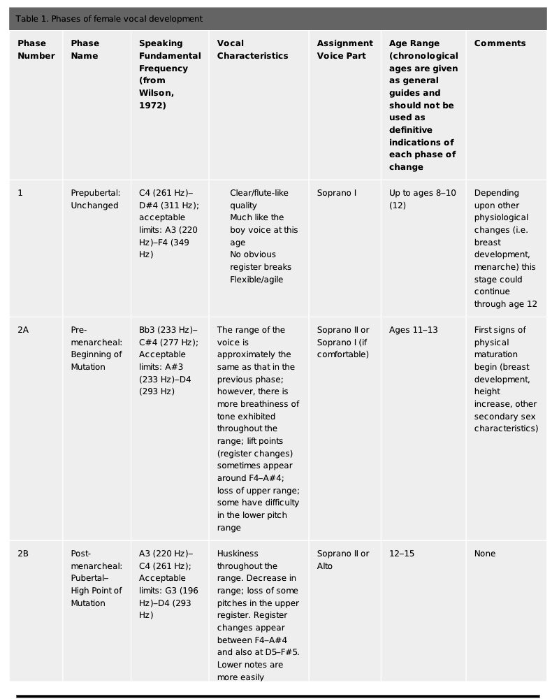
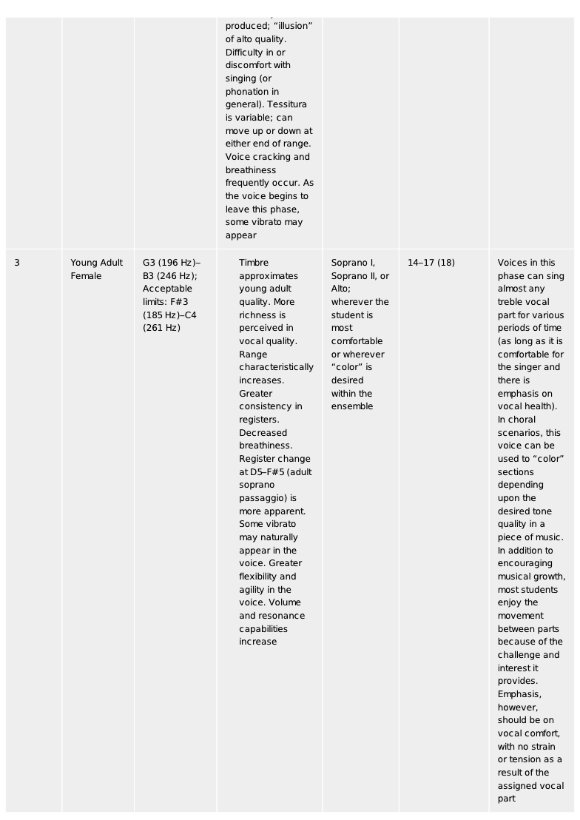

Appendix 2
Susan Yarnall’s findings from her study
Taken From: Yarnall, S. (2006) “Vocal and Aural Perceptions of Young Singers Aged Ten to Twenty-One,” The Journal of Singing, pp. 81–85.

First Stage: Age 11–12
The girls are often confident, they can have a big range and feel comfortable throughout, breathing is good with-out being particularly deep, the voice carries with good resonance, but by the end of the year there is some loss of resonance (possible decrease of formants). Graham Welch has found that differences in vocal quality be-tween boys and girls are achieved principally by training rather than fundamental anatomical differences.
Second Stage: Age 12–13
Many young singers get through this year quite happily and with a reliable vocal instrument, the beginnings of a breathy quality and some inconsistency intone can emerge depending on the age, physique, and maturity of the singer.
Third Stage: Age 13–14
The majority of singers show symptoms of air in the tone, caused by changes in the structure, length, and manner of vibration (glottal chink) of the vocal folds. Not all singers experience these problems; some continue with a rather small but high flute-like sound. others try to overcome the problems by trying a “belt” quality that is not always advisable at this vulnerable point of vocal growth. I find it is the hardest year to teach; it is difficult to maintain their interest and enthusiasm when they feel their voices are unpredictable, and there is a loss of vocal range and quality. It is at this stage more than any other that teachers need to be aware, not only of the anatomical changes but the psychological implications on self-image and self-confidence. It helps to inspire them through music that they can understand, that suggest emotions that they can express easily so that they can identify with the song even if the sound is not truly the image of their inner self.
Fourth Stage: Age 14–15
The singers begin to develop more vocal colours and a degree of control over their voices with breath strength developing. There is a growing confidence amongst the girls, but the boys are often at the most difficult stage of transition, and they do get very frustrated with their small vocal range and lack of control. The singers seem to start “owning” their voices, they have a commitment, an ability to control, a sense of “agency” which is a sign of maturation.
Fifth Stage: Age 16–18
The boys are beginning to settle into their new baritone range, though it is far from established, and new colours are emerging in both girls’ and boys’ voices. Some of the boys feel it is like a return to their treble voice only an octave lower, but it must be emphasized that vocal changes continue to take place until the singer is in his or her mid-twenties. It is too early to make judgements about a voice type. As young singers continue to mature, I have found in my experience other factors that seem to contribute to voice quality. These include general medical conditions (arthritis and kidney infection), asthma and the related medication, menstruation, muscle fatigue (athletes and dancers), poor air quality and air conditioning systems, orthodontic treatment (tight jaws and tension in spine),poor choral work and/or music theatre overloading young voices, clubbing (plus related leisure activities, smoking, late nights, etc.), and the opinions and expectations of peers, teachers, and parents with regard to their vocal skills.

Susan Yarnall
Implications for singing teachers
Taken From: Yarnall, S. (2006) “Vocal and Aural Perceptions of Young Singers Aged Ten to Twenty-One,” The Journal of Singing, pp. 81–85.

- Listen to what the students say as well as how they sound, and check that they really do understand what you are trying to do. Encourage them to listen carefully. Use good quality recording equipment and explain simple acoustic principles
- Understand adolescent vocal changes and the possible reasons for loss of tone quality. Remember the pace of change varies enormously; some young singers seem to soar through with no difficulties, others can take longer.
- Make singing exercises meaningful, students get bored easily! I often give them a sheet with an explanation of the purpose of the exercise. I also encourage singers to make up their own, which we then share with other students.
- Use music to teach technical and imaginative skills. Music inspires us as singers, and we need to show and inspire our students to love the repertoire as much as we do. Be flexible to all genres and styles but maintain integrity; do not pretend to like a song (they can see through false enthusiasm). Look at some of the contemporary ballads. If the singer wants to sing a song that means something special to him or her, you will hear a different quality in the voice and you can take that and lead him or her into other repertoire that shares similar expressive qualities.

