Introduction

I first decided to enter the digital art world back in 2014 when I was choosing my GSCE’s and chose a class called ICT CiDA (certificate in digital application). In this class I was introduced to using software such as Adobe Photoshop and Illustrator. I also messed around with Blender back at this time however gave up relatively quickly. After really enjoying this class I started to think about digital art as a career.
I started looking into what I could do next, a Visual Effects course at Uxbridge College caught my eye.
I applied for the VFX course however the course was cancelled and merged with another course before I started, but I was given the opportunity to move to the course it was merged with, “Next Gen Skills academy”’s course on 3D animation, Games design and Visual effects.
This is when my journey into 3D really began.
I was introduced to Maya. I enjoyed using it and in my spare time increased my skills and knowledge with this software.
After much research and googling I was making things like these.
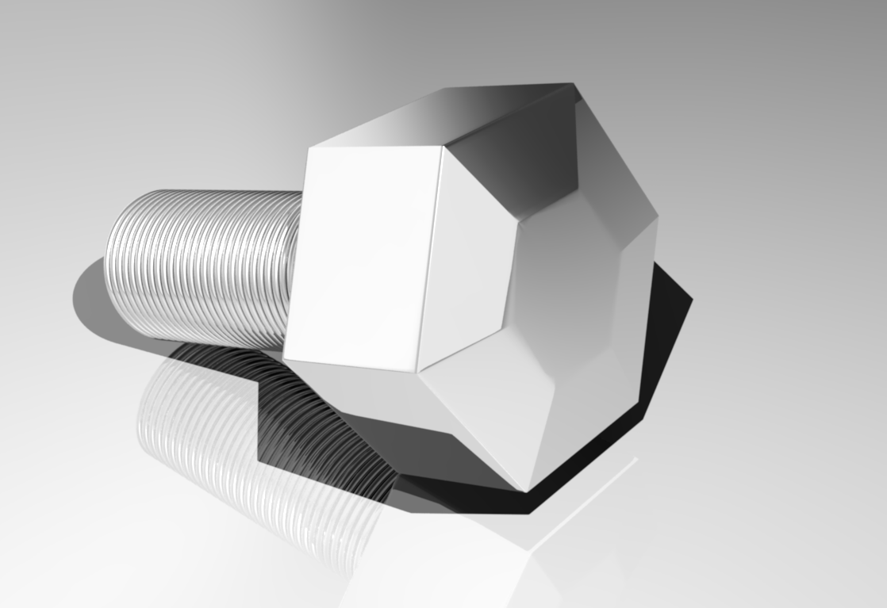 | 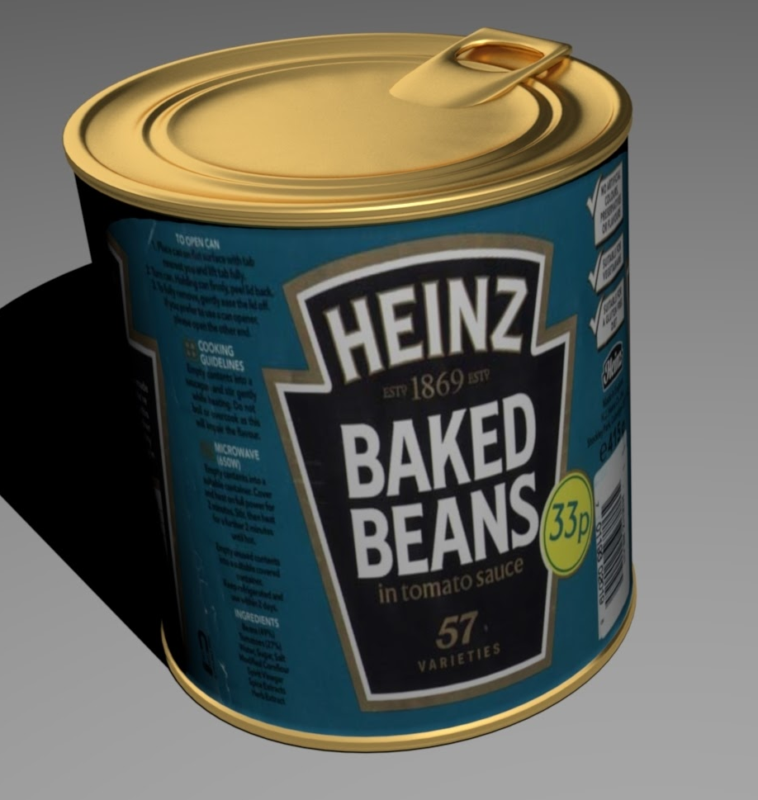 | 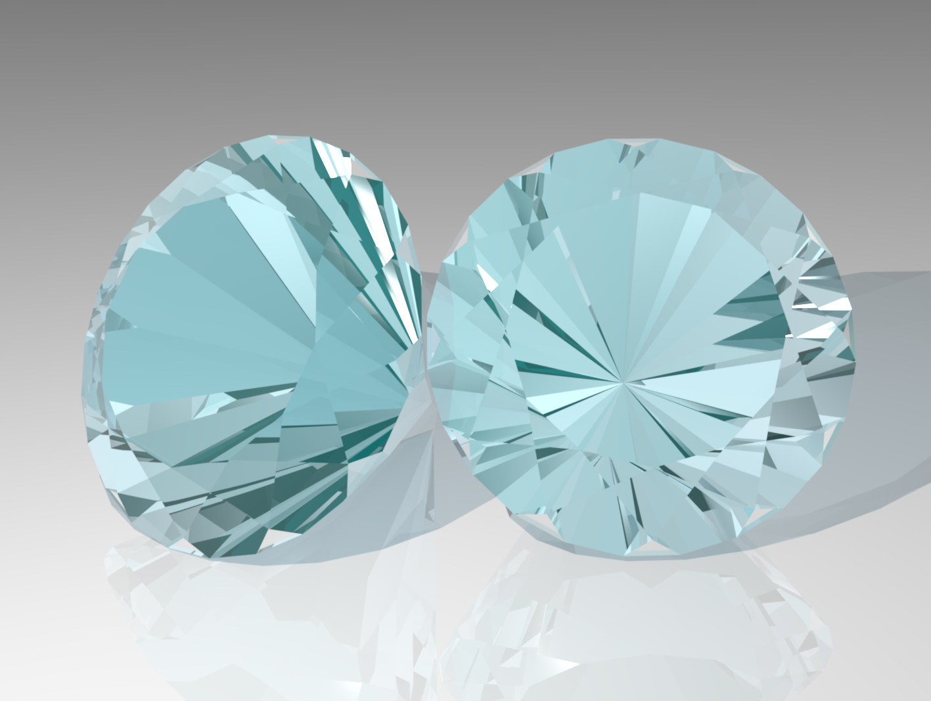

These images were produced about a month after I started to learn Maya, I remember a huge sense of achievement from completing these simple projects which inspired me to keep learning and improving.

Around this time the game “Overwatch” came out. I really enjoyed playing it and loved the designs of the characters and weapons. I began trying to recreate the games assets in around 90% of my spare time and felt my skill increasing.

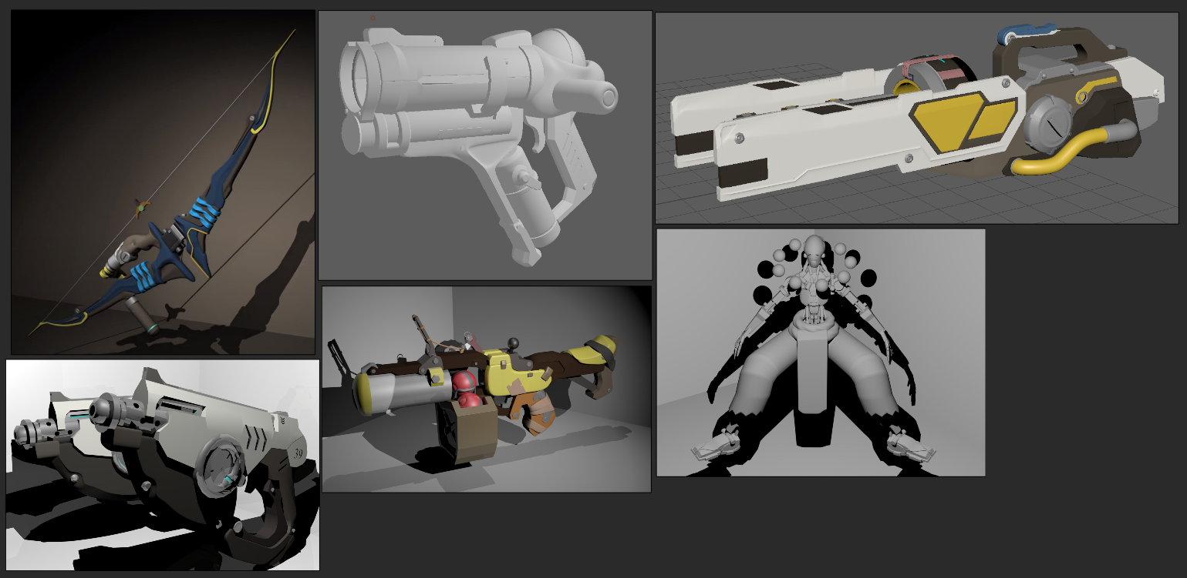

I enjoyed this independent learning and in my second year of my College course I had a group of friends pushing each other further with our 3D work.

Environments
Environments have always been a favourite of mine right back from when I first had to make one for college.
The first environment I made was a kitchen scene.
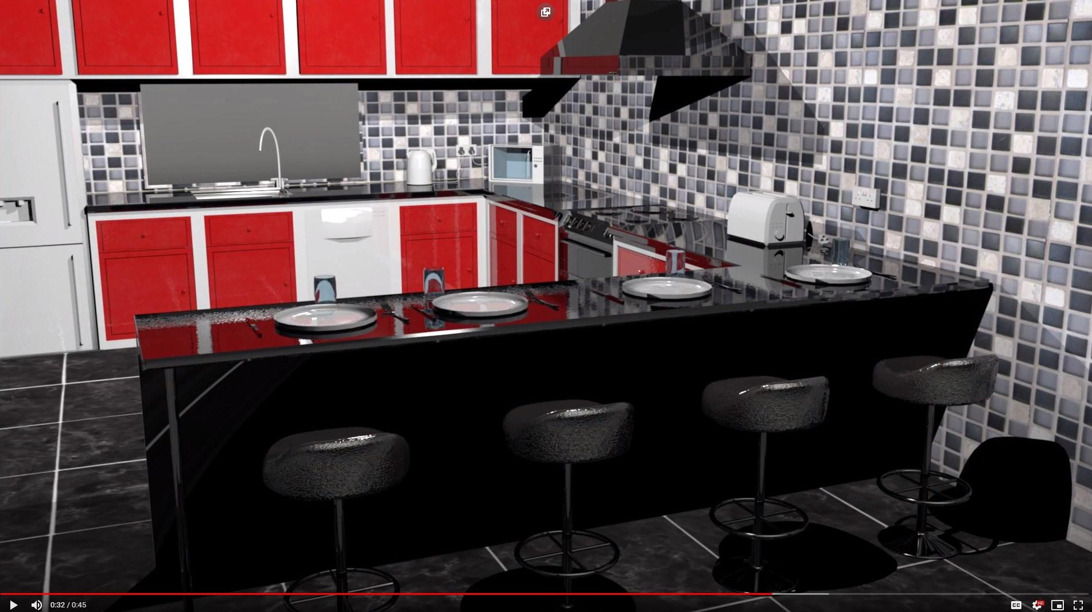

This was my first attempt at Photorealism and my love for photorealism and architectural visualisation grew from here

The second environment I created was made using Blender and Unreal Engine in my second year of college in 2017.

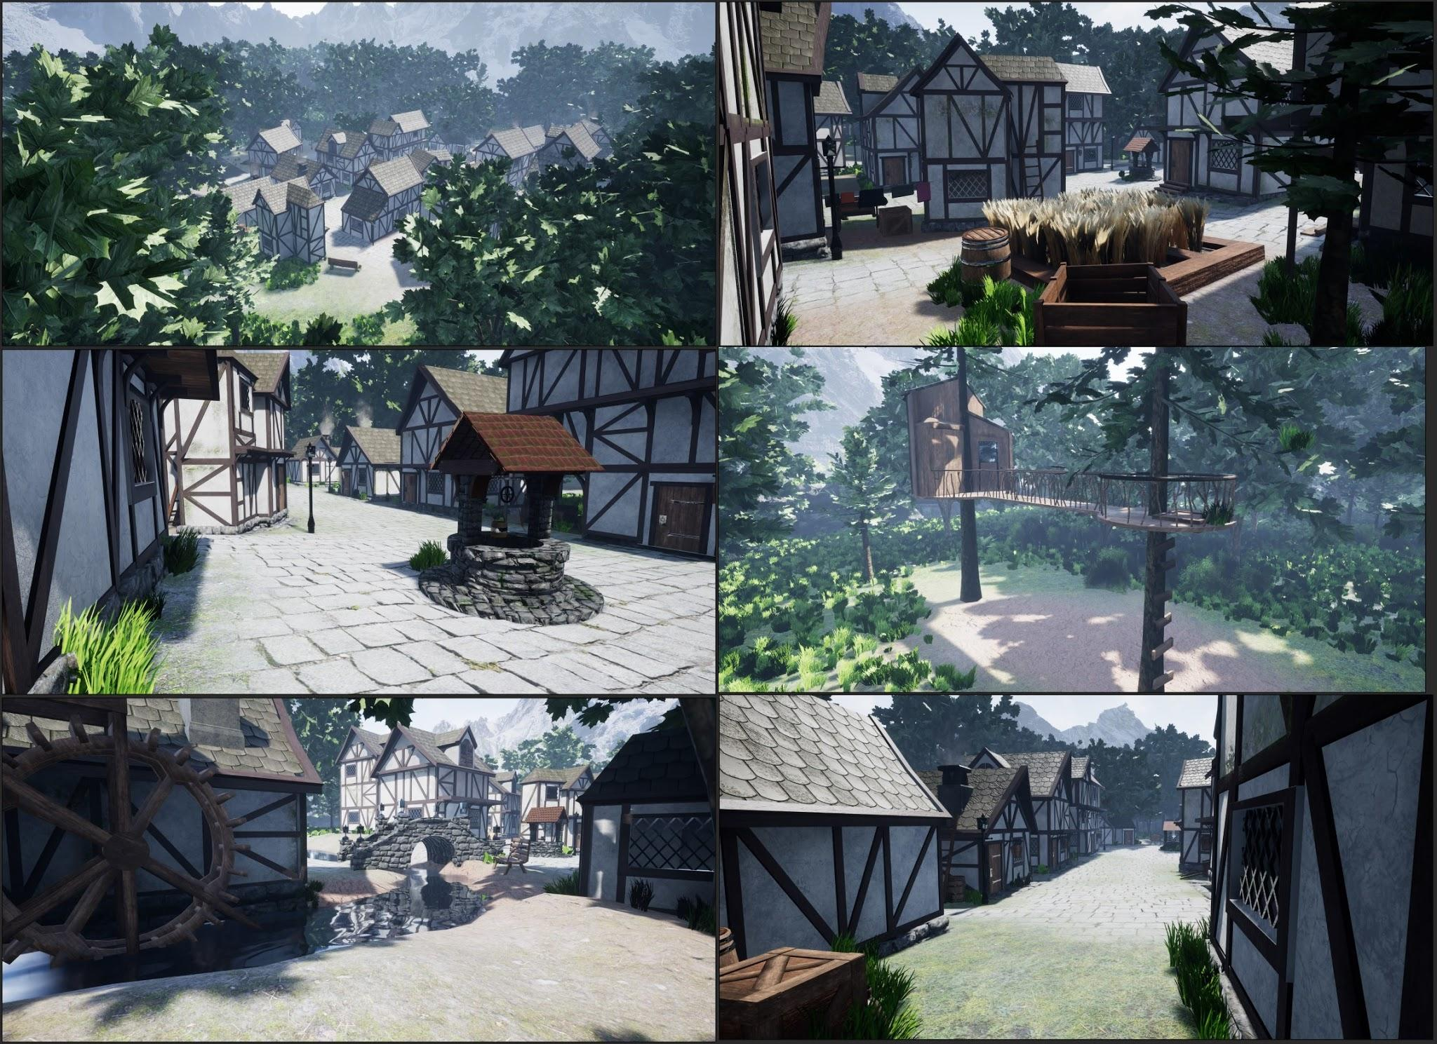

I enjoyed this group project. I was able to spend time on the environment with others from the group working on the character modelling. We used Unreal Engine (UE4). This inspired many future UE4 projects.

Over the summer before starting University I worked on a different themed village but using similar techniques.

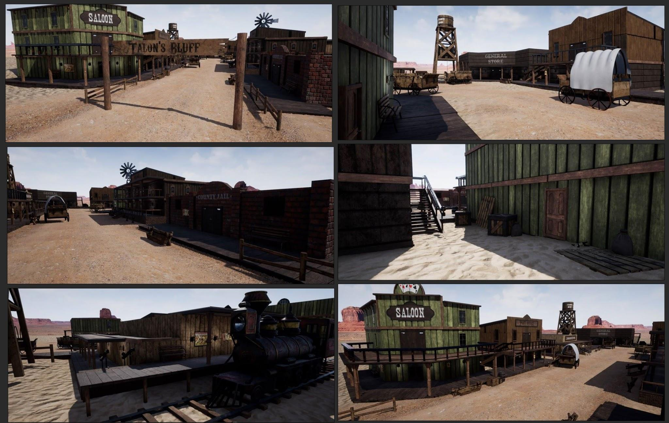

As I had a HTC Vive I was able to enter into my environment using VR. Being able to walk around in my scene was a great experience and inspired me to create environments like this again.

I started UWTSD in 2017. For my first module I created an environment with the theme "Haunted". This was one of my favourite modules over the whole course as I was able to focus and specialise in an area I enjoyed most - creating an environment.
With hindsight I can see where improvements could be made but I was happy with the result.
I learnt a lot during this module. This was the first time using volumetrics and although lighting is a weak point for me, I was pleased with it.
This was the first time that I had the elements included in a scene to suit the narrative. Previously I just used what I thought looked "nice". This is where I learnt that it is not about having a pretty render, but also about having something for an audience to follow and gain an understanding of the world the scene sits in.

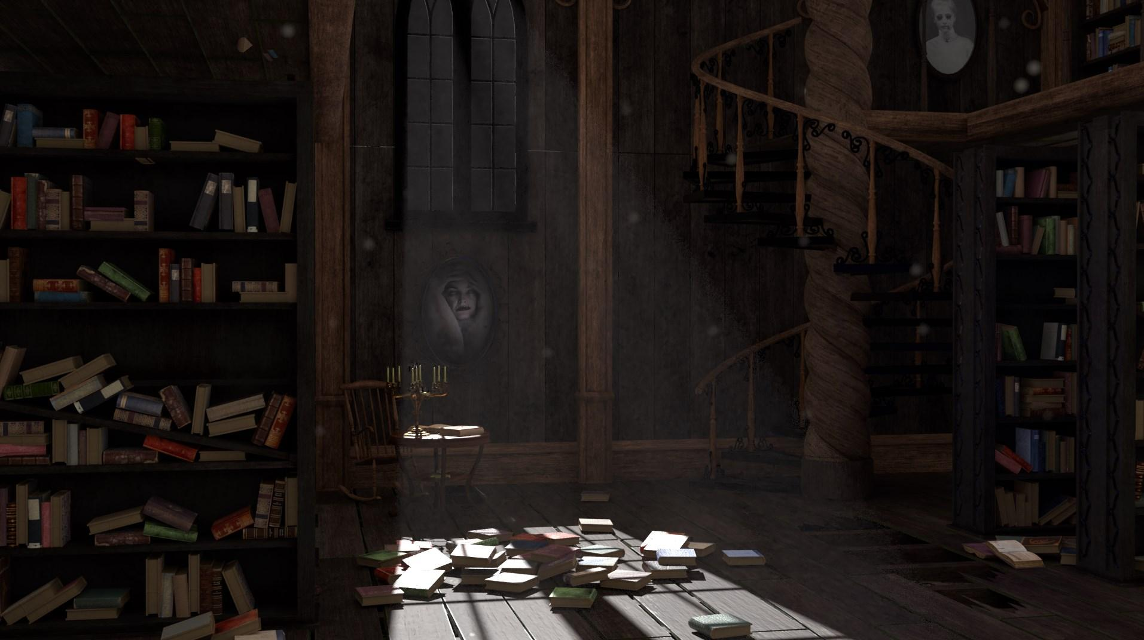

My next environment was for 3D Filmmaking. I found this the most stressful of all of the modules in University. I had to create a short animation from start to finish in a few months. This included: making, rigging and animating the character; modelling the environment and; adding sound.
I spent too much time sculpting and rigging the character which reduced the time spent on the environment. This reflected in the final result.
Although I am not happy with the final result I learnt in this module the importance of having and/keeping to a schedule. I was happy however with the brick textures which I sculpted in ZBrush then made them into textures, this was the first time I had made my own textures.
I also made the grass and dirt texture myself after learning a little bit of “Substance Designer”.
This allowed me to produce the exact textures I needed to suit the style I was going for.

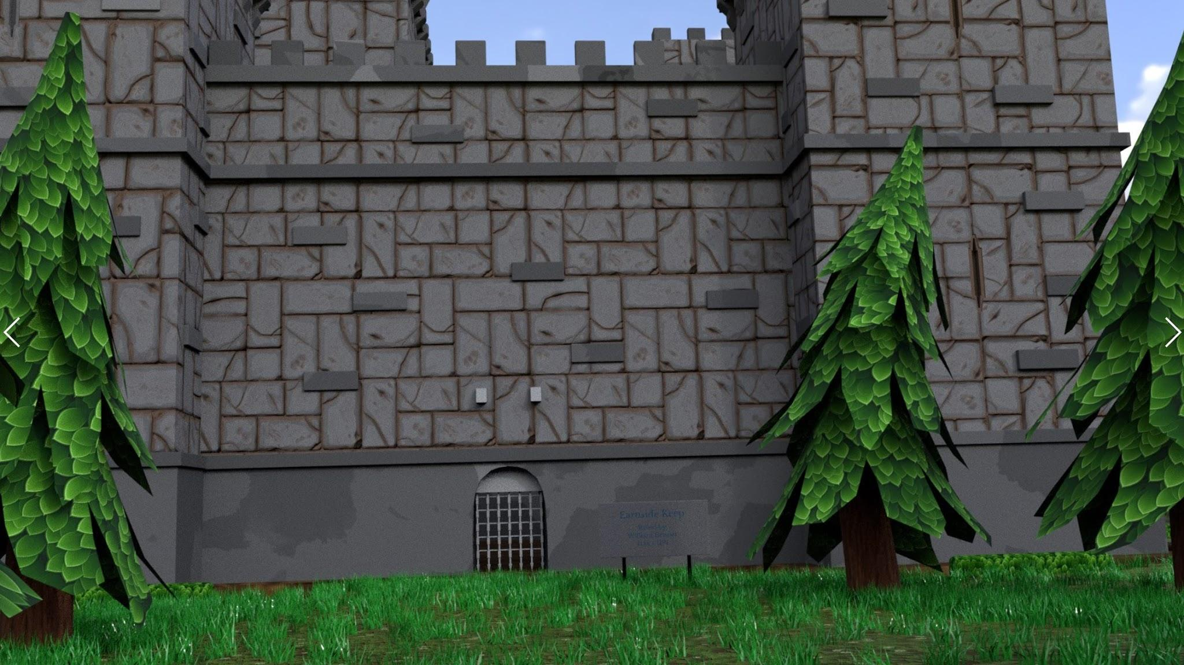 | 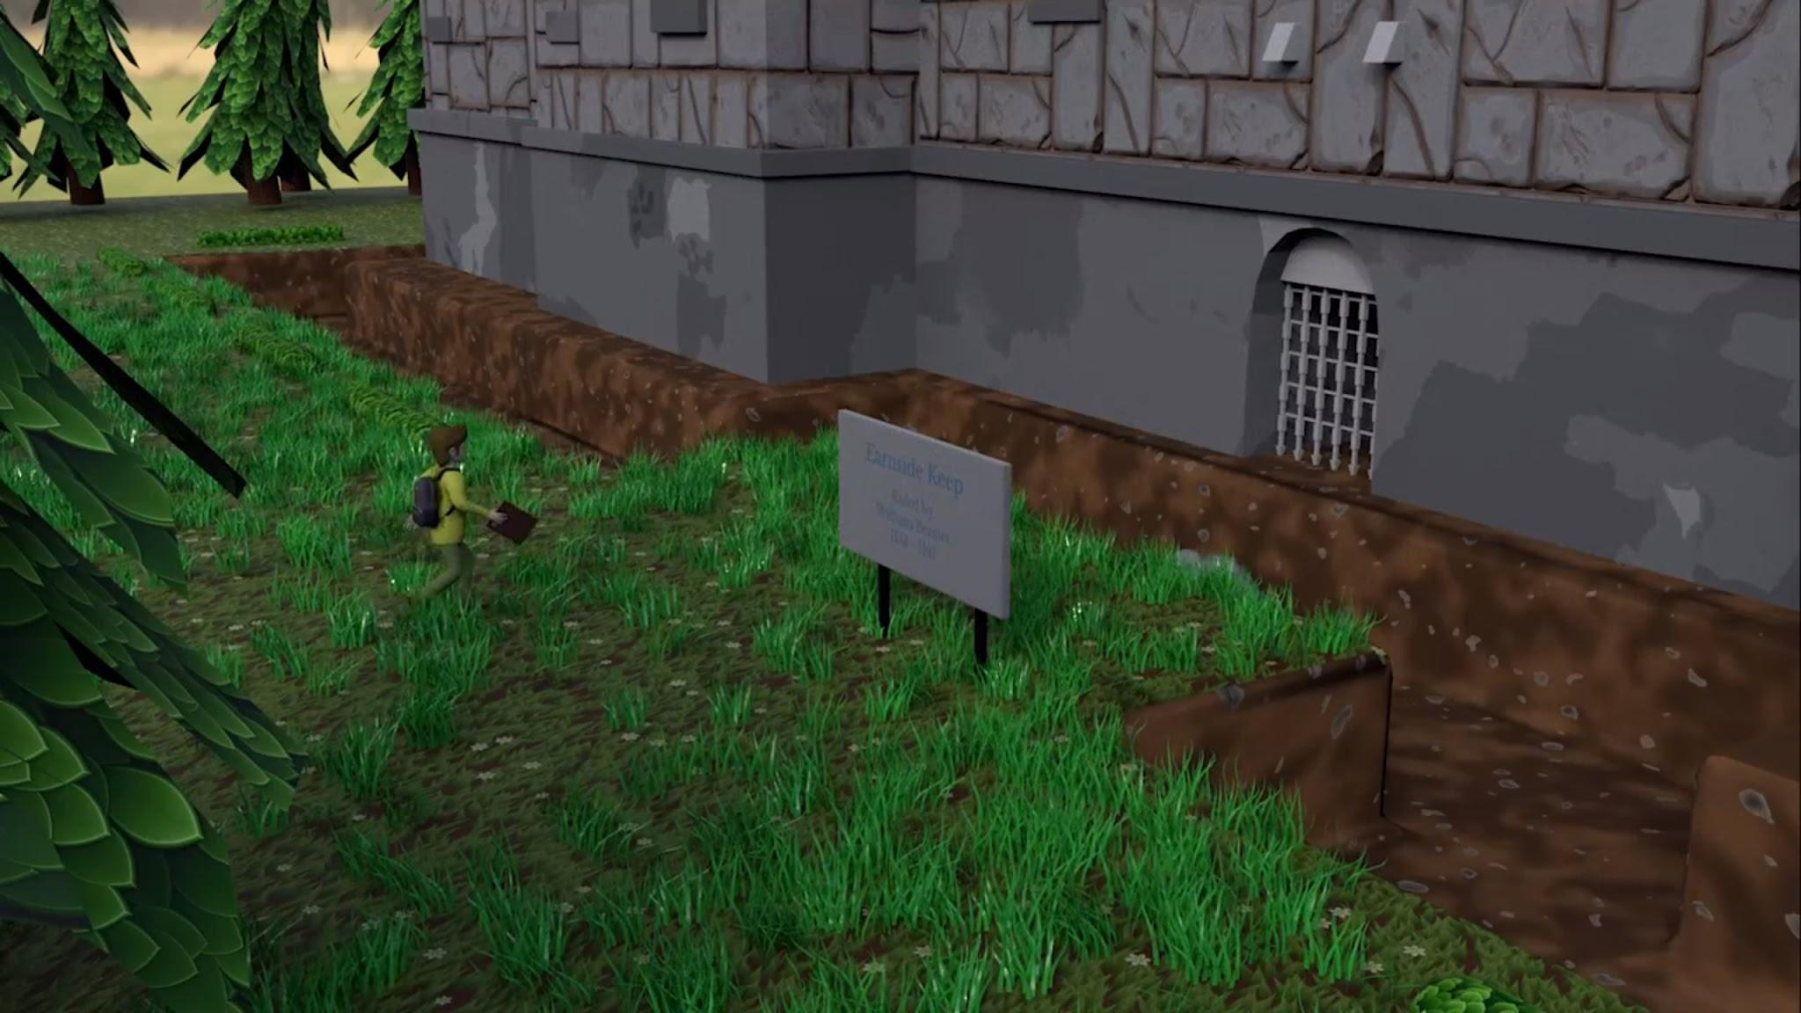

My final environment was for my Major Project where I worked in a group of three.
The other two group members were focussing on the animation. My focus was on creating the park environment , rigging, rendering and sound. I also project managed.
We chose an artstyle similar to the one used in the games "Life is Strange" and "My time at Portia" where there is no shine, only base colour (diffuse) maps.
This led to some difficulties e.g. We were hoping to have a pond in the park but it was difficult to create realistic water only using base colour maps. I looked at how "My Time at Portia" dealt with this and managed to resolve the issue. However, we later decided to cut the pond from the animation.
Previously I tried to make my work look "cool". This project gave me a new challenge. Rather than filling the scene with "cool" items it taught me to keep with the style which is important in group work.

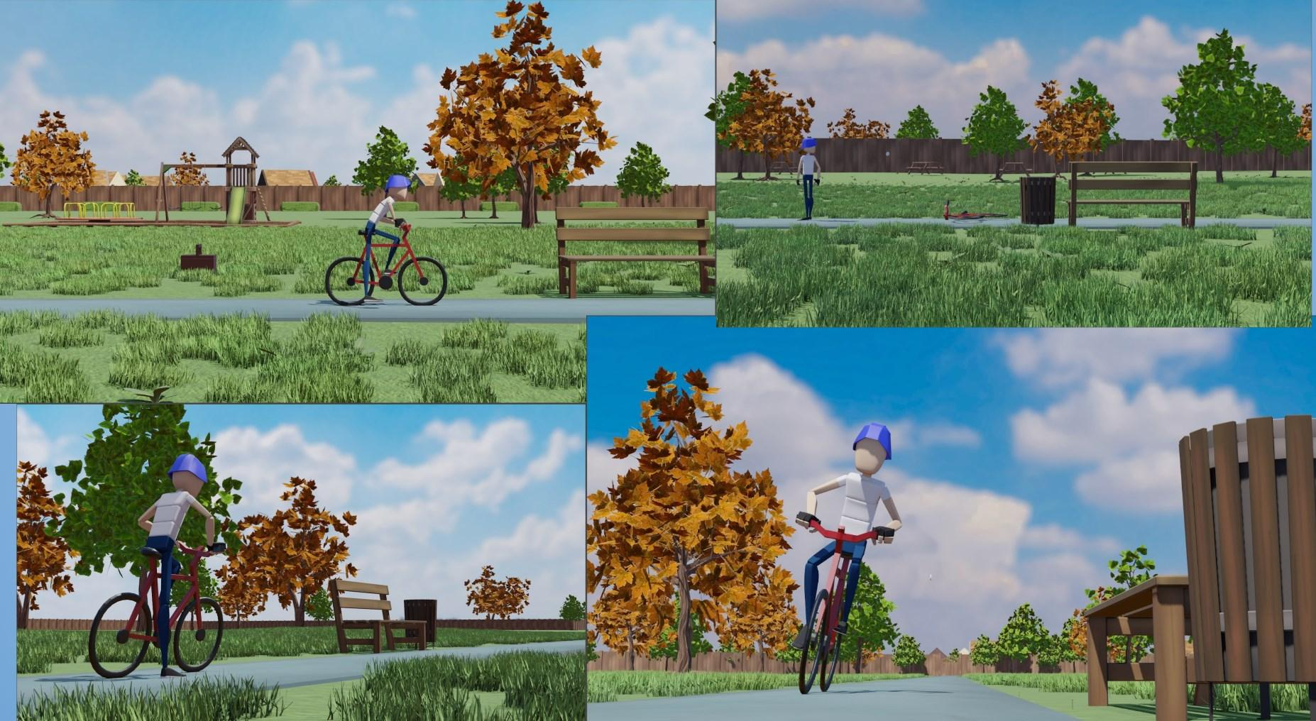

I enjoy creating and rendering environments, particularly photorealism so spend a lot of my time trying to improve skills especially ArchVis (Architectural Visualization) skills as I hope to go into ArchVis as a career in the future.

I find it is best to get as many references as possible, in order to set a good goal in quality and the mood of the scene. “Mood” is one of the most important things when constructing an image.
During this time of doing Archviz renders I learned how to have a good composition with a focus point, good leading lines, foreground interest and depth and also about the "Golden Ratio". This is something that was lacking in my earlier work. Using this has made my later work much more powerful visually.

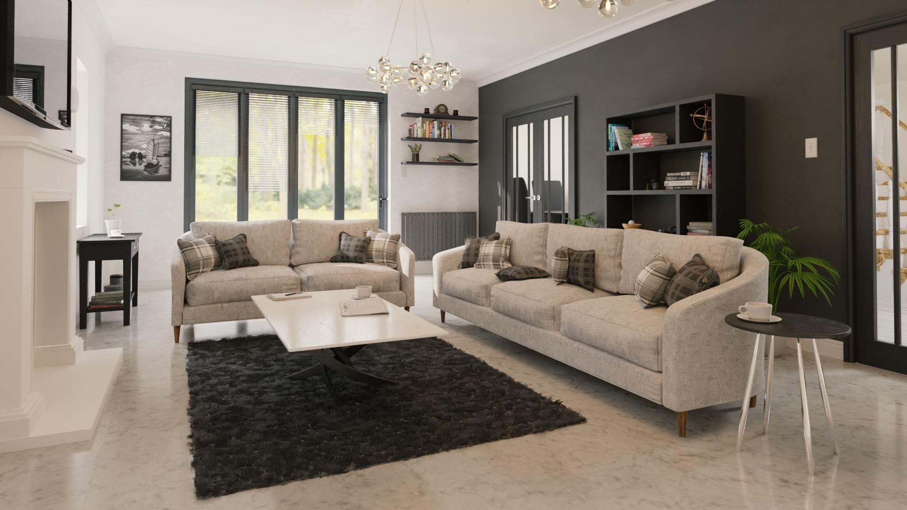

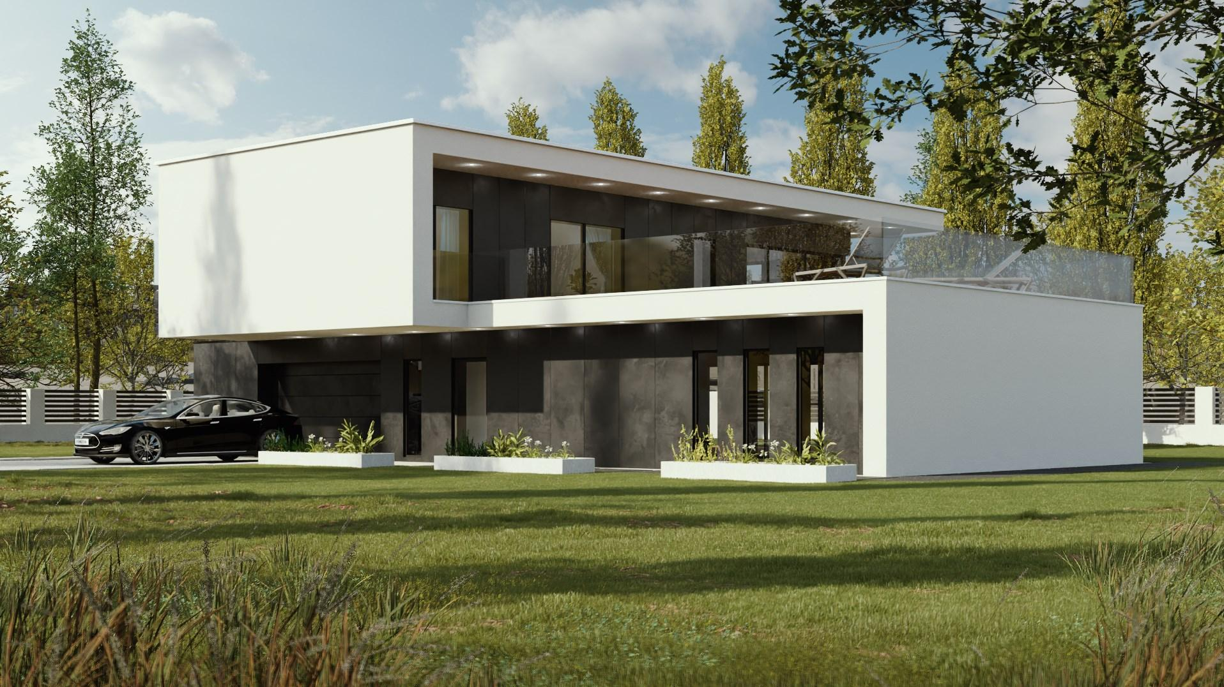

Characters

I avoided modelling characters for as long as possible after being told about the difficulty of doing so.
This being said, in the second year of College one of my assignments was to create a 3D biped character. As I didn't have to use the character in an animation I was able to focus my efforts on the characters design and modelling.
I chose a simple, stylised character. He was inspired by a fan made "Legend of Zelda" Skull Kid origin story animation. He was made entirely out of wood. This helped me avoid the "Uncanny Valley."

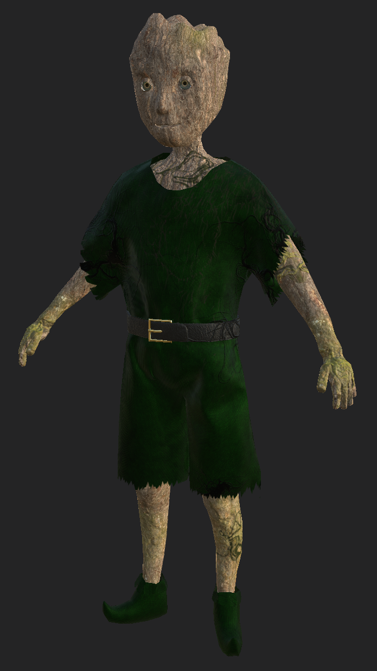

The second character I modelled was during my second year in University. This "Organic Modelling" module remains my favourite as it allowed me to specialise and focus on one area.
I used ZBrush for the first time but took a while to get used to as the UI was different to any I had previously used. This module allowed me to develop my skills as a 3D Artist both in style (previously I mainly modelled hard surface, non organic models) and software.
I started to gain an understanding of human anatomy which is essential knowledge when creating any character and is knowledge I have taken with me since.

For this module I modelled a stunt bike rider so spent a long time making sure that his pose would be dynamic and powerful. I made 2D concepts before I began 3D modelling.
This was the first time I put effort into pre production. It was worth it as it allowed me to know exactly what needed to be done before going into 3D reducing any last minute changes I would have had to have done.

I hoped to develop texturing skills. Previously I used basic single materials, drag and dropped from Substance Painter. I spent weeks perfecting the textures, ensuring all the buttons, stitches and dirt were in the places that fit a real life scenario. I was pleased with how it looked in the final piece.
To give the character a sense of place in the world and to give him more character I modelled a bike and an arena which also filled up the scene well.

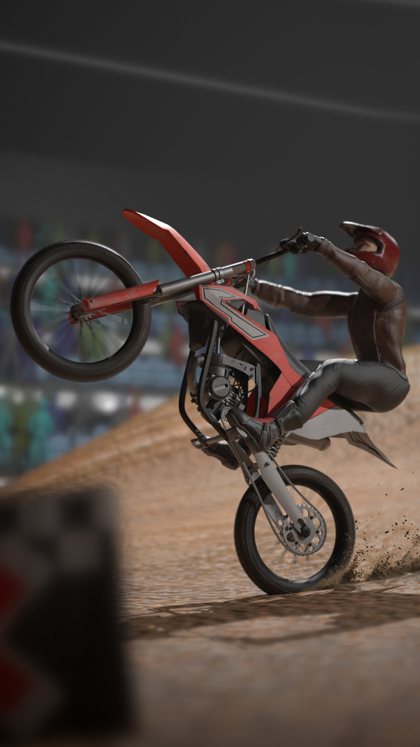
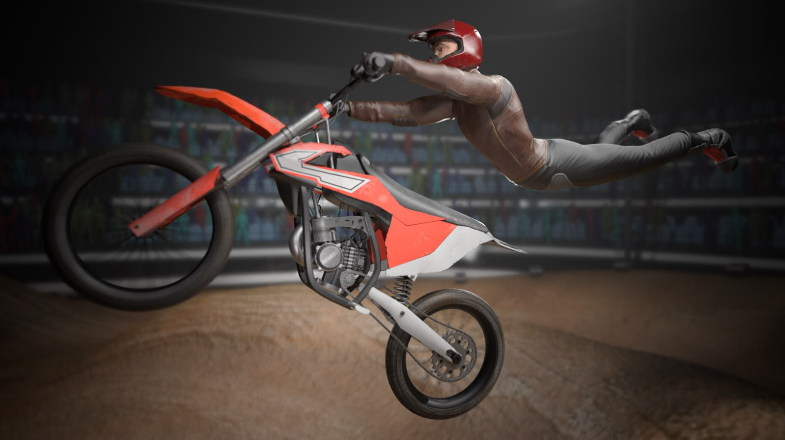

During the "Creative Practice 2" module I enjoyed working in a group, each specialising on a specific area of the CG Animation Pipeline. My role was creating the characters for the animated short.This is where I learnt about the importance of topology which I focused on to allow my characters to be rigged and animated easily. There were obviously still issues but the effort I made on topology was definitely beneficial. I also learned about edge flow during this module.
Due to time constraints I used the same character twice with slight changes. This is not the best way to create two characters but I was relatively happy with them.

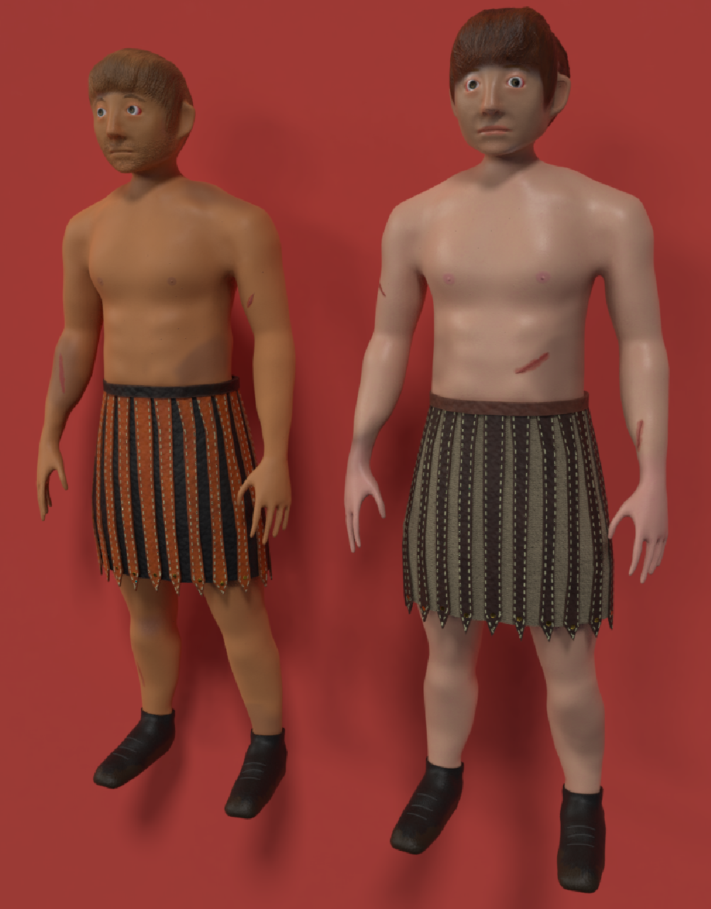
Animation
In college my animations consisted of moving rigid objects, so my animation journey really started in University.
My first animation was the "Haunted House" (mentioned previously). This was relatively similar to my previous work, simple animations of a chair rocking and candles spinning ect. However I did add more complex animations. Halfway through the sequence, books flew off bookshelves, spinning around in a tornado fashion. Instead of manually animating individual books I delved into a simulation. I had used these a little before, finding them interesting, but this would be my first time using simulations in a project. This simple shot taught me a lot about how simulations work along with the pros and cons of using them. I was pleased with the final result.

During the second semester in the "Character and Effects” module I created a simple robot model which I feel worked well in the little sequence I had planned. This was the first time I created, rigged and animated a character and the result reflected this. I had issues with the rig that I couldn't fix and couldn't find the answer elsewhere. It was a battle to animate it but as it was mainly a simple walk it wasn't too much of a pain to work with. The end result wasn't bad, but certainly not my best work.
This project gave me a better sense of timing when animating which continues to be helpful.
The second aspect to this project, "Effects" was also semi-animated. I used "MASH", which was new to me - but worked well, to create a swarm of fireflies around the character.
At this time I began experimenting with "Redshift" which unlike "Arnold" had GPU rendering. This allowed me to render quicker. This was a good decision as I was relying heavily on volumetric lights and now could spend longer animating rather than rendering. I feel this led to a better final animation.
This module taught me the importance of planning the work and knowing the "tools" for the job before starting. This is the first thing I do now before starting an animation.

My second animation was in "Creative Practice ". As I mentioned previously this was a stressful module with a lot to do in little time. My task was to carry out half the animation. This was not my best work as my time was limited due to other responsibilities. However, this is maybe the module I learnt the most from. I was involved with areas I hadn't been before, including working alongside another person animating and ensuring that my animation and the other half of the animation worked well together.

At the beginning of the second year in the "Character and Creature" module, for the first time I tried to animate a sequence without any problems with the rig or character. This was because we used premade rigs which meant I could focus entirely on the animation and make it the best I could.
My task was to create five short animations. One had to be a creature of some kind, one had to be lip synced. The others were my choice.
During these projects I developed my skill of timing and began experimenting with the "12 Principles of Animation" which are the principles used in essentially all animated movies. I began using techniques such as squash and stretch, anticipation and staging, and some follow through and overlapping action. These made the animations more appealing and pleasing to watch as well as a more professional look. It is clear to see the improvement in my animations from the first to the last.

As I mentioned previously I spent too long on the initial stages of 3D Filmmaking This led to a decrease in the animation`s quality. It was not interesting, consisting mainly of a single walk cycle of the character through a castle. The walking animation was not impressive either. This project isn't my finest however is something to learn from for the future.

At the beginning of the third year I completed "Advanced Character Animation" where I created a short animation in preparation for my “Major Project"
Although I wasn't going to be carrying out much of the Major Project animation, this module gave me an opportunity to model and rig the bike in preparation for it. I was able to work out the complexities of combining the use of two rigs (boy and bike) to provide one smooth animation. It worked well.

Writing
The writing on this course has been demanding and unfortunately the theory and non-creative parts have not been where I have excelled the most.
I received my lowest marks so far from "Ways of Thinking" and "Ways of Perceiving". I struggled in the lectures to understand how it related to my course. This is where most of my problems came from. I found the modules uninspiring and instead chose to focus on the more practical, creative modules. This being said I tried to motivate myself and did pass both assignments.

During the first semester of the second year I had another writing based module, "World Building". Although I had the same problems as in the first year, this one was significantly better. The classes were smaller and split depending on the course the students were attending. This meant it was more relevant to my course so I had more interest and was more motivated.

"Research Practices" is the first theory based module that I enjoyed. I was able to choose the
subject myself so I was interested in it and very motivated. It set up and gave myself a clear direction for my dissertation.
In this assignment I wrote about three images: One from Jurassic Park; one from Star Wars and; the last from Jungle Book. I am a fan of these movies and I learnt a lot about the CGI industry in the process.

My dissertation, the "Independent Inquiry" was the most daunting and yet most enjoyable piece of writing in all my time at University. I chose to write on the effects of CGI on an audience and considered whether we need CGI in 21st Century movies. This was related to my interests so I was motivated and highly engaged when writing. My 2:1 result reflects this, my highest mark for any written work. This was the theory assignment I learnt the most from with my research on movies today, how the movie industry began and the psychology behind watching a movie, being useful knowledge when working on an animation.

Keeping a Blog has been a major part of most of the University modules.
I found them a useful way to keep track of what I had been doing and what was next and they showed a progression of my skills.
Although my writing skills are not the best I feel my writing style suits a blog more than academic essays and I enjoyed writing them. However I found having a word count difficult especially as "Blogger" does not have a word count and so I had to work first in a Word doc, word count then copy it into Blogger. With the amount of work I was doing I found it difficult to keep to the word count and despite my efforts to keep it brief throughout, I was still over the word limit by 1500 words by the end. I felt anxious word cutting, worrying about losing marks for not having done something when in reality I had but couldn't write about it.

Group Work
There were many opportunities for group work right from the beginning of my time at University. In Creative Practise 1" we created a 2D animation of the poem "Jabberwocky" by Lewis Carroll. This was tough as we were all new to each other with no knowledge of each other's strengths and weaknesses. Everyone was careful not to "step on one another's toes”. Over the weeks we all found our "stride" and "slotted" into our roles.
The result may have not been the best but we learnt a lot about the CGI pipeline and about working collaboratively.

In the second group project, "Creative Practice 2" we worked better as a group as by now we knew and were comfortable with each other.
However the project "Romoat" was quite stressful as there were four characters and two environments to create in limited time. The group and I are partly to blame for this as we went against the Lecturer's advice to continue the work we had done for "Jabberwocky" in the previous semester, meaning we could skip pre production. Not doing this meant we had to spend a lot more time doing pre production before jumping into 3D.
We had issues during this project particularly with the render, we ended up using "Maya Software” rather than the preferred "Arnold" due to time limitations. However we were still happy with the end result considering it was our first group 3D animation.

I really enjoyed the module “Entrepreneurship”, as it gave me the understanding of how things will work when university is over. Learning how I would do things on my own in terms of starting my own business/studio. I felt this was a very important topic to cover and will definitely help me in the future.

"Creative Practice 3" was exciting with many more possibilities. We were not working only with our class but also with the "Games" class and a company in Swansea creating a game, "DragofiAR". We were working on a game that could actually become a reality for people to enjoy.
My role was to create a concept environment. I had been working on this with a lecturer over the Summer prior and it was great to have it incorporated into the module. This meant I had a clear understanding of the project from day "0".
It was a new experience to work alongside so many people on one project and I enjoyed seeing everyone's contributions. This was a great motivation for me on this module as I wanted to contribute to the project myself.

Conclusion

My time at University has been invaluable. I have gained many hard skills including creating environments and characters and all the elements within such as rigging, rendering etc along with presentation. I have also learnt soft skills such as timekeeping, team work, conflict management etc. . I have also had the opportunity to form connections to the industry which could be beneficial as I continue my career.

I am looking forward to using these skills and opportunities in the future.

