

Student name: | Lee Tak Man Anna Lisa | Student ID number: | 2124401
Programme: | DBA
Module: | Quantitative Research Methods
Module code: | HKBM7004 | Contribution to Overall Module Assessment (%): | 100%
Lecturer: | Dr Andrew Chan
Assignment Title: | Quantitative Research Methods Project Report | Word count (or equivalent): | 8,029 words
Submission deadline: | 19 December 2022 | Return date:

A Pilot Test
for
The Effect of Subjective Norms on
Hong Kong Consumers’ Consumption Behaviour
of Plant-based Meat:
A Study on Generation MZ and Baby Boomers

By: Lee Tak Man Anna Lisa
Student No.: 2124401

Abstract

Food security and food sustainability were challenging issues confronted by many global leaders of today. The current food system is in an unstable and insecure state that all earthlings should be alert of. Hong Kong people had long been accused of being one of the major culprits of environmental disruption due to their over-consumption of meat. Excessive livestock farming increases the emission of greenhouse gas, thus causing climate change. Hong Kong’s prosperity made its residents unaware of the food insecurity threat. Consumption of plant-based meat was perceived by green-lovers as a remedy to ease the pressure of food unsustainability; therefore, it is essential to conduct a study in Hong Kong to understand more about consumers’ attitude and purchasing intention and consumption behaviour of plant-based meat. The influence of subjective norms was specifically studied for the age groups of Generation MZ and Baby Boomers. In past studies, Generation MZ drew most attention in their consumption behaviour of plant-based meat, but Baby Boomers were seldom studied. The current research was a pilot test of the actual study, 50 samples were recruited to undergo online questionnaire survey, and the statistical results were analysed and interpreted by adopting the analytical tool - Jamovi. Results generated from descriptive statistics and inferential statistics revealed unexpected findings which were inverted to the researcher’s assumptions and beliefs, comparatively different from many past studies.

Table of Contents

List of Figures and Tables

Table of Acronyms

1. Introduction

Human beings have long been blamed for being the major offender of environmental destruction by releasing greenhouse gases, polluting water resources, hence causing biodiversity loss and animal extinction. Humanity is at present facing challenges of food insecurity and unsustainability around the world as a result of climate change and environmental deterioration. The issues of food insecurity and unsustainability is currently threatening mankind and all beings living on earth.

1.1 Overview of Global Food Security and Food Sustainability

Food security is a state that all earth dwellers, at all times, are having social, economic and reliable accessibility and availability to sufficient quantity of affordable, safe, and nutritional food (Berry, E. M. et al., 2015). In well-developed countries, the threat is not unduly obvious; but in less-developed regions, food security is diminishing at a rate that people start to worry. Food sustainability means food is produced under the circumstance that the environment is protected, natural resources are efficiently used, and both animals and mankind’s qualities of life are enhanced. Food sustainability was introduced by Berry et al. (2015) as a “part of food security”. Food security involved four dimensions – availability, accessibility, utilization and stability (Peng and Berry, 2019). In a secure food system, food can be produced locally and also be imported from abroad; it should be easily accessed via well-developed transportation infrastructure, and price should be affordable. With quality food and sufficient clean water, humans would be able to live a healthy life. Government of all countries should ensure the stability of food chain system to secure it from threats of natural disasters, climate change, wars, pandemics and economic instability.

1.2 Hong Kong’s Food Security and Food Sustainability
Hong Kong is unprepared to face up to the challenges of climate change. While the rest of the world is fighting against global warming, Hong Kong is still in lack of long-term policies to alleviate the impact of climate change. Global warming correlates with food insecurity since it had great impact on food availability. There are many strategies that can be employed to mitigate the negative upshot of climate change, eating green is perceived by environmentalists as one of the effective ways. Hong Kong has an extremely low self-sufficiency rate of food, of 1.82% as reported in 2015 (Tam, 2018). Currently, Hong Kong has over ninety percent of food imported from China; if China’s food supply is insecure and unsustain, it will definitely have direct impact on Hong Kong. Hong Kong people has a habit of over-consumption, especially in the context of food. Proportionately, Hongkongers consumed more meat than the rest of the world, five times of the international average (Ho, 2019). Over 77% of agricultural land in the world and over 75% of fresh water resources were contributed to planting food for livestock production (Gastaldello et al., 2022; Zhai, Y. et al.,2022). As the prime culprit of excessive meat-consumption, Hong Kong people has to bear with the accuse of causing deteriorating climate, environmental disruption and biodiversity loss. In order to safe-guard the Earth, Hongkongers have to consider eating less meat.

1.3 Hong Kong Market of Plant-based Meat

Consuming plant-based meat is perceived by green-lovers as a “life-saving straw” to ease the
pressure of food inadequacy. Hong Kong’s plant-based meat market is estimated to grow at a stunning rate of 8%, surpassing the forecast of other Asian countries (Yum, 2021). In view of the economic forecast of plant-based meat, an 8% growth rate indicated the degree of acceptability by Hong Kong people. Marketers will be interested to learn more about the underlying reasons that lead to the growth of meat-alternatives in Hong Kong, so they will react by promoting appropriate messages.

2. Problem Statement and Purpose of Study
Hong Kong’s plant-based meat market is at the blooming stage, a few local brands and imported brands were introduced into the market, but most of them can only be found in restaurants and fast-food outlets, plant-based meat has not yet gained popularity. Consumers who make conscious decisions to replace their regular meat diets with meat-alternative diets, partially or wholly, social influence plays a crucial role in motivating or discouraging the consumption behaviour. The study of Ham, Jeger and Ivković (2015) clearly stated that subjective norms should be included in research of green-food consumption. Studies showed that consumers who are surrounded by family members and friends who were interested in consuming plant-based meat, they will have the intention to consume the same, as they think these people are of importance to them (Arli et al., 2018; Marcus, Klink-Lehmann and Hartmann, 2022). Societal trend exerts the norm of behaviour for consumers to follow, a behaviour that is perceived and recognized by the society as righteous and appropriate. Subjective norms are effective to guide behaviours in situations of consumption uncertainty.
Hong Kong’s plant-based meat market is having the problems of not making full utility of social norms influences. Hongkongers liked to follow others’ footsteps when making decisions about unknowns, especially towards the consumption of plant-based meat; therefore, word-of-mouth from people of value can be seen as more effective than costly promotional campaigns. During the process of shifting from conventional meat-eating to plant-based alternatives consumption, there are motivators and interventions existed in the diet-changing passage, these factors will affect consumers’ attitudes, intention and behaviour of consumption. Subjective norms are one of the crucial drivers or inhibitors for steering behavioural change; however, subjective norms’ influences on Hong Kong consumers’ behavioural intention to consume plant-based meat was not yet investigated. This identified gap of knowledge forms the ground for the current pilot research and becomes the major objective of study.

2.1 Theoretical Insights and Significance of Research
Ajzen (1991) recognized that individuals hold two attitudes toward behaviour - they might either intend to perform certain behaviour based on their own beliefs, or they acted according to the triggers of subjective norms that existed in their surroundings, the triggers might appear in the form of negative pressure of disapproval or positive motivation of approval for the engaged behaviour. Ajzen further indicated that there are three kinds of subjective norms that would influence individuals’ decisions to perform certain planned behaviour, they are the social groups of friends and peers, family groups of close relatives, and the society. People intends to learn and act according to their observance of other people’s behavioural actions (Bandura, 1989), and their intention to behave is evaluated by their degree of readiness and acceptance to follow other people. The current research will adopt the Theory of Planned Behaviour developed by Icek Ajzen in 1991, the theoretical framework is illustrated in Figure 1.

Figure 1 Theoretical Framework of Research. Adapted from Ajzen’s Theory of Planned Behaviour and constructed by the researcher.

Past researchers had been studying on consumers’ behavioural intention and consumption behaviour of plant-based meat in many parts of the world, but the predictive power of Hong Kong consumers’ attitudes, the influential social power of Hong Kong’s subjective norms and consumers’ perceived behavioural control that lurks in their subconscious beliefs had never been studied. The pilot research focused in studying two groups of Hong Kong people differentiated by age - the Generation MZ and Baby Boomers. Generation MZ combines across the Millennials and Generation Z, covering ages between 18 to 30, they are labelled as obedient, responsible, hard-working and economical. At the other end, Baby Boomers cover the ages between 58 to 76, and they are classified as hard-working, practical and responsible. Previous researches revealed that the younger generation is the target customers for plant-based meat consumption and they were more easily to be influenced by social norms (Boukid, 2020; Bryant and Sanctorum, 2021). However, this kind of research is rarely done in Hong Kong, so it will be educational and contributable to conduct similar researches in the context of Hong Kong to investigate how the influential power of subjective norms will bring impact to Hong Kong young generation’s decisional choice of plant-based meat. Furthermore, Baby Boomers’ attitude and behavioural intention towards plant-based meat had seldom been studied around the world, so a study conducted on this age group in Hong Kong will bring the current researcher novel experiences and make the research significant.

2.2 Research Questions
With respect to the problems that bring about in question, two research questions were formulated for guiding the study. The research questions are for making sure that the study will be on focus, be specific and relevant.
Question 1:
How does the role of subjective norms affect Hong Kong’s Generation MZ and Baby Boomers in forming their behavioural intention to consume plant-based meat?

Question 2:
Will there be age-variance and gender-variance if these demographic variables are to be compared against the results of subjective norms influences?

3. Literature Review and Hypotheses Formulation
The ways in which Hong Kong consumers think and perceive plant-based meat can be incredibly crucial to both manufacturers and marketers for gaining understanding to plan their promotional strategies. Research hypotheses become the connecting bridge to link up the statements of problem and research questions with literature review. A thorough literature review of related fields of study is essential to provide insights and knowledge of past researchers to establish a framework for the current study, and benchmarks are offered for comparing research results to previous findings. Hypotheses define research variables and clearly state the expectancies of outcome. They are useful in testing theories and concepts, and by applying appropriate analyzing tools, they will confirm or disconfirm research theories, and new prospects might able be discovered. Figure 2 illustrated the Hypothesized Theoretical Framework of the pilot test, which was grounded on the Theory of Planned Behavior (Ajzen, 1991).

Figure 2 Hypothesized Theoretical Framework of Research. The framework is constructed by the researcher.

The current research had three key independent variables of attitudes, subjective norms and perceived behavioural control, two dependent variables of behavioural intention and consumption behaviour, and two demographic factors of gender and age.

3.1 Attitude and Subjective Norms
According to the Theory of Planned Behavior, attitude of consumers is having an assumption ability to predicting consumption behavior. Among the beliefs of behaviorism, behavioral beliefs create favorable or unfavorable attitudes in consumers that lead to their performance of consumption behaviors (Ajzen, 2002). Increasing the strength of beliefs would affect consumers’ attitudes and alter their perceptions toward a product or service, and hence their underlying tendencies to consume would be induced. By adding new attributes to consumers’ attitude-formation process, this would lead consumers to re-evaluate their attitude object. Attitude can be learned and be changed, provided that the attitude is not supported by string beliefs and is weak in intensity (Schiffman and Kanuk, 2007). Therefore, the researcher would like to propose the following null and alternative hypotheses:
H₀: A favorable attitude towards plant-based meat does not positively affect Hong Kong consumers’ behavioral intention to consume plant-based meat.
H₁: A favorable attitude towards plant-based meat positively affects Hong Kong consumers’ behavioral intention to consume plant-based meat.
When plant-based meat consumers are lacking of information to affirm their consumption decision, social or family influences can either lead them to deviate from their original attitude or lead them back on the consumption track. Word-of-mouth from someone of importance will be the attribute added into this decision-making process. Shin and Hancer (2016) interpreted their findings about the relationship of subjective norms and attitude, the authors discovered that “subjective norms were found to be the weakest predictor of behavioral intentions”, and some earlier researchers had even removed subjective norms from their studies. Contrarily, subjective norms were supported by Ham, Jeger and Ivković (2015) to be a significant variable that brings inspiration to consumers’ intention to consume green food. Furthermore, the study of Arli et al. (2018) also found strong correlation between consumers’ purchase intention and approval by subjective norms. Moreover, Carfora et al. (2020) also proved that consumer attitude and subjective norms were the strongest constructs for predicting behavioral intention. Research result of Carfora, Morandi and Catellani (2022) also indicated that plant-based meat consumption was influenced by societal expectations. In view of the arguments up-brought, the researcher would like to propose the following hypotheses for clarifying the phenomena in the context of Hong Kong:
H₀: Subjective norms that are in favor of plant-based meat does not positively affect Hong Kong consumers’ behavioral intention to consume plant-based meat.
H₂: Subjective norms that are in favor of plant-based meat positively affect Hong Kong consumers’ behavioral intention to consume plant-based meat.
Both hypothesis H₁ and hypothesis H₂ were adapted from the study of Marcus, Klink-Lehman, and Hartmann (2022).

3.2 Perceived Behavioural Control
In 1991, Ajzen incorporated perceived behavioural control into the Theory of Reasoned Action and had it extended to become the Theory of Planned Behaviour, this construct made the key difference between the two theories. With this additional belief, the Theory of Planned Behaviour provides wider arrays to making more accurate prediction of behaviour. Perceived behavioural control consisted of two components – self-efficacy and controllability (Ajzen, 2002). Self-efficacy is shown in a person’s performance of certain behaviour, reflecting the degree of easiness or difficulty that the person found; on the other hand, controllability is the performers’ personal belief whether the behaviour is under his or her control (Ajzen, 2006). The study of Chen (2022) clearly stated that when consumers had positive anticipation on a behavioural outcome, they would have stronger desire to perform the consumption behaviour, provided that they had the opportunities to consume, with adequate time and sufficient money. Arli et al. (2018) further supported that perceived behavioural control positively impacted consumers’ readiness to consume green. Consequently, the null hypothesis and hypothesis H₃ was proposed:
H₀: Perceived behavioral control does not have positive influence on Hong Kong consumers’ behavioral intention to consume plant-based meat.
H₃: Perceived behavioral control has positive influence on Hong Kong consumers’ behavioral intention to consume plant-based meat.
Hypothesis H₃ was adapted from the study of Arli et al. (2018).

3.3 Behavioral Intention
Behavioural intentions of consumption are consumers’ tendencies to consume products or services from unaltered entities and they would share their experiences with relatives and peers, and it also indicated an individual’s readiness to perform the consumption behaviour (Ajzen, 2002). Both theories of Ajzen shared the belief that behavioural intention is the best predictor for predicting individuals’ behaviour. For the purpose to improve the predictor power of the abovementioned theories, Marcus, Klink-Lehmann and Hartmann (2022) extended the model to include animal welfare, health concern and environmental concern as additional variables to investigate the determinants of consumers’ behavioural intention to consume plant-based meat, and results showed that consumer attitudes, subject norms and health concerns significantly affected consumer’ behavioural intention, whereas animal welfare is not a direct predictor. Bakr, Al-Bloushi and Mostafa (2022) had conducted a cross-cultural analysis on Canadian and Kuwaiti consumers. Research findings clearly indicated that all the constructs of TPB showed significant impact on consumption intention. The findings were in line with those from the study of Pandey, Ritz and Perez-Cueto (2021), except that Denmark consumers’ subjective norms showed no significant influences on their purchase intention of plant-based alternatives. The research of Stollar, Rumble and Buck (2022) emphasized the construct of “future purchasing intent”, studied along with “current purchasing intent”. However, there is a critique from the current researcher regarding Stollar, Rumble and Buck’s choice of attitude object. In their study about current and future purchasing intents of cultured meat and plant-based meat, perceived behavioural control was excluded by the authors for cultured meat, since the product was not in the market of USA, therefore participants would not be able to control their consumption behaviours for cultured meat. For this reason, the current researcher felt that this product should not be studied; or alternatively, the authors should employ the Theory of Reasoned Action instead. Regardless of the circumstance, attitude was found to be the strongest predictor. Based on the learnings from previous researchers, the current researcher would like to propose the following hypotheses for the pilot test:

H₀: Behavioral intention to consume plant-based meat does not affect Hong Kong consumers’ consuming behavior of plant-based meat.

H₄: Behavioral intention to consume plant-based meat affects Hong Kong consumers’ consuming behavior of plant-based meat.

The hypothesis H₄ was adapted from the study of Pandey, Ritz and Perez-Cueto (2021).

3.4 Demographic Factors of Age and Gender
Consumers’ age and gender identity were socio-demographic factors commonly used in the studies of food choices and dietary preferences (Clark and Bogdan, 2019). According to industry news, the plant-based meat market was driven by the younger generation in many areas of the world, particularly by the Generation Z and Millennials. For the current study, the research will be conducted on two specific age groups, the Generation MZ – a mix of Millennials and Generation Z, aged between 18 to 30; and the Baby Boomers, aged between 58 to 77. Bogueva and Marinova (2020)’s study indicated that young participants agreed to motivate more people to consume plant-based meat, for enhancing health, caring the environment and improving animal welfare. Lim, Okine and Kershaw (2021)’s study also revealed similar results, young respondents tended to have higher inclination to change their diets intentionally by influences from subjective norms, perceived behaviour control and moral satisfaction. Davitt et al. (2021) conducted research on university students and 55% of survey participants had tried eating plant-based meat, mainly due to their curiosity and enjoyment of novel food. Those who tried plant-based meat, 30% showed favourable attitudes, since they perceived plant-based meat as more environmental-friendly and they were willing to eat less meat. On the other end, baby boomers were studied by Fong et al. (2021) and Rose (2022) in their researches, and they both suggested that good dietary patterns of green diets was beneficial to healthy ageing, and eating plant-based protein would prevent or delay chronic diseases that might easily occur at old age. Young millennials showed interest in plant-based meat was due to their environmental concern and convenience to acquire, whereas baby boomers were more concern about the taste of plant-alternatives and health issues (Boukid, 2020). In view of all these findings, the current researcher would like to propose the following hypothetical assumptions:

H₀: Age has no significant association with Hong Kong consumers’ behavioral intention to consume plant-based meat.

H₅a: Age has significant association with Hong Kong consumers’ behavioral intention to consume plant-based meat.

Hypothesis H₅a was adapted from the study of Pandy, Ritz and Perez-Cueto (2021).

Gender differences reflects explicitly in gender stereotyping, there are many different ways that humans separate themselves into categories, and establish a dividing line of what and how male or female should behave separately. Gender differences could be developed by biological factors at birth, or they could be generated from social influential factors. Consumers’ preferences and choices of food clearly reflect gender differentiation. In Western societies, women double the numbers of men to become vegetarians or vegans, and there were strong biases existed in terms of masculinity and femininity when male or female decided to take on green diets. The study of Modlinska et al. (2020) had investigated the ground of these biases. The authors discovered that men might choose to conform with their masculine gender identity by making a gender-congruent choice to give up their intrinsic preferences of plant-based diets, their mindfulness towards subjective norms’ perception might become men’s major barrier to take up vegetarian diets. On the other hand, women concerned more about health, so they were more sensitive to food healthiness and nutritional knowledge, and they were more open to try out different diets if they perceived them as beneficial to health. Women consume less meaty-fat and consume more fibres, whereas men endorsed the 4Ns (nice, natural, normal and necessary) of meat more strongly, and research findings showed that men disliked the taste of vegetarian food. These findings corresponded with the research results of Rosenfeld and Tomiyama (2021). Men’s frequencies in meat-eating were higher than women’s, and men were less prepared to become vegetarians and vegans. Men’s readiness was due to health concern, whereas women were due to animal care. Hinrich et al. (2022) used a very strong phrase in the title of their research: “Why so defensive?”. The researchers aimed to explore gender differences in defensiveness of plant-based meat. Results indicated that men scored higher than women in all aspects of defensiveness towards the consumption of plant-based meat. Men of Netherlands perceived eating less meat as a threat to life, and consuming meat-alternatives implied limitations to freedom. In respect of these one-sided findings, the current researcher would like to propose the following hypothesis for testing the situation of gender differences in Hong Kong:

H₀: Gender has no significant association with Hong Kong consumers’ behavioral intention to consume plant-based meat.
H₅b: Gender has significant association with Hong Kong consumers’ behavioral intention to consume plant-based meat.

The alternative hypothesis was adapted from the study of Pandy, Ritz and Perez-Cueto (2021). The null hypothesis was for testing whether the data from samples were simply collected from chance. A table of literature review summary is exhibited in Appendix 1.

4. Research Methodologies
The pilot test started with a plan to try out the implementation process similar to that of actual research. The study adopted a quantitative research method to gather data from Generation MZ and Baby Boomers. An online survey questionnaire was constructed for primary data collection and a seven-point ordinal Likert Scale was used for measurement. Testing of data was performed on Jamovi. The pilot test timeline was developed for serving as project management guideline, clearly listed out all the tasks that had to be achieved.

Table 1 Project Timeline of Pilot Study. The timeline was constructed by the researcher.

4.1 Sampling Methods and Recruitment of Survey Respondents
For the actual research, the sample size will be determined by applying the following formula:
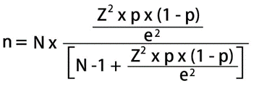

The formula will make use of a sample size calculator to calculate the actual numbers of samples needed for conducting the survey, and by numerical statistics measures, the result can be generalized to the population under research through the samples surveyed. Regarding sample size calculator, Meysamie et al. (2014) had conducted research on 59 online sample size calculators and their reliabilities were tested. Among them, only a small number could come up with accurate results. The authors advised that those websites which provided an actual calculating formula could be considered as more trust-worthy.
As of 3rd December, 2022, Hong Kong’s population reached 7,643,787 (Worldometer, 2022). The research was targeted to Hong Kong residents of at least 18 years old. There were 6,427,068 people aged 18 and over. The values for the mathematical symbols were as follows:
n = necessary samples required
N = 6,427,068 (population size)
Z = 1.96 (Z-score)
p = 0.5
e = +/- 5% (margin of error)
All the values were inserted into a sample size calculator, calculation showed that 385 respondents were needed for the actual survey.
For the pilot test, the sample size was determined by borrowing the rule of thumb of Roscoe (1975) reviewed in the study of Hill (1998). Roscoe recommended to have at least 30 samples or more, particularly in behavioural research, “sample size larger than 30 would ensure the researcher privileges of having central limit theorem” (Roscoe, 1975 in Hill, 1998). Therefore, the current researcher aimed at the minimal pilot sample size of 30 to carry out the recruitment of respondents, targeted to recruit at least 15 Generation MZ and no less than 15 Baby Boomers. For the pilot test, the researcher adopted the non-probability method of convenience sampling, recruitment continued until the sample size was reached; but for the actual research, convenience quota sampling strategy will be used by first dividing sample units into subgroups according to the proportionate dispersions of population, and then will start recruitment until the proportions of each subgroup correspond to the proportions of Hong Kong population under age 18. The final sample size of Baby Boomers for the pilot test eventually reached 29 respondents, which were out of the researcher’s expectation. The researcher’s original intention was to distribute questionnaires among acquaintances by means of convenience sampling, and 20 attempts had been made. The extra 9 responses were from snow-ball sampling, the act was not requested by the researcher, but was induced by the original respondents. This phenomenon indicated that Hong Kong people were familiar with this kind of online surveying technique, it was out from their hearts that they wanted to help with the research.

4.2 Data Collection Methods and Measurements
Quantitative data-collection methods based mostly on surveys, measured by numerical and statistical calculations. For the current research, an online questionnaire survey was conducted for gathering necessary primary data by asking multiple-choice type of close-ended questions.

4.2.1 Primary Data Collection and Measurements
Primary data for the current research were collected from an online self-administrative questionnaire distributed to respondents via the free-of-charge messaging app - WhatsApp. The questionnaire was constructed in bilingual of English and Chinese for Hong Kong residents’ easy accessibility. The front page was an introduction, informing respondents about climate change and environmental disruption, and explaining the reason why plant-based meat was taken into place, the purpose of the study was also explicitly stated. The questionnaire comprised of 6 sections. The first section asked general questions regarding respondents’ familiarities with plant-based meat, the first and third questions required respondents to answer on a nominal scale, and the second question required respondents to answer “yes” or “no” on a dichotomous scale. Section 2 was about consumer attitude, section 3 was about subjective norms, section 4 related to perceived behaviour control, and section 5 asked about behavioural intention and behaviour of consumption. These measurement items were adapted from the previous works of Marcus, Klink-Lehman and Hartmann (2022), Arli (2018) and Pandey, Ritz and Perez-Cueto (2021), and were measured on a 7-point Likert scale. Respondents could choose from strongly disagree to strongly agree. Section 6 asked about personal information. Five demographic items were asked, but only ages of Generation MZ and Baby Boomers were studied together with gender. After the bilingual questionnaire was constructed, it was then converted into a digital online form by using Google Forms, the form was then distributed to respondents via WhatsApp. The questionnaire was exhibited in Appendix 2.

4.2.2 Pilot Test of the Pilot Study
After the Google Forms questionnaire was established, it was sent to three professionals – a professor, a lecturer, and a flexitarian of meat-alternatives and real meat, for their initial preview and to invite comments. Minor amendments were made according to the professionals’
invaluable advices and feedbacks.
4.2.3 Secondary Data Collection
A tremendous amount of secondary data about plant-based meat had already been published by past researchers, reporters or bloggers. Secondary data can be retrieved from different sources, including open-access journal articles, anecdotal materials obtained on internet, published sources such as reports from government bodies, industry and trade associations, and market research reports by marketing professions. Books from libraries, newspapers and text books are also sources of secondary data. The current researcher had collected secondary data via most of the abovementioned channels.

4.3 Data Analysis Methods
The researcher adopted Jamovi version 2.3.18.0 as the analytical tool, which is a free alternative to IBM’s SPSS Statistics. Before the analytical procedures started, the researcher went through the process of wrangling data after they were input into Jamovi. Data were cleaned, reorganized, renamed, and transformed, in order to remove errors and made the data set easier to be analysed. The process of transformation was necessary to have a set of variables under one construct to be transformed into one variable by arithmetic calculation, in order to come up with an average mean with the assumption that all items were of equal weights. When the data was ready, descriptive and inferential statistics analyses could be applied.
4.3.1 Descriptive Statistical Analyses
Descriptive statistics is for describing the characteristics of data acquired from survey. The variables were described to generate accessible insights from responses collected. The researcher made use of tables and graphs to summarize the frequencies of occurrences and distributions of variables. The central tendencies of the data set were measured by means and medians. When central tendency showed where most of the data points lied, variability would measure how far apart these points were from each other. Variability was important to show how well the surveyed result could be generalized from samples to population. Among the four variance measuring methods - range, interquartile range, standard deviation and variance, standard deviation was used for the current research. Fifty respondents answered the questionnaire, but only 47 were in the age groups of Generation MZ and Baby Boomers. By using Google Forms and Jamovi, data were collected and analysed in systematic manners.

4.3.2 Inferential Statistical Analyses
Inferential statistics is for testing hypotheses, inferences could be drawn from sample data, so conclusions and hypothetical predictions could be generalized to the larger population. Reliability analysis was first to be conducted for ensuring precision and validity of the statistics. After the reliability of measurement items was confirmed, three tests would be carried out – comparison tests, correlation tests and regression tests. An independent t-test would be performed for comparison test, to determine if differences existed between the means of groups of variables. Pearson’s r test would be used for testing correlations, to quantify relationships between variables. Regression analyses were performed for investigating the strength and direction of relationships. Performance of tests were aimed to assess the relationships between variables, to justify whether the null hypotheses would be rejected or failed to be rejected.

5. Report and Analyses of Findings
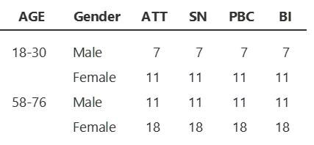
All 50 recruited respondents answered the questionnaire online; however, for the objective of the study, only the data of Generation MZ and Baby Boomers were analysed together with the factors of age and gender, a total of 47 respondents fit with the criterion. The sample size for Generation MZ was 18, of which 11 was female and 7 were male; and there were 29 Baby Boomers, 18 were female and 11 were male. Table 2 summarized the characteristics.
Table 2 Summary of Demographic Characteristics. The table was retrieved from Jamovi’s analytical output.

Three questions were asked in advance for obtaining information about respondents’ familiarities with plant-based meat. Table 3 summarized the descriptive statistics for the questions, however there was a bias detected. A Generation MZ male respondent replied that he had never eaten plant-based meat before, but later on when he was asked at where he consumed plant-based meat, or he might skip the question if he had never eaten before, he answered “consumed at restaurants”; therefore, the researcher made an assumption that the respondent had never eaten plant-based meat before, so one response was taken away from 17 “ate at restaurants” and became 16. The descriptive statistics of questions asked was demonstrated in Table 3.
Table 3 Descriptive Statistics of Questionnaire Questions. The table was retrieved from Jamovi’s analytical output.
Descriptive statistics of individual measurement items were listed in Table 4. Descriptive details run by Jamovi were displayed in Appendix 3a and 3b.

Table 4 Summary of Descriptive Statistics differentiated by Age and Gender. The table was retrieved from Jamovi’s analytical output.

In order to determine the overall consistencies of measurements, reliability test was conducted on the variables, and all variables would be transformed before the test. A summary of the transformed variables with statistics was displayed in Table 5, split by age and gender.
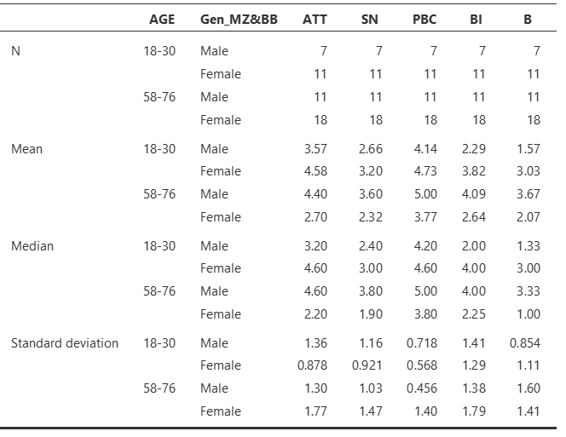
Table 5 Table of Transformed Variables. The table was retrieved from Jamovi’s analytical output.

The pilot reliability test was conducted, and the Cronbach’s alphas of the constructs were listed in Table 6. The detailed test results were displayed in Appendix 4a.
Table 6 Results of Pilot Reliability Test. The table was constructed by the researcher.

As a general rule, the Cronbach alpha (denoted by α) of 0.8 > α ≥ 0.7 is considered to be acceptable, of 0.9 > α ≥ 0.8, it is considered as good, and if above 0.90, the value is excellent. However, if the alpha value is of 0.7 > α ≥ 0.6, it is a questionable value; if the value is of 0.6 > α ≥ 0.5, it is poor. If α is below 0.5, the reliability is unacceptable (Peterson, 2013). For the pilot test, attitude and consumption behavior were having Cronbach’s alphas of above 0.9, their internal consistencies were excellent, they were reliable and could be retested. Subjective norms and behavioral intention were also having good internal consistencies. The measurement items were selected by the researcher correctly, and the respondents understood the questionnaire questions well. However, perceived behavior control’s consistency was under question, and its correlation heatmap displayed in Appendix 4a was needed to be examined. Correlation heatmaps were graphical visualization of data, showing the magnitudes of variables being tested and the values were indicated by color. PBC5 correlated negatively with the total scale, so Jamovi suggested to have the values reversed. Both heatmaps of “before reversion” and “after reversion’ were displayed to show the differences. Samuels (2012) defined the reversion towards the mean as “a shift in conditional expectation of the distribution. The application is useful for statistical reasoning and is more feasible than applying regression towards the mean”. PBC5 was about: “It is totally up to me to consume or not to consume plant-based meat”, and its correlation with PBC2 and PBC3, which were about: “consuming plant-based meat might bring improvement to environment” and “I am willing to pay more money to consume plant-based meat in order to protect environment”, showed negative correlations. As could be seen from the histogram of PBC in Appendix 3b, BB male had a fairly typical bell-curve of distribution, whereas the curve of BB female was having an irregular shape. For a small sample size of pilot test, there might be a chance that there were underlying reasons of female respondents in the BB age group that led to their unusual responses when compared to male; therefore, by assuming all other factors being equal, there might be a future predicted chance that a bigger sample size might bring different correlations. Based on these reasonings, the researcher conducted the reversion.
Comparison tests simply look for the differences among group means. They are used for testing the effect of a specific categorical variable against the mean values of other variables. T-tests were conducted for the objective to test hypotheses. Independent t-test was implemented to see if genders and age groups showed differences in their relationship with the variables.
For attitude, when comparing median of males (M=3.9, SD=1.35) to that of females (M=4, SD=1.75), males demonstrated a better score with a standard deviation more reliable as the data were more clustered to the mean; therefore, t(45)=1.38 and p=0.176, with a p-value exceeded 0.1, the null hypothesis was true. Subjective norms’ median of males (M=3, SD=1.15) was compared to that of females (M=2.6, SD=1.34), males demonstrated a better score with more reliable SD; consequently, t(45)=1.51 and p=0.137, with p>0.1, the null hypothesis was true.
Perceived behavioural control’s medium of males (M=4.8, SD=0.7) was compared to that of females (M=4.6, SD=1.23), males demonstrated a better score with more reliable SD; with t(45)=1.68 and p=0.1, with p≥0.1, the null hypothesis was true. For behavioural intention, when comparing the males’ median (M=2.90, SD=1.612) with females’ median (M=2.60, SD=1.43), males demonstrated a better score with more reliable SD; therefore, t(45)=0.822 and p=0.415, with p≥0.1, the null hypothesis was also true. For consumption behaviour, the median of males (M=2.33, SD=1.69) was compared with the median of females (M=2.33, SD=1.37), females demonstrated a better score with more reliable SD; with t(45)=0.923 and p=0.361, with p>0.1, the null hypothesis was failed to be rejected.

Attitude’s median of Generation MZ (M=4.6, SD=1.17), when compared to that of Baby Boomers (M=3.8, SD=1.79), MZ demonstrated a better score with more reliable SD; t(45)=1.77, p=0.083, with p>0.05 but less than 0.10, the researcher did not have significant evidence to accept that the null hypothesis was true, particularly the effect size showed 0.532, implying that the finding had practical significance; therefore, the null hypothesis was rejected. Subjective norms’ median of MZ (M=2.9, SD=1.03) compared to that of BB (M=2.6, SD=1.45), MZ demonstrated a better score with more reliable SD; t(45)=0.465, p=0.644, with a significantly high p-value, the null hypothesis was said to be true. Perceived behavioural control’s median of MZ (M=4.5, SD=0.676), compared to that of BB (M=4.8, SD=1.28), MZ demonstrated a better score with more reliable SD; t(45)=0.812, p=0.421, with p>0.1, the null hypothesis was true. Behavioural intention’s median of MZ (M=2.8, SD=1.291), compared to that of BB (M=2.60, SD=1.63), MZ demonstrated a better score with more reliable SD; t(45)=-0.256 and p=0.799, with p>0.1, the null hypothesis was true. For behavioural intention, MZ’s median (M=2.8, SD=1.29) to BB’s median (M=2.60, SD=1.63), MZ demonstrated a better score with more reliable SD; therefore, when t(45)=-0.256 and p=0.799, with p>0.1, the null hypothesis was failed to be rejected. For consumption behaviour, MZ’s median (M=2.33, SD=1.23) compared to BB’s median (M=2.33, SD=1.64), MZ demonstrated a better score with SD more clustered to the mean; therefore t(45)=-0.476 and p=0.637, with p>0.1, the null hypothesis was failed to be rejected.

A correlation test was conducted to evaluate the relationship between variables. The result was demonstrated in Table 7.
Table 7 Correlation Matrix of Variables. The table was retrieved from Jamovi’s analytical output.

The Pearson correlation coefficient (denoted by r) ranges between -1 to 1, from negative correlation to positive correlation. For the pilot test, the correlations between BI and variables of ATT, SN and PBC ranges between 0.479 and 0.771. The correlation between attitude and behavioural intention had a very strong positive correlation of 0.745, subjective norms and behavioural intention also had a strong positive correlation of 0.771; whereas, perceived behavioural control had a moderate positive correlation with behavioural intention of 0.479. Behavioural intention and consumption behaviour had the strongest correlation of 0.842. All these correlations had p<0.001, the correlations were statistically significant.

Figure 3 Hypothesized Theoretical Framework with Correlations. The framework was constructed by the researcher.

Table 8 was a summary table for demonstrating the results of the independent samples t-test. Other Jamovi details were displayed in Appendix 4b.
Table 8 Summary Table for Results of Independent Samples T-test. The table was constructed by the researcher with data retrieved from Jamovi’s analytical output.

Table 9 displayed the findings of independent samples t-test for behavioural intention and the demographic factors of age and gender.

Table 9 Table of Independent Samples T-test for Behavioural Intention and Demographic Characteristics. The table was constructed by the researcher with data retrieved from Jamovi’s analytical output.

From the results demonstrated in Table 8, Hypothesis H₅a was rejected, showing that age had no significant association with Hong Kong consumers’ behavioral intention to consume plant-based meat. Moreover, Hypothesis H₅b was also rejected, showing that gender had no significant association with Hong Kong consumers’ behavioral intention to consume plant-based meat.

6. Conclusion of Pilot Test
It was out of the researcher’s expectation that almost all alternative hypotheses listed below were rejected, except that Generation MZ’s responses showed acceptance to Hypothesis 1 regarding attitude towards behavioural intention of consumption.
H₁: Attitude has direct effect on Hong Kong consumers’ behavioral intention to purchase plant-based meat.
H₂: Subjective norms have direct effects on Hong Kong consumers’ behavioral intention to purchase plant-based meat.
H₃: Perceived behavioral control has direct effect on Hong Kong consumers’ behavioral intention to purchase plant-based meat.

H₄: Behavioral intention has direct effect on Hong Kong consumers’ consuming behavior of plant-based meat.

H₅a: Age has significant association with Hong Kong consumers’ behavioral intention to consume plant-based meat.

H₅b: Gender has significant association with Hong Kong consumers’ behavioral intention to consume plant-based meat.

6.1 Conclusion
Overall responses were having means and medians of below average. Respondents’ attitudes toward consumption of plant-based meat tended to be inspired by the beliefs of caring the environment and concerning animal welfare and they thought consuming PBM could be considered as a sustainable choice. Perceived behavioural control received the highest scores, mostly at average or above the average of 4. Many respondents were not sure if they would eat PBM regularly in the future, but they agreed that they had control over their own behaviour to consume or not to consume PBM, females were more significant than males. Females slightly agreed that consuming PBM would be beneficial to the environment, but they were not too willing to pay more for plant-based meat. The mean values of behavioural intention and consumption behaviour were all under average, respondents’ consuming intention was low for PBM, thus the actual consumption behaviour was also affected. Regardless of caring the environment, respondents would not purchase PBM on a regular basis and might not recommend family members and friends to buy it. Attitudes and purchase intentions did not coincide with one another.

Subjective norms received the lowest overall score of means and medians among all, matched with the research results of Shin and Hancer (2016)’s study, showing that SN was the weakest predictor. Respondents tended to disagree that the ones whom they cared for would consume PBM and they would be influenced by their important ones to consume PBM. SN seemed not to play an effective role in affecting the consumption behaviour of PBM, which was in contrary to the research findings of Ham, Jeger and Ivković (2015) that SN showed inspiration to consumers’ consuming intention. The research of Carfora (2020) even stated that subjective norms was the strongest construct in predicting behavioural intention in Italy. Although SN showed positively strong correlation of 0.771 with behavioural intention, Hong Kong respondents tended not to agree that they would be influenced by their friends and family members to consume plant-based meat. The results brought answer to Research Question 1: “How does the role of subjective norms affect Hong Kong’s Generation MZ and Baby Boomers in forming their behavioural intention to consume plant-based meat?”. Subjective norms were not playing roles to affect Hong Kong Generation MZ and Baby Boomers’ intention to consume plant-based meat. For Research Question 2: “Will there be age-variance and gender-variance if these demographic variables are to be compared against the result of subjective norms influences?” Age-variance in subjective norm was minimal, as most answers lied below the mean values. As a result, hypothesis H₅a was rejected, showing that age had no significant association with Hong Kong consumers’ behavioral intention to consume plant-based meat. The finding was different from that of the West, the research conducted by Boukid (2020) in Spain discovered that young millennials showed interest in consuming plant-based meat was due to their environmental concerns and easy accessibility of PMB, whereas the older generation was motivated by taste of PMB and their familiarities of this novel product. Young millennial female with higher education showed more concerns about the environment, while the older females cared more about healthiness. Unlike Hong Kong, respondents showed one-sided disinterest.
Hypothesis H₅b was also rejected, showing no significant association between gender and behavioral intention to consume PMB. The result was significantly different from the findings of Hinrichs (2022) that men were more defensive towards plant-based meat, and women showed less defensiveness. The research of Rosenfeld and Tomiyama (2021) also showed that men’s openness to become vegans or vegetarians were lower than that of women. The study of Modlinska et al. (2020) also stated that men had higher conformity with masculine identity, so they complied more with their intrinsic preference of meat, whereas women were more sensitive to food and nutrition healthiness, thus consuming more fibers. However, the pilot study indicated that only Generation MZ showed the highest-scored response of neither agree nor disagree to item SN5: “An individual person or a group of people’s degree of influences would strongly affect my eating decision of plant-based meat’, the means of other responses were all below average. Gender-variance was also not significant, most responses lied between the means of 2.1 and 3.67, all below the average of 4. Only the male MZ had a mean value of 4 for SN5.

As a conclusion, both male and female respondents of the pilot test, regardless of age, were reluctant to pick up plant-based diets, especially female respondents were unwilling to pay more for PBM, but men’s consuming decisions had higher likeliness to be influenced by subjective norms.

6.2 Validity of Conclusion and Replicability
Research findings concluded that there was adequate statistical power to identify the relationships among measurement items, and their correlations between variables were all significant. There were evidences to support the validity of conclusion by basing on the relations of variables. Furthermore, the variables and measurement items of the pilot test were frequently adopted in past studies, so they were proven to be valid. There was also external validity that the results of this pilot test could be generalized to Hong Kong population at large, since the reliability was proven by Cronbach’s alphas. However, the p-values were all higher than 0.05, implying that the results might be derived from chance because of small sample groups; consequently, the pilot test results might not be replicated by other researchers in other studies.

6.3 Limitations
Due to time constraint of conducting the pilot test, the researcher was not able to recruit a balanced number of respondents in both age groups. With 29 Baby Boomers and only 18 Generation MZ, the imbalance was obvious. Furthermore, the recruitment of respondents was not at all of non-probabilistic convenience, most participants were researcher’s acquaintances. Moreover, if time allowed, more inferential tests should be conducted for data-testing.

6.4 Recommendations for Further Research
The measurement items of Perceived Behaviour Control were needed to be adjusted. More appropriate constructs should be investigated for obtaining better correlation without reversion. In the future, a mixed method research design can be adopted by combining both qualitative and quantitative approaches for similar researches of plant-based meat. With anticipation to reveal new measurement items during focus group discussions which can be used in future questionnaires. Further study of plant-based meat could be performed on only one age group – the Baby Boomers, and studies of gender and other demographic factors will not be necessary. The population size of Silver Hair is on the growing trend, and studies for understanding more of their consumption behaviours will bring benefits to manufacturers and marketers of plant-based meat.

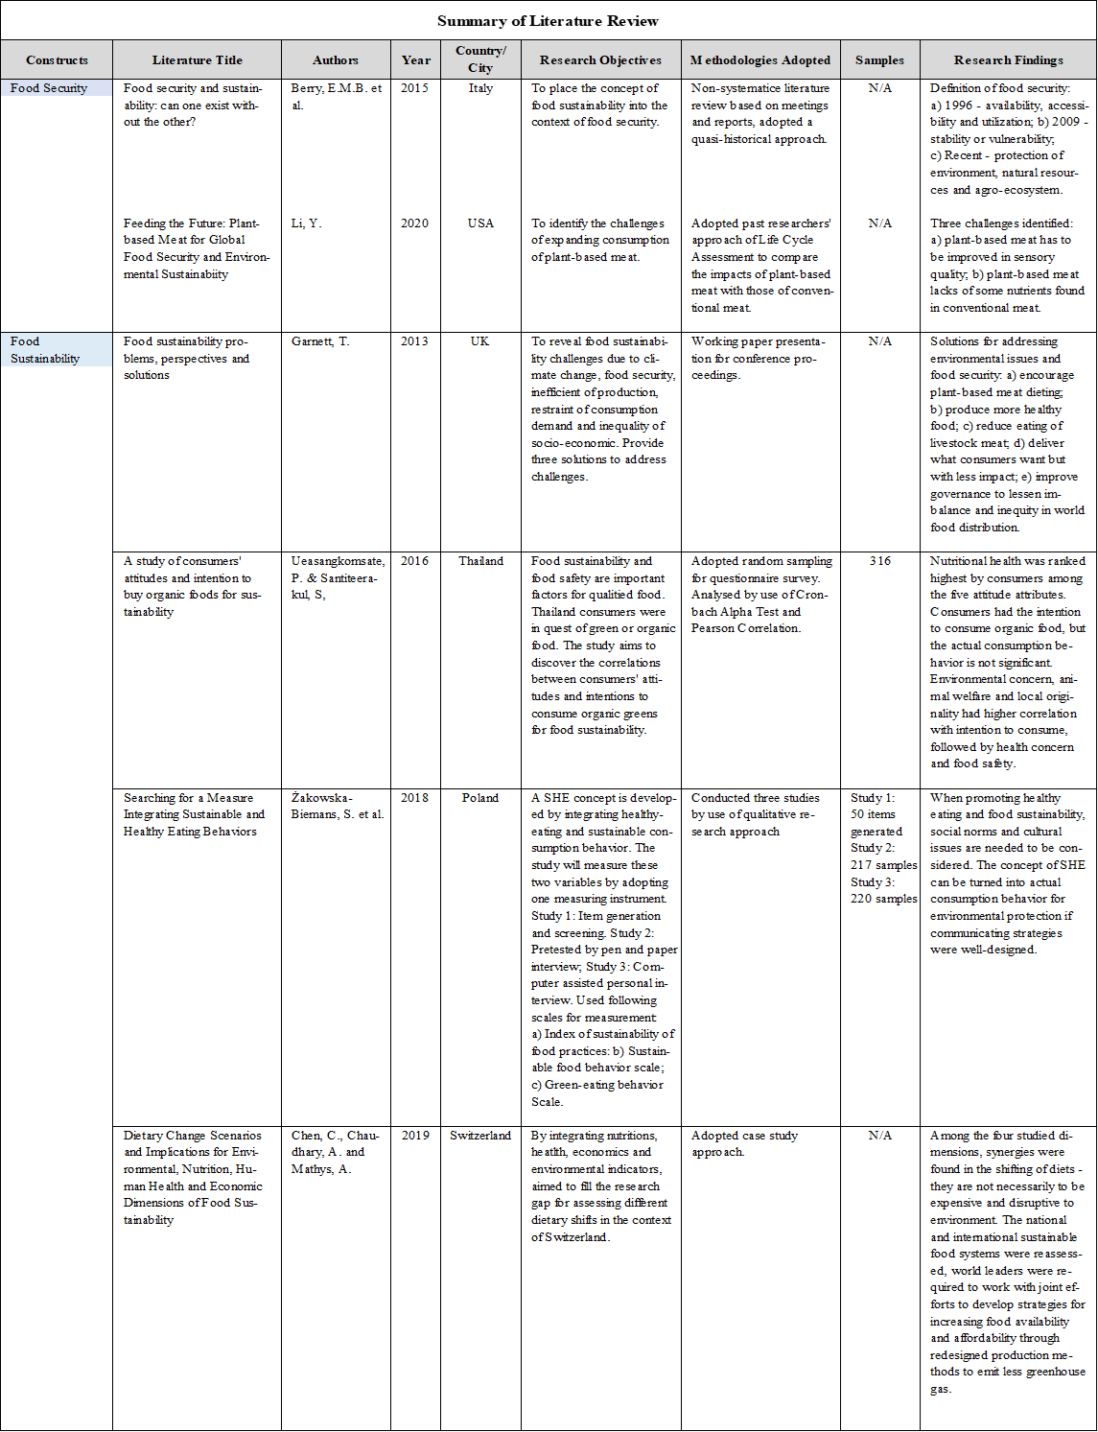
Appendix 1 Literature Review Summary

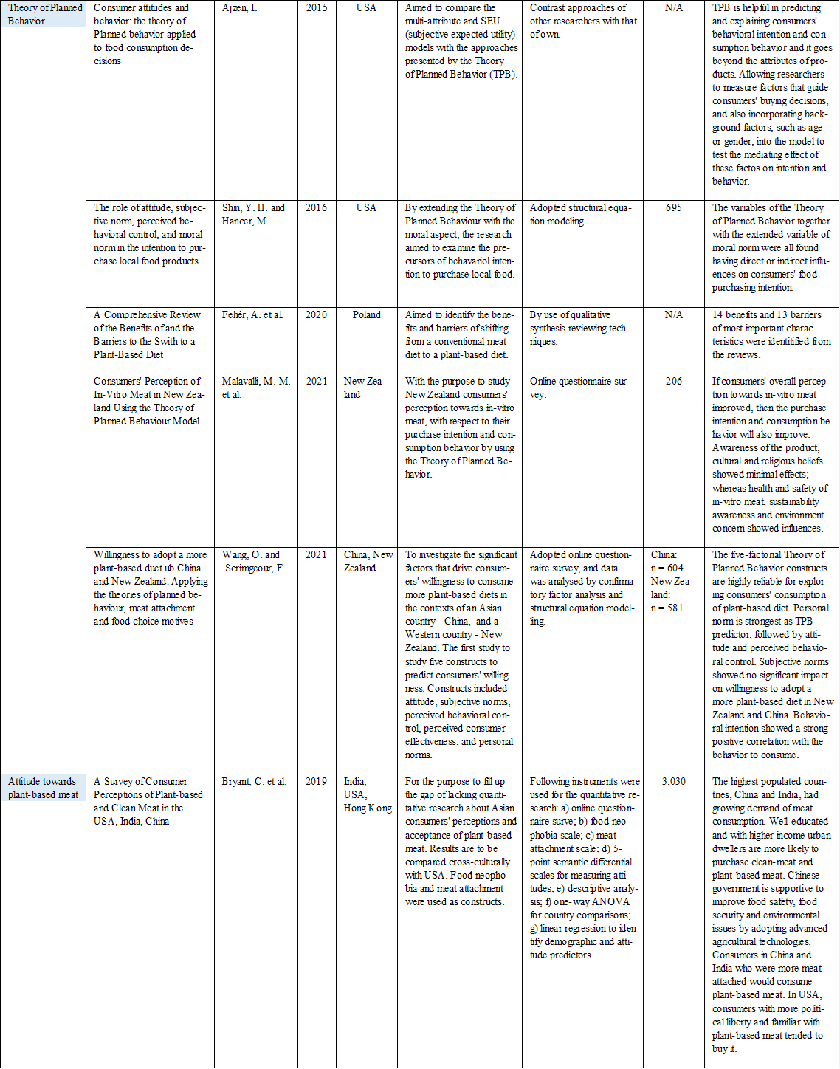

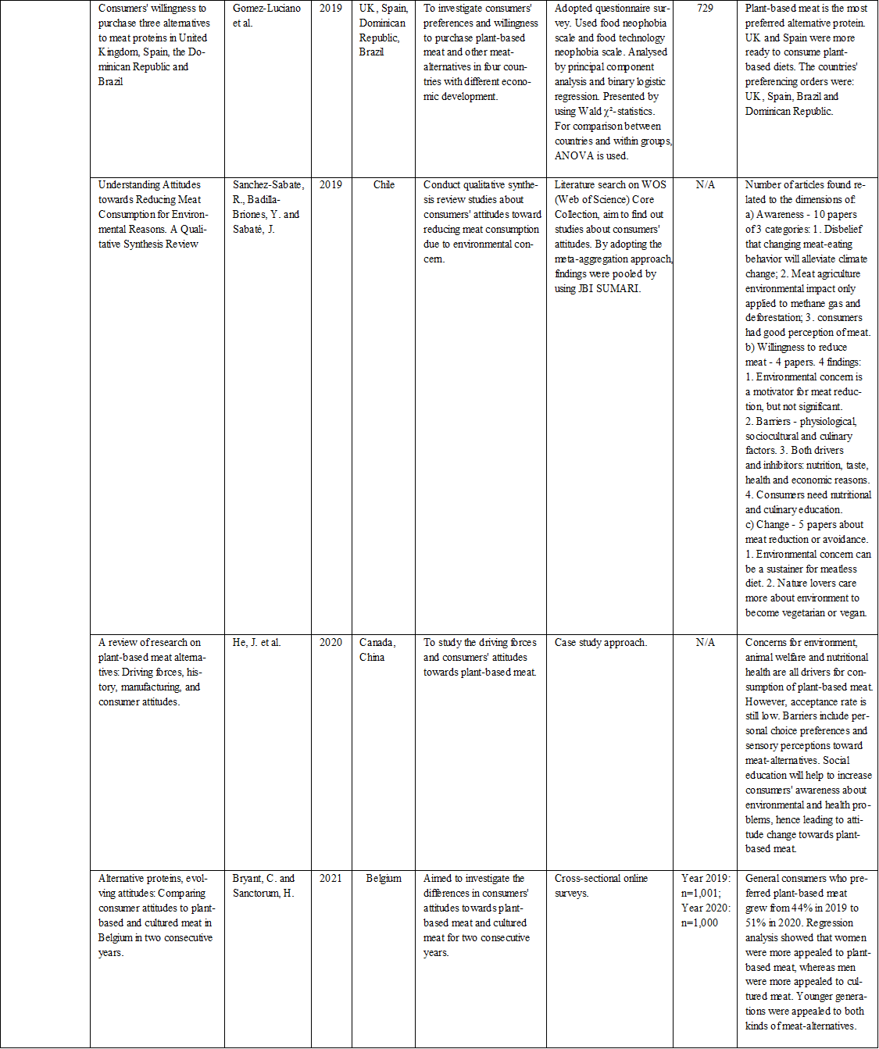

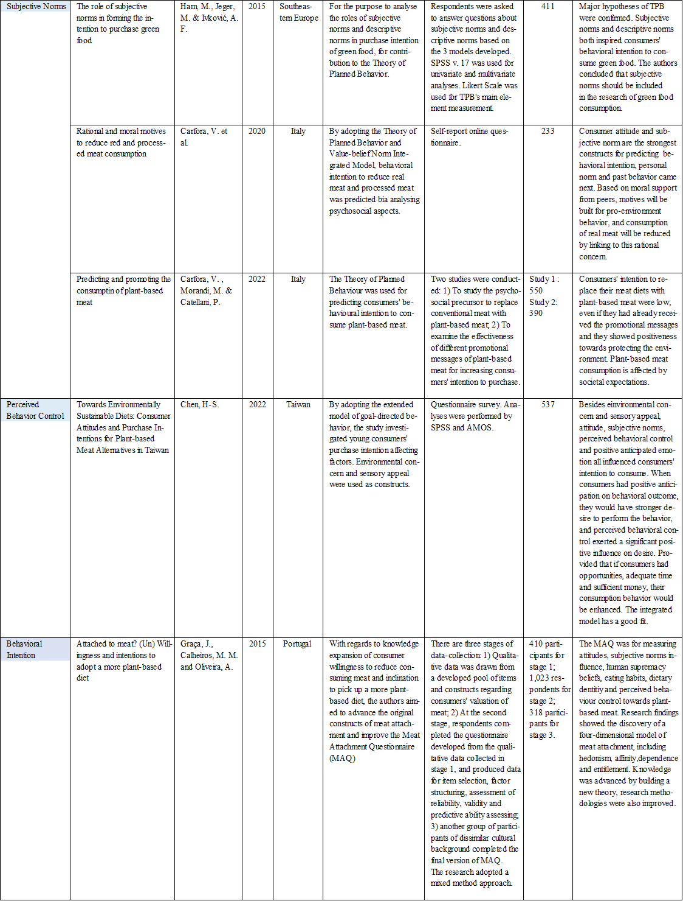

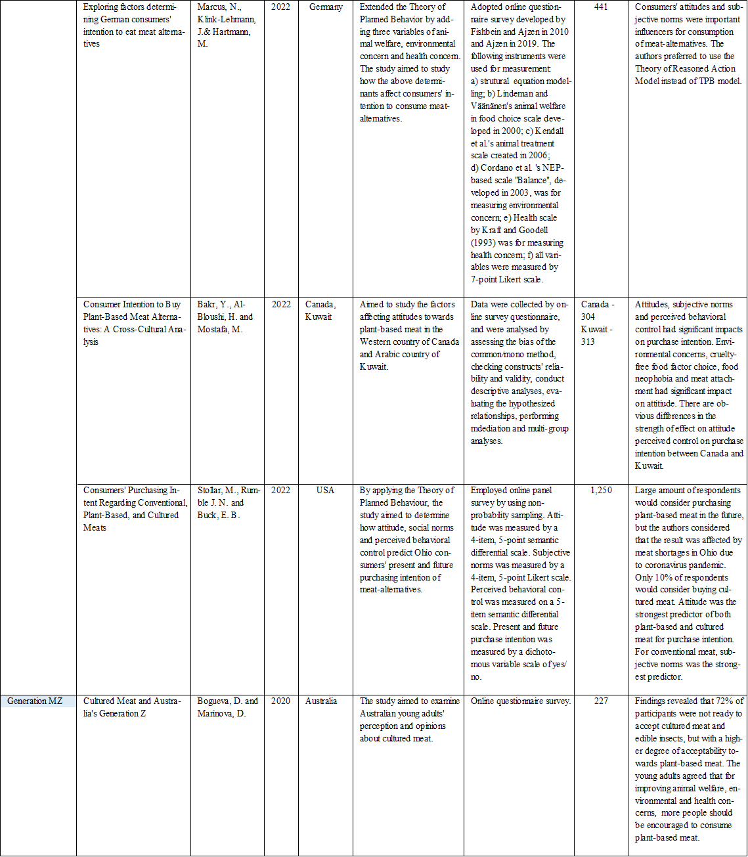
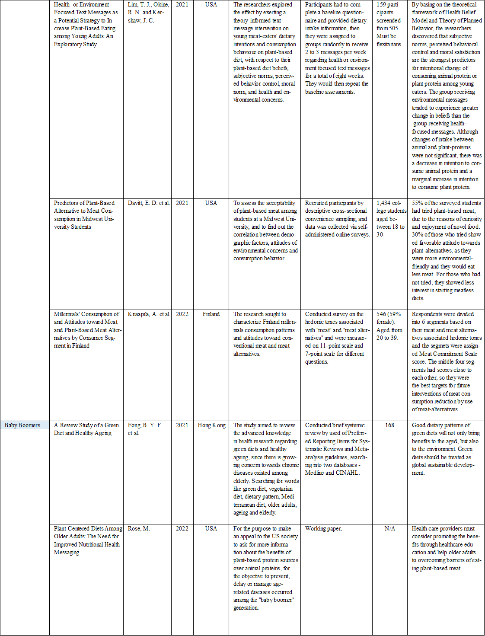
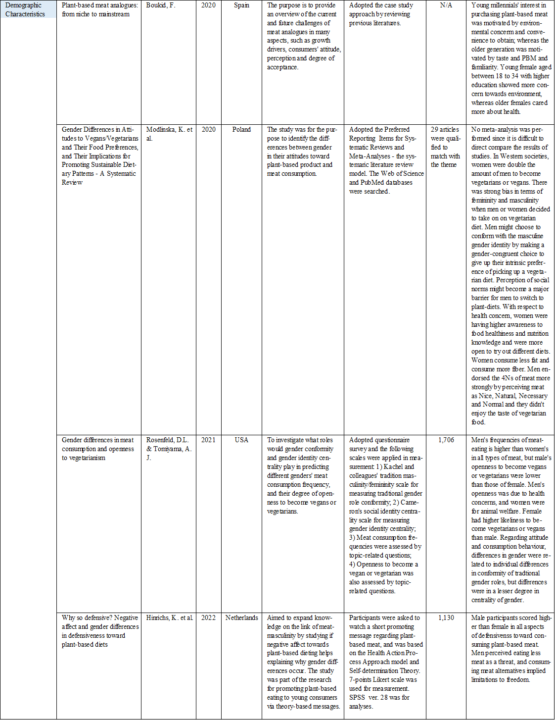
Appendix 2 Survey Questionnaire
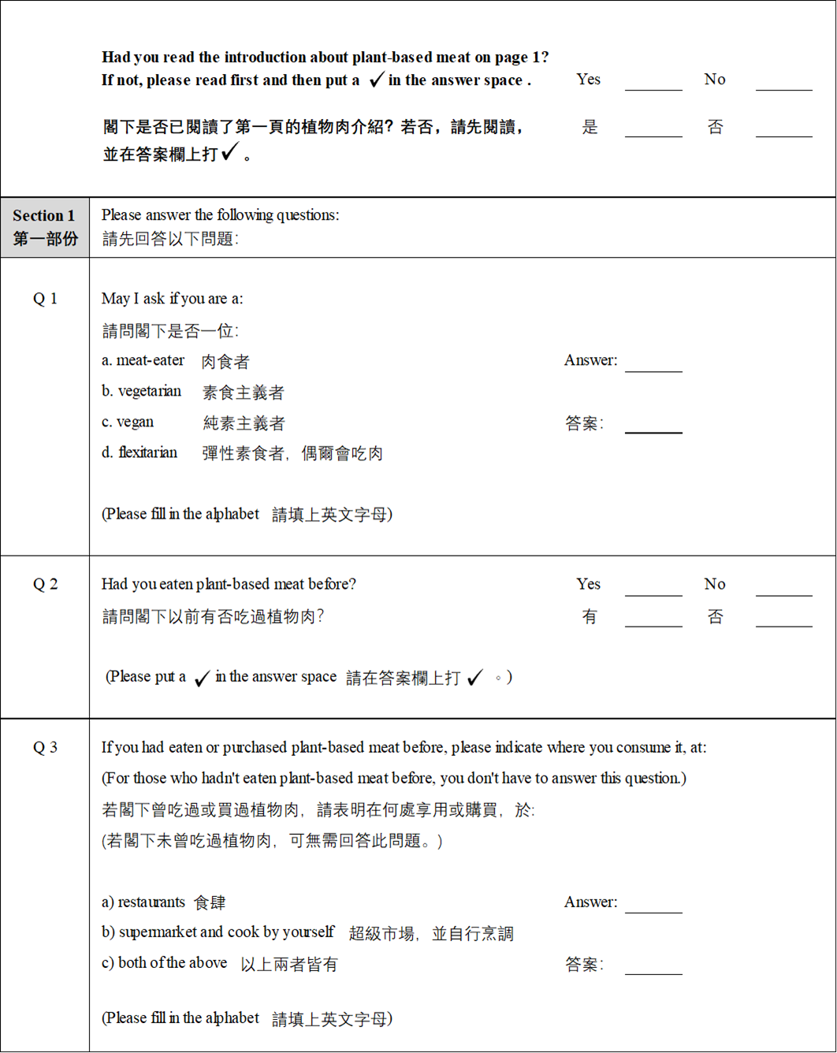

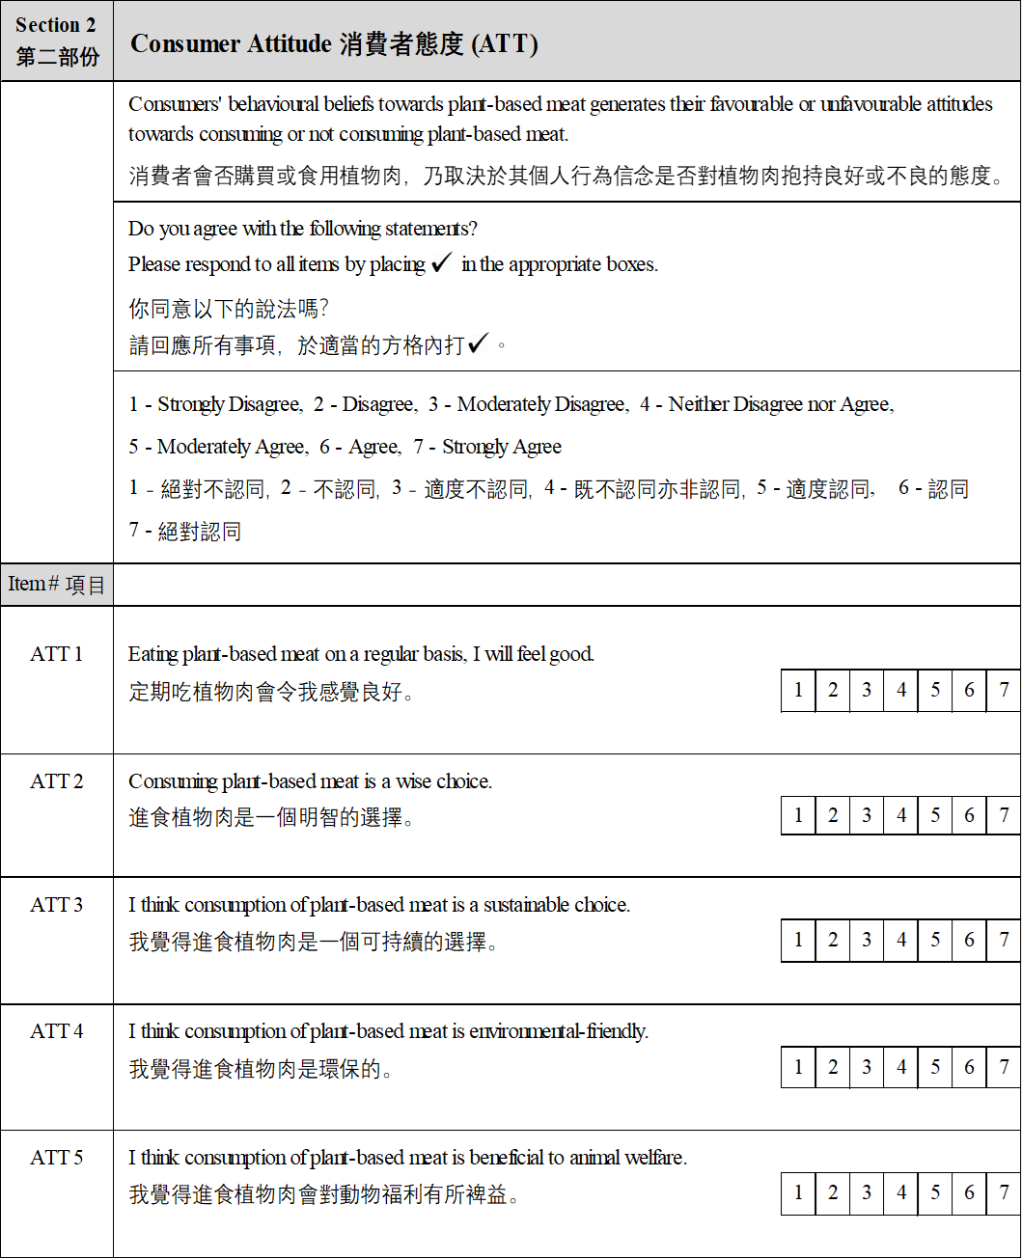

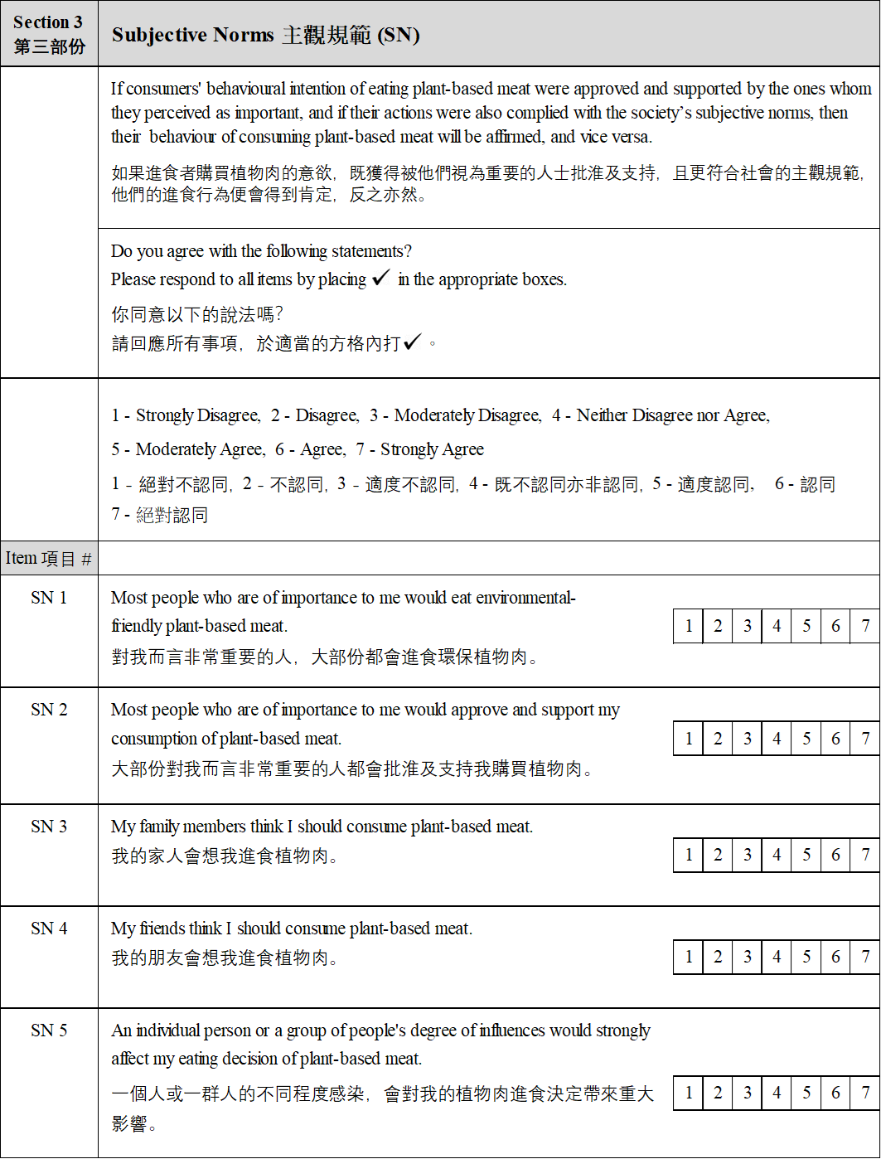
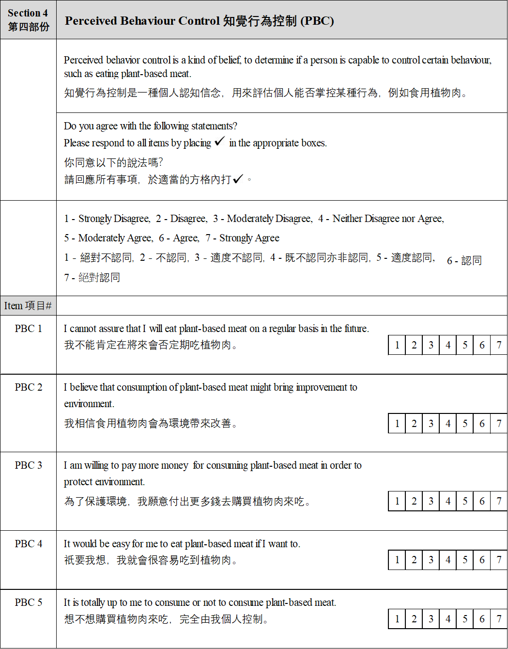

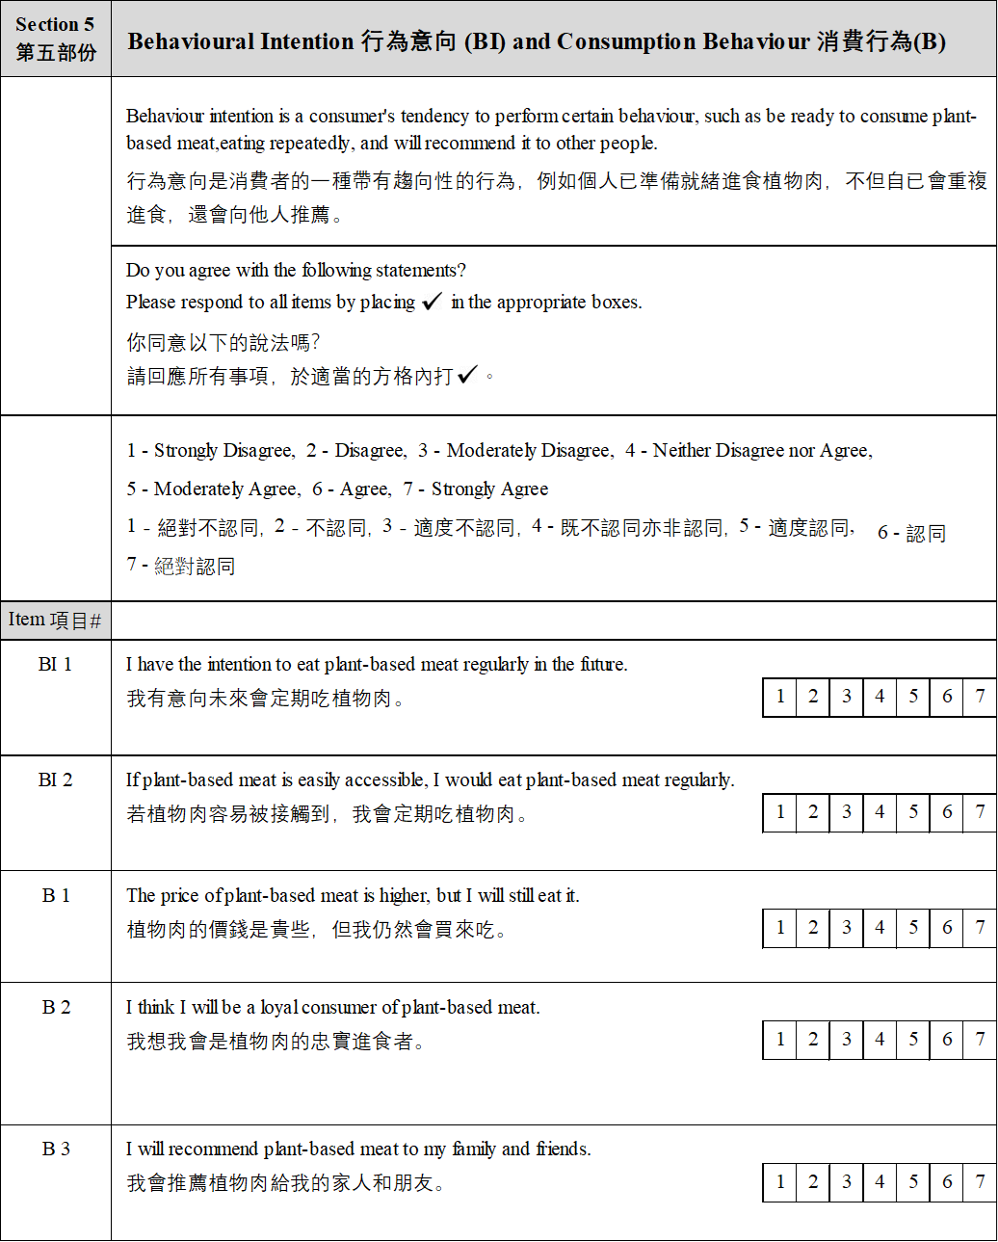

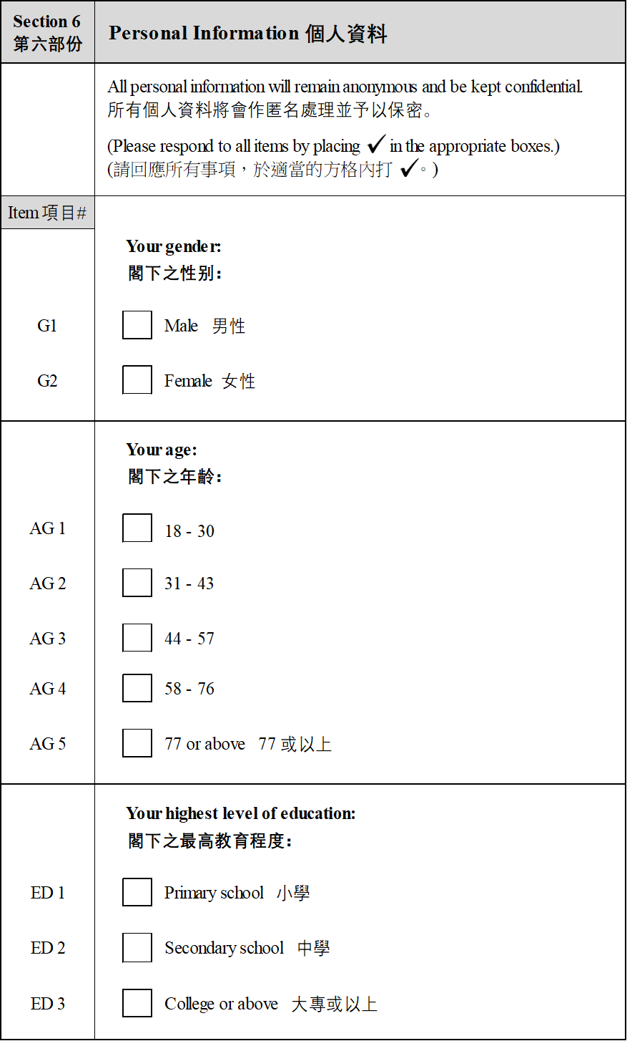
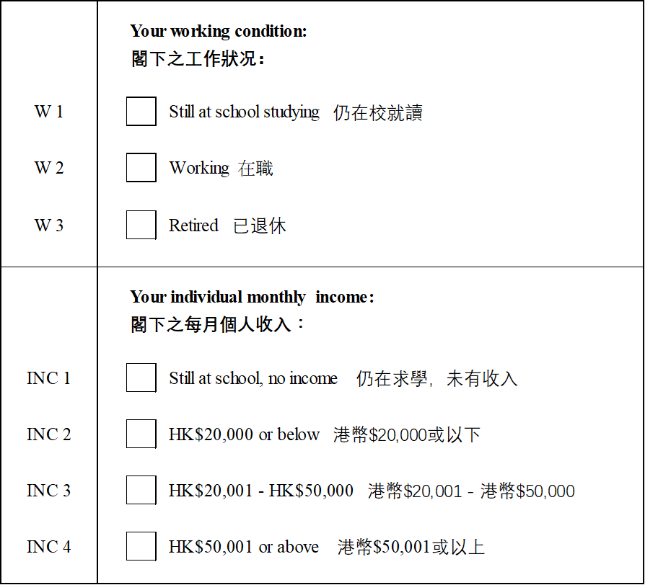

Thank you very much for your precious time!

非常感謝閣下抽出寶貴時間!

Appendix 3
Descriptives of Demographic Characteristics and Variables

Appendix 3 consisted of two sections, Appendix 3a displayed the descriptives and plots of demographic characteristics, whereas Appendix 3b exhibited the descriptives of individual variables and transformed.
Appendix 3a Descriptives of Demographic Variables
Frequencies of Demographic Characteristics
Frequencies of Generation MZ
Generation MZ |  | Gender |  |  |  | Counts |  |  | % of Total |  |  |  |  | Cumulative %
18-30 |  | Female |  |  |  | 11 |  |  | 61.1 % |  |  |  |  | 61.1 %
 |  | Male |  |  |  | 7 |  |  | 38.9 % |  |  |  |  | 100.0 %
Frequencies of Baby Boomers
Baby Boomers |  |  |  | Gender |  |  |  |  |  | Counts |  |  | % of Total |  |  | Cumulative %
58-76 |  |  |  | Female |  |  |  |  |  | 18 |  |  | 62.1 % |  |  | 62.1 %
 |  |  |  | Male |  |  |  |  |  | 11 |  |  | 37.9 % |  |  | 100.0 %
Descriptives of Variables

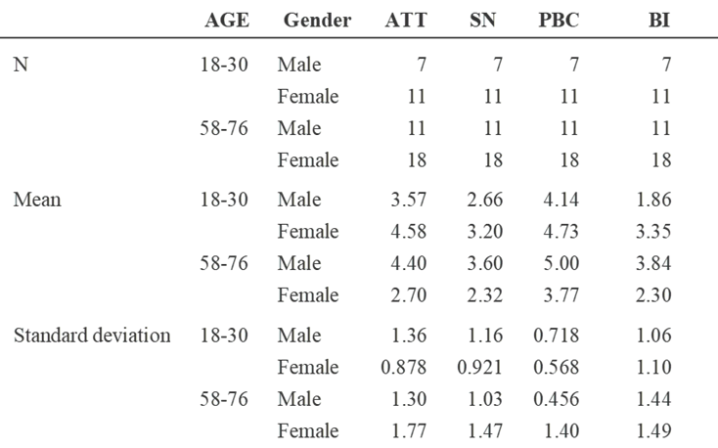
Plots

Attitude Subjective Norm
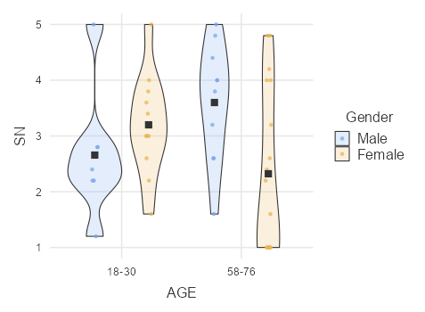
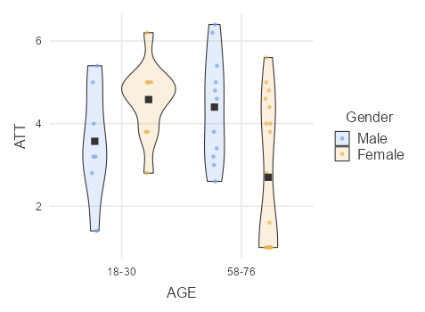

Perceived behaviour control Behavioural Intention
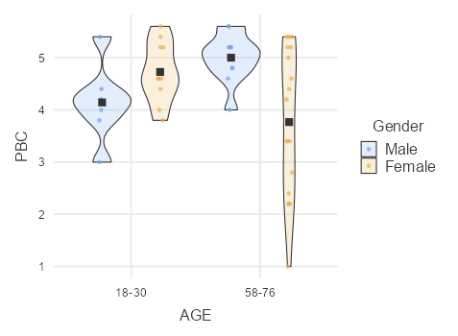
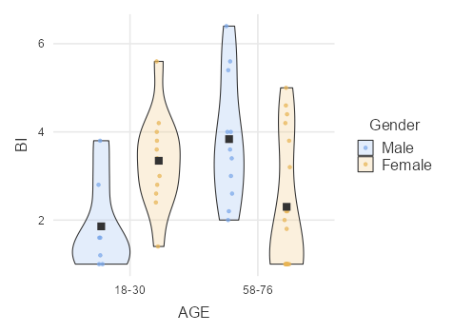

Appendix 3b Descriptives of Individual Independent Variables

Descriptive of Attitude:
Descriptives by Age
 |  | AGE |  | ATT1 |  |  |  | ATT2 |  |  |  | ATT3 |  |  |  | ATT4 |  |  |  | ATT5
N |  | 18-30 |  | 18 |  |  |  | 18 |  |  |  | 18 |  |  |  | 18 |  |  |  | 18
 |  | 58-76 |  | 29 |  |  |  | 29 |  |  |  | 29 |  |  |  | 29 |  |  |  | 29
Mean |  | 18-30 |  | 3.17 |  |  |  | 3.83 |  |  |  | 4.78 |  |  |  | 4.39 |  |  |  | 4.78
 |  | 58-76 |  | 3.07 |  |  |  | 3.03 |  |  |  | 3.24 |  |  |  | 3.72 |  |  |  | 3.66
Median |  | 18-30 |  | 3.50 |  |  |  | 4.50 |  |  |  | 5.00 |  |  |  | 5.00 |  |  |  | 5.00
 |  | 58-76 |  | 4 |  |  |  | 3 |  |  |  | 3 |  |  |  | 4 |  |  |  | 4
Standard deviation |  | 18-30 |  | 1.72 |  |  |  | 1.72 |  |  |  | 1.22 |  |  |  | 1.20 |  |  |  | 1.73
 |  | 58-76 |  | 1.81 |  |  |  | 1.74 |  |  |  | 1.90 |  |  |  | 2.05 |  |  |  | 2.07
Minimum |  | 18-30 |  | 1 |  |  |  | 1 |  |  |  | 3 |  |  |  | 1 |  |  |  | 1
 |  | 58-76 |  | 1 |  |  |  | 1 |  |  |  | 1 |  |  |  | 1 |  |  |  | 1
Maximum |  | 18-30 |  | 6 |  |  |  | 6 |  |  |  | 7 |  |  |  | 6 |  |  |  | 7
 |  | 58-76 |  | 6 |  |  |  | 6 |  |  |  | 6 |  |  |  | 7 |  |  |  | 7
Descriptives by Gender

 |  | Gen_MZ&BB |  |  |  |  | ATT1 |  |  |  | ATT2 |  |  |  | ATT3 |  |  |  | ATT4 |  |  |  | ATT5
N |  | Male |  |  |  |  | 18 |  |  |  | 18 |  |  |  | 18 |  |  |  | 18 |  |  |  | 18
 |  | Female |  |  |  |  | 29 |  |  |  | 29 |  |  |  | 29 |  |  |  | 29 |  |  |  | 29
Mean |  | Male |  |  |  |  | 3.56 |  |  |  | 3.50 |  |  |  | 4.33 |  |  |  | 4.50 |  |  |  | 4.50
 |  | Female |  |  |  |  | 2.83 |  |  |  | 3.24 |  |  |  | 3.52 |  |  |  | 3.66 |  |  |  | 3.83
Median |  | Male |  |  |  |  | 4.00 |  |  |  | 3.50 |  |  |  | 4.50 |  |  |  | 5.00 |  |  |  | 5.00
 |  | Female |  |  |  |  | 3 |  |  |  | 4 |  |  |  | 4 |  |  |  | 4 |  |  |  | 5
Standard deviation |  | Male |  |  |  |  | 1.79 |  |  |  | 1.76 |  |  |  | 1.28 |  |  |  | 1.58 |  |  |  | 1.72
 |  | Female |  |  |  |  | 1.71 |  |  |  | 1.79 |  |  |  | 2.05 |  |  |  | 1.86 |  |  |  | 2.16
Minimum |  | Male |  |  |  |  | 1 |  |  |  | 1 |  |  |  | 2 |  |  |  | 1 |  |  |  | 1
 |  | Female |  |  |  |  | 1 |  |  |  | 1 |  |  |  | 1 |  |  |  | 1 |  |  |  | 1
Maximum |  | Male |  |  |  |  | 6 |  |  |  | 6 |  |  |  | 6 |  |  |  | 7 |  |  |  | 7
 |  | Female |  |  |  |  | 6 |  |  |  | 6 |  |  |  | 7 |  |  |  | 6 |  |  |  | 7

Descriptives of Social Norms:
Descriptives by Age
 |  | AGE |  | SN1 |  | SN2 |  | SN3 |  | SN4 |  | SN5
N |  | 18-30 |  | 18 |  | 18 |  | 18 |  | 18 |  | 18
 |  | 58-76 |  | 29 |  | 29 |  | 29 |  | 29 |  | 29
Mean |  | 18-30 |  | 2.33 |  | 3.67 |  | 2.17 |  | 2.56 |  | 4.22
 |  | 58-76 |  | 2.45 |  | 3.21 |  | 2.48 |  | 2.69 |  | 3.21
Median |  | 18-30 |  | 2.00 |  | 4.00 |  | 2.00 |  | 2.50 |  | 4.00
 |  | 58-76 |  | 2 |  | 3 |  | 2 |  | 2 |  | 3
Standard deviation |  | 18-30 |  | 1.46 |  | 1.46 |  | 1.29 |  | 1.38 |  | 1.66
 |  | 58-76 |  | 1.45 |  | 1.74 |  | 1.40 |  | 1.54 |  | 2.11
Minimum |  | 18-30 |  | 1 |  | 1 |  | 1 |  | 1 |  | 1
 |  | 58-76 |  | 1 |  | 1 |  | 1 |  | 1 |  | 1
Maximum |  | 18-30 |  | 6 |  | 6 |  | 5 |  | 6 |  | 7
 |  | 58-76 |  | 6 |  | 6 |  | 5 |  | 6 |  | 6

Descriptives by Gender
 |  | Gen_MZ&BB |  | SN1 |  | SN2 |  | SN3 |  | SN4 |  | SN5
N |  | Male |  | 18 |  | 18 |  | 18 |  | 18 |  | 18
 |  | Female |  | 29 |  | 29 |  | 29 |  | 29 |  | 29
Mean |  | Male |  | 2.89 |  | 3.67 |  | 2.83 |  | 2.78 |  | 4.00
 |  | Female |  | 2.10 |  | 3.21 |  | 2.07 |  | 2.55 |  | 3.34
Median |  | Male |  | 3.00 |  | 4.00 |  | 2.50 |  | 2.00 |  | 4.00
 |  | Female |  | 2 |  | 4 |  | 2 |  | 3 |  | 4
Standard deviation |  | Male |  | 1.45 |  | 1.46 |  | 1.42 |  | 1.52 |  | 1.68
 |  | Female |  | 1.37 |  | 1.74 |  | 1.25 |  | 1.45 |  | 2.16
Minimum |  | Male |  | 1 |  | 1 |  | 1 |  | 1 |  | 1
 |  | Female |  | 1 |  | 1 |  | 1 |  | 1 |  | 1
Maximum |  | Male |  | 6 |  | 6 |  | 5 |  | 6 |  | 7
 |  | Female |  | 6 |  | 6 |  | 5 |  | 6 |  | 7

Descriptives of Perceived Behavioural Control:
Descriptives by Age
 |  | AGE |  | PBC1 |  | PBC2 |  | PBC3 |  | PBC4 |  | PBC5
N |  | 18-30 |  | 18 |  | 18 |  | 18 |  | 18 |  | 18
 |  | 58-76 |  | 29 |  | 29 |  | 29 |  | 29 |  | 29
Missing |  | 18-30 |  | 0 |  | 0 |  | 0 |  | 0 |  | 0
 |  | 58-76 |  | 0 |  | 0 |  | 0 |  | 0 |  | 0
Mean |  | 18-30 |  | 5.17 |  | 4.44 |  | 3.61 |  | 3.61 |  | 5.67
 |  | 58-76 |  | 4.69 |  | 4.14 |  | 3.17 |  | 3.31 |  | 5.86
Median |  | 18-30 |  | 5.00 |  | 5.00 |  | 4.00 |  | 4.00 |  | 6.00
 |  | 58-76 |  | 5 |  | 4 |  | 4 |  | 3 |  | 7
Standard deviation |  | 18-30 |  | 1.65 |  | 1.46 |  | 1.75 |  | 1.50 |  | 1.50
 |  | 58-76 |  | 2.14 |  | 2.05 |  | 1.83 |  | 2.09 |  | 1.64
Minimum |  | 18-30 |  | 1 |  | 1 |  | 1 |  | 1 |  | 2
 |  | 58-76 |  | 1 |  | 1 |  | 1 |  | 1 |  | 1
Maximum |  | 18-30 |  | 7 |  | 7 |  | 6 |  | 6 |  | 7
 |  | 58-76 |  | 7 |  | 7 |  | 6 |  | 7 |  | 7

Descriptives by Gender
 |  | Gen_MZ&BB |  | PBC1 |  | PBC2 |  | PBC3 |  | PBC4 |  | PBC5
N |  | Male |  | 18 |  | 18 |  | 18 |  | 18 |  | 18
 |  | Female |  | 29 |  | 29 |  | 29 |  | 29 |  | 29
Missing |  | Male |  | 0 |  | 0 |  | 0 |  | 0 |  | 0
 |  | Female |  | 0 |  | 0 |  | 0 |  | 0 |  | 0
Mean |  | Male |  | 5.28 |  | 4.61 |  | 3.44 |  | 3.72 |  | 6.28
 |  | Female |  | 4.62 |  | 4.03 |  | 3.28 |  | 3.24 |  | 5.48
Median |  | Male |  | 6.00 |  | 4.50 |  | 4.00 |  | 3.50 |  | 7.00
 |  | Female |  | 5 |  | 5 |  | 4 |  | 3 |  | 6
Standard deviation |  | Male |  | 1.78 |  | 1.46 |  | 1.79 |  | 1.87 |  | 0.958
 |  | Female |  | 2.06 |  | 2.03 |  | 1.83 |  | 1.88 |  | 1.81
Minimum |  | Male |  | 1 |  | 1 |  | 1 |  | 1 |  | 4
 |  | Female |  | 1 |  | 1 |  | 1 |  | 1 |  | 1
Maximum |  | Male |  | 7 |  | 7 |  | 6 |  | 7 |  | 7
 |  | Female |  | 7 |  | 7 |  | 6 |  | 7 |  | 7

Descriptives of Behavioural Intention by Age and Gender
Descriptives
 |  | AGE |  | BI1 |  |  |  | BI2
N |  | 18-30 |  | 18 |  |  |  | 18
 |  | 58-76 |  | 29 |  |  |  | 29
Missing |  | 18-30 |  | 0 |  |  |  | 0
 |  | 58-76 |  | 0 |  |  |  | 0
Mean |  | 18-30 |  | 2.94 |  |  |  | 3.50
 |  | 58-76 |  | 2.90 |  |  |  | 3.48
Median |  | 18-30 |  | 3.00 |  |  |  | 3.50
 |  | 58-76 |  | 3 |  |  |  | 4
Standard deviation |  | 18-30 |  | 1.39 |  |  |  | 1.82
 |  | 58-76 |  | 1.70 |  |  |  | 1.99
Minimum |  | 18-30 |  | 1 |  |  |  | 1
 |  | 58-76 |  | 1 |  |  |  | 1
Maximum |  | 18-30 |  | 6 |  |  |  | 6
 |  | 58-76 |  | 6 |  |  |  | 6
Descriptives by Gender
 |  | Gen_MZ&BB |  |  |  |  | BI1 |  |  |  | BI2
N |  | Male |  |  |  |  | 18 |  |  |  | 18
 |  | Female |  |  |  |  | 29 |  |  |  | 29
Missing |  | Male |  |  |  |  | 0 |  |  |  | 0
 |  | Female |  |  |  |  | 0 |  |  |  | 0
Mean |  | Male |  |  |  |  | 3.11 |  |  |  | 3.67
 |  | Female |  |  |  |  | 2.79 |  |  |  | 3.38
Median |  | Male |  |  |  |  | 3.00 |  |  |  | 4.00
 |  | Female |  |  |  |  | 3 |  |  |  | 3
Standard deviation |  | Male |  |  |  |  | 1.53 |  |  |  | 1.81
 |  | Female |  |  |  |  | 1.61 |  |  |  | 1.99
Minimum |  | Male |  |  |  |  | 1 |  |  |  | 1
 |  | Female |  |  |  |  | 1 |  |  |  | 1
Maximum |  | Male |  |  |  |  | 6 |  |  |  | 6
 |  | Female |  |  |  |  | 6 |  |  |  | 6

Descriptives of Behaviour of Consumption by Age and Gender
Descriptives by Age
 |  | AGE |  | B1 |  |  |  | B2 |  |  |  | B3
N |  | 18-30 |  | 18 |  |  |  | 18 |  |  |  | 18
 |  | 58-76 |  | 29 |  |  |  | 29 |  |  |  | 29
Missing |  | 18-30 |  | 0 |  |  |  | 0 |  |  |  | 0
 |  | 58-76 |  | 0 |  |  |  | 0 |  |  |  | 0
Mean |  | 18-30 |  | 2.39 |  |  |  | 2.28 |  |  |  | 2.72
 |  | 58-76 |  | 2.83 |  |  |  | 2.17 |  |  |  | 3.03
Median |  | 18-30 |  | 2.50 |  |  |  | 2.00 |  |  |  | 2.50
 |  | 58-76 |  | 2 |  |  |  | 2 |  |  |  | 2
Standard deviation |  | 18-30 |  | 1.24 |  |  |  | 1.36 |  |  |  | 1.41
 |  | 58-76 |  | 1.79 |  |  |  | 1.56 |  |  |  | 1.94
Minimum |  | 18-30 |  | 1 |  |  |  | 1 |  |  |  | 1
 |  | 58-76 |  | 1 |  |  |  | 1 |  |  |  | 1
Maximum |  | 18-30 |  | 5 |  |  |  | 6 |  |  |  | 5
 |  | 58-76 |  | 7 |  |  |  | 7 |  |  |  | 6
Descriptives
 |  | Gen_MZ&BB |  |  |  |  | B1 |  |  |  | B2 |  |  |  | B3
N |  | Male |  |  |  |  | 18 |  |  |  | 18 |  |  |  | 18
 |  | Female |  |  |  |  | 29 |  |  |  | 29 |  |  |  | 29
Missing |  | Male |  |  |  |  | 0 |  |  |  | 0 |  |  |  | 0
 |  | Female |  |  |  |  | 0 |  |  |  | 0 |  |  |  | 0
Mean |  | Male |  |  |  |  | 3.06 |  |  |  | 2.44 |  |  |  | 3.06
 |  | Female |  |  |  |  | 2.41 |  |  |  | 2.07 |  |  |  | 2.83
Median |  | Male |  |  |  |  | 2.50 |  |  |  | 2.00 |  |  |  | 2.50
 |  | Female |  |  |  |  | 2 |  |  |  | 2 |  |  |  | 2
Standard deviation |  | Male |  |  |  |  | 1.89 |  |  |  | 1.72 |  |  |  | 1.73
 |  | Female |  |  |  |  | 1.38 |  |  |  | 1.31 |  |  |  | 1.77
Minimum |  | Male |  |  |  |  | 1 |  |  |  | 1 |  |  |  | 1
 |  | Female |  |  |  |  | 1 |  |  |  | 1 |  |  |  | 1
Maximum |  | Male |  |  |  |  | 7 |  |  |  | 7 |  |  |  | 6
 |  | Female |  |  |  |  | 5 |  |  |  | 6 |  |  |  | 6

Descriptives of Transformed Variables:
Descriptives by Age and Gender
 |  | AGE |  | Gender |  | ATT |  | SN |  | PBC |  | BI
N |  | 18-30 |  | Male |  | 7 |  | 7 |  | 7 |  | 7
 |  |  |  | Female |  | 11 |  | 11 |  | 11 |  | 11
 |  | 58-76 |  | Male |  | 11 |  | 11 |  | 11 |  | 11
 |  |  |  | Female |  | 18 |  | 18 |  | 18 |  | 18
Mean |  | 18-30 |  | Male |  | 3.57 |  | 2.66 |  | 4.14 |  | 1.86
 |  |  |  | Female |  | 4.58 |  | 3.20 |  | 4.73 |  | 3.35
 |  | 58-76 |  | Male |  | 4.40 |  | 3.60 |  | 5.00 |  | 3.84
 |  |  |  | Female |  | 2.70 |  | 2.32 |  | 3.77 |  | 2.30
95% CI mean lower bound |  | 18-30 |  | Male |  | 2.31 |  | 1.58 |  | 3.48 |  | 0.880
 |  |  |  | Female |  | 3.99 |  | 2.58 |  | 4.35 |  | 2.60
 |  | 58-76 |  | Male |  | 3.53 |  | 2.91 |  | 4.69 |  | 2.87
 |  |  |  | Female |  | 1.82 |  | 1.59 |  | 3.07 |  | 1.56
95% CI mean upper bound |  | 18-30 |  | Male |  | 4.83 |  | 3.73 |  | 4.81 |  | 2.83
 |  |  |  | Female |  | 5.17 |  | 3.82 |  | 5.11 |  | 4.09
 |  | 58-76 |  | Male |  | 5.27 |  | 4.29 |  | 5.31 |  | 4.80
 |  |  |  | Female |  | 3.58 |  | 3.05 |  | 4.46 |  | 3.04
Median |  | 18-30 |  | Male |  | 3.20 |  | 2.40 |  | 4.20 |  | 1.60
 |  |  |  | Female |  | 4.60 |  | 3.00 |  | 4.60 |  | 3.40
 |  | 58-76 |  | Male |  | 4.60 |  | 3.80 |  | 5.00 |  | 3.60
 |  |  |  | Female |  | 2.20 |  | 1.90 |  | 3.80 |  | 1.90
Standard deviation |  | 18-30 |  | Male |  | 1.36 |  | 1.16 |  | 0.718 |  | 1.06
 |  |  |  | Female |  | 0.878 |  | 0.921 |  | 0.568 |  | 1.10
 |  | 58-76 |  | Male |  | 1.30 |  | 1.03 |  | 0.456 |  | 1.44
 |  |  |  | Female |  | 1.77 |  | 1.47 |  | 1.40 |  | 1.49
Variance |  | 18-30 |  | Male |  | 1.86 |  | 1.36 |  | 0.516 |  | 1.12
 |  |  |  | Female |  | 0.772 |  | 0.848 |  | 0.322 |  | 1.22
 |  | 58-76 |  | Male |  | 1.68 |  | 1.06 |  | 0.208 |  | 2.07
 |  |  |  | Female |  | 3.15 |  | 2.17 |  | 1.95 |  | 2.21
Range |  | 18-30 |  | Male |  | 4.00 |  | 3.80 |  | 2.40 |  | 2.80
 |  |  |  | Female |  | 3.40 |  | 3.40 |  | 1.80 |  | 4.20
 |  | 58-76 |  | Male |  | 3.80 |  | 3.40 |  | 1.60 |  | 4.40
 |  |  |  | Female |  | 4.60 |  | 3.80 |  | 4.40 |  | 4.00
Skewness |  | 18-30 |  | Male |  | -0.156 |  | 1.41 |  | 0.295 |  | 1.30
 |  |  |  | Female |  | -0.376 |  | 0.203 |  | -0.0300 |  | 0.332
 |  | 58-76 |  | Male |  | 0.202 |  | -0.557 |  | -0.804 |  | 0.534
 |  |  |  | Female |  | 0.269 |  | 0.588 |  | -0.354 |  | 0.693
Std. error skewness |  | 18-30 |  | Male |  | 0.794 |  | 0.794 |  | 0.794 |  | 0.794
 |  |  |  | Female |  | 0.661 |  | 0.661 |  | 0.661 |  | 0.661
 |  | 58-76 |  | Male |  | 0.661 |  | 0.661 |  | 0.661 |  | 0.661
 |  |  |  | Female |  | 0.536 |  | 0.536 |  | 0.536 |  | 0.536
Shapiro-Wilk W |  | 18-30 |  | Male |  | 0.960 |  | 0.853 |  | 0.939 |  | 0.822
 |  |  |  | Female |  | 0.916 |  | 0.982 |  | 0.939 |  | 0.978
 |  | 58-76 |  | Male |  | 0.945 |  | 0.959 |  | 0.928 |  | 0.939
 |  |  |  | Female |  | 0.803 |  | 0.813 |  | 0.908 |  | 0.810
Shapiro-Wilk p |  | 18-30 |  | Male |  | 0.817 |  | 0.130 |  | 0.631 |  | 0.067
 |  |  |  | Female |  | 0.285 |  | 0.977 |  | 0.504 |  | 0.957
 |  | 58-76 |  | Male |  | 0.585 |  | 0.762 |  | 0.389 |  | 0.508
 |  |  |  | Female |  | 0.002 |  | 0.002 |  | 0.080 |  | 0.002

Plots:

Attitude’s histogram:
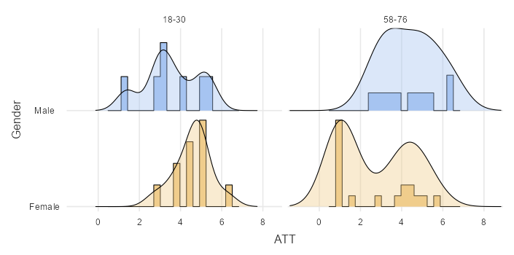

Box Plot:
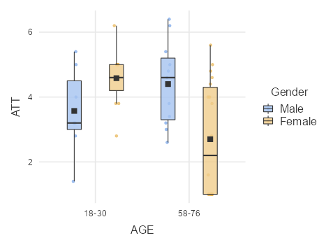

Q-Q Plots:
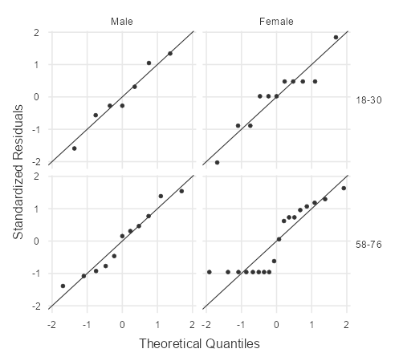

Subjective Norm’s histograms:
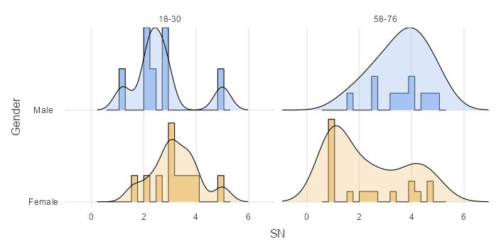
Box Plot:

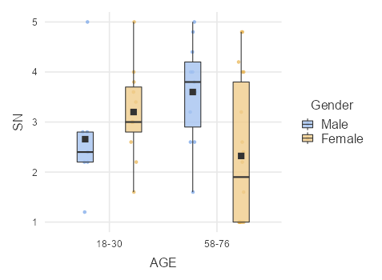

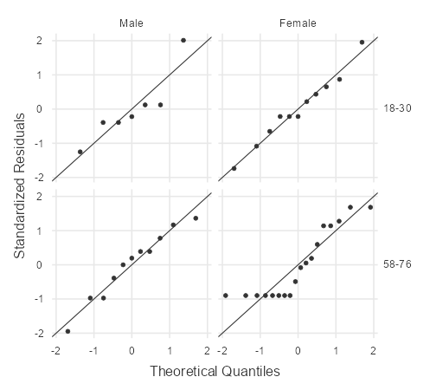
Q-Q Plots:

Perceived Behaviour Control’s Histogram:
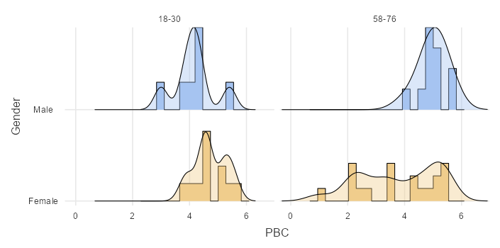

Box Plot:
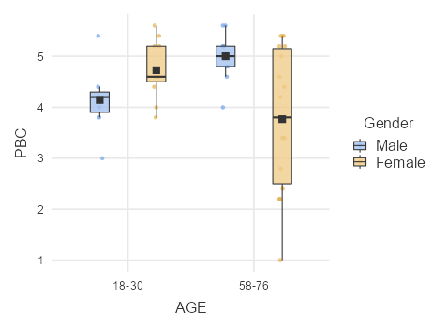

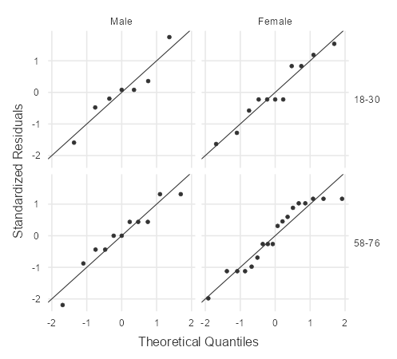
Q-Q Plots:

Behavioural Intention’s Histograms:
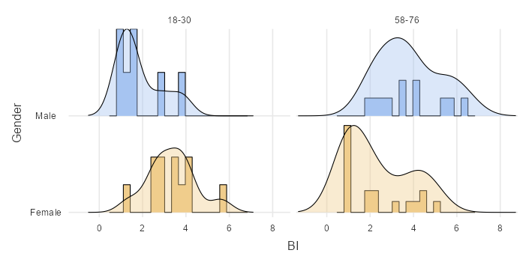

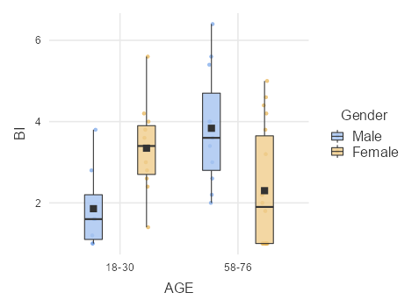
Box Plot:

Q-Q Plots:

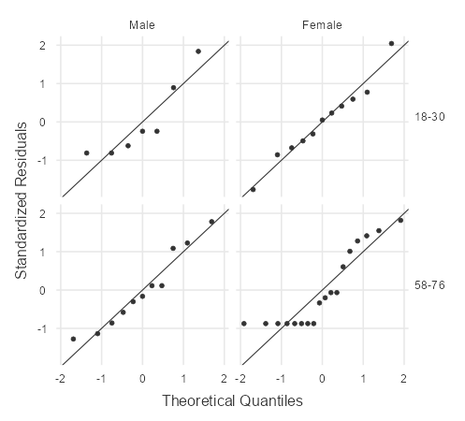
Appendix 4 Inferential Statistics Analyses
The inferential statistics analyses composed of four sections: reliability analyses, comparison tests, analyses of variance, correlation test, regression analysis and confirmatory factor analysis.

Appendix 4a Reliability Analyses
Reliability Analysis of Attitude:
 |  |  |  | Cronbach's α
scale |  |  |  | 0.930
 |  | Mean |  |  |  | SD
ATT1 |  | 3.06 |  |  |  | 1.78
ATT2 |  | 3.26 |  |  |  | 1.77
ATT3 |  | 3.74 |  |  |  | 1.86
ATT4 |  | 3.94 |  |  |  | 1.79
ATT5 |  | 4.12 |  |  |  | 2.06

Correlation Heatmap of Attitude:
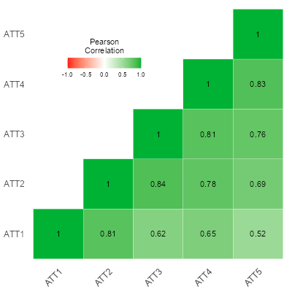

Reliability Analysis of Subjective Norms:
 |  |  |  | Cronbach's α
scale |  |  |  | 0.868
 |  | Mean |  |  |  | SD
SN1 |  | 2.32 |  |  |  | 1.43
SN2 |  | 3.30 |  |  |  | 1.66
SN3 |  | 2.34 |  |  |  | 1.36
SN4 |  | 2.56 |  |  |  | 1.46
SN5 |  | 3.60 |  |  |  | 2.03
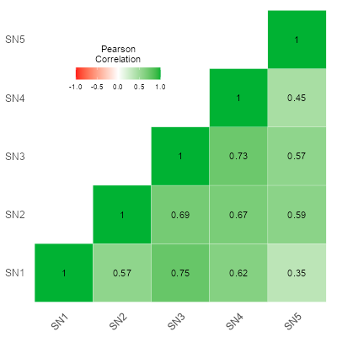
Correlation Heatmap of Subjective Norms:

Reliability Analysis of Perceived Behaviour Control:
 |  |  |  | Cronbach's α
scale |  |  |  | 0.611
 |  | Mean |  |  |  | SD
PBC1 |  | 4.86 |  |  |  | 2.01
PBC2 |  | 4.22 |  |  |  | 1.85
PBC3 |  | 3.26 |  |  |  | 1.80
PBC4 |  | 3.44 |  |  |  | 1.92
PBC5 ᵃ |  | 2.18 |  |  |  | 1.55
ᵃ reverse scaled item
Scale Reliability Statistics of Perceived Behavioural Control
 |  | Mean |  | SD |  | Cronbach's α
scale |  | 4.32 |  | 1.06 |  | 0.506
Note. 'PBC 5' correlates negatively with the total scale and probably should be reversed

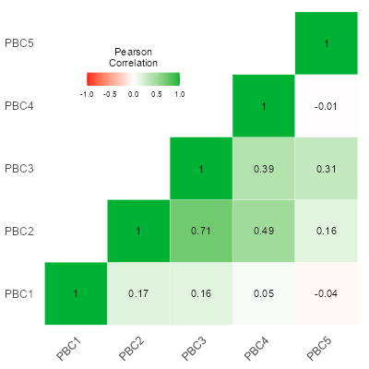
Correlation Heatmap of Perceived Behaviour Control:
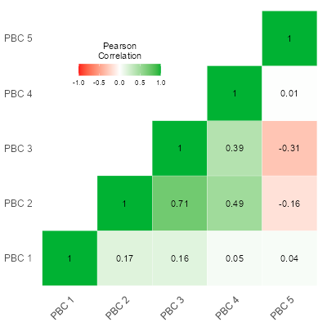
Correlation of PBC before reversion. Correlation of PBC after reversion.

Reliability Analysis of Behavioural Intention:
 |  |  |  | Cronbach's α
scale |  |  |  | 0.894
 |  |  | Mean |  |  | SD
BI1 |  |  | 2.86 |  |  | 1.58
BI2 |  |  | 3.42 |  |  | 1.93

Correlation Heatmap
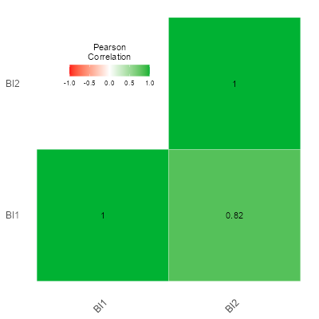

Reliability Analysis of Consumption Behaviour:
 |  |  |  | Cronbach's α
scale |  |  |  | 0.921
 |  | Mean |  |  |  | SD
B1 |  | 2.62 |  |  |  | 1.60
B2 |  | 2.16 |  |  |  | 1.45
B3 |  | 2.86 |  |  |  | 1.74

Correlation Heatmap
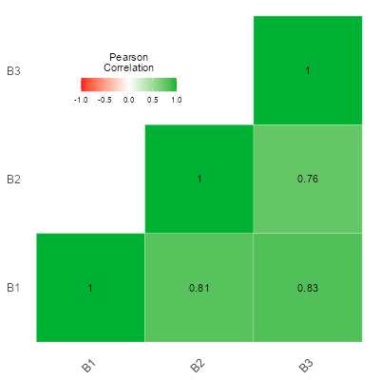

Appendix 4b Comparison Test

Independent Samples T-test for Attitude and Gender
Independent Samples T-Test
 |  |  |  |  |  | Statistic |  |  |  |  | df |  |  | p |  |  |  |  |  |  |  |  |  | Effect Size
ATT |  | Student's t |  |  |  | 1.38 |  |  |  |  | 45.0 |  |  | 0.176 |  |  |  | Cohen's d |  |  |  |  |  | 0.413
Group Descriptives
 |  | Group |  | N |  |  |  | Mean |  |  |  | Median |  |  |  | SD |  |  |  | SE
ATT |  | Male |  | 18 |  |  |  | 4.08 |  |  |  | 3.90 |  |  |  | 1.35 |  |  |  | 0.318
 |  | Female |  | 29 |  |  |  | 3.41 |  |  |  | 4.00 |  |  |  | 1.75 |  |  |  | 0.324

Plots

ATT
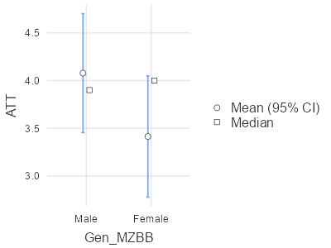

Independent Samples T-Test for Subjective Norms and Gender

 |  |  |  |  |  | Statistic |  |  |  |  | df |  |  | p |  |  |  |  |  |  |  |  |  | Effect Size
SN |  | Student's t |  |  |  | 1.51 |  |  |  |  | 45.0 |  |  | 0.137 |  |  |  | Cohen's d |  |  |  |  |  | 0.454
 |  | Group |  | N |  |  |  | Mean |  |  |  | Median |  |  |  | SD |  |  |  | SE
SN |  | Male |  | 18 |  |  |  | 3.23 |  |  |  | 3.00 |  |  |  | 1.15 |  |  |  | 0.271
 |  | Female |  | 29 |  |  |  | 2.66 |  |  |  | 2.60 |  |  |  | 1.34 |  |  |  | 0.250
Plots

SN
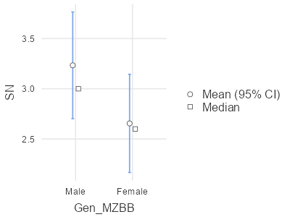

Independent Samples T-Test for Perceived Behavioural Control and Gender

 |  |  |  |  |  |  |  |  |  | Statistic |  |  |  | df |  |  |  | p |  |  |  |  |  |  |  | Effect Size
PBC |  |  |  | Student's t |  |  |  |  |  | 1.68 |  |  | ᵃ | 45.0 |  |  |  | 0.100 |  |  |  | Cohen's d |  |  |  | 0.503
 |  |  | Group |  |  | N |  |  | Mean |  |  | Median |  |  |  | SD |  |  |  | SE
PBC |  |  | Male |  |  | 18 |  |  | 4.67 |  |  | 4.80 |  |  |  | 0.700 |  |  |  | 0.165
 |  |  | Female |  |  | 29 |  |  | 4.13 |  |  | 4.60 |  |  |  | 1.23 |  |  |  | 0.229

Plots

PBC
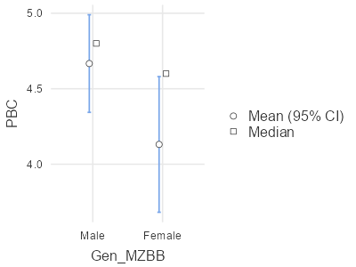

Independent Samples T-Test for Attitude and Age Groups
 |  |  |  |  |  |  |  |  |  | Statistic |  |  |  | df |  |  |  | p |  |  |  |  |  |  | Effect Size
ATT |  |  |  | Student's t |  |  |  |  |  | 1.77 |  |  | ᵃ | 45.0 |  |  |  | 0.083 |  |  |  | Cohen's d |  |  | 0.532
 |  |  | Group |  |  | N |  |  | Mean |  |  | Median |  |  |  | SD |  |  |  | SE
ATT |  |  | 18-30 |  |  | 18 |  |  | 4.19 |  |  | 4.60 |  |  |  | 1.17 |  |  |  | 0.276
 |  |  | 58-76 |  |  | 29 |  |  | 3.34 |  |  | 3.80 |  |  |  | 1.79 |  |  |  | 0.333
Plots

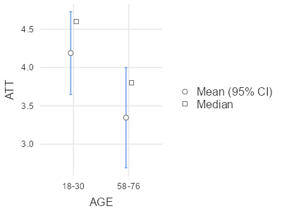
ATT

Independent Samples T-Test for Subjective Norms and Age Groups
 |  |  |  |  |  |  |  |  |  |  | Statistic |  |  |  |  | df |  |  |  |  | p |  |  |  |  |  |  |  |  |  | Effect Size
SN |  |  |  | Student's t |  |  |  |  |  |  | 0.465 |  |  |  | ᵃ | 45.0 |  |  |  |  | 0.644 |  |  |  |  |  | Cohen's d |  |  |  | 0.140
 |  |  | Group |  | N |  |  |  | Mean |  |  |  | Median |  |  |  |  | SD |  |  |  |  | SE
SN |  |  | 18-30 |  |  | 18 |  |  |  | 2.99 |  |  |  | 2.90 |  |  |  |  | 1.03 |  |  |  |  | 0.242
 |  |  | 58-76 |  |  | 29 |  |  |  | 2.81 |  |  |  | 2.60 |  |  |  |  | 1.45 |  |  |  |  | 0.268
Plots
SN
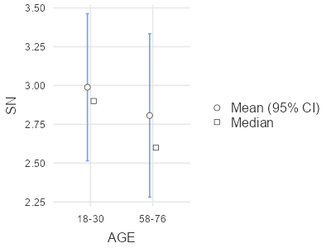

Independent Samples T-Test for Perceived Behavioural Control and Age Groups
 |  |  |  |  |  |  |  |  |  | Statistic |  |  |  | df |  |  |  | p |  |  |  |  |  |  |  | Effect Size
PBC |  |  |  | Student's t |  |  |  |  |  | 0.812 |  |  | ᵃ | 45.0 |  |  |  | 0.421 |  |  |  | Cohen's d |  |  |  | 0.244
 |  |  | Group |  |  | N |  |  | Mean |  |  | Median |  |  |  | SD |  |  |  | SE
PBC |  |  | 18-30 |  |  | 18 |  |  | 4.50 |  |  | 4.50 |  |  |  | 0.676 |  |  |  | 0.159
 |  |  | 58-76 |  |  | 29 |  |  | 4.23 |  |  | 4.80 |  |  |  | 1.28 |  |  |  | 0.237
Plots

PBC
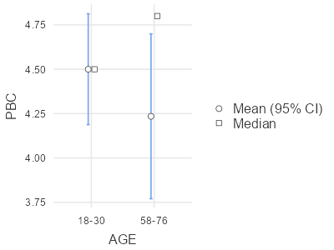

Independent Samples T-Test for Behavioural Intention and Age Groups:
 |  |  |  | Statistic |  | df |  | p |  | Mean difference |  | SE difference |  |  |  | Effect Size
BI |  | Student's t |  | 0.0648 |  | 45.0 |  | 0.949 |  | 0.0326 |  | 0.503 |  | Cohen's d |  | 0.0194
Assumptions
Normality Test (Shapiro-Wilk)
 |  |  |  |  |  |  |  |  |  | W |  |  |  |  |  |  |  |  |  |  |  | p
BI |  |  |  |  |  |  |  |  |  | 0.915 |  |  |  |  |  |  |  |  |  |  |  | 0.002
Homogeneity of Variances Test (Levene's)
 |  |  |  |  |  |  | F |  |  |  |  |  |  | df |  |  |  |  | df2 |  |  |  |  |  |  | p
BI |  |  |  |  |  |  | 1.23 |  |  |  |  |  |  | 1 |  |  |  |  | 45 |  |  |  |  |  |  | 0.272
 |  | Group |  | N |  |  |  |  | Mean |  |  |  | Median |  |  | SD |  |  |  |  | SE
BI |  | 18-30 |  | 18 |  |  |  |  | 3.22 |  |  |  | 3.50 |  |  | 1.51 |  |  |  |  | 0.355
 |  | 58-76 |  | 29 |  |  |  |  | 3.19 |  |  |  | 3.00 |  |  | 1.77 |  |  |  |  | 0.329
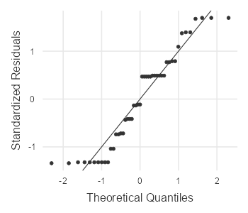
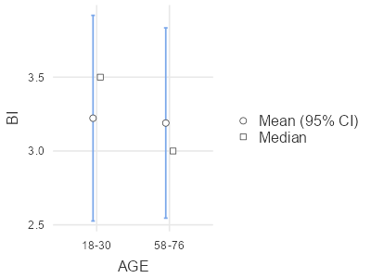
Plot

Independent Samples T-Test for Behavioural Intention and Gender:
 |  |  |  | Statistic |  | df |  | p |  | Mean difference |  | SE difference |  |  |  | Effect Size
BI |  | Student's t |  | 0.604 |  | 45.0 |  | 0.549 |  | 0.303 |  | 0.501 |  | Cohen's d |  | 0.181
Assumptions
Normality Test (Shapiro-Wilk)
 |  |  |  |  |  |  |  | W |  |  |  |  |  |  |  | p
BI |  |  |  |  |  |  |  | 0.928 |  |  |  |  |  |  |  | 0.006
Homogeneity of Variances Test (Levene's)
 |  |  |  |  | F |  |  |  |  |  |  | df |  |  |  |  | df2 |  |  |  |  |  | p
BI |  |  |  |  | 0.0251 |  |  |  |  |  |  | 1 |  |  |  |  | 45 |  |  |  |  |  | 0.875
 |  | Group |  |  | N |  | Mean |  |  |  | Median |  |  |  |  | SD |  |  | SE
BI |  | Male |  |  | 18 |  | 3.39 |  |  |  | 4.00 |  |  |  |  | 1.62 |  |  | 0.383
 |  | Female |  |  | 29 |  | 3.09 |  |  |  | 3.00 |  |  |  |  | 1.70 |  |  | 0.315

Plots

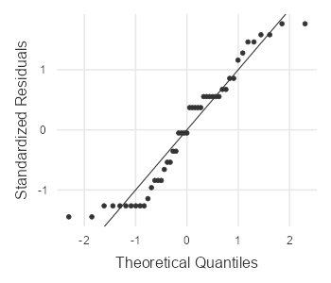
BI
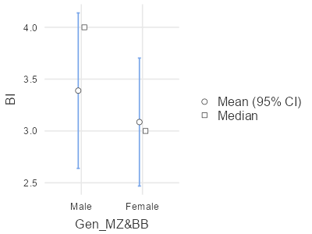

Independent Samples T-Test for Consumption Behaviour and Age:
 |  |  |  | Statistic |  | df |  | p |  | Mean difference |  | SE difference |  |  |  | Effect Size
B |  | Student's t |  | -0.476 |  | 45.0 |  | 0.637 |  | -0.215 |  | 0.453 |  | Cohen's d |  | -0.143

Assumptions
Normality Test (Shapiro-Wilk)
 |  |  |  |  |  |  |  |  |  | W |  |  |  |  |  |  |  |  |  |  |  | p
B |  |  |  |  |  |  |  |  |  | 0.916 |  |  |  |  |  |  |  |  |  |  |  | 0.002
Note. A low p-value suggests a violation of the assumption of normality
Homogeneity of Variances Test (Levene's)
 |  |  |  |  |  |  | F |  |  |  |  |  |  | df |  |  |  |  |  | df2 |  |  |  |  |  | p
B |  |  |  |  |  |  | 3.32 |  |  |  |  |  |  | 1 |  |  |  |  |  | 45 |  |  |  |  |  | 0.075
 |  | Group |  |  |  | N |  |  | Mean |  |  |  | Median |  |  | SD |  |  |  |  | SE
B |  | 18-30 |  |  |  | 18 |  |  | 2.46 |  |  |  | 2.33 |  |  | 1.23 |  |  |  |  | 0.290
 |  | 58-76 |  |  |  | 29 |  |  | 2.68 |  |  |  | 2.33 |  |  | 1.65 |  |  |  |  | 0.307

Plots

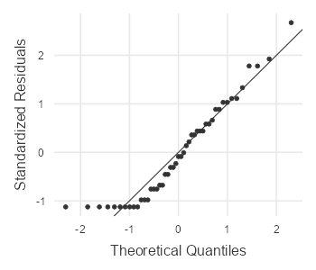
B
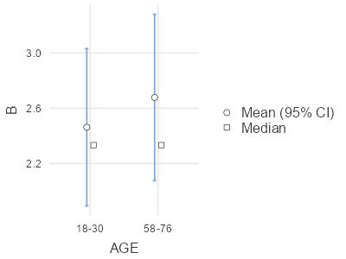

Independent Samples T-Test
 |  |  |  | Statistic |  | df |  | p |  | Mean difference |  | SE difference |  |  |  | Effect Size
B |  | Student's t |  | -0.476 |  | 45.0 |  | 0.637 |  | -0.215 |  | 0.453 |  | Cohen's d |  | -0.143

Assumptions
Normality Test (Shapiro-Wilk)
 |  |  |  |  |  |  |  |  |  | W |  |  |  |  |  |  |  |  |  |  |  | p
B |  |  |  |  |  |  |  |  |  | 0.916 |  |  |  |  |  |  |  |  |  |  |  | 0.002
Homogeneity of Variances Test (Levene's)
 |  |  |  |  |  |  | F |  |  |  |  |  |  | df |  |  |  |  |  | df2 |  |  |  |  |  | p
B |  |  |  |  |  |  | 3.32 |  |  |  |  |  |  | 1 |  |  |  |  |  | 45 |  |  |  |  |  | 0.075
 |  | Group |  |  |  | N |  |  | Mean |  |  |  | Median |  |  | SD |  |  |  |  | SE
B |  | 18-30 |  |  |  | 18 |  |  | 2.46 |  |  |  | 2.33 |  |  | 1.23 |  |  |  |  | 0.290
 |  | 58-76 |  |  |  | 29 |  |  | 2.68 |  |  |  | 2.33 |  |  | 1.65 |  |  |  |  | 0.307
Plots

B

Independent Samples T-Test for Consumption Behaviour and Gender:
 |  |  |  | Statistic |  | df |  | p |  | Mean difference |  | SE difference |  |  |  | Effect Size
B |  | Student's t |  | 0.923 |  | 45.0 |  | 0.361 |  | 0.415 |  | 0.449 |  | Cohen's d |  | 0.277

Assumptions
Normality Test (Shapiro-Wilk)
 |  |  |  |  |  |  |  |  |  | W |  |  |  |  |  |  |  |  |  |  |  | p
B |  |  |  |  |  |  |  |  |  | 0.918 |  |  |  |  |  |  |  |  |  |  |  | 0.003
Homogeneity of Variances Test (Levene's)
 |  |  |  |  |  |  | F |  |  |  |  |  |  | df |  |  |  |  |  |  | df2 |  |  |  |  | p
B |  |  |  |  |  |  | 0.913 |  |  |  |  |  |  | 1 |  |  |  |  |  |  | 45 |  |  |  |  | 0.344
 |  | Group |  |  |  | N |  |  | Mean |  |  |  | Median |  |  |  |  | SD |  | SE
B |  | Male |  |  |  | 18 |  |  | 2.85 |  |  |  | 2.33 |  |  |  |  | 1.69 |  | 0.399
 |  | Female |  |  |  | 29 |  |  | 2.44 |  |  |  | 2.33 |  |  |  |  | 1.37 |  | 0.254
Plots

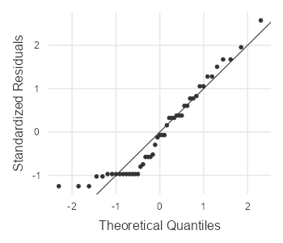
B
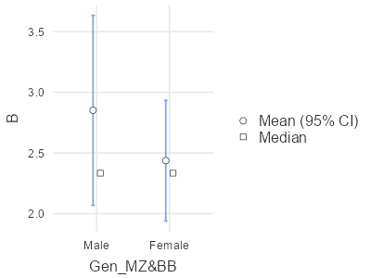

Appendix 4c Correlation and Regression Analysis

Correlation Matrix of Variables:
 |  |  |  | ATT |  | SN |  | PBC |  | BI
ATT |  | Pearson's r |  | —
 |  | p-value |  | —
 |  | 95% CI Upper |  | —
 |  | 95% CI Lower |  | —
SN |  | Pearson's r |  | 0.765 |  | —
 |  | p-value |  | < .001 |  | —
 |  | 95% CI Upper |  | 0.860 |  | —
 |  | 95% CI Lower |  | 0.619 |  | —
PBC |  | Pearson's r |  | 0.769 |  | 0.600 |  | —
 |  | p-value |  | < .001 |  | < .001 |  | —
 |  | 95% CI Upper |  | 0.863 |  | 0.752 |  | —
 |  | 95% CI Lower |  | 0.625 |  | 0.386 |  | —
BI |  | Pearson's r |  | 0.815 |  | 0.777 |  | 0.589 |  | —
 |  | p-value |  | < .001 |  | < .001 |  | < .001 |  | —
 |  | 95% CI Upper |  | 0.891 |  | 0.868 |  | 0.745 |  | —
 |  | 95% CI Lower |  | 0.694 |  | 0.636 |  | 0.372 |  | —

Plot:
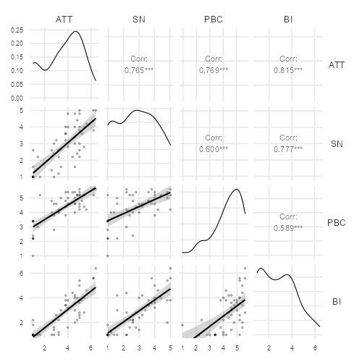

Linear Regression:
Model Fit Measures
Model |  | R |  |  |  |  | R²
1 |  | 0.888 |  |  |  |  | 0.789
Omnibus ANOVA Test
 |  |  |  |  |  |  |  | Sum of Squares |  |  |  |  |  |  | df |  |  | Mean Square |  |  |  | F |  |  |  | p
ATT |  |  |  |  |  |  |  | 1.08 |  |  |  |  |  |  | 1 |  |  | 1.084 |  |  |  | 1.68 |  |  |  | 0.202
SN |  |  |  |  |  |  |  | 5.99 |  |  |  |  |  |  | 1 |  |  | 5.991 |  |  |  | 9.28 |  |  |  | 0.004
PBC |  |  |  |  |  |  |  | 3.57 |  |  |  |  |  |  | 1 |  |  | 3.566 |  |  |  | 5.53 |  |  |  | 0.023
B |  |  |  |  |  |  |  | 15.31 |  |  |  |  |  |  | 1 |  |  | 15.309 |  |  |  | 23.73 |  |  |  | < .001
Residuals |  |  |  |  |  |  |  | 29.04 |  |  |  |  |  |  | 45 |  |  | 0.645
Model Coefficients - BI
 |  |  |  |  |  |  |  |  |  |  |  |  |  |  |  | 95% Confidence Interval
Predictor |  |  |  |  | Estimate |  |  |  |  |  |  | SE |  |  |  | Lower |  |  |  | Upper |  |  |  | t |  |  |  | p
Intercept |  |  |  |  | 1.187 |  |  |  |  |  |  | 0.515 |  |  |  | 0.150 |  |  |  | 2.2245 |  |  |  | 2.30 |  |  |  | 0.026
ATT |  |  |  |  | 0.202 |  |  |  |  |  |  | 0.156 |  |  |  | -0.112 |  |  |  | 0.5159 |  |  |  | 1.30 |  |  |  | 0.202
SN |  |  |  |  | 0.436 |  |  |  |  |  |  | 0.143 |  |  |  | 0.148 |  |  |  | 0.7239 |  |  |  | 3.05 |  |  |  | 0.004
PBC |  |  |  |  | -0.397 |  |  |  |  |  |  | 0.169 |  |  |  | -0.738 |  |  |  | -0.0569 |  |  |  | -2.35 |  |  |  | 0.023
B |  |  |  |  | 0.670 |  |  |  |  |  |  | 0.138 |  |  |  | 0.393 |  |  |  | 0.9475 |  |  |  | 4.87 |  |  |  | < .001
Assumption Checks

Normality Test (Shapiro-Wilk)
Statistic |  | p
0.911 |  | 0.001

References

Ajzen, I. (1991) ‘The Theory of Planned Behavior’. Organizational Behavior and Human Decision Processes 50, 179-211 (1991). Online. Available:Oct19Cited1ManageTHETHEORYOFPLANNEDBEHAVIOR (2).pdf [Accessed: 12th November, 2022]

Ajzen, I. (2002) ‘Perceived Behavioral Control, Self-Efficacy, Locus of Control, and the Theory of Planned Behavior’. Journal of Applied Social Psychology, 32: 665-683. Perceived Behavioral Control, Self‐Efficacy, Locus of Control, and the Theory of Planned Behavior1 (wiley.com)

Ajzen, I. (2006) ‘Constructing a theory of planned behavior questionnaire’. Online. Available: TPB-Surveyconstruction.pdf [Accessed: 12th November, 2022]

Ajzen, I. (2020) ‘The theory of planned behavior: Frequently asked questions’. Human Behavior & Emerging Technology 2020; 2:314-324. Online. Available: The theory of planned behavior: Frequently asked questions (wiley.com) [Accessed: 13th November, 2022]

Bakr, Y., Al-Bloushi, H. and Mostafa, M. (2022) ‘Consumer Intention to Buy Plant-based Meat Alternatives: A Cross-cultural Analysis’. Journal of International Consumer Marketing. Online. Available: https://doi.org/10.1080/08961530.2022.2122103 [Accessed: 8th November, 2022]

Bandura, A. (1989) ‘Human Agency in Social Cognitive Theory’. American Psychologist Vol. 44, No. 9, 1175-1184. Online. Available: Bandura1989a-with-cover-page-v2.pdf (d1wqtxts1xzle7.cloudfront.net) [Accessed: 11th November, 2022]

Berry, E. M. B. et al. (2015) ‘Food security and sustainability: can one exist without the other?’. Public Health Nutrition, 18 (13), 2293-2302. Online. Available: Food_security_and_sustainability_can_one20151107-9081-14y6z0n-with-cover-page-v2.pdf (d1wqtxts1xzle7.cloudfront.net) [Accessed: 24th November, 2022]

Bogueva, D. and Marinova, D. (2020) ‘Cultured Meat and Australia’s Generation Z’. Frontiers in Nutrition September 2020, Volume 7, Article 148. Online. Available: fnut-07-00148 (1).pdf [Accessed: 8th November, 2022]

Boukid, F. (2020) ‘Plant-based meat analogues: from niche to mainstream’. European Food Research and Technology (2021) 247: 297-308. Online. Available: Plant-based meat analogues: from niche to mainstream (springer.com) [Accessed: 30th November, 2022]

Bryant, C. and Sanctorum, H. (2021) ‘Alternative proteins, evolving attitudes: Comparing consumer attitudes to plant-based and cultured meat in Belgium in two consecutive years’. Appetite 161 (2021) 105161. Online. Available: Alternative proteins, evolving attitudes: Comparing consumer attitudes to plant-based and cultured meat in Belgium in two consecutive years (uniud.it) [Accessed: 25th November, 2022]

Bryant, C. et al. (2019) ‘A Survey of Consumer Perceptions of Plant-based and Clean Meat in the USA, India and China’. Frontiers in Sustainable Food Systems, February 2019, Volume 3, Article 11. Online. Available: fsufs-03-00011 (4).pdf [Accessed: 25th November, 2022]

Carfora, V. et al. (2020) ‘Rational and moral motives to reduce red and processed meat consumption’. Journal of Applied Social Psychology, 2020: 50: 744-755. Online. Available: Rational and moral motives to reduce red and processed meat consumption (patriziacatellani.com) [Accessed: 25th November, 2022]

Carfora, V., Morandi, M. and Catellani, P. (2022) ‘Predicting and promoting the consumption of plant-based meat’. British Food Journal. Online. Available: BFJ-07-2021-0829_proof 1..23 (patriziacatellani.com) [Accessed: 1st December, 2022]

Chen, C., Chaudhary, A. and Mathys, A. (2019) ‘Dietary Change Scenarios and Implications for Environmental, Nutrition, Human Health and Economic Dimensions of Food Sustainability’. Nutrients 2019, 11, 856. Online. Available: nutrients-11-00856 (1).pdf [Accessed: 25th November, 2022]
Chen, H.-S. (2022) ‘Towards Environmentally Sustainable Diets: Consumer Attitudes and Purchase Intentions for Plant-Based Meat Alternatives in Taiwan’. Nutrients 2022, 14, 3853. Online. Available: nutrients-14-03853.pdf [Accessed: 8th November, 2022]

Cheung, C.-K. and Cheng, J. Y.-S. ‘Resources and Norms as Conditions for Well-Being in Hong Kong’. Soc Indic Res (2016) 126: 757-775. Online. Available: Resources and Norms as Conditions for Well-Being in Hong Kong (springer.com) [Accessed: 11th November, 2022]
Clark, L. F. and Bogdan, A.-M. (2019) ‘The Role of Plant-Based Foods in Canadian Diets: A Survey Examining Food Choices, Motivations and Dietary Identity’. Journal of Food Products Marketing, 25:4, 355-377. Online. Available: Citation Manager | Taylor & Francis Online (tandfonline.com) [Accessed: 2nd December, 2022]
Davitt, E. D. et al. (2021) ‘Predictors of Plant-Based Alternatives to Meat Consumption in Midwest University Students’. Journal of Nutrition Education and Behavior. Volume 53, Number 7, 2021. Online. Available: Predictors of Plant-Based Alternatives to Meat Consumption in Midwest University Students | Elsevier Enhanced Reader [Accesed: 2nd December, 2022]

Estell, M., Hughes, J. and Grafenauer, s. (2021) ‘Plant Protein and Plant-Based Meat Alternatives: Consumer and Nutrition Professional Attitudes and Perceptions’. Sustainability 2021, 13, 1478. Online. Available: sustainability-13-01478 (2).pdf [Accessed: 8th November, 2022]

Fehér, A. et al. (2020) ‘A Comprehensive Review of the Benefits of and the Barriers to the Switch to a Plant-Based Diet’. Sustainability 2020, 12, 4136. Online. Available: sustainability-12-04136 (1).pdf [Accessed: 25th November, 2022]

Fong, B. Y. F. et al. (2021) ‘A Review Study of a Green Diet and Healthy Ageing’. International Journal of Environmental Research and Public Health 2021, 18, 8024. Online. Available: ijerph-18-08024 (1).pdf [Accessed: 26th November, 2022]

Fresán, U., Errendal, S. and Craig, W. J. (2020) ‘Influence of the Socio-Cultural Environment and External Factors in Following Plant-Based Diets’. Sustainability 2020, 12, 9093. Online. Available: sustainability-12-09093-v2 (1).pdf [Accessed: 8th November, 2022]

Garnett, T. (2013) ‘Food sustainability: problems, perspectives and solutions’. Proceedings of the Nutrition Society, Volume 72, Issue 1, February 2013, pp. 29-39. Online. Available: https://doi.org/10.1017/S0029665112002947 [Accessed: 25th November, 2022]

Gastaldello et al. (2022) ‘The rise of processed meat alternatives: A narrative review of the manufacturing, composition, nutritional profile and health effects of newer sources of protein, and their place in healthier diets’. Trends in Food Science & Technology 127 (2022) 263-271. Online. Available: The rise of processed meat alternatives: A narrative review of the manufacturing, composition, nutritional profile and health effects of newer sources of protein, and their place in healthier diets | Elsevier Enhanced Reader [Accessed: 28th November, 2022]

Gomez-Luciano, C. A. et al. (2019) ‘Consumers’ willingness to purchase three alternatives to meat proteins in United Kingdom, Spain, the Dominican Republic and Brazil’. Food Quality and Preference. Online. Available: Frank Vriesekoop consumers willingness upload.pdf (guildhe.ac.uk) [Accessed: 25th November, 2022]

Graça, J., Calheiros, M. M. and Oliveira, A. (2015). ‘Attached to meat? (Un)Willingness and intentions to adopt a more plant-based diet’. Appetite. 95, 113-125. Online. Available: graca et al 2015b.pdf (iscte-iul.pt) [Accessed: 1st December, 2022]

Ham, M., Jeger, M. and Ivković, A. F. (2015) ‘The role of subjective norms in forming the intention to purchase green food’. Economic Research 28:1, 738-748. Online. Available: The role of subjective norms in forming the intention to purchase green food (tandfonline.com) [Accessed: 8th November, 2022]

Hill, R. (1998) ‘What sample size is “enough” in internet survey research’. Interpersonal Computing and Technology: An Electronic Journal for the 21st Century Vol. 6 No. 3-4. Online. Available: IPCT-JVol6RobinhillSampleSize.pdf [Accessed: 3rd December, 2022]

Hinrichs, K. et al. (2022) ‘Why so defensive? Negative affect and gender differences in defensiveness toward plant-based meat’. Food Quality and Preference 102(2022) 104662. Online. Available: Why so defensive? Negative affect and gender differences in defensiveness toward plant-based diets | Elsevier Enhanced Reader [Accessed: 2nd December, 2022]

Ho, S. (2019) ‘Hong Kong Meat & Dairy Consumption on the Rise Despite UN Warnings’. Green Queen. Online. Available: Hong Kong Meat & Dairy Consumption On The Rise Despite UN Warnings (greenqueen.com.hk) [Accessed: 28th November, 2022]

Jang H.-W. and Cho, M. (2022) ‘Relationship between Personal Values and Intentions to Purchase Plant-Based Meat Alternatives: Application of the Dual Concern Theory’. International Journal of Environmental Research and Public Health 2022, 19, 8673. Online. Available: ijerph-19-08673-v2 (3).pdf [Accessed: 8th November, 2022]

Knaapila, A. et al. (2022) ‘Millennials’ Consumption of and Attitudes toward Meat and Plant-Based Meat Alternatives by Consumer Segment in Finland’. Foods 2022,11, 456. Online. Available: foods-11-00456-v2.pdf [Accessed: 8th November, 2022]

Lake, I. R. et al. (2012) ‘Climate Change and Food Security: Health Impact in Developed Countries’. Environmental Health Perspectives Volume 120, Issue 11. Online. Available: Climate Change and Food Security: Health Impacts in Developed Countries (nih.gov) [Accessed: 10th November, 2022]

Li, Y. (2020) ‘Feeding the Future: Plant-based Meat for Global Food Security and Environmental Sustainability’. Cereal Foods World, July-August 2020, Vol. 65, No. 4. Online. Available: 2020_CFW_Li_Plant meat.pdf (k-state.edu) [Accessed: 24th November, 2022]

Lim, T. J., Okine, R. N. and Kershaw, J. C. (2021) ‘Health- or Environment-Focused Text Messages as a Potential Strategy to Increase Plant-Based Eating among Young Adults: An Exploratory Study’. Foods 2021, 10, 3147. Online. Available: foods-10-03147-v3.pdf [Accessed: 8th November, 2022]

Malavalli, M. M. et al. (2021) ‘Consumers’ Perception of In-Vitro Meat in New Zealand Using the Theory of Planned Behavior Model’. Sustainability 2021, 13, 7430. Online. Available: sustainability-13-07430 (2).pdf [Accessed: 26th November, 2022]

Meysamie, A. et al. (2014) ‘Sample size calculation on web, can we rely on the results?’. Journal of Medical Statistics and Informatics, 2.1 (2014):3. Online. Available: (1) Sample size calculation on web, can we rely on the results? | Herbert Publications - Academia.edu [Accessed: 3rd December, 2022]

Modlinska, K. et al. (2020) ‘Gender Differences in Attitudes to Vegans/Vegetarians and Their Food Preferences, and Their Implications for Promoting Sustainable Dietary Patterns – A Systematic Review’. Sustainability 2020, 12, 6292. Online. Available: sustainability-12-06292.pdf [Accessed: 25th November, 2022]

Novi, C. D. and Marenzi, A. (2022) ‘Improving health and sustainability: Patterns of red and processed meat consumption across generations’. Health policy 126 (2022) 1324-1330. Online. Available: Improving health and sustainability: Patterns of red and processed meat consumption across generations | Elsevier Enhanced Reader [Accessed: 24th November, 2022]

Onwezen, M. C. et al. (2021) ‘A systematic review on consumer acceptance of alternative proteins: Purses, algae, insects, plant-based meat alternatives, and cultured meat’. Appetite 159 (2021) 105058. Online. Available: A systematic review on consumer acceptance of alternative proteins: Pulses, algae, insects, plant-based meat alternatives, and cultured meat (researchgate.net) [Accessed: 14th November, 2022]

Pandey, S., Ritz, C. and Perez-Cueto, F. J. A. (2021) ‘An Application of the Theory of Planned Behaviour to Predict Intention to Consume Plant-Based Yogurt Alternatives’. Foods 2021, 10, 148. Online. Available: An Application of the Theory of Planned Behaviour to Predict Intention to Consume Plant-Based Yogurt Alternatives (semanticscholar.org) [Accessed: 13th November, 2022]

Patel, V. and Buckland, N. J. (2021) ‘Perceptions about meat reducers: Results from two UK studies exploring personality impressions and perceived group membership’. Food Quality and Preference 93 (2021) 104289. Online. Available:https://reader.elsevier.com/reader/sd/pii/S0950329321001725?token=C3D105F74032703DD72C5D0CB724E1AAD188F283DF8C3AE28D6D18AADDD3137FD5A50A4CDF5F40CC25AFA8461CB52470&originRegion=us-east-1&originCreation=20221108065456 [Accessed: 8th November, 2022]

Peng, W. and Berry, E. M. (2019) ‘The Concept of Food Security’. Encyclopedia of Food Security and Sustainability, vol. 2, pp. 1-7. Online. Available: The-Concept-of-Food-Security.pdf (researchgate.net) [Accessed: 28th November, 2022]

Peterson, R. A. (2013) ‘A Meta-Analysis of Cronbach’s Coefficient Alpha’. Journal of Consumer Research, Vol. 21, No. 2, pp. 381-391. Online. Available: Peterson-AmetaanalysisofCronbachAlpha.pdf [Accessed: 8th December, 2022]

Reipurth, M. F. S. et al. (2019) ‘Barriers and facilitators towards adopting a more plant-based diet in a sample of Danish consumers’. Food Quality and Preference 73 (2019) 288-292. Online. Available:https://reader.elsevier.com/reader/sd/pii/S0950329318304348?token=0F686B49BD25651263FF14935ECE5D463F9C6624697E36F2C3ABBC0787CE024867287DA54B4B9DB37DDC097DC87BDB94&originRegion=us-east-1&originCreation=20221108062343 [Accessed: 8th November, 2022]

Samuels, M. L. (2012) ‘Statistical Reversion toward the Mean: More Universal than Regression toward the Mean’. The American Statistician, Volume 45, 1991 – Issue 4. Online. Available: Statistical Reversion toward the Mean: More Universal than Regression toward the Mean: The American Statistician: Vol 45, No 4 (tandfonline.com) [Accessed: 12th December, 2022]

Sanchez-Sabate, R. and Sabaté, J. (2019) ‘Consumer Attitudes Towards Environmental Concerns of Meat Consumption: A Systematic Review’. International Journal of Environmental Research and Public Health 2019, 16, 1220. Online. Available: ijerph-16-01220.pdf [Accessed: 25th November, 2022]

Schiffman, L. and Kanuk, L. (2007) ‘Consumer attitude formation and change’. Consumer Behavior. 9th ed. New York: Prentice Hall, pp.238-259.

Shin, Y. H. and Hancer, M. (2016) ‘The role of attitude, subjective norm, perceived behavioral control, and moral norm in the intention to purchase local food products’. Journal of Foodservice Business Research 2016, Vol. 19, No. 4, 338-351. Online. Available: The role of attitude, subjective norm, perceived behavioral control, and moral norm in the intention (tandfonline.com) [Accessed: 8th November, 2022]

Stok, F. M. et al. (2014) ‘Don’t tell me what I should do, but what other do: The influence of descriptive and injunctive peer norms on fruit consumption in adolescents’. British Journal of Health Psychology (2014), 19, 52-64. Online. Available: Don't tell me what I should do, but what others do: The influence of descriptive and injunctive peer norms on fruit consumption in adolescents (wiley.com) [Accessed: 15th November, 2022]

Stollar, M., Rumble, J. N. and Buck, E. B. (2022) ‘Consumers’ Purchasing Intent Regarding Conventional, Plant-Based, and Cultured Meats’. Journal of Applied Communications, Volume 106, Issue 1, Article 2. Online. Available: Consumers’ Purchasing Intent Regarding Conventional, Plant-Based, and Cultured Meats (newprairiepress.org) [Accessed: 26thNovember, 2022]

Szejda, K., Bryant, C. J. and Urbanovich, T. (2021) ‘US and UK Consumer Adoption of Cultivated Meat: A Segmentation Study’. Foods 2021, 10, 1050. Online. Available: foods-10-01050.pdf [Accessed: 8th November, 2022]

Tam, D. (2018) ‘Food Supply’. Hong Kong Foodworks. Online. Available: A site about Hong Kong Food System issues – HKFoodWorks [Accessed: 28th November, 2022]

Ueasangkomsate, P. and Santiteerakul, S. ‘A study of consumers’ attitudes and intention to buy organic foods for sustainability’. Procedia Environmental Sciences 34 (2016) 423-430. Online. Available: A Study of Consumers’ Attitudes and Intention to Buy Organic Foods for Sustainability (sciencedirectassets.com) [Accessed: 25th November, 2022]

Van Loo, E. J. Hoefkens, C. and Verbeke, W. (2017) ‘Healthy, sustainable and plant-based eating: Perceived (mis)match and involvement-based consumer segments as targets for future policy’. Food Policy 69 (2017) 46-57. Online. Available:https://reader.elsevier.com/reader/sd/pii/S0306919217301744?token=79A1FB13D5C8E8834EB179F46A3590B87929E3A52BABD09691D763442D9956044C8B2C423AADA6F18736774B5E807851&originRegion=us-east-1&originCreation=20221108062129 [Accessed: 8th November, 2022]

Wan, C., Shen, G. Q. and Choi, S. ‘The moderating effect of subjective norm in predicting intention to use urban green spaces: A study of Hong Kong’. Sustainable Cities and Society 37 (2018) 288-297. Online. Available: The moderating effect of subjective norm in predicting intention to use urban green spaces_ A study of Hong Kong | Elsevier Enhanced Reader [Accessed: 11th November, 2022]

Wang, O. and Scrimgeour, F. (2021) ‘Willingness to adopt a more plant-based diet in China and New Zealand: Applying the theories of planned behaviour, meat attachment and food choice motives’. Food Quality and Preference 93 (2021) 104294. Online. Available: Willingness to adopt a more plant-based diet in China and New Zealand: Applying the theories of planned behaviour, meat attachment and food choice motives | Elsevier Enhanced Reader [Accessed: 8th November, 2022]

Yum, H. (2021) ‘Plant-Based Chicken Sets Sail in Hong Kong’. Euromonitor. Online. Available: Plant-Based Chicken Sets Sail in Hong Kong - Euromonitor.com [Accessed: 29th November, 2022]

Żakowska-Biemans, S. et al. (2019) ‘Searching for a Measure Integrating Sustainable and Healthy Eating Behaviors’. Nutrients 2019, 11, 95. Online. Available: nutrients-11-00095-v2.pdf [Accessed: 25th November, 2022]

Zhai, Y. et al. (2022) ‘Grain self-sufficiency versus environmental stress: An integration of system dynamics and life cycle assessment’. Renewable and Sustainable Energy Reviews 159 (2022) 112153. Online. Available: Grain self-sufficiency versus environmental stress: An integration of system dynamics and life cycle assessment | Elsevier Enhanced Reader [Accessed: 28th November, 2022]

TPB stands for Theory of Planned Behaviour.
The formula is retrieved online together with the sample size calculator.
The data was retrieved online on 3rd December, 2022 from Worldometers.
BB was an abbreviation for baby boomers.
M denoted median and SD denoted standard deviation.
t(degrees of freedom) = t statistics, which stands for the population median.
MZ was the abbreviation for Generation MZ.
Plant-based meat was abbreviated as PBM.
Subjective norms were abbreviated as SN.

