Exploring the effect of affective traits on memory for emotion-induced stimuli.
University of Wales Trinity Saint David

Abstract

Emotional intelligence (EI) has been studied extensively regarding memory. It is defined as the ability to comprehend and manage emotions, in turn fostering effective communication and building positive relationships (Salovey & Mayer, 1990). This study looked at the effect of EI and emotion-induced stimuli on memory recall using 38 participants of varying age and gender (M = 29.05, SD = 8.88). The Participants completed the Schutte Self-Report Emotional Intelligence Test (SSEIT; Schutte et al., 1998) to examine emotional intelligence and memory recall, and then completed a computer task that involved recalling 20 words (positive, negative, and neutral) from ANEW (Bradley & Lang, 1999) over three trials. The results were analysed using a 2 x 3 mixed design ANOVA. The results indicated that there was no significant interaction between EI and the recall of emotion-induced words; F (2, 72) = 1.57, p = .22, np² = .04. The study found that individuals with high EI did not perform better at recalling positive words compared to those with low emotional intelligence. Instead, those with low emotional intelligence actually had better recall overall. These findings reject the hypothesis that high emotional intelligence is linked to improved recall of positive words.

Introduction

In the 1990s, the construct of Emotional Intelligence (EI) emerged as a significant psychological construct that was comparable to General Intelligence (Mayer et al., 1999; Salovey & Mayer, 1990), with some stating it to be more significant to a person’s well-being and success (Goleman, 2020). EI refers to an individual's capacity to perceive, utilise, comprehend, manage, and navigate emotions (Salovey & Mayer, 1990). It is an essential trait, enabling one to build strong relationships, manage stress, and communicate effectively (Fteiha & Awwad, 2020; O'Connor et al., 2019). Individuals with a high level of EI can recognise and understand their own emotions and those of others (Bradberry & Greaves, 2009).

EI is not just important for social interactions but also for effectively expressing oneself. According to Goleman (2020), people with high EI can articulate their feelings precisely. This leads to a deeper understanding of emotions and informed decision-making (Fteiha & Awwad, 2020). Bradberry and Greaves (2009) found that individuals with high EI better understand and express their emotions accurately. The connection between emotional expression and intelligence is especially significant in recalling emotion-inducing words in memory studies (Rączy & Orzechowski, 2019).

Memory and emotion are often interlinked, with concepts such as Flashbulb Memory (Brown & Kluick, 1977) theorising that when an emotion-inducing event occurs, a particular memory mechanism kicks in, enabling a person to take a mental “snapshot” of the moment, remembering it in detail. The assassination of J.F.K. was used as an example, and results showed that almost everyone asked about the event remembered in great detail where they were, what they were doing, who told them, and the immediate aftermath. Further studies replicated the findings, with participants able to recall injuries they had sustained and natural disasters that had occurred (Peterson & Bell, 1996; Peterson & Whalen, 2001, as cited in Kensinger, 2009). Moreover, according to Kensinger's (2007) research, humans are inclined to remember negative experiences due to an evolutionary need to recall potential dangers for future survival.

The power of words and emotion can be seen by observing swear words. Swearing uniquely impacts individuals and sets them apart from other language forms. It can elicit a range of experiences, including increased strength, enhanced attention, pain relief and positive social interaction (Stapleton et al., 2022; Stephens & Robertson, 2020). Classical conditioning in childhood is believed to be the root cause of the emotional impact of swearing, where children are punished for using swear words. According to Pavlenko's (2005, as cited in Stapleton et al., 2022) language embodiment theory, swear words acquire negative conditioning when associating them with prohibition and punishment during language acquisition. Further research explains how words gain emotional significance through the classical conditioning process (Jay, 2003).

Mavrou (2021) conducted a study to examine the relationship between working memory capacity (WMC) and emotional intelligence (EI) by focusing on the retrieval of emotional vocabulary. The study found negative correlations between WMC and two trait EI factors: well-being and emotionality. Trait EI was identified as the only predictor of the perceived pleasantness of retrieved words. Furthermore, the study revealed that the number of generated emotion words was influenced by trait EI, language of retrieval, and gender.

Mayer and Salovey (1997) suggest that people with higher EI may exhibit enhanced recall for emotion-inducing words. This is grounded in the idea that individuals with higher EI possess better emotional awareness and are, therefore, more adept at processing and encoding emotionally charged stimuli into memory. By contrast, Rączy and Orzechowski (2019) investigated the combined impact of mood and emotional stimuli on working memory performance. The study found that participants reacted faster to negative words regardless of their current mood. They were also more accurate when feeling positive but less accurate when dealing with positive words. This means that emotional content and mood have an impact on working memory, but their combined effect does not magnify their individual effects.

This study used the Schutte Self-Report Emotional Intelligence Test (SSEIT). It is commonly used for assessing EI and is a valid and reliable measure of EI, with much research showing positive results across cultures and demographics (Aniemeka et al., 2020; Musonda et al., 2013).

This study investigated how EI and emotional stimuli affect the ability to remember positive, negative, and neutral words. Based on previous research, the hypothesis suggests that people with high levels of EI will have better memory recall for positive words.

Method

Participants

The study involved 38 undergraduate students who were recruited through the Experimental Management System (EMS). The group comprised 22 females, 14 males, and two individuals identifying as non-binary or third gender. The age of participants ranged between 19 and 51 years (M= 29.05, SD = 8.88).

Design

The research utilised a mixed multi-factorial design, where EI was chosen as the first independent variable (IV1). EI was treated as a factor that varied between participants, with both low and high levels being considered. Participants were categorised into low or high EI groups based on their mean scores calculated from all collected data. Those with scores below the mean were classified as having low EI, while those with above were considered to have high EI. The second independent variable (IV2) involved stimuli designed to elicit emotions. These stimuli were factors within subjects and included three distinct levels: positive, negative, and neutral. The focus of the dependent variable (DV) was on the number of words that were correctly recalled per trial, with categorisations based on the type of stimuli (positive, neutral, or negative).

To analyse the data, a planned 2 x 3 mixed design Analysis of Variance (ANOVA) was conducted, considering the between-subjects factor of EI and the within-subjects factor of emotional stimuli levels.

Materials

The study utilised the Schutte Self-Report Emotional Intelligence Test (SSEIT; Schutte et al., 1998) to collect data on EI (see Appendix A). The questionnaire consisted of 33 items, such as "Emotions are one of the things that make my life worth living," and was administered using the Qualtrics system. Each item was rated on a 5-point Likert scale, ranging from 1 (Strongly Disagree) to 5 (Strongly Agree). The total score on the scale ranged from 33 to 165, with higher scores indicating higher levels of EI. After data collection, participants were categorised into low or high EI based on the mean score. Three items with negative wording were reverse-scored before analysis. In addition, the internal reliability for EI was determined to be .73., which was satisfactory with Cronbach’s alpha range.

A study was conducted using the Superlab program to test memory recall with emotion-induced stimuli. The stimuli were positive, negative, and neutral words selected from Affective Norms for English Words (ANEW) by Bradley and Lang (1999). There were three trials, and each trial featured 60 words, with 20 words per valence category. The valence means of the positive words were 7-9, negative words were 0-3, and neutral words were 4.5-5.5. Each word was displayed sequentially for 2000ms with a 400ms interval.

Participants were asked to engage in a one-minute distraction task after a word presentation. For instance, they were asked to remember the last time they rode a bike. Following the distraction task, they were asked to type in the words they recalled into a text box on the screen. The order of the 20 words was randomised in each trial, ensuring balanced conditions. After completing the trial, participants were provided with a debrief. Scoring was based on the number of words recalled correctly out of 20. The data collection was conducted in a controlled lab environment using Qualtrics and Superlab, with a separate laptop questionnaire administered before the computer task.

Procedure

Study participants were enlisted through the Experiment Management System (EMS) and were equipped with a laptop containing a Qualtrics link. After clicking the link, participants received an information sheet (see Appendix C) outlining the purpose of the study, and procedures. Subsequently, they provided with a consent form (see Appendix D), which they had to sign to participate and were reminded of their right to withdraw. Following the provision of consent, demographic information was gathered, after which participants completed the SSEIT questionnaire via Qualtrics. Following the questionnaire, participants were instructed to activate the computer screen for a memory recall task using the Superlab software. Upon task completion, the participants were given a debrief form (see Appendix E) explaining the aims and objectives of the study, and were thanked for their participation in the study.

Results

A 2 x 3 mixed-design ANOVA was conducted to explore the effect of EI on the recall of emotionally induced stimuli, including positive, negative, and neutral words. Descriptive statistics for all variables are provided in Table 1.

Table 1.
Table of Descriptive Statistics
 | Low EI |  |  | High EI
 | M | SD | N | M | SD | N
Positive | 11.52 | 2.421 | 21 | 8.53 | 3.676 | 17
Negative | 9.62 | 2.598 | 21 | 8.00 | 3.221 | 17
Neutral | 8.62 | 2.655 | 21 | 7.41 | 3.411 | 17

The interaction between EI and emotion-induced words showed no significant effect (F (2, 72) = 1.57, p = .22, np² = .04).

Nonetheless, the main impact of the words was notable (F (2, 72) = 7.35, p = .02, np² = .15), signifying variations in the recall of emotion-induced words (positive, negative, or neutral) based on their emotional attachment.

Pairwise comparisons revealed that participants remembered significantly more positive words (M = 10.18, SD = 3.36) compared to negative words (M = 8.89, SD = 2.97; p = .04) and also more positive words than neutral words (M = 8.08, SD = 3.04; p = .004). However, negative, and neutral words had no significant recall difference (p > .05).

Furthermore, the main effect of EI level was significant: F (1, 36) = 6.55, p = .02, np² = .15. This suggests a disparity in the overall number of words recalled between participants with low and high EI. Participants with low EI recalled significantly more words (M = 9.92, SD = 2.96) than those with high EI (M = 7.98, SD = 2.96).

In summary, individuals with low EI remembered more words than participants with high EI. Therefore, the hypothesis that participants with higher EI would be more likely to recall positive words must be rejected.

Discussion

As stated above, the hypothesis must be rejected following the study due to the findings that people with high EI recalled less words than those with Low. This result was in contrast to the findings of Rączy and Orzechowski (2019) who found that people with high EI and high emotional expression recalled more emotional inducing words in studies.

Based on Mayer and Salovey's (1997) suggestion that higher EI could improve recall for emotion-inducing words, a study was conducted to investigate the combined effect of EI and emotion-induced stimuli. Surprisingly, the results showed that there was no significant interaction between EI and emotion-induced words. This finding suggests that the relationship between EI and emotion-induced words may not have a direct, observable impact on memory recall. This is corroborated by Rączy and Orzechowski, (2019) who found that mood affected recall more than EI.

The significant main effect of emotion-induced words on recall aligns with established literature on emotion's role in memory formation (Kensinger, 2007). The variations in recall among positive, negative, and neutral words underscore the selective influence of emotional valence on participants' memory. The prominence of positive word recall echoes the positivity bias observed in memory, where individuals tend to recall positive information more readily than negative or neutral stimuli (Mayrou, 2021).

In Mavrou's (2021) study, negative correlations were found between WMC and two factors of trait EI (well-being and emotionality). This aligns with the observed significant main effect of EI level in the current study, where participants with low EI recalled more words than those with high EI. Pairwise comparisons further emphasise the asymmetrical recall patterns, with participants remembering significantly more positive words than negative or neutral ones. The study showed that there isn't a significant difference in recall between negative and neutral words. This is consistent with research on emotion and memory, which suggests that negative and neutral stimuli may not always be distinctly differentiated in recall tasks (Kensinger, 2007).

The study's outcomes may have been influenced by various factors such as age, cultural background, and educational level of participants. The choice of the emotional intelligence assessment tool and the complexity of the memory task could have impacted cognitive processes differently. Cultural and linguistic influences, environmental factors, and individual differences in memory strategies could have introduced variability in the results. Additionally, participant engagement and variations in how emotions are expressed and perceived could contribute to observed differences. These factors collectively highlight the nuanced factors influencing the study's outcomes.

In conclusion, while the interaction between EI and emotion-induced words did not yield a significant effect, the study highlighted the substantial impact of emotional content on memory recall. Positive words, in particular, were more effectively recalled than their negative or neutral counterparts. Moreover, the study provided evidence of a significant difference in recall between individuals with low EI and high EI, contributing valuable insights into the nature of EI and its implications for memory processes.

Reference List

Aniemeka, O. O., Akinnawo, O. E., & Akpunne, B. C. (2020). Validation of the Schutte self-report emotional intelligence test (SSEIT) on Nigerian adolescents. Journal of Education and Practice, 11(18), 177–181. https://doi.org/10.7176/jep/11-18-19
Bradberry, T., & Greaves, J. (2009). Emotional intelligence 2.0. TalentSmart.
Bradley, M.M., & Lang, P.J. (1999). Affective norms for English words (ANEW): Instruction manual and affective ratings. Technical Report C-1, The Center for Research in Psychophysiology, University of Florida.
Brown, R., & Kulik, J. (1977). Flashbulb memories. Cognition, 5(1), 73–99. https://doi.org/10.1016/0010-0277(77)90018-x
Fteiha, M., & Awwad, N. (2020). Emotional intelligence and its relationship with stress coping style. Health Psychology Open, 7(2), 205510292097041. https://doi.org/10.1177/2055102920970416
Goleman, D. (2020). Emotional intelligence. Bloomsbury.
Jay, T. B. (2003). The Psychology of Language. Pearson.
Kensinger, E. A. (2007). Negative emotion enhances memory accuracy. Current Directions in Psychological Science, 16(4), 213–218. https://doi.org/10.1111/j.1467-8721.2007.00506.x
Kensinger, E. A. (2009). Remembering the details: Effects of emotion. Emotion Review, 1(2), 99–113. https://doi.org/10.1177/1754073908100432
Mavrou, I. (2021). Emotional intelligence, working memory, and emotional vocabulary in L1 and L2: Interactions and dissociations. Lingua, 257, 103083. https://doi.org/10.1016/j.lingua.2021.103083
Mayer, J. D., Caruso, D. R., & Salovey, P. (1999). Emotional intelligence meets traditional standards for an intelligence. Intelligence, 27(4), 267–298. https://doi.org/10.1016/s0160-2896(99)00016-1
Musonda, A., Shumba, O., & P., Frank. (2013). Validation of the schutte self report emotional intelligence scale in a Zambian context. European Journal of Psychology and Educational Research, 2(2), 31–41. https://doi.org/10.12973/ejper.2.2.31
O’Connor, P. J., Hill, A., Kaya, M., & Martin, B. (2019). The measurement of Emotional Intelligence: A Critical Review of the literature and recommendations for researchers and Practitioners. Frontiers in Psychology, 10. https://doi.org/10.3389/fpsyg.2019.01116
Rączy, K., & Orzechowski, J. (2019). When working memory is in a mood: Combined effects of induced affect and processing of emotional words. Current Psychology, 40(6), 2843–2852. https://doi.org/10.1007/s12144-019-00208-x
Salovey, P., & Mayer, J. D. (1990). Emotional intelligence. Imagination, Cognition and Personality, 9(3), 185–211. https://doi.org/10.2190/dugg-p24e-52wk-6cdg
Schutte, N. S., Malouff, J. M., Hall, L. E., Haggerty, D. J., Cooper, J. T., Golden, C. J., & Dornheim, L. (1998). Development and validation of a measure of emotional intelligence. Personality and Individual Differences, 25(2), 167–177. https://doi.org/10.1016/s0191-8869(98)00001-4
Stapleton, Karyn., Beers Fägersten, Kristy., Stephens, Richard., & Loveday, Catherine. (2022). The power of swearing: What we know and what we don’t. Lingua, 277, 103406. https://doi.org/10.1016/j.lingua.2022.103406
Stephens, R., & Robertson, O. (2020). Swearing as a response to pain: Assessing hypoalgesic effects of novel “Swear” words. Frontiers in Psychology, 11. https://doi.org/10.3389/fpsyg.2020.00723

Appendix A

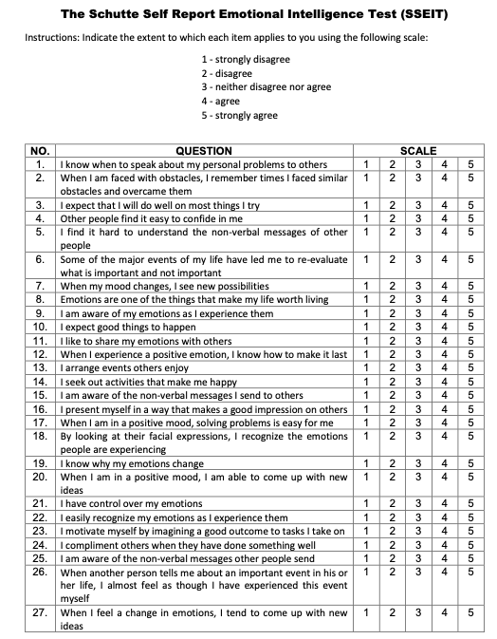
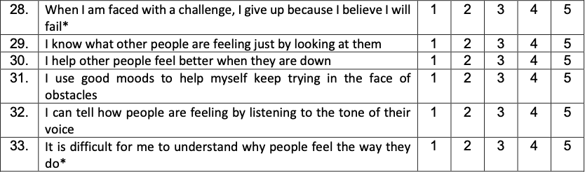

Appendix B

List of words from memory task.

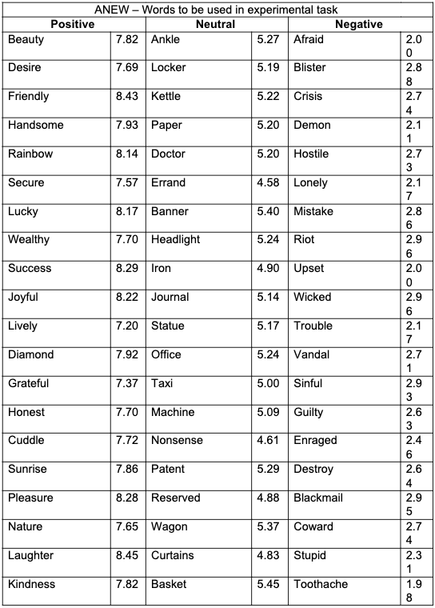

Appendix C

Information Sheet
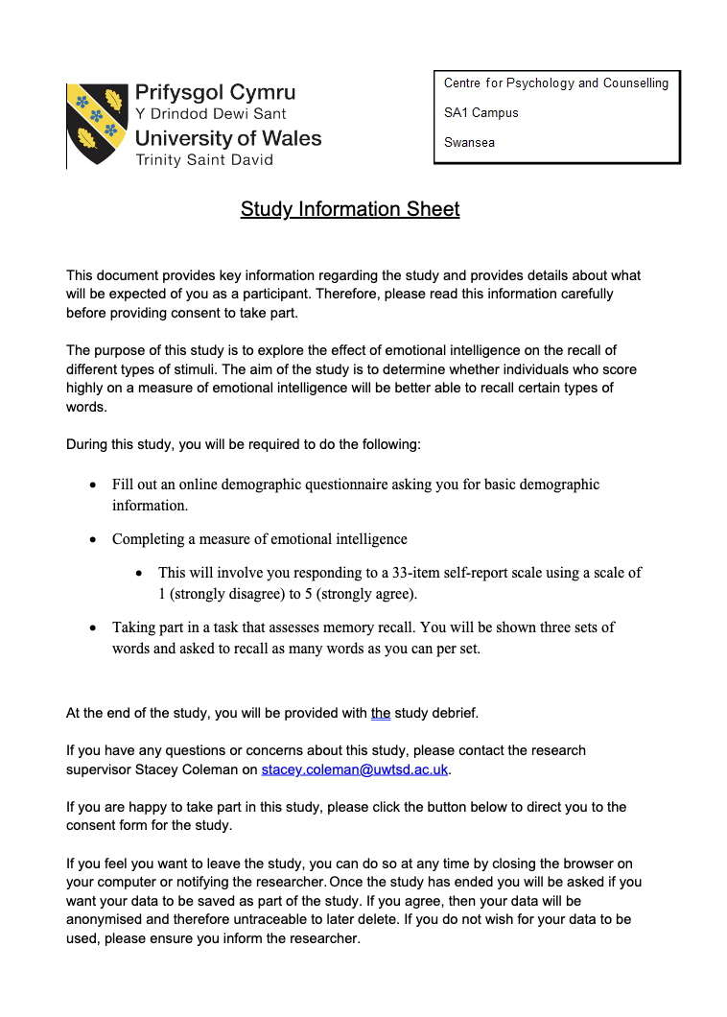

Appendix D

Consent Form

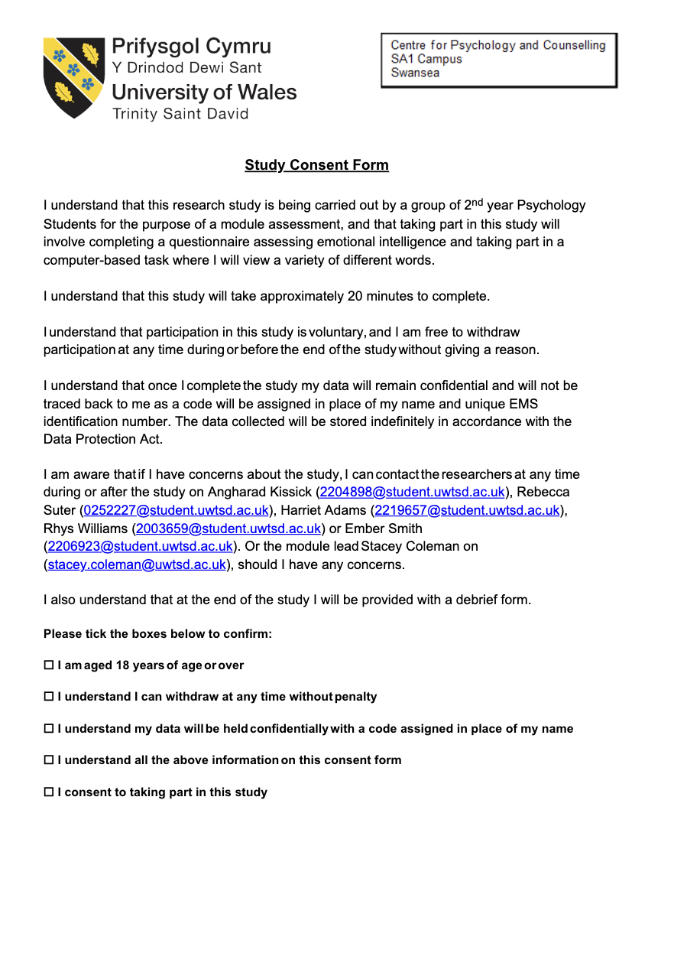

Appendix E

Debrief Form

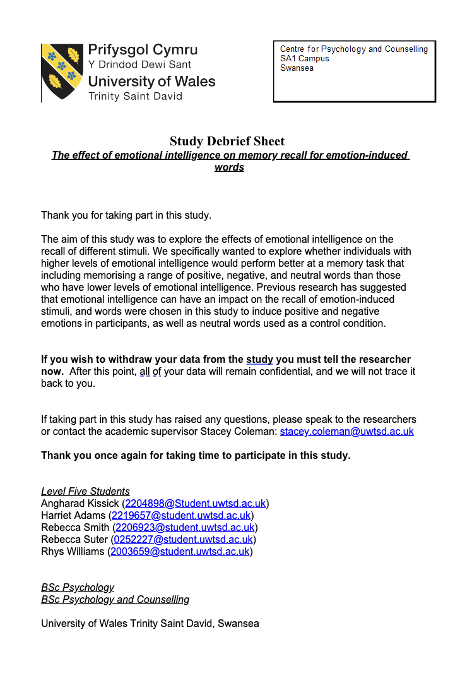

Appendix F

Full SPSS Output


