UWTSD
WISA



Engineering Problem
Engineering Design – ACHA4001

Luca Gray
2304962
4th April 2025
Contents
1 Introduction 1
2 Time Plan 2
3 Initial Design Sketches 3
4 CAD Model and Technical Drawings 6
5 Manufacturing Process 7
6 Conclusion 8

Figure 1 - The diagram provided of the tank 1
Figure 2 - The time plan created for the project 2
Figure 3 - Design 1 4
Figure 4 - Design 2 4
Figure 5 - Design 3 5

Introduction
In this assignment, I was tasked with conducting a design project as if I were an engineer working at an Original Equipment Manufacturer (OEM). There is a recurring issue with the treatment tanks (pictured in Figure 1), which are used to anodize aluminium parts. The issue is the removable cover, which is used for health and safety reasons, protecting staff from any accidents when a tank is not in use. Staff complain that it is difficult to fit the cover correctly and is also required to be used by two staff members.
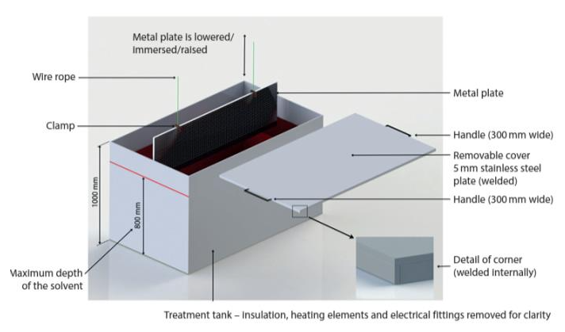
I have been asked to come up with a design for a new tank cover, which should comply with the following constraints; it must be able to be safely operated by a single staff member, the tank dimensions must stay the same however some minor modifications are allowed, and that there must be clearance above the tank so that the aluminium parts can be lowered. I have been told that the tank cover can be designed and changed how I see fit.
Figure 1 - The diagram provided of the tank

Time Plan
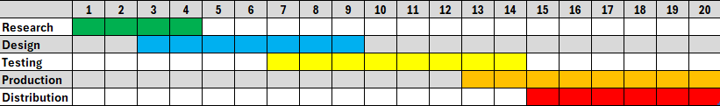
As part of the process, I created a time plan (Figure 2) which details the 5 main stages of the creation of the new tank cover, over a time period of 20 weeks (5 months). This is a realistic period of time in which a project such as this would take, due to the multiple designs that will inevitably be thought out and tested, and in companies of a certain size, multiple departments would likely be working on this together, which could cause the project to slow down somewhat.
Figure 2 - The time plan created for the project

Initial Design Sketches
Initially, I came up with 3 designs which could be used on the tank. Design 1 (Figure 3) is a simple hinge mechanism. This design is inspired by classic toolboxes which open to 90 degrees, which allows for the space needed to place the aluminium pieces in the tank. It also features a large handle to allow for one person use. However, this cover could still be very heavy as it is one large piece, which could make it difficult for a singular person to lift. Another drawback of this design still being heavy is that the hinges could be susceptible to snapping, which would cause problems. Not only could any loose material fall into the solution in the tank or hit someone, but frequent breakages could also cause major disruption to the production line, which is not ideal in this situation.
For design 2 (Figure 4), I used a similar design to number 1, except I split the cover into two separate pieces. The idea of this design was that by splitting the cover into two, it would reduce the stress on the hinges and make it easier for the person using the machine to lift the cover. However there are still some problems with this design. One of them is that the hinges might not open all the way to 90 degrees, which would mean that it would be very difficult or make it impossible to lower the aluminium pieces into the tank. Over time, this problem would only become worse as the hinges grow more tired which would lead to more delays on the production line.
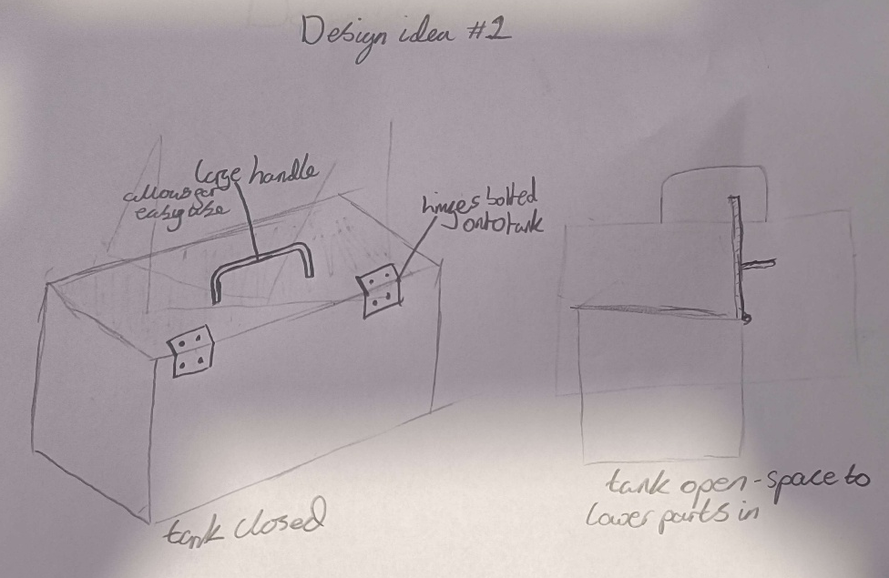
For design 3 (Figure 5), I used the same idea with two separate covers which come together to make for easier lifting. However with this design, I implemented rails on either side which can be welded onto the top of the existing tank. There would also be rails on the cover which would seamlessly fit around these, making it easy for the person using to find where to place the covers. I also included the backstop feature, which was on the original cover. This was to ensure that covers would not slide too far over and would always meet in the middle. This design also ensures that there will always be enough space to lower aluminium pieces into the tank, as the cover can be taken completely off, and can be put back on with ease when not in use. There was one drawback that I had thought possible, which is that when on the tank, the covers could come away from the center. An easy solution to this would be to include a lock which attach to both sides of the cover, however this could be looked into during the testing phase.
Figure 3 - Design 1

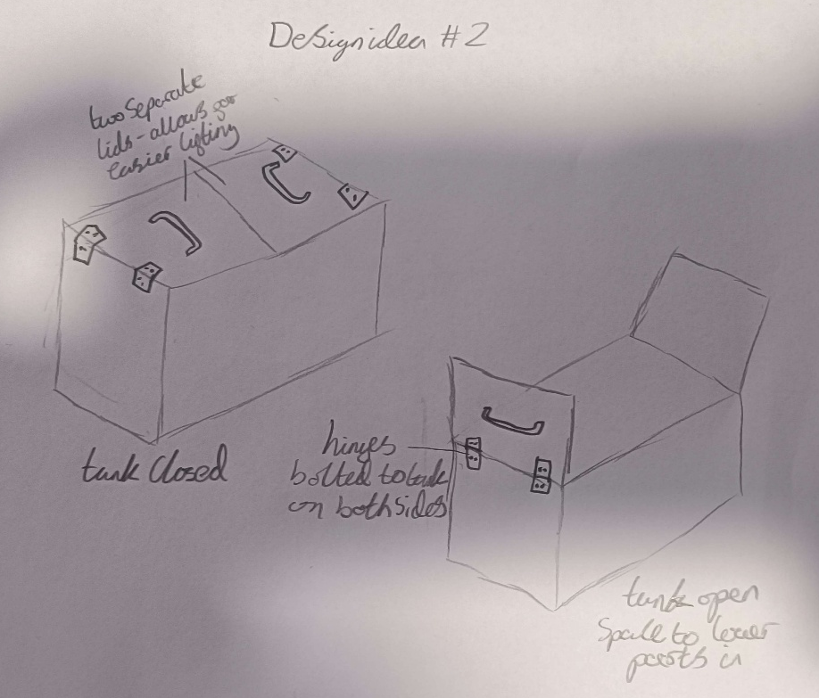
Figure 4 - Design 2

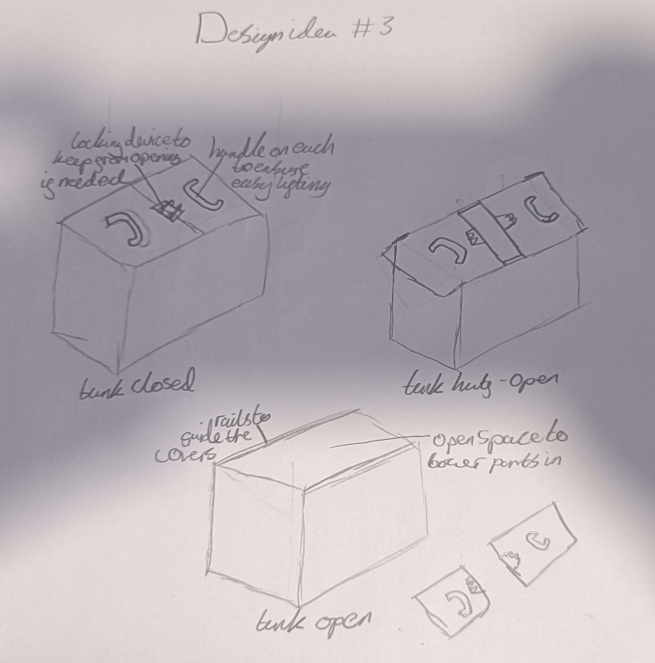
In the end, I decided to go forward with design 3 into my final design. This is due to its relatively simple design with minimal parts needed, and the fact that I think it works the best out of my 3 designs. Another reason is that because it is so similar to the original tank cover, one of them can be easily modified to prototype the design and improve it if it is found that there is a need to.
Figure 5 - Design 3

CAD Model and Technical Drawings
The CAD model and technical drawings are attached in the CAD files section of the submission.

Manufacturing Process
Both the tank cover and tank itself will use the same material – stainless steel. The tanks from before can be repurposed, by welding the rails onto them. However, this will mean that the manufacturing process will take longer since the production line will have to keep going, so there will always be some tanks in use. However, the further into the process it goes, the easier this becomes.
The tank cover will be manufactured with the same 5mm thick stainless steel as the previous version. This is due to it being proved to be durable material, and with it now being split into two separate panels can be easy for a singular staff member to handle. As will be done with the tank, the rails on the cover will be welded onto the steel.
For the handles, they will be made from 20mm diameter aluminium piping that will be custom made to fit the design. It will then also be welded on to the cover to ensure its strength. However, if this is not possible, there are plenty of options to choose from that may work, such as pre-made large door handles that can be retrofitted onto the cover.

Conclusion
To conclude, the aim of this assignment was to design a new cover for an anodization tank, while following the brief laid out. This included making the cover usable by one person, keeping tank dimensions the same (minor modifications allowed), and clearance from above to be able to lower aluminium pieces into place in the tank.
After coming up with multiple designs and evaluating each, I chose the design that I felt best matched the brief. The design (design 3) fits all the criteria laid out, being usable by one person, able to create clearance for moving parts in and out of the tank, and also using minor modifications to the original tank.

