Certificate of Higher Education in Skills for the Workplace

Module Name: Effective Team Work and Communication

Module Code: BMSW4002

Lecturer: Soban Sadiq
Student Name & ID - Victoria Mihai (2123280)

Introduction

Communication is a way to express yourself to others or receive information from them.
Our daily lives depend heavily on communication, which is also essential in the workplace. We receive, send, and process a significant amount of news and information related to virtually any business or workplace every day in the modern era in which we live. Misunderstandings resulting from dialectal variations or trouble translating are referred to as language barriers. If ethnocentrism is addressed and inclusiveness is prioritised in your workplace culture, no matter their ethnicity, team members will feel valued and included.

Models of Communication

Shannon and Weaver (1948/49)

The sender, encoder, channel, noise, decoder, and receiver are the six fundamental components of human communication, according to the Shannon and Weaver Model of Communication, a mathematical theory of communication.
(Drew, Chris and PhD, 2019)

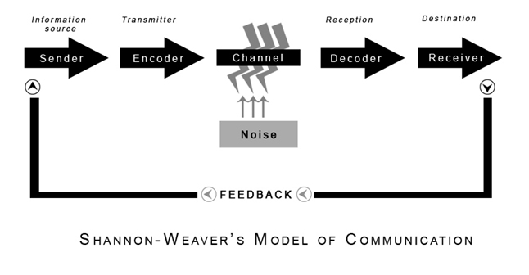

In the case of Maria and Pedro, where Pedro may have misunderstood Maria's message and instead heard "kitchen" instead of "chicken," according to a linear theory that describes how a sender sends a message through an encoder that is then decoded at the other end to make sense to the receiver.

How misunderstanding could be avoided:

- Maria needs to determining whether it’s good time and place to speak with Pedro.
- Pedro and Maria have to speak in an understandable language.
- Allowing Pedro to remain silent if he choose due to building site noise.
- Maria has to make sure that Pedro has understood her properly before terminating the phone call.

NSW Government (2020).

From my previous employment history around 4 years ago, I remember working in a restaurant to be more specific a steakhouse based in Leyton, East London. It had different variates of food on the menu along with steaks. Selections of normal drinks such as coca-cola but also mojitos ( strawberry/virgin/mango&passion fruit ) and milkshakes. On a busy Friday night, I remember one of the customers asking for a drink, we were a halal restaurant therefore no alcohol, he asked for a cocktail, the waitress that took down his order forgot to mention that we do not serve such drinks. Due to all the noise, she just placed his order as a virgin mojito. When the drink arrived, it was served at table 10 where he was seated. Shortly after sipping the mojito he realised that something isn’t right about this drink. He addressed the manager before talking to the waitress which caused the waitress to be very upset.
The manager resolved the issue by providing the man with a refund.

I’ve learned from this specific day that any small noise can cause a lot of confusion which can lead to interfering with the message that meant to be passed on the the receiver from the sender. This issue could’ve been avoided by the waitress simply repeating the order back to the customer.

Schramm (1954)

In the Schramm model, information is communicated in both directions, thus it is up to the listener to interpret what the speaker was attempting to say.
This model, which incorporates all crucial components of communication, is circular or cyclical.

(toolshero, 2022)

Encoding and decoding are two crucial components of an efficient communication, according to Schramm's approach.
Schramm's communication model differs from Shannon and Waver's because it can combine both traditional and contemporary elements, including semantic noise and feedback, into a single system.

Bhasin, H. (2020)

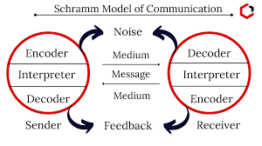

Pedro and Maria - Shramm concurred that noise can skew the message, but they countered that in order for communication to be complete, the receiver must provide feedback to the sender. Pedro could have called Maria again and inquired as to whether she meant "Kitchen" in the original call.

Around 50 of us between the ages of 15 and 19 would attend the wedding events. There was a female there who had a boyfriend, and they typically didn't fight. Before work, something transpired between them. They got into a violent altercation as we were getting ready, which resulted in the destruction of half of the food that was supposed to be served. If they would have either kept their business at home or dealt with it before work, this could have been easily avoided.

Berlo (1964)

Although Berlo's SMCR model is similar to the others, it is linear and devoid of feedback, like Shannon and Weaver's models. After the communication has been transmitted, interference or "noise" may have been created. Because of the noise, the receiver only receives a portion of the message or none at all. The receiver is subject to the same factors that may affect the sender. Background noise during a phone call, for instance, may result in external noise, as in Shannon and Weaver's model. Differences between sender and listener may lead to internal noise in:

Communication skills: Reading, listening speaking, language differences.

Attitude: Bored, not paying attention, making assumptions.

Knowledge: Dissimilarities between sender and receiver that could cause the sender to use a language that the recipient does not comprehend, for example, if the message is sent using language that are difficult for the recipient to understand.

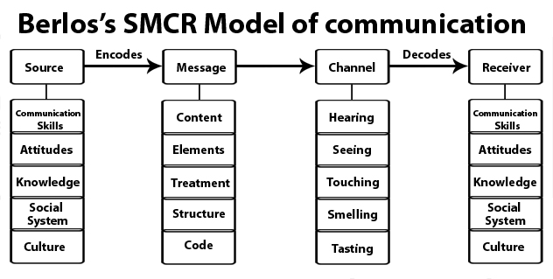

Professor Layton and the Curious Village

A distinguished English professor at Walsh University resided in a sizeable home close to a little community. Due to the fact that he felt he had nothing in common with the villagers because they were illiterate and worked manual jobs, he never went into the country and always did his shopping in the town close to his university. He was smoking his pipe one night when he fell asleep, and the pipe slipped into the carpet, sparking a fire. The professor suddenly woke up and ran into the community while yelling, "The building is being engulfed by a gigantic blaze!" No one offered to assist him because no one was paying attention to him. The following day, he went back to the village where his house had burned down and questioned the residents why they hadn't come to his aid. They remarked that if he had said that his house was on fire, they would have come to his rescue.

(Professor Layton Wiki, n.d.)

Despite Berlo expanded the concept of noise to include internal noise produced by disparities between sender and receivers, he did not incorporate feedback.
The professor and the villagers in this case study have different levels of knowledge. The professor went to them to requested for aid, but because he believed they were illiterate and of low social standing, they were unable to understand him because of his unusual spoken English. If the professor had spoken standard English and said, "Help, my house is on fire," the misunderstanding would have been avoided.
I used to serve guests at weddings when I was about 16 years old. The majority of the visitors were recent arrivals or had limited English language skills. They didn't always make sense when asking for something, so I tried to figure out what they wanted, but occasionally I would bring the wrong thing. I could have requested someone who would understand this situation better to take over my table to avoid it.

COMMUNICATION SKILLS

3.1 Verbal – spoken and written, choice of words, tone and pitch.

One of the most prevalent ways that people communicate is verbally. A person's vocal tone can convey their feelings. If they speak with a high pitch, it may indicate that they are enthusiastic and interested, but if they speak with a low pitch, it may indicate that they are depressed or unsatisfied.

3.2 Non-Verbal – Body language, facial expressions, gestures.

The process of nonverbal communication is just as significant as verbal communication. Listeners can better understand a speaker's meaning by observing their nonverbal signs, such as smiling, making eye contact, or fidgeting.

People's voices will be the first medium through which their inner state is communicated unless they learn to regulate their emotions. For instance, someone will raise their voice when they are angry or eager.

A Day with the Chief

This case study demonstrates how Mark, a salesman, misapplied communication skills when speaking with his boss, the company CEO. First, because his colleagues had labeled her as the "Wicked Witch of the West," he already had a preconceived notion of her and had already made a judgment about her before even seeing her.

After meeting her, he discovered that she was not at all like his expectations of her or how his colleagues had portrayed her. She smiled and greeted him warmly. During the conversation, Mark became a little too at ease and lost focus when he began to use unprofessional body language and gestures, such as loosened ties and crossed legs. He also began to disparage his immediate supervisor and asked for a pay raise, sending the wrong cues and coming across as very unprofessional.

3.3 Listening - Active Listening - paying attention

As an alternative, listeners can be evaluating how they compare to the speaker, planning out their next move, ruminating about the past, or wishing they were somewhere else. They might also be blocking out some portions of the speaker's message, speculating about what the speaker is thinking (mind reading), making hasty judgments, or giving out advise before they have all the facts.

Empathetic listening – listening and trying to put yourself in the speaker’s shoes.

The goal of an empathic listener is to stop the speaker from responding defensively. Even if you don't agree with what the other person is saying, try to listen patiently anyway to develop empathic listening skills.

Every time Will Smith (2022) speaks, he conveys a clear message. He also suggests some humour to keep the listener interested.

At my place of employment, for instance, the manager conducts a meeting of the entire staff in the morning and informs them of their tasks for the day. I lacked some of the necessary skills when I started working there. Sometimes, he neglects to make sure I understand. He finishes his speech and walks out, leaving me unprepared.

If there had been feedback, Maria and Pedro's situation would not have been as confusing. Similarly, our manager ought to check to see if we comprehend what he said. This will help prevent confusion and mishaps.

Advantage

Emergency communication approach that is quicker. having access to global communication. It is simpler to communicate over distance.

(Mjones, 2019)

Disadvantage

As opposed to face-to-face communication, technology is designed to be short and instantaneous rather than to convey feelings and emotions. This inhibits personal communication. The speed and instantaneity of technology also skews the clarity of the message being delivered.

(ROSI Office Systems, Inc, 2015)

CONCLUSION

To sum up, communication is an ongoing activity that happens every day. Effective communication requires a continual, thoughtful, and purposeful interchange of ideas and body language. Similar to art, communication is constantly changing and improving. It calls for work, empathy, attentive listening, and a positive outlook. Text messaging, emailing, skyping, and social networking are now all considered forms of "communicating," in addition to genuine "talking." There is no longer a need that "talking" involve direct eye contact. The aforementioned models are all in place so that we might attempt to return to the earlier ways, when communication was conducted face-to-face and without interruption.

REFERENCES:

- Shannon Weaver Model of Communication - 7 Key Concepts (2022).
Sept. 2019, Available at: https://helpfulprofessor.com/shannon-weaver-model/. [Accessed 18 July 2022].

- Shannon and weaver diagram - Google Search. Available at: https://www.google.co.uk/search?q=shannon+and+weaver+diagram&client=safari&hl=en-gb&prmd=isvn&source=lnms&tbm=isch&sa=X&ved=2ahUKEwjOrfTjo4L5AhVrSkEAHXhoBOwQ_AUoAXoECAIQAQ&biw=428&bih=746&dpr=3#imgrc=UTSx2OcjbcprBM
[Accessed 18 July 2022].

- How can I overcome communication barriers? - Practical strategies and tips for effective support. [online] Nsw.gov.au. Available at: https://www.health.nsw.gov.au/mentalhealth/psychosocial/strategies/Pages/communicating-barriers.aspx.

- Schramm Communication Model. [online] Available at: https://www.toolshero.com/communication-methods/schramm-communication-model/.

- Schramm model of communication | Elements, Advantages & Limitations. [online] Marketing91. Available at: https://www.marketing91.com/schramms-model-of-communication/.

- Professor Layton and the Curious Village. [online] Available at: https://layton.fandom.com/wiki/Professor_Layton_and_the_Curious_Village [Accessed 30 Aug. 2022].

- How Technology Changed Communication - Pros and Cons. [online] Available at: https://www.rosiinc.com/blog/how-technology-changed-communication-pros-and-cons/.

- Communication of Technology: Advantages and Disadvantages. [online] Blogspot.com. Available at: http://mackenziejones212.blogspot.com/2012/02/google-chrome-advantages-and.html.

