

University of Wales Trinity Saint David’s
School of Engineering
Contemporary Logistics Challenges
Modelling Logistics Operations
M5X01280
Bence Tary
1902733
BSc Logistics and Transportation

Abstract

This paper will show the uses modelling has within the Logistic environment, both as part of supply chains and as part of transportation models, while providing examples. Most of these examples will be derived from the software model AnyLogic, although other software like ARENA are given mention, as well as systems that are theoretically can be used in such regards.

Table of Content
1. Introduction 2
2. Modelling Concepts 3
2.1. Methods 3
3. Modelling in Supply Chains 4
3.1. Optimization 4
3.2. Warehouse 5
3.3. Supply demand prediction 6
4. Modelling in Transportation 6
4.1. Public transportation planning 6
5. Conclusion 7
6. References 8

- Introduction

Modelling as a tool to improve logistics operation has been around for years, with Borshchev et al. (2002) using AnyLogic in 2002 to simulate discrete and continuous behaviours. An even older source discusses the use of modelling in their time, and makes predictions of the future of modelling (Bowersox and Closs, 1989), having projected that modelling software will become more refined, allowing for a more detailed look into the supply chain. This has been achieved, by amongst other things the AnyLogic software (Baggio, 2015; Grigoryev, 2018).
There are two major modelling techniques, called the Discrete Event Simulation (DES) and System Dynamic (SD), which have emerged simultaneously, though independently over the years (Tako and Robinson, 2012). Tako and Robinson (2012) state that the generally accepted belief is that SD is better when used for strategic level of simulation, while DES was better for tactical level simulation. These can be referred from the names of the techniques, with SD referring to the whole system, while DES explicitly for discrete events, meaning micro level.
There is an academic debate on which of these methods are better, though the preference for either system is possibly derived from personal experience. This can be derived from the differences of the writings of Persson and Araldi (2009), who uses DES modelling in his example, describing it as simple to use, compared to Rushton et al. (2017), who talks about the usage of “rough-cut modelling” for large scale logistics being better, a feature of SD modelling. Modelling was also used to see how PT can affect the spread of diseases, which is more relevant now then ever (Ohkusa and Sugawara, 2007).
There is another system discussed by Grigoryev (2018), a system they call “agent based” (AB), which a system supported by AnyLogic, which they claim is an alternate middle ground between the two systems. The idea of the AB system is recent, emerging as a theory roughly 15 years ago, with the development of stronger and more capable softwares and hardwares. It is described as a more demanding method than either SD or DES.
This paper will deal with primarily AnyLogics, as the software is familiar to the author, and is overall and easy to use, and clear modelling software that has the capability required to complete a range of tasks, with enough features that it often does not require, or requires only a minimal amount of outside help (AnyLogic, 2012; Baggio, 2015; Magilton, 2017).
There have further been identified in literature 3 main methodologies for modelling: simulation, Heuristic; Simulation and; Analytical, also called mathematical (Bowersox and Closs, 1989; Rushton et al., 2017). These methods define what perimeters have are being utilized in setting up the model, each method with their own advantage.
Furthermore, there is a growing debate amongst academics on the topic of gamification, a term with no defined meaning, though commonly understood to mean the introduction of game elements to learning (Haahtela et al., 2015). As part of this paper, this concept will gain a mention in the form of a game, Cities: Skylines, an interactive, modern take on a city builder (Paradox Games, 2021), a simulation type game with a logistical management element involved.

- Modelling Concepts
  - Methods

As mentioned in the introduction, there are a 3 generally accepted methodologies for modelling: Heuristic, Analytical and Simulation (Bowersox and Closs, 1989; Rushton et al., 2017). The methodological differences are:

- Heuristic: This method has been described by both Bowersox and Closs (1989) and Rushton et al. (2017) as a “rule of thumb” method. Using this method, the one making the model uses previous knowledge in the field, and experience to assign values and create the situation. If a model that is being used is based on a real life situation, with pre-existing conditions, the use of this method is also justified to figure out managerial decisions that could improve productivity (Bowersox and Closs, 1989).
- Mathematical: This method uses the optimal numbers in an attempt to calculate the best location for warehouses, or best option for partners (Rushton et al., 2017). This method, also called Analytical, aims to find the best option, instead of the most optimal (Bowersox and Closs, 1989). The use of this method is the best when considering the hypothetical best solution to a problem.
- Simulation: The simulation is not an optimization tool like the Heuristic method, not a perfect solution like the mathematical, but rather a response generator that shows how components of the system would react to a situation (Rushton et al., 2017). Unlike the other two, this system can have high levels of uncertainty (Bowersox and Closs, 1989), making it ideal to “simulate” how a system would react to changes.

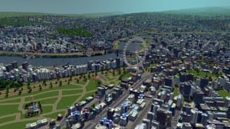
These methods can be utilized in many different ways. Systems like AnyLogic are able to use any of these, with an example of a heuristic method used by Baggio (2015) when presenting how AnyLogic can be used to optimize for supply chains, while the official AnyLogic YouTube channel have advertised the simulation capabilities of the software in 2012 (AnyLogic, 2012). These capibilites were later tested and proven by Magilton (2017), who used the simulation software during his webinar to create a warehouse that simulated arrivals, and even traffic congestion.
There is also a growing academic debate on the use of games for simulating purposes as many games are based on powerful game engines, capably of high levels of virtual simulation (Olszewski et al., 2020). For an example, the city on Figure 1 is simulated in the game Cities: Skylines. (Guardian, 2015)
Figure 1. Vienna in Cities: Skylines (Guardian, 2015)

- Modelling in Supply Chains
  - Optimization

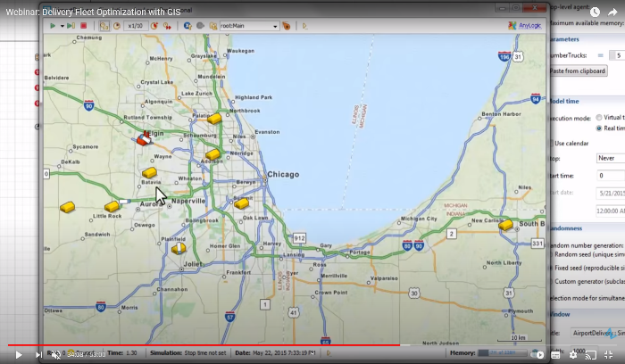
Using modelling to find the optimal solution can be a cheap way to re-organise supply chains, one that does not disrupt the existing system until a solution is found (Grigoryev, 2018; Magilton, 2017). This is advantageous for companies who do not want to upend their operations on a risky endeavour without information. Modelling an optimization strategy can show where it falls short, and where the system may succeed.
Figure 2. Screenshot of Baggio’s model in action (Baggio, 2015)
An example of this is the aircraft part distribution optimization created by Baggio (2015) in the AnyLogic software. This system is made as a tutorial showing others how the software can be used for such purposes, and uses a GIS map as a base to create the system. The map is showing the greater Chicago area, and during the tutorial 8 airports as delivery locations, and a town called Elgin as the production plant. The goals of the experiment is to optimise the number of trucks needed to fulfil all orders from the airports on time.
Optimising in such a way is important, because the real life system can be very delicate and susceptible to breaking under sudden, regular changes. If one such model can prove – or give a strong indication – of a solution that works, then the heads of the company making the change can be certain that their new method will work, and they can make a singular change without needing to go through dozens of methods before finding the right one.

  - Warehouse

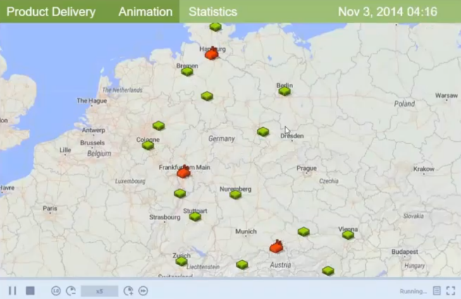
The location of warehouses is an important decision in the sustaining and creation of a supply chain (Richards, 2018), and is possibly the most important decision one will have to make. A warehouse, or a distribution centre (DC), is a large investment and is not mobile. Making the choice of where to build one – if the option exists – or select out of the possible options will impact the company for years (Richards, 2018).
Figure 3. Warehouse and manufacture locations on a GIS map (Magilton, 2017)
When selecting warehouse location, sever factors are in play, from road connectivity to availability of workforce (Richards, 2018). The distance of the warehouse from major consumer centres and/or production facilities is important to know, and it can be a deciding factor selecting the location. Figure 3 shows the location of warehouses in Germany, made in Anylogics by Magilton (2017), showing the supply chain movement between warehouses and other agents. While the purpose of the model is not to show the location selection of warehouse, the system can easily be re-programed to show each warehouse on the map as potential locations, and an efficiency counter can be programed in to monitor the performance of each warehouse. This would allow a company manager to make an informed decision to where to establish the next warehouse.
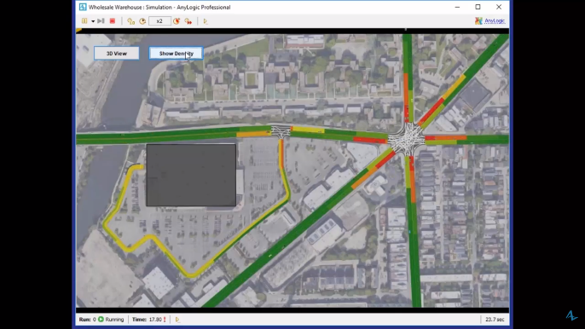
Road connectivity is another important one, and one that can be modelled using AnyLogic, as proven in the Webinar of Magilton (2017). He created a system that utilizes a GIS map, with a warehouse in the centre, with road mapping tools providing the connectivity. His model shows where the congestion points are, as shown on Figure 4, and using his model, the company in charge of the warehouse was able to improve on their activities, by shortening the waiting time at the entrance of the warehouse for trucks.
Figure 4. Congestion map by Magilton (2017)
Warehouses can also use modelling to improve space efficiency and understand worker behaviour using modelling, which was the main topic of Magilton's (2017) Webinar. He used the AnyLogic system to model the inside of a warehouse, and show how it was working. Figure 4 is a screenshot of his webinar, where not only the roads around the warehouse are modelled, but upon zooming into the warehouse, the operations of the warehouse were also simulated, and how the traffic affected the warehouse’s operations.

  - Supply demand prediction

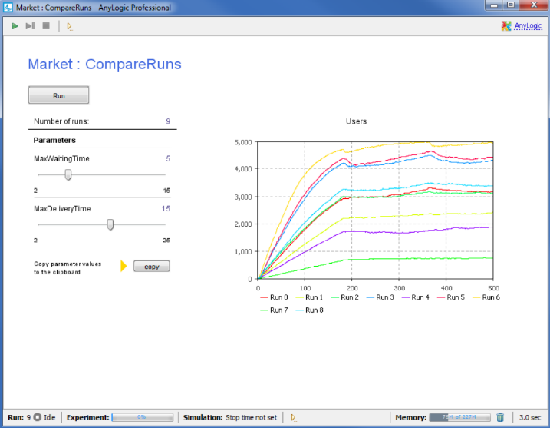
Demand prediction is an important aspect of modelling, with early sources, like Petrovic et al. (1998) proposing early fuzzy number methods to sort out the demand variability of supply chains, and how it affects supply chains. The system they propose is a fuzzy system in a mathematical method model that would interact with up and down the supply chain.
A similar system is created by Grigoryev (2018) when trying to teach the use of the AnyLogic system in their book on the system. What they propose is a simulation of the effect of marketing and how that will affect demand. The system considers the duration of time people will need to wait for their products to arrive, and word of mouth spread of news. The system they create for educational purposes shows a simplified example of how this can be implemented into supply chains. On Figure 5 can be seen the results of the model after use.
Figure 5. Marketing effect on people (Grigoryev, 2018)
The use of supply chains for these sort of purposes is important to enable effective inventory management, and production management. If the production requirements are too high, there will be waste products produced, while if the demand of too high, then production might need to be expanded to meet demand.

- Modelling in Transportation
  - Public transportation planning

Public transportation is a complex art, involving such small things as signal priority planning (Altun and Furth, 2009) and competitors that one would not necessarily consider at first, such as micro mobility options in the form of bike share systems (Campbell and Brakewood, 2017), and recently electric scooters (Hull, 2020).
City planning is also closely tied to PT, especially within city and town limits, as the construction of bus and cycle lines can help in encouraging such transport methods (Foreman and Kendler, 2018a). City planning is a complicated area of study, and involves a lot of factors, many of which can influence how a city infrastructure can handle PT. An example of bad foresight by city planners comes from London, when they scrapped the city’s expansive tram network, thinking that it will not be relevant again (Foreman and Kendler, 2018b).
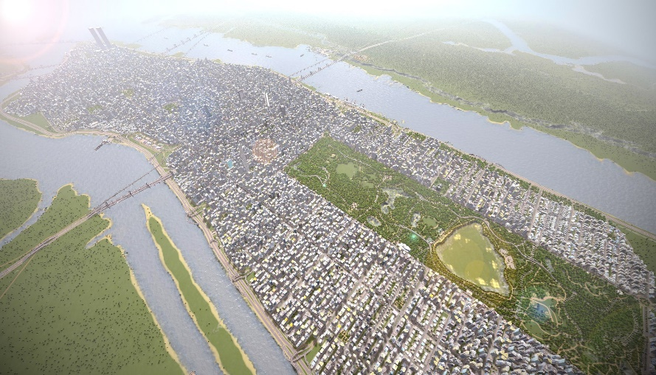
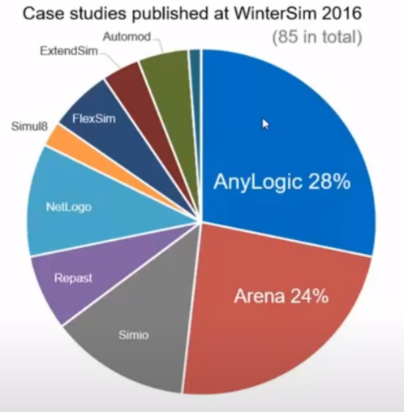
Figure 6. WinterSim 2016 studies (Magilton, 2017)
Figure 7. The city of Manhattan re-created in Cities: Skylines (Guardian, 2015)
While simulation programs like AnyLogics have GIS capibilities (Baggio, 2015; Magilton, 2017), and systems like ARENA have been used to simulate T-junctions without signal lights successfully (Kamrani et al., 2014). These programs however are hard to use for those untrained in them and hard to get into, using complicated terminology. And while the two systems had a combined 53% market share in WinterSim case study publishes in 2016, as seen on Figure 6, there is a theoretical alternative that can be used in the form of the game software Cities: Skylines.
Cities: Skylines is a game released by Paradox Interactive, and is a simplified view on a city planner game, where one takes control of the planning process for the entire town, acting as a major and a one man development committee (Haahtela et al., 2015). The game has been considered for the use of teaching city planning to university students by the Aalto university, planning to replace their existing system. The paper by Haahtela et al. (2015) explores this, and finds that the game system, while detailed and strong, without modifications (Guardian, 2015)and updates in not yet sufficient for city design. However, he does site the strong transportation and agent based model for each individual citizen as strong points for the game.
These systems are indeed strong, and with the right tools could be implemented and modified to simulate PT options. While there are no micro-mobility options in the base game, there are plenty of “fan-made” content available, which is content created by the players to enrich their own experience. The range of PT services that can be implement is also expansive (Paradox Wiki, 2021), with buses, trams, trains and even blimps.

- Conclusion

In conclusion, there are plenty of uses for modelling within the Logistics sector, and this paper is by no means able to show all of the uses, due to word count limitations. Modelling in logistics is already a well-established method for dealing with real life problems in a virtual space where the experimenting with existing systems does not pose any threats.
Limitations on what can be modelled is dependent largely on the software used, the hardware that runs the system, and the skill of the one modelling, as can be seen from the examples above. These show definitely that the current levels of modelling software are almost unlimited in what they can be used for, leaving external limitations as the major point of limits.
There are also new software emerging in the form of video games, many of which are still in their infancy, though are increasingly catching up to the capabilities of dedicated systems, and in some regards, like graphics and simulation quality are already beating most of the modelling systems. In the technicalities however, many of these games still fall short in becoming anything more than an academic “what-if”.
Overall, modelling has established itself as a part of supply chain planning and operational management tool that allows one with sufficient skill and know-how to simulate and re-create any situation that they find themselves in, and to use these models to make informed decisions.

- References

Altun, S.Z., Furth, P.G., 2009. Scheduling Buses to Take Advantage of Transit Signal Priority. Transportation Research Record 2111, 50–59. https://doi.org/10.3141/2111-07
AnyLogic, 2012. What is the AnyLogic simulation tool?
Baggio, T., 2015. Webinar: Delivery Fleet Optimization with GIS.
Borshchev, A., Karpov, Y., Kharitonov, V., 2002. Distributed simulation of hybrid systems with AnyLogic and HLA. Future Generation Computer Systems, Selected Papers presented at the 6th Int. Conf. on Parallel Computing Technologies (PaCT-2001) 18, 829–839. https://doi.org/10.1016/S0167-739X(02)00055-9
Bowersox, D.J., Closs, D.J., 1989. Simulation In Logistics: A Review Of Present Practice And A Look Into The Future. Journal of Business Logistics 10.
Campbell, K.B., Brakewood, C., 2017. Sharing riders: How bikesharing impacts bus ridership in New York City. Transportation Research Part A: Policy and Practice 100, 264–282. https://doi.org/10.1016/j.tra.2017.04.017
Foreman, J., Kendler, P., 2018a. Why drivers should want cycle lanes, Unfinished London.
Foreman, J., Kendler, P., 2018b. What happened to London’s trams?, Unfinished London.
Grigoryev, I., 2018. Anylogic in three days, 5th ed.
Guardian, 2015. Amazingly detailed metropolises recreated in Cities: Skylines – in pictures. The Guardian.
Haahtela, P., Vuorinen, T., Kontturi, A., Silfvast, H., Väisänen, M., Onali, J., 2015. Gamification of Education: Cities Skylines as an Educational Tool for Real Estate and Land Use Planning Studies.
Hull, R., 2020. E-scooters to swarm Milton Keynes from TODAY in first full-scale trial. This is Money.
Kamrani, M., Hashemi Esmaeil Abadi, S.M., Rahimpour Golroudbary, S., 2014. Traffic simulation of two adjacent unsignalized T-junctions during rush hours using Arena software. Simulation Modelling Practice and Theory 49, 167–179. https://doi.org/10.1016/j.simpat.2014.09.006
Magilton, D., 2017. Webinar: Simulation Modeling for Warehousing and Transportation.
Ohkusa, Y., Sugawara, T., 2007. Application of an individual-based model with real data for transportation mode and location to pandemic influenza. Journal of Infection and Chemotherapy 13, 380–389. https://doi.org/10.1007/s10156-007-0556-1
Olszewski, R., Cegiełka, M., Szczepankowska, U., Wesołowski, J., 2020. Developing a Serious Game That Supports the Resolution of Social and Ecological Problems in the Toolset Environment of Cities: Skylines. ISPRS International Journal of Geo-Information 9, 118. https://doi.org/10.3390/ijgi9020118
Paradox Games, 2021. Cities: Skylines | Paradox Interactive [WWW Document]. URL https://www.paradoxplaza.com/on/demandware.static/Sites-Paradox_US-Site/-/en_US/v1614063971859/ (accessed 2.27.21).
Paradox Wiki, 2021. Transportation - Cities: Skylines Wiki [WWW Document]. URL https://skylines.paradoxwikis.com/Transportation (accessed 3.2.21).
Persson, F., Araldi, M., 2009. The development of a dynamic supply chain analysis tool—Integration of SCOR and discrete event simulation. International Journal of Production Economics 121, 574–583. https://doi.org/10.1016/j.ijpe.2006.12.064
Petrovic, D., Roy, R., Petrovic, R., 1998. Modelling and simulation of a supply chain in an uncertain environment. European Journal of Operational Research 109, 299–309. https://doi.org/10.1016/S0377-2217(98)00058-7
Richards, G., 2018. Warehouse Management; A complete guide to improving efficency and minimizing costs in the modern warehouse, 3rd edition. ed. KoganPage, London.
Rushton, A., Croucher, P., Baker, P., 2017. The Handbook of Logistics and Distribution Management: Understanding the Supply Chain, 6th ed. Kogan Page Publishers.
Tako, A.A., Robinson, S., 2012. The application of discrete event simulation and system dynamics in the logistics and supply chain context. Decision Support Systems, 1)Decision Support Systems for Logistics and Supply Chain Management 2)Business Intelligence and the Web 52, 802–815. https://doi.org/10.1016/j.dss.2011.11.015

