
Topic - Nike's Digital Marketing Strategy (Social media marketing, Influencer marketing, Brand positioning)

Student Name - Omin Dineshbhai Dihora
Student ID - 2538975
Programme - master of business administration
Module - Marketing Management
Module code - LCMB7024
Assignment title - portfolio:-
- Presentation
- Report
- Reflection
Lecturer - Taonga Kaonga Sobere-Snithers (Birmingham)
Table of Contents
Element 1: Sustainable Brand Extension Poster Presentation 3
2.1 Market Segmentation 4
Multi-variable segmentation matrix for Nike Renew 4
2.2 Target Audience Selection 5
2.3 Brand Differentiation 5
2.4 Product Positioning 6
Element 3: Sustainable Marketing Mix (7Ps) 7
3.1 Product 7
3.2 Prices 8
3.3 Promotion (Influencer, Social Media and Digital Strategy) 9
Social media marketing 9
Influencer marketing 10
3.4 Place 11
3.5 People 11
3.6 Process 11
3.7 Physical Evidence 12
Element 4: Academic Reflection 12
References 15

Element 1: Sustainable Brand Extension Poster Presentation
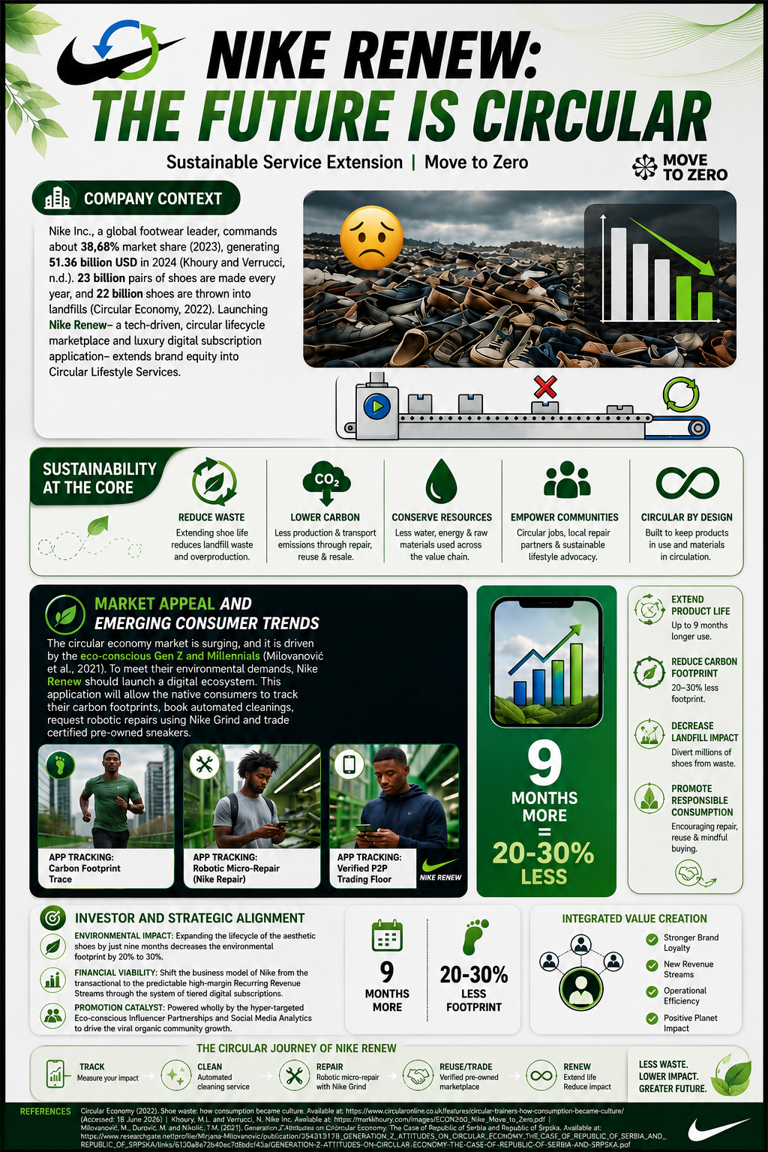
Element 2: Develop a Segmentation, Targeting, Differentiation, and Positioning (STDP)

2.1 Market Segmentation
In order to effectively launch the Nike Renew sustainable service brand extension, the company needs to make a proper segmentation of the market. The global athletic consumer market must be divided into the different actionable parts. As per the strategic segmentation framework provided by Kotler et al. (2022), the consumer base must be evaluated across the demographic, geographic, behavioural and psychographic variables to identify the market areas that are most suitable to target.

Multi-variable segmentation matrix for Nike Renew
Segmentation variable | Target market features and breakdowns
Geographic | High-density tier-1 metropolitan urban regions (like Tokyo, New York and London) can be targeted. These regions are featured by established digital infrastructure and closeness to the Nike flagship drop-off hubs.
Demographic | Millennials and Gen Z individuals (aged between 18 and 35) should be targeted. It must include the students and educated young professionals with moderate-to-high disposable income levels.
Psychographic | Lifestyles featured as ‘conscious consumers’ and ‘eco-athletes’ should be included. These must involve those who are highly aligned with personal wellness, circular economy values and eco-responsibility.
Behavioural | It should target those with a high level of mobile app engagement (like the SNKRS app and Nike Run Club). It should involve people with high usage of social media and frequent sneaker purchases exhibiting strong baseline brand loyalty to Nike.

Geographically, the service focuses on the metropolitan hubs in which consumers have high access to the smart retail drop-off lockers. Demographically, Millennials and Gen Z represent the basics as they express willingness to pay more for the certified sustainable options that prioritise wellness (McKinsey & Company, 2025).
These people are driven by the status presented by environmental preservation, while behaviourally, they present a high familiarity with the subscription-based mobile platforms and the digital lifecycle monitoring.

2.2 Target Audience Selection
Nike Renew uses the concentrated targeting strategy (on niche marketing strategy) with the major focus on resources exclusively on the high-value segment: the Eco-Active Urban Athlete.
The critical evaluation of this segment using the targeting framework presents the highest scores across the structural recognition metrics, including measurability, accessibility and sustainability (Kotler et al., 2024). Destroyed audience includes highly active consumers who viewed their athletic apparel as something which present there personal values.
Historically, the high-performance athletes experienced structural contradiction as the heavy physical wear and tear on the technical sneakers led to frequent replacement, which further results in linear landfill waste that affects the environmental values.
By focusing on this niche, Nike can convert the point of consumer function into a mechanism for deep alignment with the brand. This audience is extremely accessible and scannable through hyper-targeted social media analytics and influencer marketing. Moreover, emphasising a disk high lifetime value cohort helps to optimise the customer acquisition cost (CAC) while presenting a solid and protective base of brand advocacy.

2.3 Brand Differentiation
To manage the defensible competitive rivalry, Nike Renew differentiates itself from the independent digital sneaker cleaning applications and 3rd party cobblers across 3 primary vectors as presented below:
- Official corporate authentication: Capitalising on the elevated secondary market for footwear, this application presents official brand certification. Every product that is processed through the peer-to-peer marketplace goes to automated authenticity screening, which assures the buyers in the industry heavily affected by counterfeit products.
- Proprietary circular technology: Apart from local alternatives, Nike Renew incorporates original factory manufacturing technology into its maintenance cycle. It presents the robotic micro repairs (using automatic technologies like Nike’s experimental BILL: Bot Initiated Longevity Lab) and replaces the degraded parts using sustainable and proprietary raw materials like Nike Forward recycled textiles and Nike Grind rubber.

Feature | Nike Renew | Adidas | Local Repair
Official Authentication | ✔ | ✘ | ✘
AI-Based Repair | ✔ | ✘ | ✘
Mobile App | ✔ | Limited | ✘
Circular Economy | ✔ | Partial | ✘
Subscription Service | ✔ | ✘ | ✘

Figure 1: Nike Renew Customer Journey
(Source: Author, 2026)

2.4 Product Positioning
The strategic positioning of the Nike Renew presents the cognitive relationship of the consumer with athletic footwear. Moving beyond the traditional Linear Product Provider paradigm (take-make-waste), Nike positions this service extension as the Circular Performance Partnership.
The core value proposition is a sustainability focus without compromise on performance (Nike, 2026). It addresses the historical misconception of consumers regarding repaired or recycled athletic products as structurally inferior or less prestigious. Through the application of a premium service tier, Nike presents this upcycling and maintenance as an elite and high-tech experience for consumers.
This positioning satisfies the dual demands of the consumers for zero-waste accountability and high-tear athletic utility. It also develops a unique, psychologically compelling and legally defensible space in the minds of modern consumers.

Figure 2: Product Positioning Map
(Source: Author, 2026)

Element 3: Sustainable Marketing Mix (7Ps)
Operationalise the sustainable extension of Nike Renew, and an all-inclusive Service marketing mix framework should be developed. As Nike Renew shifts the corporate value proposition from static goods to a dynamic ecosystem of services, using the extended 7 Ps framework may be helpful in comparison to the traditional 4Ps. This approach can ensure that every operational touchpoint presents the objective of Nike towards sustainability, ‘Move to Zero’.

3.1 Product
The protector architecture of Nike Renew s digitally led and intangible circular service ecosystem which is delivered through a dedicated Android/iOS mobile interface. It is grounded in the core-v-augmented product number. The basic advantage is the longevity and restoration of the luxury footwear. The actual product is the application of Nike Renew, which presents 3 integrated consumer service lines:
- The customer of the cycling module: It is a service that allows the buyers to modify heavily brown sneakers by retrofitting them using sustainable elements like custom eco-woven lacing systems or Nike Grid outcycled outsoles.
- The renewal lab: It is an automated service request hotel in which the users book specialised odour extraction, deep cleaning and robotic micro repairs.
- The certified put to peer marketplace: An additional trading floor for purchasing and selling the verified and authenticate pre owned Nike footwear, which extends to mitigate the fast fashion linear wastage and improves product life cycles.
NIKE RENEW

│
┌──────────────────┼──────────────────┐
│ │ │
▼ ▼ ▼
Repair Service Resale Market Recycling
│ │ │
└──────────────────┼──────────────────┘
▼
Nike Renew App
│
▼
Circular Economy

Figure 3: Nike Renew Digital Ecosystem
(Source: Author, 2026)

3.2 Prices
Nike Renew uses the hybrid value based on a recurring subscription pricing strategy, which directly aligns with the modern circular business models. Instead of competing on cost, the pricing architecture presents the luxury nature of the technological potential of Nike. According to Yan et al. (2022), the pricing strategy of Nike is justified in comparison to its rivals in the industry, as it offers innovative, high-quality, and well-designed goods.

Nike Renew tiered pricing structure
Pricing Tier | Cost Structures | Service Deliverables
Pay-per-service | Flat fee (£25 - £50 per item) | Minor vulcanised rubber repairs, à la carte deep cleaning and stitch optimisation.
The Circular active tier | Monthly subscription (£14.99/month) | Involves zero cost marketplace shipping, full robotic renewals per year, and double carbon-offset reward points.
The Elite Athletic tier | Annual subscription (£149/year) | Priority lab processing, unlimited structural micro repairs, and exclusive access to limited-edition upcycled lace and accent kits.

This tiered structure decreases the entry barriers for casual users through the option of pay per, while also securing a high profit margin and forecastable recurring revenue streams from the core demographic of the brand.

3.3 Promotion (Influencer, Social Media and Digital Strategy)
The promotional strategy for Nike Renew is totally dependent on the digital channel and designed to shift the sustainability metrics into personal status symbols across social spaces.

Social media marketing
The promotion uses short-form video ecosystems (like Instagram and TikTok Reels) to emphasise ‘clean girl/boy’ aesthetics and structural transformation. World campaigns will emphasise the ASMR-style time-lapse videos, which are highly satisfying and include highly weathered sneakers perfectly restored by the automated labs of Nike.

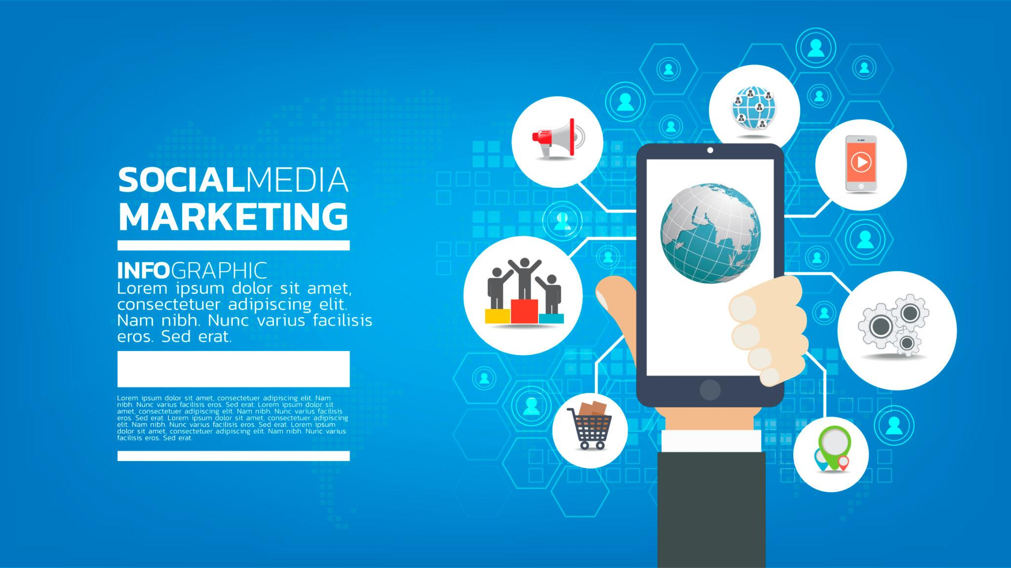
Figure 4: social media marketing
(Source: Author, 2026)
The application includes the social channels by developing a dynamic ‘Eco-Impact Badges’ whenever there is service completion. The users can quickly share the metrics, like I just diverted 2.4 kg of Co 2 and 400g of waste from the landfills with Nike Renew. This can directly be posted on Instagram stories and turn the green consumption into visible social currency.

Influencer marketing
Nike will turn away from the traditional elite athletic sponsorships for this extension. It will enter into partnership with the micro- and mid-tier influencers and the gorpcore, sustainable fashion and urban running communities (like street wear upcyclers and eco-activist runners).
New media allows athletes to develop authentic relationships with their fans and develop effective marketing campaigns that generally outperform traditional methods of advertising (Aydin, 2024).
These creators will be sent highly weathered, vintage Nike sneakers sourced from the donation bins, presenting their transition through the labs of Nike Renew. This unboxing of the renewed sneakers reframes the pre-home and repaired footwear as a premium and highly desirable lifestyle choice for consumers.

3.4 Place
The distribution strategy uses an omnichannel and closed-loop system that reduces the friction for urban shoppers. Omnichannel strategies have become the chief aspect in improving the experience of consumers by developing integrated and seamless interactions across different channels (Fauzzia et al., 2025). The digital infrastructure of the app handles all the tracking and scheduling. The physical collection layer uses 2 primary channels:
- Eco Courier direct mail: Users get a reusable, 100% recycled ocean plastic mailer bag along with a prepaid carbon-neutral shipping label, which allows direct collection from their homes.
- Smart drop-off lockers: Positioned inside the existing flagship retail stores and transit hubs of Nike. The shoppers scan a unique QR code, which is generated through the app, drop their shoes in the secure locker and track the regional optimisation centres.

3.5 People
The human aspect is critical for delivering the high-quality of service (SERV QU AL) and managing the corporate brand equity (Ahmad et al., 2022). Nike Renew makes huge investments in two employee cohorts:
- Application and digital engineers: They will be tasked with the management of algorithmic UX/UI updates, which ensure smooth authentication in the marketplace and maintain robust data privacy across the subscription portals.
- Specialised lab artisans: It will include the technical staff who will work alongside the automated robotics, who will be trained in advanced anatomy of sneakers, sustainable methods of repair and material composition. They handle the nuanced touchpoints that machinery is not able to diagnose on its own.

3.6 Process
The operational procedure is created to improve the efficiency and customer transparency. It follows a highly structured, circular flow:

Figure 4: Process
(Source: Author, 2026)
When the shoes arrive at the regional circular facility, they go through the 3D laser diagnostic scan. The application automatically updates the user with the custom digital layout of the planned repairs, along with the estimated decrease in the carbon footprint score. This interactive procedure keeps the buyers highly engaged using the service journey, developing strong trust and decreasing the perceived service intangibility.
As per CV and Agrawal (2024), the engagement between the salience of the encountered information and the goals of the consumers presents the purchase behaviour, with customer motivation as the mediator.

3.7 Physical Evidence
As the services are inherently intangible, physical evidence should clearly validate the high cost and environmental integrity of Nike Renew. The physical touchpoints consist of the architectural, minimalist layout of the smart drop-off lockers in the flagship stores, which present the real-time counters presenting the collective landfill diversion metrics of the local community.
Moreover, the packaging used to return the shoes includes the unbleached, stark, compression-moulded cardboard box made wholly from recycled post-consumer waste. This box presents the bold typographic prints presenting the specific craftsmanship of the pair, shifting the unboxing experience into a physical verification of the circular performance promise made by Nike.

Element 4: Academic Reflection
Building the Nike Renew sustainable service brand extension and its associated strategic marketing portfolio has been a very important and transformative experience during my postgraduate studies. The entire process has profoundly influenced my understanding of marketing management and transformed my perspective from a purely operational approach to a broader systemic strategic mindset.

When I started this assignment, my intention was simply to analyze Nike’s digital marketing, influencer tactics, and social media strategies as standalone promotional tools. However, a serious engagement with the project’s rules and its criteria made me realize one important thing: true master-level marketing management never views promotion as an isolated process. Instead, I realized that any promotional activity must be structurally aligned with the organization’s innovative and strong value proposition.

Basing my research on Philip Kotler’s Brand Development Framework, I had to envision a completely new service brand extension, going beyond just digital marketing methods. Developing a circular application and repair ecosystem within this helped me understand how any organization can connect its core internal capabilities with today’s broader economic realities. This balance is particularly important in the face of intense consumer pressure and regulatory pressures related to corporate sustainability and waste reduction.

In addition, combining multi-variable segmentation metrics with modern data from millennials and Gen Z consumers has enhanced my intellectual and analytical skills. Instead of relying on general market assumptions, I learned to logically justify my positioning and targeting decisions through the use of industry insights and academic literature.

Additionally, converting this broad corporate proposition into a short 3-5 minute visual poster pitch for Element 1 was an invaluable exercise in executive communication. It forced me to eliminate unnecessary details and focus only on high-impact dimensions such as structural differentiation, clear values ​​for investors, and complete environmental responsibility. Developing this portfolio has strengthened my professional preparation for senior leadership profiles.

I have gained a practical grasp of the Extended Service Marketing Mix (7Ps) and understood how operational layers such as automated authentication algorithms and robotics logistics work together to deliver on an organization’s sustainability promises. I now see corporate sustainability not just as a social responsibility (CSR), but as a key driver for high-margin business growth and increasing long-term Customer Lifetime Value.

To use this knowledge in future business projects, I want to improve my skills in quantitative financial forecasting and predictive data analytics. Such proposals can become even stronger if specific metrics such as Customer Acquisition Cost (CAC) models and accurate carbon-offset calculations are added to this strategy. This module has successfully bridged the gap between marketing principles and the real corporate world.

References
Ahmad, B., Göç, K. and Yin, X., 2022. Employee-Based Brand Equity: A Literature Review and a Way Forward. Antecedents and Outcomes of Employee-Based Brand Equity, pp.72-80. https://www.asau.ru/files/pdf/3312737.pdf - page=92
Aydin, M., 2024. The Effects of influencer athletes on sports marketing in new media. Fikret Alincak, Mustafa Özdal, pp.121-127. https://www.researchgate.net/profile/Ceylan-Akcan/publication/386656161_4th_Grade_Social_Studies_Textbooks_Games_and_Sports_Activities/links/6758842e05bf5b3e924c46d3/4th-Grade-Social-Studies-Textbooks-Games-and-Sports-Activities.pdf - page=131
Circular Economy, 2022. Shoe waste: how consumption became culture. (Online). Available at: https://www.circularonline.co.uk/features/circular-trainers-how-consumption-became-culture/ (Accessed: 18 June 2026)
CV, S.K. and Agrawal, R., 2024. Developing customer convenience and experience through increased competency and efficiency: A strategic approach to retail operations mastery. Heliyon, 10(16). https://scholar.google.com/scholar?output=instlink&q=info:aJvC0k2CUTIJ:scholar.google.com/&hl=en&as_sdt=0,5&as_ylo=2022&scillfp=12520803246526765278&oi=lle
Fauzzia, W., Rahayu, A. and Hendrayati, H., 2025. The role of omnichannel strategy in enhancing consumer experience: A literature review. Dinasti International Journal of Education Management and Social Science, 6(3), pp.1986-1994. https://www.researchgate.net/publication/389886072_The_Role_of_Omnichannel_Strategy_in_Enhancing_Consumer_Experience_A_Literature_Review
Khoury, M.L. and Verrucci, N., Nike Inc. https://marklkhoury.com/images/ECON260_Nike_Move_to_Zero.pdf
Kotler, P., Armstrong, G. and Opresnik, M.O., 2024. Principles of Marketing. 19th global ed. London: Pearson.
Kotler, P., Keller, K.L. and Chernev, A., 2022. Strategic Marketing Management. 16th ed. Chicago: Cerebellum Press.
McKinsey & Company, 2025. The $2 trillion global wellness market gets a millennial and Gen Z glow-up. (Online). Available at: https://www.mckinsey.com/industries/consumer-packaged-goods/our-insights/future-of-wellness-trends (Accessed: 18 June 2026)
Milovanović, M., Đurović, M. and Nikolić, T.M., 2021. Generation Z’Attitudes on Circular Economy: The Case of Republic of Serbia and Republic of Srpska. CIBEK, 21, p.3rd. https://www.researchgate.net/profile/Mirjana-Milovanovic/publication/354313178_GENERATION_Z'_ATTITUDES_ON_CIRCULAR_ECONOMY_THE_CASE_OF_REPUBLIC_OF_SERBIA_AND_REPUBLIC_OF_SRPSKA/links/6130a8e72b40ec7d8bdcf43a/GENERATION-Z-ATTITUDES-ON-CIRCULAR-ECONOMY-THE-CASE-OF-REPUBLIC-OF-SERBIA-AND-REPUBLIC-OF-SRPSKA.pdf
Nike, 2026. Sustainability. (Online). Available at: https://about.nike.com/en/mission/focus-areas/sustainability (Accessed: 18 June 2026)
Yan, C., Brown, C. and Greenleaf, A., 2022. Just do it: Analysis of Nike’s marketing strategies and growth recommendations. Journal of Student Research, 11(4), pp.33-37. https://www.researchgate.net/publication/370053614_Just_Do_It_Analysis_of_Nike's_Marketing_Strategies_and_Growth_Recommendations

