Changemakers: Creativity and Value Creation
Professions (BMHP5014)

Component 1: Online portfolio of set exercises

Student name: Ionela Maria Mihai
Student number: 2423135

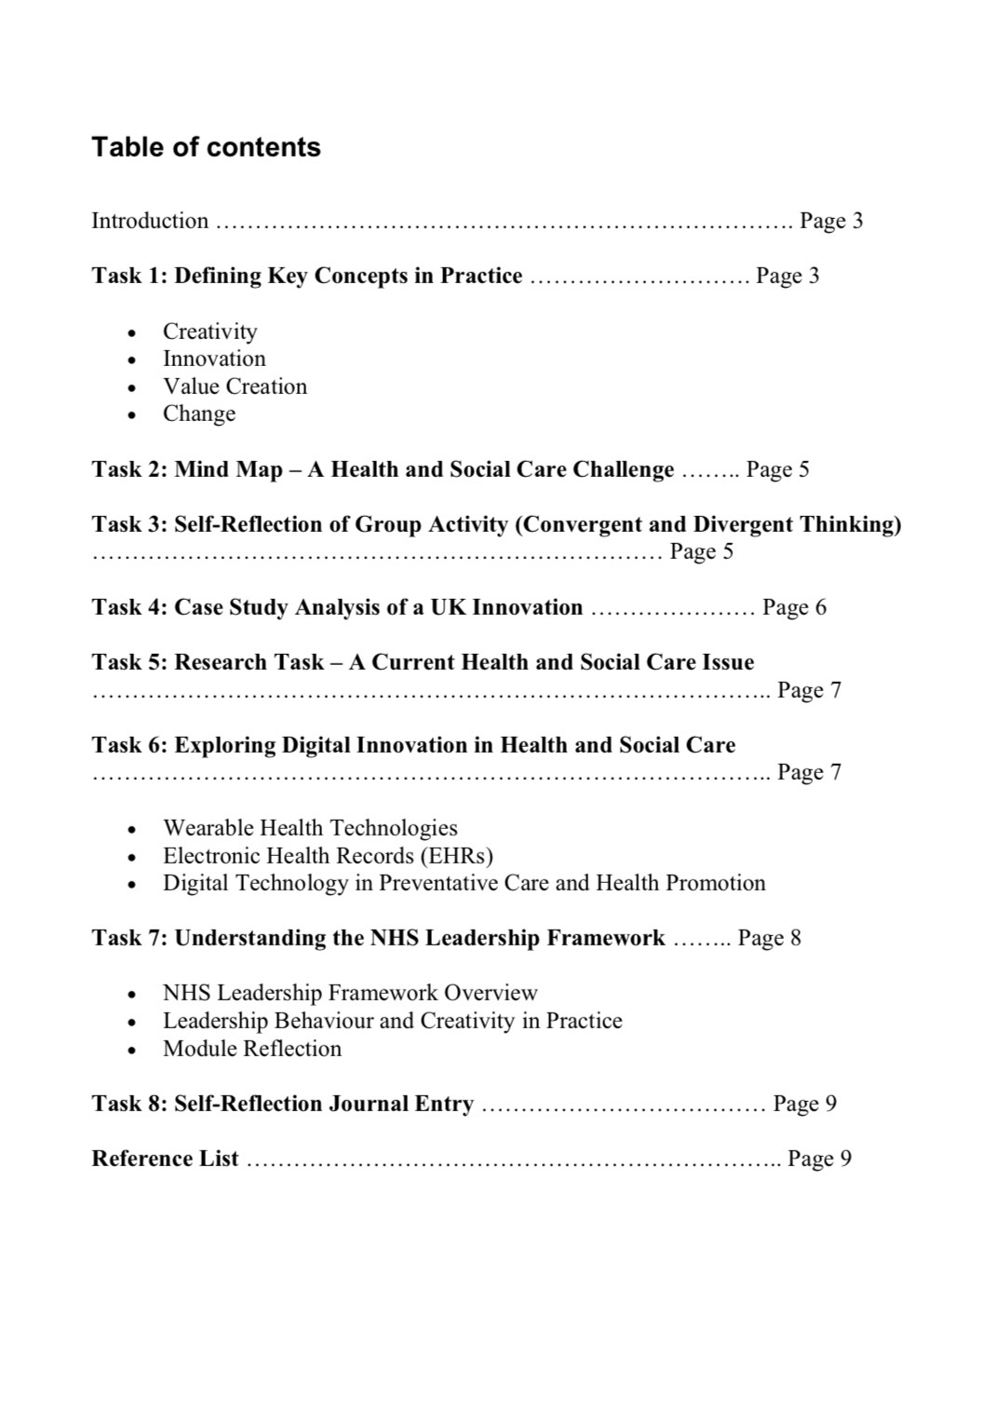

Creativity, Innovation and Value Creation in Health and Social Care: NHS Talking Therapies as a Changemaking Innovation

Introduction
This portfolio explores the role of changemakers in improving health and social care through creativity, innovation, leadership, and value creation.
Mental health has been selected as the focus of this portfolio because increasing demand for psychological support represents a significant challenge within healthcare. Barriers such as waiting times, accessibility issues, and stigma can prevent individuals from receiving timely support. This creates opportunities for healthcare professionals and organisations to develop innovative approaches that improve access and quality of care.
NHS Talking Therapies is explored as an example of a changemaking innovation because it demonstrates how creativity can be transformed into practical improvements. The service has changed the way psychological therapies are accessed by offering different delivery methods, including face-to-face appointments, telephone support, video consultations, and online interventions. This has created value by improving accessibility, supporting early intervention, and providing more person-centred care.
This portfolio will examine key concepts including creativity, innovation, value creation, and change, while applying relevant theories and examples from health and social care practice. It will also explore leadership, digital innovation, and personal reflection to demonstrate how changemakers contribute to improving healthcare services.

Task 1 – Defining Key Concepts in Practice

Creativity
Creativity is the ability to generate new and useful ideas that can address problems and create improvements. In health and social care, creativity allows professionals to question existing practices and develop alternative approaches that better meet the needs of service users.
Amabile’s Componential Theory of Creativity suggests that creativity develops through the interaction of knowledge, creative thinking skills, and motivation (Amabile, 1996). This highlights that healthcare professionals need both expertise and the ability to think differently when responding to challenges.
An example of creativity in practice is the development of new ways of delivering mental health support. NHS Talking Therapies demonstrates creative thinking by providing different options for accessing psychological therapies rather than relying only on traditional face-to-face appointments.

Innovation
Innovation involves turning creative ideas into practical solutions that create improvement or value. In health and social care, innovation can include new services, technologies, processes, or methods of working that improve outcomes for individuals and organisations.
Rogers’ Diffusion of Innovation Theory explains that innovations are adopted when they are seen as useful, compatible with existing needs, and achievable within practice (Rogers, 2003). This helps explain how healthcare innovations become accepted and integrated into services.
NHS Talking Therapies is an example of innovation because it redesigned access to psychological therapies through flexible approaches such as digital consultations and telephone support. These changes responded to barriers experienced by service users and improved opportunities for earlier support.

Value Creation
Value creation refers to producing meaningful benefits for individuals, organisations, and society. In health and social care, value is created when services improve outcomes while using resources effectively.
Porter (2010) explains that healthcare value is based on achieving better outcomes in relation to the resources used to provide care. Successful innovation should improve quality, accessibility, and effectiveness.
NHS Talking Therapies creates value by helping individuals access psychological support earlier. Early intervention may improve recovery, support wellbeing, and reduce pressure on other healthcare services.

Change
Change is the process of moving from existing ways of working towards improved approaches that respond to new challenges. Health and social care organisations must continuously adapt because of changes in population needs, technology, policies, and available resources.
Lewin’s Change Management Model explains that successful change involves three stages: unfreezing current practices, introducing new approaches, and embedding the change into normal practice (Burnes, 2017).
The introduction of digital and flexible mental health services demonstrates how healthcare organisations can manage change.
Overall, creativity, innovation, value creation, and change are connected concepts. Creativity generates ideas, innovation turns ideas into action, value creation ensures improvements benefit people, and change allows improvements to become part of everyday practice.

Task 2 – Mind Map Explanation: Mental Health Access as an Opportunity for Creative Change
The healthcare challenge chosen for the mind map is limited access to mental health support. This is an important issue because increasing numbers of people require psychological support, while services experience pressure from high demand, workforce shortages, and waiting times.
A systems thinking approach recognises that healthcare problems are influenced by several connected factors rather than one single cause (Meadows, 2008). The causes of limited access include stigma, inequalities, geographical barriers, and limited service capacity. These issues can lead to delayed treatment, worsening mental health, reduced quality of life, and increased pressure on emergency services.
The mind map identifies opportunities for creative change, including digital therapy, community-based support, early intervention, and mental health awareness. These solutions create value by improving accessibility and ensuring services are more responsive to individual needs.

Task 3 – Self-Reflection of Group Activity (Using Gibbs’ Reflective Cycle)

Description
During the convergent and divergent thinking activity, I explored how creativity can support problem-solving in health and social care. Divergent thinking involves generating a wide range of possible ideas, while convergent thinking involves evaluating ideas and selecting the most realistic solutions.
During the group activity, my group used divergent thinking to develop ideas for improving access to mental health support. Suggestions included digital therapy, peer support networks, and community-based services. We then used convergent thinking to consider which ideas were achievable and could create the greatest value for service users.

Feelings
Initially, I preferred moving quickly towards one solution rather than exploring multiple possibilities. However, the activity helped me understand that creativity requires openness and consideration of different viewpoints. Listening to other group members allowed me to develop ideas further.

Evaluation and Analysis
The activity showed me that creativity requires both idea generation and critical evaluation. This reflects the role of changemakers, who must combine imagination with evaluation when improving healthcare services.
Gibbs’ Reflective Cycle highlights the importance of reviewing experiences to develop learning and improve future practice (Gibbs, 1988). Through this activity, I recognised that teamwork and communication are essential because complex healthcare challenges require collaboration.

Conclusion and Action Plan
The activity increased my confidence in contributing creative ideas. In future group work, I will encourage everyone to participate because different perspectives can strengthen innovation. As a future healthcare professional, I will remain open to new ideas and focus on creating value.

Task 4 – Case Study Analysis of a UK Innovation: NHS Talking Therapies
NHS Talking Therapies is an example of a UK healthcare innovation developed to address increasing demand for psychological therapies. Before the programme was introduced, many people experiencing anxiety and depression faced barriers such as waiting times and limited access to evidence-based support.
Creativity contributed to this innovation by redesigning how psychological therapies could be delivered. Instead of relying only on traditional appointments, NHS Talking Therapies introduced flexible approaches including telephone support, online resources, and video consultations. This allowed services to become more accessible for people with different needs.
Rogers’ Diffusion of Innovation Theory explains that useful innovations are more likely to be adopted (Rogers, 2003). NHS Talking Therapies demonstrates this because it responded to a recognised healthcare challenge while using evidence-based psychological interventions.
The value created includes improved access for service users, earlier support for mental health difficulties, and reduced pressure on other healthcare services. However, challenges such as digital exclusion and workforce capacity must continue to be considered.

Task 5 – Research Task: Mental Health Access as a Healthcare Challenge
Mental health access remains a significant challenge within health and social care. Research identifies several factors contributing to difficulties accessing support, including increasing demand, social inequalities, stigma, and limited resources.
The World Health Organization (2022) highlights that mental health systems worldwide face challenges due to increased need and unequal access to services. This demonstrates that improving mental healthcare requires creative approaches that address both service delivery and wider social factors.
Research by NHS England (2023) also identifies the importance of improving access to psychological therapies through services such as NHS Talking Therapies. Increasing availability of evidence-based interventions can support early treatment and improve outcomes.
Both sources demonstrate that mental health challenges are complex and require solutions that combine innovation, accessibility, and person-centred care. Changemakers can respond by developing services that reduce barriers and create sustainable improvements.

Task 6 – Exploring Digital Innovation in Health and Social Care

Wearable Health Technologies
Wearable health technologies, such as smartwatches and monitoring devices, can support the management of chronic health conditions by allowing individuals and healthcare professionals to monitor health information more regularly. These technologies can track measurements such as heart rate, activity levels, and sleep patterns, helping individuals become more involved in managing their own health.
For example, wearable devices may help people with cardiovascular conditions recognise changes that require medical advice. This creates value by supporting independence, improving patient involvement, and potentially reducing pressure on healthcare services.
The Technology Acceptance Model suggests that people are more likely to adopt technology when they perceive it as useful and easy to use (Davis, 1989). Therefore, successful use of wearable technology depends on ensuring that devices are accessible and understandable for service users.

Electronic Health Records (EHRs)
Electronic Health Records improve communication and collaboration between healthcare providers by allowing relevant patient information to be accessed more efficiently. Digital records support better coordination by allowing healthcare teams to view accurate and updated information.
For example, electronic records can support communication between GPs, hospitals, and community services, helping professionals make informed decisions about patient care. This can improve safety, reduce duplication, and support continuity of care.
However, digital systems must be managed responsibly because healthcare information is sensitive. Maintaining confidentiality, security, and patient trust is essential for successful digital innovation.

Digital Technology for Preventative Care and Health Promotion
Digital technology can support preventative care by providing individuals with information, education, and tools to improve their health. Online resources, health applications, and virtual consultations can encourage people to take action before health problems become more serious.
For example, digital mental health platforms can provide access to wellbeing resources and psychological support at an earlier stage. NHS Talking Therapies demonstrates how digital approaches can improve access by allowing individuals to receive support through online and remote methods.

Task 7 – NHS Leadership Framework: Leaders as Changemakers
The NHS Leadership Framework identifies the behaviours and skills required for effective leadership within health and social care. It focuses on developing leaders who can improve services, support teams, and create positive change. Effective leadership is important because innovation requires individuals who can encourage new ideas and help organisations adapt.
Key leadership behaviours include leading with care, inspiring shared purpose, evaluating information, connecting services, and supporting improvement. These behaviours help create environments where staff feel valued and confident contributing to change.
One important behaviour is inspiring shared purpose. Leaders can encourage creativity by developing a clear vision and motivating teams to work towards common goals. In mental health services, leaders can inspire staff to improve access to care and develop solutions that respond to service user needs.
Transformational leadership theory suggests that effective leaders motivate and support individuals by creating a shared vision and encouraging innovation (Bass and Avolio, 1994). This approach is relevant to healthcare because successful change depends on teamwork and commitment from staff.
NHS Talking Therapies demonstrates the importance of leadership in innovation. Leaders, healthcare professionals, and organisations worked together to redesign mental health services and improve accessibility. This shows that leadership is essential for transforming creative ideas into sustainable improvements.

Task 8 – Self-Reflection Journal Entry
Throughout this module, my understanding of creativity and innovation in health and social care has developed significantly. Initially, I believed innovation mainly involved introducing new technology or completely new services. However, I now understand that innovation can also involve improving existing systems and finding better ways to meet people’s needs.
Exploring NHS Talking Therapies helped me recognise how creativity can transform healthcare challenges into opportunities for improvement.
Using Gibbs’ Reflective Cycle (1988) helped me evaluate my learning and identify how I can apply these skills in future practice. I have learned that healthcare professionals can all contribute to change by questioning current approaches, collaborating with others, and focusing on creating value for service users.
I aim to develop a changemaker mindset by supporting teamwork and improving accessible, person-centred care.

References
Amabile, T.M. (1996) Creativity in Context. Boulder: Westview Press.
Bass, B.M. and Avolio, B.J. (1994) Improving Organizational Effectiveness Through Transformational Leadership. Thousand Oaks: Sage.
Burnes, B. (2017) Managing Change. 7th edn. Harlow: Pearson.
Davis, F.D. (1989) ‘Perceived usefulness, perceived ease of use, and user acceptance of information technology’, MIS Quarterly, 13(3), pp.319–340.
Gibbs, G. (1988) Learning by Doing: A Guide to Teaching and Learning Methods. Oxford: Oxford Polytechnic.
Meadows, D.H. (2008) Thinking in Systems: A Primer. Vermont: Chelsea Green Publishing.
NHS England (2023) NHS Talking Therapies for anxiety and depression. London: NHS England.
Porter, M.E. (2010) ‘What is value in health care?’, New England Journal of Medicine, 363(26), pp.2477–2481.
Rogers, E.M. (2003) Diffusion of Innovations. 5th edn. New York: Free Press.
World Health Organization (2022) World Mental Health Report: Transforming Mental Health for All. Geneva: WHO.

