The Employee Lifecycle
Contents
Slide 1: Title 3
Slide 2: Introduction 4
Slide 3: Attractions 5
Slide 4: Recruitment 6
Slide 5: On boarding 7
Slide 6: Development 8
Slide 7: Retention 9
Slide 8: Separations 10
Slide 9: SWOT & PESTLE Analysis 11
Slide 10: Continue 13
Slide 11: Conclusion 15
Slide 12: References 16

Slide 1: Title

Slide 2: Introduction
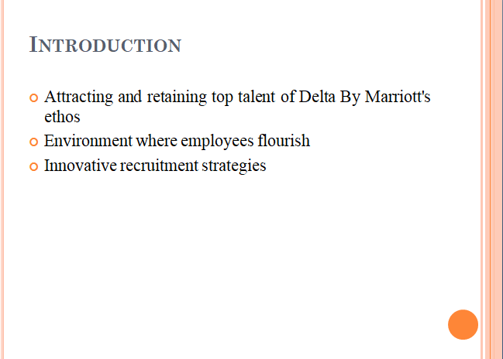
This presentation focuses on the attracting and retaining top talent is a cornerstone of Delta By Marriott's corporate ethos. Embodied in its culture of excellence, hospitality, and inclusivity, the company creates an environment where employees flourish. Through innovative recruitment strategies, robust onboarding processes, and a commitment to development, Delta By Marriott cultivates a workforce dedicated to organisational success.

Slide 3: Attractions
Delta by Marriott exudes the culture that epitomises excellence, hospitality, and diversity, developing a friendly environment in which employees can sense their own growth. Employing a team-oriented, creative, and ongoing improvement approach the company assembles the brightest minds and builds their trust by always being in favor of the employees’ professional development, collaboration inside the team, and involvement in community affairs (Ghani et al., 2022).

Slide 4: Recruitment
Delta by Marriot leverages a combined approach to recruitment, which integrates conventional practices and the latest technology. This approach includes multiple forms (for example job postings, networking, and referrals). Adopting technology such as application tracking system reduces the time and efforts involved in shortlisting candidates, giving a platform to the best candidates. With the help of new technologies, Delta By Marriott reaches its targets of making a powerful candidate marketing strategy and continued organisational development (Garg et al., 2021).

Slide 5: On boarding
The on boarding process of Delta by Marriott's is meant to employees' smooth integration into the organisation. It involves welcoming ceremony as well as clear and detailed description of company values, policies, and previously agreed procedures. Besideswise, customised training classes serve as an initiation for employees to get acquainted with their jobs and the conducive atmosphere within the company. This eventually leads to the employees’ more productivity and engagement. With this detailed mentality all employees, at whatever level, will feel supported, informed, and ready to perform at a high level right from the word go, thus enabling the organisation to achieve its goals (Azevedo et al., 2021).

Slide 6: Development
Performance reviews and feedback are important elements of Delta Marriott development strategy. The regular performance reviews help employees to understand their opportunity areas besides their strong came and support them in their job growth and promotion. The feedback mechanisms put in place help managers engage with employees in all-round conversations that breed a culture of continuous learning. Delta By Marriott enables employees to attain their personal and profession objectives through the provision of effective quarterly feedback sessions (Ghani et al., 2022).

Slide 7: Retention
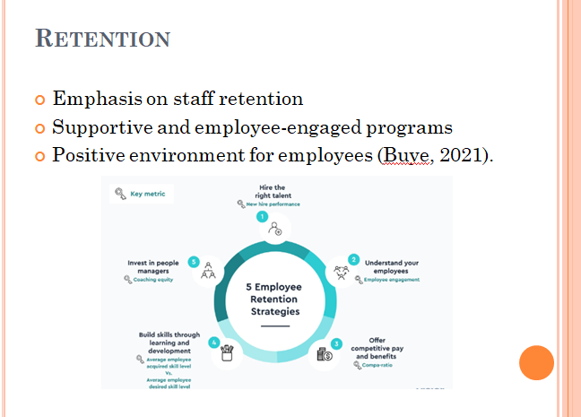
Delta by Marriott puts emphasis on the staff retention by establishing supporting and employee engaged programmes that are targeting the positive environment for the employees. The employer sells excellent access to rewards, promotion opportunities, and career development programs. Along with this, the hotel implements gratitude programs, employee wellness programs and flexible work arrangements to elevate employee satisfaction and in order to encourage long-term loyalty towards high performers. Through reinforcing its employees' well-being and job advancement, the Delta By Marriott achieves a sustainable management system of retention strategy (Buye, 2021).

Slide 8: Separations
Delta by Marriott stands for the termination to be a prevailing experience for employees through the exit interviews that usually are used to acquire key arising points from their time that they have spent with the company. However, the firm also offered these employees help and counseling, as well as a smoothly re-integrating companies ones into the organisation upon returning company property. Having in mind the contributions of leaving employees and pursing such norms of behavior as professionalism and respect while the separation process, Delta By Marriott brands itself as such a company which is worthy to deal with (George, 2021).

Slide 9: SWOT & PESTLE Analysis
SWOT Analysis:
Strengths:
Delta by Marriott is one of the flagship hotel brands that have grown in popularity with time as a result of their unsurpassed quality of service and dedication in ensuring customer satisfaction (Verawati et al., 2023).
The firm emphasises the concern of diversity and inclusion, having a diverse and gifted group of employees.
The business provides quality staff skills development which involves training and empowerment of employees hence allowing them to learn and grow in their area of job description.
Weaknesses:
The nature of the present hospitality business comprises a high level of competition which causes problems related to their profitability and market share.
Local economic strength and instability can influence consumer spending on travel and hospitality, consequently affecting the financial side of the organisation.
Opportunities:
Delta can investigate the potential of going global, where it can conquer territories in different states or countries.
Consumer knowledge of environmentally friendly practices provides a potential for the Delta by Marriott hotel to adopt some green practices and appeal to the environment preservation minded clients.
The firm may build relationships with customers by using technology that is customised to meet customer’s needs and improve their satisfaction (Puyt et al., 2020).
Threats:
Economic downturns or recessions can impact discretionary spending on travel, affecting the company's revenue.
Changes in regulations related to hospitality, labor, or environmental standards could increase operating costs and compliance burdens.

Slide 10: Continue
PESTLE Analyses
Political: Delta By Marriott must adhere to local and international regulations governing hospitality operations, taxation, and labor laws. Political instability in certain regions may impact travel patterns and tourism demand (Sanvitale., 2020).
Economic: Fluctuations in GDP, inflation rates, and currency exchange rates can affect consumer spending on travel, impacting the company's financial performance. Disposable income levels influence consumer preferences and spending on luxury accommodations and experiences.
Social: Changing demographics and shifting travel preferences among millennials influence demand for hospitality services. Delta By Marriott must adapt offerings to accommodate diverse cultural preferences and expectations.
Technological: Leveraging technology enhances operational efficiency, improves guest experiences, and keeps the company competitive. Investing in robust cybersecurity measures is crucial to protect guest data and mitigate data breach risks (George., 2021).
Environmental: Implementing eco-friendly practices such as energy conservation and waste reduction minimises environmental impact. Environmental factors like extreme weather events can disrupt travel patterns and affect operations.
Legal: Adhering to laws and regulations governing employment, health and safety, data protection, and accessibility is essential. Compliance with contractual agreements with suppliers, partners, and franchise agreements ensures operational integrity (Verawati et al., 2023).

Slide 11: Conclusion
In an ever-evolving hospitality landscape, Delta By Marriott stands as a beacon of resilience and adaptability. By prioritising employee well-being, professional growth, and engagement, the company fortifies its position as an industry leader. Through continuous innovation and a steadfast commitment to its workforce, Delta By Marriott charts a course towards sustained excellence and prosperity.

Slide 12: References

