1802758
Megan Rogers
Fine art Studio Site and Context

Word count 1481

Ryan l.Moule

The Collateral

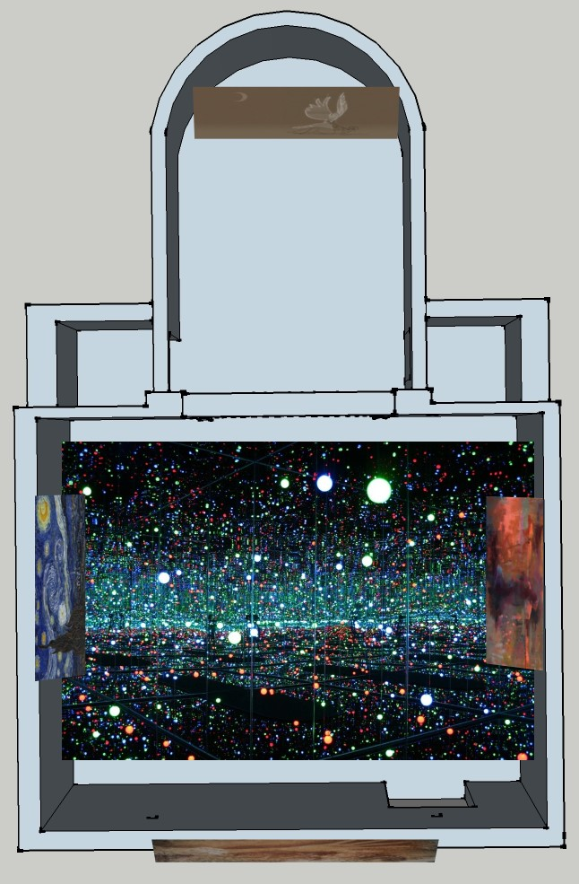
It is common for people view art as inconsequential to their everyday life but it is impossible to never see any art and as such be involved in the development of it. Initial and often emotional reaction to the art piece is tempered by your exposure to it. The public considers no value in the accomplished past its release date.
This exhibition is about art that has been turned from masterpieces to mascots. Art which has become stale because of its popularity. Some work can appear to be untouchable due to it being viewed as the pinnacle of its genre, however because of the familiarity of the work it no longer holds the emotional impact it once did. The pieces chosen for this exhibition were the ones felt to be most affected by this phenomenon, its goal is to realise this problem and change how the works are presented in the hope that by creating a new perspective the work can be felt again instead of watered down It's ironic, the popularity that an artist seeks has enveloped the piece and taken away its initial meaning.The notion that art has a role in rebalancing us emotionally promises to answer the vexed question of why people differ so much in their aesthetic tastes.(de botton 2013) This can simply the explanation for why art popular with different people and by using this concept you can theorize that it can be used to cause an emotional response when wanted so long as the parameters are met. Things such as personal narrative from in works are unable to completely plan for however most easily the nature of the work can suggest the intensity of the personal reaction.

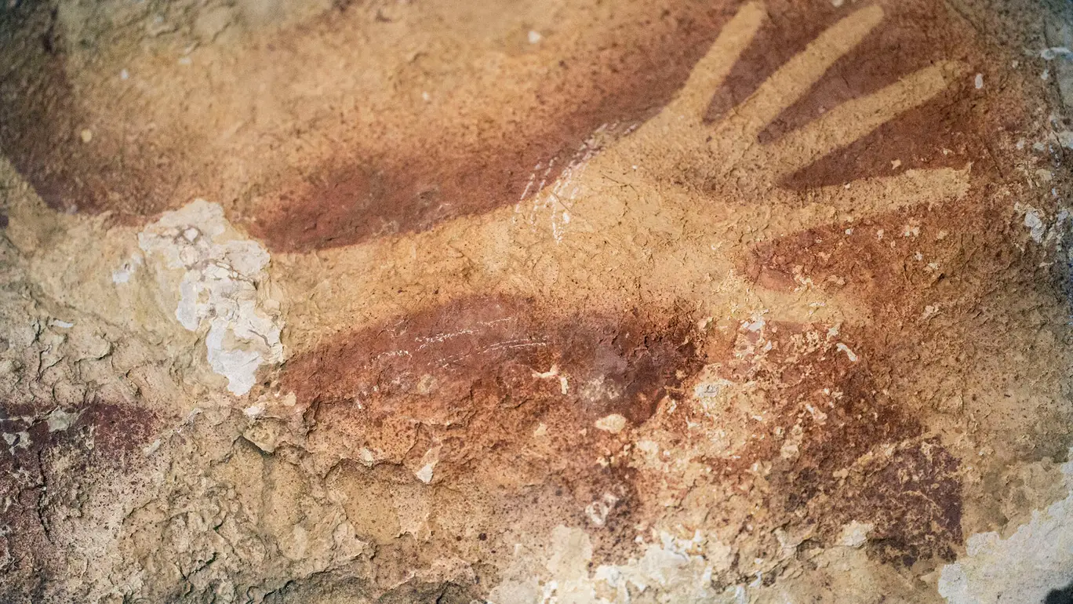(Aubert, n.d.)

A 40,000 year old cave painting isn't what most would expect in a exhibition but if your going to start at the beginning it’s the best thing to chose. The hand paint carries with it humanities first semblance of artistic passion. The want of leaving a mark behind and the nature of experimenting with materials until something looks right. it's the oldest of its kind, an entire different strain of human culture. However it's amazing discovery that was overlooked in the blink of an eye just because it is not a new idea, because it was not the first found its presence was dulled by previous experience. It stands out because it fits the least with the other pieces chosen for the exhibition yet it has the most history and should have the most influence that is why it is the first piece visible.

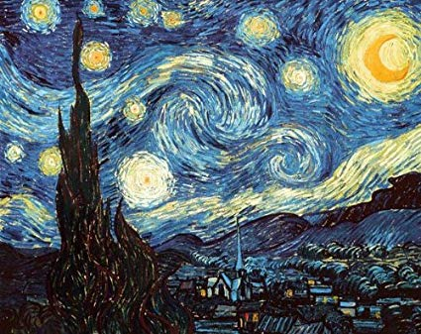(van Gogh, 1989)
Van Gogh Starry night is both fulfilling and hollow the art work is easily recognizable by its texture and spiral shapes which capture the night sky. Often the artist perspective is dreamlike to the viewer, the piece carries with it a wistfulness that lulls. Because of how popular the piece has become it has lost its meaning to the majority of the public at the image is now barely acknowledged, starry night is a victim of the familiar. Van gogh searched for escape from his circumstance, from the people and even from his mind. In this instance his found it in the stars. Starry night will be positioned as part of The souls of millions of light years away by Yayoi Kusama it will have comfort in the space and will be lit in a new light, in the light of souls.

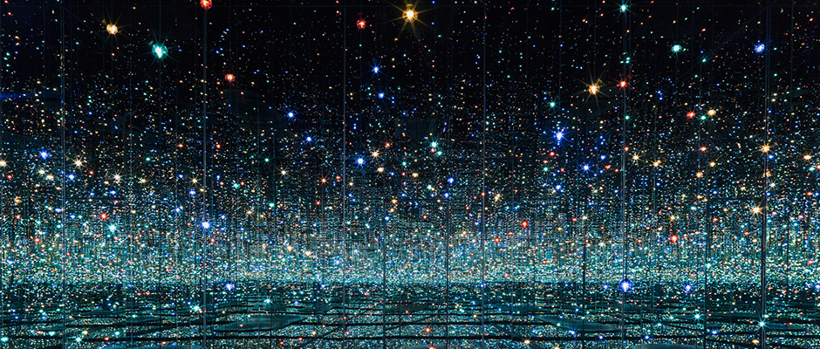(Kusama, 2013)
Have you ever wanted to be standing in space? To touch nebulas and cup your hands around a spark of the sun, that’s was Yayoi Kusama’s ‘The souls of millions of light years away’ is. To play among the stars in childlike wonder to appreciate it one needs to accept their human limits. It is a gift to be given the chance and yet the technology of today means that it is considers dated and old in its invention completely disregarding its meaning. The people of today live through their phones rarely looking up and even then it is with quick, snap judgement and jealousy it's like they, we need to be shaken awake. This piece is about hope in simply beauty and the dream that lasts. It is the centerpiece of the exhibition influencing all other work at its light with shine on to the other pieces which will change then in some way.
A cold detached critique, only because this is most commonly the mind of today the obvious choice would be to improve the piece with new technology which while not wrong, has the risk of losing aspects ot her work and in doing so changing its narrative. It would be the easiest way to make this piece relevant again to use the main interest of humanity and force them to acknowledge the work by using the technology they crave.

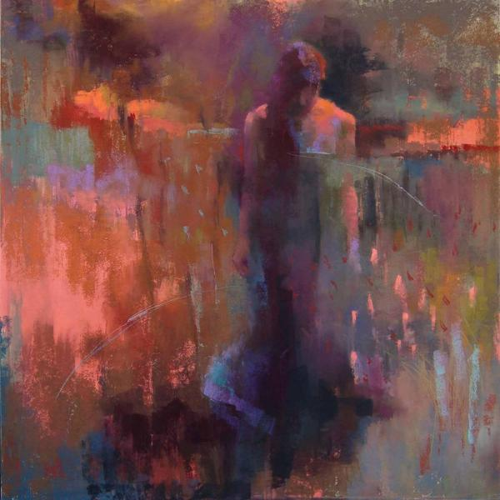(Locke, n.d.)

Pictures, even when apparently finished, envoke movement and relationship but cannot be read. Maps can be read; on maps the figures and marks do not necessarily signify something outside themselves. Even a two-dimensional image is three-dimensional in the sense that it is full of multiple potential meanings which reverberate and echo against one another. No picture can be fully explained in words; if it could there would be no need to make it. (Case and Dalley, 1992) this piece was chosen because its meaning isn't clear to the viewer. It requires no greater understanding or expectations of the public. Its simplicity is a good contract to the complicated past of ‘Starry night’ and the technological ambition of ‘The souls of millions of light years away’ it presents a calm in the pressured calamity of the other works and yet it’s solace brings a kind of withdrawal as it is isolation within itself.

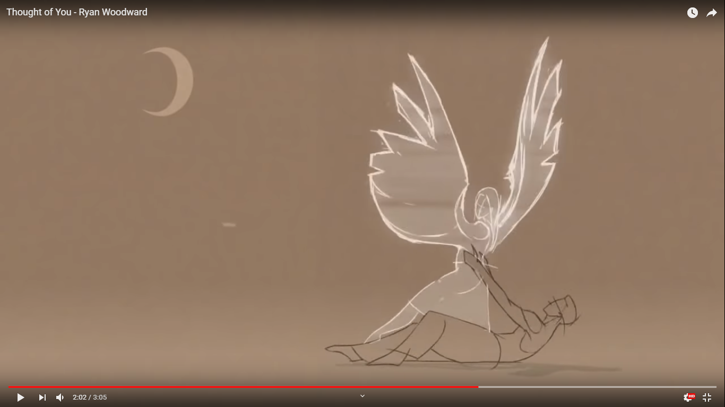(Thought of you, 2010)
The male is drowning in thoughts of a girl. He is remembering her or when he held her and the times she left of when she was continuing without him and when they were together again when she left him support her and it broke them. But she’s still around, they still try until it tears them apart and she leaves again.
He can’t it hurts it's too hard to move and she accompies him again but she is elusive dancing around him until she is real but by them he is clear he is emptied out by her has given himself into making her whole and has made her what he was. He leaves.
Ryan Woodward - Thought of you
The initial response is soft, heart felt however the curator included it because it is a confrontation to everyone whos had there heart broken. People push those memories away but this pulls at them if Van Gogh ‘Starry night’ is the perfection of the universe then this is humanities most common mistake their vulnerabilities come to light. It grounds the people while they are surrounded by stars and hurts them,m just a bit, just enough to remember. The best kind of cautionary art – art that is moral without being ‘moralistic’ – understands how easy it is to be attracted to the wrong things (de Botton, and Armstrong, 2013) the curator was worried that having of both this and Kusuma’s piece would be too much together and risk damaging the experience and so because of this the curator chose to play the video in a different room however the light from the soul piece should still be slipping into the room through its entrance to help make the exhibition flow better.

This exhibition could be classified as ‘pretty’ “people without much of an education in art tend to think that art should be about ‘ pretty things’. The cultural elite gets very nervous about this, beauty has been under suspicion for a while” Claude Monet (de Botton, and Armstrong, 2013) this issue with pretty is that people feel lost without a conclusion, a confrontation and fear that it will numb us enough to leave us ignorant to the injustices surrounding us. The same can be said about the familiar, you are numb to it because you are used to it and so no longer see it for what it is, this is the nature of pretty and what is afflicting these works. The task for artists, therefore , is to find new ways of prizing open our eyes to tiresome familiar, but critically important ideas. The content behind these pieces is so normal that we do not see or we shy away from the idea of the pain we once felt. The error of our ancestors, the reasoning of a mad man, the idea of souls, haunting loneliness and finally heartbreak. The curator has collected all of these to force the public to acknowledge them and by showing them together amplifies there meaning making them painfully relevant again.

Bibliography
Aubert, M. (n.d.). Cave Painting. [red ochre on stone] Indonesia.
van Gogh, V. (1989). Starry Night. [oil on canvas] New York City: Museum of Modern Art.
Kusama, Y. (2013). The Souls of Millions of Light Years Away. [wood, metal, glass mirrors, plastic, acrylic panel, rubber, LED lighting system, acrylic balls, and water] The Broad.
Locke, C. (n.d.). Lone Figure. [pastel on Wallis paper].
Thought of you. (2010). [video] Directed by R. Woodward. USA.
de Botton,, A. and Armstrong, J. (2013). Art as Therapy. 1st ed. Phaidon Press.
Case, C. and Dalley, T. (1992). The handbook of art therapy. USA: Routledge.

