Student name: Vanessa Andreea Eftimie
Student ID number: 2324591
Programme: BA (Hons) Business Management
Module: Learning in the Digital Era
Module code: BMBM4008 Contribution to Overall Module
Lecturer: Philippa Fitzgerald
Assignment Title: Video and Supporting Materials
Submission deadline: Monday 8th December 23.59
Key points, decisions and learning experiences that I have considered while producing my VLOG are supported by these notes. When I first read the assessment brief and realised that I was expected to give a live presentation, I immediately felt anxious. I had become accustomed to doing pre-recorded presentations with the comfort of being able to control the process, of editing endlessly, and of perfecting my delivery before I presented. I had been dependent on this comfort and security of being able to re-record if anything went wrong after I had learned that this year's assessment was going to be a live assessment. I had not had the pressure of being able to talk in front of an audience whilst someone was watching me, not having a way to stop/take a break from my presentation, or fix my mistakes along the way; this was a huge pressure that I had never experienced before.
Preparing for the presentation, I noticed quickly how different my slide making habits were in comparison to last year. In the previous year, I tended to make my slides very heavy in text because they had operated more like scripts than visual aids. I had not needed to cater to a live audience, so I had not given much thought to making my slides clear and simple. This year, however, it dawned on me that my slides were to support what I was doing with delivery and not vice versa. I initially found myself stuffing every slide with too much information; a function of being nervous and wanting to use something external to support my presentation. As I began to simplify my slides and created fewer words per slide with a clearer visual layout, and created a more visually appealing slide, I became more effective with my presentation and built my own confidence.
Practice had become a significant part of preparing for my presentation. In previous assessments, I had practiced little (out loud) since the option to do a re-recorded assessment did not require me to practice for polished delivery. As I was to present to a live audience, simply reading; silently was not sufficient. I intended to practice for timing, volume, vocal tone, and staying calm. Early attempts to present were a disaster; I stumbled over words, lost my place, and felt overwhelmed. Each rehearsal helped further to increase my fluency in delivering my presentation and prepared my brain for the unpredictability of presenting live. This experience was valuable for me to understand how much benefit can come from an active rehearsal process rather than relying on my memory.
Adding the technical aspects of presenting over Microsoft Teams to my 'to do list' added yet another learning experience for me. I learned many valuable lessons about working through the learning curve of overcoming technical issues such as screen sharing, managing multiple windows and maintaining awareness of how audio was delayed. In recorded presentations, any technical issue must be solved in real-time. I learned how to remain calm while working through unexpected technical problems while I continued to present my VLOG.
Preparing and delivering my live presentation was one of my biggest growth moments. I was nervous to start the presentation, but with each word spoken, my confidence continued to build as I presented. This assessment has encouraged me to continue to work to develop and improve my presentation skills and to develop a further adaptability and confidence when presenting to live and recorded audiences.

References
Gago, M., 2025. The power of storytelling: How to create narratives that move audiences to action. Journal of Brand Strategy, 14(1), pp.6–14.
Gibbs, G., 1988. Learning by doing: A guide to teaching and learning methods. Further Education Unit.
Khreisat, M.N., Khilani, D., Rusho, M.A., Karkkulainen, E.A., Tabuena, A.C. and Uberas, A.D., 2024. Ethical implications of AI integration in educational decision making: Systematic review. Educational Administration: Theory and Practice, 30(5), pp.8521–8527.
Kolb, D.A., 2014. Experiential learning: Experience as the source of learning and development. FT Press.
Mulyadi, D., Wijayatiningsih, T.D., Singh, C.K.S. and Prastikawati, E.F., 2021. Effects of Technology Enhanced Task-Based Language Teaching on Learners' Listening Comprehension and Speaking Performance. International Journal of Instruction, 14(3), pp.717–736.
Passarelli, A.M. and Kolb, D.A., 2023. Using experiential learning theory to promote student learning and development in programs of education abroad. In: Student Learning Abroad. Routledge, pp.137–161.
Plevka-Jones, H., 2024. Resonance: A methodology and pedagogy for socially just storytelling. Doctoral dissertation, Illinois State University.
Qi, Y., An, C., Huang, C., Lv, H. and Zhang, H., 2024. Enhancing Critical Thinking in Vocational Chemistry Education: Active Learning Strategies in Vocational Training. Journal of Chemical Education, 101(11), pp.4892–4903.
Srinivasa, K.G., Kurni, M. and Saritha, K., 2022. Learning by doing. In: Learning, Teaching, and Assessment Methods for Contemporary Learners: Pedagogy for the Digital Generation. Springer Nature Singapore, pp.147–176.

Appendix
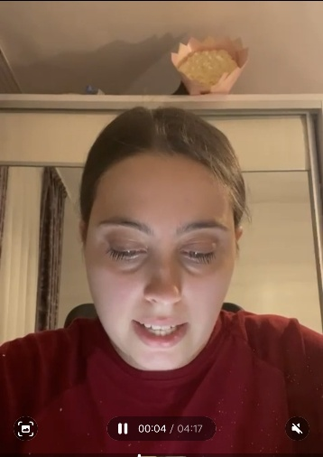
I tried to make my vlog in Microsoft, but I didn’t make it. I made it on my phone, but it didn’t work to upload it because of the size.

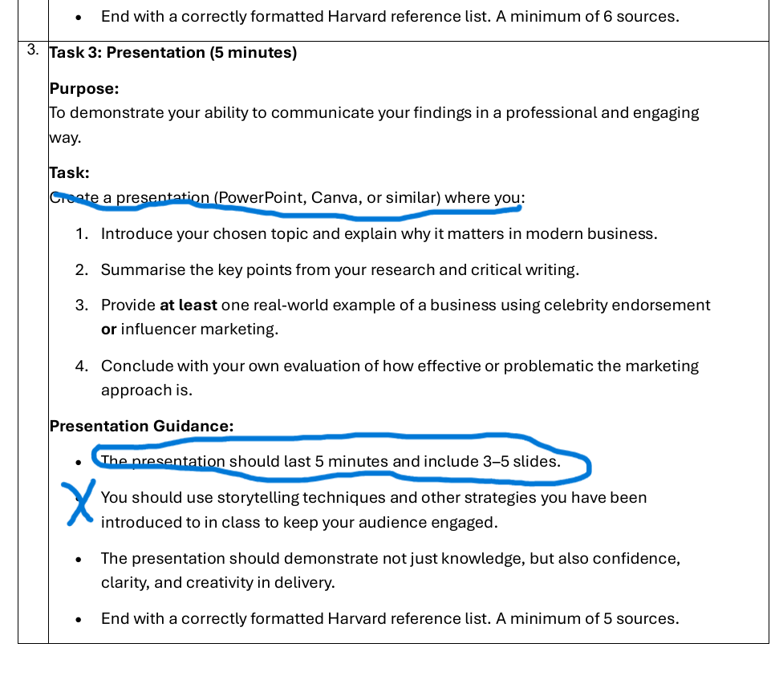

Old Presentation Recorded for last year course.
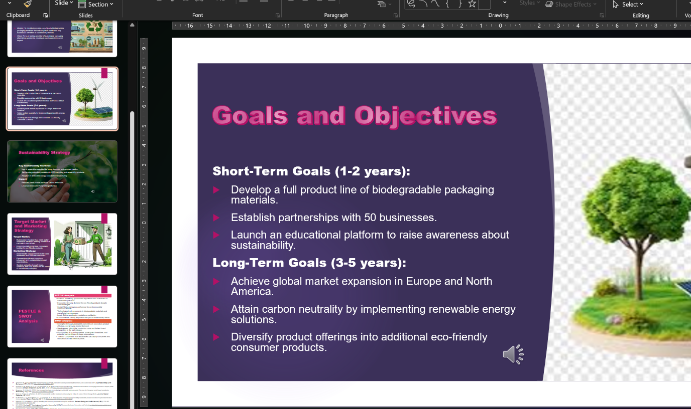

New live presentation.



