Contemporary Challenges:
Making a Difference

ECGE4006P

Joy Cole
2213158

Resonanceglobal.com (2022)
Contemporary Challenges
Can we make a difference?
Or are these “wicked problems” to difficult for us to solve?

Contemporary Challenges or threats to humankind can come in many forms. Climate Change, Poverty, Obesity, Healthcare, Mental Health, Food Security, Homelessness, Political Instability and Terrorism to name but a few. All of these are “wicked problems” for us in today’s society. Problems that are either difficult to solve or are impossible because they are constantly changing, can be contradictory and incomplete in their challenges. They are issues that are interconnected with many problems being symptoms of other wicked problems.
I regard one of the largest threats to mankind is that of our health and wellbeing, obesity playing a major part.

Why is Obesity such an issue globally?
According to National Health Service (NHS) (2023) recent data, the UK population is suffering with an obesity epidemic, with almost two thirds of adults having a body mass index (BMI) if 25 or more and hence being classified as overweight or obese.


CHECK OUT YOUR OWN BMI
https://www.nhs.uk/live-well/healthy-weight/bmi-calculator/

The amount of physical activity, (intensity, time length and frequency) and sedentary behaviour performed by us as individuals directly affects our health benefits and health risks including obesity.
The World Health Guidelines (WHO) (2020) provide evidence-based recommendations for the amount of physical activity for both children and adults including those with disabilities, pregnancy and chronic conditions, showing the direct associations between activity and health benefits. Check them out at:
https://apps.who.int/iris/bitstream/handle/10665/336656/9789240015128-eng.pdf?sequence=1&isAllowed=y

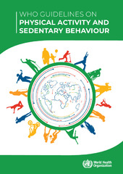

World Health Organisation (2020)

How can Obesity directly affect your health?

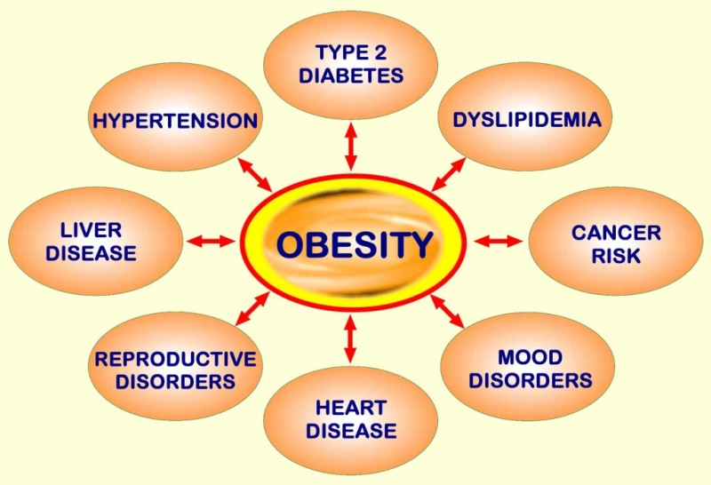
National Library of Medicine (2018)
People with obesity are more likely to develop many serious health complications, including heart and liver disease, hypertension and stokes, certain types of cancer and Type 2 diabetes.
There are many factors which have a direct impact on obesity. Diet and lack of physical activity being the most prevalent, but we must also consider others such as socioeconomic, psychological, family factors and genetics.

According to the Heart Foundation blog on Healthy Living, Erlinger (2018) highlights that family factors are extremely influential on obesity. Low socio-economic status or poor education, will promote an environment where physical activity is not encouraged and a unhealthy diet with high calories is consumed. A high socio-economic status is also more likely to promote an increase in sedentary behaviour.
An individual’s wellbeing is also affected by obesity with many people suffering with low self-esteem through peer pressure and bullying which can lead to depression.

How Obesity directly affects the burden on public expenditure?
As our global population is growing and we are living longer, the rise of healthcare costs and burden on healthcare provisions are becoming unmanageable. The Organisation for Economic Co-operation and Development (OECD) (2019) indicates that people with obesity are more likely to have two and half times more need for prescriptions than their healthy-weight contemporaries and will require more expensive complex treatments with lengthier stays in hospital. This costs the healthcare systems an average of 8.4% of their healthcare budget on obesity related issues alone.

In OECD countries obesity is
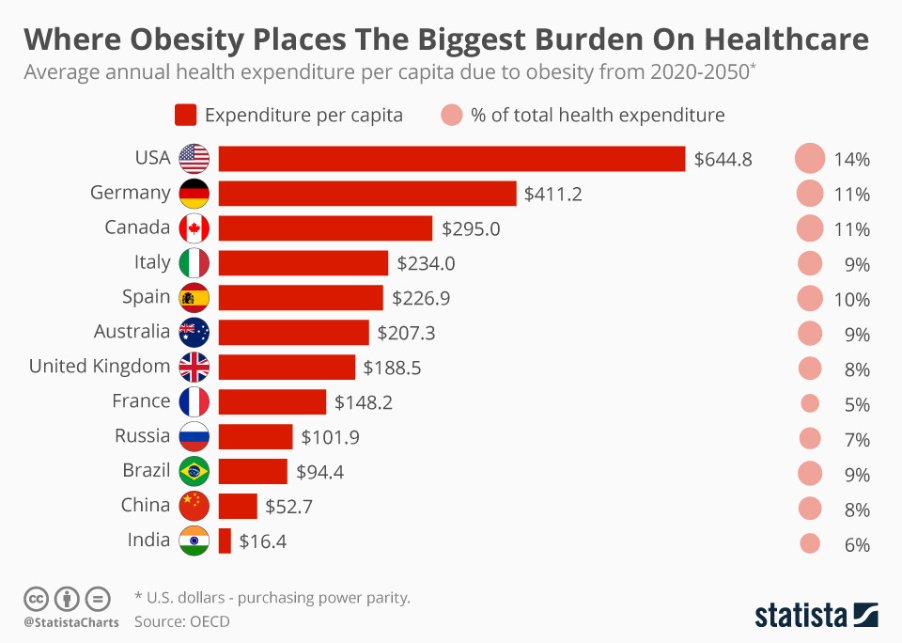
Treatment costs for obesity related diabetes is on average 70% of all treatment costs for diabetes, 9% for cancers and 23% for cardiovascular diseases.
The British Diabetic Society (no date) claim that lifestyle changes, including diet, weight loss and increased physical activity can reduce Type2 diabetes by 50%.

World Economic Forum (2019)

Can we solve Obesity?
According to the World Economic Forum (2020) “Obesity is a complex, chronic disease that is influenced by multiple aspects - including physiological, psychological, genetic, environmental and socioeconomic factors.” These factors are interconnected causing us contemporary challenges. As wicked problems they unfortunately cannot be tackled with traditional approaches where problems are defined, analysed and solved in sequential steps. Instead educating people about the knock-on effects of obesity is the way forward.
Obesity prevention needs to be a global health concern with action being taken by all to promote health, in order to enhance our quality of life and prevent morbidity and early mortality.

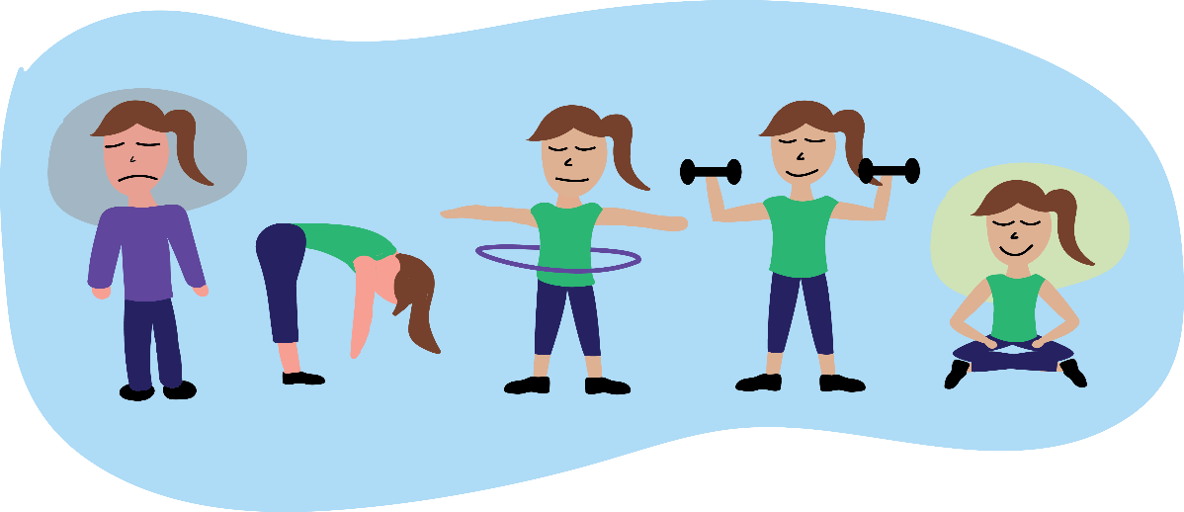
This Photo by Unknown Author is licensed under CC BY-NC

I, for one, will be considering my health status and examining my level of physical activity and sedentary behaviour.

Something that we all can, and should, promote and engage in!

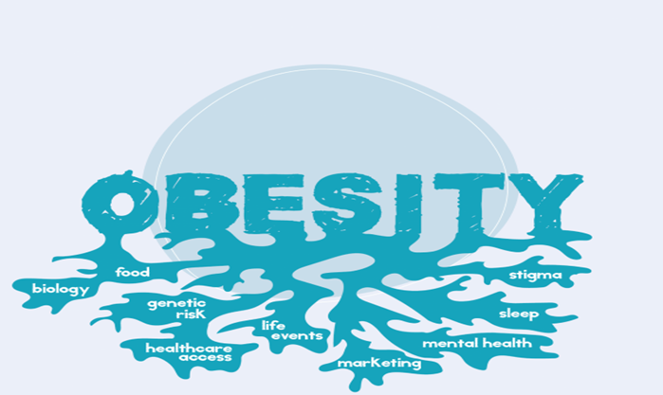
World Obesity Federation (2022)

What skills can we develop
through education
to promote the prevention of

I think that we can all agree that obesity prevention needs to be a global health concern and that action should be taken by all to enhance our quality of life to prevent morbidity and early mortality.
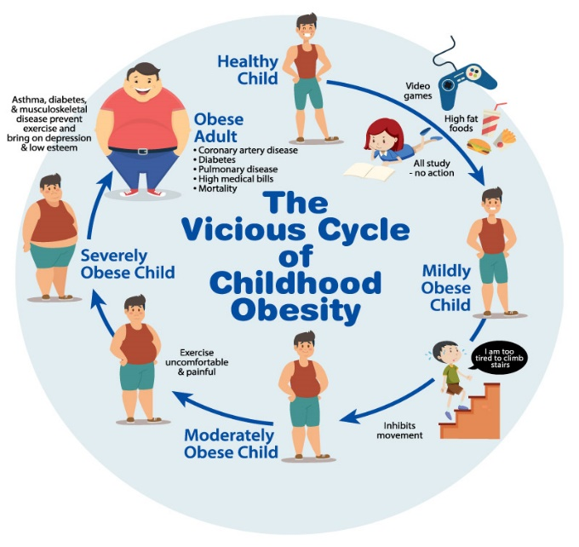
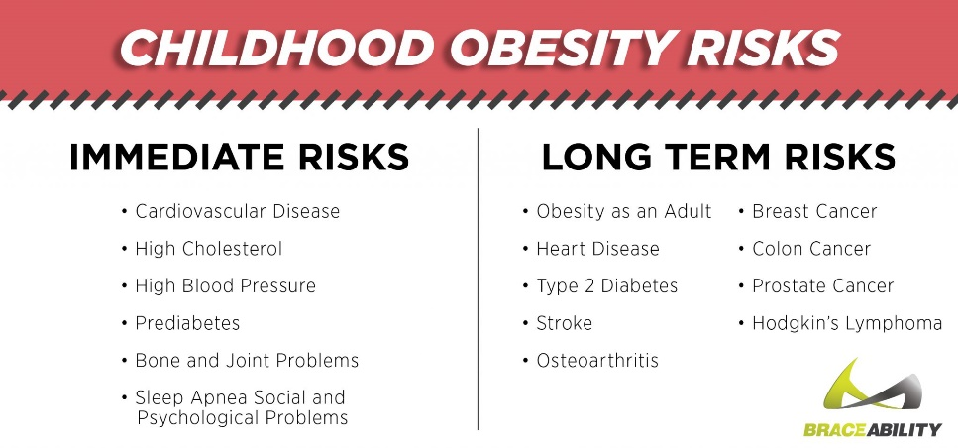
In the UK today nearly a third of children aged 2 to 15 are overweight or obese (Department for Health and Social Care, 2017). Alarmingly NHS.uk data (2023) support this view claiming the same for 1 in 5 children primary school, rising to 1 in 3 by the time they leave education.

The Heart Foundation (2018)
“Among children today, obesity is causing a broad range of health problems that previously weren’t seen until adult-hood”. (Erlinger, 2018).
To help prevent childhood obesity, Education should start early and schools are best placed to promote this.

Braceabbility (2019)

What educational skills can our children use
to prevent obesity?
Cherry (2023)
Skills like critical thinking, independent learning, listening, encouraging, empathising, group work, managing conflict, negotiating, decision making and reflecting are all important and can be developed from an early age.
Critical thinking is a cognitive process of thinking which includes evaluating information while identifying other points of view, using judgement, drawing conclusions to present a point of view (Cottrell, 2017). A crucial skill for educators to develop.
Teachers can explain, guide and encourage pupils, allowing them independence, time and patience in order to encourage a more thought out considered solution.
Group work can help a child think about problem-solving skills but also teaches them empathy and patience while co-operating with others. It will also promote negotiation and decision making.
Schools can teach and encourage many key skills to help children discover, analyse and overcome contemporary challenges like obestity.

Key Skills
According to Yuksel et al. (2020) the early intervention, by educators within schools, can have important potential in the health promotion of children especially with regards to awareness of the disease obesity, physical activity and healthy eating.
By developing children’s critical thinking skills educators can promote a clearer understanding of the disease as well as the associated risk factors. Allowing the children to participate in their own monitoring will strengthen the development of strategies in both prevention and treatment.
This will allow for individual research and teamwork when examining behaviours, activity, medical interventions and social accessibility to resources.
It will also encourage a child to reflect on results in order to be empathetic to others and negotiate alternative approaches .
World Obesity Federation (2022)
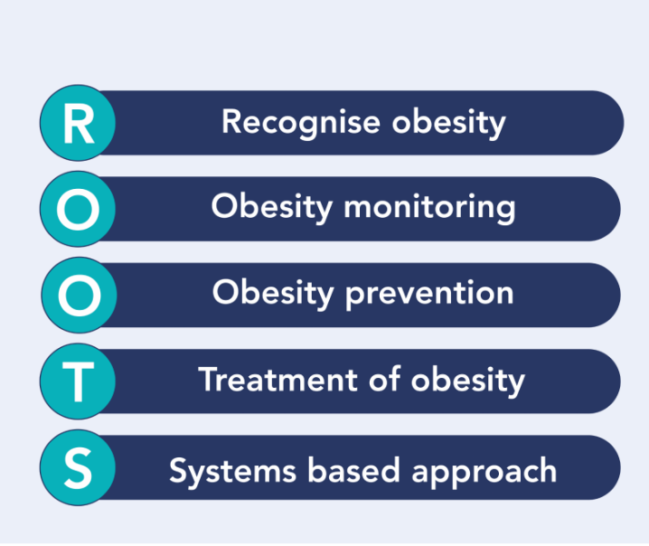
World Obesity Federation (2022)
In order to have an impact, providing children with the necessary skills to prevent and reduce obesity, comes from a broad curriculum that includes personal, social, health and economic education (PSHE), Physical Education (PE) and design and technology (D&T). (Jones, 2018).

Teamwork and individual performancce can be encouraged with a broader range of physical
activities being offered within schools to all pupils inclusively, with pupils engaging in regular sessions.
The Health and Well-being Area of Learning and Experience within our new curriculum for Wales (2019) supports children to develop knowledge of a healthy balanced diet, hydration and physical activity, highlighting the importance of health and well-being;
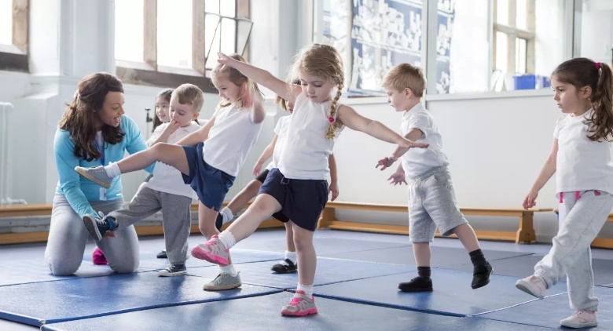
Amaven (2018)
By providing opportunities in cross-curricula activities such as PE, PSHE and D&T enables pupils to develop skills in independence, group work, negotiating, conflict managing and taking responsibility.
Educating children to empathise can reduce stigmatisation and bullying which in tern will reduce an individual’s feeling of low self-esteem and exclusion from social interaction.


TES (2019)

Interconnecting Problems
Need
Interconnecting Skills

Whilst we accept that obesity affects our children’s physical health, it is important to note its effect on their mental and emotional health, which in turn can impact on their academic performance, a view echoed in an Ofsted report (2018) where Jones makes a connection between obesity and lower educational attainment.
Porter (2019) in a TES article appreciates, like we all should, that not every child is able to achieve a high standard in sport but teachers, schools and education authorities are able ensure that some participation, individual or teamwork, can build confidence, reduces stress, release endorphins and increase mobility.
I believe that critical thinking is perhaps the most important asset we can give to our children. The continuing and escalating problem of obesity is a complex one but by educating our children early and equipping them with the necessary skills, then long-term, sustainable change can be achieved through the active engagement of schools educating individuals, families and communities.

There are many skills that our children need to master to overcome contemporary challenges like obesity.
Let’s start the change in schools!

Decipher World (2022)
Is Design Thinking
the way to deal with
contemporary challenges in education?

What is Design Thinking?
Design thinking is a user centred empathetic approach of identifying and developing creative solutions to complex problems. The use of design thinking
‘improves children's creativity, problem-solving, cooperation, communication, curiosity, questioning, and empathy. It allows children to express their ideas freely and supports social, emotional, language, and cognitive developmental domains’. (Yalcin, 2021)
This will empower a student to become an optimistic creator and innovator, a smart working member of society who solves complex contemporary challenges in a rapidly changing world.
Schools can use the Design Thinking 5 stage approach.

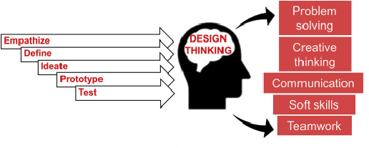
Using Empathy allows a child to develop a deeper understanding of the problem and how it affects a person or environment.

by developing a meaningful and actionable problem statement.
Students ideate by brainstorming solutions, often using sticky notes.
Building prototypes allows the student to build ideas and focus on the best solution. These can be scaled down versions.
ScienceDirect (2020)
Students then define what the problem is
Although the final stage is to test this stage is continuous so that solutions can be redefined, altered, and rebuilt.
Advantages of Design Thinking in Schools
Curiosity

Leadership

Innovation
.

There are many benefits for children to experience design thinking as it involves communicating, empathy and interviewing skills, that young children can find hard.

Enhances Empathy
.

Open mindless
.

As this learning process actively involves children, creativity is nurtured as children are free to express themselves and develop a range of skills.

Their confidence builds as they are encouraged to find many solutions and adapt their thinking.
This is confirmed in a study by Yalcin (2021) on Design Thinking Model in Early Childhood Education where evidence is seen that peer learning can be achieved when pupils support each other, ‘understand others, the needs of others, and their own place in the world as well’,
Fosters collaboration

Builds Adaptability
.

Encourages Creativity
.

Promotes Teamwork
.

Improves communication.

Visual problem solving
.

Design Thinking can accommodate learning preferences and styles, as they can overlap in the design thinking process. For instance, in a group setting, each child could exercise their preferred method of learning.
‘Imaginative learners enjoy developing ideas and brainstorming. Analytical learners create concepts and models. Common Sense learners enjoy practical application and hands-on activities. These learners would enjoy prototyping. Dynamic Learners, who enjoy action, testing and learn by trial and error.’ (IASDR, 2019)

therefore taking part and being an active and engaged member of the learning community.
IASDR (2019)
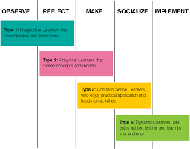
IASDR (2019

Disadvantages of Design Thinking in Schools

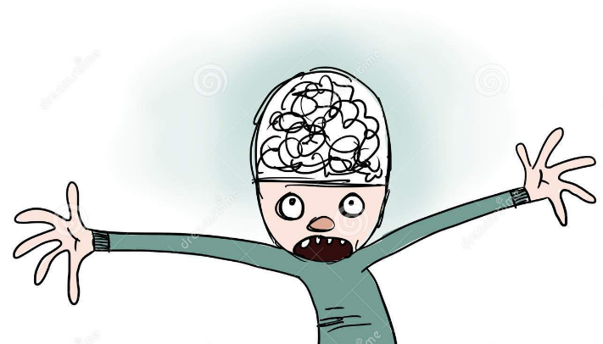

Unfortunately there are shortcomings when implementing Design Thinking in the classroom. It can be seen as a chaotic, divergent, none-linear process. So extensive in the amount of ideas, lack of detail, often muddled and mixed together, that the information may overload and confuse both pupils and teachers.

Dremstime (no date)
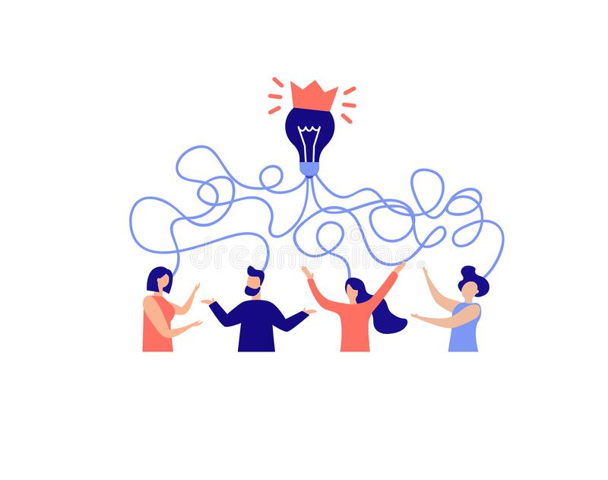

In this non-traditional process teachers will be asked to follow new perspectives and approaches every few years.

It may be overwhelming for them unless the correct training and support is put in place with an abundance of resources and attitude of flexibility.

Dremstime (no date)

To conclude, like or loath it, Design Thinking is the way forward

The skills acquired through design thinking are highly sought after by businesses who seek creative, adaptive, collaborative employees who can solve complex problems through open mindedness, creativity and flexibility when offering a variety of ideas.
As educators we can raise awareness of contemporary challenges through design thinking by ensuring that our children consider the rapidly changing world that we live in, in order to prepare them to face new situations in the future.

Business Reporter (2023)
Many schools have already embraced Coding, Artificial Intelligence and Robotics for its students over the last few years, so surely the next step is design thinking.
In 2022 India became the first country to launch a Design Thinking course as an option in schools. According to Poorvaja (2022), a ‘more on hands-on knowledge which is learnt by doing, exploring and acting upon challenges discovered within their surroundings’ can only benefit our children.
I wholeheartedly agree that
“Adding a ‘Design Thinking’ elective in our education system, will hopefully open doors for subjectivity and creativity in our pedagogy!


Facebook (no date).
As educators why wouldn’t we want to develop empathetic members of society who want to solve the complex challenges and make our world a better place.

REFERENCES

Amaven (2018). Children Fitness [Image]. Education Blog. Available at: https://www.amaven.co.uk/blog/schools-told-pupils-should-exercise-in-maths-english-lessons-to-boost-learning (Accessed: 27 March 2023).

Business Reporter (2023). Business Landscape. [Image]. The Independent. 22 March. Available at: https://www.independent.co.uk/news/business/business-reporter/inefficient-payment-processes-businesses-suppliers-b2305068.html (Accessed: 30 March 2023)

Braceability (2016). ‘The 4 Scariest Musculoskeletal Injuries Your Overweight Child Could Develop. [Blog]. 28 November. Available at: https://www.braceability.com/blogs/articles/injuries-caused-by-childhood-obesity (Accessed 26 March 2023).

British Diabetic Society (no date). Available at: https://www.diabetes.org.uk/preventing-type-2-diabetes/prevention#:~:text=Research%20has%20consistently%20shown%20that,2%20diabetes%20by%20about%2050%25. (Accessed 24 March 2023).
Cherry, K (2023) ’Jigsaw’ [Image]. Verywellmind article. Available at: https://www.verywellmind.com/problem-solving-2795008 (Accessed: 26 March 2023).
Cottrell, S. (2017). Critical thinking skills. Effective analysis, argument and reflection. London: Bloomsbury Publishing.
Decipher World (2022). Child at whiteboard [‘image]. Why its Important to Introduce Design Thinking to Kids. [Blog]. 31 December. Available at: https://www.decipherworld.com/why-its-important-to-introduce-design-thinking-to-kids/ (Accessed: 29 March 2023)
Department for Education for Health and Social Care (2017). Childhood Obesity: A plan for action. Available at: https://www.gov.uk/government/publications/childhood-obesity-a-plan-for-action/childhood-obesity-a-plan-for-action#fn:32 (Accessed: 27 March 2012),
Dreamstime (no date). Confused Brain, Confused People [Image]. Available at: https://www.dreamstime.com/confusing-ideas-illustration-person-head-full-confused-image101676743 (Accessed 30 March 2023).
Eniolorunda, O. (2022) ‘How to solve wicked problems with design thinking’, Garden Academy [blog]. 22 October. Available at: https://gardenacademy.io/how-to-solve-wicked-problems-with-design-thinking/ (Accessed: 21 March 2023).
Eirlinger, C, (2018) ‘Childhood Obesity’ Healthy Living [Blog]. 9 February. Available at: https://theheartfoundation.org/2018/02/09/childhood-obesity/ (Accessed 23 March 2023).
Facebook (no date). World in hands [Image]. Available at: https://www.facebook.com/betterworldforthefuture/ (Accessed: 30 March 2023),
International Association of Societies of Design Research Conference (IASDR)(2019). Design Revolutions. Design Thinking for Preschoolers: Encouraging Empathy through Play. Available at: https://iasdr2019.org/uploads/files/Proceedings/le-f-1157-Coo-J.pdf (Accessed 29 March 2023).
Jones, C. (2018). Tackling obesity: A shared problem. [Ofsted Blog] Available at: https://educationinspection.blog.gov.uk/2018/07/18/tackling-childhood-obesity-a-shared-problem/ (Accessed 28 March 2023)
Kyrou, I. (2018) ‘Clinical problems caused by obesity’ National Library of Medicine. Available at: https://www.ncbi.nlm.nih.gov/books/NBK278973/ (Accessed: 24 March 2023).
NHS,uk (2023). Obesity. Available at: https://www.nhs.uk/conditions/obesity/ (Accessed: 28 March 2023)
OECD (2019) ‘The Heavy Burden of Obesity: The Economics of Prevention’ OECD Health Policy Studies. Available at: https://read.oecd-ilibrary.org/social-issues-migration-health/the-heavy-burden-of-obesity_67450d67-en#page1 (Accessed: 23 March 2023).

Poorvaja, S. (2022). CBSE schools enthused by focus on ‘Design Thinking’, The Hindu. 12 October. Available at: https://www.thehindu.com/news/cities/chennai/cbse-schools-enthused-by-focus-on-design-thinking/article66001950.ece (Accessed: 30 March 2023).
Porter, T. (2019) The key to good mental health? Physical activity, [Image]. TES Magazine, 6th June. Available at: https://www.tes.com/magazine/archive/key-good-mental-health-physical-activity (Accessed 28 March 2023).
Resonanceglobal (2022) ‘Wicked problems’ [Image]. Available at: https://www.resonanceglobal.com/blog/the-characteristics-of-wicked-problems (Accessed 21 March 2023).
ScienceDirect (2020) Design Thinking [Image]. Available at: https://www.sciencedirect.com/science/article/pii/S1473837619300425 (Accessed 21 March 2023).
The Heart Foundation (2018) Childhood obesity [Image] Available at: https://theheartfoundation.org/2018/02/09/childhood-obesity/ (Accessed: 27 March 2023).
Welsh Government (2019). Healthy Weight: Healthy Wales. Available at: https://www.gov.wales/sites/default/files/publications/2019-10/healthy-weight-healthy-wales_0.pdf (Accessed : 28 March 2023)
World Economic Forum (2020) Health and Healthcare ‘Obesity: It’s time to challenge the Status Quo’.[Image]. 14 January. Available at: https://www.weforum.org/agenda/2020/01/obesity-its-time-to-challenge-the-status-quo/ (Accessed: 22 March 2023).
World Economic Forum (2019) Global Health: ‘This is where obesity places the biggest burden on healthcare’. 22 October. Available at: https://www.weforum.org/agenda/2019/10/obesity-healthcare-expenditure-burden/ (Accessed 23 March 2023).
World Heath Organisation (2020) ‘Who Guidelines on Physical Activity and Sedentary Behaviour. 25 November. Available at: https://apps.who.int/iris/bitstream/handle/10665/336656/9789240015128-eng.pdf?sequence=1&isAllowed=y (Accessed: 21 March 2023),
World Health Organisation (2020) Who Guidelines on Physical Activity and Sedentary Behaviour [Image] Available at: https://www.who.int/publications/i/item/9789240015128 (Accessed 21 March 2023)
World Obesity Ferderation (2022). ‘The Roots of Obesity’ and “’Roots’ [image] Available at: https://www.worldobesity.org/what-we-do/our-policy-priorities/the-roots-of-obesity (Accessed: 24 March 2023).
World Obesity Forum (2021). ‘World Obesity Day Declaration’. Available at: https://www.worldobesityday.org/assets/downloads/WOD_Declaration_FINAL_25_2_21_Compressed.pdf (Accessed 25 March 2023).
Yalcin, V. (2021) Design Thinking Model in Early Childhood Education. International Journal of Psychology and Educational Studies (IJPES). Available at: https://files.eric.ed.gov/fulltext/EJ1332349.pdf (Accessed: 29 March 2023)

Yuksel, , et al. (2020). School-Based Intervention Programs for Preventing Obesity and Promoting Physical Activity and Fitness: A Systematic Review. International Journal of Environmental Research and Public Health. Vol 17(1). Available at: https://www.mdpi.com/1660-4601/17/1/347 (Accessed: 26 March 2023).

