Paola Andrea Izquierdo Escobar (2315723)
Nishi Ramsurrun Sharma
August 18/ 2026

Examining the Role of Employee Motivation in Enhancing Workplace Engagement: Evidence from Pret a Manger U. K
independent proyect dessertation

Table of Contents
Introduction 5
LITERATURE REVIEW 8
2.1 Evolution of Employee Motivation 9
2.2 Current Understanding of Employee Motivation 11
2.3 Understanding Workplace Engagement 11
2.4 Relationship Between Employee Motivation and Workplace Engagement 13
2.5 Critical Evaluation of Maslow's Hierarchy of Needs and Herzberg's Two-Factor Theory 13
2.6 Research Gap and Conceptual Framework 14
METHODOLOGY 15
3.1 Research Philosophy and Research Approach 16
3.2 Research Design 16
3.3 Sampling Strategy 16
3.4 Sampling Strategy 17
3.5 Data Collection and Instrument Design 17
Examining the Role of Employee Motivation in Enhancing Workplace Engagement: Evidence from Pret A Manger UK 18
3.6 Data Analysis 19
3.7 Reliability and Validity 19
3.8 Ethical Considerations 20
RESULTS AND DISCUSSION 20
Survey Results and Discussion 20
4. Results 20
4.1 Descriptive statistics 20
4.2 Frequency analysis by question 21
4.3 Summary of Results 26
4.4.1 Daily Employee Motivation 27
4.4.2 Managerial Recognition and Appreciation 28
4.4.3 Learning and Career Development 29
4.4.4 Commitment and Workplace Engagement 30
4.4.5 Perceived Relationship Between Motivation and Engagement 31
5.1 Overall Discussion of Findings 32
5.2 Research and Practical Implications 33
6.1 Limitations of the Research 34
6.2 Recommendations 34
6.2.1 Strengthen Consistent Employee Recognition 35
6.2.2 Improve Career Development 35
6.2.3 Address Everyday Barriers to Motivation 35
6.2.4 Develop a More Engaging Working Environment 35
Examining the Role of Employee Motivation in Enhancing Workplace Engagement: Evidence from Pret a Manger U.K 48
Outline any anticipated risks that may adversely affect any of the participants, the researchers and/or the University, and the steps that will be taken to address them. 55
1 55
Full risk assessment completed and appended? 55
Yes 55
☒ 55
No 55
☐ 55
References 62

Declaration
I declare that this dissertation is my own work and that all sources used have been appropriately acknowledged and referenced. I confirm that this work has not been submitted previously for another academic award.
Name: Paola Andrea Izquierdo Escobar
Student ID: 2315723
Date: 18/08/2026

Acknowledgement
I am sincerely grateful to my parents, sister, classmates and teachers for their continuous support, encouragement and guidance throughout the completion of this dissertation. Their help, dedication and motivation were invaluable and made this work possible. I truly appreciate everyone who supported me throughout this journey.

CHAPTER 1

Introduction
In this dissertation project, the role of employee motivation in enhancing workplace engagement is examined within the context of Pret A Manger UK. Employees are one of the most valuable resources in any organisation because they directly influence customer satisfaction, service quality and organisational performance. This is particularly important in the food retail and hospitality industry, where employees work in fast-paced environments and interact with customers throughout the day. Organisations such as Pret A Manger therefore rely on motivated and engaged employees to deliver consistent service, maintain high operational standards and achieve long-term business success.
Over recent years, organisations have recognised that employee performance depends on more than financial rewards. Modern workplaces require employees to remain committed, adaptable and willing to contribute beyond their basic job responsibilities. As a result, organisations are increasingly investing in employee recognition, training, career development and supportive management practices to improve both motivation and workplace engagement. Despite these efforts, many organisations continue to experience challenges related to employee turnover, workload, stress and maintaining employee commitment. Understanding the factors that influence motivation and engagement has therefore become an important area of research for both academics and managers.
Although employee motivation and workplace engagement are closely related, they represent different concepts. Employee motivation refers to the factors that encourage employees to perform their work, achieve organisational goals and remain committed to their roles. Workplace engagement, however, refers to the level of enthusiasm, involvement and commitment employees demonstrate while carrying out their daily responsibilities. Previous research suggests that motivated employees are generally more engaged, productive and committed. However, engagement is also influenced by leadership, organisational culture, communication, career opportunities and the overall working environment. This indicates that motivation alone may not be sufficient to achieve high levels of employee engagement.
Pret A Manger provides an appropriate case study because it operates in a highly competitive customer-service environment where employee behaviour directly affects customer experience. Employees are expected to provide efficient service, maintain product quality and work effectively as part of a team while operating under time pressure. These working conditions make it important to understand how motivation influences employees' willingness to remain engaged in their work. The findings of this research may therefore provide practical recommendations that support both employee wellbeing and organisational performance.
To investigate this topic, the dissertation adopts a quantitative research approach. Primary data were collected through an online questionnaire distributed to employees working at Pret A Manger UK. The questionnaire consisted of five Likert-scale questions measuring employees' perceptions of daily motivation, managerial recognition, learning and career development, workplace engagement and the relationship between motivation and engagement. A total of 32 valid responses were collected and analysed using descriptive statistics, including frequencies and mean scores. This approach allows employee perceptions to be measured objectively and provides evidence to support the research objectives.
The literature review examines both classical and contemporary theories of employee motivation and workplace engagement. Classical theories, including Maslow's Hierarchy of Needs and Herzberg's Two-Factor Theory, provide a foundation for understanding why employees seek both financial and psychological rewards. Contemporary literature extends this understanding by recognising the importance of organisational support, leadership, recognition, career development and employee wellbeing. The review also examines recent empirical studies to identify areas of agreement, disagreement and the research gap that this dissertation addresses.
The methodology chapter explains the research philosophy, research approach, sampling strategy, questionnaire design, data collection procedures, ethical considerations and methods of data analysis. The study follows a positivist research philosophy because it aims to measure employee perceptions objectively using numerical data. Ethical principles, including voluntary participation, anonymity and confidentiality, were maintained throughout the research process.
The findings chapter presents the results obtained from the questionnaire. The data are analysed using tables, charts and descriptive statistics to identify patterns in employees' responses. The discussion then compares these findings with the literature reviewed in Chapter Two, allowing similarities and differences between previous research and the current study to be identified. The discussion also considers the practical implications of the findings for Pret A Manger.
The final chapter provides an overall conclusion by summarising the main findings of the research and evaluating whether the research aim and objectives have been achieved. It also presents practical recommendations for Pret A Manger, discusses the limitations of the study and suggests areas for future research.
Overall, this dissertation seeks to contribute to a better understanding of how employee motivation influences workplace engagement within a fast-paced food retail organisation. By combining recent academic literature with primary data collected from Pret A Manger employees, the study provides evidence-based conclusions and practical recommendations that may help organisations create a more motivated, engaged and productive workforce. The research also demonstrates the importance of recognising that employee engagement is influenced not only by motivation but also by management practices, career development opportunities, communication and the everyday working environment. Through this investigation, the dissertation aims to provide valuable insights for both academic research and management practice while addressing a topic that remains highly relevant in today's service industry.

CHAPTER 2

LITERATURE REVIEW
Employee motivation and workplace engagement have become two of the most widely researched topics in human resource management because they directly influence employee performance, organisational success, and customer satisfaction. Organisations operating in highly competitive service industries increasingly recognise that employees are valuable assets whose attitudes and behaviours contribute significantly to business performance. This is particularly relevant within the hospitality and food retail sector, where employees work in fast-paced environments that require continuous interaction with customers while maintaining high service standards. In organisations such as Pret A Manger, maintaining motivated and engaging employees is essential for delivering consistent customer experiences and achieving long-term business success.
Although motivation and engagement are closely related, researchers continue to debate how these concepts influence one another. Early motivation theories, such as Maslow's Hierarchy of Needs (1943) and Herzberg's Two-Factor Theory (1959), remain important because they explain why employees seek both financial and psychological rewards. However, more recent research argues that employee engagement is influenced not only by motivation but also by leadership, communication, organisational culture, wellbeing, job resources, and opportunities for personal /professional development. Studies published in the hospitality sector continue to show that supportive human resource practices and intrinsic motivation are important drivers of employee engagement and organisational performance.
The understanding of employee motivation has therefore evolved from focusing mainly on individual needs to recognising that employee behaviour is shaped by a combination of organisational practices, leadership, working conditions, and psychological factors. While many previous studies have investigated motivation and engagement separately, there is still limited quantitative evidence examining how specific motivational factors such as recognition, career development, management support, workload, and pay influence workplace engagement within UK food retail organisations such as Pret A Manger. The chapter critically reviews both classical and contemporary literature by comparing key theories, examining recent empirical studies, identifying areas of agreement and disagreement, and highlighting the research gap that this dissertation aims to address.

2.1 Evolution of Employee Motivation
Employee motivation has been one of the most important topics in management research for over seventy years because it directly influences employee performance, organisational commitment, and business success. Early researchers mainly focused on understanding why employees work and what encourages them to perform better. Over time, the concept of motivation has developed considerably as organisations have become more competitive and employee expectations have changed.
One of the earliest theories was developed by (Maslow, 1943, pp. 370–396), who suggested that employees are motivated by a hierarchy of five different needs, beginning with basic physiological and safety needs before progressing towards social belonging, esteem, and self-actualisation. Maslow argued that employees become motivated to achieve higher goals only after their lower-level needs have been satisfied. This theory remains widely recognised because it introduced the idea that employee motivation extends beyond financial rewards and includes personal growth and psychological wellbeing.
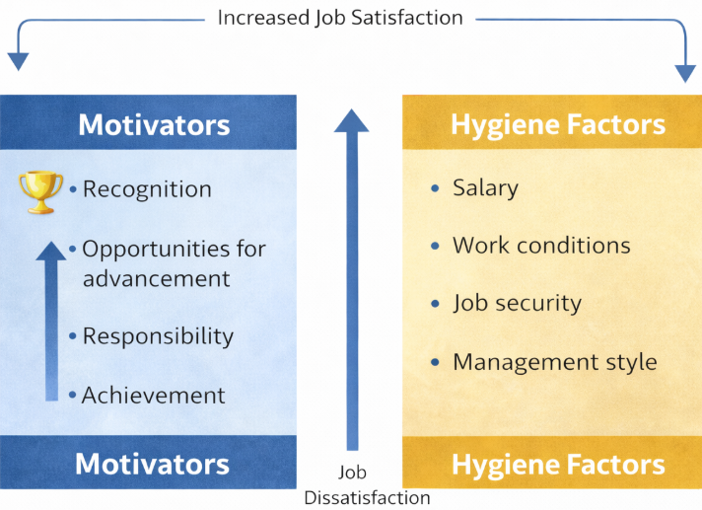
Figure 1Figure Herzberg motivational and hygiene factors adapted to Pret a Manger (Herzberg, 1959)
Several years later, (Herzberg, 1959) expanded this understanding by introducing the Two-Factor Theory. Unlike Maslow, Herzberg argued that motivation depends on two different categories of factors. Hygiene factors, including salary, company policies, and working conditions, help prevent employee dissatisfaction, while motivators such as recognition, responsibility, achievement, and career development create genuine job satisfaction. Herzberg's work represented an important development because it suggested that simply improving salaries would not necessarily increase employee motivation over the long term.

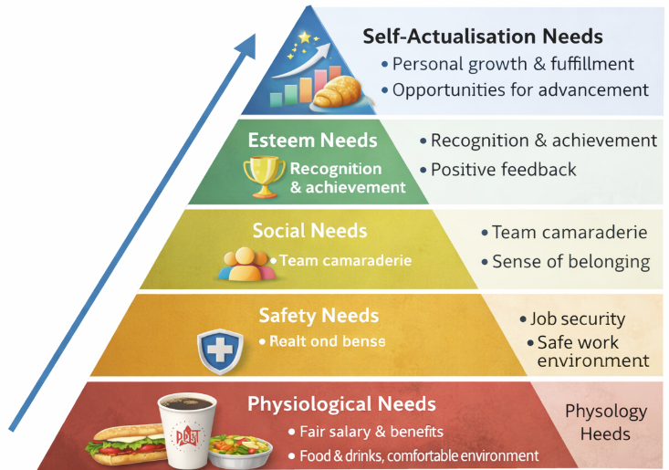
Figure 2 Maslow Hierarchy adapted to Pret a Manger (Maslow, 1943, pp. 370–396)
Although these classical theories remain influential, researchers have increasingly argued that they do not fully explain motivation in modern workplaces. Employees now work in more dynamic and demanding environments where leadership style, organisational culture, employee wellbeing, flexible working practices, and career opportunities also influence motivation. Contemporary research therefore considers motivation as a multidimensional concept that combines both individual and organisational factors especially with the use of Artificial intelligence (AI) and growing of technology also considering mutigenerational gap.
Recent research also supports this broader understanding of employee motivation. (Saks 2022) argues that organisations can improve employee motivation by investing in supportive human resource practices, including employee recognition, career development, effective communication, and management support. These practices encourage employees to become more committed and engaged in their work. Similarly, (Bakker et al., 2023) explain that organisations providing sufficient job resources, such as training opportunities, supportive leadership, and constructive feedback, are more likely to maintain high levels of employee motivation and engagement while reducing the negative effects of workplace stress.
The development of motivation theory therefore demonstrates an important shift in management thinking. Early theories focused mainly on individual needs and rewards, whereas contemporary research recognises that motivation is also shaped by organisational support, leadership, workplace culture, and employee wellbeing. This broader perspective is particularly relevant to organisations such as Pret A Manger, where employees work in fast-paced customer service environments and require both practical support and meaningful recognition to remain motivated.

2.2 Current Understanding of Employee Motivation
Employee motivation is widely recognised as an important factor influencing organisational performance because motivated employees are more productive, committed, and willing to provide high-quality customer service. While early theories focused mainly on employee needs and rewards, recent research suggests that motivation is influenced by both personal and organisational factors.
According to (Ryan & Deci, 2020) employees are more motivated when their psychological needs for autonomy, competence and relatedness are satisfied. Their Self-Determination Theory explains that employees who feel trusted and empowered, capable and supported are more likely to develop intrinsic motivation, leading to higher job satisfaction and stronger organisational commitment. This suggests that motivation depends not only on financial rewards but also on creating a positive working environment.
Similarly, (Bakker et al., 2023) explain through the Job Demands–Resources (JD-R) Theory that employee motivation increases when organisations provide sufficient job resources, including supportive leadership, training opportunities, recognition and career development. However, they argue that excessive workloads and workplace stress can reduce motivation if employees do not receive adequate organisational support.
Recent hospitality research also supports these findings. (Miao et al., 2021) found that positive employee attitudes and personal capabilities contribute to improved job performance in hospitality organisations, highlighting the importance of creating supportive workplaces where employees can perform effectively. These findings suggest that organisations should combine fair rewards with supportive management and opportunities for development to maintain employee motivation.
For organisations such as Pret A Manger, these findings indicate that maintaining employee motivation requires more than competitive pay or financial rewards. Employees are more likely to remain motivated when they receive management support, opportunities for career development and recognition for their contributions. Therefore, modern research views employee motivation as a combination of organisational support, personal development and positive workplace relationships.

2.3 Understanding Workplace Engagement
Workplace engagement has become one of the most important topics in human resource management because it is closely linked to employee performance, job satisfaction, and organisational success. Although employee motivation and engagement are related, they represent different concepts. Motivation explains why employees choose to perform their work, while engagement reflects the level of energy, commitment, and enthusiasm employees demonstrate in their daily roles. Recent research shows that organisations with highly engaged employees often experience better productivity, stronger organisational commitment, improved customer satisfaction, and lower employee turnover.
The concept of workplace engagement was originally introduced by (Kahn 1990), but recent studies have expanded this understanding by examining the organisational factors that influence employee engagement to sustain for growth both personally and professionally. A systematic literature review by (Kossyva et al., 2023) found that employee engagement is affected by leadership, organisational support, communication, career development and progression, and workplace wellbeing. The review also concluded that engaged employees contribute positively to both individual performance and organisational outcomes.
Similarly, (Pattamol Kanjanakan et al., 2021) conducted a meta-analysis of 134 hospitality studies and found that job resources, including management support, learning opportunities, recognition, and positive workplace relationships, have a significant positive effect on employee engagement. Their findings also showed that engaged employees demonstrate higher job satisfaction, stronger organisational commitment, and improved service quality. These findings are particularly relevant to the hospitality sector because employees regularly work in demanding environments where customer satisfaction depends on employee performance.
Recent evidence also highlights that excessive job demands, such as heavy workloads, emotional pressure, and insufficient organisational support, can reduce workplace engagement. Therefore, organisations should balance job demands with appropriate resources, including supportive leadership, training, feedback, and employee recognition, to maintain high engagement levels.
For organisations such as Pret A Manger, workplace engagement is essential because employees work in a fast-paced environment where customer experience depends on teamwork, communication, and service quality. Employees who feel valued, supported, and recognised are more likely to remain engaged, deliver excellent customer service, and contribute to the long-term success of the organisation. Therefore, understanding workplace engagement is essential for examining how employee motivation influences organisational performance. (CIPD, 2021)

2.4 Relationship Between Employee Motivation and Workplace Engagement
Employee motivation and workplace engagement are closely related because motivated employees are more likely to be committed, productive, and contribute to organisational success. While motivation explains why employees perform their work, engagement reflects the level of energy and commitment they show in their daily roles.
According to (Ryan & Deci, 2020) employees are more engaged when their psychological needs for autonomy, competence, and relatedness are supported. This suggests that organisations can improve engagement by creating a positive work environment where employees feel valued and recognised.
Similarly, (Bakker et al., 2023) argue that motivation and engagement increase when organisations provide sufficient job resources, such as supportive leadership, training, career development, and financial and non-financial recognition. However, excessive workloads and workplace stress may reduce both motivation and engagement if employees do not receive appropriate support which thus affect productivity and morale.
Research in the hospitality industry also confirms this relationship. (Pattamol Kanjanakan et al., 2021) found that motivated employees demonstrate higher levels of engagement, organisational commitment, and customer service quality. These findings are particularly relevant to Pret A Manger, where employees work in a fast-paced environment that depends on teamwork and high service standards.
Overall, the literature indicates a strong positive relationship between employee motivation and workplace engagement. However, there is limited research focusing specifically on fast-paced food retail organisations such as Pret A Manger. This study therefore seeks to examine how motivation influences workplace engagement within this organisational context.

2.5 Critical Evaluation of Maslow's Hierarchy of Needs and Herzberg's Two-Factor Theory
Motivation theories help explain why employees behave differently in the workplace. Among the most influential are Maslow's Hierarchy of Needs and Herzberg's Two-Factor Theory, which continue to provide a foundation for understanding employee motivation. Although both theories remain relevant, recent research suggests they should be applied alongside modern management practices to reflect today's changing workplace.
Maslow (1943) argues that employees are motivated by a hierarchy of needs, progressing from basic needs such as salary and job security to higher-level needs including recognition and self-development. In organisations such as Pret A Manger, this suggests that employees are more likely to perform well when both their basic and psychological needs are met. However, (Ryan & Deci, 2020) argue that motivation does not always follow a fixed order, as employees value different needs depending on their personal and work circumstances.
(Herzberg, 1959) distinguish between hygiene factors, such as pay and working conditions, and motivators, including recognition, achievement, and responsibility. According to this theory, hygiene factors reduce dissatisfaction, while motivators encourage higher levels of performance. This view is supported by who found that job resources such as supportive leadership, recognition, and career development improve both employee motivation and engagement.
Despite their importance, both theories have limitations. Maslow assumes that employees have similar needs, while Herzberg separates satisfaction and dissatisfaction more clearly than many modern workplaces demonstrate. Recent studies suggest that motivation is influenced by individual differences, organisational culture, and changing work environments rather than a single motivational model.
Overall, Maslow's and Herzberg's theories provide a valuable foundation for understanding employee motivation. Together, they help explain how meeting employee needs and providing meaningful work can improve workplace engagement, making them appropriate theoretical frameworks for this research.

2.6 Research Gap and Conceptual Framework
Although many studies have examined employee motivation and workplace engagement, several gaps remain. Most previous research has focused on a wide range of industries, with limited attention given to fast-paced retail food organisations such as Pret A Manger. Employees in this sector experience demanding workloads, time pressure, and continuous customer interaction, which may influence motivation and engagement differently from other workplaces.
In addition, many existing studies discuss motivation and engagement separately rather than examining how motivation directly influences engagement within a single organisational context. This makes it difficult to identify which motivational factors have the greatest impact on employee engagement in organisations such as Pret A Manger.
This study addresses these gaps by investigating the relationship between employee motivation and workplace engagement using quantitative data collected from employees at Pret A Manger in the United Kingdom. The research focuses on key motivational factors, including recognition, pay, career development, workload, and management support, to determine how they influence workplace engagement.
The conceptual framework for this study identifies employee motivation as the independent variable and workplace engagement as the dependent variable. Based on the literature, the study proposes that effective motivation strategies positively influence employee engagement, leading to improved job satisfaction, stronger organisational commitment, better customer service, and improved organisational performance.

Employee Motivation Workplace Engagement

Recognition Higher Job Satisfaction
Pay and Rewards Better Customer Service
Career Development Higher Employee Retention
Management Support Improved Performance
Workload
Figure 3 Conceptual framework developed by the researcher based on Ryan and Deci (2020), Saks (2022), and Bakker, Demerouti and Sanz-Vergel (2023).

CHAPTER 3:

METHODOLOGY
This chapter explains the research methodology used to investigate the relationship between employee motivation and workplace engagement at Pret A Manger in the United Kingdom. It describes and justifies the research philosophy, research approach, research design, sampling strategy, data collection methods, instrument design, data analysis techniques, and ethical considerations. Each methodological decision is supported by academic literature to ensure the research is reliable, valid, and appropriate for addressing the research aim and objectives. Providing a clear explanation of these methods also allows other researchers to replicate the study in similar organisational settings.

3.1 Research Philosophy and Research Approach
Research philosophy provides the foundation for how a study is conducted and helps researchers select the most appropriate methods to answer their research questions. According to (Johnson and Christensen, 2024) the choice of research philosophy should be based on the purpose of the research and the type of data required to achieve reliable findings.
This study adopts a positivist research philosophy because it aims to examine the relationship between employee motivation and workplace engagement using measurable numerical data collected from employees at Pret A Manger. (Johnson and Christensen, 2024) explain that positivism is appropriate when researchers seek objective evidence and use statistical analysis to identify relationships between variables. Since this research measures employees' perceptions through a structured questionnaire, a positivist philosophy provides a suitable approach for producing reliable and unbiased findings.
A quantitative research approach was selected because it enables data to be collected from a larger group of employees and analysed using statistical techniques. (Creswell, 2018) argue that quantitative research is appropriate when studies aim to measure variables and test relationships using numerical data. Therefore, this approach supports the aim of this research by providing objective evidence of how employee motivation influences workplace engagement at Pret A Manger.

3.2 Research Design
The research design provides the plan for collecting and analysing data to answer the research questions. According to (Anderson and Fontinha, 2024) an effective research design ensures that the research methods are aligned with the study's aim and objectives. In this study, a cross-sectional research design was selected because data were collected from Pret A Manger employees at a single point in time. This design is appropriate because the research aims to examine the current relationship between employee motivation and workplace engagement rather than changes over a long period. A survey strategy was chosen because it allows the researcher to collect consistent information from several employees using the same questionnaire, making it suitable for quantitative analysis.

3.3 Sampling Strategy
Sampling is the process of selecting participants who can provide information relevant to the research objectives. (van Rooij, 2025) explain that researchers should select a sampling method that matches the purpose of the study while recognising practical limitations such as access to participants and available resources. For this research, the target population consists of employees working at Pret A Manger stores in the United Kingdom. A sample of approximately 50 employees will be selected using purposive sampling because participants have direct experience of the organisation and can provide relevant information about employee motivation and workplace engagement. The sample will include employees from different job roles to obtain a wider range of experiences and improve the quality of the findings.

3.4 Sampling Strategy
Sampling is the process of selecting participants who can provide information relevant to the research objectives. According to (Adu and Miles, 2023) researchers should choose a sampling method that reflects the purpose of the study while considering practical factors such as access to participants, time, and available resources.
The target population for this research consists of employees working at Pret A Manger stores in the United Kingdom. A sample of approximately 50 employees will be selected using purposive sampling because the participants have direct experience of the organisation and are able to provide relevant information about employee motivation and workplace engagement. Employees from different job roles and levels of experience will be included to obtain a broader understanding of the workplace.
The sample size was chosen because this research is a small-scale master’s dissertation with limited time and access to participants. As (Johnson and Christensen, 2024) explain, the size of a sample should be appropriate for the research objectives and the resources available to the researcher. The purpose of this study is to examine patterns of employee motivation and workplace engagement within Pret A Manger rather than to generalise the findings to all organisations in the UK. Therefore, a sample of approximately 50 employees is considered suitable for achieving the research aim while remaining practical and manageable.

3.5 Data Collection and Instrument Design
Data collection is an important stage of the research process because it provides the information needed to answer the research questions. According to (Ganesha & Aithal, 2022), researchers should select a data collection method that is consistent with the research philosophy, objectives, and overall design. As this study follows a positivist philosophy and a quantitative approach, an online questionnaire was considered the most appropriate method for collecting numerical data from employees at Pret A Manger.
The questionnaire consisted of five closed-ended questions measured using a five-point Likert scale ranging from 1 (Strongly Disagree) to 5 (Strongly Agree). The questions were developed to measure the main variables of this study, including employee motivation, management recognition, career development, workplace engagement, and the relationship between motivation and engagement. According to (Mohajan,2018) a structured questionnaire using a Likert scale is appropriate for quantitative research because it provides consistent data that can be analysed statistically. The decision to use a short questionnaire was made to encourage participation from employees working in the fast-paced environment of Pret A Manger, where time available to complete surveys is limited.

Questionnaire

Examining the Role of Employee Motivation in Enhancing Workplace Engagement: Evidence from Pret A Manger UK

Participant Information
Thank you for taking part in this research. The purpose of this questionnaire is to understand how employee motivation influences workplace engagement at Pret A Manger UK. Your participation is voluntary, and all responses will remain anonymous and confidential. The questionnaire will take approximately 2–3 minutes to complete.
Instructions
Please indicate how much you agree with each statement by selecting one answer.

Scale | Meaning
1 | Strongly Disagree
2 | Disagree
3 | Neutral
4 | Agree
5 | Strongly Agree

Section A: Employee Motivation and Workplace Engagement
Q1. I feel motivated to do my job well every day at Pret A Manger.
☐ 1 ☐ 2 ☐ 3 ☐ 4 ☐ 5
Q2. My manager recognises and appreciates the work that I do.
☐ 1 ☐ 2 ☐ 3 ☐ 4 ☐ 5
Q3. Pret A Manger provides opportunities for me to learn new skills and develop my career.
☐ 1 ☐ 2 ☐ 3 ☐ 4 ☐ 5
Q4. I feel committed and engaged while working at Pret A Manger.
☐ 1 ☐ 2 ☐ 3 ☐ 4 ☐ 5
Q5. Overall, I believe that employee motivation has a positive effect on workplace engagement at Pret A Manger.
☐ 1 ☐ 2 ☐ 3 ☐ 4 ☐ 5

3.6 Data Analysis
Data analysis is the process of organising and interpreting the information collected during the research to answer the research questions. According to (Berthold & Hand, 2021), quantitative data should be analysed using statistical techniques that clearly identify patterns and relationships between variables.
The responses from the questionnaire will be entered into Microsoft Excel for analysis. Descriptive statistics, including frequencies, percentages, and mean scores, will be used to summarise employees' responses for each question. These techniques will help identify the overall level of employee motivation and workplace engagement at Pret A Manger. The findings will be presented using tables and charts to make the results easier to understand and compare. The analysis will then be discussed in relation to the research objectives and the literature reviewed in Chapter Two to determine whether the findings support previous studies.

3.7 Reliability and Validity
Reliability and validity are important because they help ensure that research findings are accurate and trustworthy. (Taherdoost, 2016) explain that reliability refers to the consistency of the research instrument, while validity considers whether the questionnaire measures what it is intended to measure.
To improve reliability, all participants will complete the same questionnaire using identical response options. To improve validity, the questionnaire was designed to reflect the research objectives and was developed from concepts identified in the literature on employee motivation and workplace engagement. Clear and simple language was used throughout the questionnaire to reduce misunderstanding and improve the accuracy of participants' response.

3.8 Ethical Considerations
Ethical considerations are essential to ensure that research is conducted responsibly and protects the rights of participants. According to (Glattke, 2020) researchers should ensure that participants are treated fairly and that their information remains confidential throughout the study.
Participation in this research will be voluntary, and all participants will receive information about the purpose of the study before completing the questionnaire. Responses will remain anonymous, and no personal information will be collected that could identify individual participants. Participants will have the right to withdraw from the study at any stage before submitting their responses. All collected data will be stored securely and used only for academic purposes in accordance with the University's ethical guidelines.

CHAPTER 4:

RESULTS AND DISCUSSION

Survey Results and Discussion
Based on 32 valid responses

4. Results
This chapter presents the findings from the employee motivation and workplace engagement survey conducted in relation to Pret A Manger. The questionnaire contained five statements measured on a five-point Likert scale, where 1 represented Strongly Disagree and 5 represented Strongly Agree. A total of 32 complete responses were available for analysis. The analysis uses frequencies, percentages, means and sample standard deviations to summaries the pattern of responses. Positive responses refer to ratings of 4 (Agree) and 5 (Strongly Agree). The results are descriptive and should therefore be interpreted as evidence about the participating group rather than as proof that the findings represent every Pret A Manger employee.

4.1 Descriptive statistics
Table 4.1. Descriptive statistics for survey items
Item | N | Minimum | Maximum | Mean | SD | Positive %
Q1 | 32 | 1 | 5 | 3.28 | 1.40 | 53.1%
Q2 | 32 | 1 | 5 | 3.38 | 1.13 | 46.9%
Q3 | 32 | 1 | 5 | 3.50 | 1.22 | 59.4%
Q4 | 32 | 1 | 5 | 3.34 | 1.15 | 46.9%
Q5 | 32 | 1 | 5 | 3.72 | 1.22 | 65.6%
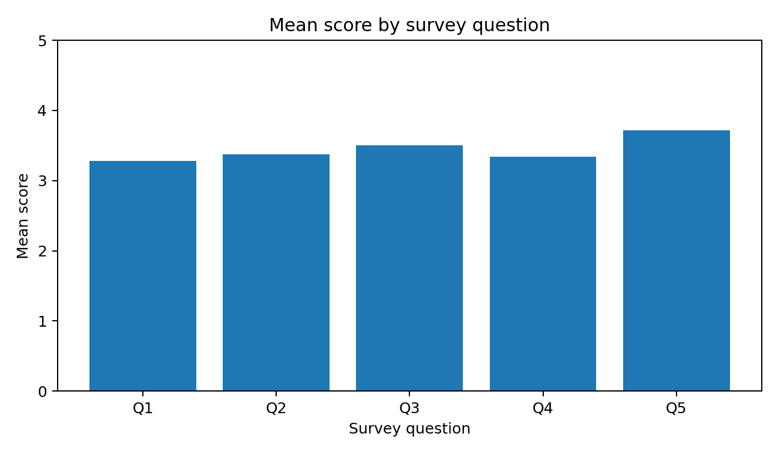
Note. SD = sample standard deviation. Positive responses combine Agree and Strongly
Figure 4. Mean score by survey question

The overall mean (Average) across the five items was 3.44. This indicates a broadly neutral-to-positive pattern, although the average did not reach 4.00, which would represent general agreement across the survey. Question 5 produced the highest means (M = 3.72, SD = 1.22), showing that respondents were most positive about the proposition that employee motivation has a beneficial effect on workplace engagement. Question 3 had the next highest mean (M = 3.50, SD = 1.22), suggesting moderately favorable perceptions of learning and career-development opportunities. Question 2 (M = 3.38, SD = 1.13), Question 4 (M = 3.34, SD = 1.15) and Question 1 (M = 3.28, SD = 1.40) were closer to the neutral point. The standard deviation was largest for Question 1, indicating that employees differed most strongly in their reported day-to-day motivation.

4.2 Frequency analysis by question
4.3.1 Q1: I feel motivated to do my job well every day at Pret A Manger.
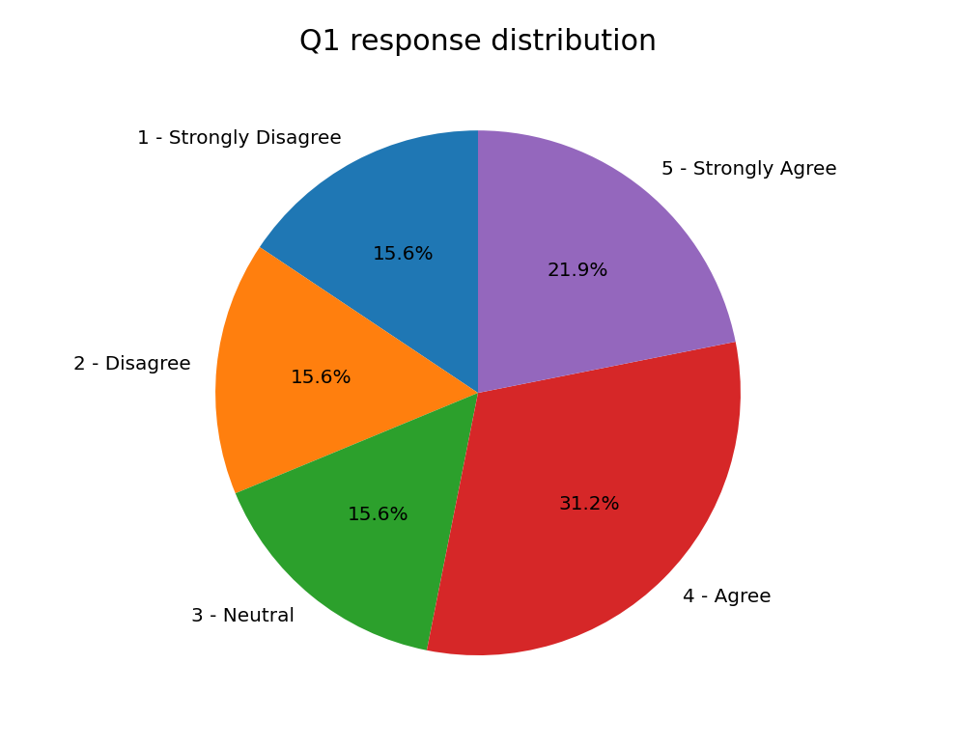
Table 4.2. Frequency distribution for Q1
Figure 5. Q1 response distribution
Rating | Category | Frequency | Percent | Valid % | Cumulative %
1 | Strongly Disagree | 5 | 15.6 | 15.6 | 15.6
2 | Disagree | 5 | 15.6 | 15.6 | 31.2
3 | Neutral | 5 | 15.6 | 15.6 | 46.9
4 | Agree | 10 | 31.2 | 31.2 | 78.1
5 | Strongly Agree | 7 | 21.9 | 21.9 | 100.0
 | Total | 32 | 100.0 | 100.0

For Q1, 17 respondents (53.1%) selected Agree or Strongly Agree, compared with 10 (31.2%) who selected Disagree or Strongly Disagree. The remaining 5 respondents (15.6%) selected Neutral. Although positive responses formed by the largest combined group, the distribution was dispersed across all five categories. This supports the mean of 3.28 and suggests that daily motivation was not experienced consistently by all respondents.
4.3.2 Q2: My manager recognizes and appreciates the work that I do.
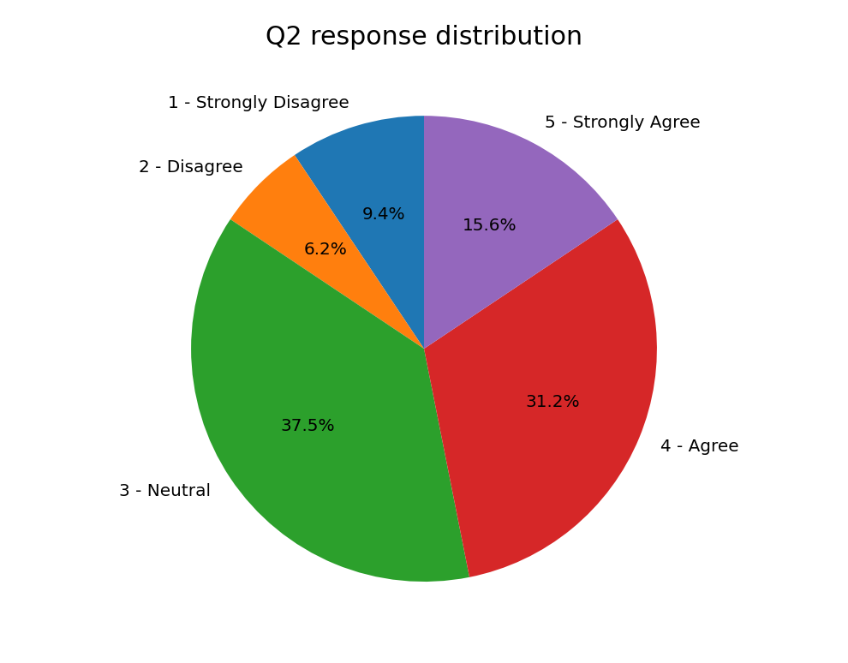
Table 4.3. Frequency distribution for Q2
Figure 6. Q2 response distribution

Rating | Category | Frequency | Percent | Valid % | Cumulative %
1 | Strongly Disagree | 3 | 9.4 | 9.4 | 9.4
2 | Disagree | 2 | 6.2 | 6.2 | 15.6
3 | Neutral | 12 | 37.5 | 37.5 | 53.1
4 | Agree | 10 | 31.2 | 31.2 | 84.4
5 | Strongly Agree | 5 | 15.6 | 15.6 | 100.0
 | Total | 32 | 100.0 | 100.0

For Q2, 15 respondents (46.9%) reported positive perceptions of managerial recognition, while 5 (15.6%) reported negative perceptions and 12 (37.5%) selected Neutral. Neutral was the single most common response category. The results therefore suggest that manager recognition was viewed positively by many employees, but a substantial proportion did not express a clear positive or negative position.
4.3.3 Q3: Pret A Manger provides opportunities for me to learn new skills and develop my career.
Table 4.4. Frequency distribution for Q3
Rating | Category | Frequency | Percent | Valid % | Cumulative %
1 | Strongly Disagree | 2 | 6.2 | 6.2 | 6.2
2 | Disagree | 6 | 18.8 | 18.8 | 25.0
3 | Neutral | 5 | 15.6 | 15.6 | 40.6
4 | Agree | 12 | 37.5 | 37.5 | 78.1
5 | Strongly Agree | 7 | 21.9 | 21.9 | 100.0
 | Total | 32 | 100.0 | 100.0
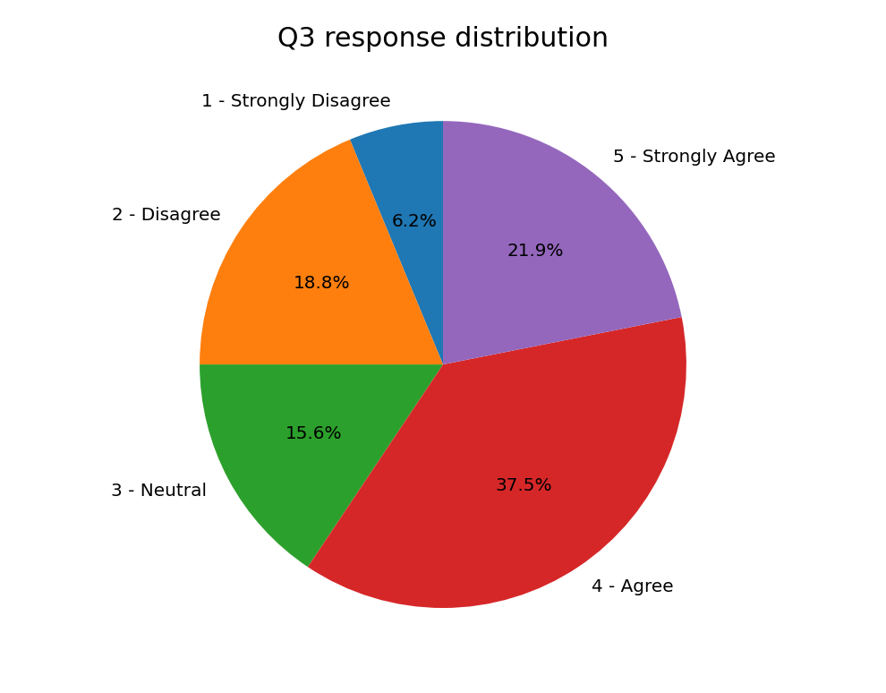

Figure7. Q3 response distribution

For Q3, 19 respondents (59.4%) selected Agree or Strongly Agree regarding opportunities to learn and develop, while 8 (25.0%) selected one of the disagreement categories. The mean of 3.50 indicates moderate agreement. Nevertheless, the presence of both negative and neutral responses shows that access to development opportunities may not be perceived uniformly across employees or work settings.
4.3.4 Q4: I feel committed and engaged while working at Pret A Manger.
Table 4.5. Frequency distribution for Q4
Rating | Category | Frequency | Percent | Valid % | Cumulative %
1 | Strongly Disagree | 3 | 9.4 | 9.4 | 9.4
2 | Disagree | 3 | 9.4 | 9.4 | 18.8
3 | Neutral | 11 | 34.4 | 34.4 | 53.1
4 | Agree | 10 | 31.2 | 31.2 | 84.4
5 | Strongly Agree | 5 | 15.6 | 15.6 | 100.0
 | Total | 32 | 100.0 | 100.0
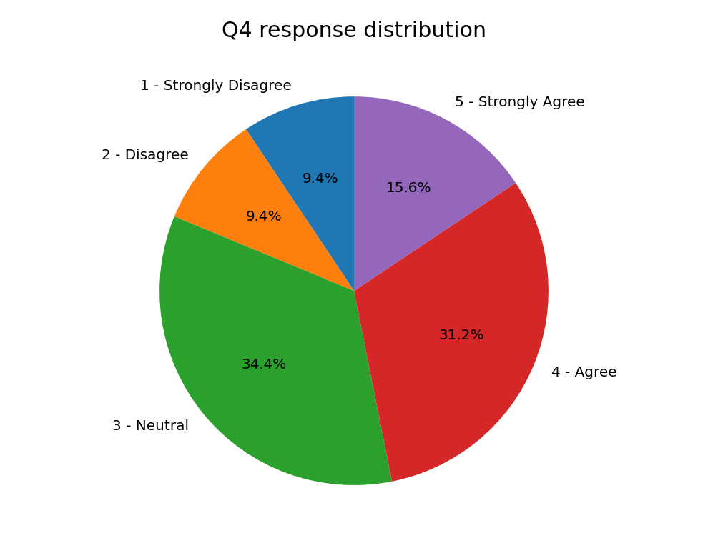
Figure 8 Q4 response distribution

For Q4, 15 respondents (46.9%) selected Agree or Strongly Agree, 6 (18.8%) selected Disagree or Strongly Disagree, and 11 (34.4%) selected Neutral. Neutral was the most frequent single category. The distribution indicates a slightly positive but mixed level of commitment and engagement, consistent with the mean score of 3.34.
4.3.5 Q5: Overall, I believe that employee motivation has a positive effect on workplace engagement at Pret A Manger.
Table 4.6. Frequency distribution for Q5
Rating | Category | Frequency | Percent | Valid % | Cumulative %
1 | Strongly Disagree | 2 | 6.2 | 6.2 | 6.2
2 | Disagree | 4 | 12.5 | 12.5 | 18.8
3 | Neutral | 5 | 15.6 | 15.6 | 34.4
4 | Agree | 11 | 34.4 | 34.4 | 68.8
5 | Strongly Agree | 10 | 31.2 | 31.2 | 100.0
 | Total | 32 | 100.0 | 100.0
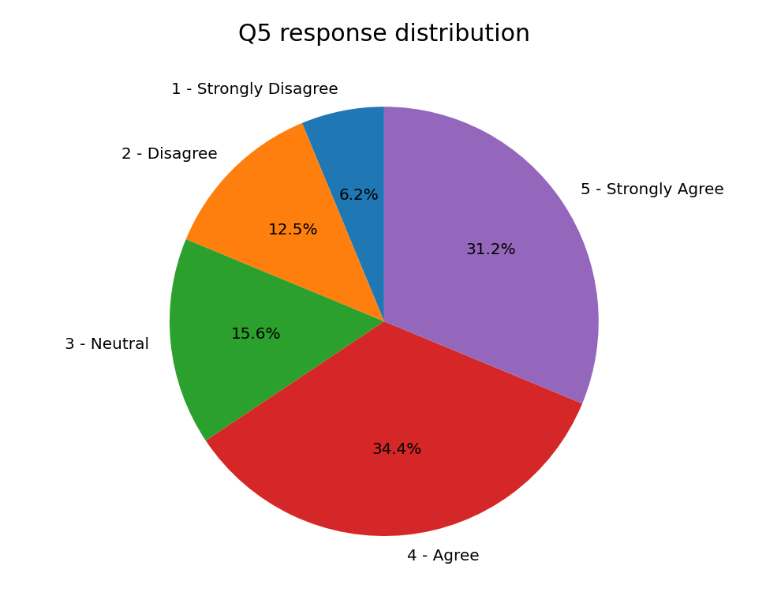

Figure 9. Q5 response distribution

For Q5, 21 respondents (65.6%) selected Agree or Strongly Agree, making this the strongest positive result in the survey. Only 6 respondents (18.8%) selected a disagreement category, while 5 (15.6%) selected Neutral. The mean of 3.72 demonstrates that most participants accepted the general relationship between employee motivation and workplace engagement.

4.3 Summary of Results
The survey findings provide an overall picture of how employees at Pret A Manger perceive motivation and workplace engagement. The questionnaire was completed by 32 employees using a five-point Likert scale, where 1 represented Strongly Disagree and 5 represented Strongly Agree. The analysis focused on five statements relating to daily motivation, managerial recognition, learning and career development, employee engagement, and the relationship between motivation and engagement.
Overall, the findings indicate that employees have a moderately positive perception of motivation and engagement within Pret A Manger. None of the five statements produced a mean score below the midpoint of the scale, suggesting that employees generally view the organisation positively. However, none of the statements achieved a mean score above 4.0, which indicates that employees did not express a consistently high level of agreement across all areas. This suggests that although many employees have positive experiences at work, there is still room for improvement.
Among the five questions, the highest mean score was recorded for Question 5 (Mean = 3.72), where employees agreed that motivation has a positive effect on workplace engagement. This result demonstrates that most participants recognise the importance of motivation in influencing how employees perform, interact with colleagues and contribute to organisational success. In contrast, Question 1, which measured employees' daily motivation, recorded the lowest mean score (Mean = 3.28). This finding suggests that while employees understand the value of motivation, they do not always experience high levels of motivation during their daily work.
Questions relating to managerial recognition, career development and employee engagement all produced moderate mean scores between 3.34 and 3.50. These results indicate that employees generally have favourable opinions regarding these areas but also highlight that positive experiences are not shared equally by everyone. A noticeable proportion of respondents selected either Neutral or Disagree, suggesting differences in employee experiences across teams or working environments.
Overall, the results demonstrate that employee motivation and workplace engagement are present within Pret A Manger, but they are not consistently experienced by all employees. These findings provide a useful basis for exploring the factors that influence employee attitudes and for identifying practical strategies that could improve motivation, engagement and organisational performance.

4.4.1 Daily Employee Motivation
Q1 produced the lowest mean score of the five questions (3.28). Of the 32 respondents, 10 (31.3%) agreed and 7 (21.9%) strongly agreed, meaning that 53.2% gave a positive response. However, 5 respondents (15.6%) disagreed and another 5 (15.6%) strongly disagreed, while 15.6% remained neutral. The results therefore indicate a moderately positive but mixed level of daily motivation.
This finding is important because it suggests that motivation is not experienced equally by all employees. In a fast-paced service environment such as Pret A Manger, daily motivation may be affected by workload, customer demands, teamwork, working conditions and opportunities to develop. The relatively large variation in responses indicates that some employees may experience these factors more positively than others.
Recent hospitality research supports the importance of motivation in employee experiences. (Meira et al., 2023) examined hospitality employees in England and Brazil and found differences in the importance of intrinsic and extrinsic motivation between employees in the two countries. Their findings demonstrate that motivational factors can vary according to employee and organisational context.
Similarly, (Grobelna & Wyszkowska-Wróbel, 2023) found that intrinsic motivational factors, including achievement, responsibility and the work itself, were significantly related to job satisfaction among hotel employees. These findings suggest that motivation may depend on more than financial rewards and can also be influenced by how meaningful and rewarding employees find their work.
For Pret A Manger, the Q1 findings therefore suggest that managers should pay attention to the reasons why some employees feel less motivated. Regular communication, manageable workloads, opportunities to take responsibility and recognition of employee contributions could help strengthen daily motivation.
Overall, Q1 shows that employee motivation is generally positive but not consistently strong. This is significant because improving motivation among the employees who reported neutral or negative experiences may provide an opportunity to strengthen workplace engagement

4.4.2 Managerial Recognition and Appreciation
Question 2: My manager recognises and appreciates the work that I do.
Q2 produced a mean score of 3.38. Almost half of the respondents (46.9%) agreed or strongly agreed that their manager recognised and appreciated their work. However, 37.5% selected Neutral, while 15.6% gave a negative response. The results therefore suggest that managerial recognition is viewed moderately positively, but it is not experienced consistently by all employees.
This finding is important because recognition can help employees feel that their contribution is valued. This may be particularly relevant in fast-paced food-service environments, where employees depend on teamwork and regular interaction with customers. A recent field study in six fast-food restaurant locations found that team-based employee recognition was associated with improvements in employee engagement and effort (Presslee et al., 2023). This provides relevant support for the present findings because the study was conducted in a similar service environment.
However, the relatively large neutral group in the present study suggests that recognition at Pret A Manger may not always be sufficiently visible or consistent. Managers could therefore improve motivation through regular and specific feedback, appreciation of good performance and recognition of teamwork. Recognition should also be fair and accessible to different employees rather than being limited to individuals.
Overall, Q2 indicates that managerial recognition is a potential area for improvement. While many respondents view recognition positively, the results suggest that a more consistent approach could help strengthen employee motivation and engagement.

4.4.3 Learning and Career Development
Question 3: Pret A Manger provides opportunities for me to learn new skills and develop my career.
Q3 produced a mean score of 3.50, making it the second-highest result in the survey. Of the 32 respondents, 12 (37.5%) agreed and 7 (21.9%) strongly agreed, meaning that 59.4% gave a positive response. However, 5 respondents (15.6%) disagreed and 2 (6.3%) strongly disagreed, while 5 (15.6%) remained neutral. The findings therefore suggest that most respondents have a positive perception of learning and career development, although these opportunities are not experienced equally by everyone.
This finding is important because opportunities to learn and develop can strengthen employees' skills and confidence while also giving them a clearer reason to remain committed to an organisation. (Kwon et al., 2024) found that intrinsic motivational factors were positively associated with employee work engagement in the hospitality sector. Their findings suggest that employees' internal motivation and positive experiences of their work can contribute to stronger engagement. This supports the present finding because development opportunities may help employees feel more capable and motivated in their roles.
The result is also consistent with (Tukiran & Lisa Chandrasari Desianti, 2025) whose systematic review identified talent management and employee development as important factors associated with employee engagement. This suggests that organisations can strengthen engagement by providing employees with opportunities to develop their skills and progress professionally.
For Pret A Manger, the positive result is encouraging because training and career development may help employees see a longer-term future within the organisation. This could be particularly valuable for employees who want to progress towards supervisory or management positions. However, the 21.9% who gave a negative response should not be overlooked. Their responses suggest that development opportunities may not be equally accessible or clearly communicated to all employees.
Pret A Manger could therefore improve this area by making career pathways clearer, communicating available training more effectively and ensuring that employees working different shifts or locations have similar access to development opportunities. Managers could also hold regular development discussions with employees to identify their skills, interests and future goals.
Overall, Q3 represents one of the more positive findings in the survey. Nevertheless, the results indicate that further improvement in access to training and career development could help strengthen employee motivation and workplace engagement.

4.4.4 Commitment and Workplace Engagement
Question 4: I feel committed and engaged while working at Pret A Manger.
Q4 produced a mean score of 3.34. Of the 32 respondents, 10 (31.3%) agreed and 5 (15.6%) strongly agreed, meaning that 46.9% gave a positive response. However, 11 respondents (34.4%) selected Neutral, while 6 respondents (18.8%) gave a negative response. The results therefore indicate a moderate level of workplace engagement, rather than a consistently strong level.
This finding is important because employee engagement reflects more than simply completing required tasks. Employees who feel engaged are more likely to show energy, involvement and commitment towards their work. In a customer-facing organisation such as Pret A Manger, this can be particularly important because employee attitudes and behaviour can influence teamwork and the quality of customer service.
The findings are consistent with (Md Asadul Islam & Mohammad Nurul Alam, 2024) who examined work engagement among 384 hospitality employees. Their study found that work engagement was an important factor linking workplace conditions with employee stress and identified job autonomy as relevant to employee engagement. This supports the present findings because it suggests that engagement can be influenced by the way employees experience their working environment, rather than being determined only by individual motivation.
The relatively high neutral response in Q4 is also significant. It suggests that many employees may be neither strongly disengaged nor highly engaged. Pret A Manger could therefore strengthen engagement by improving communication, giving employees appropriate responsibility, supporting teamwork and ensuring that employees have opportunities to contribute ideas.
Overall, Q4 suggests that workplace engagement at Pret A Manger is moderately positive but has room for improvement. The findings also support the wider argument of this dissertation that employee motivation and the quality of the working environment are important considerations when seeking to improve employee engagement.

4.4.5 Perceived Relationship Between Motivation and Engagement
Question 5: Overall, I believe that employee motivation has a positive effect on workplace engagement at Pret A Manger.
Q5 produced the highest mean score of the survey (3.72). Of the 32 respondents, 11 (34.4%) agreed and 10 (31.3%) strongly agreed. Therefore, 65.6% of respondents gave a positive response. Five respondents (15.6%) selected Neutral, while 6 respondents (18.8%) gave a negative response. This makes Q5 the strongest result in the survey and suggests that most participants perceive a positive connection between employee motivation and workplace engagement.
This finding is particularly important because it directly relates to the focus of this research. Recent research by (Zada et al., 2025) examined the relationship between motivating language and work engagement in the tourism and hospitality sector. Their study found that motivating communication from leaders can contribute to work engagement, with psychological meaningfulness playing an important role in this relationship.
This supports the current findings because it suggests that employees' motivation and their experience of engagement can be connected through workplace factors such as communication, leadership and the meaning employees attach to their work. In the Pret A Manger context, employees who feel motivated and supported may therefore be more likely to feel involved and committed to their daily work.
However, Q5 should be interpreted carefully. The question measures employees' perception that motivation affects engagement, rather than statistically proving that motivation causes engagement. The survey used only 32 respondents and five single-item questions. Therefore, the finding demonstrates a strong perceived relationship but cannot establish causality.
The difference between Q5 and Q4 is also important. While 65.6% agreed that motivation positively affects engagement, only 46.9% gave a positive response to feeling committed and engaged at work. This suggests that employees may recognise the importance of motivation without necessarily experiencing high engagement themselves.
Overall, Q5 provides the strongest support for the central proposition of the dissertation. The findings suggest that employees generally believe motivation and engagement are positively connected, while the lower Q1 and Q4 results indicate that there is still room for Pret A Manger to improve employees' actual experience of motivation and engagement.

5. Discussion

5.1 Overall Discussion of Findings
The purpose of this research was to examine the role of employee motivation in enhancing workplace engagement at Pret A Manger UK. The findings from 32 respondents show an overall moderately positive perception of motivation and engagement, although the results also identify several areas where employees' experiences could be improved.
The strongest result was Q5, which examined whether employees believed that motivation has a positive effect on workplace engagement. The mean score was 3.72, with 65.6% of respondents selecting Agree or Strongly Agree. This suggests that most participants recognise a connection between being motivated and feeling engaged at work. This finding is consistent with recent research in the hospitality sector. (Zada et al., 2025) found that motivating communication and psychological meaningfulness can contribute to stronger work engagement. This supports the argument that motivation is not only related to employees' willingness to perform their duties but can also influence their psychological involvement in their work.
However, the results also show an important difference between employees' belief about motivation and their actual experience of engagement. Although 65.6% agreed that motivation positively affects engagement, only 46.9% agreed or strongly agreed that they personally felt committed and engaged at work (Q4). This difference is significant because it suggests that employees may understand the importance of motivation without necessarily experiencing a high level of engagement themselves. Therefore, improving employee engagement may require more than simply encouraging employees to be motivated.
Q1 provides further evidence of this issue. Daily motivation produced the lowest mean score of 3.28, with 53.2% of respondents providing a positive response. Although this represents a majority, almost one-third of respondents selected a negative response. This suggests that some employees may experience difficulties maintaining motivation during their everyday work. In a fast-paced food-service organisation, factors such as workload, customer pressure, staffing and relationships with managers or colleagues may influence employees' daily experiences.
The results for managerial recognition also require attention. Q2 produced a mean of 3.38, with 46.9% giving a positive response. However, 37.5% selected Neutral. This relatively large neutral group may indicate that recognition is not consistently experienced across employees. Recognition can be particularly important because employees may be more motivated when they feel that their work is noticed and valued. In practical terms, managers could provide more regular and specific feedback rather than relying only on formal rewards.
Q3 produced a more positive result, with a mean of 3.50 and 59.4% of respondents giving a positive response to learning and career development opportunities. This suggests that development is one of the stronger aspects of the employee experience. Nevertheless, 21.9% of respondents selected a negative response, showing that development opportunities may not be equally experienced by all employees. Recent research by (Tukiran & Lisa Chandrasari Desianti, 2025) similarly highlights the importance of training and development in supporting employee engagement through improvements in employee competence and organisational support.
Taken together, the five questions demonstrate that motivation and engagement at Pret A Manger should not be viewed as a single issue. The findings show positive perceptions of motivation, development and the relationship between motivation and engagement, but weaker results for daily motivation and personal engagement. This suggests that the organisation may have effective motivational practices in place, while some employees may still experience challenges in their everyday working environment.

5.2 Research and Practical Implications
The findings provide useful implications for both research and management practice. From a research perspective, the results support the view that employee motivation and workplace engagement are related, as 65.6% of respondents agreed or strongly agreed that motivation positively affects engagement. However, the difference between Q5 and Q4 suggests that recognising the importance of motivation does not necessarily mean that employees experience high engagement. Future research could therefore examine motivation and engagement separately using larger samples and validated multi-item measures.
From a practical perspective, the findings suggest three main priorities for Pret A Manger. First, managers could provide more regular and consistent recognition, as Q2 produced a moderate mean of 3.38. Second, the organisation could improve access to training and career development, which received a more positive mean of 3.50 but still produced some negative responses. Third, managers could investigate factors affecting daily motivation, as Q1 recorded the lowest mean of 3.28.
These findings are consistent with recent research showing that employee engagement can be influenced by organisational support and working conditions. Therefore, Pret A Manger could use regular employee feedback to identify specific motivational barriers within individual teams and branches.

Chapter 6

6.1 Limitations of the Research
This study has several limitations that should be considered when interpreting the findings. First, the sample consisted of only 32 respondents. This relatively small sample means that the findings cannot be confidently generalised to all Pret A Manger employees. Research using survey samples also recognises that sample size and sampling method can affect the generalisability of findings.
Second, the study used a cross-sectional design, meaning that the data were collected at one point in time. Therefore, the results can show employees' perceptions and possible relationships between motivation and engagement, but they cannot prove that motivation causes engagement. Recent employee-engagement research similarly notes that cross-sectional designs are limited when establishing causality.
Third, the questionnaire relied on self-reported responses. Participants may have been influenced by their recent experiences or may have provided answers they considered socially acceptable. Self-reported surveys are useful for measuring employee perceptions, but researchers recognise the possibility of response and common-method bias.
Finally, the questionnaire contained only five questions, meaning that motivation and engagement were measured relatively simply. A larger study could use validated multi-item scales and statistical tests such as correlation or regression to provide stronger evidence about the relationship between the two variables.
Overall, these limitations mean that the findings should be treated as useful evidence about the surveyed participants rather than definitive conclusions about the entire Pret A Manger workforce. This cautious interpretation strengthens the academic credibility of the research.

6.2 Recommendations
Based on the literature, methodology and findings, four recommendations are proposed.

6.2.1 Strengthen Consistent Employee Recognition
The results indicate that recognition could be improved. Although 46.9% of respondents responded positively to Q2, 37.5% selected Neutral. Pret A Manger should therefore encourage managers to provide regular and specific recognition for good performance, customer service and teamwork.
Recognition should be fair and consistent rather than provided only when exceptional performance occurs. This could help employees feel that their contribution is valued and may strengthen motivation.

6.2.2 Improve Career Development
Learning and development were one of the stronger areas in the survey, with a mean of 3.50. However, some employees still reported negative experiences. Pret A Manger should make training and career opportunities more visible and accessible.
Clear information about progression routes, training programmes and promotion requirements could help employees understand how their current role can contribute to their future career. This may also encourage employees to remain engaged with the organisation.

6.2.3 Address Everyday Barriers to Motivation
Daily motivation produced the lowest mean score of 3.28. This suggests that Pret A Manger should investigate factors that may reduce motivation during everyday work.
Managers could regularly ask employees about workload, staffing, customer pressure, shift arrangements and communication. Short feedback discussions could help identify problems within individual teams and allow managers to respond to employees' specific needs.

6.2.4 Develop a More Engaging Working Environment
The research suggests that improving engagement requires more than motivational rewards. Pret A Manger could provide employees with greater opportunities to communicate their ideas, participate in workplace decisions and take responsibility.
Combining recognition, development, communication and supportive management may create a stronger overall employee experience. These practices could be monitored through regular employee surveys to determine whether engagement improves over time.

Conclusion

This dissertation examined the role of employee motivation in enhancing workplace engagement at Pret A Manger UK. The research considered how motivation has developed within human resource management, examined contemporary understanding of workplace engagement, reviewed the relationship between motivation and engagement, and investigated employees' perceptions through a quantitative questionnaire.
The literature reviewed demonstrates that employee motivation is influenced by more than financial rewards. Contemporary research highlights the importance of recognition, development opportunities, supportive management, meaningful work and positive working conditions. The literature also indicates that workplace engagement involves employees' psychological involvement, commitment and energy towards their work. Therefore, motivation and engagement are closely connected, although they should not be treated as identical concepts.
A quantitative methodology was selected because the research aimed to measure employees' perceptions numerically and identify patterns within the responses. The questionnaire consisted of five Likert-scale questions focusing on daily motivation, managerial recognition, career development, engagement and the perceived relationship between motivation and engagement. A total of 32 responses were analysed using descriptive statistics, including frequencies and mean scores.
The findings provide cautious support for the main research argument. The strongest result was Q5, with a mean of 3.72, and 65.6% of respondents agreeing or strongly agreeing that employee motivation has a positive effect on workplace engagement. This indicates that most participants recognise a connection between motivation and engagement.
However, the results also demonstrate that employees' actual experiences were more mixed. Daily motivation recorded the lowest mean of 3.28, while personal engagement recorded 3.34. Managerial recognition produced a mean of 3.38, suggesting further opportunities for improvement. Learning and career development was more positive, with a mean of 3.50.
Taken together, the findings suggest that Pret A Manger employees generally have a moderately positive perception of motivation and engagement, but these experiences are not consistent for all employees. This supports the argument developed throughout the dissertation that motivation can contribute to engagement but is influenced by wider organisational factors.
The research therefore concludes that employee motivation plays an important role in enhancing workplace engagement, but motivation alone is unlikely to guarantee high engagement. Recognition, career development, management support, communication and everyday working conditions should also be considered.

Reflective Essay – Gibbs’ Reflective Cycle
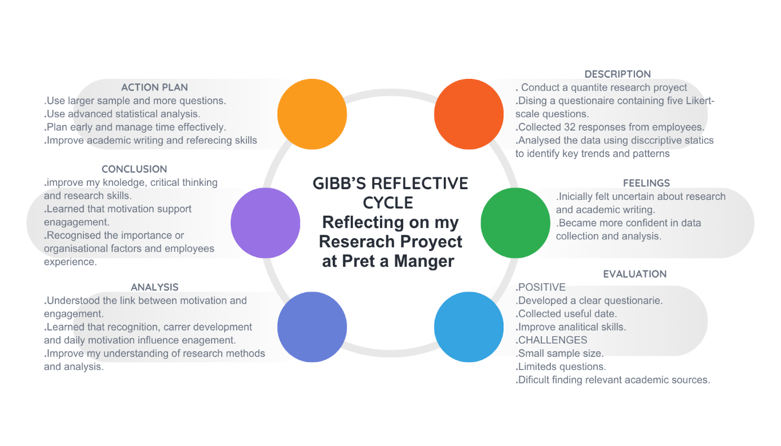
Figure 10 Reflective Essay – Gibbs’ Reflective Cycle

For this reflection, I have used Gibbs’ Reflective Cycle, which provides a structured approach to reflecting on an experience through six stages: description, feelings, evaluation, analysis, conclusion and action plan. I selected this model because it allowed me to reflect systematically on the process of completing my independent research project, from developing the research idea to collecting and analysing questionnaire data.
1. Description
The research project focused on examining the role of employee motivation in enhancing workplace engagement at Pret A Manger UK. I used a quantitative methodology and designed a short questionnaire containing five Likert-scale questions. The questionnaire focused on daily motivation, managerial recognition, career development, workplace engagement and the perceived relationship between motivation and engagement. A total of 32 responses were collected and analysed using frequencies and mean scores.
2. Feelings
At the beginning of the project, I felt uncertain about how to develop a suitable research question and methodology. I also found academic references and research design difficult to understand. As the project progressed, I became more confident in understanding the difference between motivation and engagement and in connecting the literature with my research findings. Collecting the questionnaire responses was particularly useful because it allowed me to move from theoretical ideas to actual employee perceptions.
3. Evaluation
One positive aspect of the project was the development of a clear and focused questionnaire. Keeping the questionnaire short made it easier for participants to complete. Analysing the results also helped me understand how quantitative data can identify patterns. For example, the highest mean score was 3.72 for the perceived positive relationship between motivation and engagement.
However, the project also presented challenges. The small sample of 32 respondents limited the generalisability of the findings. I also initially found it difficult to identify appropriate recent academic sources and understand how to use references to support my arguments rather than simply adding citations.
4. Analysis
Reflecting on the research process, I learned that successful research requires clear alignment between the research question, methodology, questionnaire and analysis. The quantitative approach was appropriate because the research aimed to measure employee perceptions numerically. However, I realised that using only five questions provided limited information about the complexity of motivation and engagement.
I also learned the importance of critically evaluating academic sources. During the project, I became more aware that a reference should be relevant, credible and sufficiently recent rather than selected simply because it discusses the topic. This improved my approach to academic writing and strengthened my ability to connect evidence with my own findings.
5. Conclusion
Overall, completing the project improved my confidence in conducting independent research. I developed skills in questionnaire design, data analysis, academic research and critical discussion. More importantly, I learned that research findings should be interpreted carefully and that limitations must be acknowledged rather than ignored.
6. Action Plan
In future research, I would begin the planning process earlier and identify suitable academic sources before writing each section. I would also aim to use a larger and more representative sample and, where possible, combine quantitative data with qualitative responses. This would provide a deeper understanding of employees' experiences. I would also improve my statistical knowledge so that future research could use correlation or regression analysis to examine relationships between variables more rigorously.
Development objectives | Activities involved | Success criteria | Target date
Time management | Keeping personal and professional diary, Use and apply Pomodoro techniques and Eisenhower matrix | To avoid procrastinating | 28th February 2027
Academy writing | Attending seminars, ted talks, group focus | Professional writing | 01st August 2027
Critical thinking | Make smoother and productive decision | Overcome challenges and make effective decision | 31st July 2027
Research and statical skills | Advance research using SPSS, data analytics, AI generators | Ensuring accurate data | 31st December 2027
Confidence in presentation and communication | Practice different means to communicate such as verbal, graphics | Professional standard as per CIPD | 31st December 2026
Figure 11 Personal Development Plan and Success Criteria

Poster Submission: Research Process and Findings

Examining the Role of Employee Motivation in Enhancing Workplace Engagement: Evidence from Pret A Manger UK
Research Aim
The aim of this research was to examine the role of employee motivation in enhancing workplace engagement at Pret A Manger UK. The study focused on employees' perceptions of motivation, recognition, career development and workplace engagement.
Research Objectives
The research aimed to:
- Examine factors influencing employee motivation.
- Investigate the relationship between employee motivation and workplace engagement.
- Identify areas where employee motivation and engagement could be improved.
- Provide practical recommendations based on the findings.
Research Process – Methodology
A quantitative research approach was selected because the research aimed to collect numerical data that could be compared and analysed. A positivist approach was adopted to support an objective examination of employees' perceptions.
Primary data were collected through an online questionnaire. The questionnaire contained five questions using a five-point Likert scale:
1 = Strongly Disagree, 2 = Disagree, 3 = Neutral, 4 = Agree, 5 = Strongly Agree.
The questions examined five areas: daily employee motivation, managerial recognition, learning and career development, workplace engagement, and employees' perceptions of the relationship between motivation and engagement.
A total of 32 respondents participated in the survey. The questionnaire was designed to be short and easy to complete, supporting a higher likelihood of participation. The responses were analysed using descriptive statistics, particularly frequencies and mean scores. The results were presented using a graph to make the main patterns easier to identify.
Ethical considerations were also taken into account. Participation was voluntary, responses were treated as anonymous, and participants were informed about the purpose of the research.
Research Output – Key Findings
The results showed a moderately positive overall perception of employee motivation and workplace engagement.
The highest mean score was Q5 (3.72), which measured whether respondents believed that employee motivation positively affects workplace engagement. 65.6% of participants selected Agree or Strongly Agree. This provides the strongest support for the main research proposition.
Q3, concerning learning and career development, produced a mean of 3.50, indicating that respondents generally had a positive perception of development opportunities.
Q2, measuring managerial recognition, produced a mean of 3.38. This suggests that recognition exists but may not be experienced consistently by all employees.
Q4, measuring workplace engagement, produced a mean of 3.34, indicating moderate rather than strong engagement.
The lowest result was Q1, measuring daily motivation, with a mean of 3.28. This suggests that some employees may experience difficulties maintaining motivation in their everyday work.
Overall Conclusion
The findings suggest that employee motivation has a positive perceived relationship with workplace engagement at Pret A Manger, but motivation alone does not guarantee high engagement. Recognition, career development, management support and everyday working conditions may also influence employees' experiences.
Recommendations
Based on the findings, Pret A Manger could:
- Strengthen employee recognition through regular and fair feedback.
- Improve career development by making training and progression opportunities clearer.
- Address daily motivational barriers, including workload, staffing and communication.
- Strengthen employee engagement by encouraging employee feedback and participation.
Limitations
The main limitations were the small sample of 32 respondents, the use of a cross-sectional design, the five-question questionnaire and reliance on self-reported data. Therefore, the findings should not be generalised to the entire Pret A Manger UK workforce.
Overall, the research provides useful evidence that supporting employee motivation may contribute to a more engaged workforce, while also highlighting areas for further organisational improvement.

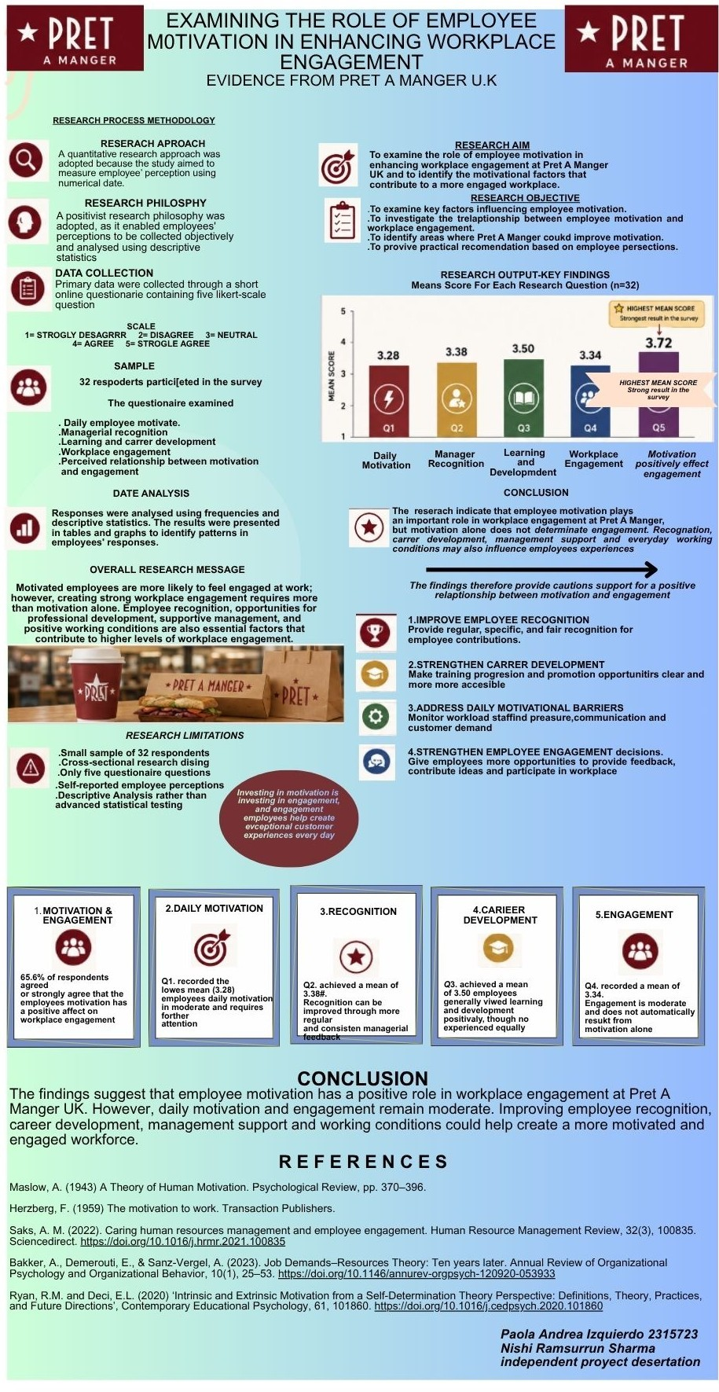

APPLICATION FOR ETHICAL APPROVAL

RESEARCH STUDENTS
This form is to be completed by the student within SIX months for full-time students and TWELVE months for part time students, after the commencement of the research degree or following progression to Part Two of your course.

Once complete, submit this form via the MyTSD Doctoral College Portal at (https://mytsd.uwtsd.ac.uk).

This document is also available in Welsh.

RESEARCH STAFF ONLY
All communications relating to this application during its processing must be in writing and emailed to pgresearch@uwtsd.ac.uk , with the title ‘Ethical Approval’ followed by your name.

STUDENTS ON UNDERGRADUATE OR TAUGHT MASTERS PROGRAMMES should submit this form (and receive the outcome) via systems explained to you by the supervisor/module leader.

In order for research to result in benefit and minimise risk of harm, it must be conducted ethically. A researcher may not be covered by the University’s insurance if ethical approval has not been obtained prior to commencement.

The University follows the OECD Frascati manual definition of research activity: “creative work undertaken on a systematic basis in order to increase the stock of knowledge, including knowledge of man, culture and society, and the use of this stock of knowledge to devise new applications”. As such this covers activities undertaken by members of staff, postgraduate research students, and both taught postgraduate and undergraduate students working on dissertations/projects.

The individual undertaking the research activity is known as the “principal researcher”.

Ethical approval is not required for routine audits, performance reviews, quality assurance studies, testing within normal educational requirements, and literary or artistic criticism.

Please read the notes for guidance before completing ALL sections of the form.

This form must be completed and approved prior to undertaking any research activity. Please see Checklist for details of process for different categories of application.

SECTION A: About You (Principal Researcher)
1 | Full Name: |  | Paola Andrea Izquierdo Escobar
2 | Tick all boxes that apply: |  | Member of staff: | ☐ | Honorary research fellow: | ☐
 | Undergraduate Student | ☒ | Taught Postgraduate Student | ☐ | Postgraduate Research Student | ☐

3 | Institute/Academic Discipline/Centre: | IICL
4 | Campus: | LONDON
5 | E-mail address: | 2315723@student.uwtsd.ac.uk
6 | Contact Telephone Number: | 07534176358
 | For students:
7 | Student Number: | 7315723
8 | Programme of Study: | BA (HONS) LEADERSHIP AND MANAGEMENT
9 | Director of Studies/Supervisor: | Nishi Ramsurrun

SECTION B: Approval for Research Activity
1 | Has the research activity received approval in principle?  (please check the Guidance Notes as to the appropriate approval process for different levels of research by different categories of individual) |  | YES | ☒ | NO | ☐
 |  |  |  |  | Date
2 | If Yes, please indicate source of approval (and date where known): Approval in principle must be obtained from the relevant source prior to seeking ethical approval | Research Degrees Committee |  | ☐
2 |  | Institute Research Committee |  | ☐
2 |  | Other (write in) |  | ☒

SECTION C: Internal and External Ethical Guidance Materials
 | Please list the core ethical guidance documents that have been referred to during the completion of this form (including any discipline-specific codes of research ethics, location-specific codes of research ethics, and also any specific ethical guidance relating to the proposed methodology). Please tick to confirm that your research proposal adheres to these codes and guidelines. You may add rows to this table if needed.
1 | UWTSD Research Ethics & Integrity Code of Practice | ☒
2 | UWTSD Research Data Management Policy | ☒
3 | [List any other relevant documents here] | ☐

SECTION D: External Collaborative Research Activity
If there are external collaborators then you should gain consent from the contact persons to share their personal data with the university. If there are no external collaborators then leave this section blank and continue to section E.
1 | Institution
2 | Contact person name
3 | Contact person e-mail address
4 | Is your research externally funded? |  | YES | ☐ | NO |  | ☐
5 | Are you in receipt of a KESS scholarship? |  | YES | ☐ | NO |  | ☐
6 | Are you specifically employed to undertake this research in either a paid or voluntary capacity? | Voluntary | YES | ☐ | NO | ☐
7 |  | Employed | YES | ☐ | NO | ☐
8 | Is the research being undertaken within an existing UWTSD Athrofa Professional Learning Partnership (APLP)? | If YES then the permission question below does not need to be answered. | YES | ☐ | NO |  | ☐
9 | Has permission to undertake the research has been provided by the partner organisation? | (If YES attach copy)  If NO the application cannot continue | YES | ☐ | NO |  | ☐

Where research activity is carried out in collaboration with an external organisation
10 | Does this organisation have its own ethics approval system? | YES | ☐ | NO | ☐
 | If Yes, please attach a copy of any final approval (or interim approval) from the organisation (this may be a copy of an email if appropriate).

SECTION E: Details of Research Activity
1 | Indicative title: | Examining the Role of Employee Motivation in Enhancing Workplace Engagement: Evidence from Pret a Manger U.K
2 | Proposed start date: | 11/07/2026 | Proposed end date: | 18/08/2026
Introduction to the Research (maximum 300 words per section)
Ensure that you write for a Non-Specialist Audience when outlining your response to the points below:
- Purpose of Research Activity
- Proposed Research Question
- Aims of Research Activity
- Objectives of Research Activity
Demonstrate, briefly, how Existing Research has informed the proposed activity and explain
- What the research activity will add to the body of knowledge
- How it addresses an area of importance.
3 | Purpose of Research Activity  Examining the Role of Employee Motivation in Enhancing Workplace Engagement: Evidence from Pret a Manger U.K  (this box should expand as you type)
4 | Research Question  What is the current level of employee motivation and engagement at Pret a Manger?  What is the level of employee engagement? Which motivation strategies are most effective?.  How does employee motivation impact workplace engagement, performance, and satisfaction?  What strategies can be implemented to improve motivation and engagement at Pret a Manger?  (this box should expand as you type)
5 | Aims of Research Activity  The aim of this research is to examine the relationship between employee motivation and workplace engagement at Pret a Manger in the UK by collecting and analysing quantitative survey data from employees within a defined study period. The study will focus on identifying key motivational factors, such as recognition, pay, career development, and management support, and evaluating their impact on employee performance, satisfaction, and retention  (this box should expand as you type)
6 | Objectives of Research Activity  To measure the current level of employee motivation and engagement among Pret a Manger employees using survey data.  To identify and analyse key factors influencing employee motivation, including recognition, workload, pay, and career development.  To develop practical recommendations for improving motivation and engagement based on research findings  (this box should expand as you type)
Proposed methods (maximum 600 words)
Provide a brief summary of all the methods that may be used in the research activity, making it clear what specific techniques may be used. If methods other than those listed in this section are deemed appropriate later, additional ethical approval for those methods will be needed. You do not need to justify the methods here, but should instead describe how you intend to collect the data necessary for you to complete your project.
7 | This research uses a positivist philosophy because it focuses on collecting objective and measurable data to study the relationship between employee motivation and workplace engagement at Pret a Manger. A quantitative approach is used because it allows the collection of numerical data that can be analysed to produce reliable and clear results. Data is collected through an online structured survey completed by employees, with questions about motivation, engagement, job satisfaction, and views on management. The survey uses a five-point Likert scale to measure responses and support statistical analysis. Around 50 employees from different branches, job roles, and levels of experience are selected using purposive sampling to ensure a range of opinions and experiences are included. The collected data is analysed using descriptive statistics, such as averages and percentages, to identify patterns, while correlation analysis is used to examine the relationship between motivation and engagement. Ethical issues are carefully considered, as participation is voluntary, responses remain anonymous, and participants can withdraw from the study at any time without any negative consequences. All information is stored securely and used only for research purposes. To improve reliability and validity, the survey is tested before being distributed to ensure the questions are clear and easy to understand. In addition, all questions are linked directly to the research objectives, and the use of quantitative analysis helps provide consistent, objective, and comparable results across all participants.  (this box should expand as you type)
Location of research activity
Identify all locations where research activity will take place.
8 | LONDON, U,K  (this box should expand as you type)
Research activity outside of the UK
If research activity will take place overseas, you are responsible for ensuring that local ethical considerations are complied with and that the relevant permissions are sought. Specify any local guidelines (e.g. from local professional associations/learned societies/universities) that exist and whether these involve any ethical stipulations beyond those usual in the UK (provide details of any licenses or permissions required). Also specify whether there are any specific ethical issues raised by the local context in which the research activity is taking place, for example, particular cultural and/or legal sensitivities or vulnerabilities of participants. If you live in the country where you will do the research then please state this.
9 | N/A  (this box should expand as you type)

10 | Use of documentation not in the public domain: Are any documents NOT publicly available? | NO | ☐
10 |  | YES | ☐
11 | If Yes, please provide details here of how you will gain access to specific documentation that is not in the public domain and that this is in accordance with the current data protection law of the country in question and that of England and Wales.  (this box should expand as you type)

 | Does your research relate to one or more of the seven aims of the Well-being of Future Generations (Wales) Act 2015? | YES | NO
12 | A prosperous Wales | ☐ | ☒
13 | A resilient Wales | ☐ | ☒
14 | A healthier Wales | ☐ | ☒
15 | A more equal Wales | ☐ | ☒
16 | A Wales of cohesive communities | ☐ | ☒
17 | A Wales of vibrant culture and thriving Welsh language | ☐ | ☒
18 | A globally responsible Wales | ☐ | ☒
19 | If YES to any of the above, please give details:
 | (this box should expand as you type)

SECTION F: Scope of Research Activity
 | Will the research activity include: | YES | NO
1 | Use of a questionnaire or similar research instrument? | ☒ | ☐
2 | Use of interviews? | ☒ | ☐
3 | Use of focus groups? | ☐ | ☒
4 | Use of participant diaries? | ☒ | ☐
5 | Use of video or audio recording? | ☒ | ☐
6 | Use of computer-generated log files? | ☒ | ☐
7 | Participant observation with their knowledge? | ☒ | ☐
8 | Participant observation without their knowledge? | ☐ | ☒
9 | Access to personal or confidential information without the participants’ specific consent? | ☐ | ☒
10 | Administration of any questions, test stimuli, presentation that may be experienced as physically, mentally or emotionally harmful / offensive? | ☐ | ☒
11 | Performance of any acts which may cause embarrassment or affect self-esteem? | ☐ | ☒
12 | Investigation of participants involved in illegal activities? | ☐ | ☒
13 | Use of procedures that involve deception? | ☐ | ☒
14 | Administration of any substance, agent or placebo? | ☐ | ☒
15 | Working with live vertebrate animals? | ☐ | ☒
16 | Procedures that may have a negative impact on the environment? | ☐ | ☒
17 | Other primary data collection methods. Please indicate the type of data collection method(s) below. | ☐ | ☒
 | Details of any other primary data collection method:  (this box should expand as you type) | ☐ | ☒
If NO to every question, then the research activity is (ethically) low risk and may be exempt from some of the following sections (please refer to Guidance Notes).

If YES to any question, then no research activity should be undertaken until full ethical approval has been obtained.

SECTION G: Intended Participants
If there are no participants then do not complete this section, but go directly to section H.

 | Who are the intended participants: | YES | NO
1 | Students or staff at the University? | ☐ | ☒
2 | Adults (over the age of 18 and competent to give consent)? | ☒ | ☐
3 | Vulnerable adults? | ☐ | ☒
4 | Children and Young People under the age of 18? (Consent from Parent, Carer or Guardian will be required) | ☐ | ☒
5 | Prisoners? | ☐ | ☒
6 | Young offenders? | ☐ | ☒
7 | Those who could be considered to have a particularly dependent relationship with the investigator or a gatekeeper? | ☐ | ☒
8 | People engaged in illegal activities? | ☐ | ☒
9 | Others. Please indicate the participants below, and specifically any group who may be unable to give consent. | ☐ | ☒
 | Details of any other participant groups:  (this box should expand as you type) | ☐ | ☒

Participant numbers and source
Provide an estimate of the expected number of participants. How will you identify participants and how will they be recruited?
10 | How many participants are expected? | 30  (this box should expand as you type)
11 | Who will the participants be? | Employees and Managers  (this box should expand as you type)
12 | How will you identify the participants? | By surveys  (this box should expand as you type)

 | Information for participants: | YES | NO | N/A
13 | Will you describe the main research procedures to participants in advance, so that they are informed about what to expect? | ☒ | ☐ | ☐
14 | Will you tell participants that their participation is voluntary? | ☒ | ☐ | ☐
15 | Will you obtain written consent for participation? | ☒ | ☐ | ☐
16 | Will you explain to participants that refusal to participate in the research will not affect their treatment or education (if relevant)? | ☒ | ☐ | ☐
17 | If the research is observational, will you ask participants for their consent to being observed? | ☒ | ☐ | ☐
18 | Will you tell participants that they may withdraw from the research at any time and for any reason? | ☒ | ☐ | ☐
19 | With questionnaires, will you give participants the option of omitting questions they do not want to answer? | ☒ | ☐ | ☐
20 | Will you tell participants that their data will be treated with full confidentiality and that, if published, it will not be identifiable as theirs? | ☒ | ☐ | ☐
21 | Will you debrief participants at the end of their participation, in a way appropriate to the type of research undertaken? | ☒ | ☐ | ☐
22 | If NO to any of above questions, please give an explanation
 | (this box should expand as you type)

 | Information for participants: | YES | NO | N/A
24 | Will participants be paid? | ☐ | ☒ | ☐
25 | Is specialist electrical or other equipment to be used with participants? | ☐ | ☒ | ☐
26 | Are there any financial or other interests to the investigator or University arising from this study? | ☐ | ☒ | ☐
27 | Will the research activity involve deliberately misleading participants in any way, or the partial or full concealment of the specific study aims? | ☐ | ☒ | ☐
28 | If YES to any question, please provide full details
 | (this box should expand as you type)

SECTION H: Anticipated Risks

Outline any anticipated risks that may adversely affect any of the participants, the researchers and/or the University, and the steps that will be taken to address them.

If you have completed a full risk assessment (for example as required by a laboratory, or external research collaborator) you may append that to this form.
1 | Full risk assessment completed and appended? |  | Yes | ☒
1 |  |  | No | ☐
2 | Risks to participants  For example: sector-specific health & safety, emotional distress, financial disclosure, physical harm, transfer of personal data, sensitive organisational information
 | Risk to participants:  N/A  (this box should expand as you type) | How you will mitigate the risk to participants:  N/A  (this box should expand as you type)
3 | If research activity may include sensitive, embarrassing or upsetting topics (e.g. sexual activity, drug use) or issues likely to disclose information requiring further action (e.g. criminal activity), give details of the procedures to deal with these issues, including any support/advice (e.g. helpline numbers) to be offered to participants. Note that where applicable, consent procedures should make it clear that if something potentially or actually illegal is discovered in the course of a project, it may need to be disclosed to the proper authorities
N/A

(this box should expand as you type)
4 | Risks to the investigator  For example: personal health & safety, physical harm, emotional distress, risk of accusation of harm/impropriety, conflict of interest
 | Risk to the investigator:  N/A  (this box should expand as you type) | How you will mitigate the risk to the investigator:  N/A  (this box should expand as you type)
5 | University/institutional risks  For example: adverse publicity, financial loss, data protection
 | Risk to the University:  N/A  (this box should expand as you type) | How you will mitigate the risk to the University:  N/A  (this box should expand as you type)
6 | Environmental risks  For example: accidental spillage of pollutants, damage to local ecosystems
 | Risk to the environment:  (this box should expand as you type) | How you will mitigate the risk to environment:  (this box should expand as you type)

 | Disclosure and Barring Service
 | If the research activity involves children or vulnerable adults, a Disclosure and Barring Service (DBS) certificate must be obtained before any contact with such participants. | YES | NO | N/A
7 | Does your research require you to hold a current DBS Certificate? | ☐ | ☒ | ☐
8 | If YES, please give the certificate number. If the certificate number is not available please write “Pending”; in this case any ethical approval will be subject to providing the appropriate certificate number.

SECTION I: Feedback, Consent and Confidentiality

1 | Feedback  What de-briefing and feedback will be provided to participants, how will this be done and when?
 | (this box should expand as you type)
2 | Informed consent  Describe the arrangements to inform potential participants, before providing consent, of what is involved in participating. Describe the arrangements for participants to provide full consent before data collection begins. If gaining consent in this way is inappropriate, explain how consent will be obtained and recorded in accordance with prevailing data protection legislation.
 | (this box should expand as you type)
3 | Confidentiality / Anonymity  Set out how anonymity of participants and confidentiality will be ensured in any outputs. If anonymity is not being offered, explain why this is the case.
 | (this box should expand as you type)

SECTION J: Data Protection and Storage

 | Does the research activity involve personal data (as defined by the General Data Protection Regulation 2016 “GDPR” and the Data Protection Act 2018 “DPA”)? | YES | NO
1 | “Personal data” means any information relating to an identified or identifiable natural person (‘data subject’). An identifiable natural person is one who can be identified, directly or indirectly, in particular by reference to an identifier such as a name, an identification number, location data, an online identifier or to one or more factors specific to the physical, physiological, genetic, mental, economic, cultural or social identity of that natural person. Any video or audio recordings of participants is considered to be personal data. | ☐ | X
 | If YES, provide a description of the data and explain why this data needs to be collected:
2 | (this box should expand as you type)
 | Does it involve special category data (as defined by the GDPR)? | YES | NO
3 | “Special category data” means sensitive personal data consisting of information as to the data subjects’ –  (a) racial or ethnic origin,  (b) political opinions,  (c ) religious beliefs or other beliefs of a similar nature,  (d) membership of a trade union (within the meaning of the Trade Union and Labour Relations (Consolidation) Act 1992),  (e) physical or mental health or condition,  (f) sexual life,  (g) genetics,  (h) biometric data (as used for ID purposes), | ☐ | X
 | If YES, provide a description of the special category data and explain why this data needs to be collected:
4 | (this box should expand as you type)

 | Will data from the research activity (collected data, drafts of the thesis, or materials for publication) be stored in any of the following ways? | YES | NO
5 | Manual files (i.e. in paper form)? | ☒ | ☐
6 | University computers? | ☐ | ☒
7 | Private company computers? | ☐ | ☒
8 | Home or other personal computers? | ☐ | ☒
9 | Laptop computers/ CDs/ Portable disk-drives/ memory sticks? | ☐ | ☒
10 | “Cloud” storage or websites? | ☐ | ☒
11 | Other – specify: | ☐ | ☒
12 | For all stored data, explain the measures in place to ensure the security of the data collected, data confidentiality, including details of backup procedures, password protection, encryption, anonymisation and pseudonymisation:
 | (this box should expand as you type)

 | Data Protection
 | Will the research activity involve any of the following activities: | YES | NO
13 | Electronic transfer of data in any form? | ☐ | ☒
14 | Sharing of data with others at the University outside of the immediate research team? | ☐ | ☒
15 | Sharing of data with other organisations? | ☐ | ☒
16 | Export of data outside the UK or importing of data from outside the UK? | ☐ | ☒
17 | Use of personal addresses, postcodes, faxes, emails or telephone numbers? | ☐ | ☒
18 | Publication of data that might allow identification of individuals? | ☐ | ☒
19 | Use of data management system? | ☐ | ☒
20 | Data archiving? | ☐ | ☒
21 | If YES to any question, please provide full details, explaining how this will be conducted in accordance with the GDPR and Data Protection Act (2018) (and any international equivalents, where appropriate):
 | (this box should expand as you type)
22 | List all who will have access to the data generated by the research activity:
 | (this box should expand as you type)
23 | List who will have control of, and act as custodian(s) for, data generated by the research activity:
 | (this box should expand as you type)
24 | Give details of data storage arrangements, including security measures in place to protect the data, where data will be stored, how long for, and in what form. Will data be archived – if so how and if not why not.
 | (this box should expand as you type)
25 | Please indicate if your data will be stored in the UWTSD Research Data Repository (see https://researchdata.uwtsd.ac.uk/ ). If so please explain. (Most relevant to academic staff)
 | (this box should expand as you type)
26 | Confirm that you have read the UWTSD guidance on data management (see https://www.uwtsd.ac.uk/library/research-data-management/) | YES | ☒
27 | Confirm that you are aware that you need to keep all data until after your research has completed or the end of your funding | YES | ☒

SECTION K: Declaration
The information which I have provided is correct and complete to the best of my knowledge. I have attempted to identify any risks and issues related to the research activity and acknowledge my obligations and the rights of the participants.

In submitting this application I hereby confirm that I undertake to ensure that the above named research activity will meet the University’s Research Ethics and Integrity Code of Practice which is published on the website: https://www.uwtsd.ac.uk/research/research-ethics/
1 | Signature of applicant: | Paola Andrea Izquierdo Escobar | Date:  20/06/2026

For STUDENT Submissions:
2 | Director of Studies/Supervisor: | Nishi Ramsurrun | Date:6th July 2026
3 | Signature: | NRamsurrun | Date:6th July 2026

For STAFF Submissions:
4 | Academic Director/ Assistant Dean: |  | Date:
5 | Signature: |  | Date:

Checklist: Please complete the checklist below to ensure that you have completed the form according to the guidelines and attached any required documentation:
☒ | I have read the guidance notes supplied before completing the form.
☒ | I have completed ALL RELEVANT sections of the form in full.
☒ | I confirm that the research activity has received approval in principle
☐ | I have attached a copy of final/interim approval from external organisation (where appropriate)
☐ | I have attached a full risk assessment (where appropriate) ONLY TICK IF YOU HAVE ATTACHED A FULL RISK ASSESSMENT
☒ | I understand that it is my responsibility to ensure that the above named research activity will meet the University’s Research Ethics and Integrity Code of Practice.
☒ | I understand that before commencing data collection all documents aimed at respondents (including information sheets, consent forms, questionnaires, interview schedules etc.) must be confirmed by the DoS/Supervisor, module tutor or Academic Director.

RESEARCH STUDENTS ONLY
Once complete, submit this form via the MyTSD Doctoral College Portal at (https://mytsd.uwtsd.ac.uk).

RESEARCH STAFF ONLY
All communications relating to this application during its processing must be in writing and emailed to pgresearch@uwtsd.ac.uk , with the title ‘Ethical Approval’ followed by your name.

STUDENTS ON UNDERGRADUATE OR TAUGHT MASTERS PROGRAMMES should submit this form (and receive the outcome) via systems explained to you by the supervisor/module leader.

References

Maslow, A. (1943) A Theory of Human Motivation. Psychological Review, pp. 370–396.
Herzberg, F. (1959) The motivation to work. Transaction Publishers.
Saks, A. M. (2022). Caring human resources management and employee engagement. Human Resource Management Review, 32(3), 100835. Sciencedirect. https://doi.org/10.1016/j.hrmr.2021.100835
Bakker, A., Demerouti, E., & Sanz-Vergel, A. (2023). Job Demands–Resources Theory: Ten years later. Annual Review of Organizational Psychology and Organizational Behavior, 10(1), 25–53. https://doi.org/10.1146/annurev-orgpsych-120920-053933
Ryan, R.M. and Deci, E.L. (2020) ‘Intrinsic and Extrinsic Motivation from a Self-Determination Theory Perspective: Definitions, Theory, Practices, and Future Directions’, Contemporary Educational Psychology, 61, 101860. https://doi.org/10.1016/j.cedpsych.2020.101860
Booth, A., Sutton, A. and Papaioannou, D. (2016) Systematic approaches to a successful literature review. 2nd edn. London: SAGE.
Bryman, A. (2016) Social research methods. 5th edn. Oxford: Oxford University Press.
Hart, C. (2018) Doing a literature review: Releasing the research imagination. 2nd edn. London: SAGE.
Miao, C., Humphrey, R.H. and Qian, S. (2021) ‘Emotional Intelligence and Job Performance in the Hospitality Industry: A Meta-analytic Review’, International Journal of Contemporary Hospitality Management, 33(8), pp. 2632–2652. https://doi.org/10.1108/IJCHM-04-2020-0323
Kahn, W.A. (1990) ‘Psychological Conditions of Personal Engagement and Disengagement at Work’, Academy of Management Journal, 33(4), pp. 692–724.
Kanjanakan, P., Zhu, D., Doan, T. and Kim, P.B. (2023) ‘Taking Stock: A Meta-Analysis of Work Engagement in the Hospitality and Tourism Context’, Journal of Hospitality & Tourism Research, 47(5), pp. 851–876. https://doi.org/10.1177/10963480211066958.
Hanson, W.E., Creswell, J.W., Clark, V.L.P., Petska, K.S. and Creswell, J.D. (2005). Mixed methods research designs in counseling psychology. Journal of Counseling Psychology, 52(2), pp.224–235. doi:10.1037/0022-0167.52.2.224.
Bell, J. and Waters, S. (2018). Doing Your Research Project. 7th edn. Open University Press.
Bryman, A. and Bell, E. (2015). Business Research Methods. 4th edn. Oxford University Press.
Creswell, J.W. and Creswell, J.D. (2018). Research Design. 5th edn. SAGE.
Johnson, B. and Christensen, L.B. (2024). Educational research : quantitative, qualitative, and mixed approaches. Los Angeles: Sage Publications, Inc.
Creswell, J.W. (2018). EDUCATIONAL RESEARCH : planning, conducting, and evaluating quantitative and qualitative research. Upper Saddle River: Pearson.
Anderson, V. and Fontinha, R. (2024). Research Methods in Human Resource Management. Kogan Page Publishers.
van Rooij, S.W. (2025). The Business Side of Learning Design and Technologies. Taylor & Francis.
P. Toyong, N.M., Zainal Abidin, S. and Mokhtar, S. (2021). Data Collection Instrument in Designerly Intuition Study. Environment-Behaviour Proceedings Journal, 6(SI5), pp.33–39. doi:10.21834/ebpj.v6isi5.2925.
Ganesha, H. R., & Aithal, P. S. (2022). Choosing an Appropriate Data Collection Instrument and Checking for the Calibration, Validity, and Reliability of Data Collection Instrument Before Collecting the Data During Ph.D. Program in India. International Journal of Management, Technology, and Social Sciences, 7(2), 497–513. https://doi.org/10.47992/ijmts.2581.6012.0235
Mohajan, H.K. (2018). Qualitative Research Methodology in Social Sciences and Related Subjects. Journal of Economic Development, Environment and People, 7(1), pp.23–48.
Machi, L.A. and McEvoy, B.T. (2016) The literature review: Six steps to success. 3rd edn. Thousand Oaks, CA: Corwin
Berthold, M., & Hand, D. J. (2021). Intelligent data analysis : an introduction. Springer.
Grobelna, A., & Wyszkowska-Wróbel, E. (2023). Promoting hotel employees’ work engagement and its service outcomes: The critical role of intrinsic motivation. International Journal of Management and Economics, 59(3), 264–274. https://doi.org/10.2478/ijme-2023-0011
Taherdoost, H. (2016). Validity and Reliability of the Research Instrument; How to Test the Validation of a Questionnaire/Survey in a Research. International Journal of Academic Research in Management, 5(3), 28–36. https://doi.org/10.2139/ssrn.3205040
Braun, V. and Clarke, V. (2006). Using thematic analysis in psychology. Qualitative Research in Psychology, 3(2), pp.77–101.
Bryman, A. and Bell, E. (2015). Business Research Methods. 4th edn. Oxford University Press.
Cottrell, S. (2017). Critical Thinking Skills. 3rd edn. Palgrave Macmillan.
Pallant, J. (2020). SPSS Survival Manual. 7th edn. McGraw-Hill Education.
Saunders, M., Lewis, P. and Thornhill, A. (2019). Research Methods for Business Students. 8th edn. Pearson.
Sinisterra, L., Peñalver, J., & Salanova, M. (2024). Connecting the organizational incomes and outcomes: a systematic review of the relationship between talent management, employee engagement, and turnover intention. Frontiers in Psychology, 15. https://doi.org/10.3389/fpsyg.2024.1439127
Presslee, A., Richins, G., Saiy, S., & Webb, A. (2023). Small sample field study:The effects of team-based recognition on employee engagement and effort. Management Accounting Research, 59, 100829. https://doi.org/10.1016/j.mar.2022.100829
Meira, J. V. de S., Hancer , M., Anjos, S. J. G. dos, & Eves, A. (2023). Human resources practices and employee motivation in the hospitality industry: Cross-cultural research. Tourism and Hospitality Management, 29(2), 157–167. https://doi.org/10.20867/thm.29.2.1
Tukiran, M., & Lisa Chandrasari Desianti. (2025). The Role of Training and Development in Enhancing Employee Engagement: A Systematic Literature Review. Feedforward: Journal of Human Resource, 77–95. https://doi.org/10.19166/ff.v5i2.10268
Md Asadul Islam, & Mohammad Nurul Alam. (2024). Does workplace fun reduce job stress? Role of work engagement and job autonomy in the hospitality industry. Tourism and Hospitality Research. https://doi.org/10.1177/14673584241286139
Bell, J. and Waters, S. (2018). Doing Your Research Project. 7th edn. Open University Press.
Bryman, A. and Bell, E. (2015). Business Research Methods. 4th edn. Oxford University Press.
Cottrell, S. (2017). Critical Thinking Skills. 3rd edn. Palgrave Macmillan.
Pears, R. and Shields, G. (2019). Cite Them Right: The Essential Referencing Guide. 11th edn. Bloomsbury.
Saunders, M., Lewis, P. and Thornhill, A. (2019). *Research Methods for Business Students. 8th edn. Pearson.
Zada, M., Abdalla, A. A., Estay, C., & Waleed Ahmed Nureldeen. (2025). Leading with purpose: unraveling the impact of motivating language on work engagement with a focus on psychological meaningfulness in the tourism and hospitality sector. BMC Psychology, 13(1). https://doi.org/10.1186/s40359-025-02977-6
Gibbs, G. (1988) Learning by Doing: A Guide to Teaching and Learning Methods. Oxford: Oxford Polytechnic.

