Reflections on the Design Practice and Research Process
1 Introduction
The core question of this study revolves around the elements and compositional methods within narrative spaces, aiming to explore how spatial design can express storylines and how spaces can simultaneously serve as narrative carriers and narrators. This question not only concerns spatial design and artistic expression but also touches upon the deep mechanisms of how humans perceive, experience, and assign meaning within environments.
Theoretically, this study is primarily underpinned by narratology and spatial narratology. Traditional narratology, predominantly applied in literature and film, emphasizes the relationship between narrative structure and audience comprehension. However, as narrative research has grown more complex and spatial theories have evolved, the boundaries of narratology have expanded, giving rise to the new branch of spatial narratology. Spatial narratology unfolds narrative actions through the medium of three-dimensional space, highlighting the dual relationship between narrative temporality and spatiality (Long, 2008). Within spatial narratives, audiences are not mere “readers” but become co-narrators of the spatial story through active participation.
In specific design contexts, narrative pathways within spaces often rely on the selection and combination of elements. These elements create suggestive cues, yet varying sensitivity to these cues among participants results in distinct narrative trajectories. Materials, colors, lighting, sounds, and layouts trigger viewers' perceptions and emotions through their “accessibility,” thereby constructing narrative atmospheres. Simultaneously, spatial narratives involve the organization and layering of “multiple spaces” (龙迪勇，2008). The attributes and functions of spaces at different levels vary, carrying distinct narrative meanings and emotional atmospheres. Within these multiple spaces, composite functionality is also a key characteristic of public spaces (Yun He, Hongjun Liu, 2024)—the same space can switch functions and atmospheres at different times and under different circumstances, thereby offering greater possibilities and flexibility for narrative.
Based on these considerations, this research adopts a three-stage progressive approach:
Stage One focuses on the effects of individual elements, using single-variable experiments to explore how fundamental components—such as shape, material, light, and sound—influence viewers' attention and emotions, thereby identifying the “minimal syntactic units of spatial narrative.”
Phase Two shifts to the holistic nature of individual buildings, examining which elements, symbols, or layouts within a complete architectural space can guide audiences toward resonance and form recognizable narrative paths within space.
Phase Three extends the research to first-person navigation in virtual spaces. By simulating the holistic spaces of rural or urban environments, it explores whether viewers in virtual settings can experience immersion and narrative engagement comparable to physical visits. This phase specifically addresses how virtual spaces can transcend physical constraints while preserving narrative logic to foster heightened emotional immersion.
Through this progressive research process, this study aims to answer, both theoretically and practically: How can narrative elements and path construction be employed in spatial design to achieve spatial storytelling?
In summary, this research not only focuses on the artistic and symbolic aspects of spatial narrative but also emphasizes its operational feasibility in experimental validation and design methodology. Through multi-level analysis integrating theory, experimentation, and case studies, it aims to provide new insights and frameworks for future design practices in both virtual and real narrative spaces.
2 Practical process
The central question explored in this chapter is: Can space tell a story? If so, who is the storyteller? Is it space itself, the designer, the user, or the interaction and co-construction between space and user? This question serves as the core driving force for this research. I have divided this chapter into three phases: Phase One involves comparative studies of individual elements; Phase Two examines the impact of elements and symbols within individual buildings on audiences; Phase Three explores whether audiences exhibit similarities to those visiting physical spaces by simulating activities within an integrated spatial environment.
2.1 Phase One—Individual Elements
At this stage, I aim to explore and investigate which elements influence audience perception and emotion. By controlling variables, I will alter only one element within identical spaces to observe audience responses. This research process is divided into three parts: 1. Contrasting individual elements; 2. Comparing spaces of the same type; 3. Placing the same building in different environments.
For the single-element comparison group, I selected windows—a distinctive object within architectural spaces—as the primary subject. Windows are unique as spatial structures connecting interior spaces with the external environment. Scholars suggest that design variables such as geometric shapes, natural or artificial lighting, color, the presence of windows, natural or artificial landscapes, and spatial layout directly influence human emotions and stress levels. (Gary W. Evans, 2003, p541)( Juan Luis Higuera-Trujillo et al., 2021, p21-23). Users can observe both interior and exterior spaces or views through windows. In this section, I ensured the views visible through the windows remained consistent, comparing audience reactions to different window shapes, sizes, and positions.
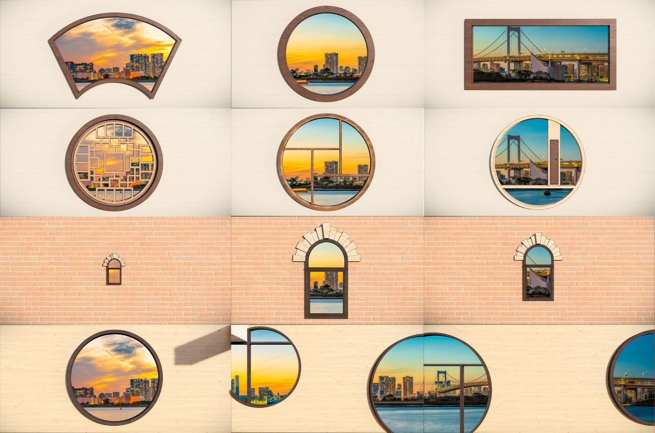
Survey findings revealed that most participants first noticed the window's shape or size before observing the exterior scenery. Some feedback indicated that window decorations obstructed their view, while others perceived windows as framing the exterior scenery. However, more respondents noted that when the view outside featured sufficiently rich colors, they immediately noticed these landscapes. Nearly all viewers stated that a window's position on the wall significantly impacts the appreciation of the exterior scenery. This is primarily because unconventional window placements can somewhat affect the viewer's experience.
Figure 1: Grouped Comparison of Window Elements; Image source: Author's own illustration
In the second group—spaces of the same type but with contrasting designs—I deliberately selected rooms featuring rectangular, triangular, and circular elements as primary spatial design components. This group explored whether spaces of the same type could evoke similar feelings in viewers despite differing primary design elements. Analysis of the questionnaires revealed that in this group, viewers actively imagined themselves within the spaces. Some viewers noted that in relatively open environments like Figure 2 (top), spaces with warm color temperatures felt more relaxing. The red brick walls in Figure 2 (middle) created a strong sense of being indoors, whereas the other two spaces felt more like outdoor environments by comparison, thus evoking the comfort associated with open spaces. Figure 2 (bottom) presents a unique case due to its abundance of natural elements. In biophilic design, natural elements can induce relaxation in users—a concept supported by scholarly research. For instance, Ulrich proposed that natural landscapes accelerate post-operative recovery (Roger S. Ulrich, 1991), while Sakallaris et al. (Sakallaris et al., 2015) revealed that the view of nature was the most significant variable in the perception of healing, followed by brightness, color, and ceiling height. Comparing the three sets of images, some viewers noted that designs with more circular elements evoke a greater sense of security. Fachrudin and Yasmin also stated in their paper that circular designs promote the natural flow of energy within a space. Their symbolic meaning—representing harmony, unity, and continuity—creates a sense of security and tranquility for users (Fachrudin, H.T. and Yasmin, D.A., 2025).
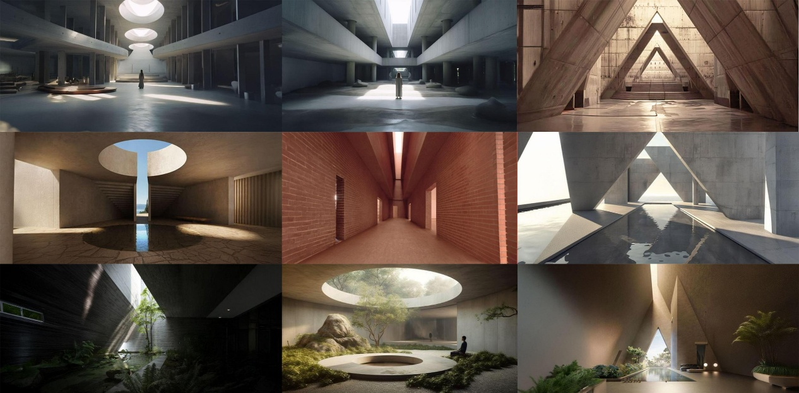
The third set of comparisons placed the same building in different natural environments—forest, seaside, and desert—to assess which setting made the structure appear more livable. Feedback for this group was influenced primarily by the following factors: 1. Viewers' personal perceptions: Most respondents visually perceived the forest setting as more harmonious with the architecture, while the other two environments seemed less plausible for real-life habitation. 2. Personal preference: Since most viewers reside in inland areas for extended periods, the seaside-style combination became a choice for some. 3. Influence of architectural typology: The building featured is Mies van der Rohe's Farnsworth House. Although primarily a residential structure, some viewers lacked architectural or related professional backgrounds. From the image alone, they couldn't identify it as a residential design. Many perceived it more as an open public space, leading them to believe it would be more interesting when placed by the sea after comparison.
Figure 2: Comparing Identical Space Types; Image source: Author's own illustration
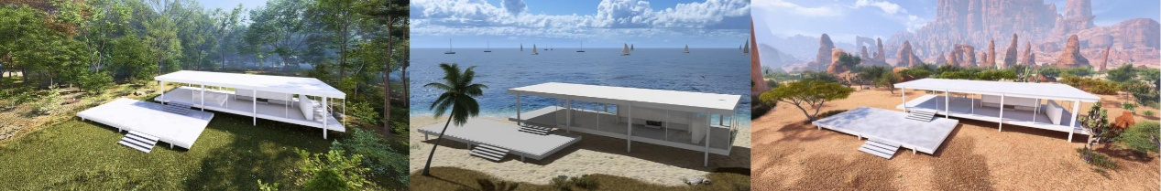
2.2 Phase Two - Individual Buildings
Figure 3: Compares the same building placed in different natural environments; Image source: Author's own illustration
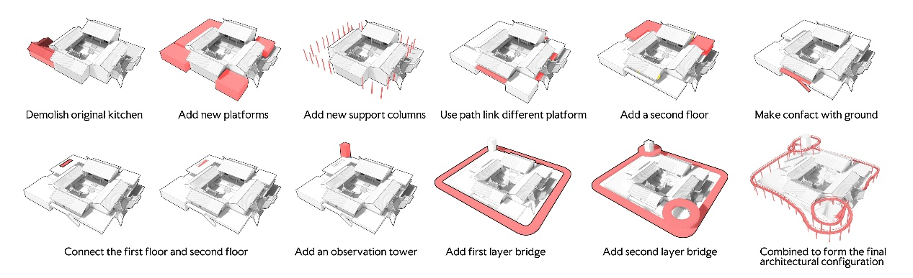
I selected standalone buildings as the research subjects for the second phase primarily because the final set of findings from the first phase revealed that, beyond the relationship between buildings and their surroundings, the inherent attributes of the buildings themselves significantly influence user experience. The standalone building type chosen for this phase is the family ancestral hall. The unique “temporal nature” of ancestral hall architecture often renders them ‘empty’ structures outside of ancestral worship periods. This “emptiness” primarily refers to unused, idle buildings (Li Yang, Wen Zhao, et al. 2016). Compared to the original structure, the primary renovation approach involved demolishing the old kitchen and enhancing the building's usability and interactivity by adding platforms and verandas (as shown in the figure). This transformation opened up the space, allowing visitors to freely enter and exit, exploring the entire area through a “non-linear path” (Jade McPike, 2025).
Figure 4: The generative process of ancestral hall architecture; Image source: Author's own creation
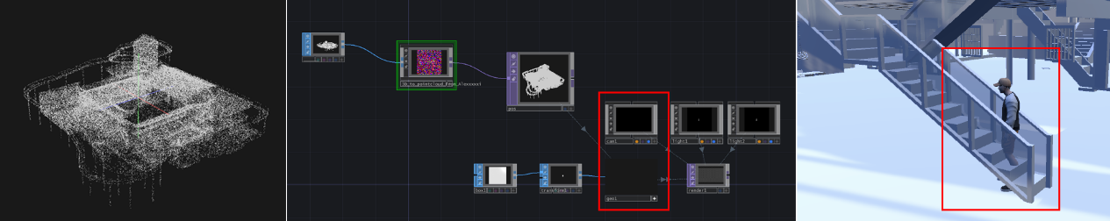
Two initial concepts emerged during this phase: 1. Employing point cloud technology to blur architectural edges, enabling viewers to perceive both the holistic spatial experience and localized architectural details through suggestive means. 2. Incorporating collision and rigid-body models into the VR software to provide users with a participatory experience. VR offers a strong sense of presence (spatial and social), which serves as a key mediator linking immersion to subjective positive emotions (particularly arousal). Enhancing this sense of presence proves more effective than solely pursuing high-immersion equipment in eliciting positive audience emotions (Pavic, K., Chaby, L. et al., 2023). However, the production process encountered numerous challenges, primarily technical issues. Due to limited exposure to relevant software within my professional background, unresolved technical problems arose during certain output stages, preventing the full realization of the aforementioned concepts (As indicated by the red box in Figure 5). The final presentation format selected a first-person perspective navigation animation video, utilizing VR headsets as the display tool.
Figure 5: Initially anticipated outcomes and issues encountered; Image source: Author's own creation
Feedback indicated that some viewers experienced a sense of calm and immersion within the architecture, attributing this to design elements that alleviated emotional tension. Lighting within the structure emerged as a significant resonant element, with viewers noting similarities to light patterns in rural buildings from their childhoods. Ching (Ching, F.D., 2023) highlights in his work that light is crucial for describing three-dimensional forms and spatial relationships. Conversely, some viewers noted that certain narrow passages within the structure evoked a sense of oppression. Simultaneously, the materials used for the exterior walls elicited familiarity among these viewers, as these building materials are commonly encountered in daily life. This familiarity fosters a sense of authenticity. Moreover, the integration of these traditional building materials with modern pergolas creates a relaxed atmosphere distinct from that of traditional ancestral halls.
2.3 Phase Three - Roaming Experience in the Virtual Village
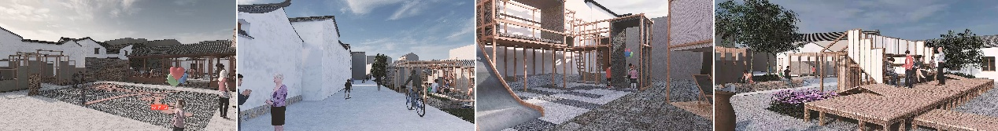
The final stage features a first-person perspective video tour within virtual rural space. Its primary research objective is to explore whether viewers can experience the rural life depicted in the video through visual perception, thereby deepening their engagement with the overall spatial environment. The central question explored in this phase is the narrative quality within virtual spaces. The primary issue with this village lies in its ambiguous spatial zoning and weak functionality. Public spaces often serve merely as “parking lots”—large areas with simple, singular functions and little to no narrative coherence. The goal is to enhance the practicality and utilization of rural spaces by strengthening the connection between “village-tourist-villager” through design renewal.
Figure 6: Rural Spatial Scenes Display (Excerpt); Image Source: Author's Own Production

For this phase, I selected a project case from my past involvement in rural planning and renovation in Southwest China. We categorized the entire village space into three types: ritual spaces (ancestral halls, village temples, Guan Sheng Gong, hosting ceremonial activities), living spaces (squares, well platforms, alleys, facilitating daily interactions), and productive spaces (farmlands, drying squares, associated with agricultural activities). We then redesigned selected spaces. Throughout the design process, we aimed to foster symbiotic relationships and narrative connections between rural spaces.
When designing specific areas, the core approach mirrored Phase Two: shifting from “single-function” to “multi-purpose spaces.” Examples include transforming the supply and marketing cooperative into an “inn + theater stage” and repurposing the ancestral hall as a “sacrificial site + exhibition space.” This “functional integration” enhances spatial vitality and utilization rates. For instance: transforming the ancestral hall from an “idle” structure into a village history museum, preserving its traditional functions and spatial layout while adding reading areas; the village entrance square retains its original function but incorporates new installations and facilities to enrich its usability.
In the final phase, I presented the project through an immersive room experience. A first-person perspective video guided viewers through the space. The primary drivers of immersive experiences are system immersion, spatial immersion, social/empathic immersion, and narrative/sequential immersion. This process involves multisensory engagement, acceptance of the present moment, and the formation of fluid, uninterrupted physical, psychological, or emotional interactions. It culminates in lasting psychological and emotional impacts on users post-experience (Han, D.I.D., Melissen, F., & Haggis-Burridge, M., 2024). However, achieving this state requires certain guiding elements. Through reflection and research, several reasons were identified for why some viewers experience weaker immersion: 1. The video perspective differs from the viewer's, making it difficult to become fully immersed. 2. The video itself lacks sufficient fluidity; occasional stuttering or lag can cause viewers to feel disconnected.
Facilitators | Core Essence
Systems | User engagement with the experience mechanism at both physical and psychological levels requires balancing “challenge-skill” to avoid monotony.
Spatial | Utilize environmental design elements—such as physical separation and lighting effects—to create a sense of presence that makes users feel as though they have entered a new environment.
Social/Empathic | Foster emotional connections and cultural resonance between users and others (or virtual characters)
Narrative/Sequential | Engage users with a cohesive storyline to encourage continuous exploration.
Table 1: Key Enablers of Immersive Experiences; Table Source: Author's Own Creation
The primary perspectives guiding the entire practice process are as follows: the visual dimension, the structural dimension, and the symbolic dimension. Within the visual dimension, key elements considered include color, light, and related aspects. The structural dimension focuses on architectural frameworks and the design of spatial pathways. The symbolic dimension emphasizes the symbols appearing within the space, the symbolism of installations, or the implications within the scenes. The integration of narrative construction throughout the practice and its connection to relevant theories will be discussed in the next chapter.
Perspective | Key elements | Research Focus
Visual | Color, light, environment (natural elements), building materials, materials used in installations within public spaces | Does color immediately influence mood? How does light shape spatial ambiance (e.g., how “holy light” in churches fosters reverence)? Can natural elements enhance spatial experience (requires experimental verification)? How do different materials convey distinct emotions (e.g., wood structures evoke warmth, steel structures convey technological sophistication)?
Structural | Architectural Structure, Path Design (Narrative Path) | Does the path (open/winding) affect the user experience? How are the starting point, endpoint, and transitions of the space defined?
Symbol | Symbols appearing in the space, the symbolic meaning of the installation's form, and the implications of the character and scene arrangements. | Do specific shapes (such as arches) carry fixed symbolic meanings? How do symbols integrate within spaces and convey information?
Table 2: Three principal dimensions in the research process Table source: Author's own illustration
2.4 Reflection on Challenges and Limitations
This practice demonstrates the potential for virtual space narratives to resonate with users through subtle elements, yet implementation faced several challenges. Technically, creating the virtual reality model proved far more difficult than anticipated. Due to my own technical limitations, the original plan to use point cloud models for the overall architectural representation and game-like interactive features could not be fully realized. These shortcomings resulted in only partial fulfillment of the design intent, with the final outcome resembling a guided tour rather than a truly participatory environment.
The methodology for gathering phased feedback also exhibited certain flaws. Although the project collected some feedback through questionnaires and observation, overreliance on subjective self-reports undermined the reliability of the results. For instance, participants' emotional responses to window designs or spatial atmospheres often varied significantly due to individual cultural backgrounds, past experiences, and aesthetic preferences. Additionally, the relatively small sample size limits the generalizability of research conclusions. In comparative studies of natural environments versus architectural layouts, contextual factors remain difficult to fully eliminate, and participants' personal preferences also influence feedback data. Furthermore, my personal selection of architectural samples overlooked audience considerations, failing to choose relatively representative or architecturally distinctive examples. The scene construction was also rather crude, contributing to data bias.
On the other hand, narrative approaches within VR devices also face inherent limitations. Current VR technology struggles to support highly fluid content and suffers from relatively low levels of participant engagement. Scholars describe narrative-driven life experiences as participatory theater within VR, where participants' experiences, behavioral responses, and outcomes play a pivotal role in shaping the narrative. This approach emphasizes the intimacy and empathy of participants as the “authors” of their personal stories, focusing on the psychological interaction between participants and the narrative rather than the narrative itself (Vallance, M. and Towndrow, P.A., 2022).
Interestingly, the issues also reveal the polysemy of spatial narratives—spaces can tell stories through suggestion, yet interpretation remains inherently tied to individual perspectives. The variability in user experiences is strongly linked to individual participants. To fully convey the intended message of a story, some level of guidance is necessary. Through discussions with other presenters during this practice, it became clear that knowledge background is a key factor in how audiences interpret the meaning of narrative spatial contexts. However, effective guidance can significantly help viewers correctly understand the designer's intended message.
3 Case Study
Throughout the entire practice process, I repeatedly pondered one question: How should the narrative path of a narrative space be constructed, and what constitutes a relatively successful design for such spaces? During my research, I discovered that designers Carlo Scarpa and Bernard Tschumi are highly representative figures in the field of narrative space design. Carlo Scarpa's Brion Family Mausoleum stands as a highly representative work, while Bernard Tschumi's spatial montage and open-ended narrative approach have also made significant contributions to advancing spatial storytelling.
3.1 Carlo Scarpa: The Brion Family Cemetery
The Brion Family Cemetery in San Vito, Italy, was built for the Italian Brion family. Its uniqueness lies not only in its commemorative function but also in Scarpa's experimental approach, treating it as a synthesis of architecture, landscape, symbolism, and narrative. Structured around the concept of “journey,” the cemetery progressively reveals its core narrative of “redemption” through three distinct travel experiences: physical, visual, and mythical (imagined time). — from recollections of a “lost ideal,” through the experience of “life and death in the present world,” to the aspiration for “future redemption.” This mirrors the logic of Catholic eschatology: “original sin—the present world—judgment” (Bell, Barry, 1999).
Scarpa's cemetery is not a singular monument but a “narrative journey” composed of multiple nodes, paths, and elements. This spatial logic echoes the literary structure of “exposition-development-transition-resolution,” transforming the cemetery into a walkable “story text”: from the Meditation Pavilion to the main burial chamber, it recounts the life of Monsieur Brion. The Meditation Pavilion serves as the opening, establishing an atmosphere of silence and reflection, functioning as the narrative's “prologue.” The Intersecting Rings, as the cemetery's central symbol, embody eternity, vows, and unity, forming the narrative's climax. The journey from the Meditation Pavilion to the Double Ring space chronicles Monsieur Brion's gradual maturation—from leaving home to encountering his beloved. The transition from the linear corridor to the dual corridors symbolizes encounters and parallel paths in life, hinting at the couple's lifelong love and forming the narrative's “developmental segment.” Water, representing life and cycles, enhances the contemplative quality of the space through reflections in the water courtyard and lotus pond, akin to the “emotional backdrop” in a story. The Tombs: Two graves tilt toward each other, as if engaged in a whispered dialogue, forming the narrative's “conclusion”.
The spatial materials juxtapose concrete with brass and wood, contrasting roughness with refinement to suggest life's tension. Narrow openings and low eaves regulate light ingress, creating shifts between light and shadow akin to narrative rhythm changes. Elements like rings, bridges, water, and window openings form potent spatial metaphors hinting at cycles, connections, rebirth, and transcendence. Through careful analysis, it becomes evident that visitors are both walking “readers” and the cemetery itself serves as the “narrator” of the Brians' story. Through the progression and pauses along the path, visitors gradually immerse themselves in the narrative rhythm established by Scarpa. This experience is not passive but co-created through walking and sensory engagement.
3.2 Bernard Tschumi: Spatial Montage and Open Narratives
In the 1980s, Tschumi proposed a triadic theory of space-event-movement and introduced the concept of “spatial montage.” He criticized traditional architecture for overemphasizing form, advocating instead that architecture should be closely integrated with human behavior and events. In The Manhattan Transcripts (Tschumi, 1994), Tschumi employed spatial montage techniques to transcend the limitations of conventional architectural representation, which focused solely on spatial form. He juxtaposed space, movement, and events in his presentation. Drawing from film montage's “frame and sequence” concept, he decomposed each scene into “Frames,” forming ‘Sequences’ through their combination. He thus conceptualized architectural space as a medium capable of generating tension and narrative through “editing, jump cuts, and juxtaposition.”
In the chapter “MT 1: The Park,” using New York's Central Park as a prototype and centering on a murder case, he employs a “three-marker method” (photographs guiding events, floor plans revealing spatial logic, diagrams annotating character movements) to demonstrate the deep binding between space and extreme events, embodying the application of spatial montage in architectural narrative. This approach disrupts the fixed relationships between form and function, space and use in traditional architectural design and theory, offering fresh perspectives for architectural creation. Tschumi further proposed that within a building, the intermingling of space, movement, and events constitutes the structure itself, existing in an equal relationship.
Tschumi further applied and developed this theory in his 1983 competition-winning design for Paris's Parc de la Villette. Through a systematic organization of points, lines, and planes, he combined buildings of diverse functions, linear pathways, and open public spaces to create richly varied spatial experiences, challenging conventional park design paradigms (Michaela Gugeler, 2005). The “point, line, plane” organizational relationship also became a crucial structural principle for narrative spaces. Throughout the aforementioned practice, the entire village constructed its spatial relationships using this “point, line, plane” framework as the fundamental spatial structure. Each newly designed node space functions as a “point” space, while the village streets form “line” spaces. The interconnection of these “points” and ‘lines’ ultimately creates the village's overall “plane” space.
Bernard Tschumi has also proposed that space is not equivalent to form but rather a field of action. In Architecture and Disjunction, Tschumi articulated a core paradox of architecture: humans cannot simultaneously “question the essence of space” and “experience/create real space.” This underscores that space must be integrated with the actions of its users to gain meaning. My research aligns with this perspective. Contemporary interior design and exhibition design transcend mere observation, prioritizing user-space interaction. Participatory engagement significantly enhances design rationality, functionality, and even playfulness. In Tschumi's view (Bernard Tschumi, 2005), traditional architecture treats space as a “box containing functions.” His manuscripts demonstrate that space and events are “mutually shaping relationships”—events imbue space with meaning, while space shapes the course of events. Architecture need not narrate a fixed story itself; rather, it provides conditions for events to generate narratives. These narratives unfold not as singular paths but as fragmented nodes and multiple trajectories.
Regarding Tschumi's Parc de la Villette project in Paris, Kush Upendra Patel (2016) argues that issues with park management and the geometry of the architecture itself—including a lack of social inclusivity—led to outcomes later diverging from Tschumi's original vision. For instance, the park's geometric systems (such as orthogonal promenades and fixed locations for the Madhouse) still implicitly guide foot traffic, making it difficult for users to break free from the framework of “spatial representation” for autonomous adaptation. Additionally, the park management later leased portions to commercial entities, restricting the occurrence of “unplanned events” and transforming the “event space” into a “consumer space.” These insights have introduced new directions for my subsequent research.
3.3 Comparative Analysis:
Comparing the two, Scarpa's designs exhibit greater linearity, symbolism, and ritualistic elements, resembling a linear narrative with distinct beginnings, developments, climaxes, and conclusions, emphasizing the designer's predetermined role. Tschumi's approach is more nonlinear, fragmented, and open-ended, resembling a spatial montage where participants actively piece together the story. In terms of element usage, Scarpa emphasizes the use of symbols, materials, and light to evoke emotion and symbolism, viewing the audience as experiencers of the narrative. Tschumi, however, relies on structural frameworks and the randomness of events to highlight narrative diversity, regarding the audience as co-creators within the narrative process.
Designer | Carlo Scarpa | Bernard Tschumi
Narrative logic | Linear Narrative: Space, like a literary text, possesses a beginning, development, climax, and conclusion. | Non-linear Narrative: Space functions like cinematic montage, generating polysemy through juxtaposition and jump cuts of fragments.
Core concept | Spatial Symbols and Metaphors | Spatial Montage
Audience role | Guided “story participants” enter the narrative pre-set by the designer. | Proactive “narrative editors”, who piece together stories through selection and action
Methodological significance | Emphasise symbolic anchors and linear progression to ensure narrative clarity and emotional depth. | Emphasising openness and generativity, it posits that architecture provides a stage for events, with narratives generated by the audience.
Inspiration for Virtual Space Design | Suitable for constructing “narrative nodes” within virtual spaces, fostering a sense of symbolism and atmosphere. | Suitable for offering multiple narrative paths within virtual spaces, allowing audiences to freely piece together the story.
Table 3: A Comparative Study of Spatial Narratives by Carlo Scarpa and Bernard Tschumi; Table source: Author's own illustration
3.4 Engagement with Contemporary Debates
In summary, Scarpa's linear symbolic approach and Tschumi's fragmented nonlinear montage offer two complementary paradigms for spatial narrative. Both design methodologies are highly representative in spatial design: Scarpa's symbolic anchors provide direction and meaning, while Tschumi's openness grants users freedom and space for multiple interpretations. In virtual space design, these approaches are neither mutually exclusive nor necessarily implemented singly. Analysis of other case studies and literature reveals significant potential for their combined application, ultimately determined by the designer's narrative intent.
Through this practical research and prior experience, it becomes evident that spatial sequencing design arises not solely from function but also from narrative techniques, atmospheric creation, or user interaction. This perspective aligns with Tschumi's critique of architecture—that buildings should not be mere functional containers but rather sites for actions and events. Consequently, I hope this experience will serve as a foundation for future research into narrative spaces and spatial narrative media.
Through this study and previous research, spatial design has increasingly intersected with users' emotional well-being. User responses to natural elements, lighting conditions, and material properties indicate that spatial narratives are inextricably linked to emotional resonance (Eleanor Ratcliffe, 2021). This aligns with current interdisciplinary research on healing spaces, environmental psychology, and biophilic design. Consequently, I am exploring whether situating narrative design within these fields could elevate its significance beyond aesthetics or design, extending into the social dimension.
4 Analysis of the correlation between theory and practice
4.1 Conclusion
This study explores how to conceptualize the design of architecture and public spaces through spatial narratives. The core questions are: Can space tell stories? If so, who is the narrator? The research unfolds in three progressive stages—focusing on individual elements, single buildings, and the overall village space—ultimately demonstrating that space is not merely a passive carrier of function. It can actively construct meaning through materiality, form, light, symbolism, and user interaction. Spatial narratives emerge not only from designers' intentions but also from users' interpretations and actions. This co-creative process itself becomes the narrative unfolding within space.
Analysis of Scarpa's Brion Cemetery and Tschumi's spatial montage theory provides theoretical underpinnings for this research. Scarpa's linear symbolism demonstrates how architecture can function like a text with distinct beginnings, development, climaxes, and conclusions. Tschumi's non-linear montage theory positions architecture as a framework for events and actions, generating meaning through openness and fragmentation. Scarpa provides narrative anchors ensuring symbolic clarity, while Tschumi opens possibilities for multiplicity and user agency. In my practice-based research, I found these two models to be complementary. Spaces require symbolic design elements to suggest narrative potential, and participatory methods allow users to interact with the space itself, enhancing the experience of the narrative process.
The greatest challenge and limitation during the research was technical issues. For instance, adding rigid-body models and collision effects in Unity was unsuccessful, and Touchdesign's point cloud model generation also failed to perform adequately. These were critical technical problems encountered during the process. Participant feedback exhibited significant variation, revealing the multi-semantic nature of spatial narratives: the same design approach might be interpreted as soothing by one viewer yet oppressive by another. These findings confirm that practice-oriented research uniquely generates embodied and contextual knowledge, yet remains inevitably constrained by subjective contingencies and technical limitations.
Nevertheless, these limitations underscore the distinct value of practice-driven inquiry. By directly engaging in the design production process, this study validated spatial hypotheses within an immersive environment and captured the complexity of real user experiences—outreach beyond the reach of purely theoretical or representational methods. Consequently, this research offers both methodological insights for integrating narrative into spatial design and practical strategies for implementation.
4.2 Outlook
Throughout this research, I discovered that technological advancements such as VR/AR combined with AI-driven generative design hold promise as tools for constructing more interactive and adaptive narrative environments. These technologies enable designers to rapidly build story frameworks, with VR enhancing user immersion and AR boosting interactivity. Future narrative design in virtual spaces could further deepen user experiences by integrating real-time feedback systems like eye-tracking, biosensors, or emotion/motion recognition. Data collected via these sensors could then inform design iterations.
During this practice, I observed that my content failed to effectively guide the audience, resulting in data collection that did not fully align with my original expectations. Future research could consider more deliberate guidance or incorporating quantitative methods to ensure collected data better informs design content. For instance, rigorously employing light, color, or natural elements for effective experimental design could enable audiences to intuitively grasp design concepts through participatory approaches, allowing them to provide accurate feedback based on their personal experiences post-immersion. When opportunities arise, expanding participant diversity—selecting individuals from varied professional backgrounds, age groups, and genders—will enhance the reliability and inclusivity of research conclusions.
Throughout this practice, I continued my previous research focus. In spatial design, I prioritized narrative as the primary design concept and sought to maximize interactivity, though technical limitations prevented full realization. In terms of expression, I experimented with integrating digital art practices, using immersive environments as the primary exhibition space to explore the potential for constructing architectural narratives within virtual reality (VR) settings. Concurrently, I incorporated insights from healing spaces and environmental psychology research to investigate how virtual environments can create authentically relatable spaces that evoke audience empathy.
In summary, this practical research prompted me to re-examine my research content, clearly identifying gaps in my methodology and necessary technical enhancements. It also clarified my future research direction. The next phase will focus on exploring how spatial narratives can be integrated into virtual space construction, examining spatial metaphors and the application of affordance design principles within virtual environments. Through theoretical research, I aim to progressively address technical deficiencies, laying the groundwork for further expanding my research scope.

Reference
Bell, B., 1999. The Brion Cemetery and the Narrative of Redemption. In La Città Nouva. Proceedings of the 1999 ACSA International Conference (pp. 341-345). Rome: Association of Collegiate Schools of Architecture.
Ching, F.D., 2023. Architectural graphics. John Wiley & Sons.
Evans, G.W., 2003. The built environment and mental health. Journal of urban health, 80, pp.536-555.
Fachrudin, H.T. and Yasmin, D.A., 2025, February. Healing Environment Approach on Wellness Center Design Toward Sustainable Development. In IOP Conference Series: Earth and Environmental Science (Vol. 1452, No. 1, p. 012024). IOP Publishing.
Gugeler, M., 2005. Der Parc de la Villette–Würfelwurf der Architektur. Das Zusammenwirken von Bernard Tschumi und Jacques Derrida beim Parc de la Villette in Paris. kritische berichte-Zeitschrift für Kunst-und Kulturwissenschaften, 33(2), pp.44-57.
Han, D.I.D., Melissen, F. and Haggis-Burridge, M., 2024. Immersive experience framework: a Delphi approach. Behaviour & information technology, 43(4), pp.623-639.
He, Y. and Liu, H., 2024, March. Research on Functional Composite and Interactive Experience Design in Museum Public Space-Take the Shenzhen Art Museum (New Venue) as a Case Study. In Proceedings of the 3rd International Conference on Culture, Design and Social Development (CDSD 2023) (Vol. 834, p. 307). Springer Nature.
Higuera-Trujillo, J.L., Llinares, C. and Macagno, E., 2021. The cognitive-emotional design and study of architectural space: A scoping review of neuroarchitecture and its precursor approaches. _Sensors_, _21_(6), p.2193.
龙迪勇, 2008. 空间叙事学. 未出版博士论文, 上海师范大学, 上海.
李杨, 文昭, 柳肃 and 唐经纬, 2016. 功能更替下城镇祠堂的改造思路探究——以湖南省平江县县城现存祠堂建筑为例. 南方建筑, (4), pp.121-128.
McPike, J., 2025. A Seat at the Table: Expanding the Narrative of Period Rooms.
Patel, K., 2016. Realizing Henri Lefebvre: Ideas of Social Space in Lucien Kroll's La Meme, Brussels 1969-1972 and Bernard Tschumi's Parc de la Villette, Paris 1982-1987 (Doctoral dissertation).
Pavic, K., Chaby, L., Gricourt, T. and Vergilino-Perez, D., 2023. Feeling virtually present makes me happier: The influence of immersion, sense of presence, and video contents on positive emotion induction. Cyberpsychology, Behavior, and Social Networking, 26(4), pp.238-245.
Ratcliffe, E., 2021. Sound and soundscape in restorative natural environments: A narrative literature review. Frontiers in psychology, 12, p.570563.
Sakallaris, B.R., Macallister, L., Voss, M., Smith, K. and Jonas, W.B., 2015. Optimal healing environments. Global advances in health and medicine, 4(3), pp.40-45.
Tschumi, B., 1994. The manhattan transcripts.
Tschumi, B., 1996. Architecture and disjunction. MIT press.
Tschumi, B., 2005. Event-cities 3: Concept vs. context vs. content.
Ulrich, R.S., 1991, January. Effects of interior design on wellness: theory and recent scientific research. In Journal of Health Care Interior Design: Proceedings from the... Symposium on Health Care Interior Design. Symposium on Health Care Interior Design (Vol. 3, pp. 97-109).
Vallance, M. and Towndrow, P.A., 2022. Perspective: Narrative storyliving in virtual reality design. Frontiers in virtual reality, 3, p.779148.

