Log book for the Therapy Assistant Practitioner course

Date: February 2025
Name: Natalie Mcculloch

The Therapy Assistant Practitioner (TAP) demonstration of competencies in the following areas:
- Log of supporting documents from mentor: | Details to include: | Date of completion: | Mentors signature: | Page number
- Log of assessments and goal setting. | A completed initial assessment or detailed screening form, including evidence of patient centred goal document. | 31.01.25 | 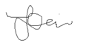 | 6
- Log of a wide range of assessments. | A minimum of three assessments completed, demonstrating a range of skills and tools. | 31.01.25 |  | 7-10
C: Log of clinical interventions within scope of practice. | A minimum of three interventions completed, demonstrating a range of skills within scope of practice. | 31.01.25 |  | 11-14
- Log of a risk assessment and how it informs practice. | A completed risk assessment within the workplace, which can include clinical practice or department procedure. This can include case notes, reports, DATIX or professional discussion, which consists of risk identified, how the learner managed the risk and informed progress. | 31.01.25 |  | 15-22
- Report on learner’s time and workload management. | A completed report with mentor’s feedback of the learner’s time and workload management. The report can be completed on a word document and will need to be signed and dated. The report will need to include an example of how the learner demonstrates good time and workload management. | 31.01.25 |  | 23
- Log of compliance with mandatory training. | A copy of the learner’s compliance with mandatory training. Compliance is required to be 80% or above. | 31.01.25 |  | 24-25
- Copy of a recent Personal Development Appraisal Review (PDAR). | A copy of the most recent PDAR document completed with supervisor / mentor. | 31.01.25 |  | 26-49
- Copy of recent supervision records. | A minimum of two supervision records, demonstrating attendance and contribution to supervision and agreement to actions. | 31.01.25 | 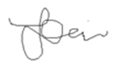 | 50
- Copy of peer review document. | An attached copy of the peer review document completed following observations of others presentations. | 16.02.25 |  | 51-54

Please notes: Alongside the above information contained in the log book there are an additional 2 pages:
Explanation of key terms used in dialog – Page 4
References list – page 55

Information for reader of portfolio.
As I have used a selection of notes to demonstrate the required supporting documentation, I kept the original abbreviations in the text to maintain authenticity. I have demonstrated these in the key below. These abbreviations are in line with the Cardiff and Vale guidance.
KEY
AO1 – assistance of one
CB – Call bell
DR – doctor
HCSW – Health care support worker
MPRA – Multi Professional Rehabilitation Assistant
NIC – Nurse in charge
OBS – Observations
ONS – Oral nutritional supplement
OT -Occupational therapist
PT – Patient or physiotherapist
QS – Quad Stick
RD – Registered Dietician
RN – Registered nurse
RZF – Rollator Zimmer Frame
STS – Sit to stand
SV – supervision
Tx – transfer
VCG – Verbal consent gained

Throughout my portfolio I have deleted the patients name at the top in order to retain confidentiality as outlined in the NHS code of practice (CONFIDENTIALITY CODE OF CONDUCT The Principals of Confidentiality for all staff, n.d.)

- Log of assessments and goal setting.
Below shows an example of the ‘outcome measures’ process the MPRA team complete with every patient at the start and end of every patient’s period of MRPA treatment. This is in order to collect data on the service which can then be used in therapeutic interventions, service development and evaluation.
I assess the level of assistance a patient will need to complete it and provide support as required, for example, some people can complete it independently whereas others need some support with vision, motivation to complete a task, understanding, writing etc. sometimes just completing this with a patient is a session in itself as it can show elements of cognition and abilities and perceptions the patient has.
We have a few versions. When I began in the service the aphasia friendly version didn’t exist and, as we have a lot of patients requiring this resource, I created one alongside a speech therapy student as part of my initial training phase. Sometimes I use this alongside the circle answer form for people without aphasia as it is clear and large print.
For every patient, I combine the outcome measure completion with additional goal setting I do on back which I can use, alongside their hobbies, to tailor therapy to them within my scope of practice. For example, if a patient enjoys cooking and her goal is to return to providing a meal for her family every Sunday, we can explore this to see what barriers, aids and strengths we can utilise to accomplish this, and then work on this. The goals we set originally are also a helpful reflection for the individual, for example, they may have a goal of putting their socks on again, sometimes these ‘little things’ get forgotten about but it is something that is important to the patient, thus shows person centred care, and is something that if a patient gets to the stage they can do it routinely they may forget that they couldn’t before. Then, once they are due for discharge, we can then reflect on the differences from the initial piece of data collected and allows a reflection of original goals at the end if this is appropriate.
These are then stored securely and logged by my line manager in line with the trust data protection policy.

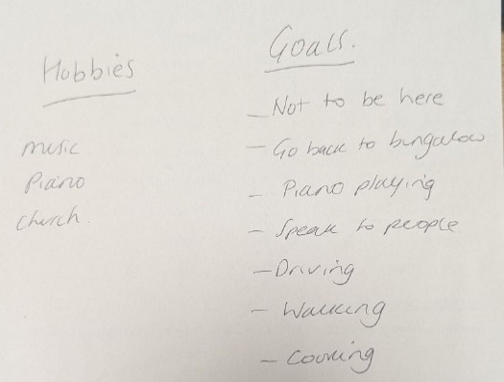
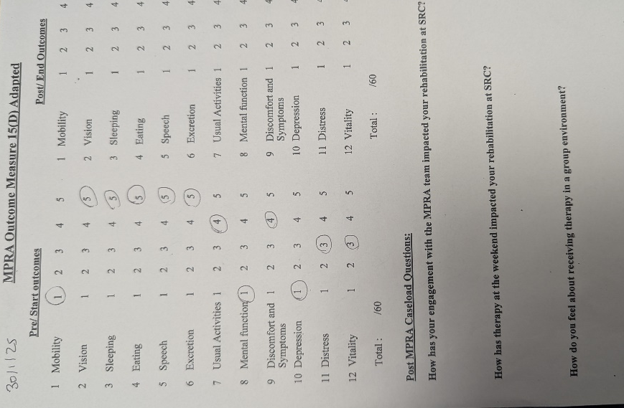
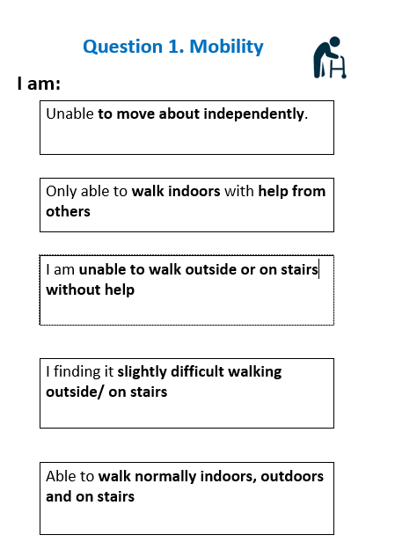
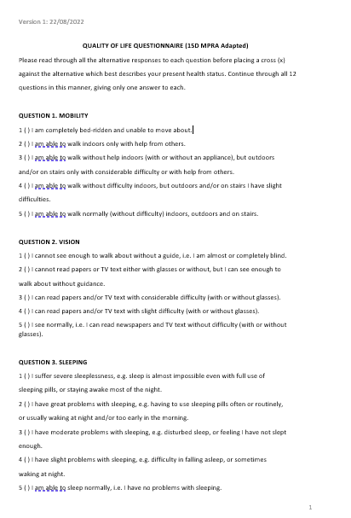

Please note: Figures go left to right 1 -4
Figure 1Aphasia friendly
Figure 2 completed alongside the aphasia friendly version
Figure 3example of a patient’s goals and hobbies to help inform therapeutic intervention
Figure 4 page one of the outcome measures

- Log of a wide range of assessments.

Below I have copied notes from assessments I have done In my job role.
They demonstrate the variety of disciplines that we, as MPRA’s, cover and showcase some of the skills and tools we require in our role.

- MPRA NOTES 12/01/25 PATIENT NAME 16.00

S – Patient approached for trial of an ONS as requested by RD. VCG. Obs stable as charted.
O – Patient repositioned to enable sufficient posture for trial.
Purpose of trial explained to patient as had been explained to MPRA by RD. To increase patient nutritional intake and meet protein needs for wound healing. To make sure patient is able to tolerate the ONS and try to accommodate flavour provision preferred.
Patient tried the Ensure Plus and reported the volume was daunting. Patient tried the Ensure Plus Compact and found this manageable. Patient tried 3 flavours and stated a preference for the strawberry version.
ONS removed from patient until prescribed by RD/DR.
Patient left comfortable. CB in hand.
A – Patient willing to try different ONS and found Ensure Compact 125ml less daunting than 330ml version. No swallowing difficulties or difficulties with intake noted.
P – MPRA to inform RD.

Natalie Mcculloch (MPRA)

The above assessment demonstrates me utilising the information I was given from the dietician whilst still recognising the limitations of my band 4 status (i.e. I cannot prescribe or decide on supplements to trial). I attempted to use patient focused care to deduce a suitable flavour for the patient and listen to the feedback and adapt the supplements as able to within the scope of MPRA role.

- MPRA NOTES Patient Name 25/1/25 12.50
S – patient approached for therapy. VCG. Obs stable
O – patient updated me on her progress but feels exhausted and like she’s ‘not doing very well’. Patient reassured she is doing amazingly with rehabilitation and due to the nature of the condition and the rehabilitation process, fatigue is anticipated and normal and her recognition of fatigue is commendable.
Patient steady on request to bathroom to maintain safety in recognition of patient fatigue and Tx to shower chair having stood and pulled pants down independently with prompts.
Needed prompt to doff top but able to with sv only
Patient set up with gel/cloths/shower head. Requested shower to be turned on but then left to continue. Patient requested MPRA find her gel/cloths but reminded to look and scan around her, able to locate and use them independently after this, whilst mpra held shower. Just needed help with back.
Patient able to stand with sv and use of wall bars to wash as required.
Patient needed help to dry back and feet. Found leaning forward creating too much pressure on her quad/hip.
Patient supported to dry undercarriage but needed a lot of reassurance to trust standing balance ability.
Patient able to dress top half but needed help to put lower half on. Patient requested to use sock aid to help with sock application and able to with minimal assistance.
Patient assisted to put matrix and shoes on and encouraged to do matrix strap up independently.
Patient mobilised to sink with QS and was able to balance completely independently to do teeth in standing
Patient mobile to bedside with hand hold of 1 to wheelchair. Reported fatigue so wanted to rest.
Provided with coffee. Planned a cooking session for cheese bake tomorrow. Patient able to list ingredients needed and states she doesn’t need a recipe
A – patient continues to struggle with confidence in her ability and also fatigue. Patient states loss of sleep due to bed 33 crying over night. Able to complete a wash and dress with A01.
P – continue with therapy with dressing practice, sock aid use and mobility confidence. Provide a back sponge to increase independence. Request if patient could be considered for another bed space to aid sleep to minimise fatigue. MPRA to provide information from stroke association on fatigue. Cooking tomorrow lunch time.
Natalie Mcculloch
These notes demonstrate me helping a patient with an activity of daily living (ADL) and trying to encourage her independence through identifying aids and adaptions to suggest that may assist her. This session was an assessment as it was the first wash and dress so it allowed me to observe where I needed to assist or supervise or where the patient was able to be independent. It showcases my recognition of the limits of my scope of practice that, as a band 4, I am not to use aids unless prescribed by qualified member of the team. It shows my use of communication skills to help patient recognise her fatigue is normal but also validate her feelings. It demonstrates my ability to identify adaptions needed to regress a patient as needed (use of a steady machine not walking), risk assess a situation In situ (that she could try balancing with close supervision) and also communicate to teams in charge of rehabilitation program ideas I have from my assessment (further balance work, provision of aids).
- MPRA NOTES Patient Name 27/1/25 11.00

S – Patient approached for trial of back sponge as identified in a previous intervention in order to maintain patient independence. Permission obtained to trial aid from OT. VCG. Obs stable.
O – Patient had already had a wash so declined further personal care but agreed to trial of sponge in a shower scenario.
Patient able to stand with QS + A01 and mobilise to bathroom. Patient given instructions about the purpose of aid and how to use. MPRA demonstrated.
Patient attempted to use in sitting which she managed well. Patient wanted to trial using it in standing with close supervision of MPRA to ensure safety was maintained. Patient was unsteady in doing so and needed MPRA intervention. Patient assisted to sit safely but felt shaken by this. Patient reassured about her progress and the level of balance required for the task she attempted and advised we can feed this back to PT team to advise. Patient mobilised back to bedside with QS + A01.
A - Patient able to demonstrate sufficient dexterity and cognition to use the bath sponge in sitting but needs further rehabilitation to improve dynamic standing balance in order to complete task in seated position.
P – MPRA to feedback to OT/PT team. Patient to continue to use bath sponge in seated position to promote independence as able with view to progress to standing if advised by PT team.
Natalie McCulloch (MPRA)

This set of notes reflects on an assessment of a patient following a previous session and consent from OT team to provide her with an aid. It demonstrates my ability to risk assess in situ (allowing patient to stand but then adapting task accordingly following identified risk) it also demonstrates my ability to be person centred in my approach (recognising patients preference to wash in standing). It demonstrates my ability to identify potential areas that patient may need further rehabilitation in (dynamic standing balance) and recognition that, as a band 4, I do not have knowledge to advise patient that this will be the solution we can work on, but that I can take the issue back to discuss with her team prescribing her rehabilitation plan.

C: Log of clinical interventions within scope of practice.

Below shows a selection of notes that demonstrate some examples of clinical interventions I carry out as an MPRA and the ways in which I have to adapt within my scope of practice.
- MPRA NOTES PATIENT NAME 16/01/25 16:00
Session 1
S – Patient requested to mobilise back from Rubicon and PT (Jess) agreed to a joint session to enable this. Obs stable as charted.
O – Patient able to STS independently and walked with QS and SV02 to end of corridor with some prompts to stand tall and abduct leg at times.
Patient then trialled hand hold A02 with only a light hold noted. Patient needed prompts to lift foot at times but managed well following this. Mpra progressed to HHA01 and SV01.
Jess (PT) progressed patient to mobilising with support on torso which patient states was beneficial but ‘scary’.
Patient rested after approx. 15m and returned to bedside. Patient able to rate her confidence in various aids use and chose QS as less stressful currently.
A – patient appears keen to engage but continues to struggle to lift foot sufficiently at times and with processing/planning which can create a falls risk. Patient able to be progressed with aids under supervision of Physiotherapy team.
P – MPRA to continue with therapy as charted. Nursing Staff to follow guidance of Physiotherapist for mobility on ward.
Natalie Mcculloch (MPRA)
This intervention involved assisting patient to progress with mobility under the supervision of Physiotherapist. This demonstrates scope of practice limits of MPRA (assessing patients with aids following a trial by Physiotherapist but waiting for further progress from Physiotherapist) . Im aware that as a band 4 I am allowed to progress exercises as demonstrated by the handhold and 1 (HHA01) under supervision of PT.

- MPRA NOTES PATIENT NAME 25/1/25 17.30
S – Patient approached for mealtime assistance. Vcg. Obs stable as charted.
O – Patient needed repositioning with A02. Patient able to follow verbal commands to sit forward and achieve this with A01 and side rails support.
Patient declined porridge or yoghurt and actively pushed both away but agreed verbally to try a banana and then able to eat half of it once peeled. This is in keeping with the ISDT recommendations from SALT team of level 7 easy chew.
Patient supported with tablets but didn’t follow verbal prompts to not chew the capsules.
Patient declined to drink milk or tea provided in blue drink rite cups. Instead she grabbed the milk bottle that was on her table overnight. This was semi skimmed and warm and both myself and the nurse advised she didn’t drink it due to health and safety reasons and especially out of the bottle due to swallow recommendations. Patient gripped hold of it and drank it and wouldn’t let it go.
Patient declined any further intake.
Patient left with drink rite cups in reach and encouraged to drink.
A - Patient appears to struggle with drink rite cups but declined to try with MPRA. Patient opting for open cups despite recommendations. Patient able to self-feed a banana once opened. Patient able to assert her preferences at times. Patient continues to struggle with communication due to aphasia.
P – Continue with mealtime support. Consult SALT team re: guidelines.
Natalie Mcculloch
This intervention is involving an intervention with assisting a patient with mealtime support. The patient is not under a DOLS so this further restricts the right of the MPRA to remove items from her even if SALT have deemed them unsafe. I have previously raised the issue with the SALT team about her lack of compliance with their guidance for safe hydration and the patient is to be encouraged to comply but ultimately it is not within my scope of practice to remove her drink from her but it is my responsibility to acknowledge and report the risk she is under.

- MPRA NOTES 13/3/24 Patient name 12:50
S – Patient approached for mobility practice. Low Blood pressure observed. VCG.
- - Patient has a current diagnosis of covid 19 and medical update from nurse in charge suggests increased fatigue and decreased engagement generally due to this. Barrier nursing and confinement to the four bedded ward to contain spread of infection in line with IPC guidance observed.
- Patient cheerful in herself and felt able to continue with some sort of PT rehabilitation and ‘stiff’ from lack of movement.
- Patient discussed the current situation with her observations being low and covid status, with MPRA, and how this is affecting her, patient given options for session. Patient felt confident to try barefoot walking having successfully done this previously with physiotherapist team.
- Patient able to TX to standing with support initially to steady self on stick.
- Patient attempted to step forward and was unsteady. Dorsiflexion movement on foot appeared to be less active than previous sessions. Patient tried another few steps but MPRA requested patient rest to preserve safety currently. Patient agreed she was struggling.
- Patient agreed to TX to bed and engaged well in bed exercises as prescribed.
- Patient then assisted to don matrix splint as this is still recommended when walking longer distance. Patient able to manage the Velcro straps of this independently which she states gives her a bit of confidence. Assisted with shoes.
- Patient mobilised with stick and matrix in situ approx. 15m with a 90’ turn and back to chair. Patient stated this was fatiguing but she was glad she had achieved this having not walked for a couple of days owing to health.
- Patient left at bedside and encouraged to continue mobilising, as able, with matrix in situ always currently.
A – patient appears to be fatigued through current medical status and keen to engage. Patient appears to benefit, currently, from use of aid and reduced distance with close supervision. Patient able to acknowledge fatigue at times.
P – continue with short distance walks and matrix splint in situ at all times. Mpra to update team.
Natalie Mcculloch
This intervention demonstrates the importance of adapting a plan in order to recognise risk and maintain safety. Regressing a patient is within the scope of practice for myself, as a band 4 and is a duty I have to maintain safety. Alongside this this shows I acknowledge that patients wish to continue with rehab when unwell and this is preferable owing to the fact that patients will naturally get unwell during recovery/future and it is my responsibility to make the treatment patient centred.

- Log of a risk assessment and how it informs practice.
GENERAL RISK ASSESSMENT FORM – PART 1

Location: University Hospital Llandough  Stroke Centre |  | Division  Directorate CD&T |  |  |  | Department: Occupational Therapy  Kitchen/Group activity rooms e.g. Day Room, conservatory
Activity /Tasks  (Brief Description) | Potential Risk/Issue |  | See Tables 1-3  Consequence X Likelihood = Current Risk Rating |  |  |  | Further Action required e.g. Undertake more detailed Risk Assessment if score 6 or above
Running of Groups  (Cognitive, upper limb and activity groups run by staff with patients) | Manoeuvring in a limited space.  Risk of injury to staff and patients  Risk of infection control  Reduced staffing levels-safe supervision levels e.g. domestic activity |  | 2  2  1 | 2  2  4 | 4  4  4 |  | Clutter free environment to be maintained  Manual Handling training undertaken and ensure up to date by MDT  Attend and follow Infection Prevention and Control Training  Ensure use of alcohol gel sinks in locality  Ensure cleaning of equipment after use using recommended cleaning products.  PPE if required  Groups provided when safe appropriate staffing level/  supervision/support –risk assessment

Assessors Name (s) |  | Natalie Mcculloch |  |  | Signature (s) |  |  | NM |  |  | Position (s) |  | MPRA Band 4
Date | 24/11/24 |  | Review  Period | 1 year |  |  | Dates of  Review |  | 24/11/25 | 24/11/26 |  | 24/11/27

- Previous history of risk assessment:

Date | 11.11.2020 | Review  Period | 1 year |  | Dates of  Review | 11.11.21 | 11.11.22 | 11.11.23

The above shows a risk assessment I completed in order to begin hosting groups on the ward alongside my MPRA colleague. Sadly, following this assessment he had to take sick leave and thus I was left as the only MPRA in the ward. Owing to this, and the acknowledgment that safe staffing levels are required to run a group, and in light of their being no other staff to cover, I decided to cancel the group and stick to running individual sessions in that time slot. Group postponed until safe staffing levels return. This demonstrates I was able to manage the risk and inform the process in light of current situation. This demonstrates how risk assessments can inform practice and how we need them to influence safe practice.
Further to this, since my colleague returned the ward has been closed due to the ‘Covid 19 infection’ which means that the infection control risks are too high to allow the safe running of a group, in light of this we will postpone the group until the infection is clear and the department enable us to run groups again. This is an important acknowledgment in line with the infection control risk identified in the assessment.

RISK ASSESSMENT FORM

Clinical Board: | Medicine |  | Location of Risk: | UHL -SRC
Directorate: | STROKE |  | Date Form Completed: | 23.12.24

Risk Title
Groups: being facilitated and ran by MPRAs

Description of Risk:
Explain risk
The risks are low, but like all groups there are risks to consider are:
: there is not a 1:1 ratio so patients will not be 100% fully supervised even though someone will always be present in the room
: although a wardroom, there are rarely other staff going in and out regularly and therefore dependent on the MPRAs to maintain safety. The MPRAs are B4 so able to progress and regress but not prescribe.
: some of the functional activities might be around cooking (knifes and heat) or standing/ walking (postural drops/ falls), crafts (sharp objects)
: fatigue in the session
: any complicated interactions between other patients
: increased risk of infection due to people in close proximity and sharing space and resources

Cause / Source / Event
Stroke patients: potential symptoms- level of cognition, behavioral issues safety awareness, fatigue, respiratory issues or physical issues.

Impact / Consequence
Positive impacts: Patients will have increased therapy and therefore work towards their goals
Benefits in Social interaction and wellbeing.
Negative impacts: too over whelming, the patient doesn’t enjoy any of the social interactions, patient needs more supervision for task if not well considered for group.

Score Risk without Current Controls (Initial Risk Score)
Consequence | 2 | X | Likelihood | 3 | = | Risk Rating | 6

Controls in Place:
- To make sure that there is adequate space for emergencies for equipment and resources to come in and out.
- Inclusion of patients that are medically stable
- Any patients that are showing signs of respiratory virus or have respiratory needs should not attend/ a separate risk assessment should be carried out
- Any patients needing 1:1 should have 1:1 in the group or not be allowed to attend
- Patient with high-risk behavioral issues should be independently risk assessed and considered not appropriate for the group
- Make sure that high risk equipment is only used with patients who can safely use it
- All equipment wiped down/ for one patient only use
- Team members to clean hands before and after and encourage patients to before activity
- There must be always 2 members of staff in there and preferably a 1:2/ 1:3 ratio of staff to patient
- If there are any changes in patients' medical stability or comfort at any time, then one of the MPRAs must get a member of nursing to come and review the patient immediately- therefore there must be a minimum 2 MPRAs in the group always
- If it is an acute medical emergency use the red emergency button and get help immediately These group will be either in the OT kitchen or day room where there is call bells and access to other staff on the ward if needed.
- Make sure all staff on the ward are aware the group is on and who is in the group using the nursing handover book and verbally
- Make sure that patient wellbeing and emotions are monitored throughout the sessions
Score Risk with Current Controls (Current Risk Score)
Consequence | 2 | X | Likelihood | 2 | = | Initial Risk Rating | 4

Main Risk Type: please tick one only
Clinical Care/Quality | Communication/PR | Compliance with Standards | Corporate Governance | Estates
Financial | Health & Safety | Information Governance | Infection Control | Legal
Safeguarding | Security | Social Care | Strategic

Signature of Assessor | Jess Simms
Date of Assessment | 23.12.24
Risk Owner
Signature of Clinical Board Director
Date

Above is a risk assessment Jess, my line manager, and myself completed surrounding the safe running of groups. Due to staffing levels remaining low this has resulted in some groups being cancelled completely to maintain safety and, similarly to the last risk assessment, due to infections being on the ward the groups had to be cancelled owing to infection control issues and the additional likelihood of fatigue which would both pose risk to safety. This demonstrates how such a template can be essential to help inform working practice.

e. Report on Natalie’s time and workload management
STRENGTHS  - Natalie is always very punctual and often early for work  - Natalie understands principles of prioritisation and will plan her day according to these  - Nat utilises her time well to prioritise clinical time with patients, but always make time for the essential nonclinical jobs such as statistics | WEAKNESSES  -Due to Natalies strong work ethic she often works over her hours : but has done really well to try and work on this and it is improving  -Natalie has an extremely caring nature and kind nature that is essential for her work. Natalie can sometimes get pulled into work and situations that are not a priority for her role and increases her workload which again she has worked well to still be kind but have barriers.
OPPORTUNITIES  - Natalie should see the change in team members and dynamics as an opportunity to reflect on her own time management and learn from others  - Natalie should consider being more barriered in protecting her work life balance and make sure manages her time to leave on time which she is working on and I am proud of this | THREATS  - The ward environment has complex dynamics and therefore with changes all the time this can make planning much more complex  - The ward can have a lot of other demands and with low staffing MPRAs can easily get pulled to other jobs

F log of compliance with mandatory training:

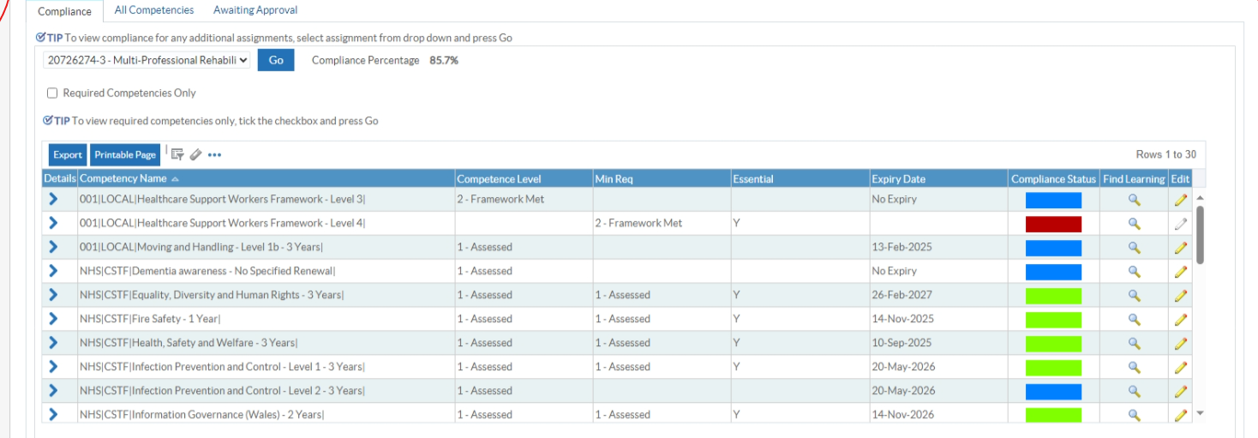

This demonstrates I am currently at 85.7% compliance and I have also booked a place on two courses which are outstanding which should enable it to progress to 100% by end of April.
I have now completed another section of my mandatory training as detailed below. The completion of such training is often difficult to fit in alongside other work commitments but is something, as a band 4, I am required to incorporate into my workload as able.
To |  | McCulloch, Natalie
Sent |  | 03-Feb-2025 10:53:53
ID |  | 1321582307

Competency
Your completion of the Learning Certification 001 Domestic Violence against Women, Domestic Abuse and Violence - Certification has automatically updated your personal competency profile with the following competencies:

Competency Updated | Level
NHS|MAND|Violence Against Women, Domestic Abuse and Sexual Violence - 3 Years|

2. Copy of a recent Personal Development Appraisal Review (PDAR).
Please note the comments are from the last line manager I had, James Hinder, as Jess is due to comment on it at the end of 2025 but, as the date I completed it suggests, we have recently reflected on this.
Values Based Appraisal (Appraisal) is for everyone and is a focussed conversation around development and recordable outcomes for staff. Your appraisal should cover the development you need, the value you bring, and the position(s) that best suit your skills currently and into the future on your career journey.
Date of Appraisal | Click here to enter text.
Next Pay Progression Date | Click here to enter text. |  | Is Pay Progression to be awarded at this time? | Choose an item.
Revalidation Date (If applicable) | Click here to enter a date.
 | Name | Job Title |  |  | Clinical Board | Department
You | Natalie Mcculloch | Multi-Professional Rehabilitation Assistant |  |  | Click here to enter text. | SRC
Your Manager | James Hinder JESS SIMMS | Senior Physiotherapist& MPRA lead |  |  | Click here to enter text. | SRC

Your appraisal - will involve discussion around the following;
- Values and Behaviours – evidence your demonstration of UHB values and behaviours
- Your Performance – review of previous work based objectives
- Talent Management – your aspirations for the future and agreement of your position on the Career Conversation Framework
Before your Appraisal - It’s worth taking the time to prepare for the conversation so that you come away with a clear sense of direction and your manager is able to give you the right support over time. Therefore, in advance of the meeting please;
- Complete the self-assessment* and print out the results page to bring with you.
- Seek feedback from a range of people you work with about how they see you and how what you do and say impacts them.
- Read through the Values-Based Appraisal guidelines* and think about examples of your work that you can discuss. Record these in this document.
- Find and bring any other documentation that may be useful; previous objectives, KSF outline, job description and person specification. Ask your manager if you haven’t got copies.
- Start to think about what you need to achieve in the year ahead and what support you need to reach those achievements.
- Return this Appraisal documentation to your manager at least one week in advance of your meeting

* documents are available on the on the Cardiff and Vale UHB Internet Site.

Where are you now?
Please think about how what you do links to the aims of Cardiff & Vale UHB, which are:
What We Want to Achieve
Our mission: Caring for People, Keeping People Well
Our vision: A person’s chance of leading a healthy life is the same wherever they live and whoever they are.
Our strategic objectives are:
For Our Population - we will:
- reduce health inequalities;
- deliver outcomes that matter to people; and
- all take responsibility for improving our health and wellbeing.
Our Service Priorities - we will:
- offer services that deliver the population health our citizens are entitled to expect.
Sustainability - we will:
- have an unplanned (emergency) care system that provides the right care, in the right place, first time;
- have a planned care system where demand and capacity are in balance; and
- reduce harm, waste and variation sustainably making best use of the resources available to us.
Culture - we will:
- be a great place to work and learn;
- work better together with partners to deliver care and support across care sectors, making best use of our people and technology; &
- excel at teaching, research, innovation and improvement and provide an environment where innovation thrives.

Where are you now?
This is a great chance to share with your manager your thoughts about the difference you’re making now, what you do best, what’s holding you back, where you want to be and how you’ve used your values and behaviours to meet your objectives over the last 12 months.
The answers you record here will help you to discuss and share your progress with your manager. As you write and talk about where you are now, use any feedback you have and your self-assessment to support your responses.
Not all the questions will be relevant to you and your manager might want to change them or add more to make them more suitable for you. You don’t have to answer everything but the more information you include, the better the discussion will be.
I will use purple font for updated answers ready for 2024 RV.
Questions | Staff Responses | Managers Comments
What do you consider are the most important aspects of your present job?  What do you believe you have accomplished in the past year? | Being able to promote and provide rehabilitation opportunities to the patients in our caseload to help them reach their goals  Being focused on delivering multi-professional activities tailored to the needs of each of our patients. Being able to look at the goals of each discipline and incorporate them into an activity.  Sticking to the guidance directed by qualified staff members but being creative with tasks incorporating objectives to be met. Progressing patients as safe to do  Demonstrating good confident practice with team – acting as a role model i.e. to new starters, nursing staff.  Promoting good practice on the ward supporting safe practice when able but not getting too involved in others roles. i.e. giving guidance on safe use of equipment/application of splints BUT not doing too much nursing outside of caseload.  Being available on weekends and bank holidays to provide a 7 day service  Being confident that my role is worthwhile and challenging queries of this and reflecting with Jess how to establish role as a worthwhile role.  Kept the MPRA role despite personal challenges, no static team and criticism from MDT.  Tried to keep treating patients to the best of my ability despite no static team and been more assertive about my capacity.  Tried to advocate for the use of the MPRA role despite a lot of negativity from staff/misunderstanding of role from others.  Stopped nursing shifts completely so I can focus on MPRA role BUT also been honest about my reasons for wanting more than 37.5 hours  Have plans to use all my annual leave  Did some shifts in UHW to learn more about the pathway.  Presented about MPRA at the away day in 2023/4 | Natalie understands the job role well. She has developed in this understanding over the last year. Natalie previously put a lot of emphasis on the wellbeing aspect of the role and would struggle to link the rehabilitation side into this. Over the last year Natalie has developed this skill and changed her mindset to create sessions which are rehab focussed but have wellbeing elements to them. Natalie has also improved on her recognition that the admin side of the role is as important at times as the patient contact aspect. Natalie has taken the admin side of the role very seriously and this has had a large positive impact on the service as a whole.  Natalie is now a senior member of the team in relation to experience. With new starters coming into the role this is challenging for Natalie mentally however she needs to be confident that her abilities are at a high standard and that she has knowledge and skills to offer the new starters. Natalie will need to step into a leadership role at times over the next year to help educate new staff on the processes, day to day running and the culture of the team.  Natalie has achieved much more than just maintaining her employment!
How do you feel about your performance & behaviours over the last 12 months?  What do other people say about you, your performance, and your behaviour, what you bring? | I want to be able to do the role better and more confidently. But I acknowledge there will always be scope to improve.  I feel I always try hard and try and put in extra time and effort but I have recognised that working 2-3 hours extra unpaid consistently is not helping service or me. I want to regain work life balance, take breaks and increase clinical time/reduce admin time.  I feel very judged by others that I am not good enough. I am very sensitive to criticism and I feel judged and criticised by nursing staff and some members of the MDT (especially those that compare me to the past MPRA’s or state when I feel MPRA role is seen an unnecessary and I got a lot of stick for my band 4 position from band 2’s who feel they deserve the band 4 not me. I know people don’t see the in’s and outs of it all and some do. This has affected how I behave, I feel, as I feel I try and go OTT to prove I am worthy, I feel I am doing this less lately.  I feel I’ve increased my skills and confidence in some aspects of the role, I feel more confident to ask for help too.  I feel I’ve been too emotional and allowed my personal issues to get ahead of me at times especially since starting therapy and being overly involved with the nursing team and the issues there ‘nursing negativity’ I recognise I use work as a way to stop focusing on my issues.  Some people (i.e. Jess, Renell and Chris) have been very encouraging of my current abilities but flag up my need to improve my prioritisation and also self-belief. Trusting my own insight into this.  Patients and staff and visitors are sometimes quite complimentary about what I do but a lot have recently highlighted that I don’t see them enough and their rehab is suffering.  I think the team expect too much of me sometimes, misunderstand what I am there to do.  A member of the MDT told me, I’m the only therapy member that’s not seen as a therapist. | Natalie has progressed significantly over the last 12 months. Natalie Managed to use all of her annual leave last year, she has reduced her nursing hours significantly, she has developed her knowledge and skills, she understands the role much more and takes a lead on sessions and groups and delivers therapy to a high standard.  This has all been excellent steps forward but are all things to continue to improve on. Natalie can take her leave more regularly throughout the year so that there is not a lot of hours left at the end. Natalie must recognise when her mental health is not as good and not to fill this period with increased hours as this is not something that has worked for her in the past.  Natalie is always extremely Hardworking and the rapport that she builds with patients is excellent. She has expanded her knowledge and skills significantly. The next step in Natalie’s clinical progression is to start to develop her knowledge on why she is doing specific exercises and tasks. A goal is to start to develop her clinical reasoning.  Natalie gets a lot of positive feedback not just from myself but from others in the MDT as well as patients. The amount that Natalie can see patients is nothing to do with the level of work that Natalie is doing but more because of the staffing issues that the service has had for the last 5 months. Natalie must not take these things to heart as she is extremely hardworking and the service would not be where it was if it wasn’t for her hard work.  Members of the MDT worry about Natalie when her mental health is low. Natalie must recognise that staff want to help support her in work and not make this a stressful environment. However, at times does not allow for this help and this means that she can get emotional and stressed over things that she can receive support for.
What motivates you and makes you feel valued at work?  What do you find most interesting in your job?  How do you motivate or pass your expertise on to others?  What have you done to motivate your team / colleagues / networks? | I am motivated when I see a patient progressing or I feel I have contributed to a patient’s progression or when one of my activities/ideas/ interventions goes down well/gets good feedback  Getting good feedback in general motivates me. I’ve really appreciated the ongoing encouragement and positivity from Jess and MDT.  The variety of each shift and diversity of each patient, the opportunities to learn and progress with help from qualified staff.  I like the study sessions and doing joint sessions with MDT, I enjoy the stroke conference and in-service training.  I try and share any knowledge I have if asked or see a need unmet which I can help with (i.e. someone steadying my patient because they aren’t confident to walk them, if I can help them to learn how best to walk them, I will. ) I need to put more time into my own development in order to be able to support others  I try and encourage people to see the positive of rehabilitation progress (i.e. not think that patients mobilising is a nuisance because it increases falls risk, but see it as progress for their individual goals).  I try and communicate clearly with patients using the knowledge I have and answer questions if I am able to  Set up and continued to update well-being board to offer staff support. I no longer do this sadly, but I do want to get back to it at some point if able.  I try and be positive especially around underconfident people or new starters.  I have had students and new team members shadow me.  I try and stay positive about the role and with colleagues including giving positive feedback, and nominating people for awards. | Natalie is a good motivator in work to both staff and patients. Natalie is excellent at planning and running groups but needs to stop putting pressure on herself and having the expectation that the groups will be perfect.  Natalie’s skills are highly valued throughout the MDT she has started to pass this knowledge and skills onto nursing staff and will have to start to impart this knowledge on the new starters. As a team lead I massively value the work that Natalie has put in. for months she has run this service independently which is an extremely difficult challenge but she has done an amazing job.  Natalie has worked on her own a lot during this last year due to losing members of staff. It may be difficult for Natalie to re integrate back into a team environment but she must be aware that people will have different ways of working and that she needs to find a middle ground to find a way that works for the team, colleagues and patients.
What do you consider your strengths to be? How do you use them in your work?  What gets in the way of you doing a good job? What, in your opinion, have been the real difficulties you have had to overcome in the past year?  What changes should be made so that you can achieve your objectives in the year ahead? | I think I am quite bubbly and friendly and willing to have a go at things in general. I think this helps me adapt to the diverse range of patients and tasks we have in SRC.  Hard working and committed to giving good patient care  Skills from previous experiences (i.e. creativity in groups/running groups/nursing skills)  Consider people holistically / person centred care – treat people as I would want to be treated  Being able to take autonomy in service running a lot of the time and seek support if needed.  I really struggle with criticism and comments off others, I also struggle with self-esteem, inferiority complex and comparisons.  I don’t feel I am good enough for this role and I don’t feel I pick stuff up quick enough or retain information enough and I also fear I don’t have the right problem-solving skills.  I fear my mental health problems are making the role difficult (i.e. depression, avoidance of social situations especially those involving food)  I feel having just me on the team has meant the service productivity and purpose has faltered  Poor time management, too much time on notes and lack of assertiveness (improving)  I want to attend lunch group as I feel I miss out on a lot socially in that group and may come across as rude/antisocial.  I need to engage in help for my own mental health and also be more confident to ask for help and training without fearing this will show me up as being incompetent. | Natalie brings a lot of strengths to the role. She is everything that she has described which make her very good at her role. She is also very organised which has led to the service to continue to be a success. She is very dependable and is a good communicator.  Natalie will always look for the best in others but the worst in herself. She has come a long way this year and has grown a lot, both personally and professionally. She still has things to work on, but she should be really proud of the steps and the changes she has made.
What ambitions do you have for the future? What do you see as your next move? Or are you happy what you are doing?  How do you feel about your development so far? Do you wish to develop further? | I need to develop my skills more, do more training, attend courses/conferences etc. I haven’t done much since being lone working as patients must come first in my mind,  Completing the TAP course  I would like to stick at the MPRA job  I would like to improve my work life balance which I struggle with  I want to improve my physical and mental health (i.e. gym performance and diet)  There is so much I feel I need to improve on in order to be good at this role I really feel I need to do more doubles and educate myself a lot more.  I feel I have learnt a lot in the time I have been here, I know some more terminology and feel more confident with doing interventions. I feel I’ve become more confident within the team  I feel I need more understanding of strokes, the effects on the individuals of certain strokes and the individual disciplines interventions with strokes.  I feel I need to brush up on my terminology and anatomy/physiology. | Natalie is performing extremely well in the role. To take things to the next level we need to work on Natalie being able to understand why she is doing what she is doing. Having and understanding of why she is progressing or regressing exercise and linking this in with a stroke pathology. When she is able to do this, she will have a lot more clinical reasoning skills.  Natalie needs to continue to work on the things she finds difficult such as taking annual leave and reducing the need to be in work.
What do you suggest you need to learn or have experience of in the year ahead? | Assertiveness  Prioritisation/ time management  Being kinder to self  More physiotherapy orientated skills  More speech orientated skills to increase abilities  Complete the agored/ TAP  Attend courses/conferences as able  Leave shift on time and take breaks  Relationships with colleagues | Click here to enter text.
Any other comments? | Click here to enter text. | Click here to enter text.

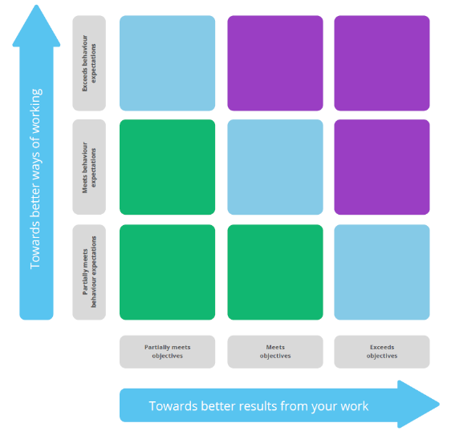
Career Conversation Framework
This framework is designed to enable a conversation about your role in the NHS. Think of it as a map you can use to plot your position and direction.
Where you’re placed on the framework is decided by the previous scores on the horizontal scale for performance (towards better results) and the vertical scale for behaviour (towards better ways of working).
The discussion is now about not just what you do (better results) but how you do it (better ways of working).
See ‘Values Based Appraisal Guide’ for the complete framework and the descriptions of the boxes.

Finding your place on the Career Conversation Framework
☐
☐
☐
“There are no right or wrong places to be – the most important thing is the quality of the conversation, in helping you understand and maximise your potential.”

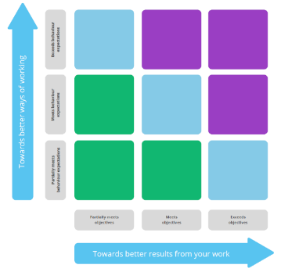
☐
☒
☐
☐
☐
☐
☐
☐
☐
☐
☐
☐
☐
☐
☐
☐
☐
☐
☐
☐
☐
☐
☐
☐

Tick the area that best represents where you feel you currently sit. Your position can, and will, change over time.
Confirm the area that you and your manager have AGREED best represents where you currently sit.
Tick the area that best represents where your manager feels you currently sit. This again can, and will, change over time.

Your manager will record on ESR where you are right now based on your ratings for behaviours and performance and the outcome of your discussions. This information will be used to direct you towards appropriate support, development opportunities and succession planning.

Where do you need to be? – Setting Future Objectives
Once you have agreed where you are right now, you are now ready to plan for the next 12 months. Your objectives should clearly set out what is to be done, and how well. You should be clear how you will know if you are doing a good job. You should also discuss how that links together with the objectives of your manager, team, department and Cardiff & Vale UHB (see page 3).
You will also discuss what support you need to meet those objectives and agree this. As you complete your objectives with your manager, add any required support or training into the Development Action Plan.
Team objective 1: |  |  |  | Build better relationships in work
Individual objective: |  |  |  | Click here to enter text.
Key tasks identified in achieving the objective: |  |  |  |  | Date for completion: | How will you know if you are doing well?
1.1 |  | Attend social things despite food aspect in time |  |  | ongoing | Click here to enter text.
1.2 |  | Stop seeing everyone else as ‘knowledgeable’ and me as ‘inferior’ |  |  | ongoing | Click here to enter text.
1.3 |  | Reflect not react |  |  | Ongoing as appropriate | Click here to enter text.

Team objective 2: |  | Be more confident in the role
Individual objective: |  | Click here to enter text.
Key tasks identified in achieving the objective: |  |  | Date for completion: | How will you know if you are doing well?
2.1 | Continues learning /training (including agored) |  | ongoing | Click here to enter text.
2.2 | Reflections on what went right/wrong – check in with Jess |  | Ongoing | Issues are resolved not left to escalate
2.3 | Be confident in what role is and the purpose it serves , as part of this possibly help RV service criteria |  | ongoing | Able to clearly communicate role purpose

Team objective 3: |  | Attend bridges course/motivational interviewing/ continue with TAP
Individual objective: |  | Click here to enter text.
Key tasks identified in achieving the objective: |  |  | Date for completion: | How will you know if you are doing well?
3.1 | Attend and put into practice |  | ongoing | Click here to enter text.
3.2 | Use support to ensure I stay in TAP course |  | Click here to enter a date. | Click here to enter text.
3.3 | Click here to enter text. |  | Click here to enter a date.

Team objective 4: |  | Improve note writing
Individual objective: |  | Click here to enter text.
Key tasks identified in achieving the objective: |  |  | Date for completion: | How will you know if you are doing well?
4.1 | Clearer notes, more precise, less rushed |  | asap | Jess completes audit and is happy
4.2 | Return to writing by hand not using computer |  | Click here to enter a date. | Click here to enter text.
4.3 | Click here to enter text. |  | Click here to enter a date. | Click here to enter text.

Team objective 5: |  | Continue work life balance
Individual objective: |  | Click here to enter text.
Key tasks identified in achieving the objective: |  |  | Date for completion: | How will you know if you are doing well?
5.1 | Socialise with colleagues (including meals) |  | ongoing | I will have lunch with colleagues and attend parties as able
5.2 | Take annual leave |  | ongoing | I will not end up with excess of leave at the end of the year
5.3 | Fill my time outside with activities |  | Click here to enter a date. | Leaving on time and not being so fixated on work/having more to discuss with dad etc when we meet than work

Team objective 6: |  | Optimise Learning opportunities
Individual objective: |  | Click here to enter text.
Key tasks identified in achieving the objective: |  |  | Date for completion: | How will you know if you are doing well?
6.1 | Attend and reflect on in- services and complete e learning. Don’t let my inferiority complex ruin my engagement with other MDT |  | ongoing | Less meltdowns
6.2 | Continue with TAP |  | Ongoing | Continuing with course
6.3 | Keep up to date with training |  | Ongoing | ESR will be 100%

How will you get there? - Development Action Plan
 | Individual Objective No: | Support needed or development opportunities identified | How are support / development needs going to be met? | By when:
1 | Attend TAP COURSE | Ongoing support with SL and advice as able to provide and emotional support as appropriate to get through it | JAMES TO KEEP IN TOUCH WITH NAT ON THIS | MONTHLY
2 | Attend MI | Information on motivational interviewing course and opportunities to learn/progress | JAMES TO RESEARCH MI COURSE | Click here to enter a date.
3 | WORKLIFE | If any overtime or band ¾ bank opportunities come up to flag this up to support the work/life balance if able | Click here to enter text. | ONGOING
4 | SV | Supervision and continued support as ongoing | SCHEDULED APPOINMTENTS | ONGOING
Your manager will record your Development Action Plan on ESR. This information will be used to direct you towards appropriate support, development opportunities and succession planning.
Final comments
This is an opportunity to cover anything else you want to talk about, including your health and wellbeing at work and any relevant issues outside of work. What else could you share that would allow your manager to support you better?
Staff Member comments |  | Manager comments
I’m enjoying the role and learning constantly, there is always more to learn and im hopeful that im going to be able to more engaged now that the team is more staffed.  I realise my low self-esteem and mental health are barriers to my progression especially with the infertility tearfulness and with new MPRA’S starting with ‘different’ (more) knowledge than me I feel it’s going to put to shame how I have run service and make a mockery of what I have been doing myself  I need to be confident in my role and the purpose of It and not get wrapped up in the politics of nursing side  I’ve been incredibly grateful for the support of Jess and learned a lot from the attitudes of new mpra Kate  Im grateful to have been given the opportunity to begin the TAP course.  I need to be more objective about what I can do and what I am doing and not so hard on myself. |  | Natalie has made great progress this year. She has built her knowledge and skills to a good level. She has stepped up in a very difficult time for the service and has taken on a lot of responsibility which she has managed with ease. She should be proud of the positive, professional and personal steps she has taken this year and know that she will always be supported in working towards improving these.
 |  | Manager has recorded on the Electronic Staff Record (ESR):
 |  | ☐ Appraisal completion date
 |  | ☐ Placement on Career Conversation Framework
 |  | ☐ Development Action Plan
Signature  Staff Member | NMcCulloch | Signature  Manager | James Hinder
Date | 28/10/2024 | Date | 25/05/2023
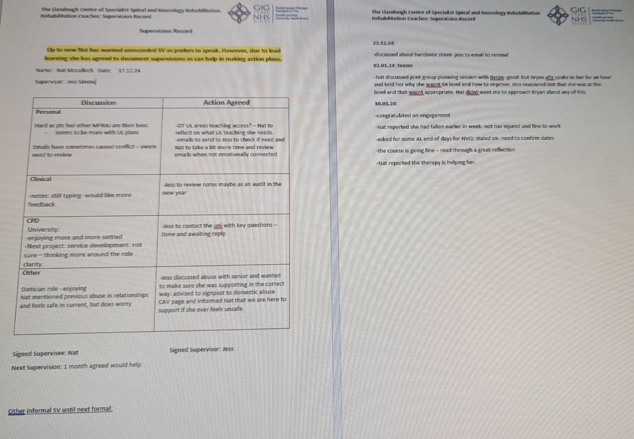
3 - Copy of recent supervision records.

4, 2 peer reviews

Appendix:


Therapy Assistant Practitioner:
Demonstrating Practice
Peer Review Feedback form

This peer review feedback was completed by: Natalie Mcculloch Date: 11/02/2025

The following tables will contain peer review feedback on presentations demonstrating quality improvement projects, using a PDSA cycle.

Feedback one: | Presentation topic: ‘This is me’ documentation
Congratulations | What does the presenter do well?  Gemma was calm and went first in the presentations in a calm, confident manner  Gemma gave good explanations of why she was doing the study and explained the topic in suitable depth to aid understanding  Gemma ‘talked around’ the slides and included good research to support her slides  Gemma appeared very knowledgeable on her topic.  Her slides were eye catching and well set out including screenshots of the form.  What were the presenters’ main points?  ‘This is me’ documentation is a tool to gain life history from patients with dementia.  The issue in Gemma’s workplace involved staff not reading the tool which intend to provide valuable information to aid care  Gemma’s aims are to improve the quality of care delivery, be in line with her trust policies and empower staff and patients.  How she did the project, why she did it, what feedback she got/what difference it made and what she will do next to maintain the positives in her workplace.
Ask for clarifying questions. | What aspects of the presentation were confusing or unclear? Why?  - Why she only collected data from 12 people.  - Any barriers she faced with data collection.  What suggestions (at least 2) do you have for the presenter, in order to improve this presentation?  - Include a brief slide about the barriers she faced in the study  - Have confidence in how well she did with her execution of the presentation and the project in total.
Request more. | What would you like to know more about the topic?  Any barriers she faced when collecting the data and for the project itself.
Evaluate its value. | What specific details would you take forward into your own practice?  Utilising the life history forms and monitoring the impact on provision of patient centred care.
Summarize | What new information have you learnt? Has this influenced you to think differently?  The fact that her health board (HDUHB) specify the completion of a life history within 5 days, made me wonder if the ward I work on has similar? It has made me reflect on what an essential tool these are and if they may help our patients also.

Feedback two: | Presentation topic: To improve post outcome measures responses
Congratulations | What does the presenter do well?  Eleri gave a good explanation of why she was doing it and relevant references to support the project  She included positives and negatives in her reflective comments  Good reflection on the Welsh use in her trust.  Her slides are clear and have reference to the PDSA cycle on each  What were the presenter’s main points?  What she does and where she works  The impact of the QR code in responses of outcome measures  Pre outcome measures are not a problem to collect  Why the outcome measures matter  What she did and why  What Eleri is going to do to improve across counties not just in her workplace  How she is going to bring it to other counties and evaluate it.
Ask for clarifying questions. | What aspects of the presentation were confusing or unclear? Why?  How she will communicate clearly with other counties to get them involved. Whether her manager supports this by giving her time as it seems a timely procedure especially if she is doing it on her own (she highlighted it takes a long time).  What PROM AND PREM is exactly.  What specific suggestions (at least 2) do you have for revising the unclear parts of this presentation?  Operationalise PREM AND PROM on a slide at the start  Explain how her time management and organisation skills enabled her to fulfil this process and how it will going forward.
Request more. | What would you like to know more about the topic?  Whether Eleri had a ‘plan b’ in case people didn’t respond , were all patients applicable to be involved or were there only these 5.  How she got in touch with the government to enable sharing of data, I have never heard of this and I feel it could be beneficial in my job.
Evaluate its value. | What specific details would you take forward into your own practice?  The use of phoning patients to ensure outcome measures are collected at the end of treatment as a lot of ours get missed because of discharging on days we don’t work.
Summarize | What new information have you learnt? Has this influenced you to think differently?  The government committee approval enables direct sharing of data, I would like to look into this to support the data we collect and our service especially as it’s a new one in the UHB.

REFERENCES
CONFIDENTIALITY CODE OF CONDUCT The Principals of Confidentiality for all staff. (n.d.). Available at: https://cavuhb.nhs.wales/files/policies-procedures-and-guidelines/corporate-policy/c-corporate-policy/confidentiality-code-of-conduct-review-may17-pdf/. (Accessed 28.01.2025)
‌
‌

