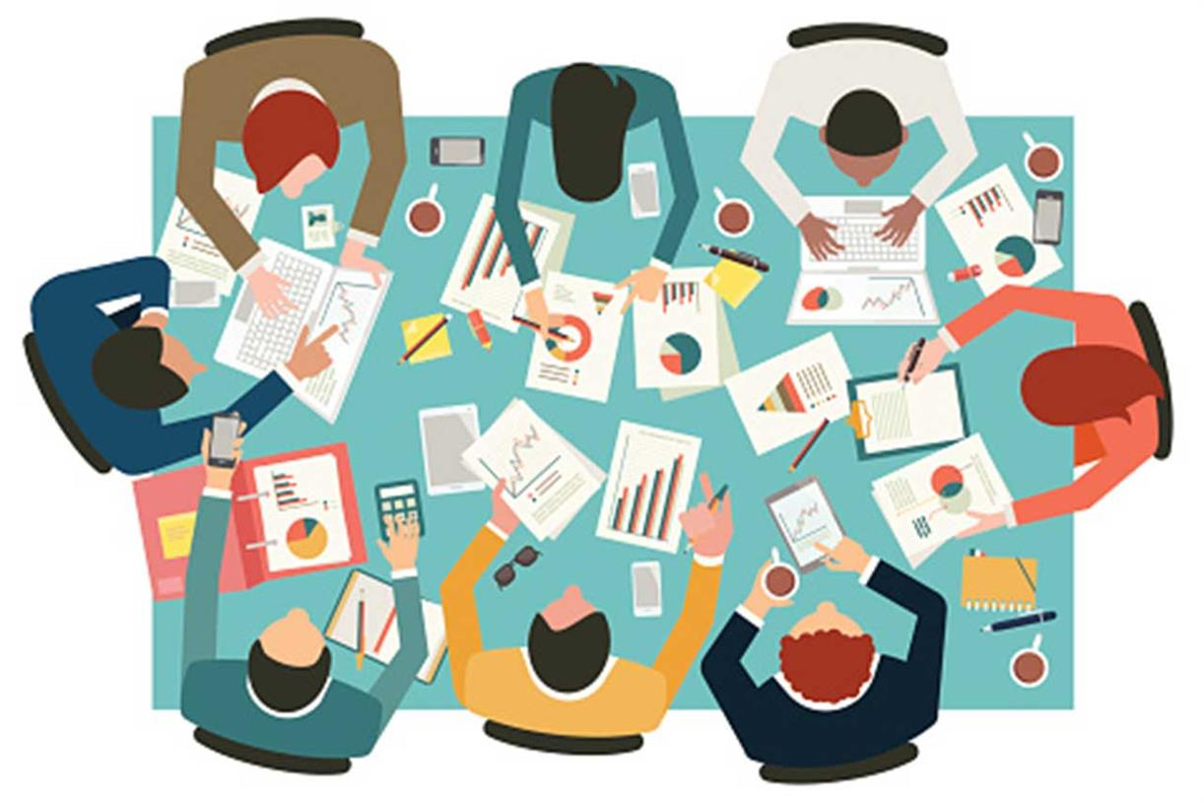
My name: Shokat Nawaz
Student number: 1807434
Assignment title: Bmsw5005 – Workplace culture and its impact on organizational efficiency
Assignment due date: 03/07/20
Lecturer’s name: Eric Osei

Contents page
Introduction……………………………………………………………………………………………3
PESTEL analysis on Argos’s retail environment
PESTEL analysis on Argos’s retail environment continued……………………………………...4
Analysis of the culture at Argos……………………………………………………………………...5
The changes in technology which affect organizational culture
Three ethical dilemmas managers need to resolve……………………………………………….6
The pros and cons of the actions taken at Argos
The pros and cons of the actions taken at Argos continued……………………………………...7
References…………………………………………………………………………………………….8

Introduction
For this task a report will be introduced which will be demonstrating a detailed understanding of the working environment culture as well as the context of an organization which I have previously worked for which is Argos. There will be a further critical analysis based on the retail industry of Argos where there will be a PESTEL analysis used towards the retail organization of Argos which will explain the political, economic, social, technological, environmental and legal factors of the retail organization and the impact that it has on Argos. Furthermore, there will be a detailed analysis of the culture within Argos’s organization and this will used according to the cultural web. There will also be an explanation of the extent of changes in technology which have an affect also on the organizational culture. Next, there will be three identified dilemmas which will be explained which is believed to have the managers of the organization to consider and to make appropriate decision-making techniques to resolve these ethical dilemmas. Lastly, the pros and cons of the actions that have been chosen to reach these decisions will be related to Argos towards the external parties and the employees also. This report will be relating to Argos’s workplace culture but is also related to many other working environments also within the retail sector.
PESTEL analysis on Argos’s retail environment
Political factors:
As for the political factors affecting Argos is due to the revenue and the profitability and this can be mainly because of the retail stores that Argos has with the government policies being affected and these regulations have a huge impact on the economy as well as the consumer buying habits. The international trade laws are also affected because the regulations that change within the retail organization have an affect also on the products which can be imported to the country and exported from the country to be sold within their stores not only in the UK but other countries as well so this leads a negative impact also on the economy. According to a study is has been said that the main political factors which are impacting the retail industry are related to bureaucracy, the corruption levels, freedom of the press, tariffs, trade control, the educational law, the anti-trust law and the employments laws which all affect the retail businesses including Argos which then leads to economy being affected in various ways according to (Political Factors Affecting Business, 2015). The political risks that involve international businesses results within different factors that have a negative impact on a company’s income or complicate its business strategies. These types of factors include macroeconomic problems like the higher interest rates and the social problems such as civil unrest according to (Nordmeyer, 2019).
Economic factors:
When it comes to the economic factors being affected within the retail organization is a lot more to do with the demand of the consumer goods including wages, inflation, customer confidence, unemployment, foreign exchange rates and the interest rates. According to (Sampath, 2019) it has been said that the leading factors are mainly the prime reasons for the economic activity. The decisions made are influencing the behaviour of the people in the economy so these decisions are mapped it has the ability to sum up the actions that people will make in the future and that is why human actions are known to drive the market. The demand cycle varies due to multiple events which some can be frequent and others not so frequent. To be able to predict events in advance does tend to help to overcome inventory shortages and bulk-ups, capital investments and the allocation of resources as well. These are some of the reasons why the economy is then affected especially the retail businesses.

Social factors:
The social factors affecting Argos’s retail industry is related to acceptance of the internet commerce as well as age distribution and advertising preferences. These types of social factors are factors which the ability to affect a person’s lifestyle and this can include wealth, religion, education levels, family size, structure, population density and buying habits and these are some of the examples that take place within the retail industry in many workplaces and does happen within Argos’s workplaces and these factors are very important for marketers when they are targeting certain customers for their business. In the retail industry the impact of social factors is not only just important for the operational aspect but also the marketing aspect of the business and this is related a good understanding of the customers, the lifestyles, levels of education and the beliefs in the society that would be a great help to design both products and marketing messages which can lead to a venture becoming a success within the retail industry according to (Murphy, 2018).
Technological factors:
For the technological affecting the retail industry include the existence of 3D technology, engine efficiency, internet connectivity, automation, wireless charging, computer speed and power and lastly, the ability of computers which can create truly random numbers. There are ways that technology can affect the environment negatively and these ways are caused by pollution, air, water, heat and noise pollution which all can be caused by producing the technology. Upon manufacturing technology has the ability to create a significant amount of waste along with used computers and electronics to get thrown out as rubbish/waste when they have been broken or then become to be outdated according to (Green Computing - Environmental Issues - The Carnegie Cyber Academy - An Online Safety site and Games for Kids, 2020). Many people think that the latest technology in the modern-day workplace doesn’t affect the retail industry but as matter of fact it does, and the internet has changed the face of retail dramatically. It has empowered consumers with various ways to gain large amounts of information to make the buying decisions easier and simpler and to create a platform for consumers to be able to provide their feedback electronically to the retailers about the brands and the product quality and services they have provided.
Environmental factors:
There are many changes which have a huge impact on Argos due to the macro-environment factors that have been changed. The macro-environment factors do have an impact of the Porter’s Five Forces which is used as a strategy as well as a competitive landscape that can impact on individual firm’s competitive advantage and the profit levels of the business. An industry such as Argos for instance may have a huge source of profit and the strength to grow and expand their business quite well but may not be so good for Argos if the business/company is unstable within an unstable political environment. These types of issues within the environment of Argos can really create many problems and it can impact the business in a negative manner where the long-materialized profits they have gained maybe impacted in a negative way according to (Strategic Analysis of Argos UK Retail Company – The Write Pass Journal, 2012). There are many other issues which impact Argos’s retail environment which are due to the environmental policies that are considered as the major external factors which can impact the strategies of a business. More environmental factors which are affecting Argos is due to the green agenda, the climate change, recycling and pollution in the environment which has a negative impact towards the retail industry according to (Farooq, 2018).

Legal factors:
The legal factors which affect Argos are related to external factors that refer to the law affects in the way that many retail businesses are operating and, in the way, that the customers are behaving. The product transportation, viability of some of the markets and the profit margins are all the examples of things that can be influenced by the legal factors which have been set. Most retail businesses including Argos would need to abide by the laws and regulations which have been set to standard for all retail businesses such as having the National Minimum Wage Act 1998 in place where every employee would need to be paid a minimum salary that government has stated for all employees within the working environment of all businesses. There is also the Health and Safety at Work Act 1974 that should be followed by all businesses including Argos and both of these laws would be stated in contract of employment that have to been agreed by all employees of the business from customer service employees to managers and higher according to (Sawyer, 2014).
Analysis of the culture at Argos
Within the retail industry at Argos the culture is quite a solid way which can differentiate businesses within the marketplace and it also makes majority businesses different from the rest. Having said this it can also result to keeping the businesses strong to stay competitive with the competitors of the businesses just like Argos and can even help the business to take control and become the leading most successful retail business out there in the marketplace. The retail culture can come in many forms which can range from the company values to the workplace attire according to (Altman, 2019). The trends in the retail industry that are becoming very important to the consumers is to have a personalized shopping experience and personalization within the retail environment often has to involve the retailers giving the consumers suggestions according to their taste, order history, previous searches and their location as well. The retail world is currently changing in the modern days because there is constant connectivity and contextual relevance as well as a multiscreen world which has the abilities to change both the online and offline shopping experiences for everybody around the world. As for the digital and the in-store experiences, there are many doors opening up exciting new possibilities for further thinking retailers. The consumers will no longer see a distinction in between the online and the offline shopping.
The changes in technology which affect organizational culture
The changes in technology which is having a huge affect on the organizational culture is due to the technology being mostly used to change a culture or to sustain as well as reinforce a culture when a organization is at a turning point so using technology as a method to improve and increase the engagement of the workforce in a scalable way can help to improve the working environment in the retail industry according to (Deloatch, 2018). Technology has always been created to make a much easier life for everybody and this doesn’t only hold the positive affects but it does have a lot of negative effects as well especially on the culture and that is even if it is initially providing benefits. The advancement in technology can directly affect how the organizational culture evolve because when the organizational cultures evolve, they seem to be creating newer technology. One of the most common problems and the most harmful impacts of technology within the working environment is “distraction”. Most importantly a scientist known to be Gloria Mark has said that the result to this is that the people are compensating for interruptions by working harder and faster which leads to stress, frustration and pressure as well according to (Negative impact of technology in the workplace, 2019).

Three ethical dilemmas managers need to resolve
- Discrimination and Harassment needs to looked into a lot more and maintained within the retail working environment because this is very serious in the working environment and should be looked into according to the laws and regulations which are also introduced by the government as well and this is because the employees working in an environment like Argos for instance want to be treated equally and work as part of a good working team and to effective communicators in between each other but if this wasn’t maintained the employees wouldn’t be lasting long within an environment like that and there may also be that employees would have to be dismissed from work leaving the business with less employees meaning less work being done which impacts the business significantly in various ways.
- Conflicting goals should also be considered and investigated and the reason to this is that sometimes many workplaces tend to write off a goal because your very first plan conflicts with another goal, so your first goal gets written off. Argos should get creative with their options for the internal stakeholders and have clarity in their goals and they can also use some accountability in reaching them by maintaining them more frequently and looking into further options more frequently to overcome these types of situations without having to cause a conflict in their goals as this can also lead to employees becoming demotivated.
- There is a type of dilemma also known as a communication dilemma which only exists when it is at a collective interest of the network members to communicate. The importance of communication should be looked into seriously by all businesses and should be taken seriously because without communication every business would be struggling to succeed and effective communication is quite significant for managers also in many organizations this is because in order to perform basic functions of being able to manage a business effectively the leading and controlling policies should looked into in depth as well as planning and organizing which will help managers to be able to perform their jobs and responsibilities more effectively.
The pros and cons of the actions taken at Argos
Pro: the Argos business within the retail industry is quite simple and easy to start the business so the reason as to why there are a lot of retail businesses open on the local high streets is because they are easy to start.
Con: the negative thing about having a business like Argos is that there are a lot of expenses in a business like this and one of the biggest cons of a business like that is that making so many expenses doesn’t mean that the business will be successful and will be maintained quite easily because sometimes the items may not sell or may not attract the customers so to make a reasonable amount of profit and expenses may lead to a business loss due to the amount of expenses that may need to be made.
Pro: Argos being a successful retail business is making a huge amount of money selling a variety of items within their retail stores which attract their customers. Argos tend to use the KYC method to attract their customers which is also known as the Know Your Customer method where the business is able to gather information using both primary and secondary data resources to sell items which their customers want for instance using their loyalty schemes to gather the important information and items to sell to make a substantial amount of profit for their business.
Con: there will be a lot of competition if the business is successful because that will then mean that the business will have to employ more staff, make more sacrifices, invest a lot more money in the business, maintain the business much more frequently, the more employees the more wages will need to be paid and that will reduce the profit margin of the business and lastly, the competitors will do as much as they can possibly to stay in control and to stay competitive so a good strategy and plan will be required in order to keep up and stay competitive yourself without being able to do these the business increases its chances of failing and the business can lose a lot of money and may not succeed so there is a lot issues that can occur if this isn’t maintained well by the retail business.

References
Altman, R., 2020. The best ways to brand a retail culture. [online] Your Business. Available at: https://yourbusiness.azcentral.com/ways-brand-retail-culture-13772.html [Accessed 13 June 2020].
Deloatch, P., 2018. Can Technology Drive Organizational Culture? [online] HR Dive. Available at: <https://www.hrdive.com/news/can-technology-drive-organizational-culture/518822/> [Accessed 16 June 2020].
Farooq, U., 2018. Environmental factors affect business | marketing tutor. [online] Marketing Tutor. Available at: https://www.marketingtutor.net/environmental-factors-affect-business [Accessed 7 June 2020].
Carnegiencyberacademy.com 2020. Green Computing – Environmental Issues – The Carnage Cyber Academy – An Online Safety Site and Games for Kids. [online] Available at: https://www.carnegiecybereacademy.com/facultypages/environment/issues.html [Accessed 19 June 2020].
Murphy, F., 2018. Argos Resources Limited PESTEL & environment Analysis. [online] Essay48. Available at: https://www.essay48.com/term-paper/12289-Argos-Resources-Limited-Pestel-Analysis [Accessed 17 June 2020].
Nordmeyer, B., 2019. How Does Political Risk Affect International Business? [online] Bizfluent. Available at https://bizfluent.com/about-6363401-political-risk-affect-international-business-.html [Accessed 11 June 2020].
PESTLE Analysis. 2015. Political Factors Affecting Business. [online] Available at: https://pestleanalysis.com/political-factors-affecting-business/ [Accessed 7 June 2020].
Sampath, S., 2019. Economic Factors Influencing Retail Operations. [online] Medium. Available at: https://medium.com/@sriramworkdegree/economic-factors-influencing-retail-operations-976107b357b0 [Accessed 15 June 2020].
Sawyer, J., 2014. The Political, Social and Legal Factors Affecting Tesco. [online] prezi.com. Available at: https://prezi.com/mzeb6eearnr6/the-political-social-and-legal-factors-affecting-tesco/ [Accessed 13 June 2020].
The Write Pass Journal. 2012. Strategic Analysis of Argos UK Retail Company – The Write Pass Journal. [online] Available at: https://writepass.com/journal/2012/11/strategic-analysis-of-argos-uk-retail-company/ [Accessed 6 June 2020].
Deloatch, P., 2018. Can Technology Drive Organizational Culture? [online] HR Dive. Available at: <https://www.hrdive.com/news/can-technology-drive-organizational-culture/518822/> [Accessed 16 June 2020].
Fact Suite Blog. 2019. Negative Impact of Technology in the Workplace. [online] Available at: https://factsuite.com/blog/negative-impact-of-technology-in-the-workplace/ [Accessed 14 June 2020].

