Question title I have chosen to answer: From the MESSAGE, MEDIUM, CONTEXT research strand lectures, choose a theme, movement, or selection of artists or designers that relate to your practise or interests, and construct a 2500-word essay. Critically assess primary themes, key writers, and relevant practitioners.

Student number: 1902690

BA course title: Illustration BA HONS

Word count: 2,671 (with in text citations)

Lecturers name: Gwen Beynon

The Pre-Raphaelites were a young and rebellious group, creating a new art movement in London. Originally consisting of William Hunt, John Millais, and Dante Rossetti, they started working together in 1848, alongside the Victorian Industrial revolution. Their style of art juxtaposed everything around them at the time. They disliked artists who took Raphael’s “unimaginative” (Pre-Raphaelite Brotherhood, 2019) art and copied it. The group explicitly publicised their distaste of Raphael by working under the umbrella of the ‘Pre-Raphaelite brotherhood’ they were instead inspired by the “Italian art of the 14th and 15th centuries” (Pre-Raphaelite Brotherhood, 2019) and the writings of Ruskin, an accomplished art critic at the time. This essay will analyse and critically assess the primary themes, key writers and relevant practitioners of the Pre-Raphaelite art movement.

The brotherhood was inspired by narrative, nature, and emotion. They stood against the academic view on art, using ‘normal’ people for their models. The artists were inspired by the ideas of art critic John Ruskin. The two were interlinked as he later defended them against the negative writings of people like Charles Dickens. The Pre-Raphaelites today have a very different relationship with the art world, and people such as Andrew Lloyd Webber are now collectors of their work.

The Pre-Raphaelites were one of the many groups in the Romantic movement. Romanticism was a response to Neoclassicism, which was inspired by Greek and Roman art, which had “principles of simplicity, symmetry, and mathematics” (theartstory, 2018) within all of their works. The Neoclassic style was taught in artistic academia, essential when creating a ‘great’ work of art. To create art by Greek standards, the models would have to be the “idealized human form” (theartstory, 2018a), which became the foundation for beauty ideals.

The Pre-Raphaelite’s disagreed with the Royal Academy’s teachings and in retaliation, only used ‘normal’ people for their models, giving the paintings a sense of “unprecedented realism” (Tate, n.d.) which juxtaposed the artwork around them. When Millais painted “Christ in the House of His Parents (‘The Carpenter’s Shop’)” (Tate, 2016) he painted the Holy Family as ‘real’ people. Charles Dickens writes that Mary looked “horrible in her ugliness” (Callow, 2012) and that the painting was “repulsive” (Callow, 2012). Everyone hated this depiction of the Holy Family, as they were always presented as perfect and beautiful. From then on, many people considered the Pre-Raphaelites’ work to be “sacrilegious or even blasphemous” (Tate, n.d.), the belief that you needed beautiful people in your work was a firm ideal so when it was challenged by the Pre-Raphaelites, it was met with universal disapproval. Although having normal people pose for their paintings, many of the women were still attractive. Elizabeth Siddal hired by Pre-Raphaelite artist Walter Deverell for her ‘plainness’, was known throughout her modelling life for her beauty, and even caught the eyes of other artists in the brotherhood. Even though the Pre-Raphaelites wanted ‘normal’ looking people in their work, they used beautiful women in many of their paintings, aligning with the Greek principles of beauty. During the Victorian era, photography became widely available, and because of this artists were getting their inspiration from what was around them, and not from fiction. Inspired by writers like Charles Dickens who wrote about social politics and people’s working conditions, art had now become fixated on the documentation of living during the industrial revolution.

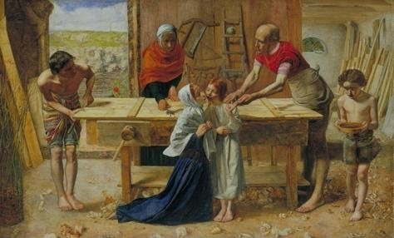(Tate, 2016)

Pre-Raphaelite work was heavily inspired by emotions and narrative. All their paintings were inspired by a story or play, each scene having a strong emotion connected to it. Knowing what was going on in the world at the time, the paintings could also be seen as a form of escapism.

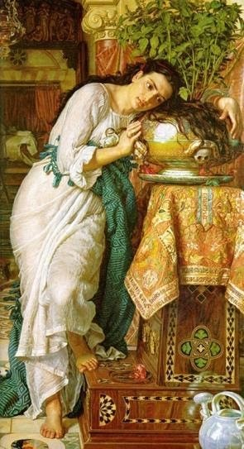(Chatfield, 2017)

The painting “Isabella and the Pot of Basil” by William Hunt displays a strong sense of
“melancholy” (Chatfield, 2017) as a series of events leads Isabella’s lovers' head to be planted in a basil pot. Hunt, inspired by this story, created the painting. His wife, who modelled for Isabella, was pregnant at the time and died during childbirth. Hunt continued it as a memorial to her, feeling a similar emotion to how Isabella felt. Looking at the meaning behind paintings shows the audience what the painter was inspired by, how they were feeling and how they chose to illustrate that. This painting can be seen as a strong emotion, a response to one’s loss and grief. It displays how the Pre-Raphaelites got their inspiration from somewhere other artists were ignoring.

Pre-Raphaelite paintings can be seen as hyperbolic pictures, through the bright colours, the ‘perfect’ women as the subject, and how they were inspired by fantasy. The idea ‘noble grounds for noble emotion’ was key in the Victorian era, as emotion was depicted through literature as it was thought to be superior to painting, therefore, the paintings from the brotherhood were never taken seriously by the art community. The paintings were then sold for very little because no one wanted them. The brotherhood was heavily inspired by stories, plays and poems when producing their paintings, and it is one of the primary themes because it runs through all of their pieces. The irrefutable link to emotion and narrative in the Pre-Raphaelites work is absolute.

The Pre-Raphaelites rarely made paintings that showed what was going on around them, and because of this, they were inspired by nature. The Brotherhood believed in the quote “go to nature” (Chatfield, 2019). It inspired the brotherhood to create photographic detail when painting their natural backgrounds, the brotherhood was taught to paint everything, “rejecting nothing, selecting nothing and scorning nothing” (Chatfield, 2019). This allowed them to create reality within the fantasy of their work. Even when not painting nature directly, they were inspired by “rejoicing always in the truth” (Chatfield, 2019) which came from a distant inspiration from the Realists, another art movement at the time. In Ophelia, a famous painting by Millais, the intricate details of the foliage and flowers around her are photographic. Millais was able to get these details painted perfectly because he spent months creating them before painting the model. Having the model painted first was the traditional way of working but Millais, inspired by Ruskin, put nature first making sure to get every minuscule detail down. After Millais had painted the background, he painted Elizabeth Siddal as ‘Ophelia’. She posed in a bathtub, heated by oil lamps, which in one session went out leaving the water freezing giving Siddal an illness that would affect her for the rest of her life, but because Millais was so focused on drawing and painting, he didn’t notice. This example shows how much Millais concentrates on what he is creating, even at expense of the model’s health.

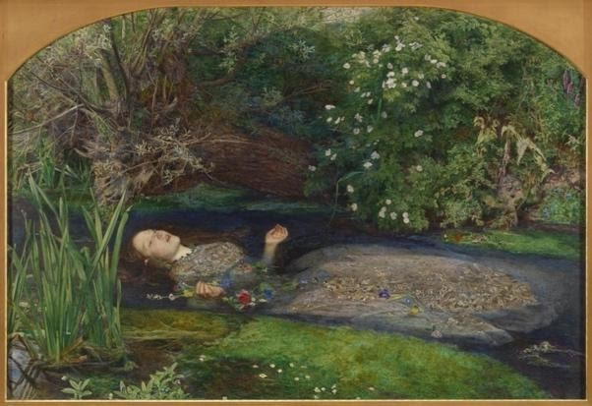
(Tate, 2018).

The natural look of the work was being questioned, critics accusing them of using photographs in their work. John Ruskin, known to ‘attack’ people who represented the establishment, defended the brotherhood against these claims. Despite the allegations of photography, the Pre-Raphaelites had nature at the forefront of their minds when painting, never ‘improving’ the scene. Wanting to escape the cruel reality of the Industrial era was evident.

John Ruskin was one of the most prominent art critics of the time. He stood against those who represented the establishment, thinking that one group could not be the only ones to judge art. Ruskin, being a “competent and trained” (Leight, 2000) artist himself, his defence held weight, people believed that he “knew what he was talking about” (Leight, 2000). This led to him have a close relationship with the Pre-Raphaelites. The Pre-Raphaelites were inspired by Ruskin and his writings. Ruskin defended them against critics because he favoured their work, which might be because they used his quotes to prompt their focus when painting. It could also be the fact that they were rebelling against academia. As well as inspiring the brotherhood, he famously “championed” (The British Library, n.d.) them against other art critics, by saying how he “perceived” (Leighton, 200) the “essence and the authority of the Beautiful and the True” (Leight, 2000). Ruskin had experience with changing people’s minds about art, as he had helped Turner become a respected artist, but he, unfortunately, didn’t have the same success with the Pre-Raphaelites. He continued to help and fund their work, but they remained unpopular with the art world. Although their work was inspired by Ruskin, it became dependent on him to sell. The public at the time still disliked it, and unlike Turner’s, could not be salvaged from humiliation.

The industrial revolution made life horrible for many people, and Charles Dickens “provided a window into the difficulties” (IT’S HISTORY, 2015) during the time, because of this many people considered him to be a ‘cultural hero’. He was a firm believer in documenting and commenting on the events of the time, which could have given him a bias against the Pre-Raphaelites, who painted fantasy scenes to escape reality. Dickens describes their style of painting as “mean, odious, repulsive, and revolting” (Callow, 2012). Further, into his journal entry he talks about how Millais is “indisputably accomplished” (Callow, 2012) in his artistic skill, and even though his skill is recognised, the humiliation it gives Millais was so much, he never showcased his work publicly again.

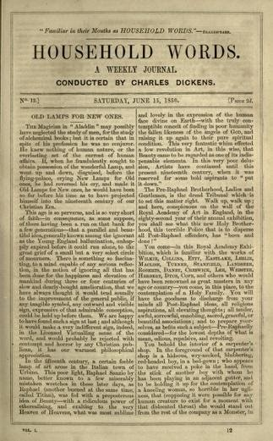 (Callow, 2012)

Charles’ writings had become renowned for critiquing the industrial revolution, his feelings about how the upper classes should be aware of the people's living conditions contributed towards a personal bias against the brotherhood’s paintings. The first time he met Millais, whose painting he had shamed when it was on show at the Royal Academy, he wrote about how he had “expressed admiration for his genius” (Tobin, 2020). After being introduced to the rest of the brotherhood Dickens was “seen so often in the company of the Pre-Raphaelites” (Tobin, 2020) and they were enthused by his writings, and produced paintings such as ‘Awakening Conscience’ which was inspired by his book ‘David Copperfield’.

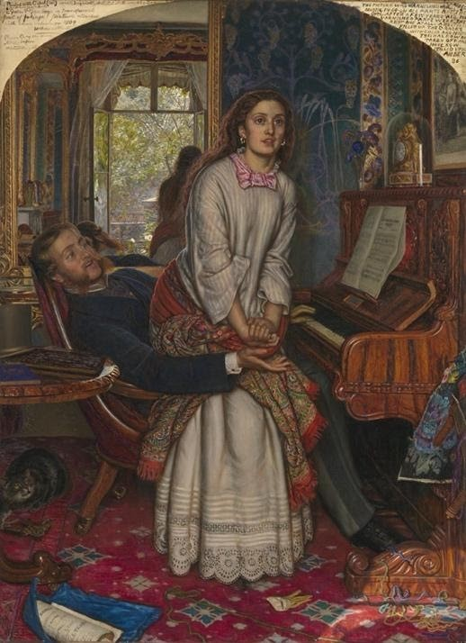(Tate, 2016b)

Dickens’ public disapproval didn’t help the Pre-Raphaelites to become respected artists, instead, it solidified the idea that their paintings were not to be taken seriously, and that they were not to be seen as ‘good’ art.

Since they were first made, the price and admiration of Pre-Raphaelite artwork have increased significantly. Although not everyone shares the same opinion, the Pre-Raphaelites today are a hugely famous group of painters. Their artwork is always on show in galleries and museums, and their paintings are also some of the most popular postcards to buy.

Today a key enthusiast of the Pre-Raphaelite movement is Andrew Lloyd Webber. When thinking about what makes the Pre-Raphaelites relevant in British culture, Webber states that the brotherhood painting stories from famous British writers, landscapes from around the UK, and “contemporary subjects such as prostitution” (Documentaries, 2013) Makes them an integral part to the “British mainstream” (Documentaries, 2013). Another area of the movement that Webber admires is the Pre-Raphaelite architecture. In the 19th century, William Butterfield became inspired by Medieval gothic architecture and created Keble college in Oxford, which Webber describes as “one of the greatest buildings in the country” (Documentaries, 2013).

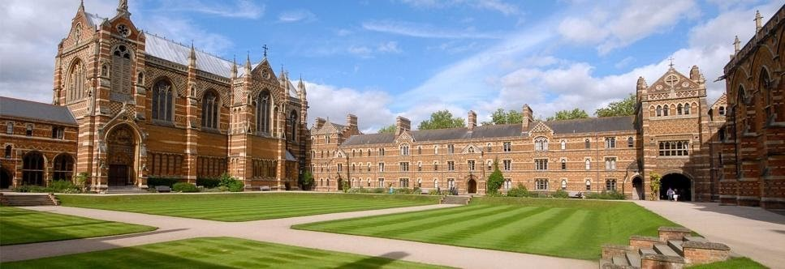 (University of Oxford, n.d.)

Although the present-day opinion on the Pre-Raphaelites is overwhelmingly positive, there are still people who do not like them. A writer, Jonathan jones for the guardian, talks about how he feels that the “Victorian brotherhood will never go away” (Jones, 2007). Against Andrew Lloyd Webbers view on the movement, people such as a “senior curator” (Jones, 2007) in the Tate stated that they would “get complaints from “teenage girls”” (jones,2007) if they didn’t show work from the brotherhood. The quote shames people for liking the movement just because teenagers like it, and because of this their art still isn’t completely taken seriously by everyone in the art community.

Andrew Lloyd Webber is a key figure for the pre-Raphaelites today. Focusing on their love of literature and using it to create beautiful paintings. Being such a big fan of their artwork, Webber has brought some of their ideas, Millais design for an arch, to life. Webber adores the paintings and architecture from the brotherhood, and his view on the Pre-Raphaelites is shared by many people today, and although some people do not like their work, just because it is popular with younger girls, it still is a prominent and important movement in art history.

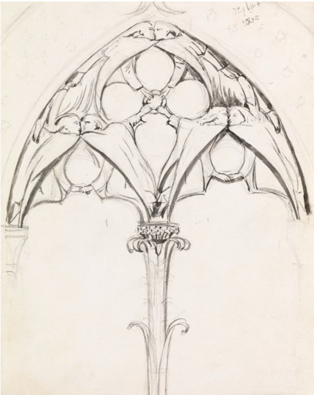(Maas Gallery, 2017)

The Pre-Raphaelite brotherhood wask famously known to sleep with the women they painted. Most of the relationships were destructive, and often the women would leave them worse than the men. The most well-known for womanising was Rossetti. Renowned for having many affairs with his models and other people’s wives, he was described to be “complex and deeply flawed” (Chatfield, 2012) when it came to his relationships.

His first significant relationship was with Elizabeth Siddal, whom he met through a fellow painter Walter Deverell. Rosetti fell “deeply and profusely” (Allingham, n.d.) in love with her. He “painted her image obsessively” (Chatfield, 2012) which could give the impression he was infatuated with her, but it’s said that Rossetti had made it obvious that he only saw her as an “artistic muse and not as flesh and blood woman” (Chatfield, 2012). Rossetti requested that she model exclusively for him, but their relationship suffered due to Elizabeth’s constantly decreasing health and Rossetti’s affairs. Rossetti reluctantly married Elizabeth, but still had affairs and left her alone for lengthy periods. Unfortunately, due to a miscarriage and an addiction to Laudanum, she overdosed. After, he had a relationship with Jane Morris that left the “most eminent mark in Rossetti’s art” (Bolor Jargalsaikhan, 2017). She started to sit for Rossetti three years after Elizabeth’s death, and she was described to be “idealised and portrayed as flawless” (McNay, 2014). Their affair was obvious to everyone, even Jane’s husband. After Jane found out about his addiction to chloral, they both decided to stop the affair but to remain friends.

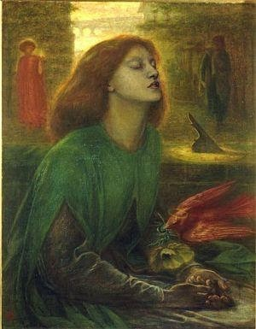(Chatfield, 2012)

Even though Rossetti treated the women awfully, he wasn't completely neglectful. Elizabeth’s health was declining, and he would go to see her and be by her side when it got especially rough, as he did still care for her. After Elizabeth passed away, Rossetti kept painting her, which could be seen as him missing her but is more likely because he liked her appearance. Rossetti was terrible to women. He was never completely neglectful as he did go to his wife when she needed him, but that is the bare minimum considering that he was married to her. Having affairs with women throughout his whole life, even when he was married, shows how he disregarded the thoughts and feelings of the women in his life. He treated his friends in the Brotherhood badly too, as he also slept with their wives. It could be him purely seeing them as objects, not considering their feelings, and their situations, or he could have cared about them all but had a problem with staying monogamous. Either way, he was awful in the way he treated them, and hurt them all either in or at the end of the relationship.

To conclude, the Pre-Raphaelites lacked significance. The lack of significance on mainstream trends in art was due to the unpopular themes in their work, drawing inspiration from nature, literature, as well as the mundane depiction of models. The lack of commentary in the brotherhoods works juxtaposed the art around them, which further reduced their popularity, as the public perceived it as irrelevant. Despite being constantly defended by John Ruskin, the art movement was never taken seriously. Famous critics, such as Charles Dickens, had written about how they hated it, and so the public followed the consensus. The controversy of the brotherhood was amplified by the lives of the artists, as they were known to have scandalous relationships, and treat the models poorly. Even though in their time they were disliked, they are now one of the most popular movements in art history. Today, as well as the general public, successful celebrities, such as Andrew Lloyd Webber, praise and collect the Pre-Raphaelite artwork. Therefore, whilst in their own time they were seen as insignificant, today they are an important movement in the world of art.

Reference list
Allingham, M. (n.d.). Dante Gabriel Rossetti and Elizabeth Siddal – Merryn Allingham. [online] Marryn Allingham. Available at: https://merrynallingham.com/19th-century/dante-gabriel-rossetti-and-elizabeth-siddal/ (Accessed 5 Dec. 2020).
Bolor Jargalsaikhan (2017). Women in Rossetti’s art: his muses and lovers that shaped his art. [online] DailyArtMagazine.com - Art History Stories. Available at: https://www.dailyartmagazine.com/women-in-rossettis-art/ (Accessed 5 Dec. 2020).
Callow, S. (2012). Volume I - Page 265. [online] www.djo.org.uk. Available at: https://www.djo.org.uk/household-words/volume-i/page-265.html (Accessed 29 Nov. 2020).
Chatfield, S. (2012). The Marriage of Dante Gabriel Rossetti and Elizabeth Siddal. [online] Pre-Raphaelite Sisterhood. Available at: http://preraphaelitesisterhood.com/pre-raphaelite-marriages-dante-gabriel-rossetti-and-elizabeth-siddal/ (Accessed 5 Dec. 2020).
Chatfield, S. (2017). What Grows from Grief. [online] Pre-Raphaelite Sisterhood. Available at: http://preraphaelitesisterhood.com/what-grows-from-grief/ (Accessed 29 Nov. 2020).
Chatfield, S. (2019). “Go to nature in all singleness of heart.” [online] Pre-Raphaelite Sisterhood. Available at: http://preraphaelitesisterhood.com/go-to-nature-in-all-singleness-of-heart/ (Accessed 29 Nov. 2020).
Documentaries, A. (2013). 3/4 A Passion for the Pre-Raphaelites : Andrew Lloyd Webber. YouTube. Available at: https://www.youtube.com/watch?v=PRBpNxdLotw&t=393s (Accessed 4 Dec. 2020).
IT’S HISTORY (2015). Arts and Culture During THE INDUSTRIAL REVOLUTION. YouTube. Available at: https://www.youtube.com/watch?v=hXivAiMXClg (Accessed 4 Dec. 2020).
Jones, J. (2007). We can’t escape the pre-Raphaelites. [online] the Guardian. Available at: https://www.theguardian.com/artanddesign/jonathanjonesblog/2007/may/16/wecantescapethepreraphaeli (Accessed 5 Dec. 2020).
Leight, M. (2000). Art/Museums - Ruskin, Turner and the Pre-Raphaelites. [online] www.thecityreview.com. Available at: https://www.thecityreview.com/ruskin.html (Accessed 4 Dec. 2020).
Maas Gallery (2017). Maas Gallery - Category: British Pictures 2017 - Image: 16. Sir John Everett Millais, 1829-1896. [online] www.maasgallery.co.uk. Available at: http://www.maasgallery.co.uk/component/joomgallery/british-pictures-2017/british-pictures-2017-17-2058 (Accessed 5 Dec. 2020).
McNay, A. (2014). Rossetti’s Obsession: Images of Jane Morris. [online] Studio International. Available at: https://www.studiointernational.com/index.php/rossettis-obsession-images-jane-morris-review-lady-lever-art-gallery-wirral (Accessed 5 Dec. 2020).
Tate (2016a). ‘Christ in the House of His Parents (“The Carpenter’s Shop”)’, Sir John Everett Millais, Bt, 1849–50. [online] Tate. Available at: https://www.tate.org.uk/art/artworks/millais-christ-in-the-house-of-his-parents-the-carpenters-shop-n03584 (Accessed 29 Nov. 2020).
Tate (2016b). ‘The Awakening Conscience’, William Holman Hunt, 1853. [online] Tate. Available at: https://www.tate.org.uk/art/artworks/hunt-the-awakening-conscience-t02075 (Accessed 5 Dec. 2020).
Tate (2018). ‘Ophelia’, Sir John Everett Millais, Bt, 1851-2 | Tate. [online] Tate. Available at: https://www.tate.org.uk/art/artworks/millais-ophelia-n01506 (Accessed 29 Nov. 2020).
Tate (n.d.). Why were the Pre-Raphaelites so shocking? – Essay. [online] Tate. Available at: https://www.tate.org.uk/art/art-terms/p/pre-raphaelite/why-were-pre-raphaelites-so-shocking (Accessed 20 Nov. 2020).
The British Library (n.d.). Pre-Raphaelitism by John Ruskin. [online] The British Library. Available at: https://www.bl.uk/collection-items/pre-raphaelitism-by-john-ruskin (Accessed 29 Nov. 2020).
The Editors of Encyclopaedia Britannica (2019). Pre-Raphaelite Brotherhood. In: Encyclopædia Britannica. [online] Available at: https://www.britannica.com/art/Pre-Raphaelite-Brotherhood (Accessed 26 Nov. 2020).
theartstory (2018a). Greek and Roman Art and Architecture. [online] The Art Story. Available at: https://www.theartstory.org/movement/classical-greek-and-roman-art/ (Accessed 29 Nov. 2020).
theartstory (2018b). Neoclassicism Movement Overview. [online] The Art Story. Available at: https://www.theartstory.org/movement/neoclassicism/ (Accessed 2 Dec. 2020).
Tobin, T.J. (2020). Charles Dickens and the Pre-Raphaelites. [online] Google.com. Available at: https://www.google.com/url?sa=t&rct=j&q=&esrc=s&source=web&cd=&ved=2ahUKEwjG3dzv57btAhXIEcAKHasJCWMQFjAAegQIBBAC&url=http%3A%2F%2Fmathcs.duq.edu%2F~tobin%2Fcv%2Fessay.dickens.rtf&usg=AOvVaw0X1lOOP9homTuN95YsTJGu (Accessed 5 Dec. 2020).
University of Oxford (n.d.). Keble College | University of Oxford. [online] www.ox.ac.uk. Available at: https://www.ox.ac.uk/admissions/undergraduate/colleges/college-listing/keble-college (Accessed 5 Dec. 2020).
‌

