ECDE7017 Supporting Notes

Table of Contents
Structure of the academic poster – plan for component 3 2
Notes for each section: 4
Section 2: Context & Section 3: Education sector’s responses on the use of AI/GAI 4
Section 4: UK government policies on AI/GAI 4
Section 6: Consequences/Impact of the policies on AI/GAI in HE 5
Section 7: Key takeaways 5
Section 8: Cited References 6
Section 9: Contact information 7
Brainstorming Notes: 8

Structure of the academic poster – plan for component 3

Title: Understanding the Impact of Generative AI (GAI) on Education: from JCQ guidance to DfE Policy
Section 1: Purpose of this study (brief overview, highlight focus and set expectations)
Section 2: Context (timeline, chart)
- The rise of GAI (An overview of GAI developments since OpenAI ChatGPT 3.5 release in Nov 2022)
- Excitement and Panic in HE (with reference to academic literature)
  - Opportunities
  - Challenges
Section 3: Response from the education sector - analysing JCQ guidance and Russell Group principles on AI (GAI) use and examples of GAI guidelines in UK universities. (use time line to show the response speed in comparison with UK government policies on AI/GAI, with reference to academic literature, use charts/tables to show plan to analyse text?)
- Joint Council for Qualifications’ guidance on AI use in assessments (April 2023, updated in Feb 2024)
- Russell Group principles on the use of generative AI tools in education (July 2023)
Section 4: UK policies on AI and GAI – slower than HE’s responses (with reference to academic literature)
- DSIT – A pro-innovation approach to AI regulation - August 2023
- DfE – Generative Artificial Intelligence in Education – October 2023
- Their influence on HE in terms of regulation and guidance.
Section 5: Approaches to Policy text analysis (focusing on DfE, JCQ guidance and Russell Group principles)
- Look at time of publication
- Look at responses to Policy papers
- Draw connections between the focused big P-Policy paper and small p – guidance and principles.
- Focusing on academic integrity?
Section 6: Consequences/impact of the policies (media treatment, international influence, with reference to academic literature and other various platforms)
- Universities’ guidelines and policies on GAI - JISC
- Future uncertainties and challenges
Section 7: Key takeaways (bullet points – highlights for the readers)
- Despite that GAI impost tremendous challenges to HE institutions, they respond quickly to identify the issues and addressing them.
- The major challenges GAI brought to HE are: academic integrity, GAI literacy for both staff and students, AND MORE
Section 8: Reference list
Section 9: Contact information (name, email, QR code?)

Notes for each section:

Section 2: Context & Section 3: Education sector’s responses on the use of AI/GAI
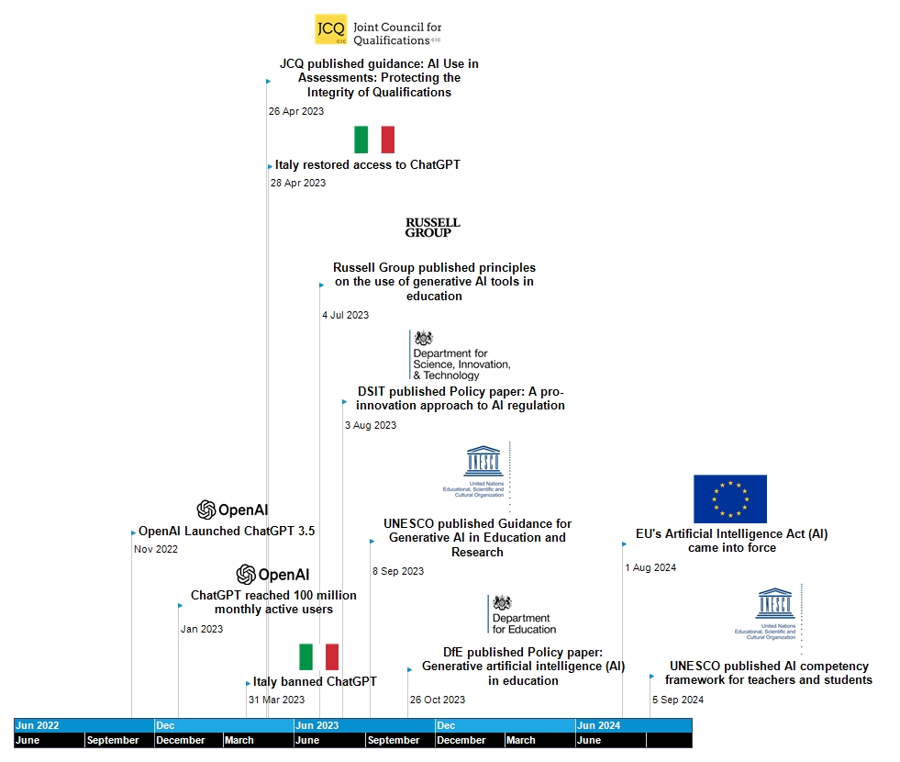
This timeline was created through MindView 8.0 to demonstrate a timeline of release of policy and guidelines in reaction to the rise of GAI. Information, date and icons found using Google search.

Section 4: UK government policies on AI/GAI
DSIT – public confidence – all things they do are laden with value. (political and historical agenda), their own agenda – change of government lead to change of direction. (of/for the people), try to stay in power (parties and personal ambitions), transparency.
- Three levels of communication. Macro (national level), meso (local authority/region consortia), micro (where it actually happened - schools)
- Confidence in all these levels.
- How is it achieved

Section 6: Consequences/Impact of the policies on AI/GAI in HE
- How the universities see the policy – related to values, purposes of education and so on.
- Polity refraction.
- Dynamic policy – keep updating – how responsive is it (are the voices of teachers being heard – consultation process, and do people get heard after that? What is the feedback system to the policy)
- ​Consequences of Government Policies:
- UK government's position on AI exacerbated the impact GAI impose on education (esp. the speed of develop of technology and universities' response to the challenges). ​ The position of the UK government impact on how the technology can influence education.
- ​Local policies and regulations are missing due to the change of political parties and power, GAI and its impact on education does not seem to be the priority for government as national policies on AI/GAI regulations are missing (evidence needed).
- ​Universities start to provide guidelines and training to embrace the technology, yet discrepancies in staff understanding of, attitudes and commitments to GAI, will affect GAI literacy for all affected staff and students in the short term.​
- Universities responded differently to the rise of GAI, some were more proactive than others in embracing the technology and establishing guidance on its usage, but many were concerned the challenges and detrimental effect GAI is going to bring to education and affecting the integrity and value of degree and education, more of these concerns were from scholars in humanities and social science subjects. Many university staff expressed the concern over the tremendous speed of the development GAI tools, as many are difficult to keep up with the change. (evidence needed)
- Universities start to provide guidelines and embrace the tools, yet there is a discrepancy in staff's attitudes towards the issue and thus would impact on the effectiveness of university regulations to make sure a sufficient level of GAI literacy is reached for all affected staff and students.

Section 7: Key takeaways
Highlight key ideas

Section 8: Cited References
ArXiv (2024) Chronological display of LLM release [Screenshot]. Available at: https://arxiv.org/html/2307.06435v9 (Accessed: 20 Oct 2024).
Bobula, M. (2024) ‘Generative Artificial Intelligence (AI) in higher education: a comprehensive review of challenges, opportunities, and implications’, Journal of Learning Development in Higher Education, 30. Available at: DOI https://doi.org/10.47408/jldhe.vi30.1137
Dabis, A. and Csáki, C. (2024) ‘AI and ethics: Investigating the first policy responses of higher education institutions to the challenge of generative AI’, Humanities & Social Sciences Communications, 11(1), pp. 1006. Available at: DOI:10.1057/s41599-024-03526-z
Department for Education (2023) Generative Artificial Intelligence (AI) in Education. Available at: https://www.gov.uk/government/publications/generative-artificial-intelligence-in-education/generative-artificial-intelligence-ai-in-education (Accessed: 6 Oct 2024).
Department for Science, Innovation and Technology (2023) A Pro-Innovation Approach to AI Regulation. Available at: https://www.gov.uk/government/publications/ai-regulation-a-pro-innovation-approach/white-paper (Accessed: 15 Oct 2024).
Department for Science, Innovation and Technology (2023) The Bletchley Declaration by Countries Attending the AI Safety Summit. Available at: https://www.gov.uk/government/publications/ai-safety-summit-2023-the-bletchley-declaration/the-bletchley-declaration-by-countries-attending-the-ai-safety-summit-1-2-november-2023 (Accessed: 17 Oct 2024).
Marsden, C. T. (2024) [Forthcoming] ‘Generative AI Regulation in the UK’. in P. Hacker, S. Hammer, A. Engel, B. Mittelstadt (ed.), Handbook on Generative AI. Oxford: Oxford University Press. Chapter 44. Available at: http://dx.doi.org/10.2139/ssrn.4944690
Hu, K. (2022) ‘ChatGPT’ Sets Record for Fastest-Growing User Base – Analyst Note, Reuters, 2 February. Available at: https://www.reuters.com/technology/chatgpt-sets-record-fastest-growing-user-base-analyst-note-2023-02-01/ (Accessed: 20 Oct 2024).
Joint Council for Qualifications (2024) AI use in assessments: protecting the integrity of qualifications. Available at: https://www.jcq.org.uk/wp-content/uploads/2024/07/AI-Use-in-Assessments_Feb24_v6.pdf (Accessed: 05 November 2024).
Russell Group (2023) Russell Group principles on the use of generative AI tools in education. Available at: https://russellgroup.ac.uk/media/6137/rg_ai_principles-final.pdf (Accessed: 05 November 2024).

Section 9: Contact information
- Name, email address.
- QR code for collecting questions and feedback on the academic poster: 

Brainstorming Notes:


