Introduction

This essay will be assessing and critiquing the use of Environmental Impact Assessments (EIA) by using Bristol International Airport (BIA) as a case study.

Key Terms. - Table 1.
- Environmental Impact Assessment (EIA) - “A formal procedure through which decision-makers gather environmental information about projects and take this information into account in decision-making” - (Bell et al. 2017, p.446).

- Strategic Environmental Assessment (SEA) - “In EU law, the assessment of plans and programmes which, in certain sectors, set a framework for the future development of consent of projects subject to EIA, or which are required under the EU Habitats Directive” - (Bell et al. 2017, p.446).

- Environmental Statement. - “A statement, prepared by the developer, of the main environmental impacts of the project and any proposed mitigating measures to reduce the significance of those impacts” - (Bell et al. 2017, p.446)

An Environmental Impact Assessment (EIA) is a process carried out to identify, predict and evaluate any environmental impacts which could be caused by a certain action. This is done so that all aspects of broad range of environmental issues are dealt with; considerations for social, cultural and health effects are all taken into account in an EIA. Ultimately the main aim of a EIA is to prevent harm to the environment, also to mitigate and offset serious harmful effects from proposed actions (Bell et al. 2017, p.444).

The aims and objectives of an EIA can be categorised into two sections: immediate and long term.

- The immediate aims of an EIA in the remit of development projects is to advise the initial decision making processes by establishing potential negative environmental effects caused by the project. In doing so, there a number of objectives which are fulfilled. This step can improve the environmental design of the project proposal as it foresees the issues beforehand such as identifying measures for the mitigation of certain actions caused by project. This step is crucial for the next step of decision making and the continuation of the project so that all aspects of the environment are considered to not be harmed (Raymond Sumo University, 2006).

- The long term aims of an EIA is to promote sustainable development by making sure that project developments aren’t degrading the natural environment past the point of irreversible change. As well as the natural environment, long term goals include protecting human health and the livelihood of communities which surround the proposed project area and beyond. Not only should an EIA protect, it should also enhance social aspects of the proposed project and reinforce social and community development as much as possible to safeguard the future and wellbeing of communities (Raymond Sumo University, 2006).

Project Background.

Bristol International Airport (BIA) is located to the south west of Bristol, within North Somerset. BIA is situated in the rural countryside with agricultural land adjacent to the A38 and residential areas (Lulsgate Bottom and Redhill). It opened in 1930 (Bristol International Airport, 2006). In 2005, the operational land covered 176 hectares (ha), Image 1 illustrates the airport boundaries. There is an additional 10ha of land to the south of the airport which could be acquired (Bristol International Airport, 2005). The main access route for the airport was the A38 with regular busses from the city centre. In 2005, the airport facilities comprise of:

- passenger terminal building.
- runway and taxiway systems.
- main passenger aircraft parking apron.
- short and long term car parks.
- air traffic control tower.
- administration and operational offices in the old terminal building.
- ancillary facilities such as the fuel farm, flight catering, general aviation facilities, aircraft hangars and car hire. (Bristol International Airport, 2005).

Image 1 & 2 illustrates the airport boundaries and the above bullet points in situ.
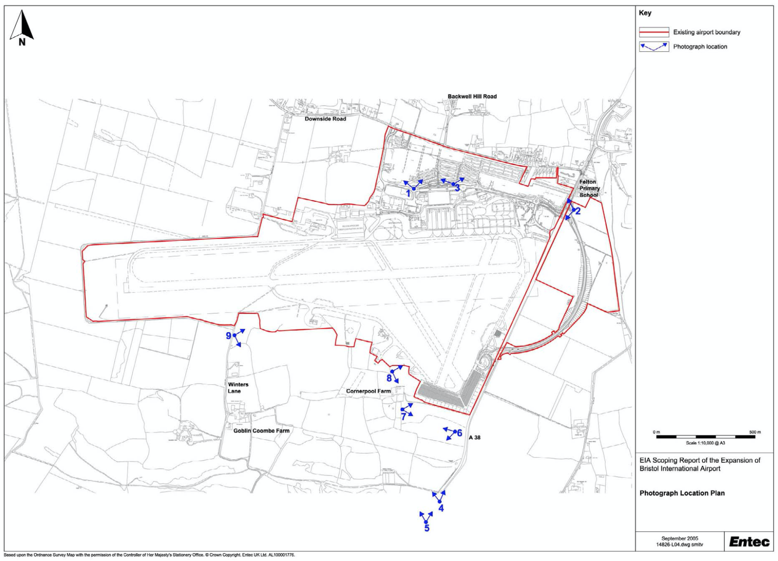
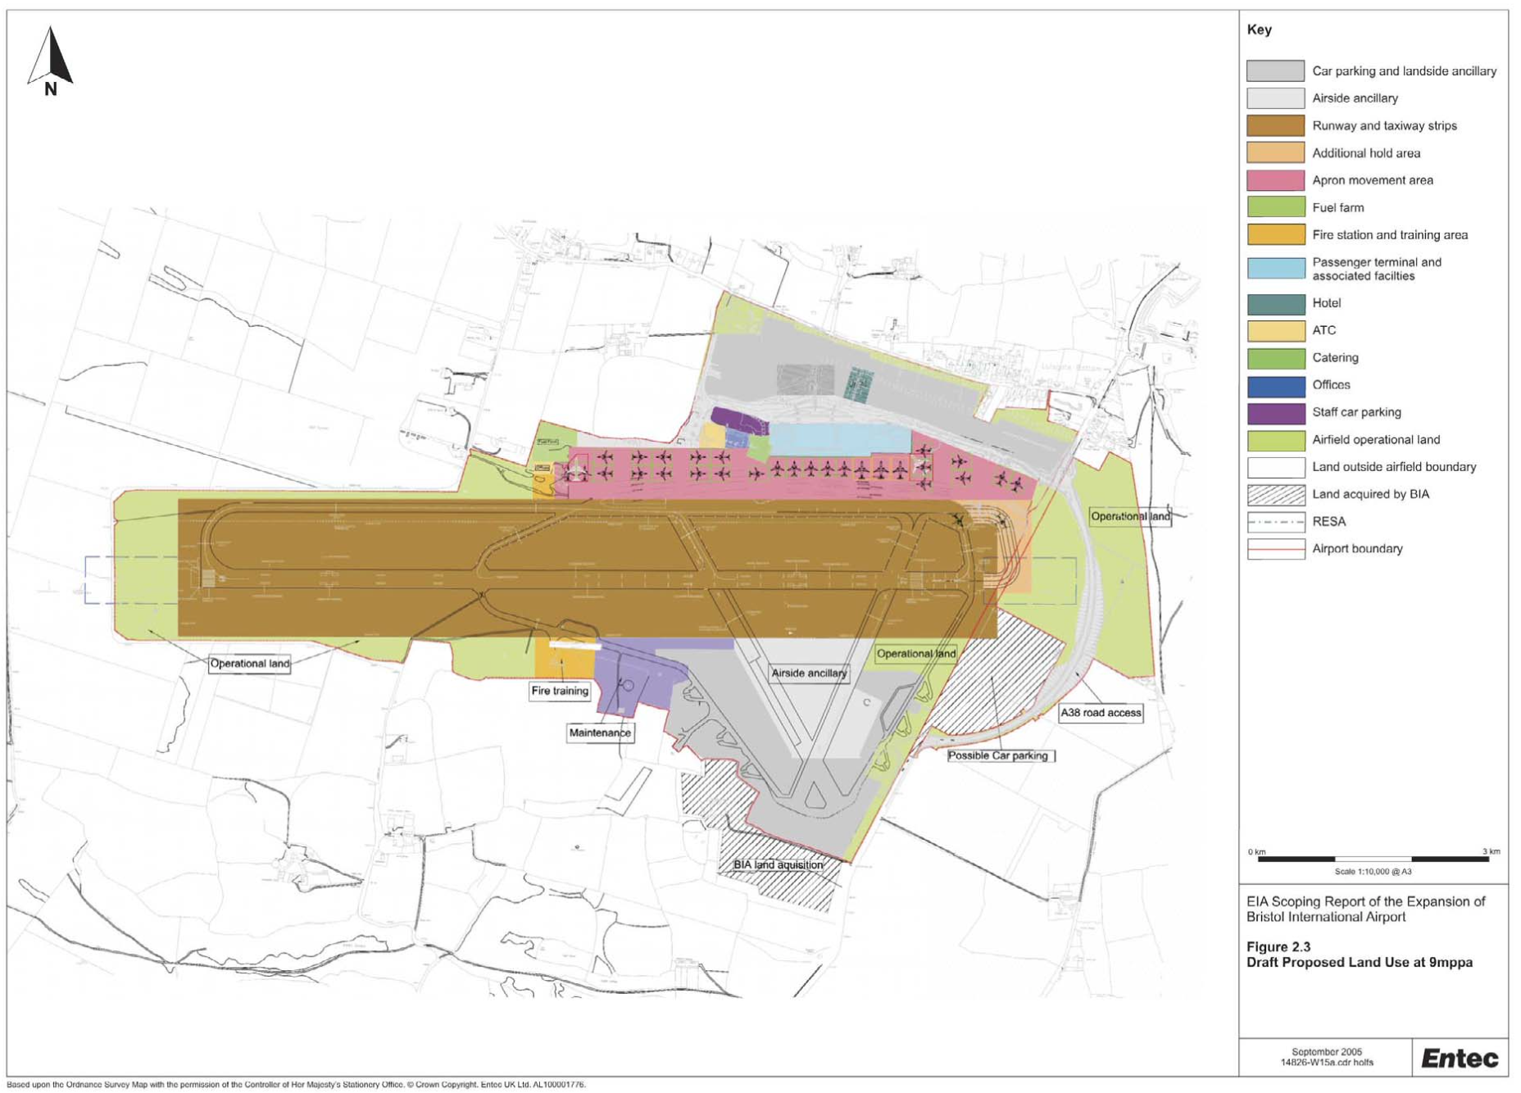
Image 1 - Airport boundaries (Entec, 2005).
Image 2 - Land use (Entec, 2005).
In December 2003 the Government published “The Future of Air Transport”. This white paper set out a framework for the next 30 years for Air transport in the United Kingdom. The paper stated that BIA is the largest airport in the South West of England (Department for Transport, 2003) and has seen a large growth in the number of passengers, between 2000 and 2003 passenger throughput had almost doubled with the airport handling approximately 4 million passengers per annum (mppa). The white paper forecasts that there could be between 10mppa - 12mppa by 2030. The terminal could accommodate up to 8mmpa when these forecasts were made, however beyond this number, a second terminal would have to be developed along with a runway extension (Department for Transport, 2003). The key elements of the proposed development are listed below:

- Expansion of passenger terminal
- New mezzanine floor and aircraft access piers in the existing terminal building.
- Apron extensions.
- Provision of new multi storey car parking facilities.
- Long stay car park to south of airport.
- Demolition of former terminal building and existing fire station.
- Hotel accommodation.
- New fuel farm.
- Fire station relocation.
- Provision of new office accommodation.
- New road infrastructure.
- Runway and taxiway.
- General aviation.
- Freight.

Main Body.

On the 27th of June 1985 the Council Directive on the assessment of the effects of certain public and private projects on the environment was created (EIA Directive 1985). This directive was amended on several occasions; in 1997, 2003 and 2009. The directive was then codified in 2011 and again in 2014. At the time of the project proposal the EIA regulations which oversaw the scoping EIA report and the Master Plan was the Directive 2003/35/EC of the European Parliament and of the council of 26th May 2003 (EIA Directive 2003).

Directive 2001/42/EC (SEA directive) was created for the assessment on the effects which certain plans and programs will have on the environment. Later in 2003, as part of the Espoo Convention, the protocol on SEA was adopted in a transboundary context within the EIA. The SEA protocol augments the Espoo convention and ensures that environmental assessments are completed by individual parties at the early stage of planning.

Aarhus Convention | United National Economic Commission for Europe Convention on Access to Information, Public Participation in Decision-Making and Access to Justice in Environmental Matters (European Commission, 2017).
Espoo Convention. | United National Economic Commission for Europe Convention on Environmental Impact Assessment in a Transboundary context (European Commission, 2017).

These conventions established a number of key aspects to aid the EIA directive. The Aarthus Convention secured rights to the public in regards to the environment which relates to the three pillars; access to environmental information, public participation in decision-making and access to justice in environmental affairs (European Commission, 2017). The first two pillars are part of EU law via directives 2003/35/EC and 2003/4/EC. The Espoo Convention establishes an obligation to notify states on all major projects which could have significant negative environmental impacts across boundaries.

Structure of mitigation table is as follows: the EIA column states what the EIA by Entec has highlighted as areas to consider further mitigation for and the second column how the Environmental Statement, the BIA master plan, plans to follow through with the mitigation process. The mitigation by BIA section takes into account pre and during construction mitigation and also mitigation for operational effects of the development (Bristol International Airport, 2006).

Cultural Heritage

Firstly, it states that there could be a loss of sub surface archaeological remains dating back to the prehistoric date. Secondly there may be a loss of a early post medieval lead extraction site known as “Gruffy Ground” and lastly there may be a loss of features of the WWII Lulsgate Airfield. To further understand the effects of the development on these Archaeological and culturally important sites, desk study and consultation proposed (Entec, 2005).

Mitigation.
EIA (Entec, 2005). | BIA mitigation (Bristol International Airport, 2006)
Loss of archaeological remains. | - Desk based research for prehistoric remains (though they are not seen significant to warrant their preservation)  - Consultation to pinpoint exact measure of mitigation OR compensation to North Somerset Council.  - Working in accordance with the Planning Policy Guidance 16: Archaeology and Planning (PPG 16).
Loss of WWII airfield. | - Further research to determine exact measure of mitigation and/or compensation with North Somerset Council.  - Working in accordance with the Planning Policy Guidance 16: Archaeology and Planning (PPG 16).
Loss of remains of “Gruffy Ground”. | - Unlikely they will be affected.  - Working in accordance with the Planning Policy Guidance 16: Archaeology and Planning (PPG 16).

The BIA Master Plan states that the development is not likely to cause a significant issue to the cultural heritage of the land and that the actions taken are supplemented in accordance to the PPG 16. The PPG 16 states the importance of archeological remains and the weight of significance of the remain (PPG 16, 1990). BIA follow through their due diligence by using the PPG 16 and therefore took the right precautions for Cultural heritage in a legal sense.

Geology and land quality.

The main concern of the EIA is sources of contamination. The potential sources of concern are contaminated soil and/or shallow groundwater arising from contaminative sources from past and present activities. Other potential effects are the further contamination to soils, biodiversity, groundwater, groundwater fe surface watercourses.

The EIA suggests that mitigation should include protective gear and employ safe working practices to minimise potential risks to construction workers (Entec, 2005) and also suggests a SEMP should set out measures on how to minimise further contamination to the wider environment.

EIA (Entec, 2005). | BIA mitigation (Bristol International Airport, 2006).
Contamination to constructors and public. | - Exclusion of site visitors from working areas.  - Provision of appropriate safety induction training and Personal Protection Equipment (PPE) to construction workforce.  - Adoption of best practice techniques in the design and operation of new infrastructure and equipment.  - Testing for potential contaminants.
Further contamination. | - Adoption of best practice techniques and design.  - Site investigation.  - Testing for potential contaminants.

There is a significant concern for contamination for both construction workers and towards the public but BIA have laid out a number of procedures to mitigate these impacts. Firstly, testing for potential contaminants is to be complete in order to perform any remediation to the land before construction begins and PPE is to be given to the construction workforce and effective mitigation processes are in place for further contamination incidences.

Community

The EIA highlights how air quality, construction, noise and vibration, mental and physical health, visual disturbance and transport could all have an effect. Potential effects needing further consideration is also listed. The data gaps identified that a economic impact assessment should be undertaken as a separate piece of work and that effects on health on community are to be written up in an Environmental Statement (ES) which is in the form of the master plan.

EIA statement (Entec, 2005). | Mitigation (Bristol International Airport, 2006).
Air Quality.  - Effects on health during operation of expansion. | - Dust control strategy to be implemented during construction and monitored.  - Increased use of clean technology and public transport.  - Optimal design of road layouts, design of aircraft stands, taxiways to maximise buffer distance from residential/employment/Felton primary school.  - Continued monitoring of PM10 and NOx data  - Siting junctions and intersections away from sensitive receptors.
Archaeology & Cultural Heritage.  - Effects on rural characteristic of area. | - Provision of a rural character assessment survey.
Biodiversity.

Geology and land quality.  - Contamination. | - Potential exposure of contamination will be dealt by adoption of best practice techniques.
Landscape and Visual.  - Effects on recreation from changes in land or disturbance.  - Effects on rural characteristic of area and change of view. | - Adoption of measures to reduce appearance of the airport through selection of materials, colour and screening vegetation.  - Careful choice on architectural style.  - Lighting scheme to minimize glare and off-site pollution.  - Augmentation of vegetation.
Noise.  - Effects on health during operation of expansion. | - “Considerate Constructors” Scheme.  - Limit construction to day time.  - “Noise insulation grant scheme.  - Construction of acoustic screen.  - Road layout design.
Transport.  - Effects on health during operation of expansion.  - Increased Traffic. | - Improved road infrastructure.  - Deliver new road infrastructure including A38/A370 link road.  - Traffic Calming in Barrow Gurney.
Vortex and Vibration.  - Effects on health during operation of expansion. | - “Considerate Constructors” Scheme.  - BIA vortex repair scheme.
Water.  - Effects on health during operation of expansion. | - Robust construction site environmental and health and safety management plan.  - Monitoring of water quality.

Engagement with the local community is paramount and under the Aarhus convention, it is a legal requirement. BIA stated right at the start of the MP that comments from the community have been carefully considered and have had significant impacts on the development. That said, it is evident that community engagement is reflected throughout the master plan(Bristol International Airport, 2006).

BIA was met with much backlash from the community surrounding the airport. It’s a difficult and sensitive topic to handle. On one hand; the airport doesn’t serve only the local community, it serves a global infrastructure and economy. On the other hand; the local community will be the ones to suffer from the negative consequences of the expansion.

An increase in traffic was a large concern of the community, this being said, BIA proactively dealt with these concerns and mitigated the impact of increased traffic though traffic calming in Barrow Gurney and supporting the link road on the A38/A370.

The government states there is importance of air travel to both national and regional economic growth (Department for Transport, 2003) and so economic drive is a large push for the expansion of BIA. The EIA states that BIA is contributing to the regional economy by creating opportunities for investment, thereby supporting the economic growth of the area (Bristol International Airport, 2006). However, the argument for job creation has been challenged by Professor Jon Whitelegg. Whitelegg criticised the development for BIA in 2005, mainly for the lack of evidence that supports claims of economic growth in aviation. He reports that there is a widely accepted view that airports act as “engines of the local economy” and that there isn’t enough criticism of this, especially from the BIA Master plan (Whitelegg, J., 2005).

Unfortunately, BIA has still had negative impacts on the area such as St Katherine’s School, Felton, which was located near BIA. The school was approved for noise insulation even though it fell outside of the 63 dBA range but the school closed in 2010 due to difficulties in numbers of student but the BBC also states that it’s location near BIA was also a problem (BBC, 2010). The school has been running for 164 years and the village was disheartened to see it close.

Air Quality

The EIA recognised the potential for the development to have a significant negative effect on air quality due to the increase in aircraft and road traffic emissions, it also identifies that dust nuisance could increase. The EIA also identifies that changes in pollutant concentrations and disposition rates could change at sensitive ecological sites (Entec ,2005). The following steps were suggested to assess the significance of these effects:

- To assess aircraft, road traffic emissions and changes in pollutant concentrations; an assessment using a dispersion model (ADMS) is to be carried out (Entec ,2005).
- Dust Nuisance is to be assessed using a qualitative assessment estimated on the probable activities of construction while taking meteorological conditions into account (Entec ,2005).

The dominant pollutants found within airports are; Nitrogen Oxides, volatile organic compounds, carbon monoxide, carbon dioxide, sulphur dioxide and particulates. Monitoring of air quality is undertaken by both North Somerset Council and BIA. Review and assessment concluded that NO2 was of the greatest concern, however, no pollutants were forecasted to breach the Air Quality Objectives (AQO) (Entec ,2005).

EIA (Entec, 2005). | BIA mitigation (Bristol International Airport, 2006)
Increase in aircraft & road traffic emissions to air. | - Air quality in the local area is to be monitored and will meet the national and EU health standards.  - Increase in public transport.  - Surface Access Strategy.  - Use of alternative fuels and technologies.  - Optimal design of development and road layouts.
Pollutant concentration and deposit rate changes at ecological sites. | - Detail air quality study. (Found that no expected exceedents in pollutants but in 2020 they expect NOx to exeed annual average standard.)  - Continued monitoring of nitrogen dioxide.  - Dust Control Strategy and monitoring.  - Pm10 monitoring for “post-scheme air quality monitoring”

Air quality is arguably one of the major threats of the expansion, not only affecting the local environment/health, but also contributing to the global issue of Climate Change. Entec concluded that no pollutants are forecasted to breach the Air Quality Objective act, however, the EIA was written in 2005. The Climate Change act came into force in 2008 so it is understandable that it is not a key factor in the EIA. However, the EIA acknowledged CC (The only mention of CC is under the ‘Water Resources and Quality’ under subsection ‘Predicted trends’, “Climatic variables are likely to alter as a result of climate change” – (Entec, 2005)) and so it is questionable as to why it has only been mentioned once when it could’ve been mentioned in many other sections of the assessment.

The BIA master plan has a large section on Air Quality, however, the main mitigation processes were the monitoring of pollutants, alongside air quality studies. The air quality study found that there is to be no expected exceedance of pollutants, other than NOx in 2020. Nonetheless, anything that increases air pollution increases the toxicity of the air we breathe and put’s people’s health at risk. In the UK, each year, around 40,000 deaths are attributed to air pollution (Royal College of Physicians, 2016). The monitoring of the pollutants is important, however, it does not solve the issue at hand. To proactively reduce the impact of aircraft and traffic emissions to the air, BIA have committed to the use of alternative fuels and technologies. Alongside this, a push for public transport is to be implemented and also a redesign of road layout to relieve urbanised areas of increased road traffic emissions.

Landscape and the visual environment

The EIA recognises potential for significant long-term changes to the landscape as a result from the development and also a change to the wider landscape due to construction activity. The visibility of the development stated to have a certain change of the building due to the whole infrastructure changing. Specific attention has been mentioned to the effects which increased lighting will have during the construction and operation.

Assessment of these identified issues are to be taken forward (stated by the EIA0 by methods which are promoted by the “Second Edition of the Guidelines for Landscape and Visual Impact Assessment”.

EIA (Entec, 2005). | Mitigation (Bristol International Airport, 2006).
Loss of mature vegetation | - “effective” landscape scheme.  - Avoid damage/loss of mature vegetation “(where appropriate)”.
Short term & long-term changes to wider landscape | - “effective” landscape scheme.  - “Strengthen” boundaries existing alongside Cornerpool Farm such as hedgerows and long-term management.  - Boundary planting.
Visibility of new infrastructure. | - New infrastructure will be designed to minimise visual impact.  - “Aesthetic Design” for tank farm.  - Use of underground tanks.  - Provide “sufficient space to create a sense of arrival…”
Effects of increased lighting. | - Car parking lighting will be designed to minimise light pollution with the use of block parking and green roofs.(How the heck does a green roof help with lighting?)  - Lighting scheme.
Visibility of construction activities. | - Provide “sufficient space to create a sense of arrival…”
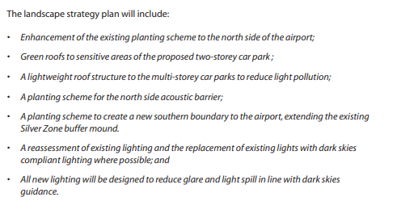
Image 3 - Landscape strategy plan (Bristol International Airport, 2006).

Much of the language used in the mitigation process for Landscape and the visual environment has a sense of ambiguity. For example; “sufficient space to create a sense of arrival” was used to describe the mitigation towards the visibility of construction activities. BIA does not define what is meant by “sufficient”, therefore it is unclear what is meant by this.

Another criticism is the “effective” landscape scheme. The use of the word “effective” is unnecessary and it feels as though it has been used for dramatic effect, after-all, you would not create an ineffective landscape scheme. The landscape scheme, shown in FIGURE ?, shows nothing new compared to what has already been said in the document. The misleading use of an “effective landscape scheme” suggests that more to be done to protect the landscape and visual environment.

Biodiversity

A number of potential negative effects on biodiversity are listed in the report. Firstly, demolition of structures such as trees or WWII dispersal pens which could host as a habitat for bats. Others include damage and/or disturbance to a number of species such as badgers, great crested newts, dormouse and reptiles. Many of these species are listed on the Biodiversity Action Plan (BAP) (JNCC, 1994). There was also the recognition of the effect increase in air traffic movements may have on roosting bats and also the change in vegetation composition due to an increase in nitrogen disposition. Lastly, a risk in groundwater contamination was recognised. Many of these issues were dealt with by surveys taken with guidance from English Nature (now known as Natural England) and also reviews of air quality information and surface water quality information.

EIA (Entec, 2005). | Master Plan mitigation (Bristol International Airport, 2006).
Disturbance to bats through demolition of habitat, loss of foraging habitat, light disturbance. | - Detailed surveys to be undertaken on impacts of protected species (bats, great crested newts, badgers, Enhancement of foraging sites for bats in southern areas of the airport.
Disturbance to protected species. | - Alternative habitats are to be created where disturbance is unavoidable.  - Detailed surveys to be undertaken on impacts of protected species.  - Monitoring of species.
General Biodiversity. | - A nature conservation management plan will aid the plans for the south side car park.  - Green roofs in areas of the north side car parks.  - Update of the “Nature Conservation Strategy”.  - Enhancements of habitats.  - Expansion to be designed with minimal disturbance to wildlife.

There is great emphasis on the green roofs throughout the master plan, of which there are to be two of. Green roofs increase biodiversity and also give a natural aesthetic to built infrastructure. However, the species which are of concern here are bats, great crested newts, badgers. Green roofs are not of great use to these species, although they do have potential to increase insect species which could improve feeding grounds. Nevertheless, BIA do state that if there is any loss of habitat then alternative habitats will be created. However; the increase in footfall, noise (pre, during and post construction) of traffic and aircraft and air pollution all have knock on effects to the biodiversity of the area. It is all well and good having a nature conservation management plan for certain areas of the airport but realistically, the species of concern are not going to want to live near such an urbanised area. The BIA master plan states “Expansion to be designed with minimal disturbance to wildlife”, but there is no follow up as to how this will be achieved.

Noise

Potential effects identified in the EIA relating to noise was from construction, ground operations and variation in airborne noise. The next step in combating the noise from construction using the methodology in BS 5228 Noise from construction and open sites. This methodology provides protection against noise and vibration for people who are living and/or working near construction developments. It also provides protection for those working on the construction (BSI, 2014). Other potential effects will be monitored using a computer modelling system to create noise map contours (for both ground operation and aircraft) and calculate noise contours throughout the day and night to estimate whether it complied with the Environmental Noise Directive (END).

EIA (Entec, 2005) | Mitigation (Bristol International Airport, 2006).
Construction noise (Including construction traffic) | - ‘Considerate Constructors’ Scheme.
Variation in ground operation noise. | - Construction of acoustic screen.  - Operational restrictions.  - Use of quieter ground equipment.  - Noise monitoring.  - Optimal design of road layouts.
Variation in airborne noise. | - Phase out nosier aircraft.  - Noise insulation grant scheme for houses affected by noise over 63 dBA.

Firstly, the EIA highlighted that the onset of significant community annoyance from noise was 57 dBA, however, the noise insulation grant scheme only covers houses affected by 63 dBA of noise. This immediately present a flaw. Whitelegg states:

“Noise is not just an annoyance. It damages health, it detracts significantly from the quality of life, it stops local residents enjoying their gardens or simply enjoying peace and quiet, it damages wildlife, it damages the learning ability of school children…” - (Whitelegg, J., 2000)

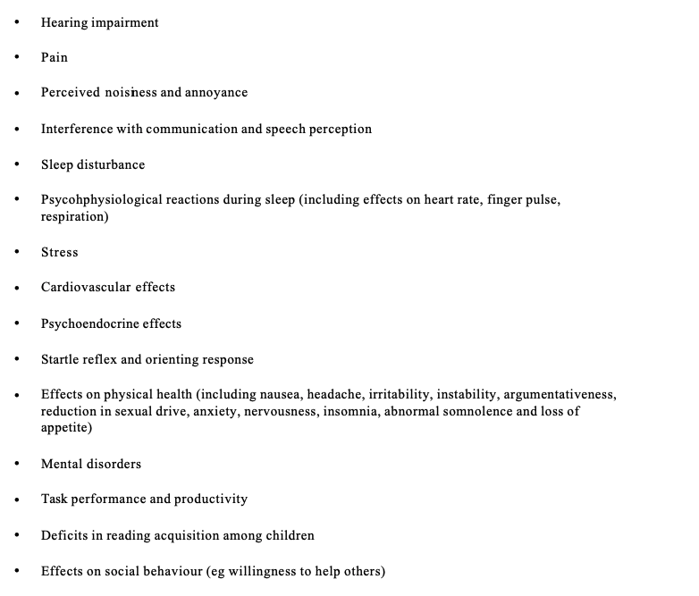
Image (?) lists the scientific evidence on the effects of noise, taken from the World Health Organisation in 1993. This is particularly worrying due to the fact the grant scheme doesn’t cover the wide enough scope where noise annoyance is prevalent, thus having the ability to cause any one of these.
Image 4 - Noise health effects (World Health Organisation, 1993).

Therefore, the main criticism for the mitigation for noise is the Noise insulation grant scheme. However, BIA are taking some steps in the right direction by phasing out noisier aircrafts and restricting the noisiest aircrafts to the daytime.

Transport

The EIA outline a number of potential effects of transport on the surrounding environment. For example, changes in the traffic as a result of construction activity could impact traffic speeds and highway links and junctions. There would also be an effects on traffic flows involving local residents, community facilities, schools and businesses (Entec, 2005). There is also an increased risk in road safety and an elevated risk of potential accidents during the operational phase.

The identified next steps were a series of assessments and analysis of information in order to further identify the risks of these potential effects. For example, the EIA suggests an analysis of Injury Accident data records on the surrounding area to work out high risk areas. A similar strategy to manage the traffic flows was suggested through the identification of traffic sensitive areas to generate a routing strategy. Assessments of information is also stated to be prepared using guidelines such as “Guidelines for the Environmental Assessment of Road Traffic”.

EIA (Entec, 2005) | Mitigation (Bristol International Airport, 2006).
Changes in baseline traffic from construction activity. | - Transport Assessment (Includes traffic modelling)  - Standard Construction techniques.  - Site Environmental management plan.  - Construction transport management plan.
Road safety for vulnerable road users. | - N/A.
Change in general highway operations. | - Public Transport strategy
Increase in traffic flows. | - Integrated traffic signals.  - Changes in road layout in the local area.  - “StaffTravel Plan” to be implemented to reduce single occupancy car journeys.  - Traffic Calming in Barrow Gurney.

The master plan identified that good surface links were important to BIA and mitigation processes were adequately followed through with. Many of the challenges raised from the community have been spoken about previously. BIA will enrol a “public transport strategy” and a “Staff Travel Plan” which will both aid in a decrease of single occupied cars. Due diligence is followed through when it comes to changes in construction activity through the different assessments and management plans. One criticism is that the EIA highlights that road safety for vulnerable road users should be assessed using Injury Accident data records but there is no mention of this in the Master plan.

Water.

The potential effects of the development in relation to water are as follows; an increase of de-icing chemicals and re-fuelling operations (chemical pollution), risk of accidental pollution from expansion of fuel farm and fire station and lastly an increase of surface runoff from expansion of car-parking areas could likely cause on-site flooding (Entec, 2005).

The EIA suggests a review of existing pollution prevention, control and response measures to manage these potential effects. It also suggests that a consultation with the Environment Agency in regards to discharge. Lastly, the EIA suggests a review of the likelihood of on-site flooding and suggests the use of Sustainable Drainage Systems (SuDS) and proposes the idea of exploring opportunities of reusing water (Entec, 2005).

EIA (Entec, 2005) | Mitigation (Bristol International Airport, 2006).
Increased use of de-icing chemicals and increased re-fueling operations. | - Integrated water management system.  - Bunds/double-skinned tanks.  - Monitoring quality of discharge to groundwater.
Risk of accidental pollution | - Integrated water management system.
Increase in surface run-off . | - Integrated water management system.  - Sustainable drainage systems (SuDS).  - Storm water attenuation through green roofs.

Due diligence has been followed through in terms of water through an integrated water management system. Management will continue to monitor water to make sure it is following certain guidelines and some innovative solutions such as SuDS and water attenuation through green roofs are also proposed.

Conclusion.

In conclusion, the master plan is reflective of the EIA. There are still areas of ambiguity which are apparent in both reports which I have commented on throughout this report. Although, in my opinion, the master plan went into significantly more detail than the EIA in certain areas such as community and transport.

However, while inspecting these two documents it seems clear that some areas aren’t as focused on as much as other areas. For example, community engagement is highly investigated and mitigation is followed through with sufficiently. Although when it comes to biodiversity, the mitigation doesn’t follow through with the same amount of detail and it is questionable as to why this is the case. It suggests that BIA does not care about these issues on the same level and this is a theme throughout. I suggest that there needs to be an unbiased level of commitment to all areas of concern from the development so that all areas are given the same protection as one another.

The EIA also creates an impression as though, if a development has prepared an EIA and a ES, they can just go ahead with the development no matter the cost. Even though that some aspects such as air quality would exceed or that noise would increase, the plans would still go ahead. There are now more plans in 2021 to expand the airport again now that development has finished and that begs the question of how necessary is another development. This new development has had even more of the community fighting back, with protest groups such as “STOP Bristol Airport Expansion”. This development will have more pressure due to Climate Change, which the documents discussed didn’t have a great deal on (especially the EIA), and will be interesting to see how much this will impact the new development.

Referencing.

- BBC (2010) Felton village school closing for good. Available at: https://www.bbc.co.uk/news/uk-england-bristol-10713664 (Accessed: 15 January 2021).
- Bell, S., McGillivray, D., Pedersen, O,W., Lees, E., Stokes, E. (2017) Environmental Law. Ninth Edition. Glasgow: Bell & Bain Ltd.
- Bristol International Airport (2006) Master Plan 2006 - 2030. Available at: file:///Users/asahipollock/Downloads/Bristol%20Airport%20Master%20Plan.pdf (Accessed 24 December 2020).
- BSI (2014) Code of practice for noise and vibration control on construction and open sites. Available at:https://www.warrington.gov.uk/sites/default/files/2020-08/cf53_bs_5228_pt1-2009a1-2014.pdf (Accessed: 3 January 2021).
- Department for Environment Food & Rural Affairs (2019) Air Quality: explaining air pollution at a glance. Available at: https://www.gov.uk/government/publications/air-quality-explaining-air-pollution/air-quality-explaining-air-pollution-at-a-glance (Accessed: 2 January 2021).
- Department for Transport (2003) The Future of Air Transport. Available at: https://assets.publishing.service.gov.uk/government/uploads/system/uploads/attachment_data/file/685595/6046.pdf (Accessed 24 December 2020).
- EIA Directive 1985, c.15. Available at: https://eur-lex.europa.eu/legal-content/EN/TXT/?uri=CELEX:31985L0337 (Accessed: 24 December 2020).
- EIA Directive 2003, c.15 Available at:https://eur-lex.europa.eu/legal-content/EN/TXT/?uri=CELEX:32003L0035 (Accessed: 24 December 2020).
- Entec (2005) Environmental Impact Assessment of the Expansion of Bristol International Airport: Scoping Report. Available at: http://www.aerohabitat.eu/uploads/media/21-07-2008_-_Bristol_International_Airport_EIA_Report_01.pdf (Accessed: 24 December 2020).
- European Commission (2017) Environmental Impact Assessment of Projects. Available at: https://ec.europa.eu/environment/eia/pdf/EIA_guidance_EIA_report_final.pdf (Accessed: 26 December 2020).
- JNCC (1994) UK Biodiversity Action Plan. Available at: https://data.jncc.gov.uk/data/cb0ef1c9-2325-4d17-9f87-a5c84fe400bd/UKBAP-BiodiversityActionPlan-1994.pdf (Accessed: 2 January 2021).
- Ministry of Housing, Communities & Local Government (2015) Strategic environmental assessment and sustainability appraisal. Available at: https://www.gov.uk/guidance/strategic-environmental-assessment-and-sustainability-appraisal (Accessed: 2 January 2021).
- Parish Councils Airport Association (2011) PCAA Position Statements for Core Strategy Examination. Available at: https://www.n-somerset.gov.uk/sites/default/files/2020-03/PS402%20Parish%20Councils%20Airport%20Association.pdf (Accessed: 2 January 2021).
- PPG 16. (1990) PPG 16: Archaeology and Planning (ODPM) Available at: https://uk.practicallaw.thomsonreuters.com/6-106-4663?transitionType=Default&contextData=(sc.Default)&firstPage=true (Accessed 15 January 2021).
- Raymond Sumo University (2006) 1-2 Purpose and aims of EIA. Available at: http://www.raymondsumouniversity.com/eia-local/page93.htm (Accessed: 3 January 2021).
- Royal College of Physicians (2016) Every breath we take. The lifelong impact of air pollution. Available at: https://www.rcplondon.ac.uk/projects/outputs/every-breath-we-take-lifelong-impact-air-pollution (Accessed: 15 January 2021).
- Whitelegg, J (2005) The Economic Impact of Bristol International Airport. Available at: https://www.aef.org.uk/uploads/whitelegg_report.pdf (Accessed: 15 January 2021).
- Whitelegg, J. (2000) AVIATION: the social, economic and environmental impact of flying. Available at: https://www.researchgate.net/publication/267377910_AVIATION_the_social_economic_and_environmental_impact_of_flying (Accessed: 15 January 2021).
- Whitelegg, J. (2005) The economic Impact of Bristol International Airport. Lancaster: Eco-Logica Ltd.
- World Health Organisation (1993) The ICD-10 Classification of Mental and Behavioural Disorders. Available at: https://books.google.co.uk/books?hl=en&lr=&id=cnU0DgAAQBAJ&oi=fnd&pg=PP1&dq=World+Health+Organisation+(1993)+Community+Noise.+Environmental+Health+Criteria+Document,+WHO&ots=HaWVy_Jjgs&sig=2SXNnQDDlJo2ZVGvPktNGNJB7r4#v=onepage&q&f=false (Accessed: 15 January 2021).

