Katie L Pullen-O’Brien

HPHP4902 – Academic Skills
Assignment 3: Could the Nazi invasion of the Channel Islands during World War Two of been avoided?
Could the Nazi invasion of the Channel Islands during World War Two of been avoided?

As of 30 June 1940, the Channel Islands became the only area of the British Isles seized by the Wehrmacht. The Channel Islands are known as the Bailiwicks of Jersey and Guernsey and are a part of the British Crown Dependency Islands, positioned just 80 miles south of the English coast in the English Channel. The Guernsey Bailiwick includes multiple islands, including Guernsey, Alderney, Herm, Sark and smaller islands Lihou, Jethou and Brechou.

As a result of the Nazis successfully invading mainland Europe, the French Government fell and new Nazis in control of the majority of France; the German Army had its sights placed on the British Isles. Hitler believed this would be his stepping stone into Britain. As a result, the occupation of the Channel Islands lasted for most of the war from 30 June 1940 until liberation on 9 May 1945. This occupation later resulted in the fortification of the Islands as a part of the Nazis’ Atlantic Wall, a series of defences along coastal Europe to keep the Allies out.

What did the British Government do?
On 3 September 1939 at 11:15 am, Prime Minister Neville Chamberlin announced that war between Great Britain and Germany was officially declared due to Germany invading Poland and World War Two begun for Great Britain. The British Government had to decide what to do with the Channel Islands and their residents. The 15 June 1940 became the day when the British Government decided that the Channel Islands would become de-militarised and would not be protected as it had no strategic significance, and the loss of life could be significant. The Prime Minister at the time of this decision, Winston Churchill hesitated about making the decision. The British Government informed the residents that they had to register to leave. The situation in the Channel Islands was debated by the House of Lords shortly after it was announced that the Government would not send soldiers to defend the Islands. The Lords drew attention to the financial implications of evacuating the Island and for those who remained. In addition, multiple Members raised concerns about the fact that the islands had been abandoned without support.

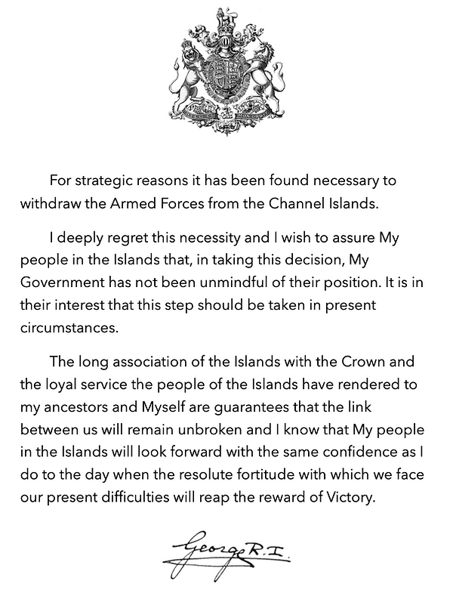
Image One is a copy of an original announcement by King George VI in 1940 about the Government announcing the de-militarisation of the Channel Islands. This announcement was sent to the authorities of the Channel Islands as a letter of assurance and was on display for the public in Jersey’s Royal Square and made available in the parish church notices.

Life on the Islands
At the time of the invasion, over 40,000 islanders were still living on the island and had to adapt quickly literally overnight. These islanders became victims of the Nazi regime as they became imprisoned on the island, arrested, or even deported some individuals who got in their way. As a result, it is believed that approximately 25,000 individuals were able to evacuate. Every Island’s Government believed differently in evacuations. The authorities in Alderney suggested all Islanders evacuate; however, in Sark, they wanted residents to say. Evacuations of the Islands could have been planned and executed more strategically by the Islands and the British Government. This caused havoc across all islands.

All Islands were vulnerable to attack from air and sea due to them being open, but the decision to de-militarise was final. The Germans did not know that Great Britain had left the Islands unmanned so the Germans came with force and bombed the harbours of Guernsey and Jersey. Forty-four people died because of the raids as they thought lorries waiting at the port were filled with soldiers, not supplies. Operation Grüne Pfeil or Green Arrow was the operation name given by the Nazis for six German Battalions who were set to invade the Channel Islands. Three battalions for the invasion of Jersey, Two battalions for Guernsey and one battalion for Alderney. Each island would have German soldiers in their thousands as the war went on to help enforce law and order.

Overnight, all the Islands learnt very quickly how to live under Wehrmacht rule, later becoming the most fortified place in the world and gaining the title 'Hitler's Island Madness'. By implementing restrictions, the Germans enforced strict regulations to keep order on the Islands. Authorities and Police Forces had to adapt to the new German ways and enforce these new regulations and restrictions. The residents would have their homes, property lands, vehicles, food, and belongings removed. Restrictions such as changing to Central European time and German currencies such as the Reichsmark, censorship of media/ press and strict curfews were in place. As you can imagine, there was a significant language barrier between all parties and miss communication was a big problem; as a result, individuals would get in trouble. If individuals did not obey these, they would be sent to concentration camps on the Islands or even deported. With restrictions such as these in place, the Channel Islands became fully shut off from Britain.
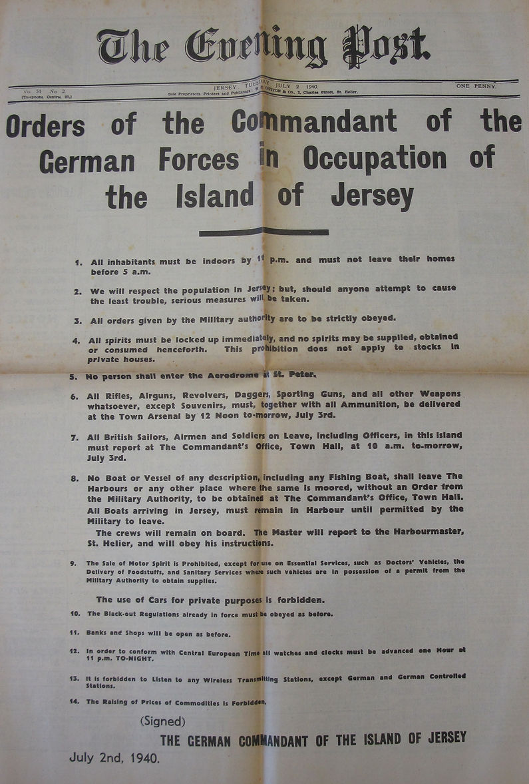
Image Two is a newspaper article from 2 July 1940, where the German Commandant of the Island of Jersey issued some of the German Forces’ new demands.

In research conducted by Duncan Barrett for his book 'Hitler's British Isles’, his findings found that many residents saw the German Soldiers as men in uniform who were ordinary just like them, and the knowledge that "there were Nazis, and there were Germans". Barrett's research found that Islanders who interacted with Germans discovered that the most wanted to go back home to Germany to be with their families and were not like the Allied propaganda. Many German Soldiers tried to interact with Islanders kindly, but a few soldiers were Nazis and idealised Hitler.

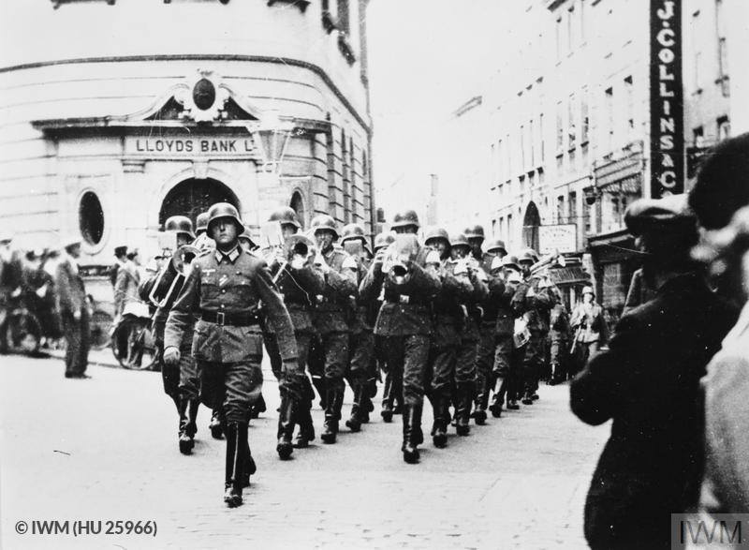

Image Three is a well-known photograph showing the German soldiers parading through the St Peter Port town centre outside the Lloyds Bank. This image was significantly used for German propaganda as it shows them in a part of Britain
Due to weather conditions and changes in the war in Europe, Islanders and the Germans quickly ran out of food supplies and started to starve. Alongside this, medical supplies were nearly enough readily available. Police Officers on the Islands took actions into their own hands and started to steal a variety of food from the Nazis to try and save residents. Unfortunately, most convicted Officers would be imprisoned or sent to European concentration camps. Luckily for the Residents in December 1944 came with a spark of luck as a Red Cross ship called the SS Vega docked at the Islands. The Swedish Ship was chartered by the Red Cross and was allowed to dock and supply the Islands with medical supplies and food. This drop-off was vital for the residents to survive.

Like the Resistance taking a stand in mainland Europe, the Resistance on the Channel Islands was trying to work hard to fight against the Nazis. However, regardless of an organised group, these groups acted in small numbers or even as alone as individuals who would carry out covert operations. Guernseyman Frank Falla, a journalist who opposed the Nazis' handiwork and, along with many other Islanders, helped create an underground newsletter called the Guernsey Underground News Service (GUNS). Individuals like Frank would secretly listen to radio broadcasts by the British Broadcasting Company (BBC) to get the correct information out to the residents. The only problem, the Germans had banned the use of radios and any information released about the war was controlled and shared in the form of Nazi propaganda.

Unfortunately, in cases like Frank's, Frank and other fellow Islanders were detained at the Alderney Gaol, deported or sent to one of the on-island Concentration Camps, one being Norderney on the Island of Alderney. In early September 1942, approximately 2,300 islanders were deported and sent to over 120 prisons or camps in Occupied Nazi territories in Europe. Residents were joined by thousands of fellow prisoners of war (PoWs) who were forced to build Hitler's impregnable fortress, the Atlantic Wall. These PoWs were forced to live in camps, poorly fed, treated like slaves and forced to work long hours without rest. The Atlantic Wall was a defensive line of defence from the Baltic to the Spanish Frontier and was to keep the Allies out of Europe. As the Germans realised they had not won the war by this point, they decided to fortify the Islands. This defensive line on the Channel Islands constituted over a hundred reinforced bunkers, beaches riddled with mines, a variety of tunnels and gun emplacements. The Island of Alderney became the most fortified out of them all. On all Islands, concrete structures can be viewed along the coast and on the mainland today.
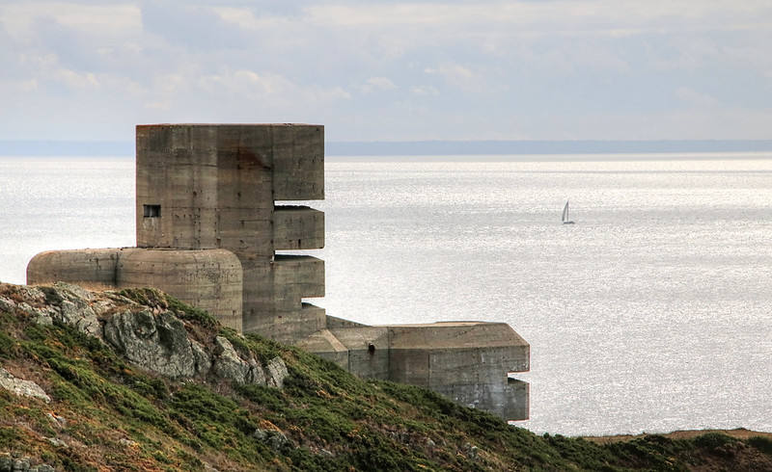
Image Four is an image of a fortification that remains on Guernsey. There are many of these situated around the Islands along the coast and on the mainland.

Liberation:
Due to Hitler's committed suicide and his Nazi Government collapsed, German Forces left the Islands and officially, on 8 May 1945, Winston Churchill declared in a broadcast that all Wehrmacht forces had surrendered and announced that 'our dear Channel Islands are also to be freed to-day'. With the declaration of unconditional surrender signed on 9 May, on 9 and 10 May 1945, all Nazi flags were lowered, and HMS Bulldog and Beagle arrived in the Nazi-occupied Islands to liberate them and become under British rule once again. Even though the Liberation of the Channel Islands happened without any armed conflict, many German and British soldiers, unfortunately, lost their lives by clearing the beaches of mines.

Police Officers who were arrested and charged by the Nazis for crimes would later become unable to return to their original roles as Police Officers after the war or claim a pension. This was due to their new war criminal convictions and failure of criminal pardons. 'See what they did as a Robin Hood-type act. It is not a crime for personal gain; it was to feed hungry people, and as policemen, they were in the position to do something about it.' Keith Friend, the Son of Charles Friend, a Guernsey Police Officer during World War Two, makes a bold statement in an article with the BBC. Many individuals despised Authorities for not allowing them to return to work if able to and would press for compensation. However, despite being unable to return to work, many were physically and/or mentally affected till they died and had to live with their criminal records.

After the war, many who survived the occupation and those who returned to the Channel Islands, considerable amount of them suffered from mental ill-health or from physical injuries obtained by the occupation. Many Islanders or other individuals who suffered at the hands of the German soldiers and their persecution pressed for compensation. The West German State agreed to this and gave the British Government £1 million to compensate. However, out of 4,000 applications, only 1,015 were successful, with only 50 successful applications from the Channel Islands. The British Government decided that the remaining did not meet the criteria as they had to show evidence of their detainment.

Conclusion:
during the
1940–45 German occupation of the
Channel Islands had a number of immediate effects
The Germans' occupation of Channel Islands during 1940-45 had many immediate effects on residents of the Islands, some of which affected them long-term. These could have been easily reduced or even avoided if the British Government had decided to militarise the Islands.

The British Government may have thought that the Islands had no strategic value, but thousands of people lived on the Islands and had their lives affected as a result. This could have been changed or significantly reduced if there had been military support on the Island to protect them against the Germans. The fact that the British Government debated it after the decision was final, but kept their decision the same, shows that there was some significant value.

Bibliography

Atlantikwall Europe (AWE), The Atlantic Wall
(2022) <https://www.atlantikwalleurope.eu/en/page/the-atlantikwall> [accessed 23 December 2022]

BBC, About the BBC
(2022) <https://www.bbc.co.uk/aboutthebbc> [accessed 25 December 2022]

BBC, The 'Robin Hood' policemen who stole from the Nazis
(2020) <https://www.bbc.co.uk/news/world-europe-guernsey-54106579> [accessed24 December 2022]

Carr, Gilly and Shaw, Emma, The Channel Islands' victims and survivors of Nazi persecution,
(2022) <https://www.cam.ac.uk/channelislandsvictims> [accessed 25 December 2022]

Dinning, Rachel, Life under Nazi rule: the occupation of the Channel Islands
(2020) <https://www.historyextra.com/period/second-world-war/channel-islands-occupation-ww2-nazi-germany/> [accessed 24 December 2022]

Frank Falla Archive, About Frank Falla
(2022) <https://www.frankfallaarchive.org/about-frank-falla/> [accessed 25 December 2022]

Frank Falla Archive, Alderney Gaol
(2022) <https://www.frankfallaarchive.org/prisons/alderney-gaol/> [accessed 24 December 2022]

Frank Falla Archive, Norderney Concentration Camp
(2022) <https://www.frankfallaarchive.org/prisons/norderney-concentration-camp/> [accessed 24 December 2022]

Gordon, Stephanie, The Nazi Occupation of the Islands of Guernsey
(2022) <https://www.historic-uk.com/HistoryUK/HistoryofBritain/Nazi-Occupation-Channel-Islands-WWII/> [accessed 23 December 2022]

Hay, Dr George & Willmott, Lauren, ‘How were British victims of Nazi persecution compensated?’, The National Archives,
Thursday 31 March 2016 <https://blog.nationalarchives.gov.uk/compensation-nazi-persecution/> [accessed 27 December 2022]

Historical Association, Hitler’s British Isles: The Real Story of the Occupied Channel Islands
(2018) <https://www.history.org.uk/historian/resource/9400/hitlers-british-isles-the-real-story-of-the-occu> [accessed 28 December 2022]

History.com Editors, France to surrender to Nazis
(2021) <https://www.history.com/this-day-in-history/france-to-surrender> [accessed 24 December 2022]

Holocaust Memorial Day Trust, 30 June 1940: Nazi Occupation Of The Channel Islands Begins
(2022) <https://www.hmd.org.uk/resource/30-june-1940-nazi-occupation-of-the-channel-islands-begins/> [accessed 24 December 2022]

House of Commons, Winston Churchill’s VE Day Broadcast,
<https://winstonchurchill.org/resources/speeches/1941-1945-war-leader/end-of-the-war-in-europe/> [accessed 28 December 2022]

House of Commons, Chamberlain announces Britain is at war with Germany – radio – September 1939,
<https://www.bbc.com/historyofthebbc/anniversaries/september/war-announced/> [accessed 24 December 2022]

Imperial War Museum, national currency, Reichsbanknote, 20 Reichsmark, Germany
(2022) <https://www.iwm.org.uk/collections/item/object/30037023> [accessed 28 December 2022]

International Committee of the Red Cross, Prisoners of war: What you need to know
(2022) <https://www.icrc.org/en/document/prisoners-war-what-you-need-know> [accessed 25 December 2022]

Jersey Bunker Tours, The German Invasion of Jersey
(2022) <https://www.jerseybunkertours.com/the-capture-of-jersey-in-ww2> [accessed 25 December 2022]

Johnson, Ben, The Atlantic Wall
(2022) <https://www.historic-uk.com/HistoryMagazine/DestinationsUK/Guernsey/> [accessed 23 December 2022]

Lamy, Albert Peter/ Guernsey Police, Policing During The Occupation 1940 – 1945
<https://www.guernsey.police.uk/CHttpHandler.ashx?id=5470> [accessed 25 December 2022]

LRE Foundation, The Liberation-of-the Channel Islands
(2022) <https://www.liberationroute.com/stories/195/the-liberation-of-the-channel-islands> [accessed 24 December 2022]

Ray, Michael, Wehrmacht
(2022) <https://www.britannica.com/topic/Wehrmacht> [accessed 28 December 2022]

Simple History, WW2 "Bobbies" who Stole from the Germans (Occupied ﻿Guernsey, UK)
[video]. 2022 <https://youtu.be/rFQQFq1vV3k> [accessed 29 December 2022]
States of Guernsey, Information on the location of the islands and their constitution
(2022) <https://www.gov.gg/article/120176/Information-on-the-location-of-the-islands-and-their-constitution> [accessed 28 December 2022]

States of Guernsey, The Islands of Guernsey during WWII
(2020) < https://www.visitguernsey.com/articles/2020/the-islands-of-guernsey-during-wwii/> [accessed 26 December 2022]

States of Jersey, Facts about Jersey
(2022) <https://www.gov.je/Leisure/Jersey/pages/profile.aspx> [accessed 28 December 2022]

The German Commandant of the Island of Jersey, ‘Orders of the Commandant of the German Forces in Occupation of the Islands of
Jersey’, Jersey Evening Post, 2 July 1940

The Royal Household, Crown Dependencies
(2022) <https://www.royal.uk/crown-dependencies> [accessed 23 December 2022]

The Wiener Holocaust Library, On British Soil: Victims of Nazi Persecution in the Channel Islands
(2021) <https://wienerholocaustlibrary.org/exhibition/on-british-soil-victims-of-nazi-persecution-in-the-channel-islands-online/> [accessed 27 December 2022]

UK Government, Past Prime Ministers- Neville Chamberlain
(2022) <https://www.gov.uk/government/history/past-prime-ministers/neville-chamberlain> [accessed 24 December 2022]

UK Government, Past Prime Ministers - Sir Winston Churchill
(2022) <https://www.gov.uk/government/history/past-prime-ministers/winston-churchill> [accessed 23 December 2022]

Unknown (Photographer), ‘The Occupation And Liberation Of The Channel Islands 1940-1945’ (IWM HU 25966) <https://www.iwm.org.uk/collections/item/object/205088496> [accessed 24 December 2022]

Winchester, Nicole, The Channel Islands: Occupation and liberation
(2020) <https://lordslibrary.parliament.uk/the-channel-islands-occupation-and-liberation/> [accessed 23 December 2022]

Michael Ray, Wehrmacht, (2022) <https://www.britannica.com/topic/Wehrmacht> [accessed 28 December 2022].
States of Jersey, Facts about Jersey (2022) <https://www.gov.je/Leisure/Jersey/pages/profile.aspx> [accessed 28 December 2022].
States of Guernsey, Information on the location of the islands and their constitution (2022) <https://www.gov.gg/article/120176/Information-on-the-location-of-the-islands-and-their-constitution> [accessed 28 December. 22].
The Royal Household, Crown Dependencies (2022) <https://www.royal.uk/crown-dependencies> [accessed 23 December 2022].
Ben Johnson, The Atlantic Wall (2022) <https://www.historic-uk.com/HistoryMagazine/DestinationsUK/Guernsey/> [accessed 23 December 2022].
History.com Editors, France to surrender to Nazis (2021) <https://www.history.com/this-day-in-history/france-to-surrender> [accessed 24 December 2022].
LRE Foundation, The Liberation-of-the Channel Islands (2022) https://www.liberationroute.com/stories/195/the-liberation-of-the-channel-islands> [accessed 24 December 2022].
Atlantikwall Europe (AWE), The Atlantic Wall (2022) <https://www.atlantikwalleurope.eu/en/page/the-atlantikwall> [accessed 23 December 2022].
UK Government, Past Prime Ministers- Neville Chamberlain (2022) <https://www.gov.uk/government/history/past-prime-ministers/neville-chamberlain> [accessed 24 December 2022]
House of Commons, Chamberlain announces Britain is at war with Germany – radio – September 1939, <https://www.bbc.com/historyofthebbc/anniversaries/september/war-announced/> [accessed 24 December 2022].
Nicole Winchester, The Channel Islands: Occupation and liberation (2020) <https://lordslibrary.parliament.uk/the-channel-islands-occupation-and-liberation/ > [accessed 23 December 2022].
UK Government, Past Prime Ministers - Sir Winston Churchill (2022) <https://www.gov.uk/government/history/past-prime-ministers/winston-churchill> [accessed 23 December 2022].
Stephanie Gordon, The Nazi Occupation of the Islands of Guernsey (2022) <https://www.historic-uk.com/HistoryUK/HistoryofBritain/Nazi-Occupation-Channel-Islands-WWII/> [accessed 23 December 2022].
Nicole Winchester, 2020.
The Royal Household, ‘King George VI Speech De-militarisation of Channel Islands’ (1940) <https://www.jerseybunkertours.com/the-capture-of-jersey-in-ww2> [accessed 25 December 2022].
Ben Johnson, 2022
Holocaust Memorial Day Trust, 30 June 1940: Nazi Occupation Of The Channel Islands Begins (2022) <https://www.hmd.org.uk/resource/30-june-1940-nazi-occupation-of-the-channel-islands-begins/> [accessed 24 December 2022].
Nicole Winchester, 2020
States of Guernsey, The Islands of Guernsey during WWII (2020) < https://www.visitguernsey.com/articles/2020/the-islands-of-guernsey-during-wwii/> [accessed 26 December 2022].
Jersey Bunker Tours, The German Invasion of Jersey (2022) <https://www.jerseybunkertours.com/the-capture-of-jersey-in-ww2> [accessed 25 December 2022].
Stephanie Gordon, 2022
Albert Peter Lamy/ Guernsey Police, Policing During The Occupation 1940 – 1945, <https://www.guernsey.police.uk/CHttpHandler.ashx?id=5470> [accessed 25 December 2022].
Imperial War Museum, national currency, Reichsbanknote, 20 Reichsmark, Germany (1939) <https://www.iwm.org.uk/collections/item/object/30037023> [accessed 28 December 2022].
The German Commandant of the Island of Jersey, ‘Orders of the Commandant of the German Forces in Occupation of the Islands of Jersey’, Jersey Evening Post, 2 July 1940.
Historical Association, Hitler’s British Isles: The Real Story of the Occupied Channel Islands (2018) <https://www.history.org.uk/historian/resource/9400/hitlers-british-isles-the-real-story-of-the-occu> [accessed 28 December 2022].
Rachel Dinning, Life under Nazi rule: the occupation of the Channel Islands (2020) <https://www.historyextra.com/period/second-world-war/channel-islands-occupation-ww2-nazi-germany/> [accessed 24 December 2022].
Unknown (Photographer), ‘The Occupation And Liberation Of The Channel Islands 1940-1945’, (IWM HU 25966) <https://www.iwm.org.uk/collections/item/object/205088496> [24 December 2022].
Holocaust Memorial Day Trust, (2022) <https://www.hmd.org.uk/resource/30-june-1940-nazi-occupation-of-the-channel-islands-begins/> [accessed 24 December 2022].
BBC, The 'Robin Hood' policemen who stole from the Nazis (2020) <https://www.bbc.co.uk/news/world-europe-guernsey-54106579> [accessed24 December 2022].
Holocaust Memorial Day Trust), 2022
Emma Shaw and Gilly Carr, The Channel Islands' victims and survivors of Nazi persecution, (2022) <https://www.cam.ac.uk/channelislandsvictims> [accessed 25 December 2022].
Frank Falla Archive, About Frank Falla (2022) <https://www.frankfallaarchive.org/about-frank-falla/> [accessed 25 December 2022].
Frank Falla Archive, 2022
BBC, About the BBC (2022) <https://www.bbc.co.uk/aboutthebbc> [accessed 25 December 2022].
Frank Falla Archive, Alderney Gaol (2022) <https://www.frankfallaarchive.org/prisons/alderney-gaol/> [accessed 24 December 2022].
Frank Falla Archive, Norderney Concentration Camp (2022) <https://www.frankfallaarchive.org/prisons/norderney-concentration-camp/> [accessed 24 December 2022].
International Committee of the Red Cross, Prisoners of war: What you need to know (2022) <https://www.icrc.org/en/document/prisoners-war-what-you-need-know> [accessed 25 December 2022].
Robin Denton (Owner), ‘German Fortification, Pleinmont Guernsey’, 2018 <https://www.flickr.com/photos/smithandjones/45154009121> [accessed 28 December 2022].
House of Commons, Winston Churchill’s VE Day Broadcast (1945) <https://winstonchurchill.org/resources/speeches/1941-1945-war-leader/end-of-the-war-in-europe/> [accessed 28 December 2022].
LRE Foundation, 2022
British Broadcasting Company, 2020.
Simple History, WW2 "Bobbies" who Stole from the Germans (Occupied ﻿Guernsey, UK) [video]. 2022 <https://youtu.be/rFQQFq1vV3k> [accessed 29 December 2022].
British Broadcasting Company, 2020.
Dr George Hay & Lauren Willmott, ‘How were British victims of Nazi persecution compensated?’, The National Archives, Thursday 31 March 2016 <https://blog.nationalarchives.gov.uk/compensation-nazi-persecution/> [accessed 27 December 2022].
The Wiener Holocaust Library, On British Soil: Victims of Nazi Persecution in the Channel Islands (2021) <https://wienerholocaustlibrary.org/exhibition/on-british-soil-victims-of-nazi-persecution-in-the-channel-islands-online/> [accessed 27 December 2022].

