University of Wales Trinity Saint David

Leadership and management, theory and practice
(LCBB6003)

Assessment 1-Essay
FEB 2023

Student’s name: Radoslav Bozhkov
Student’s number:2010794
Professor’s name: Dr. Mushfiqur Rahman

Table of Contents
Introduction 3
Royal Bank of Scotland (RBS) 4
Leadership and management theories and models 4
Leadership Theories 4
Great Man Theory 4
Trait Theory 4
Blake and Mouton model 4
Theory X and Y 5
Human Relations Theory 5
Application of theories and models to the leader of The Royal Bank of Scotland 7
Application of Human Relation Theory in the Royal bank of Scotland: 7
Impact of leadership on the organization 8
My experience of leadership and areas for my personal development 8
Conclusion 9
References 10
Appendix 12
Leadership development plan 12

Introduction
The process of influencing and directing an individual or a group of workers toward the accomplishment of an organisational goal is known as leadership. Leadership has its styles and process. Different theories have been given by various researchers. Effective guidance, responsibility, and a positive work environment must be implemented by leaders for their workforce. Leadership styles act differently in the organization. It implies that conditions, decisions, work culture, working environment, new laws and regulations, organisational complexities, and changes match the style of leadership. The needs of the team and the situation will determine the best type of leadership. A capable leader will be able to modify their approach to leadership to best suit the situation and the followers they are guiding.

Royal Bank of Scotland (RBS)
Royal Bank is one of the most dependable and stable financial banks in Edinburgh, Scotland. It is a part of the NatWest Group, one of the largest banking industries in the United Kingdom. The bank was founded in the United Kingdom in 1727, and because of its long history, it has earned a strong reputation and customer trust. Personal banking, wealth management, business banking, investment banking, and commercial banking are just a couple of the services available. Due to the recent financial crisis, RBS had to go through major restructuring and processing operations. Successfully operating and giving services to their customers (Kerr and Robinson, 2016).

Leadership and management theories and models

Leadership Theories

Great Man Theory
The Great Man theory was introduced as the initial leadership theory. This theory implied that great leaders are born instead of made, and it was largely accepted in the 19th and early 20th centuries. Under this theory, leaders are not formed through learning but moreover through the possession of such inborn traits (Madanchian et al, 2016).

Trait Theory
The Trait Theory of Leadership focused on various behavioural traits of leaders. According to the Trait Theory, people inherit certain traits and qualities that differentiate them as great leaders. Qualities like strength, weight, height, appearance, intelligence, knowledge, and creativity. According to those who believe in trait theory, outstanding leaders are those who are born with the ability to lead. The skill of being a leader is something that is only inherited. Stogdill argued that the principles of trait theory failed to adequately capture the essence of leadership. Possessing a certain trait does not necessarily determine who will become the next leader (Scheffer and Heckhausen, 2018).
Leadership Models

Blake and Mouton model
The managerial grid model by Blake and Mouton characterises two key issues.
1. Concern for people
2. Concern for production
A managerial grid model is a behavioural leadership model that helps managers analyse their leadership style. There are two axes in this model. The concern for people is represented by one axe, while the concern for production is represented by another axe (Mindapa, 2022).
Fiedler's Contingency Model
Contingency refers to the term "uncertainty." When a manager deals with unexpected situations in any organisation, that is known as contingency. The main motive of this model is to find out how well a leader is capable of dealing with unexpected situations. Fiedler's Contingency Model believes that there is no single style of leadership appropriate to all situations (Simha, 2022).
Management Theories

Theory X and Y
Theory X: No delegation of authority in this approach. Employees must have to follow their supervisors' orders and act accordingly. Managers are required to supervise employees at all times.
Theory Y: The superiors delegate the authority among the employees. Supervisors don't have to supervise the work at every level of management. Promotions and rewards are given by the leader to motivate employees and as result goals can be achieved (The Economic Times, 2023).

Human Relations Theory
The Human Relations Theory focuses on the needs and behaviours of individual employees or groups. This approach increases employee morale which leads to greater productivity and efficiency in the organization. By treating the employees in a good manner managers can promote the productivity of the employees and those efforts can lead the organization on the path to success (Nicotera, 2019).
Management Models
Deming Cycle Model
The Deming Cycle is also referred to by the term Plan-Do-Check-Act (PDCA) cycle. This cycle is divided into four stages which will cover all the important aspects of effective management:
1. Plan
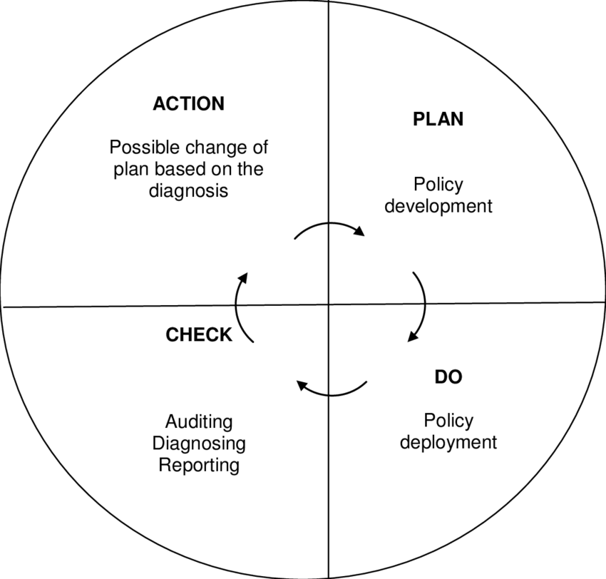
Setting goals and developing an improvement strategy are all part of this step. I was also involved in identifying and analysing the challenges or improvement opportunities.
2. Do
In this phase, the major step is plan implementation. All the improvement processes are carried out.
3. Check
The check involves the activity of measuring the results and evaluating them against the goals and objectives set in the planning stage.
4. Action
Figure 1 Deming Cycle Model Source: researchgate.net, 200ss4
This is the final Act stage, where appropriate actions are taken to standardize the procedure, make improvements, and implement changes based on the findings of the check stage (Nasution, 2016
Total Quality Management
Total Quality Management (TQM) is a management approach that focuses on customer satisfaction. The main focus of TQM is customer satisfaction. By understanding their needs, expectations, and requirements, organizations can create products or services that are according to the expectations. By applying this organization tries to deliver the highest possible value to the customer. Customer satisfaction is the key to TQM's long-term success, as it places the customer at the centre of everything, and involves all employees in continuous improvement (Souza et al 2022).
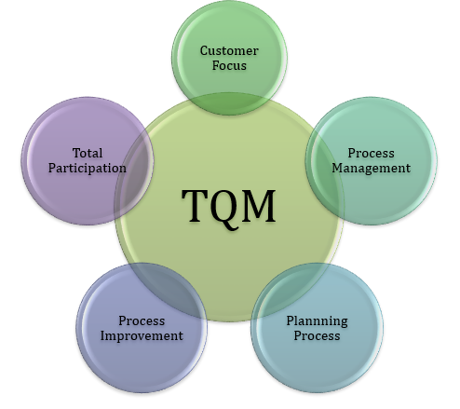

Figure 2 Total Quality Management (TQM)
Source: prodyogi.com, 2018

Application of theories and models to the leader of The Royal Bank of Scotland

Application of Human Relation Theory in the Royal bank of Scotland:
Human relation theory: Leading employees’ efforts towards the organization's purpose is just one aspect of leadership. It involves giving the employee the proper care that they require. Seeing each person as an individual and taking into account their social and psychological requirements define effective leadership. RBS can raise staff morale and work satisfaction by using this strategy.
Application of Total Quality Management Model for RBS:
Customer focus: The Royal Bank of Scotland (RBS) has a variety of services for its customers. RBS should understand its customers’ requirements so that it can actively participate in the feedback process. The business should concentrate on using a total quality management model to collect feedback from customers. After taking feedback, they analyse the comments of the customers and take action accordingly (Green, 2016).

Impact of leadership on the organization
Leadership can effectively lead the organization performance and make it successful. success and performance of an organization depend upon the employees’ efforts and proper leadership. Effective leadership can inspire and motivate employees to work together toward the organization's objectives.
High Morale: Leaders can create an encouraging work environment by involving their team members in a variety of activities that enhance morale and increase satisfaction. In a negative environment, employees will not be able to give their best, which will result in the unfulfillment of the objectives of the organisation and low morale of the employees (Bolden, 2016).
Productivity: Proper leadership can motivate and inspire employees to work together and more efficiently. Effective leaders can help in increasing productivity and higher quality work. Poor leadership can lead to low productivity and poor-quality work (Ibrahim and Daniel, 2019).

My experience of leadership and areas for my personal development
My experience has been a balance of both success and failure as a leader. In the company, I tried incorporating leadership theories and models so that I become more efficient at it. I try to be democratic and maintain good conditions for the workers which enhance motivation according to the theory of X and Y. Effective communication plays an important part in building trust, empowering collaboration, and inspiring others to work towards a common goal. Leadership helps in the development of strong communication skills, the development of relationships, and the inspiration of others to work together. I need to enhance my communication skills. Planning and making a strategic plan in advance help managers deal with an uncertain situation. To lead effectively, managers must be able to make strategic plans and ideas. Understanding opportunities and challenges, and developing strategies are leadership abilities. I should be committed to continuous learning and development. Developing a habit of constant learning can assist anyone in staying on track. It is important to put learning into practice otherwise the desired outcome will not be achieved. Thus, I need to enhance my communication skills, time management, etc.

Conclusion
Leadership and management are the two most important aspects of organisational success. Leadership requires inspiring and motivating people to work towards a common goal. On the other hand, to achieve certain objectives, management focuses on organising, planning, and regulating resources. Taking employees into account in various plans will allow the organization to accomplish its goals more quickly and effectively. The right leadership can create a work culture that encourages respect, innovation, and creativity. Good decisions can help organizations succeed in the long term. Any organization needs to remain focused and ready to adjust according to the requirements. Leadership and management are important aspects to deal with uncertainties. Leaders should use the theories and models given by various theorists to develop the necessary skills in today's complex business environment. Organizations can promote innovation, develop strong and dependable teams, and accomplish their objectives with the support of a systematic approach.

References
Bolden, R. (2016) Leadership, management and organisational development. In Gower handbook of leadership and management development (pp. 143-158). Routledge.
Green, M. F. (2016). "Not for Wimps or Cowards: Leadership in the Post-Heroic Age." Educational Record 75(3): 55-60.
Ibrahim, A.U. and Daniel, C.O. (2019) Impact of leadership on organisational performance. International Journal of Business, Management and Social Research, 6(2), pp.367-374.
Kerr, R. and Robinson, S. (2016) Architecture, symbolic capital and elite mobilisations: The case of the Royal Bank of Scotland corporate campus. Organization, 23(5), pp.699-721.
Madanchian, M., HUSSEIN, N., NOORDIN, F. and TAHERDOOST, H. (2016) Leadership theories; an overview of early stages. Recent advances in energy, environment and financial science, 198, p.201.
Mindapa, A.K. (2022) Critical Evaluation of Blake And Mouton’s Managerial Grid and Its Application To Baze University Library. Library Philosophy & Practice.
Nasution, M.N. (2016) A Deming Cycle as a Tool of Improving A Continuous Service Quality. Indonesian Management and Accounting Research, 5(1), pp.53-78.
Nicotera, A.M. (2019) Human relations theory. In Origins and Traditions of Organizational Communication (pp. 106-127). Routledge.
Scheffer, D. and Heckhausen, H. (2018) Trait theories of motivation. Motivation and action, pp.67-112.Indeed (2023) The blake and mouton managerial grid: Guide and use. Available at: https://www.indeed.com/career-advice/career-development/blake-and-mouton-managerial-grid (Accessed: March 27, 2023).
Simha, A. (2022) Contingency and Situational Leadership. In Leadership Insights for Wizards and Witches (pp. 33-39). Emerald Publishing Limited.
Souza, F.F.D., Corsi, A., Pagani, R.N., Balbinotti, G. and Kovaleski, J.L. (2022) Total quality management 4.0: adapting quality management to Industry 4.0. The TQM Journal, 34(4), pp.749-769.
The Economic Times (2023) What is theory X & theory Y? definition of theory X & theory Y, theory X & theory y meaning, The Economic Times. Available at: https://economictimes.indiatimes.com/definition/theory-x-theory-y (Accessed: March 27, 2023).

Appendix

Leadership development plan
What are my Leadership development Objectives? | What leadership activities do I need to undertake to achieve my objectives? | Where will I develop my leadership to achieve my leadership objectives? | The target date for achieving my objectives
Management of my team members' actions | A proper set of motivation and a clear vision will help in this. | In a classroom of the college | 30 April
Management of time | I have decided to do the following things:  1. Set a particular time for each task  2. Make a to-do list  3. Use the 80/20 rule | I will practise these activities in a classroom and at home | 30 April
Learn clear communication skills | To communicate clearly, I will read books, write journals | I will go to the library and write journals at home | 30 April
Management of work pressure | To manage work pressure, I will divide the work into different parts, and set small goals. | I will discuss with others to reduce it | 30 April
Focus on the right objectives | To improve my focus, I will do the following things:  1. Mediation  2.Reduce multitasking  3. Proper sleep | I will do these activities at home | 30 April

