Ivonna Radu 2010088. Lecture name:Mery Needham
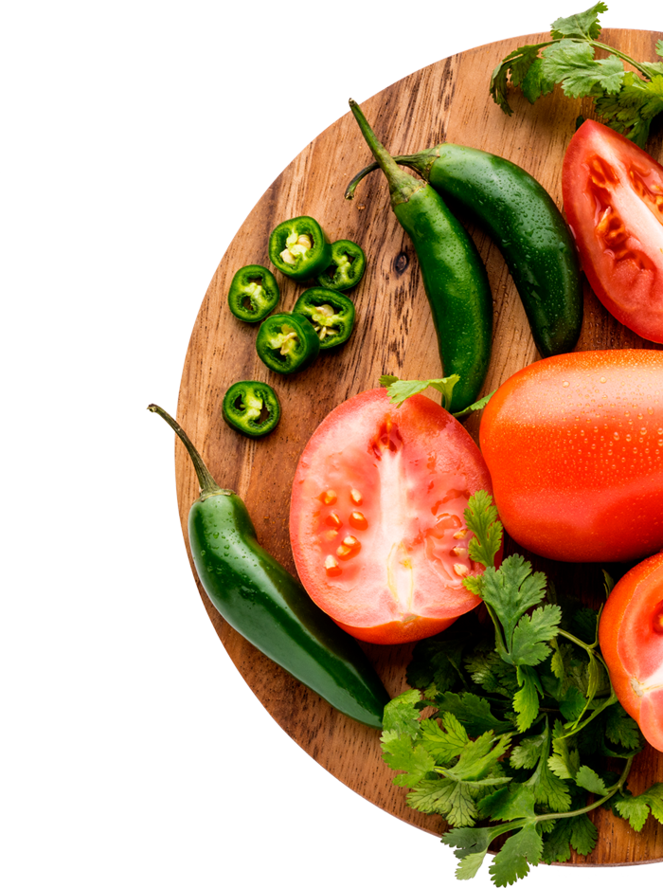
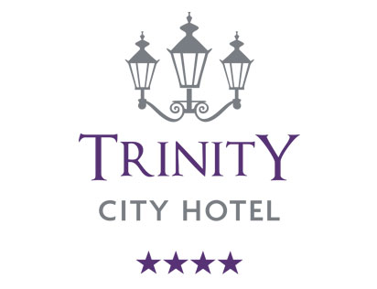

Take- Away
Menu

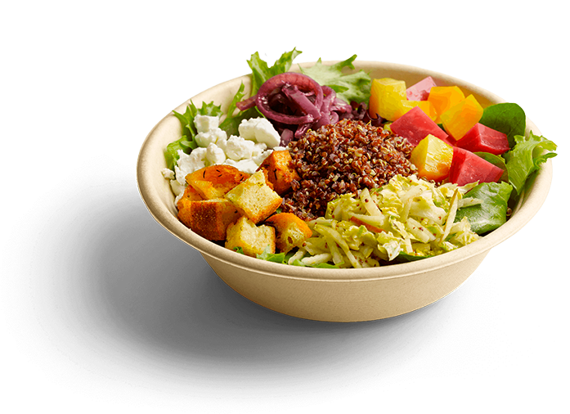
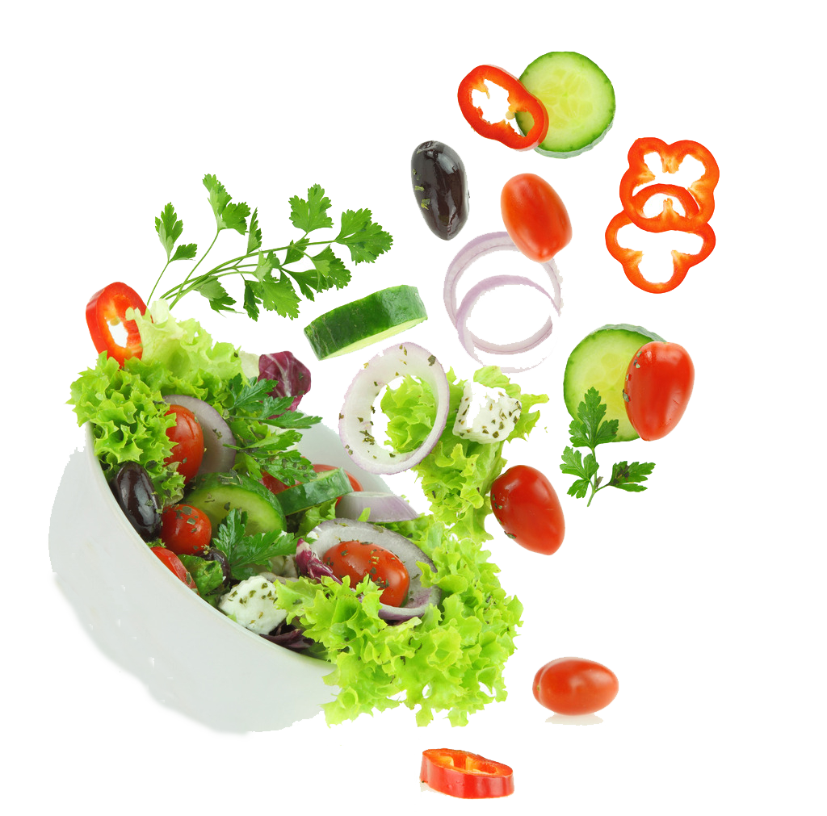


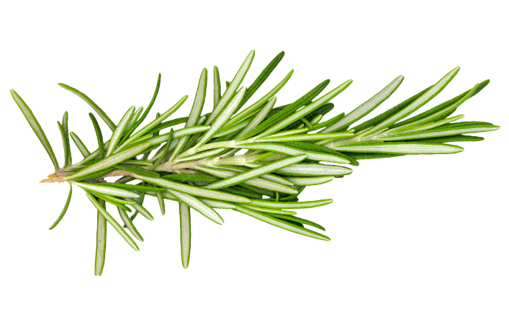
Breakfast
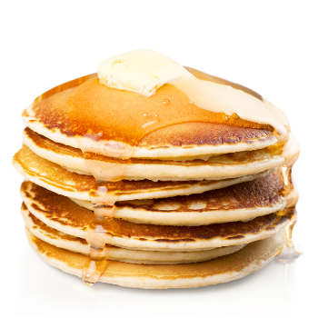
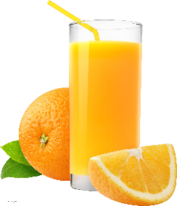
Pancakes with honey &
Apple Juice
14.5 £


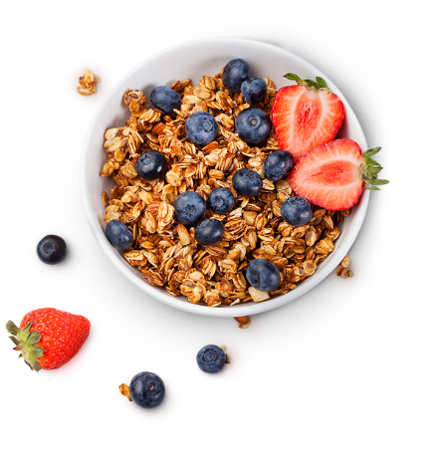
------------------------------------------------------
Granola Bowl &
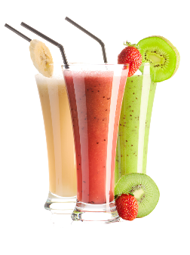
Smoothie
19.5 £


------------------------------------------------------
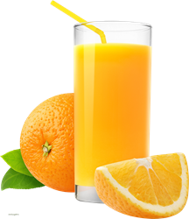
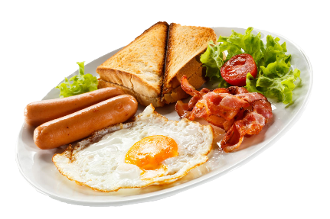
English Breakfast &
Orange Juice
20 £


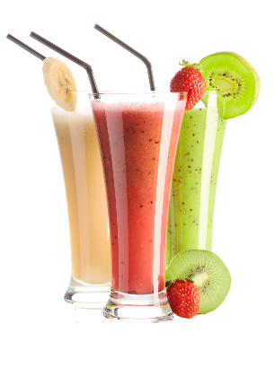
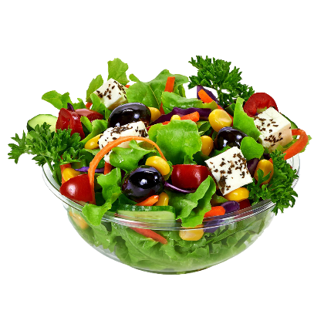

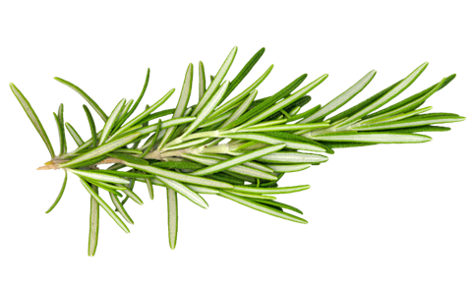
Salad
Greek Salad &
Fruit Smoothie
18.5 £

----------------------------------------------------
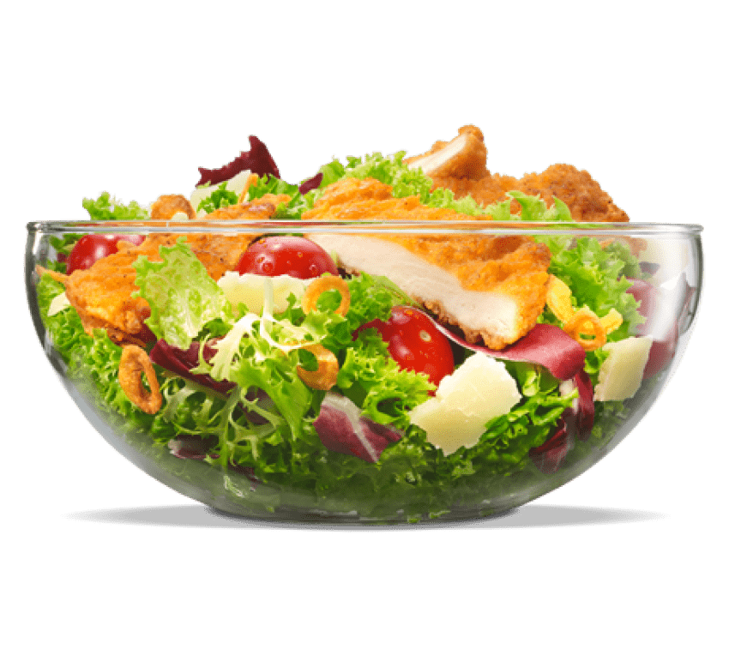
Caesar Salad &
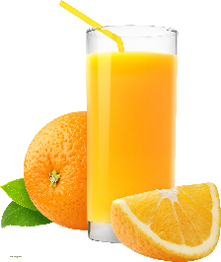
Apple Juice or

Coffee
21 £

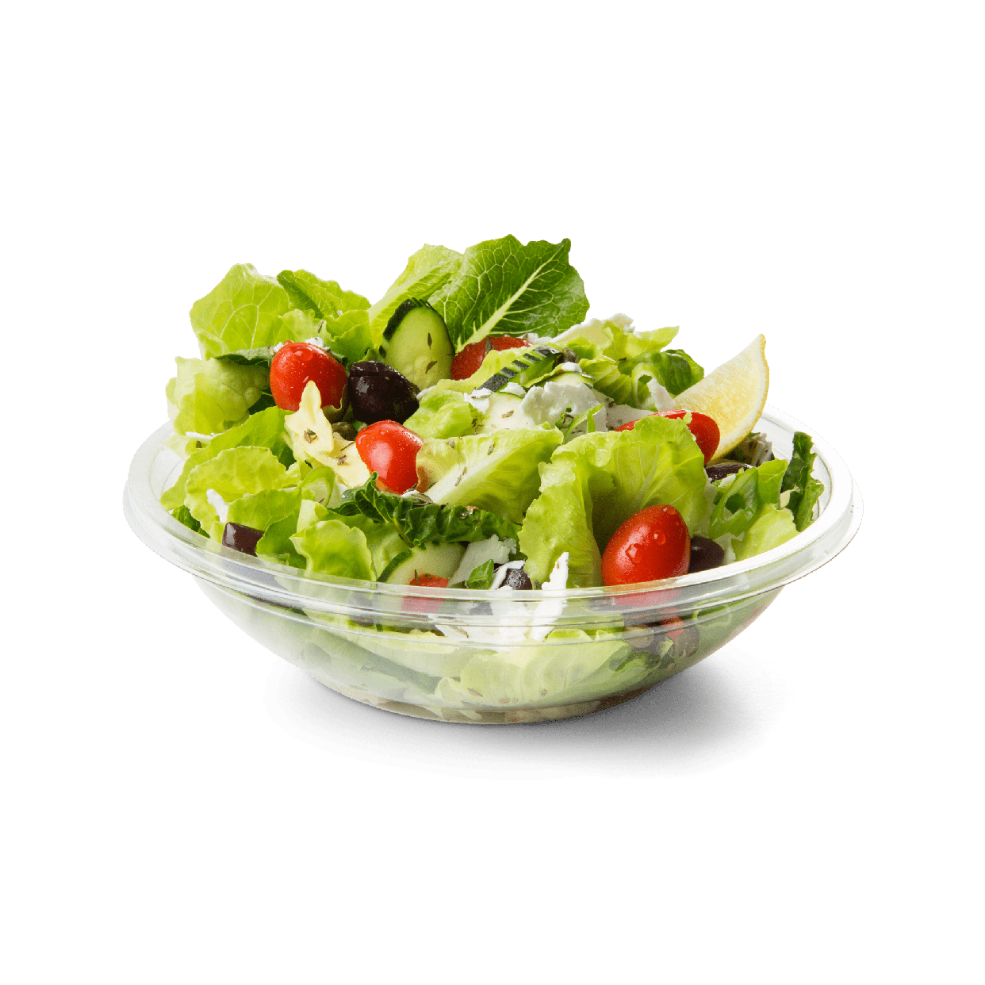
----------------------------------------------------

Italian Salad &
Espresso
20 £

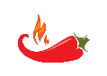

Main Dishes
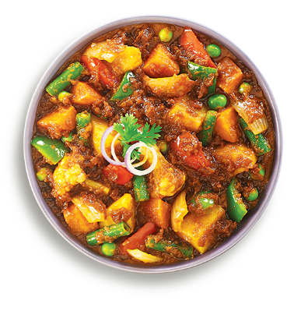
Chana Masala &
Still/ Sparkling Water
22 £

-------------------------------------------------------
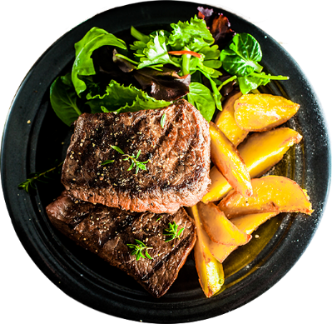
Grilled Beef with potatoes
And fresh salad &
Still/ Sparkling Water
26.5 £

--------------------------------------------------------
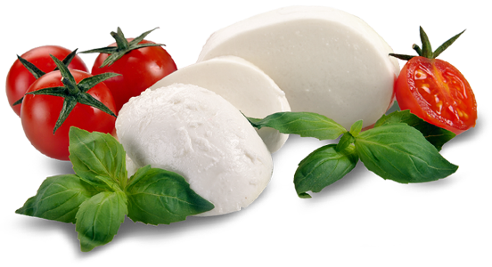
Buratta Cheese with basil and
Tomatoes &
Still/ Sparkling Water
18 £


Burger
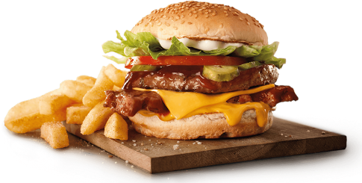
Beef Burger with
French fries &
Sauces
13.5 £

----------------------------------------------------
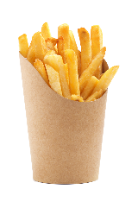
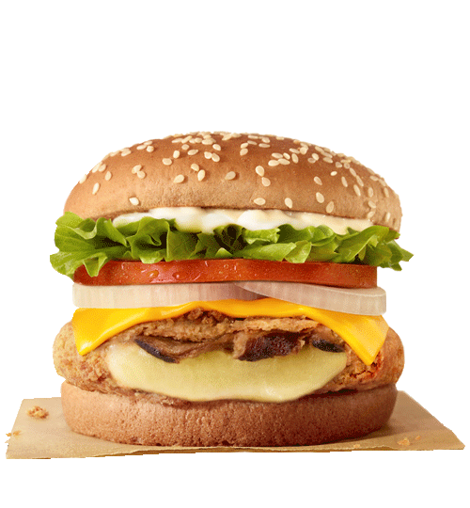
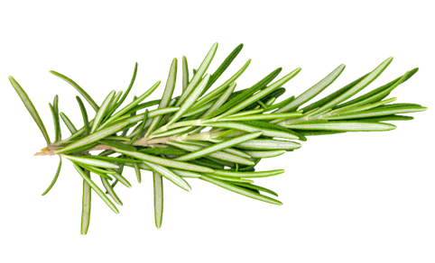
Vegan Burger with
French Fries &
Sauces
11 £
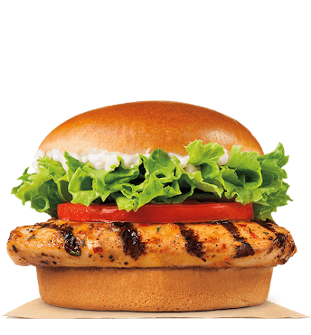
-----------------------------------------------------
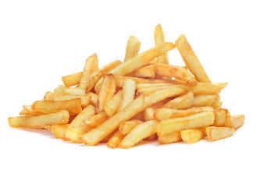
Chicken Burger with
French Fries &
Sauces
12.5 £

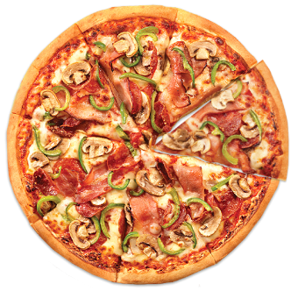


Pizza
Quatro Stagioni Pizza &
Sauce
15 £

-----------------------------------------------------------
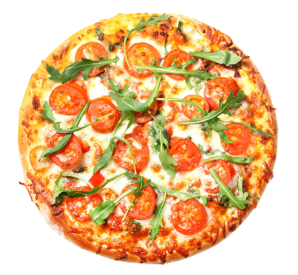
Margherita Pizza &
Sauce
11 £

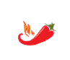
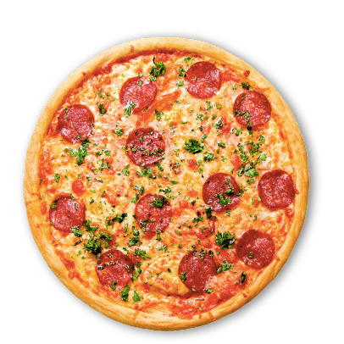
-----------------------------------------------------------
Diavolo Pizza &
Sauce
13 £


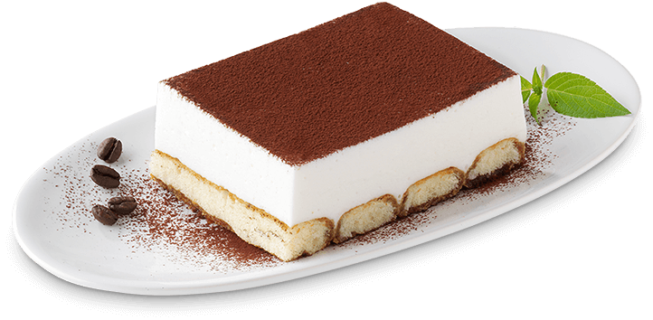
Desert
Tiramisu
5 £

----------------------------------------------------------
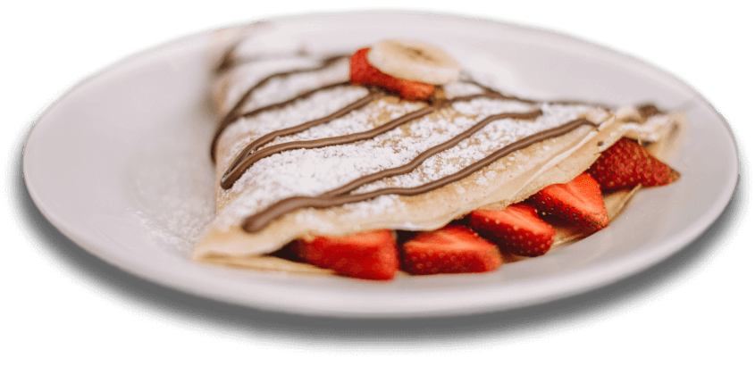
Sweet Crepes
With Nutella
Or Jam
4 £
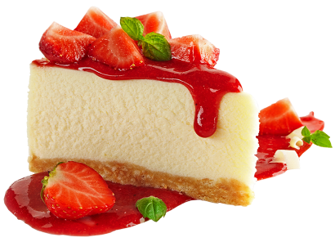
----------------------------------------------------------
Cheesecake

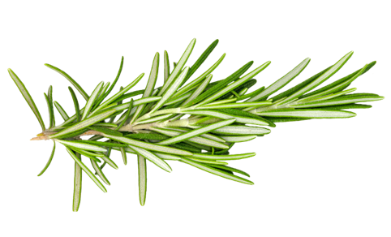
6 £

Drinks
Espresso …………………….2 £
Caffee Latte…………………3 £
Capuccino……………………2.5 £
Still Water………….………. 1 £
Sparkling Water…………...…1 £
Orange Juice…………………3 £
Smoothie…………………….3.5 £




Details
Time Availability
08:00 – 20:00

Payment
Cash Card


Contact
Phone: +44 1702 342282
Adress: 3 Trinity Ave, Westcliff-on-Sea, Southend-on-Sea, Westcliff-on-Sea SS0 7PU, United Kingdom

