Managing People
Assessment 2
Institutional Affiliation: University of Wales Trinity Saint David
Student Iva Naydenova (1914746)

Date : 03/09/2021

Table of Contents
Introduction 3
The Concept and Drivers of Employee Engagement. 3
Diagnostic Tools for Measuring Employee Engagement. 6
Employee Value Proposition. 8
EVP 9
Conclusion 11
References 11

Introduction
When the Covid-19 pandemic hit the world, organisations were forced to re-strategise their culture to cope with the challenges that came with the pandemic. There has been significant changes in the workplace leading to a significant shift in the way organisations value and treat their employees and recognise the impact of employees on the success of the organisation. Employees are the key drivers of success, and every organisation should strive to create a culture and environment that will focus on engaging their employees and at the same time reflect their organisational values, mission and goals. This report will analyse the concept and drivers of employee engagement and evaluate the diagnostic tools for measuring employee's engagement. The report will also focus on the employee value proposition.

The Concept and Drivers of Employee Engagement.
Employee engagement is concerned with the emotional commitment employees have towards their organisation and actions taken by employees to ensure their organisation achieves its goals and objectives. When employees are effectively engaged, they demonstrate dedication, care, enthusiasm and accountability towards their work and the organisation and focus on results. 'Engaged' employees do not need supervision to do their work, they are willing to get their job done because of their commitment, and they have a high level of accountability (Martin and Siebert, 2016). They are always willing to stand up for their company and are proud to be part of their organisation. Engaged employees find solutions to problems in their workplace and create ideas to improve. The level of employee engagement depends on how their organisation treats them.
Employee engagement is the accountability of the organisational leadership team. It is a culture change in how the leaders lead, the decisions they make and their actions. The most crucial step towards employee engagement is for the management to understand and believe that engaging their employee is vital for the success of their organisation (Griffin, Phillips and Gully, 2016) Employee engagement is a process of continuous change and improvement. The process focuses on motivating the employees to make them want to change and behave differently and implement new ways of working to embed the change. An effective change programme should be able to change the mindset of the employees as well as deliver a plan and a process for behavioural change to enable a sustainable result.
The management of an organisation will need to understand what motivates their employees and drives them to be personally invested in their work to improve employee engagement. Drivers of employee engagement vary from one organisation to the next and from one group of employees to another within a single organisation (Martin and Siebert, 2016). Drivers can also change over time depending on the external factors affecting an organisation, such as economic depression or a public health crisis. Drivers of employee engagement are the factors that quantify the level of workplace quality that impacts engagement. The following are some of the employee engagement drivers;
Autonomy; this driver plays a very significant role by inspiring employees to maximise their potential in their work performance. When a workplace has autonomy, it means that the employees are trusted to determine how best they should do their job (Leroy et al., 2018). Employees should be given the freedom to make decisions regarding time management and how to apply their expertise. When there is autonomy at work, employees feel more invested in the company and its mission.
Capacity; this is an essential driver of employee engagement; it refers to how comfortable employees feel when doing their job. Employees should be made to feel capable of putting their physical, intellectual and emotional energy into their work (Leroy et al., 2018). This can be enhanced by availing employees' necessary resources to help them in their work.
Coworker Relationship; employee relationships amongst themselves can have a significant impact on the performance of their work. When team members have a healthy relationship with one another, a positive relationship is instilled with trust. A good employee relationship is important, especially when colleagues collaborate closely (Leroy et al., 2018). The organisation can nurture this relationship by promoting good relationship in the organisation.
Fairness; how employees feel regarding how they are treated within the organisation is critical. The organisation's management should be mindful of how they treat their employees by setting clear expectations and ensuring there is a consistent process around rewards; employees naturally compare their work situation with others (Sun and Bunchapattanasakda, 2019)
Feedback; when employees receive adequate feedback about their work, it helps them understand whether or not they are meeting expectations and how they can improve to meet these expectations (Eldor and Vigoda-Gadot, 2017). Constructive feedback has a positive impact on employee engagement and also strengthens the employee-management relationship.
Professional Development; this is a crucial driver of employee engagement and focuses on the presence of opportunities for growth in the workplace that are provided by the organisational management to support employees in their professional development (Sun and Bunchapattanasakda, 2019). Apart from offering the right resources to help employees achieve their goals, the leaders should also encourage teams to take advantage of these opportunities.

Diagnostic Tools for Measuring Employee Engagement.
The ultimate measure of the level of employee engagement in an organisation is the productivity of a business. When an organisation has successfully enhanced their employee engagement, it should result in increased creativity and level of output. The organisation should adopt effective ways for monitoring and measuring the level of their employee's engagement. The following are some of the tools management can use to measure engagement.
Employee Survey; Surveys are one of the most commonly used tools for measuring employee engagement. This is achieved by analysing the feedback gathered from employees concerning their feelings and attitudes towards their work and the organisation as a whole (Chandani et al., 2016). The best way of carrying out a survey is by filling out survey questionnaires and having them submitted anonymously. This way, more employees will be able to participate and give more honest responses. Also, organisations should prefer using third-party administrators such as Survey Monkey. Employees will feel more comfortable and will be more forthright with their opinions without fear of retaliation when dealing with a survey administrator from outside their organisation. A good survey should be designed well to help management understand the motivation, passion, level of job satisfaction of their employees and the quality of work relationships. For instance, employees are likely to be motivated by professional growth, monetary incentives and having achieved a work/life balance.
HR software; surveying employees can be carried out once or twice in a year, however, surveys do not provide feedback that is real-time, ongoing and holistic. Apart from employees' surveys, organisations need another supplementary periodic survey to help them track their employee's engagement year-round (Chandani et al., 2016). There are several versatile software programs organisations can use for carrying out periodic surveys in their organisation. These tools help in collecting feedback and measuring employee satisfaction and at the same time allow proper management of employees and their data by storing survey results in one place. For instance, performance management software is good at facilitating and tracking more frequent conversations that take place between managers and their employees. The data gathered can be used to ensure everyone is happy, are on track, and work together to achieve the individual, department, and company-wide goals.
Social media; is a very powerful tool, and it is very accessible to employers. For instance, monitoring Glassdoor ratings and reviews can help organisations measure the employee's sentiments (Popli and Rizvi, 2016). Also, internal social media network such as the company's intranet allows employees to post and engage in conversations. Management can analyse these conversations to help them understand their team and get a sense of their morale and overall company culture.
Exit and Stay Interviews; in organisations, employees leave at different points for different reasons. The Human resource of organisations should seeks to understand these reasons. In some cases, employees will cite that they don't feel engaged or their job is not exciting for them, and they need something more challenging (Osborne and Hammoud, 2017). These are some of the common reasons employees give for leaving an organisation. HR should conduct exit interviews and stay interviews to help them understand what they should improve on to help improve employee engagement. Also, exit interviews help management know what can be done differently to improve engagement and stay interviews helps to understand what the organisation is already excelling at.
Small Focus Groups; it can be challenging for HR for large organisations to conduct a one to one meeting with their employees. In this case, focus groups could be the best option (Osborne and Hammoud, 2017). The management of an organisation arrange members from the same or different teams into groups. A set of questions is prepared based on asking employees whether they feel that their work is essential or not or whether they have all the necessary tools to do their work. Feedback from these groups will help organisations know what they can improve on to enhance employee engagement and productivity.

Employee Value Proposition.
Employee Value Proposition is a key tool for organisations when building employee loyalty and increasing engagement. EVP is a set of factors that employees perceive as values gained through employment in an organisation. These factors include attributes, experiences, rewards and opportunities. Companies need a talented workforce to grow; with a compelling EVP companies can outperform their competitors by attracting and retaining a superior workforce.
As a result of the Covid-19 crisis, organisations were forced to alter their EVPs to help them adapt to the new environment. These changes include remote work, striving for better flexibility and work balance, restructuring roles, and making their workplace "Covid-19 safe" (Kramer and Kramer, 2020). The changes have shifted the landscape for company recruitment as a pool of potential employees has expanded to include potential employees beyond the previous geographic boundaries.

EVP
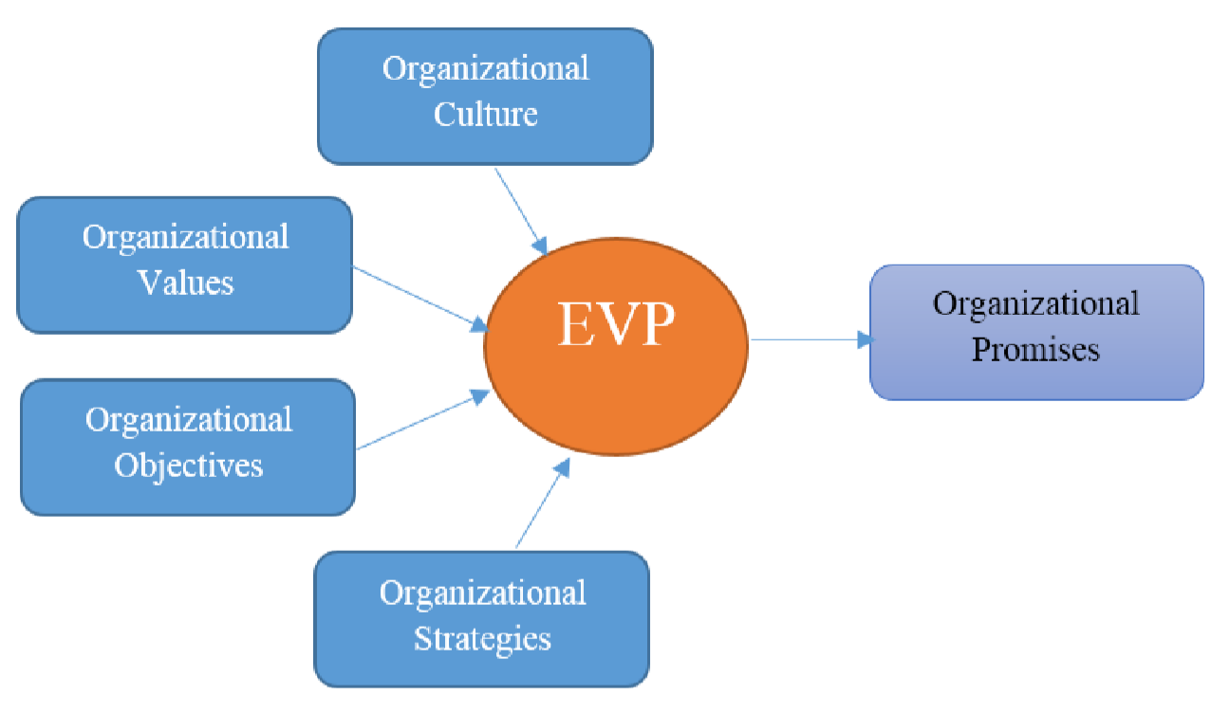

Organisational Culture; involves sharing the vision of the organisation, its values and assumptions to form a common environment in the company that impacts people's behaviour. All the work attributes of the organisation should be affected positively by the organisational culture.
Organisational Values; this is made up of a set of values that guides the actions and perspectives of the organisation. The management should ensure a proper establishment of these values to help the company develop its culture. Some of the core values that an organisation should adopt are honesty and integrity; it goes a long way into building strong relationships among employees, stakeholders and customers. A high level of employee engagement forms the backbone of an entire organisation. Employees work together with the system to help the organisation achieve growth and profitability. An organisation has a great responsibility towards their employees by showing utmost respect to their employees; this results in reduced employee turnover rate (Elsmore, 2017). Also, ensuring a healthy workplace environment for all employees forms an integral part of caring for employees and respecting them. Management should ensure a healthy workplace, especially during the ongoing pandemic, by creating a 'Covid-19 free' workplace. Innovation is an essential value of an organisation. It can be promoted by encouraging employees to be dynamic and to come up with ideas that can translate into successful products for the company.
Organisational Strategies; strategies adopted by an organisation consists of a set of actions that helps the company in attaining its objectives. These strategies help the organisation achieve its long-term effect on its profitability. For the strategies to be effective, an organisation needs the efforts and involvement from everyone, which can be achieved by implementing a unique employee value proposition in the organisation at all levels. Some of the strategies organisations should implement to keep their employees engaged include:
- Offering security to their employees.
- Creating fair and performance-based compensation.
- Training employees in relevant skills.
- Creating a flat and egalitarian organisation and making information easily accessible to those who need it.
Flextime Strategy is very effective in delivering clear engagement results. Employees tend to be more motivated when they are offered a flexible schedule. Implementing a flex-time policy can attract the best talent into a company, improve retention and reduce the cost of replacing employees (Elsmore, 2017).
Organisational Objectives; objectives of an organisation are driven by activities designed to help achieve the company's medium- and short-term goals. They are designed to shape the organisation's structure, policies and rules using the available resources. The success of an organisation can only be assured when there is a compelling employee value proposition.

Conclusion
As the business world becomes more and more competitive, employee engagement is becoming a critical driver of business success. Businesses that can achieve a high level of engagement promote retention of top talents and attract the best talents into their organisations. This promotes customer loyalty and improves organisational performance. There are no universal drivers of employee engagement; however, an organisation should analyse their employees to understand what drives them to be personally invested in their work. Diagnostics tools used for measuring employee engagement includes employee survey, small-group focus, HR soft wares and social media.
The employee value proposition of an organisation is the core of its brand and should be characterised by the organisation's substance and why it is unique. The EVP demonstrates some benefits employees get, consequently offering their skills, capabilities, and experiences to an organisation.

References
Chandani, A., Mehta, M., Mall, A. and Khokhar, V. (2016). Employee engagement: A review paper on factors affecting employee engagement. Indian Journal of Science and Technology, 9(15), pp.1-7.
Eldor, L. and Vigoda-Gadot, E. (2017). The nature of employee engagement: Rethinking the employee–organization relationship. The International Journal of Human Resource Management, 28(3), pp.526-552.
Elsmore, P., 2017. Organisational Culture: Organisational Change?: Organisational Change?. Routledge.
Griffin, R.W., Phillips, J.M. and Gully, S.M. (2016). Organizational behavior: Managing people and organizations. Cengage Learning.
Kramer, A. and Kramer, K.Z. (2020). The potential impact of the Covid-19 pandemic on occupational status, work from home, and occupational mobility.
Leroy, H., Segers, J., Van Dierendonck, D. and Den Hartog, D. (2018). Managing people in organizations: Integrating the study of HRM and leadership.
Martin, G. and Siebert, S. (2016). Managing people and organizations in changing contexts. Routledge.
Osborne, S. and Hammoud, M.S. (2017). Effective employee engagement in the workplace. International Journal of Applied Management and Technology, 16(1), p.4.
Popli, S. and Rizvi, I.A. (2016). Drivers of employee engagement: The role of leadership style. Global Business Review, 17(4), pp.965-979.
Sun, L. and Bunchapattanasakda, C. (2019). Employee engagement: A literature review. International Journal of Human Resource Studies, 9(1), pp.63-80.

